INSTRUCTIONS:

- This task should be done individually.
- You need to submit the hard copy of this task by the end of the class.
- Any plagiarism and late submission will be penalized.

LEARNING OUTCOMES
Upon the completion of this lab session, students will have the ability to transform ERD/EERD to relational model.

QUESTION:
- Refer to The Labsheet 1 (ERD) and 2 (EER), convert ERD/EER to relational model.

Case 1: Business rules
  - A company operates many departments.
  - Each department employs one or more employees.
  - Each of the employees might or might not have one or more dependents.
  - Each employee might or might not have an employment history

ERD:
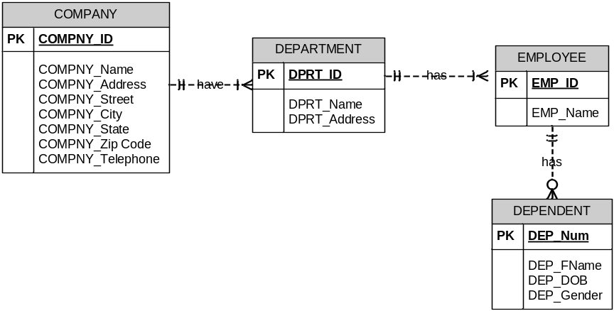

Case 2: Business rules for Little League baseball program:
- A City sponsor one or more teams, but each team is only sponsored by only one city.
- A team has many players, but each player plays for only one team.
- It takes at least 10 players to make a team.
- Each team plays each of the other teams twice, one at home and once as the visiting team.
ERD:
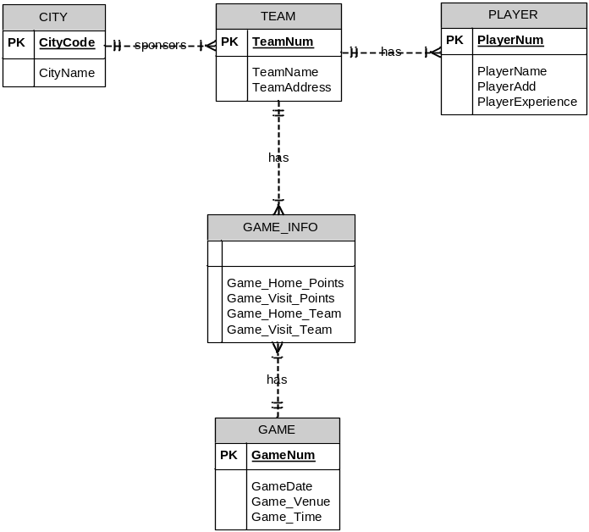
Case 3: Business rules:
- An INVOICE is written by a SALESREP. Each sales representative can write many invoices, but each invoice is written by a single sales representative.
- The INVOICE is written for a single CUSTOMER. However, each customer can have many invoices.
- An INVOICE can include many detail lines (LINE), each of which describes one product bought by the customer.
- The product information is stored in a PRODUCT entity.
- The product’s vendor information is found in a VENDOR entity.
ERD:
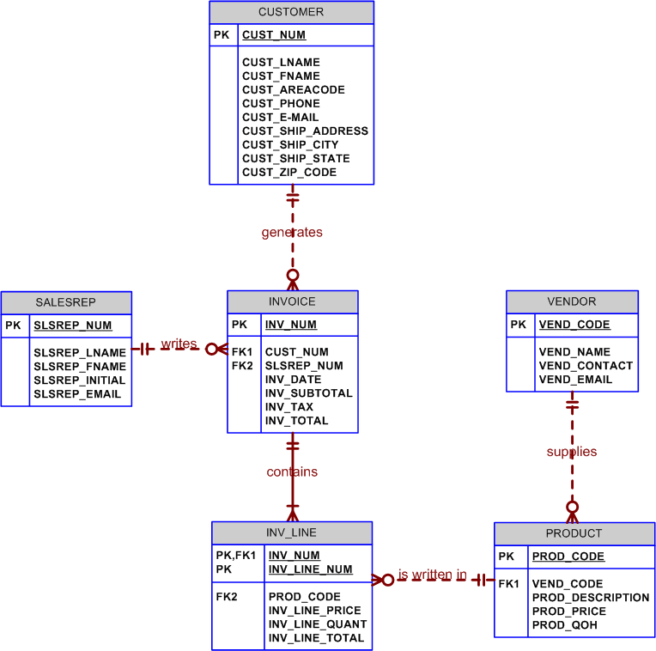
Labsheet 2: Exercise Case 1
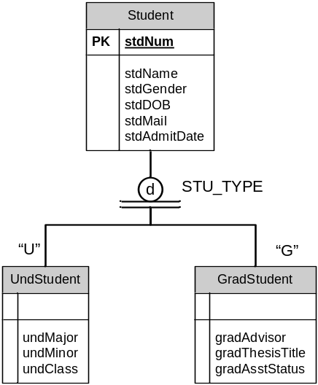

Labsheet 2: Exercise Case 2A
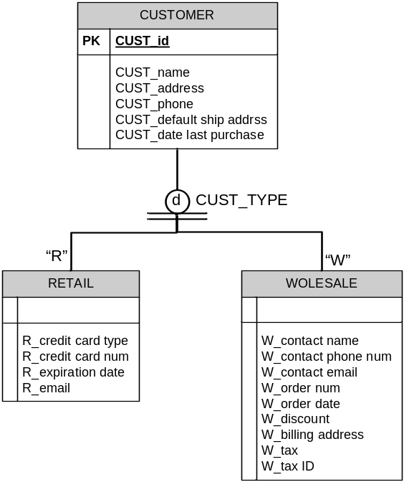
Labsheet 2: Exercise Case 2B

