DATABASE SYSTEM DCI2033
SEMESTER I, ACADEMIC YEAR 2011/2012

Labsheet 2
Attention:
- Create table for Student Information based on the figure above and use the appropriate data types for each column.
- Answer all questions based on the table you have created.
- Shows the answer in SQL command and print screen all results.
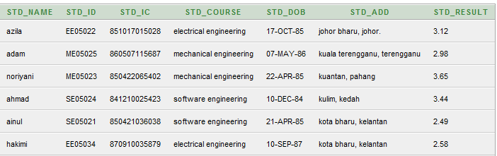
Figure 1: Student Information Table
- Display all students’ name from the student information table.
- Display all students’ name and course order by result.
- List all students’ name, course and result where the results should greater than 3.00.
- Display all records from “software engineering” or “electrical engineering” course.
- Display all records from “software engineering” and “electrical engineering” course.
- Display the student’s name and course where the result between 2.50 to 3.50.
- List all students’ name who has registered in Software Engineering and Mechanical Engineering course.
- List all students who have registered in Electrical Engineering course.
- List all records where the first character in student’s course is S.

