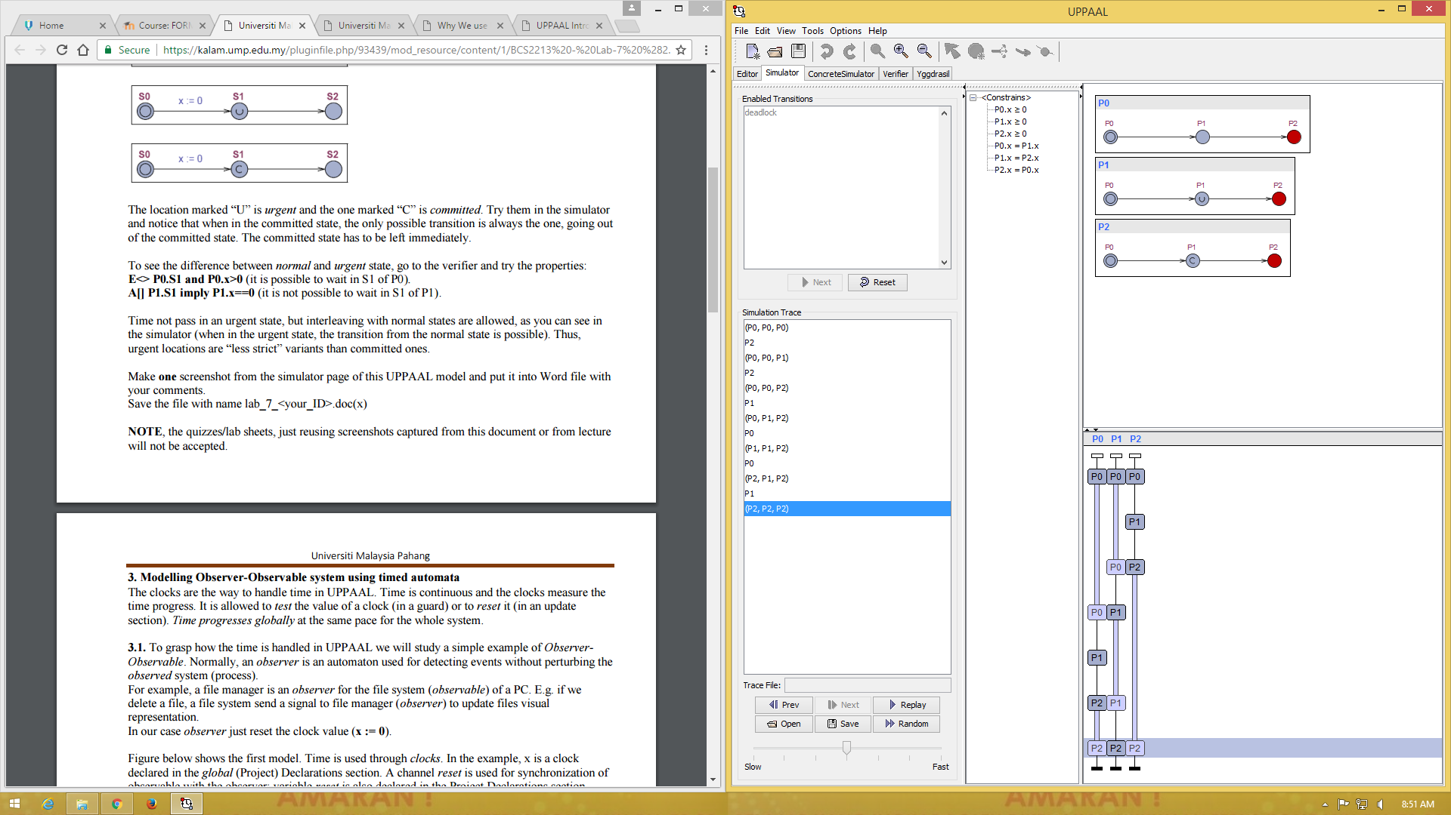

3 operation working parallel. But once the work is on committed, the option is only to finish the committed operation and they can continue the other two operation.

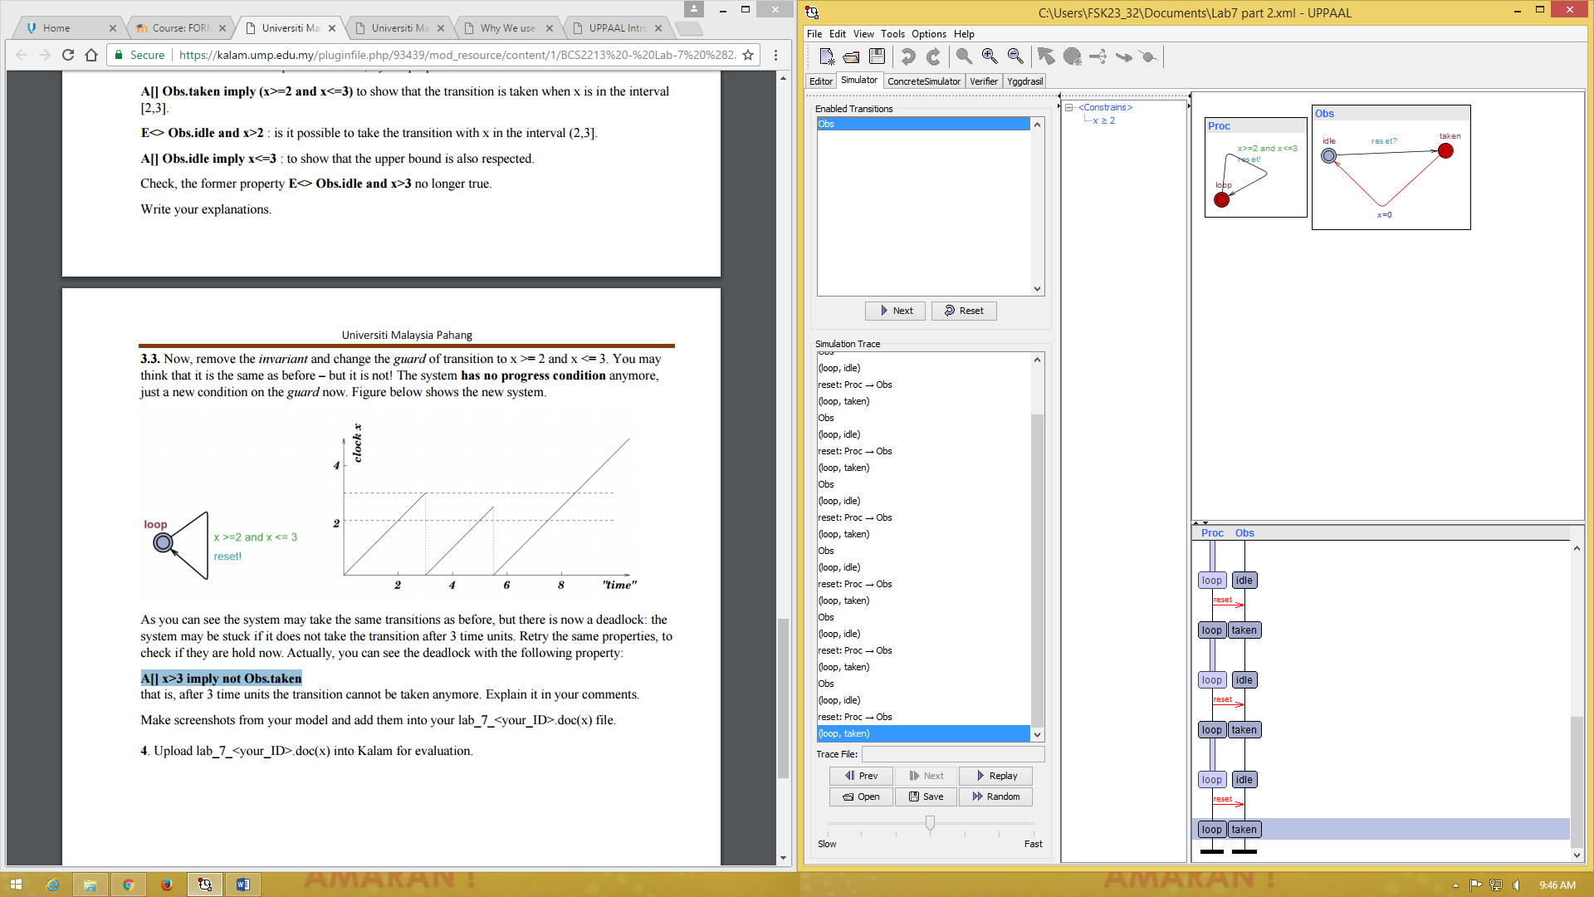

process is loop, the observer repeat with the condition. Some query allowed the repetition to repeat 3 times and after that the property not satisfied.