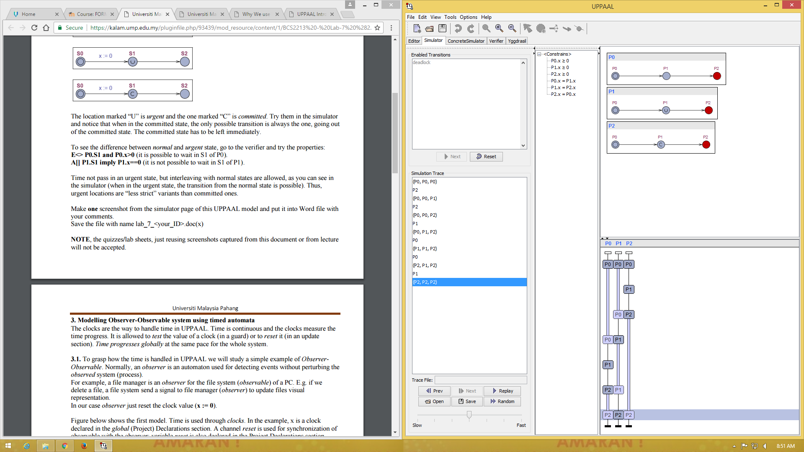

Note that in this part, all this 3 operation working parallel. But once the work is on committed, the option is only to finish the committed operation and they can continue the other two operation.

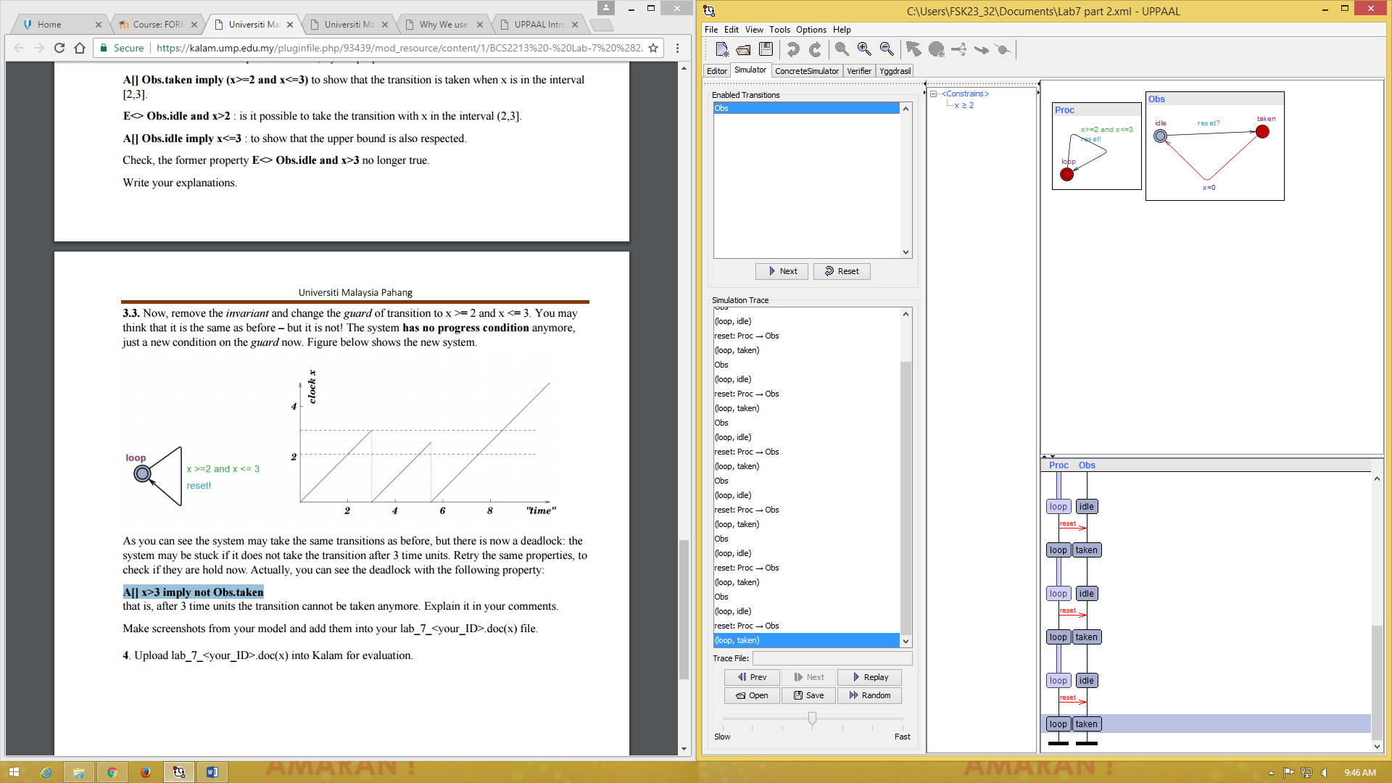

As seen that the process is loop, then the observer will repeat with the condition. Some of the query allowed the repetition to repeat 3 times and after that the property is not satisfied.