FINAL YEAR PROJECT PORTAL:

SUPERVISOR & EXAMINER EVALUATION MODULE

MOHD AMIRULHANIF BIN ABDUL RAZAK

A thesis submitted in fulfilment of the requirements

for the award of the degree of

Bachelor of Computer Science (Software Engineering)

Faculty of Computer System & Software Engineering

UNIVERSITI MALAYSIA PAHANG

MAY 2017

**STUDENT DECLARATION**

I hereby declare that the work in this thesis is my own except for quotations and summaries which have been duly acknowledged.

Signature :

Name : Mohd AmirulHanif Bin Abdul Razak

ID Number : CB14015

Date : 4 May 2017

**STUDENT DECLARATION**

I hereby declare that I have read this thesis and in my opinion this thesis is sufficient in terms of scope and quality for the award of the degree of Bachelor of Computer Science Software Engineering

Signature :

Supervisor’s Name : Dr. Adzhar Bin Kamaludin

Date : 4 May 2017

**ABSTRACT**

Final Year Project is a final assignment for each student university before they complete their studies. Each student is required to implement a project either project web-based or research-based in two semesters. Students who take a final year project need to find a lecturer to be a supervisor of student projects. Students must submit an application form with the name of the supervisor including project title at the faculty to get a permission from the coordinator. After obtaining permission from the coordinator, students can start a project by documenting their project. The document is divided into several chapters and each chapter students are required to submit by require time that manage by coordinator. This process takes place manually because students are required to print each chapter to showed their work progress. Students need to spend money to print each chapter. Thus, a system to facilitate the student, supervisor and the coordinator in managing the final year project is needed. System that large will facilitate students in finding a supervisor and the coordinator in coordinating facilitate final year project.

**ABSTRAK**

Projek Tahun Akhir merupakan tugasan terakhir bagi setiap pelajar universiti sebelum mereka menamatkan pengajian mereka. Setiap pelajar dikehendaki melaksanakan satu projek sama ada projek yang berasaskan web atau berasaskan penyelidikan dalam masa dua semester. Pelajar yang mengambil projek tahun akhir perlu mencari seorang pensyarah sebagai penyelia projek pelajar. Pelajar perlu menghantar borang permohonan tajuk bersama nama penyelia di fakulti untuk mendapat kebenaran daripada penyelaras. Setelah mendapat kebenaran daripada penyelaras, pelajar boleh mulakan projek dengan mendokumenkan projek mereka. Dokument tersebut dibahagikan kepada beberapa bab dan pelajar dikehendaki menghantar setiap bab mengikut masa yang ditetapkan oleh penyelaras. Proses ini berlaku secara manual kerana pelajar dikehendaki mencetak setiap bab mereka untuk menunjukan kemajuan kerja mereka. Pelajar perlu mengeluarkan duit untuk mencetak setiap bab. Oleh itu, satu system untuk memudah pelajar, penyelia dan penyelaras dalam menguruskan projek tahun akhir amat diperlukan. Sistem yang diperluakan akan dapat memudahkan pelajar dalam mencari penyelia projek dan memudahkan penyelaras dalam menyelaras projek tahun akhir.

**TABLE OF CONTENTS**

**CONTENT**

**STUDENT DECLARATION i**

**SUPERVISOR DECLARATION ii**

**ABSTRACT iii**

**ABSTRAK iv**

**TABLE OF CONTENTS v**

**LIST OF TABLES vii**

**LIST OF FIGURES viii**

**LIST OF ACRONYMS / ABBREVIATION / GLOSARY ix**

**CHAPTER 1 1**

**INTRODUCTION 1**

**1.1 Project Background 1**

**1.2 Problem Statement 2**

**1.3 Objective 3**

**1.4 Scope 3**

**1.5 Report Organization 4**

**CHAPTER 2 5**

**LITERATURE REVIEW 5**

**2.1 Introduction 5**

**2.2 Overview 5**

**2.3 Review of Existing System 6**

**2.4 Comparison Feature Existing System 13**

**2.5 Review of Methodology 14**

**2.6 Comparison of Three Methodologies 17**

**2.7 Conclusion 18**

**CHAPTER 3 19**

**METHDOLOGY 19**

**3.1 Introduction 19**

**3.2 Rapid Application Development (RAD) Methodology 20**

**3.3 Hardware and Software 26**

**3.4 Gantt Chart 28**

**3.5 Implementation 29**

**3.6 Testing 29**

**APPENDICES 30**

**LIST OF TABLES**

**Table 2.1 Comparison of Features for three existing system 13**

**Table 2.2 Comparison three Methodology 17**

**Table 3.1 List of Software Items 26**

**Table 3.2 List of Hardware Items 27**

**LIST OF FIGURE**

**Figure 2.1 Interface creating a question 6**

**Figure 2.2 Interface answering the question 7**

**Figure 2.3 Interface responses statistic 7**

**Figure 2.4 Interface of creating a client 8**

**Figure 2.5 Interface of sending assessment form 9**

**Figure 2.6 Interface of assessment question 9**

**Figure 2.7 Interface of assessment report 10**

**Figure 2.8 Interface creating form title 11**

**Figure 2.9 Interface of create from question 11**

**Figure 2.10 Interface sending question form 12**

**Figure 2.11 Interface analysis the responses 12**

**Figure 2.12 Process Waterfall Model 14**

**Figure 2.13 Process Agile Model in Sprints Series 15**

**Figure 2.14 Process Rapid Application Development 16**

**Figure 3.1 Rapid Application Development Phase 20**

**Figure 3.2 Use Case for FYP Portal 22**

**Figure 3.3 Context Diagram for FYP Portal 23**

**Figure 3.4 Dialog Diagram for FYP Portal 24**

**LIST OF ACRONYMS / ABBREVIATION / GLOSARY**

**ABBREVIATION TITLE**

FYP Final Year Project

UMP Universiti Malaysia Pahang

UML Unified Model Language

RAD Rapid Application Development

DFD Data Flow Diagram

ERD Entity Relationship Diagram

SDLC Software Development Life Cycle

# **CHAPTER 1**

# **INTRODUCTION**

# **Project Background**

Final Year Project (FYP) Portal: Supervisor and Examiner Evaluation Module, is the web base system for supervisor and examiner at Universiti Malaysia Pahang (UMP) used during evaluation process on student who take final year project. Supervisor and examiner must login into the system before they can evaluate and give mark to the student. This system can help supervisor and examiner in manage the student mark. In order to evaluate student, supervisor and examiner can view and download the chapter that already uploaded by student before give a mark.

Student role in this system is to follow the time line that set by coordinator. Student require to upload their chapter by using this system based on the time given. Failure to upload during the time given will affect the mark.

Coordinator will monitor student activity by view all the chapter that already upload by all student. Coordinator also can view if there are some student not upload their chapter and give the student a memo or reminder.

# **Problem Statement**

Before the invention of FYP portal, student need to submit each chapter to their supervisor by giving the hardcopy of the document. If student need to do a correction on their chapter, they need to edit the chapter then submit again to their supervisor.

During the evaluation day, student need to prepare three hardcopies their full report and give the hardcopy to their supervisor and to the both examiner. Student also required to burn their report into the cd-r for faculty. Examiner need to use evaluation form during evaluate student. All the given mark and comment must be state at the form before return to the coordinator. Student mark from examiner will be insert by coordinator. In order to key in student mark, coordinator need to review each evaluation form before inset a student mark into the E-COM.

All the process is done manually. Student will waste a paper where they need to print the document and show to their supervisor for checked. For the evaluation day, coordinator need to prepare the hardcopy form for examiner use to evaluate student. Coordinator also need to manage manually examiner and student before evaluation day.

Therefore, FYP Portal is requiring to develop a system that will manage student, supervisor, examiner and coordinator during presentation day. This system will manage the process of submitted student document to their supervisor by uploading through the system without waste a paper. This system also will help coordinator in managing examiner and student for the evaluation. Supervisor can view the document that already upload by student and give a comment or message to the student if there have a correction on the document.

# **Objective**

The objective need to be apply in this system:

1. To manage evaluation process between examiner and student by using online system.
2. To manage student mark from supervisor and examiner by using online system.
3. To monitor student progress by upload a student document into FYP Portal.

# **Scope**

1. **System User**

There are four users can use this system which is coordinator, supervisor, examiner and student.

1. **Function**

The function of this system is to manage evaluation process from examiner and supervisor by saving the data into the database. This system also available to upload and download the document from student.

# **Report Organization**

There are five total chapter in this thesis:

1. **Chapter 1** discusses about FYP Portal Module Evaluation system background. This chapter also explain about the reason this system need to be develop by discover the problem statement. From the problem statement, objective and scope for this system can be archive in this chapter.
2. **Chapter 2** discusses about the literature review of FYP Portal. This chapter also discuss about comparison the existing system with FYP Portal by state the advantage and disadvantage the existing system.
3. **Chapter 3** discusses about the usage of methodology in FYP Portal. This chapter cover the UML diagram that use to develop FYP Portal such as use case, context diagram, activity diagram and class diagram.
4. **Chapter 4** discusses about the implementation and testing. How this system develop will state in this chapter by record the code.
5. **Chapter 5** discusses about conclusion. Limitation and future works about this system can be state in this chapter.

# **CHAPTER 2**

# **LITERATURE REVIEW**

# **Introduction**

The concept of the entire project which is supervisor can view and download the chapter that upload by student to give a mark. Student task is to upload each chapter base on period time given and view a mark that they got from supervisor. Coordinator can monitor student activity by view total student that already upload the chapter in this portal. Coordinator also will manage the student and the evaluator before the presentation day. Evaluator can view and download student finalize chapter during evaluation day. The criteria of evaluation and total mark will manage by coordinator.

# **Overview**

In this chapter, there had four subtopics that described the definitions about evaluation system. Subtopic 2.3 and 2.4 will discuss about review and compare the three existing systems that similar with this system and being reference for this system. Subtopic 2.5 and 2.6 will discuss about review and compare the three methodologies that can be model of methodology to develop this system.

# **Review of Existing System**

* + 1. **SurveyMonkey**

Surveymonkey is an online survey site by make a survey process easy and considerably. For asking a questions, Surveymonkey offers 17 formats in survey design phase. Multiple choice question is one of example formats in Surveymonkey. Another example of formats is true false and open-end question. Surveymonkey can change the appearance of the survey by provide a various color palette. Ability to track respondents helps user to re-contact a candidate that no respond to a survey and avoid pestering those who have already participated a survey. Surveymonkey can generate frequencies for each question and allows user to export data into programs for more complex analysis. The Surveymonkey webpage will convey the study and ensuing re-minders for client if client outfit a rundown of email addresses and will likewise furnish client with a connection to the overview which can then be posted on your site or incorporated into an email for you to send to members.

Figure 2.1 show the interface for creating a question. User need to insert the question and multiple answer.

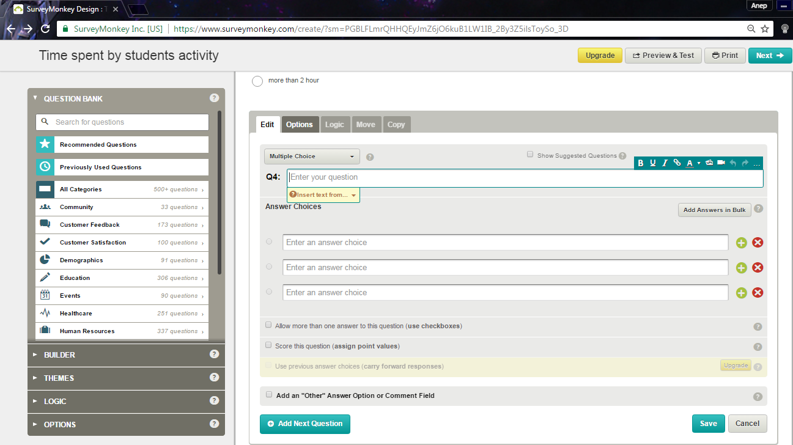

**Figure 2.1 Interface creating a question**

Figure 2.2 show the interface when the question shows at public.

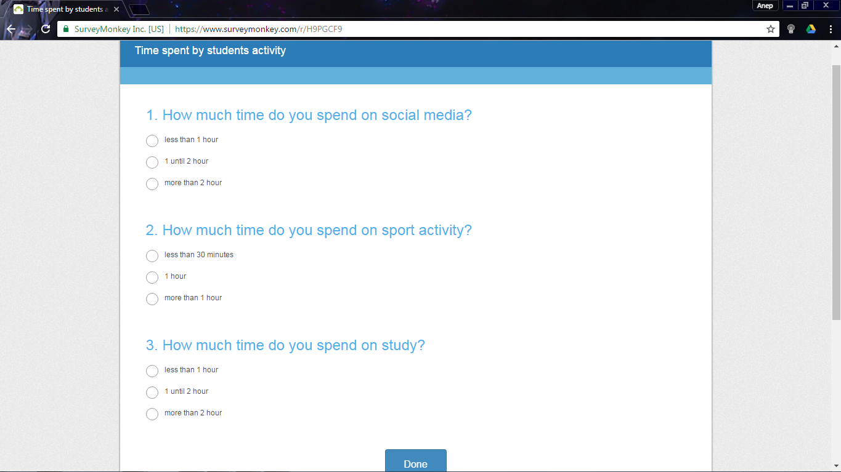

**Figure 2.2 Interface answering the question**

Figure 2.3 show the interface for statistic. User can view the statistic for responding survey by select type of provided graph.

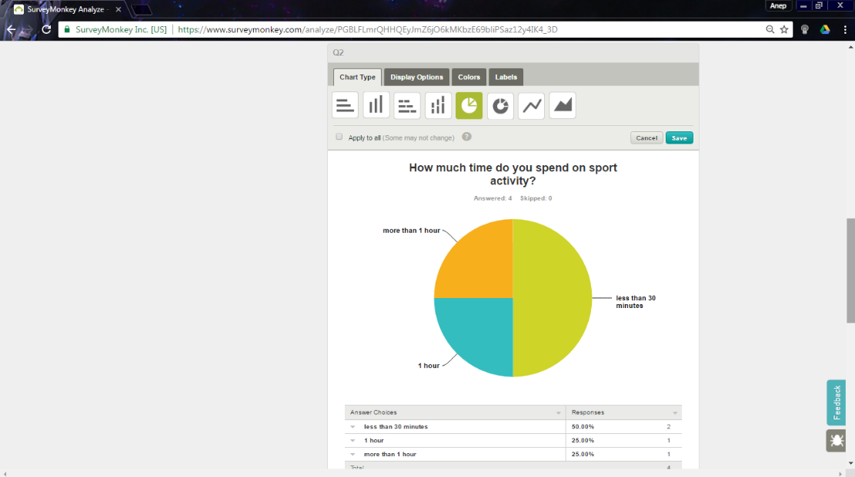

**Figure 2.3 Interface responses statistic**

* + 1. **WPS Online Evaluation System**

The WPS Online Evaluation System makes scoring assessments faster and more accurate. WPS Online Evaluation System likewise offering enhanced clinical effectiveness at the same per-utilize cost as customary printed frames. User need to register before be an admin for the assessments. For the registration, user need to purchase a license for each WPS assessment that need to use.

User can register their client before give an assessment. The assessment is a question that user will give to their client by using the email. User can view all their client report in graph form.

Figure 2.4 show the interface of creating a client. User need to register their client before do an evaluation by giving a client the assessment question.

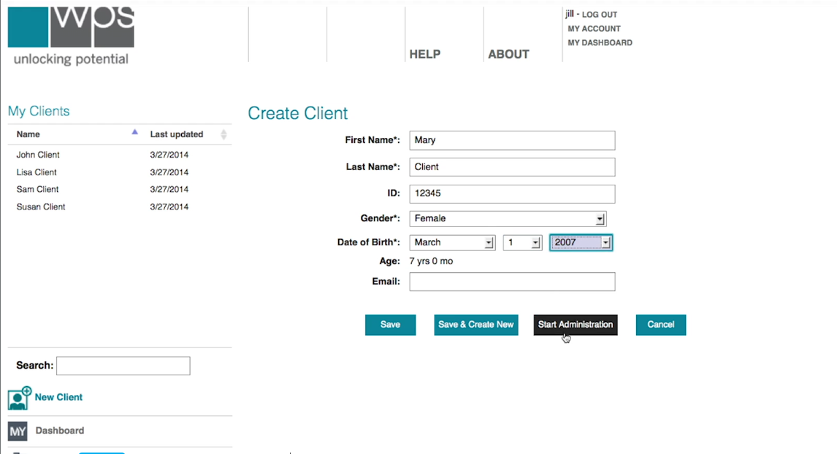

**Figure 2.4 Interface of creating a client**

Figure 2.5 show the interface of sending the assessment form. User will sent the assessment form by using the email address.

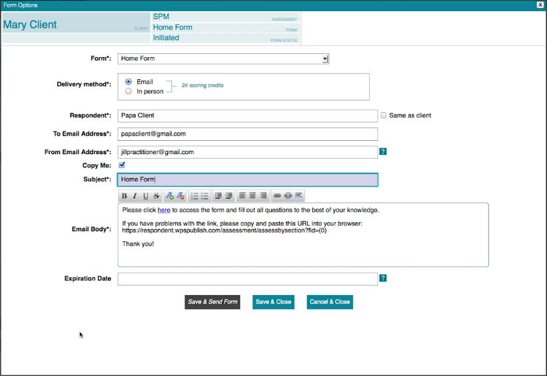

**Figure 2.5 Interface of sending assessment form**

Figure 2.6 show the interface of assessment question. Client will receive this assessment form through the email.

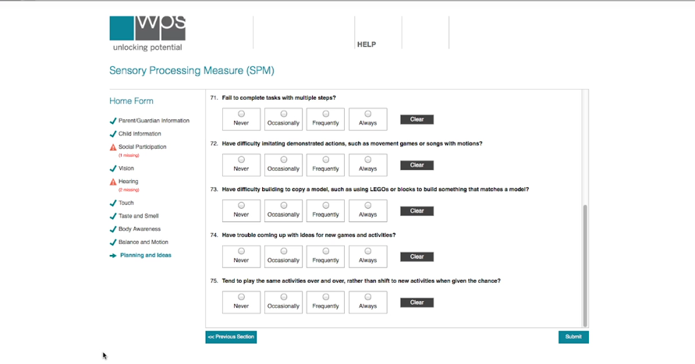

**Figure 2.6 Interface of assessment question**

Figure 2.7 show the interface of assessment report. User can view the statistic base on client respond.

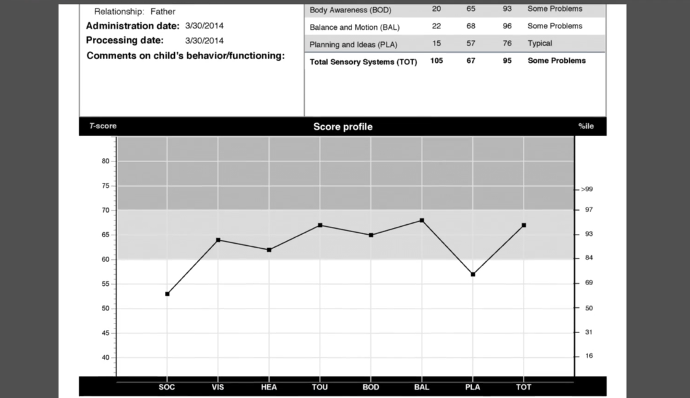

**Figure 2.7 Interface of assessment report**

* + 1. **Google Form**

Google Form is a free online instrument from Google that enables you to make a shape. Google Form can make and dissect overviews by utilizing web program without required extraordinary programming. During process creating a form, Google Form automatically save the form when the changes be made. User can outline their own frame to make the shape more appealing. The form has been made by user can be share work together by embed an email at sharing setting. User can view the analysis form at responses bar.

Figure 2.8 show the interface of creating form title.

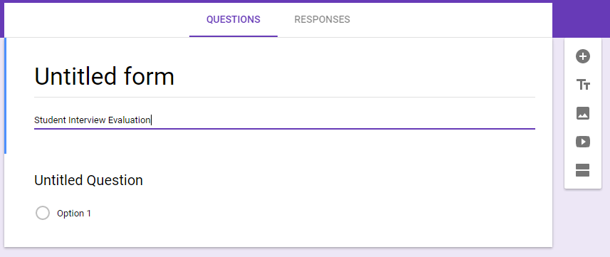

**Figure 2.8 Interface creating form title**

Figure 2.9 show the interface of create a question at the form. User can manage the question and answer at this form.

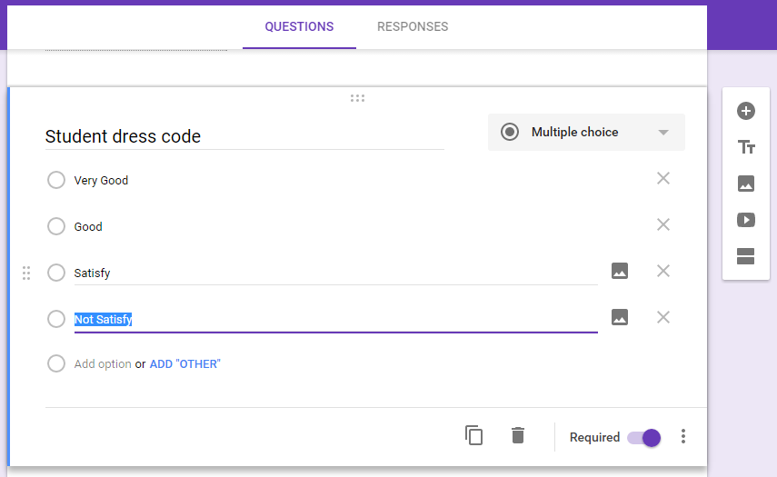

**Figure 2.9 Interface of create from question**

Figure 2.10 show interface of sending question form. User can share the question form to the person they want to share by using an email.

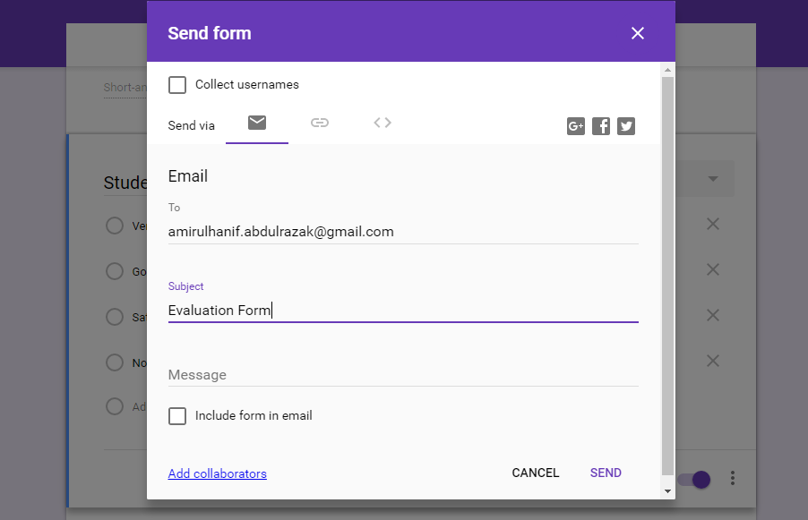

**Figure 2.10 Interface sending question form**

Figure 2.11 show the interface of analysis the responses. User can view total responses.

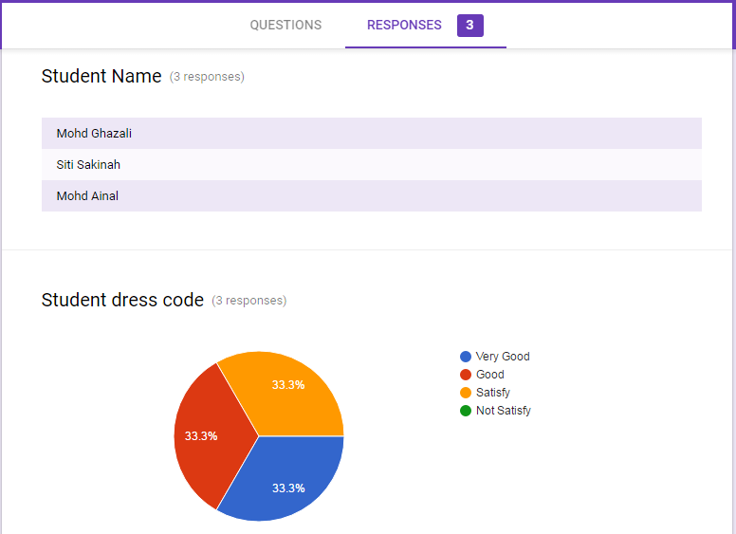

**Figure 2.11 Interface analysis the responses**

# **Comparison Feature Existing System**

|  |  |  |  |
| --- | --- | --- | --- |
| **Features** | **Surveymonkey** | **WPS Online Evaluation System** | **Google Form** |
| Security | * Require user to login into the web site. * Secure access by using https. | * Require user to login into the web site. * Secure access by using https. | * Require user to login into the web site * Secure access by using https. |
| Interoperability | Ability to view in window screen and mobile screen. | Ability to view in window screen. | Ability to view in window screen and mobile screen. |
| Support Form | Provide helps center to support user understanding. | Provide helps center to support user understanding. | Provide helps center to support user understanding. |
| Flexibility | Layout resolution not flexible. | Layout resolution not flexible. | Flexible layout resolution. |
| Security | * User can login by link with google account or facebook account. * User also can register as normal user. | * User need to register and purchase a license before use this system. | * Use google account as user profile. |
| Advantage | * Available to use as free user | * Private evaluation form. | * Auto save during editing the form. |
| Disadvantage | * Data responded not available to download for free user. | * Require user to make a payment during registration. | * Only user that have google account can use this form. |

**Table 2.1 Comparison of Features for three existing system**

# **Review of Methodology**

* + 1. **Waterfall Model**

Waterfall model is a traditional methodology since this model was first model in SDLC to be use in Software Engineering. Waterfall demonstrate comprises six stage and each stage must be finished before go to the following stage since waterfall model was outlining in programming advancement by direct successive stream. In waterfall model there are no overlapping phases.

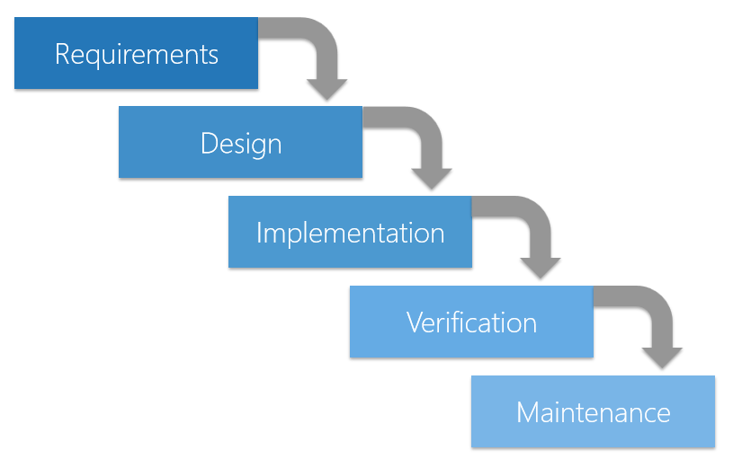

**Figure 2.12 Process Waterfall Model**

* + 1. **Agile Model**

Agile model is a combination of two process model which is iterative process and incremental process that focus on process adaptability and customer satisfaction by rapid delivery of working software product. Coordinated model isolated assignment into little time spans to convey particular components for a discharge. Iterative approach is taken and working programming construct is conveyed after every emphasis. Each form is incremental until the last form holds every one of the components required by the client.

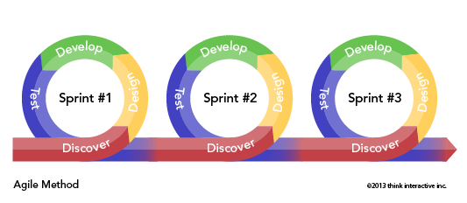

**Figure 2.13 Process Agile Model in Sprints Series**

* + 1. **RAD Model**

RAD (Rapid Application Development) model is based on prototyping and iterative development with no specific planning involved. Prototype in RAD is working model that functionally equivalent to a component of the product. RAD functional modules are develop in parallel as prototypes. RAD modules likewise are coordinated to make the total item for quicker item conveyance. This model simpler to fuse the progressions on the grounds that there are no subtle elements preplanning. RAD activities was take after the iterative model and incremental model. RAD extend working dynamically on their model by having a little groups involving engineers, space specialists, client agents and other IT assets.

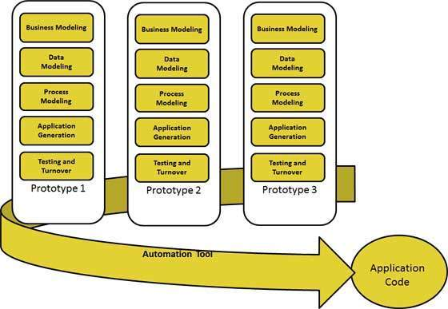

**Figure 2.14 Process Rapid Application Development**

# **Comparison of Three Methodologies**

|  |  |  |  |
| --- | --- | --- | --- |
| **Factor** | **Waterfall Model** | **Agile Model** | **RAD Model** |
| Scope | Works well as long the requirements is known. | Works well even the requirement not clear and available to make changes but expensive cost. | Work focused on speed to developed faster by using prototyping. |
| Customer Availability | Requires customer involvement at the beginning. | Prefers customer available throughout project. | Requires customer involvement at the beginning. |
| Direction | Linear and unidirectional. | Non-linear and some phase involve loops. | Non-linear and some phase involve loops. |
| Compatibility | Small project. | Larger project. | Larger project. |
| Pros | * Easy to manage and understand by completed a phase once time. * Works well for smaller projects where requirements are very well understood. | * Suitable model for fixed or changing requirements. * Give flexibility to developers. | * Reduced development time. * Changing requirements can be accommodated. |
| Cons | * Not suitable for the projects where requirements are at a moderate to high risk of changing. * Inappropriate for complex and object-oriented projects. | * Not suitable for handling complex dependencies. * Depends more on customer interaction. | * Dependency on technically strong team members for identifying business requirements. * Requires user involvement throughout the life cycle. |

**Table 2.2 Comparison three Methodology**

# **Conclusion**

In this chapter, we already discuss about three existing system that similar with evaluation system. Then, we discuss the details of three existing system and their features to making a comparison. Base on the advantage and disadvantage from three existing systems, there are some features that we can use to develop this system.

From the comparison of methodology, this system will be using RAD model as methodology of this project. This system can be develop rapidly by following RAD module.

# **CHAPTER 3**

# **METHDOLOGY**

# **Introduction**

Software Development Life Cycle or Methodology is a process flow of software project. Methodology consist the description about software project which is the details about development project. There are several models of methodology in software development process such as Waterfall model, Agile model, Spiral model, V-Model and Rapid Application Development (RAD). In order to develop FYP Portal, choosing RAD model as methodology can manage the development process and can improve the quality of the project flow. This model focus on prototyping and reuse the existing component will make the requirement deliver rapidly.

# **Rapid Application Development (RAD) Methodology**

The methodology of FYP Portal is Rapid Application Development model. This model use prototypes as functional modules and produce fast product delivery. RAD model suitable with the short time period project. Since RAD model is flexible with requirement changes, it easier to incorporate the changes within the development process because planning not prioritized. The reason RAD be a methodology of this project is:

1. FYP Portal need to be develop rapidly.
2. Involvement of the user in the design and construction phase.
3. Possible to have requirement changes during development.

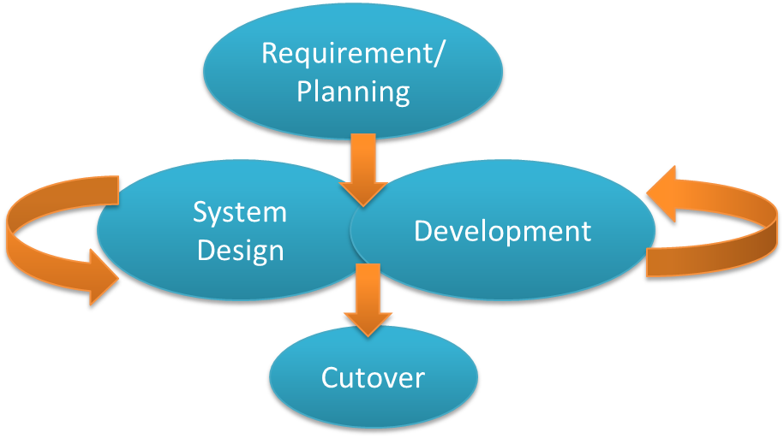

**Figure 3.1 Rapid Application Development Phase**

* + 1. **Requirement Phase**

In Systems Development Life Cycle (SDLC), this phase is a combination of system planning and system analysis. Developer need to comprehended the venture degree and assemble all the necessity and information that should be execute in FYP Portal. Data also can be collect by reviewing the existing system that similar with FYP Portal. The customer and engineer ought to concur on the venture scope and acquire administration approval.

* + 1. **System Design Phase**

Unified Model Language (UML) are being made at this phase. Engineer demonstrate the framework stream for customer by displaying the UML with a specific end goal to help customer comprehend and get a thought regarding this framework. Designer need to correspondence with customer amid advancement a model. This procedure is iterative that enable engineer to change the model until the customer fulfilled.

* + - 1. **Use Case**

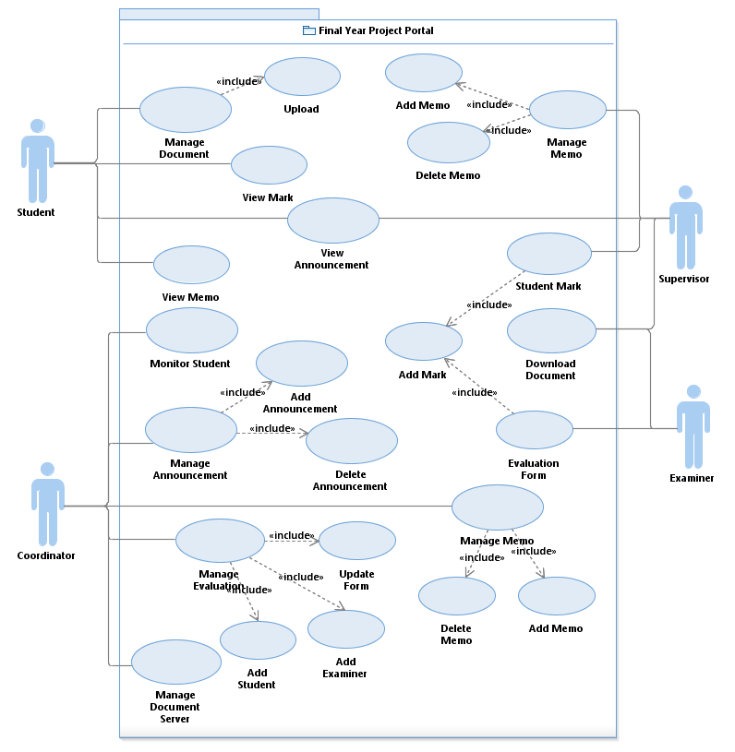

**Figure 3.2 Use Case for FYP Portal**

* + - 1. **Context Diagram**

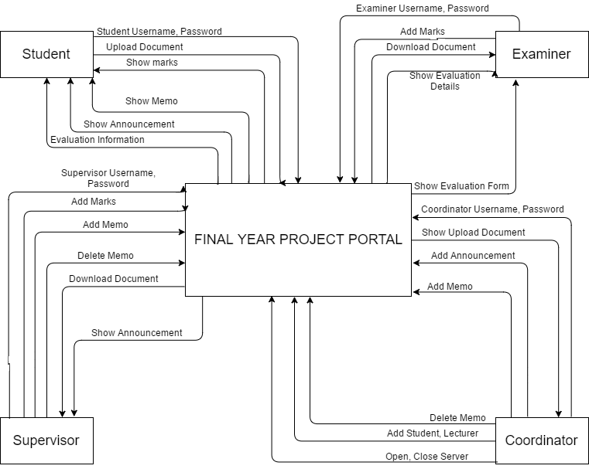

**Figure 3.3 Context Diagram for FYP Portal**

* + - 1. **Dialog Diagram**

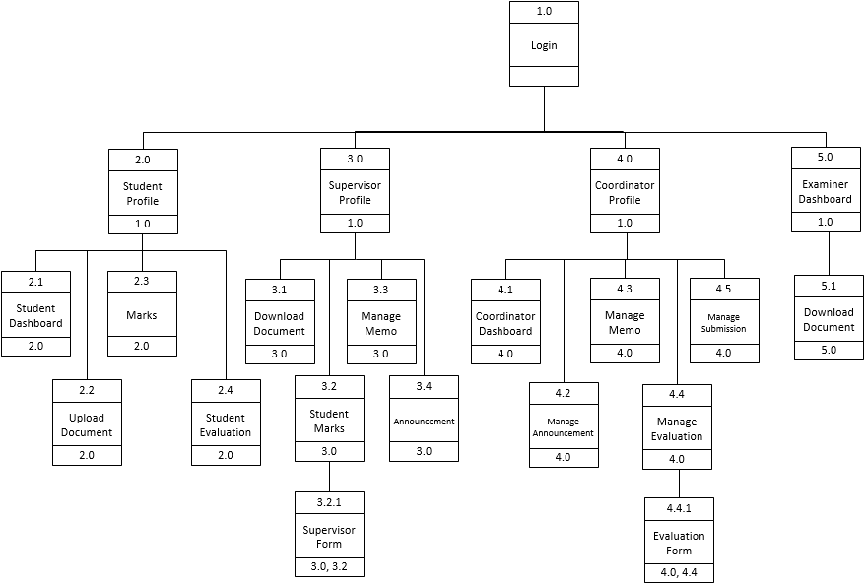

**Figure 3.4 Dialog Diagram for FYP Portal**

* + 1. **Development Phase**

At this phase, FYP Portal focuses on program and application development task similar to the SDLC. In RAD model, users continue to participate and can still give suggestion to changes or improvements as actual screens or reports are developed. The tasks are programming and application development, coding, unit-integration and system testing.

* + 1. **Cutover Phase**

During this phase, it resembles the final task in the SDLC implementation phase, including data conversion, testing, changeover to the new system, and user training. Compared with traditional methods, the entire process is compressed.

# **Hardware and Software**

* + 1. **Software**

Specific software need to be consider before

|  |  |  |
| --- | --- | --- |
| **Software** | **Version** | **Purpose** |
| Windows 7 Ultimate | 64bit Operating System | Operating system that used to manage computer hardware and software by run all program required in order to complete the system. |
| Microsoft Word 2013 | Pro 2013 64bit | One of Microsoft Office application that used to complete a documentation. |
| Microsoft Project 2013 | Pro 2013 64bit | Used to create a Gantt Chart. |
| Rational Software Architect (RSA) | Version 8.5 | Project management software from Microsoft that used to create a UML diagram. |
| XAMPP | Version 5.6.3 (PHP 5.6.3) | An open-source web server package that use to connect the system with the server. |
| Visual Studio 2013 | Ultimate 2013 64bit | A complete set of development tools for building web application system. |
| Justinmind Prototyper | Version 7.4.0 | Application to create an interface of the system |

**Table 3.1 List of Software Items**

* + 1. **Hardware**

|  |  |
| --- | --- |
| Hardware | Description |
| Notebook | Personal computer that used to develop the system and create the documentation of the project. |
| Mouse | Pointing device that use to drack and drop during development an interface. |
| External Hard Disk | External data storage device that use to store a backup of the system and the documentation of the project. |

**Table 3.2 List of Hardware Items**

# **Gantt Chart**

Appendix 1

Appendix 2

# **Implementation**

In Software Development Life Cycle (SDLC), implementation phase is a development stage where developer need to develop the system. Developer should start writing a code to develop a system by following the user requirement.

# **Testing**

After the system completely develop, the system should be tested in order to verify the system follow the requirement. Tester should record or make a report in order to improve the system at maintenance phase.

**APPENDICES**

**APPENDIX 1**

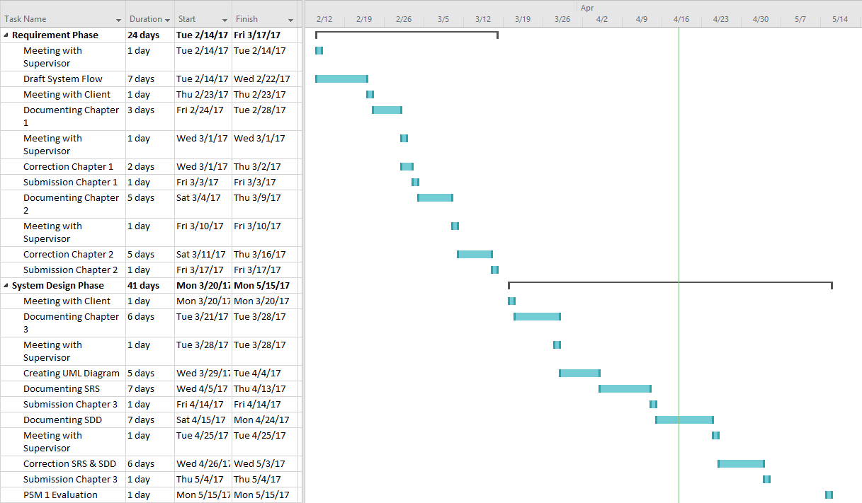

**APPENDIX 2**

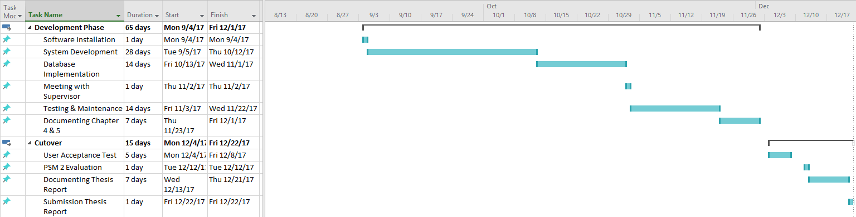

**Version**

**1**

FINAL YEAR PROJECT PORTAL: SUPERVISOR & EXAMINER EVALUATION MODULE

Faculty of Computer Systems & Software Engineering

Software Requirement Specification (SRS)

**TABLE OF CONTENT**

1. **FUNCTIONS 1**
2. **DATA FLOW DIAGRAM LEVEL 0 (DFD LEVEL-0) 3**
3. **DATA FLOW DIAGRAM LEVEL 1 4**
4. **ALGORITHM OR STRUCTURED ENGLISH 9**
5. **DATA MODELLING (ERD) 12**

**LIST OF TABLE**

**Table 1.1: Glossary Table 2**

**LIST OF FIGURE**

**Figure 3.1 Data flow diagram for FYP Portal 3**

**Figure 3.2 Data flow diagram 1.0 (login) 4**

**Figure 3.3 Data flow diagram 2.0 (Student Activity) 5**

**Figure 3.4 Data flow diagram 3.0 (Supervisor Activity) 6**

**Figure 3.5 Data flow diagram 4.0 (Coordinator Activity) 7**

**Figure 3.6 Data flow diagram 5.0 (Examiner Activity) 8**

**Figure 5.1 Entity Relationship Diagram 12**

1. **FUNCTIONS**

|  |  |
| --- | --- |
| **TERM** | **DEFINITION** |
| **Student** | Undergraduate student of Universiti Malaysia Pahang who enrolled final year project. |
| **Supervisor** | Lecturer of Universiti Malaysia Pahang who became an adviser to the students taking final year project. |
| **Coordinator** | Lecturer of Universiti Malaysia Pahang who conduct a Final Year Project course. |
| **Examiner** | Lecturer of Universiti Malaysia Pahang that became evaluator for student during FYP presentation. |
| **Login Verification** | Function to verify user (Student, Supervisor, Coordinator, Examiner) of this system during login into this system. |
| **Student Profile** | Display personal detail of student. |
| **Supervisor Profile** | Display personal detail of supervisor. |
| **Coordinator Profile** | Display personal detail of coordinator. |
| **Upload Document** | Function to manage a document by upload to the system. |
| **Student Dashboard** | Menu interface for student. |
| **Coordinator Dashboard** | Menu interface for coordinator. |
| **Examiner Dashboard** | Menu interface for examiner. |
| **Download Document** | Process to download a document that uploaded by student. |
| **Student Mark** | Process to manage student mark that given by supervisor. |
| **Marks** | Display process where student can see their latest mark. |
| **Manage Memo** | Process to create a memo by supervisor and coordinator to send to the specific student. |
| **Manage Announcement** | Process to publish an announcement by coordinator to student and supervisor. |
| **Announcement** | Process to display an announcement from coordinator. |
| **Supervisor Form** | Process to evaluate student by supervisor. |
| **Manage Evaluation** | Process to manage evaluation by assign a lecturer be the examiner to evaluate student by state a specific time and place. |
| **Evaluation Form** | Form that use by examiner to evaluate student. |

**Table 1.1: Glossary Table**

1. **DATA FLOW DIAGRAM LEVEL 0 (DFD LEVEL-0)**

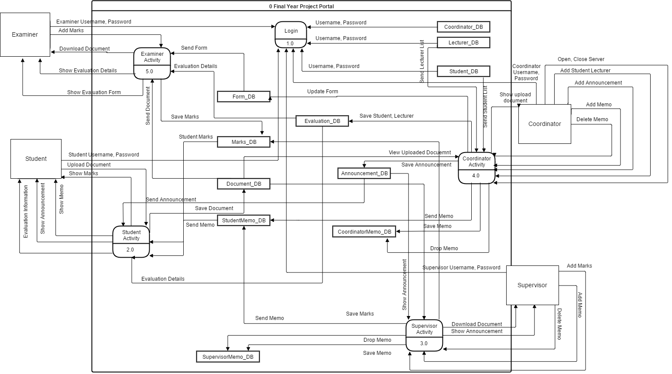

**Figure 3.1 Data flow diagram for FYP Portal**

1. **DATA FLOW DIAGRAM LEVEL 1**
   1. Data Flow Diagram 1.0 (Login)

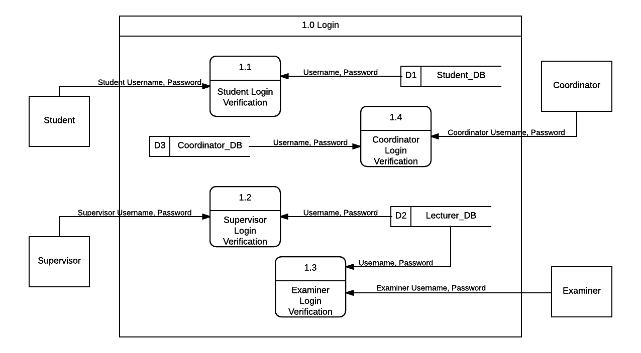

**Figure 3.2 Data flow diagram 1.0 (login)**

* 1. Data Flow Diagram 2.0 (Student Activity)

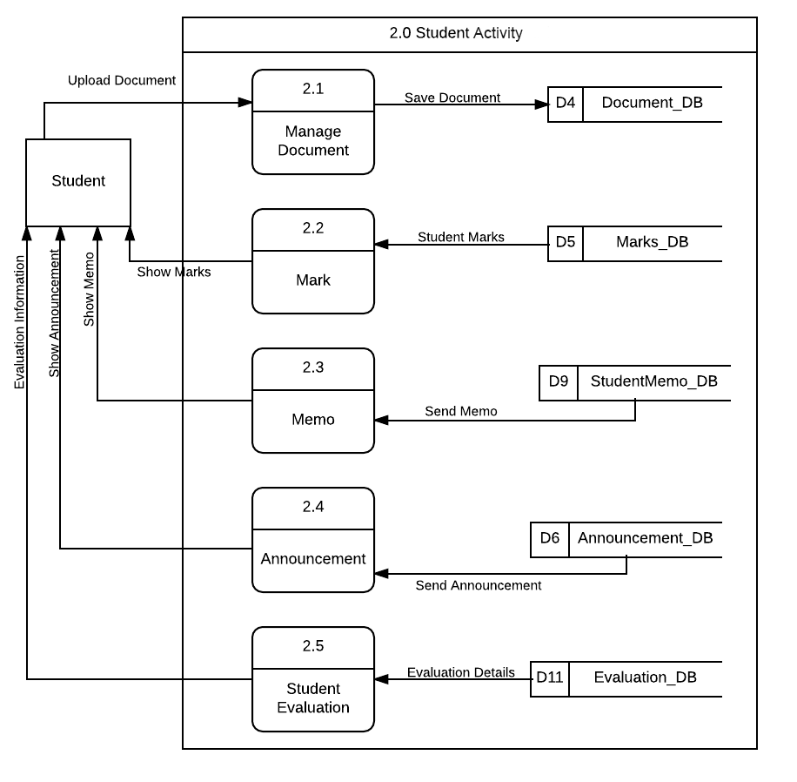

**Figure 3.3 Data flow diagram 2.0 (Student Activity)**

* 1. Data Flow Diagram 3.0 (Supervisor Activity)

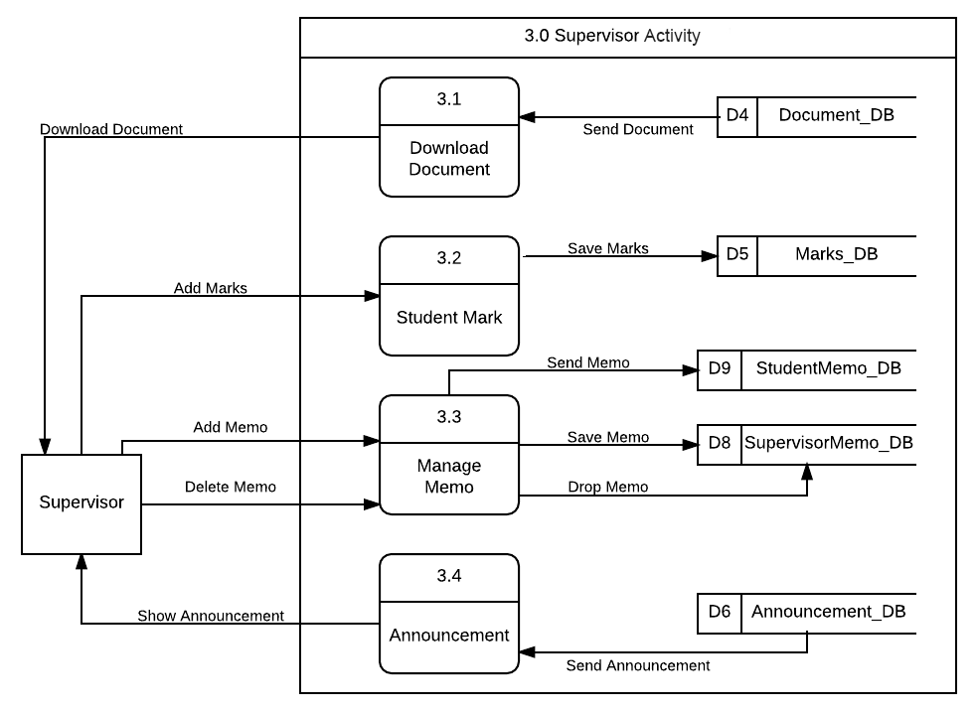

**Figure 3.4 Data flow diagram 3.0 (Supervisor Activity)**

* 1. Data Flow Diagram 4.0 (Coordinator Activity)

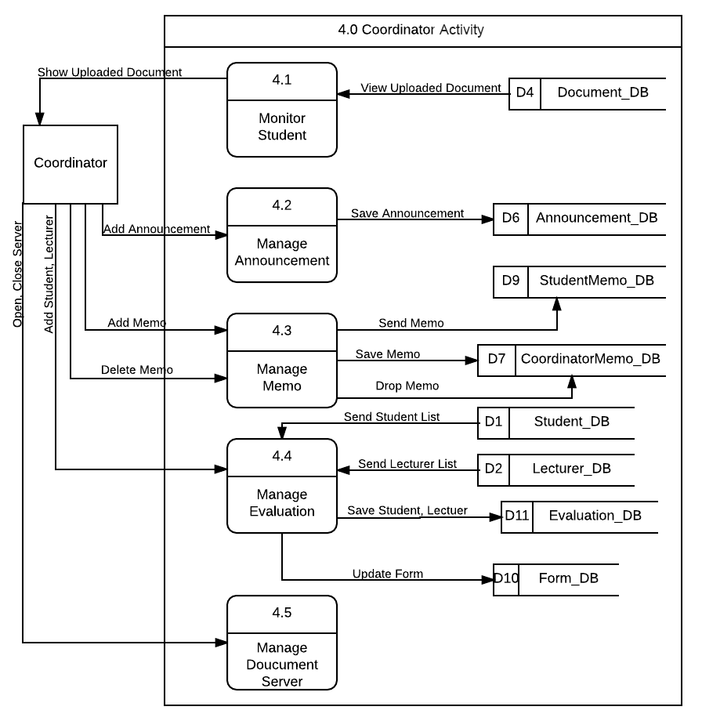

**Figure 3.5 Data flow diagram 4.0 (Coordinator Activity)**

* 1. Data Flow Diagram 5.0 (Examiner Activity)

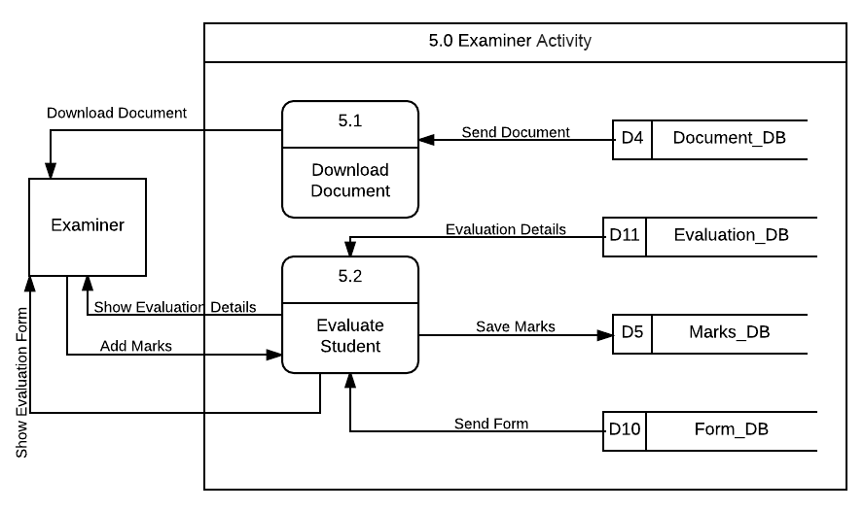

**Figure 3.6 Data flow diagram 5.0 (Examiner Activity)**

1. **ALGORITHM OR STRUCTURED ENGLISH**
   1. **Login**
2. Process start with user need to insert username and password.
3. Before login user need to select login type.
4. Login type consist of student, supervisor, coordinator, examiner.
   1. **User Profile**
5. Is the first interface after student, supervisor and coordinator login to the system.
   1. **Student Dashboard**
6. Process to display announcement and memo.
7. Student can view list of announcement.
8. Student can view personal messages form supervisor and coordinator at memo table.
9. Student can delete a memo.
   1. **Upload Document**
10. Student need to submit their chapter by upload to the system before the submission meet the dateline.
11. Student able to upload the document after the coordinator open the server submission.
    1. **Download Document**
12. Process to download a document that uploaded by student.
13. Supervisor can download a document after student upload the document by chapter to the system.
14. Examiner can download a complete document during evaluation day.
    1. **Manage Memo**
15. Process start with supervisor or coordinator select student name or id first before proceed write a memo.
16. Supervisor only can send a memo to their student under their advice.
17. Supervisor and coordinator can view and delete history of memo that send to the student.
    1. **Mange Announcement**
18. Coordinator can publish the news or announcement by create an announcement.
19. Coordinator need to insert title of announcement and description of announcement before publish to the system.
20. Coordinator can view and delete a history of announcement.
    1. **Manage Evaluation**
21. Process start with coordinator need to select student name first.
22. After select a student, coordinator can select two lecturers to become examiner to evaluate student.
23. To complete the process, coordinator must insert a venue, time and date of evaluation.
    1. **Evaluation Form**
24. Process where coordinator can update form of evaluation criteria.
25. Coordinator can update the description of evaluation by rows.
    1. **Manage Submission**
26. Process where coordinator can open the submission of student document by chapter.
27. Coordinator need to insert the dateline of the submission before open the submission server.
    1. **Coordinator Dashboard**
28. Process to display all student progress and announcement.
29. Coordinator can view student progress by show the statics of uploaded chapter by student.
30. Coordinator also can view all the student including view the status chapter uploaded.
    1. **Examiner Dashboard**
31. Process to display form of evaluation to evaluate student.
32. Examiner need to select student name first before start to evaluate student and give a mark of evaluation.
33. **DATA MODELLING (ERD)**

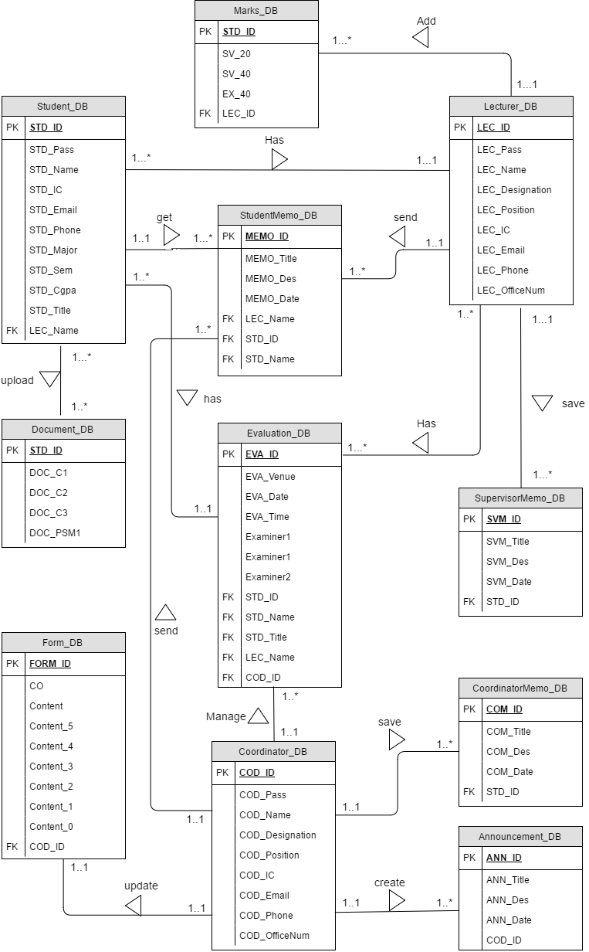

**Figure 5.1 Entity Relationship Diagram**

1. **SYSTEM REQUIREMENTS APPROVAL**

|  |  |  |
| --- | --- | --- |
|  | **Name** | **Date** |
| **Verified by:**  Developer |  |  |
| **Approved by:**  Client |  |  |

**APPENDICES**

**Version**

**1**

FINAL YEAR PROJECT PORTAL: SUPERVISOR & EXAMINER EVALUATION MODULE

Faculty of Computer Systems & Software Engineering

Software Design Document (SDD)

**TABLE OF CONTENT**

**1. DATA DICTIONARY 2**

**2. USER INTERFACE 6**

**3. SYSTEM DESIGN APPROVAL 20**

**LIST OF TABLE**

**Table 1.1 Table of Data Dictionary for Student 2**

**Table 1.2 Table of Data Dictionary for Lecturer 2**

**Table 1.3 Table of Data Dictionary for Coordinator 3**

**Table 1.4 Table of Data Dictionary for Document 3**

**Table 1.5 Table of Data Dictionary for Student Marks 3**

**Table 1.6 Table of Data Dictionary for Announcement 4**

**Table 1.7 Table of Data Dictionary for Coordinator Memo 4**

**Table 1.8 Table of Data Dictionary for Supervisor Memo 4**

**Table 1.9 Table of Data Dictionary for Student Memo 4**

**Table 1.10 Table of Data Dictionary for Form 5**

**Table 1.11 Table of Data Dictionary for Evaluation 5**

**LIST OF FIGURE**

**Figure 2.1 Interface for login 6**

**Figure 2.2 Interface for student profile 6**

**Figure 2.3 Interface for student dashboard 7**

**Figure 2.4 Interface for upload document 8**

**Figure 2.5 Interface for student marks 8**

**Figure 2.6 Interface for student evaluation 9**

**Figure 2.7 Interface for supervisor profile 9**

**Figure 2.8 Interface for supervisor download document 10**

**Figure 2.9 Interface for supervisor insert marks 10**

**Figure 2.10 Interface for supervisor evaluate student. 11**

**Figure 2.11 Interface for supervisor manage memo 12**

**Figure 2.12 Interface for announcement 12**

**Figure 2.13 Interface for coordinator profile 13**

**Figure 2.14 Interface for coordinator dashboard 13**

**Figure 2.15 Interface for manage announcement 14**

**Figure 2.16 Interface for manage memo 15**

**Figure 2.17 Interface for manage evaluation 16**

**Figure 2.18 Interface for evaluation form. 17**

**Figure 2.19 Interface for manage submission 17**

**Figure 2.20 Interface of examiner dashboard. 18**

**Figure 2.21 Interface of examiner download 19**

1. **DATA DICTIONARY**

|  |  |  |  |
| --- | --- | --- | --- |
| **Field Name** | **Description** | **Data Type** | **Constraint** |
| STD_ID | Student unique id | Varchar | Primary key |
| STD_Pass | Password student for login | Varchar |  |
| STD_Name | Name of FYP student | Varchar |  |
| STD_IC | Student identity card number | Integer |  |
| STD_Email | Student email address | Varchar |  |
| STD_Phone | Student contact number | Number |  |
| STD_Major | Student major course | Varchar |  |
| STD_Sem | Student current semesters | Varchar |  |
| STD_Cgpa | Student current CGPA | Double |  |
| STD_Title | Student project title | Varchar |  |
| LEC_Name | Supervisor name | Varchar | Foreign key |

**Table 1.1 Table of Data Dictionary for Student**

|  |  |  |  |
| --- | --- | --- | --- |
| **Field Name** | **Description** | **Data Type** | **Constraint** |
| LEC_ID | Lecturer unique id | Varchar | Primary key |
| LEC_Pass | Password lecturer for login | Varchar |  |
| LEC_Name | Lecturer name | Varchar |  |
| LEC_Designation | Lecturer designation | Varchar |  |
| LEC_Position | Lecturer job position | Varchar |  |
| LEC_IC | Lecturer identity card number | Integer |  |
| LEC_Email | Lecturer email address | Varchar |  |
| LEC_Phone | Lecturer contact number | Number |  |
| LEC_OfficeNum | Lecturer office contact number | Number |  |

**Table 1.2 Table of Data Dictionary for Lecturer**

|  |  |  |  |
| --- | --- | --- | --- |
| **Field Name** | **Description** | **Data Type** | **Constraint** |
| COD_ID | Coordinator unique id | Varchar | Primary key |
| COD_Pass | Password Coordinator for login | Varchar |  |
| COD_Name | Coordinator name | Varchar |  |
| COD_Designation | Coordinator designation | Varchar |  |
| COD_Position | Coordinator job position | Varchar |  |
| COD_IC | Coordinator identity card number | Integer |  |
| COD_Email | Coordinator email address | Varchar |  |
| COD_Phone | Coordinator contact number | Number |  |
| COD_OfficeNum | Coordinator office contact number | Number |  |

**Table 1.3 Table of Data Dictionary for Coordinator**

|  |  |  |  |
| --- | --- | --- | --- |
| **Field Name** | **Description** | **Data Type** | **Constraint** |
| STD_ID | Student unique id | Varchar | Primary key |
| DOC_C1 | Chapter 1 document | Varchar |  |
| DOC_C2 | Chapter 2 document | Varchar |  |
| DOC_C3 | Chapter 3 document | Varchar |  |
| DOC_PSM1 | PSM1 thesis document | Varchar |  |

**Table 1.4 Table of Data Dictionary for Document**

|  |  |  |  |
| --- | --- | --- | --- |
| **Field Name** | **Description** | **Data Type** | **Constraint** |
| STD_ID | Student unique id | Varchar | Primary key |
| SV_20 | Marks form supervisor 20 percent | Double |  |
| SV_40 | Marks form supervisor 40 percent | Double |  |
| EX_40 | Marks from evaluator | Double |  |
| LEC_ID | Lecturer unique ID | Varchar | Foreign key |

**Table 1.5 Table of Data Dictionary for Student Marks**

|  |  |  |  |
| --- | --- | --- | --- |
| **Field Name** | **Description** | **Data Type** | **Constraint** |
| ANN_ID | Announcement id number | Integer | Primary key |
| ANN_Title | Announcement title | Varchar |  |
| ANN_Des | Description of announcement | Varchar |  |
| ANN_Date | Date of announcement | Varchar |  |
| COD_ID | Coordinator unique id | Varchar | Foreign key |

**Table 1.6 Table of Data Dictionary for Announcement**

|  |  |  |  |
| --- | --- | --- | --- |
| **Field Name** | **Description** | **Data Type** | **Constraint** |
| COM_ID | Memo id number | Integer | Primary key |
| COM_Title | Memo title | Varchar |  |
| COM_Des | Description of memo | Varchar |  |
| COM_Date | Date of memo | Varchar |  |
| STD_ID | Student unique id | Varchar | Foreign key |

**Table 1.7 Table of Data Dictionary for Coordinator Memo**

|  |  |  |  |
| --- | --- | --- | --- |
| **Field Name** | **Description** | **Data Type** | **Constraint** |
| SVM_ID | Memo id number | Integer | Primary key |
| SVM _Title | Memo title | Varchar |  |
| SVM _Des | Description of memo | Varchar |  |
| SVM _Date | Date of memo | Varchar |  |
| STD_ID | Student unique id | Varchar | Foreign key |

**Table 1.8 Table of Data Dictionary for Supervisor Memo**

|  |  |  |  |
| --- | --- | --- | --- |
| **Field Name** | **Description** | **Data Type** | **Constraint** |
| MEMO_ID | Memo id number | Integer | Primary key |
| MEMO _Title | Memo title | Varchar |  |
| MEMO _Des | Description of memo | Varchar |  |
| MEMO _Date | Date of memo | Varchar |  |
| LEC_Name | Name sender of memo | Varchar | Foreign key |
| STD_ID | Student unique id | Varchar | Foreign key |
| STD_Name | Student name | Varchar | Foreign key |

**Table 1.9 Table of Data Dictionary for Student Memo**

|  |  |  |  |
| --- | --- | --- | --- |
| **Field Name** | **Description** | **Data Type** | **Constraint** |
| FORM_ID | Form id number | Integer | Primary key |
| CO | CO of question content | Varchar |  |
| Content | Content of evaluation | Varchar |  |
| Content_5 | Description for student get 5 marks | Varchar |  |
| Content_4 | Description for student get 4 marks | Varchar |  |
| Content_3 | Description for student get 3 marks | Varchar |  |
| Content_2 | Description for student get 2 marks | Varchar |  |
| Content_1 | Description for student get 1 marks | Varchar |  |
| Content_0 | Description for student get 0 marks | Varchar |  |
| COD_ID | Coordinator unique id | Varchar | Foreign key |

**Table 1.10 Table of Data Dictionary for Form**

|  |  |  |  |
| --- | --- | --- | --- |
| **Field Name** | **Description** | **Data Type** | **Constraint** |
| EVA_ID | Evaluation id number | Integer | Primary key |
| EVA_Venue | Place for evaluation | Varchar |  |
| EVA_Date | Date of evaluation | Varchar |  |
| EVA_Time | Time of evaluation | Varchar |  |
| Examiner1 | First examiner name | Varchar | Foreign key |
| Examiner2 | Second examiner name | Varchar | Foreign key |
| STD_ID | Student unique id | Varchar | Foreign key |
| STD_Name | Student name | Varchar | Foreign key |
| STD_Title | Student project title | Varchar | Foreign key |
| LEC_Name | Supervisor Name | Varchar | Foreign key |
| COD_ID | Coordiantor id number | Varchar | Foreign key |

**Table 1.11 Table of Data Dictionary for Evaluation**

1. **USER INTERFACE**
   1. **Login**

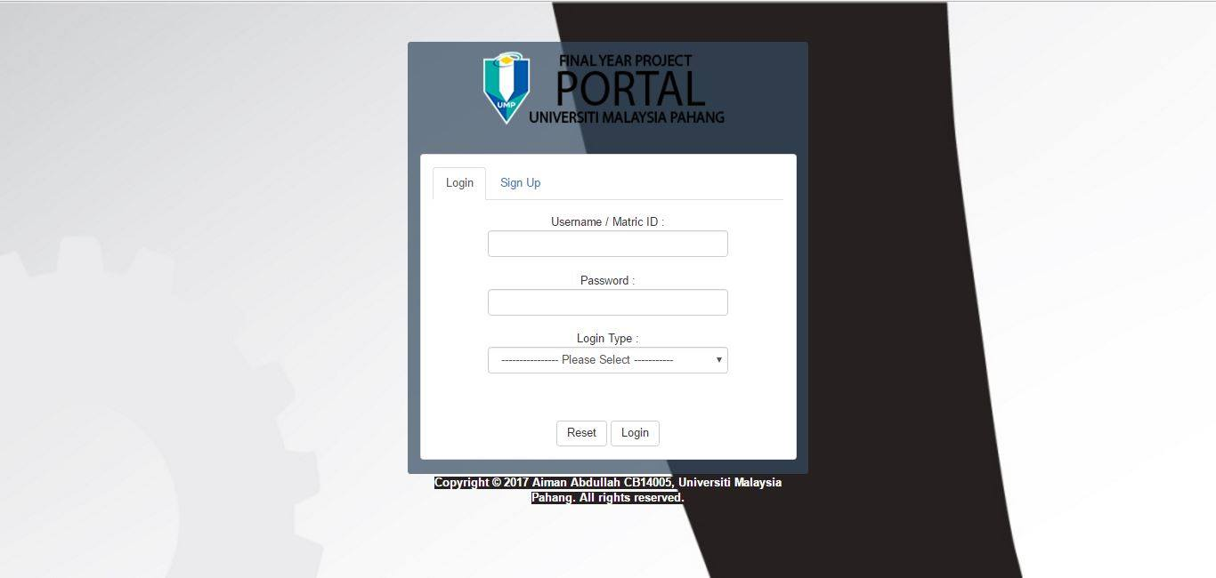

**Figure 2.1 Interface for login**

Figure 2.1 show the interface for user to login before continue using FYP Portal. User need to insert username, password and select the login type either student, supervisor, coordinator and examiner.

* 1. **Student Interface (Student Profile)**

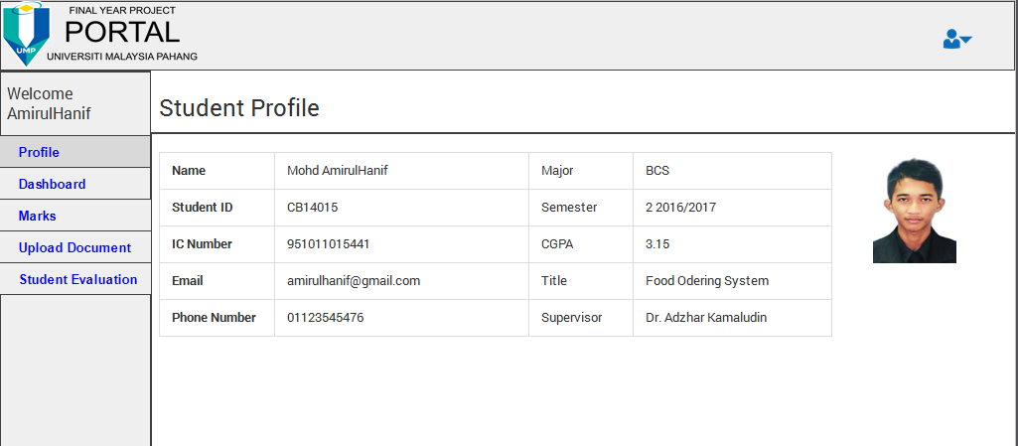

**Figure 2.2 Interface for student profile**

Figure 2.2 show the first interface for student after successful login to the system. This interface shows student profile.

* 1. **Student Interface (Student Dashboard)**

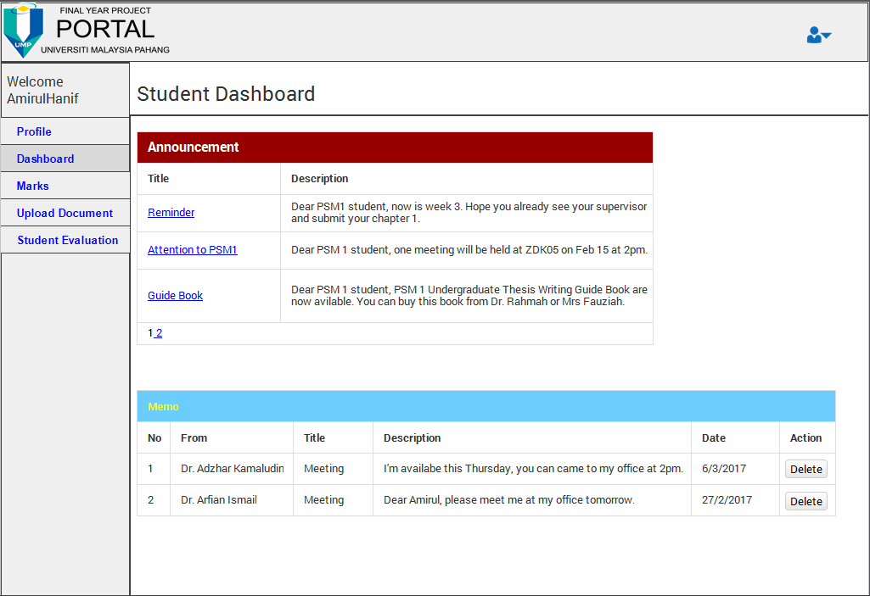

**Figure 2.3 Interface for student dashboard**

Figure 2.3 show the interface for student dashboard. Student can use this interface to view the announcement from coordinator and view a memo from coordinator and supervisor.

* 1. **Student Interface (Upload Document)**

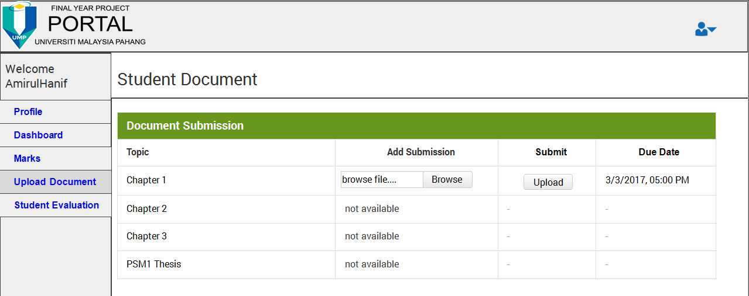

**Figure 2.4 Interface for upload document**

Figure 2.4 show the interface for student submit their document by chapter through this system. Coordinator will open the submission and student need to submit the document before the date line.

* 1. **Student Interface (Marks)**

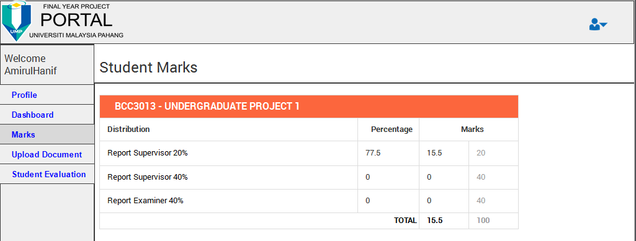

**Figure 2.5 Interface for student marks**

Figure 2.5 show the interface for student view their marks. Marks is given by supervisor twice base on student progress and examiner during the evaluation day.

* 1. **Student Interface (Student Evaluation)**

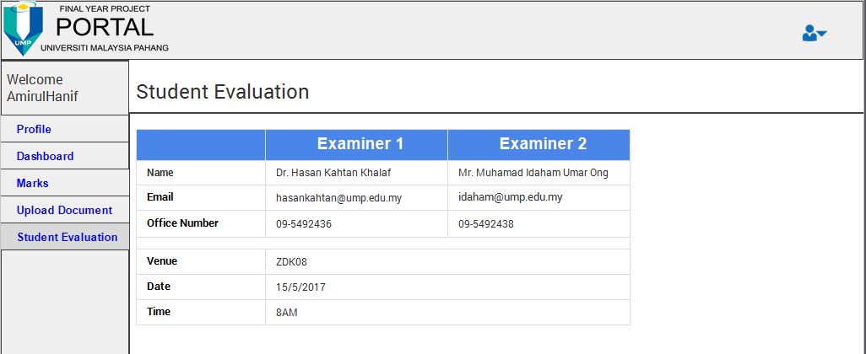

**Figure 2.6 Interface for student evaluation**

Figure 2.6 show the interface for student view their evaluation details and schedule. This schedule was managing by the coordinator.

* 1. **Supervisor Interface (Supervisor Profile)**

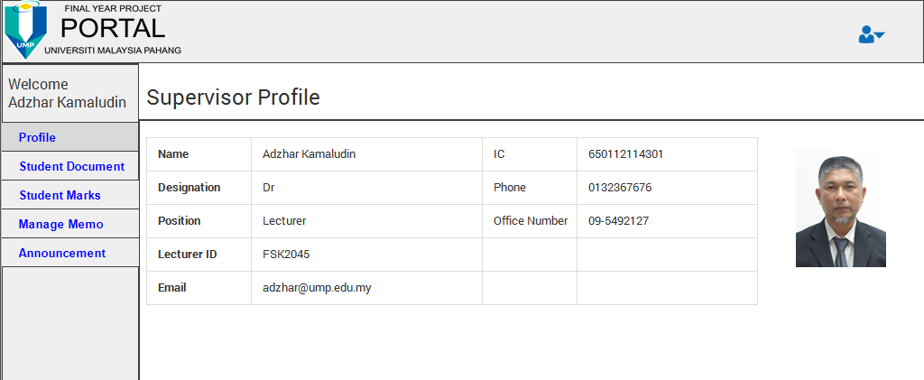

**Figure 2.7 Interface for supervisor profile**

Figure 2.7 show the profile interface for supervisor. Supervisor can view their personal details at this interface.

* 1. **Supervisor Interface (Download Document)**

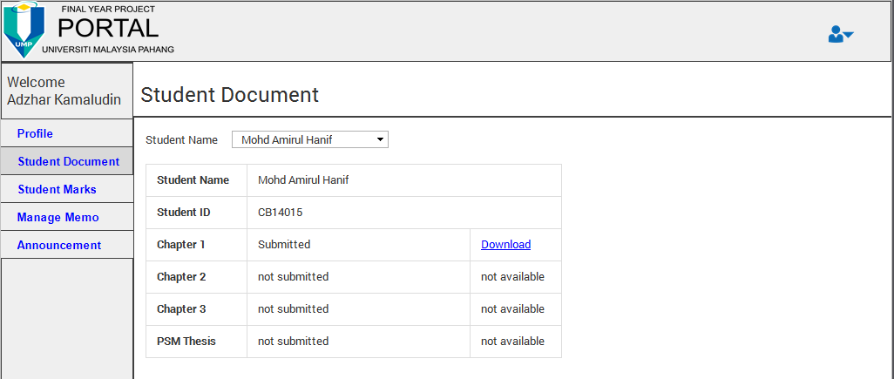

**Figure 2.8 Interface for supervisor download document**

Figure 2.8 show the interface for supervisor download the document that uploaded by their student. Supervisor can select his student name before download the document. The download link only appears after student upload the document through the system.

* 1. **Supervisor Interface (Students Marks)**

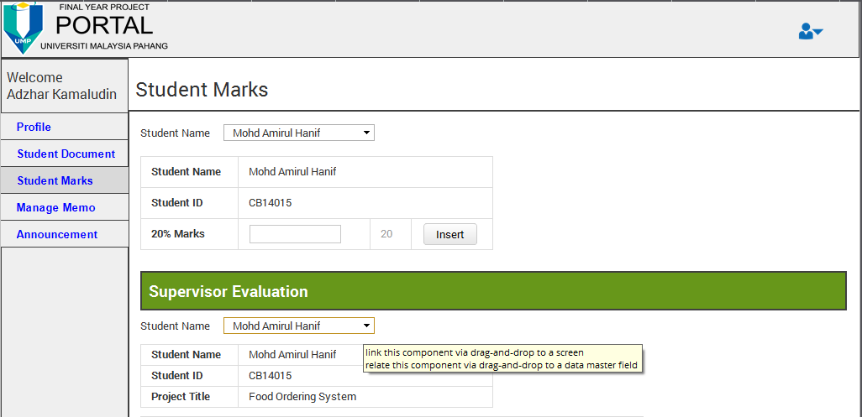

**Figure 2.9 Interface for supervisor insert marks**

Figure 2.9 show the interface for supervisor add his student marks at the first form. Supervisor need to select student name first before add 20percent marks to the student.

* 1. **Supervisor Interface (Supervisor Form)**

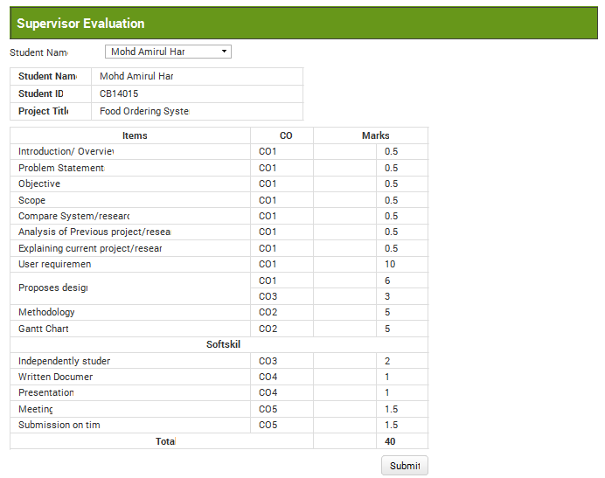

**Figure 2.10 Interface for supervisor evaluate student.**

Figure 2.10 show the interface for supervisor add 40percent marks to his student by using evaluation form.

* 1. **Supervisor Interface (Manage Memo)**

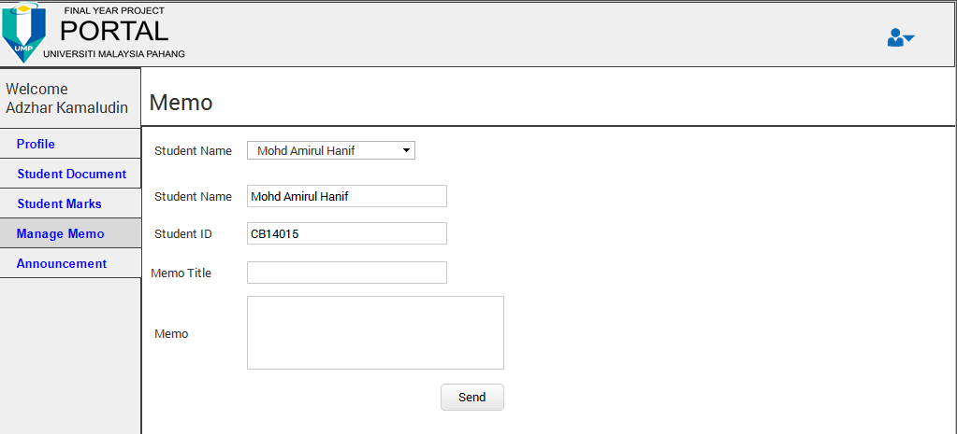

**Figure 2.11 Interface for supervisor manage memo**

Figure 2.11 show the interface for supervisor send a memo to his student. Supervisor need to select student name first before write a memo to the student. Supervisor can state a title of memo and write a memo before sent to his student.

* 1. **Supervisor Interface (Announcement)**

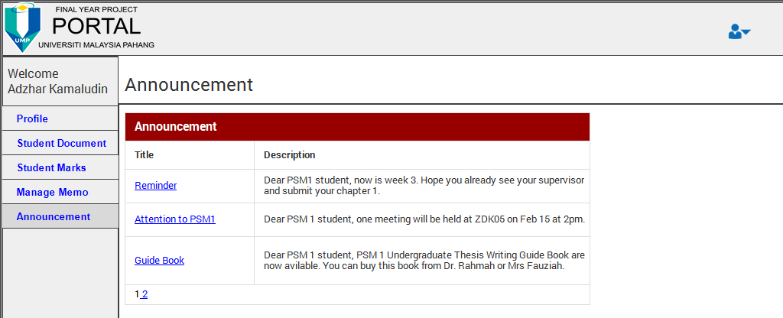

**Figure 2.12 Interface for announcement**

Figure 2.12 show the interface for supervisor view the announcement form coordinator.

* 1. **Coordinator Interface (Coordinator Profile)**

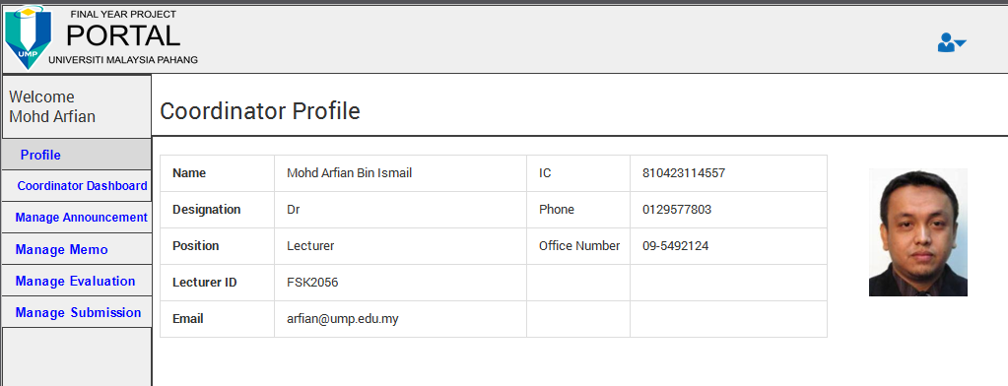

**Figure 2.13 Interface for coordinator profile**

Figure 2.13 show the interface for coordinator after their successfully login to this system. Coordinator can view their personal details at this interface.

* 1. **Coordinator Interface (Coordinator Dashboard)**

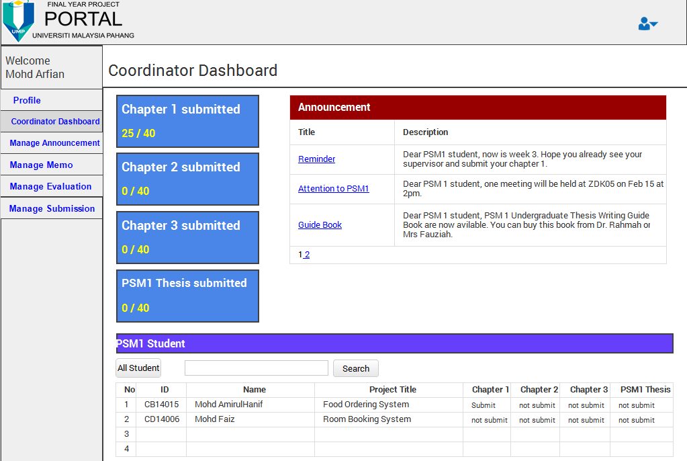

**Figure 2.14 Interface for coordinator dashboard**

Figure 2.14 show the interface for coordinator dashboard. At this dashboard coordinator can view the statistic of student upload a chapter. At the right interface, coordinator can view their announcement. Bottom of the interface was a table that show all student with their progress by upload the chapter. Coordinator can search a student name or id and view the result at the table.

* 1. **Coordinator Interface (Manage Announcement)**

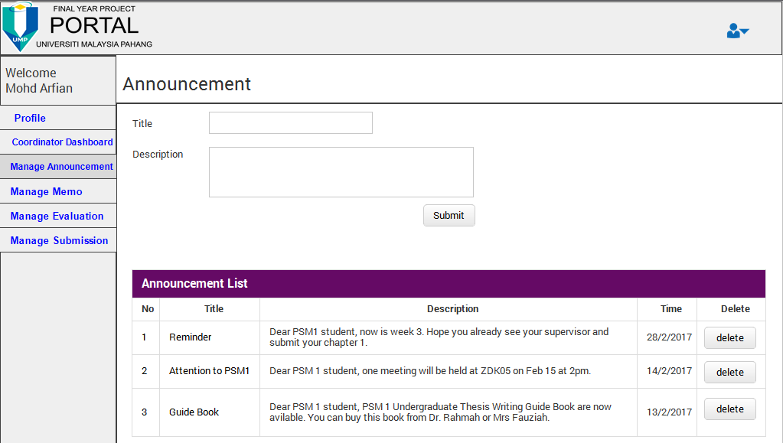

**Figure 2.15 Interface for manage announcement**

Figure 2.15 show the interface where coordinator can create an announcement for student and coordinator. Announcement list is for coordinator view and coordinator can delete the announcement if coordinator want to remove the announcement form the system.

* 1. **Coordinator Interface (Manage Memo)**

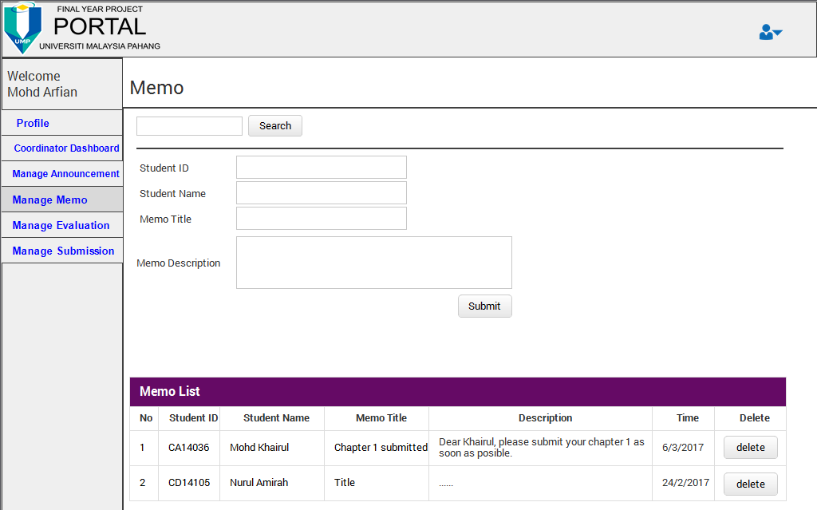

**Figure 2.16 Interface for manage memo**

Figure 2.16 show the interface of coordinator send a memo to student. Coordinator can search student id and student id and student name will appear at text box memo form. Coordinator can send a memo to the student by selected student id. Memo list is a history of memo that create by coordinator and coordinator can deleted a memo if it no longer need.

* 1. **Coordinator Interface (Manage Evaluation)**

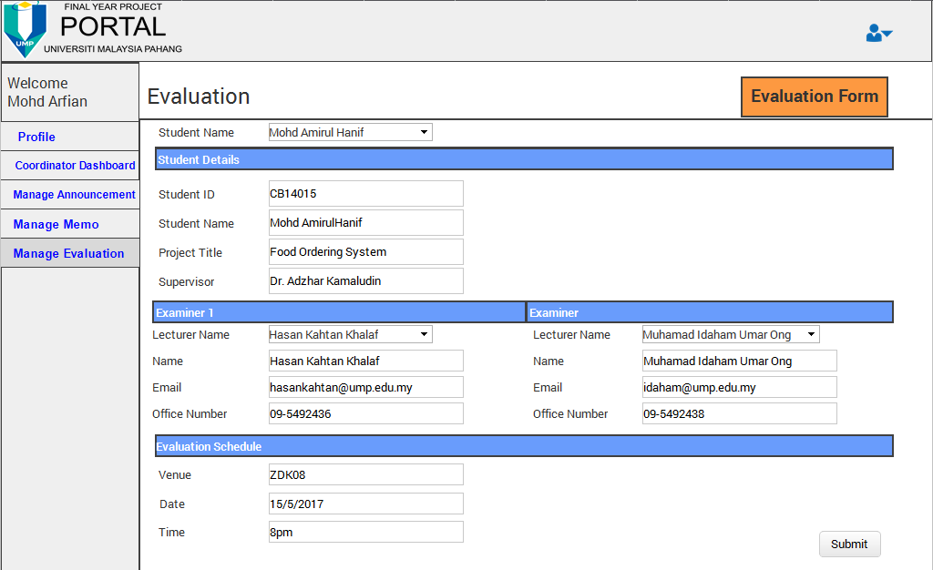

**Figure 2.17 Interface for manage evaluation**

Figure 2.17 show the interface of coordinator can manage evaluation process. Coordinator need to choose student name at dropdown list and student details will appear at the text box. To assign the examiner, coordinator also need to find lecturer name at dropdown list and their details will appear at the text box. To completed a schedule of evaluation, coordinator need to insert a venue, date and time at the form before save to database. At the right top of interface there are link to coordinator view the evaluation form.

* 1. **Coordinator Interface (Evaluation Form)**

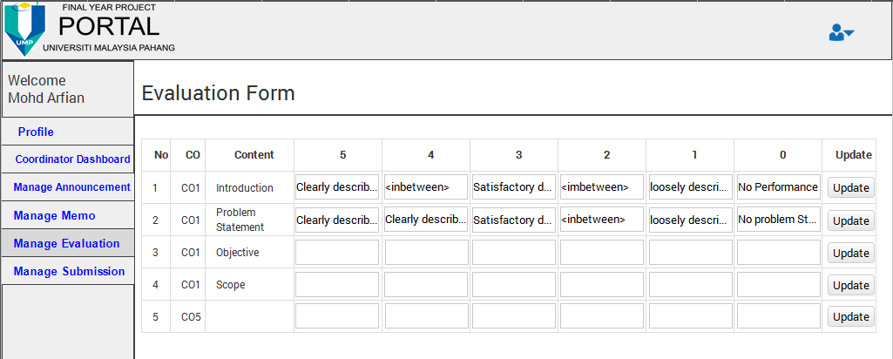

**Figure 2.18 Interface for evaluation form.**

Figure 2.18 show the interface for coordinator update the evaluation form. Coordinator can update the form by rows.

* 1. **Coordinator Interface (Manage Submission)**

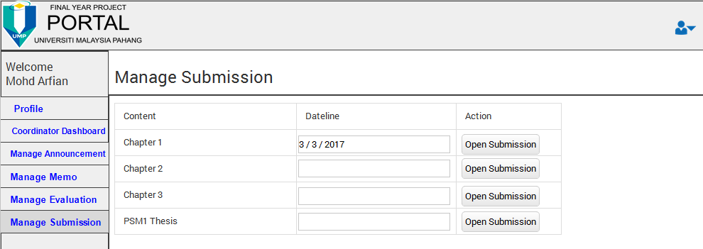

**Figure 2.19 Interface for manage submission**

Figure 2.19 show the interface of coordinator control the submission of student document. Coordinator need to insert the dateline of the submission before open the server for the submission.

* 1. **Examiner Interface (Examiner Dashboard)**

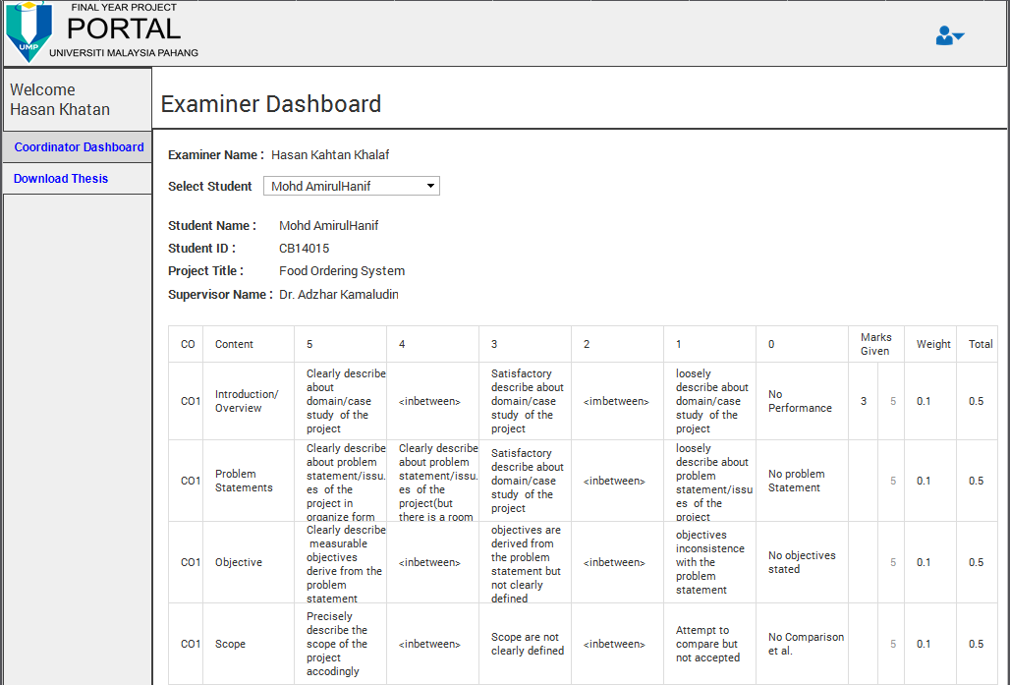

**Figure 2.20 Interface of examiner dashboard.**

Figure 2.20 show the interface of examiner dashboard. At this dashboard, examiner can evaluate student by use the evaluation form. Examiner can select student name that assign by coordinator to evaluate at dropdown list. Student details show after the examiner select a student name. After examiner done evaluate a student, mark from this evaluation will save to student marks.

* 1. **Examiner Interface (Examiner Download)**

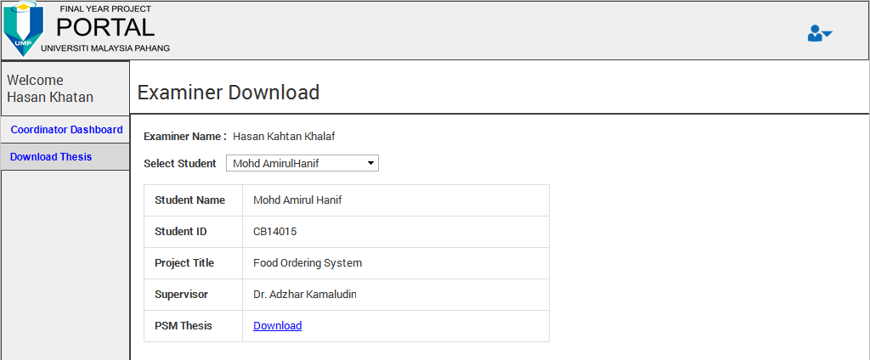

**Figure 2.21 Interface of examiner download**

Figure 2.21 show the interface for examiner download student PSM1 thesis. Examiner need to select student name before download a student thesis.

1. **SYSTEM DESIGN APPROVAL**

|  |  |  |
| --- | --- | --- |
|  | **Name** | **Date** |
| **Verified by:**  Developer |  |  |
| **Approved by:**  Client |  |  |

**APPENDICES**