SOFTWARE DESIGN DOCUMENT

**(SDD)**

**For**

**[Online Car Rental Management System]**

of the

**ON-BOARD AUTOMOBILE**

**(OBA)**

CONTRACT NO:

**CASE (Man_Doc_006)**

CDRL SEQUENCE NO:

**CASE (Man_Doc_008)**

**Prepared for:**

**[Kereta Sewa Murah Mesra]**

**Generated By:**

|  |  |
| --- | --- |
| Team Members | ID Number |
| Sivapriyan A/L S Kummar | CB14094 |
| Wan Noorafirah binti Wan Ramli | CB12129 |
| Noraisyah binti Yaakub | CB14105 |
| Ruzdiana Aniera binti Ramli | CB14069 |
| Ahmad Solehin bin Sharudin | CB15003 |

**November 2016**

|  |  |  |  |  |  |  |
| --- | --- | --- | --- | --- | --- | --- |
| **Approval List Table** | | | | | | |
| Index | 01 | 02 | 03 | 04 | 05 | 06 |
| Writed by:  Name: | Date: | Date: | Date: | Date: | Date: | Date: |
| Verified by:  Quality Manager  Name: | Date: | Date: | Date: | Date: | Date: | Date: |
| Check by:  Configuration Manager  Name: | Date | Date: | Date: | Date: | Date: | Date: |
| Approved by:  Work Package Manager  Name: | Date | Date: | Date: | Date: | Date: | Date: |
| Authenticated by:  Project Manager  Name: | Date | Date: | Date: | Date: | Date: | Date: |

|  |  |
| --- | --- |
| **Revision History** | |
| **Revision** | **Description** |
| 01 |  |
| 02 |  |
| 03 |  |
| 04 |  |
| 05 |  |
| 06 |  |

**TABLE OF CONTENTS**

|  |  |
| --- | --- |
| **1. SCOPE**...............................................................................................................  1.1. Identification ..................................................................................................  1.2. Overview of the System ….............................................................................  1.3. Overview of the Document …........................................................................ | 1  1  1  2 |
| **2. REFERENCED DOCUMENTS**...................................................................... 2.1. Reference Documents........................................................................ | 5  5 |
| **3. PRELIMINARY DESIGN**...............................................................................  3.1. System Overview ............................................................................................  3.1.1 System Architecture ...................................................................................  3.1.2 System States and Modes........................................................................... | 6  7  7  10 |
| **4. DETAILED DESIGN**.......................................................................................  4.1 Registration Subsystem............................................................................  4.1.1 Registration Package......................................................................  4.2 Manage car Subsystem.................................................................................  4.2.1 Manage Car Package..........................................................................  4.3 Manage Customer Info Subsystem..........................................................  4.3.1 Manage Customer Info Package........................................................  4.4 Manage Booking Subsystem…….................................................  4.4.1 Manage Booking Package…...........................................................  4.5 Generate Bill Subsystem…………………………………  4.5.1 Generate Bill Package….................................................................... | 11  11  11  17  17  25  25  33  33  51  51 |
| **5. DATA DICTIONARY……………………………………………………..** | 61 |
| **6. REQUIREMENTS TRACEABILITY………………………………………**  **7. NOTES** ............................................................................................................... | 62  62 |

# SCOPE

## Identification

System name: Online Car Rental Management System

Abbreviation: OCRMS

System ID No.: OCRMS-V.01-2016

## Overview of the System

The objective of this project is to develop a web based computer system to support existing manual car rental management process.OCRMS will convert manual car rental management into a computerized system which is integrated with a database system. By this integration,the system is capable to insert,save, update, delete, retrieve records and data. This system can keep huge data organized, secured and may reduce the uses of lots of paper. This system is a web-based application which means that Graphic User Interfaces (GUI) are implemented using any web browser. By default it is an internet-based application whereas user need an internet connection to access this system. The users of this system are customer,employee and manager who have different level of authority and function access to the system .Plus, the outsider is able to access OCRMS home page as it is public.

The major activities of the system are supporting the management information of the car rental process which include the manipulating the specific data, which are booking,customers and cars details. By using this system, the customer can book car for rental online.This include modifying the booking details which include update and cancelling the booking.The employee can update car availability and info,view customer info and generate bill using this system.While the manager can use this system to view monthly rental reports.These system features makes the car rentaling process more efficient and less complicated while contributing to better management process.

**Purpose of the System:**

The purpose of this system is to support existing manual car rental management process. OCRMS will convert manual car rental management into a computerized system which is integrated with a database system. These document explained the purpose and features of the system, the interfaces that being used, what the system can do, the constraint under which it must operate and how the system will react to external stimuli. This document is intended for both the stakeholders and the developers of the system.

## Overview of the Document

This Software Requirement Specification(SRS) document have seven different part which is Scope ,Referenced Documents, Preliminary Design, Detailed Design, CSCI Data and CSCI Data Files, Requirements Traceability, Notes.

The purpose of this document is to outline the entire requirement that has been gathered for the Online Car Rental Management System. In the first chapter, the **scope** of this system have been stated. Then the overview for the overall system are stated where all the functions provided by the system are explained with details. The reference that we refer also stated as prove.

The second chapter is the **Referenced Documents**, which gives an overview of the functionality of the product. It describes the informal requirements and is used to establish a context for a technical requirements specification in the third chapter.This chapter is more to explaining the system.It describes the user that will use the system, system function, the system constraints and the assumptions and dependencies. This to make sure that the client can understand the system flow and the weakness of system.OCRMS is accessible with any compatible browser such as Internet Explorer, Mozilla Firefox and Google Chrome.

Third chapter is **Preliminary Design**, it describes the software requirements to a level of more details that enables designers to design a system that satisfy those requirements and well-functioning as well. Besides that, it also explains every input and output of the system with all functions performed by the system in response.By this, client can get to know more about the product features, the interface requirements and the requirement traceability.

The fourth chapter, **Detailed Design**, of this documentation typically describes what is needed by the system user as well as requested properties of inputs and outputs. A functional specification is the more technical response to a matching requirements document, e.g. the Product Requirement Document “PRD”. Thus it picks up the results of the requirements analysis stage. On more complex systems multiple levels of functional specifications will typically nest to each other, e.g. on the system level, on the module level and on the level of technical details.

The fifth chapter, **Data dictionary,** of this documentation data dictionary is a collection of descriptions of the data objects or items in a data model for the benefit of programmers and others who need to refer to them. A first step in analyzing a system of objects with which users interact is to identify each object and its relationship to other objects. This process is called data modeling and results in a picture of object relationships.

The sixth chapter, **Specification requirement**, of this document is basically a table that has been constructed with all of the unfamiliar abbreviations such as OCRMS which stands for Online Car Rental Management System so if users come across an abbreviation that they are not familiar with they can simply turn to the table and look up the word they are looking for.

The seven chapter, **Notes and abbreviation**, of this document is basically a table that has been constructed with all of the unfamiliar abbreviations such as OCRMS which stands for Online Car Rental Management System so if users come across an abbreviation that they are not familiar with they can simply turn to the table and look up the word they are looking for.

In general, this SDD is divided into 8 sections as the following:

|  |  |
| --- | --- |
| **Chapter 1** | Describes the scope identification, system overview and the document overview. |
| **Chapter 2** | Referenced documents, government documents and non-government documents. |
| **Chapter 3** | Describes the preliminary design for the OCRMS. The preliminary design will identify OCRMS, Describes the OCRMS Architecture, static organization and dynamic organization. |
| **Chapter 4** | Describes the detail design. |
| **Chapter 5** | Describes the data dictionary |
| **Chapter 6** | Specification requirement |
|  |  |
| **Chapter 7** | Notes and abbreviations. |

# 2. REFERENCED DOCUMENTS

This section lists the document number and document name referenced in this document. Any discrepancies of this document in describing the software development process should be covered by the documents listed in this chapter. The following documents were referred as the basis for this SDD preparation.

Copies of specification, standards, drawings and publication requested by suppliers in contact with the specified supplying functions may be obtained by contacting the agency or directly through the contracting office.

## 2.1. Reference Documents

This section consists of the contractual documents and non-contractual documents.

[You must list all related reference document in your design document, book,etc]

1. SDP (FT-10-037-) Software Development Plan
2. SRS (OCRMS-V.01-2016) Software Requirements Specification

|  |  |  |
| --- | --- | --- |
|  |  |  |
|  |  |  |
|  |  |  |

# 3. PRELIMINARY DESIGN

## 3.1. System Overview

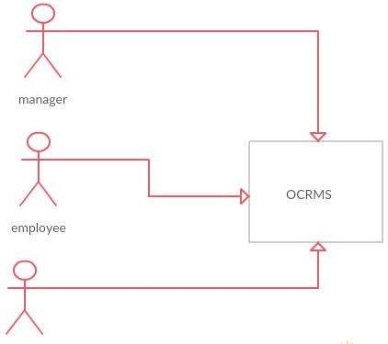

Customer

Figure 1: System Design Overview

## 3.1.1 OCRMS Architecture

This paragraph identifies the internal organizational structure of the system. The relationship among system subsystem will be described.

## 3.1.1.1 Static Organization

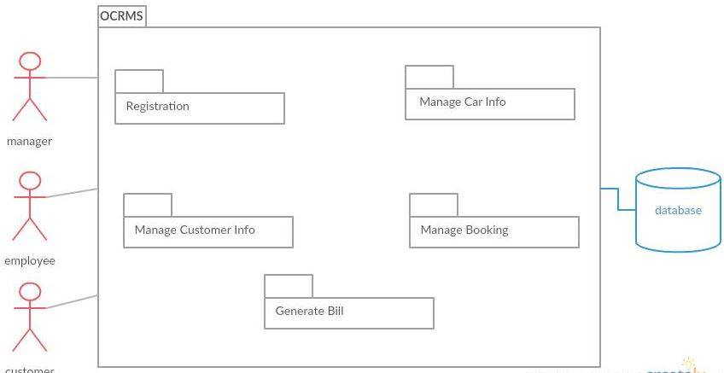

Figure 2: Static Organization of [your system name]

This section describes the detail for each subsystem/package .

This section describes the detail for each subsystem/package.

* 1. **Registration**

This subsystem is responsible to assists the customer to complete the registration procedure. The customer will register manually. Then, the employee will key in their information. Their detail will be recorded into the system and the ID will be generated for each and every new customer and teachers that have registered. The customer are allowed to use the system by login using their id number given.

* + 1. Authentication
    2. Customer
    3. Register
  1. **Manage Car Info**

This subsystem is responsible to ensure available car so that there is no redundant booking on date and time.

* + 1. Car
    2. Employee
  1. **Manage Customerr Info**

This subsystem is able to update the customer info if there is a change.

* + 1. Employee
    2. Customer
  1. **Manage Booking**

This subsystem is responsible for employee to manage booking based on customer requirements.

* + 1. Employee
    2. Customer
  1. Generate Billmary

This subsystem is responsible to display receipt and financial summary.

* + 1. Employee
    2. Financial
    3. Receipt
    4. Report

**3.1.1.2. Dynamic Organization**

Figure 3 diagram shows components and their relationships between each other in System

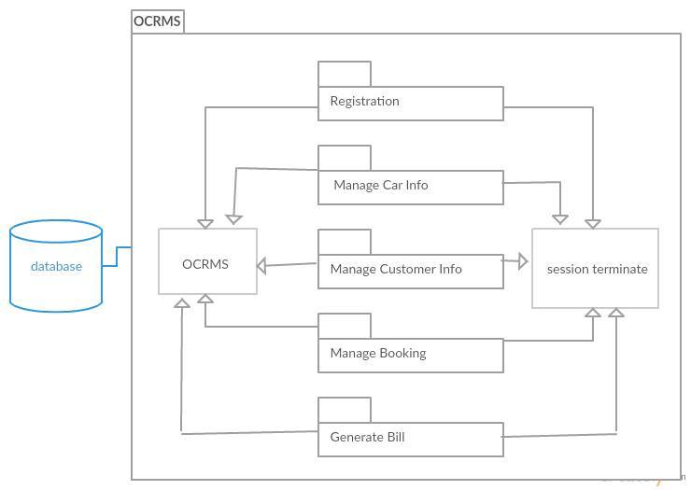

Figure 3: Component Diagram of OCRMS

# 

# 4. DETAILED DESIGN

This section divided into the following paragraphs and subparagraphs to describe the detailed design.

## 4.1 Registration Subsystem (SDD-REQ-S01)

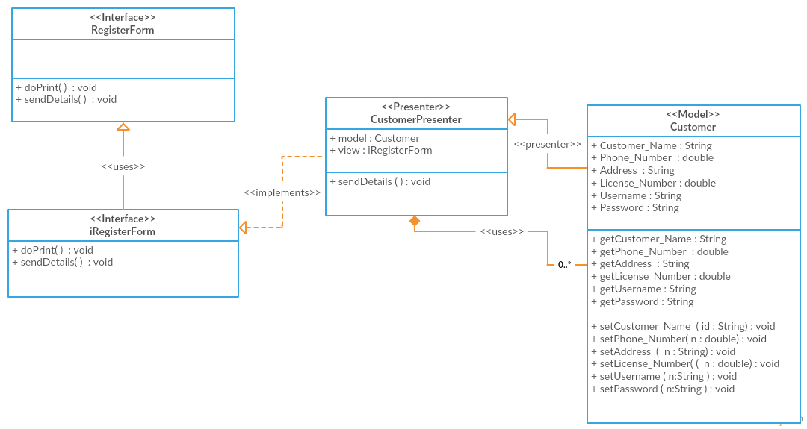

**Figure 4.1: Registration Detail Design**

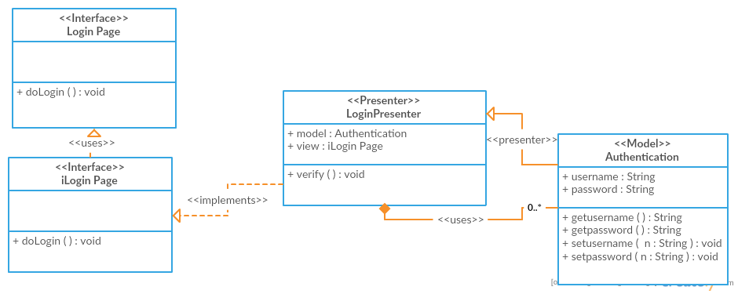

**Figure 4.1: Login Detail Design**

**4.1.1 Model class design(SDD-REQ-4.1.1)**

This subparagraph specifies the design of model class.

1. Authentication
2. Customer
3. Register

4.1.1.1 Authentication class (SDD-REQ-4.1.1.1)

1. **Input/output data elements**

List of input and output data elements :-

Input : username, password

Output : verify username and password

1. **Local data elements**

Table 4.1.1.1.1: Local Data Definition for Data Element

|  |  |
| --- | --- |
| Name | username |
| Description | Contain username for employee and customer |
| Data type | String |
| Precision/ resolution | - |

Table 4.1.1.1.2: Local Data Definition for Data Element

|  |  |
| --- | --- |
| Name | password |
| Description | Contain password for employee and customer |
| Data type | String |
| Precision/ resolution | - |

1. **Algorithms**

The purpose of this class is to store the username and password.

Class type : Model class

Responsibility : To verify username and password

Attributes : username : String

Password : String

Methods : setUsername(), getUsername(), setPassword(), getPassword()

1. getUsername() , setUsername()

Responsibility : get and set username

Input parameter : String username

Output parameter : username

Algorithm :

BEGIN

getUsername();

setUsername( username );

END

1. getPassword(), setPassword()

Responsibility : get and set password

Input parameter : String password

Output parameter : password

Algorithm :

BEGIN

getPassword();

setPassword( password );

END

4.1.1.2 Customer class (SDD-REQ-4.1.1.2)

1. **Input/output data elements**

List of input and output data elements :

Input : Customer_Name, Phone_Number, Address , License_Number, Username , Password.

Output : get customer information

**b) Local data elements**

Table 4.1.1.2.1: Local Data Definition for Data Element

|  |  |
| --- | --- |
| Name | Customer_Name |
| Description | Contain customer name |
| Data type | String |
| Precision/ resolution | - |

Table 4.1.1.2.2: Local Data Definition for Data Element

|  |  |
| --- | --- |
| Name | Phone_Number |
| Description | Contain Phone of customer |
| Data type | double |
| Precision/ resolution | - |

Table 4.1.1.2.3: Local Data Definition for Data Element

|  |  |
| --- | --- |
| Name | Address |
| Description | Contain customer Address |
| Data type | String |
| Precision/ resolution | - |

Table 4.1.1.2.4: Local Data Definition for Data Element

|  |  |
| --- | --- |
| Name | License_Number |
| Description | Contain customer License_Number |
| Data type | String |
| Precision/ resolution | - |

Table 4.1.1.2.5: Local Data Definition for Data Element

|  |  |
| --- | --- |
| Name | Username |
| Description | Contain Username of customer |
| Data type | String |
| Precision/ resolution | - |

Table 4.1.1.2.6: Local Data Definition for Data Element

|  |  |
| --- | --- |
| Name | Password |
| Description | Contain Password |
| Data type | String |
| Precision/ resolution | - |

**c) Algorithms**

The purpose of this class is to allow staff to retrieve and store input information of customer into system.

Class type : Model class

Responsibility : To input information of customer into system

Attributes : Customer_Name : String

Address : String

Phone_Number : Double

License_Number : String

Username : String

Password : String

Methods :getCustomer_Name (),setCustomer_Name (),getAddress (),set Address (), getLicense_Number (),set License_Number (),getPhone_Number(), setPhone_Number, getUsername (), setUsername (), getUsername (), getPassword(), setPAssword ().

1. getCustomer_Name () and setCustomer_Name ()

Responsibility : get and set customer name

Input parameter : Customer_Name

Output parameter :getCustomerrName

Algorithm :

BEGIN

getCustomer_Name ();

setCustomer_Name (Customer_Name);

END

1. getPhone_Number () and setPhone_Number ()

Responsibility : get and set Phone_Number

Input parameter : Phone_Number

Output parameter : getPhone_Number

Algorithm :

BEGIN

getPhone_Number ();

setPhone_Number (Phone_Number );

1. getAddress () and setAddress ()

Responsibility : get and set customer address

Input parameter : Address

Output parameter : getAddress

Algorithm :

BEGIN

getAddress ();

setAddress (Address)

END

1. getLicense_Number() and setLicense_Number()

Responsibility : get and set License_Number

Input parameter : License_Number

Output parameter : getLicense_Number

Algorithm :

getLicense_Number ();

setLicense_Number (License_Number );

BEGIN

END

1. getUsername () and setUsername ()

Responsibility : get and set Username

Input parameter : Username

Output parameter : getUsername

Algorithm :

BEGIN

getUsername ();

setUsername (Username );

END

1. getPassword () and setPassword()

Responsibility : get and set Password

Input parameter : Password

Output parameter : getPasssword

Algorithm :

BEGIN

getPassword ();

setPassword (Password );

END

## 4.2 Manage Car Info Subsystem (SDD-REQ-S02)

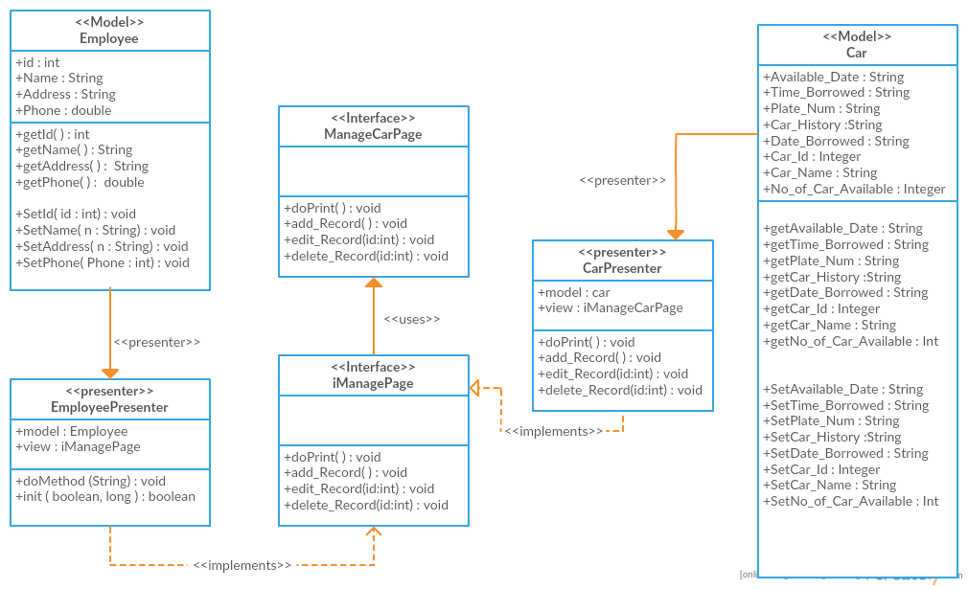

**Figure 4.2 : Manage Car Info Detail Design**

**4.2.1 Model class design(SDD-REQ-4.2.1)**

This subparagraph specifies the design of model class.

1. Car
2. Employee

**4.2.1.1 Car class (SDD-REQ-4.2.1.1)**

1. **Input/output data elements**

List of input and output data elements :

Input :Car_ID, Car_Name, Plate_Num , Car_History, Available_Date , Time_Borrowed , Date_Borrowed, No_of_Car_Available

Output : get car information

**b) Local data elements**

Table 4.2.1.1.1: Local Data Definition for Data Element

|  |  |
| --- | --- |
| Name | Car_ID |
| Description | Contain car id |
| Data type | String |
| Precision/ resolution | Alphanumeric |

Table 4.2.1.1.2: Local Data Definition for Data Element

|  |  |
| --- | --- |
| Name | Car_Name |
| Description | Contain car name |
| Data type | String |
| Precision/ resolution | - |

Table 4.2.1.1.3: Local Data Definition for Data Element

|  |  |
| --- | --- |
| Name | Plate_Num |
| Description | Contain car plate number |
| Data type | String |
| Precision/ resolution | - |

Table 4.2.1.1.4: Local Data Definition for Data Element

|  |  |
| --- | --- |
| Name | Car_History |
| Description | Contain car history |
| Data type | String |
| Precision/ resolution | - |

Table 4.2.1.1.5: Local Data Definition for Data Element

|  |  |
| --- | --- |
| Name | Available_Date |
| Description | Contain available date of car |
| Data type | String |
| Precision/ resolution | day/month/year (dd/mm/yy) |

Table 4.2.1.1.6: Local Data Definition for Data Element

|  |  |
| --- | --- |
| Name | Time_Borrowed |
| Description | Contain time borrowed |
| Data type | String |
| Precision/ resolution | - |

Table 4.2.1.1.7: Local Data Definition for Data Element

|  |  |
| --- | --- |
| Name | Date_ Borrowed |
| Description | Contain date borrowed |
| Data type | String |
| Precision/ resolution | day/month/year (dd/mm/yy) |

Table 4.2.1.1.8: Local Data Definition for Data Element

|  |  |
| --- | --- |
| Name | No_of_Car_Available |
| Description | Contain number of car available |
| Data type | Integer |
| Precision/ resolution | - |

**c) Algorithms**

The purpose of this class is to allow tuition staff to input information of teacher into system.

Class type : Model class

Responsibility : To input information of car into system

Attributes : Car_ID : Integer

Car_Name : String

Plate_Num : String

Car_History : String

Available_Date : String

Time_Borrowed : String

Date_ Borrowed : String

No_of_Car_Available : Integer

Methods : getCar_ID(), setCar_ID(), getCar_Name (),setCar_Name (),getPlate_Num (),setPlate_Num (), getCar_History (),setCar_History (),get Available_Date (), set Available_Date, get Time_Borrowed (), set Time_Borrowed (), get Date_ Borrowed (), set Date_ Borrowed (), getNo_of_Car_Available (), set No_of_Car_Available ().

1. getCar_ID () and setCar_ID ()

Responsibility : get and set car id

Input parameter : Car_ID

Output parameter : getCar_ID

Algorithm :

BEGIN

getCar_ID ();

setCar_ID (Car_ID);

END

1. getCar_Name () and setCar_Name ()

Responsibility : get and set car name

Input parameter : Car_Name

Output parameter :getCar_Name

Algorithm :

BEGIN

getCar_Name ();

setCar_Name (Car_Name);

END

1. getPlate_Num () and setPlate_Num ()

Responsibility : get and set car plate number

Input parameter : Plate_Num

Output parameter :getPlate_Num

Algorithm :

BEGIN

getPlate_Num ();

setPlate_Num (Plate_Num)

END

1. getCar_History () and setCar_History ()

Responsibility : get and set Car_History

Input parameter : Car_History

Output parameter :get Car_History

Algorithm :

get Car_History ();

set Car_History (Car_History);

BEGIN

END

1. get Available_Date () and set Available_Date ()

Responsibility : get and set Available_Date

Input parameter : Available_Date

Output parameter :get Available_Date

Algorithm :

BEGIN

get Available_Date ();

set Available_Date (Available_Date);

END

1. get Time_Borrowed () and set Time_Borrowed ()

Responsibility : get and set Time_Borrowed

Input parameter : Time_Borrowed

Output parameter :get Time_Borrowed

Algorithm :

BEGIN

get Time_Borrowed ();

set Time_Borrowed (Time_Borrowed);

END

1. get Date_ Borrowed () and set Date_ Borrowed ()

Responsibility : get and set Date_ Borrowed

Input parameter : Date_ Borrowed

Output parameter :get Date_ Borrowed

Algorithm :

BEGIN

get Date_ Borrowed ();

set Date_ Borrowed (Date_ Borrowed);

END

1. get No_of_Car_Available () and set No_of_Car_Available ()

Responsibility : get and set No_of_Car_Available

Input parameter : No_of_Car_Available

Output parameter :get No_of_Car_Available

Algorithm :

BEGIN

get No_of_Car_Available ();

set No_of_Car_Available (No_of_Car_Available);

END

4.2.1.2 Employee class (SDD-REQ-4.2.1.2)

1. **Input/output data elements**

List of input and output data elements :

Input : id , Name, Address, Phone

Output : get customer information

**b) Local data elements**

Table 4.2.1.2.1: Local Data Definition for Data Element

|  |  |
| --- | --- |
| Name | Id |
| Description | Contain customer id |
| Data type | Integer |
| Precision/ resolution | Alphanumeric |

Table 4.2.1.2.2: Local Data Definition for Data Element

|  |  |
| --- | --- |
| Name | Name |
| Description | Contain customer name |
| Data type | String |
| Precision/ resolution | - |

Table 4.2.1.2.3: Local Data Definition for Data Element

|  |  |
| --- | --- |
| Name | Address |
| Description | Contain customer Address |
| Data type | String |
| Precision/ resolution | - |

Table 4.2.1.2.4: Local Data Definition for Data Element

|  |  |
| --- | --- |
| Name | Phone |
| Description | Contain Phone of customer |
| Data type | double |
| Precision/ resolution | - |

**c) Algorithms**

The purpose of this class is to allow staff to retrieve and store input information of customer into system.

Class type : Model class

Responsibility : To input information of customer into system

Attributes : id : Integer

Name : String

Address : String

Phone : Double

Methods : get_ID(), setID(), getName (),setName (),getAddress (),set Address (),getPhone ()

1. getID () and setID ()

Responsibility : get and set customer id

Input parameter : id

Output parameter : getID

Algorithm :

BEGIN

getID ();

setID (id);

END

1. getName () and setName ()

Responsibility : get and set customer name

Input parameter : Name

Output parameter :getName

Algorithm :

BEGIN

getName ();

setName (Name);

END

1. getAddress () and setAddress ()

Responsibility : get and set customer address

Input parameter : Address

Output parameter : getAddress

Algorithm :

BEGIN

getAddress ();

setAddress (Address)

END

1. getPhone () and setPhone ()

Responsibility : get and set Phone

Input parameter : Phone

Output parameter : getPhone

Algorithm :

BEGIN

getPhone ();

setPhone (Phone );

END

## 4.3 Manage Customer Info Subsystem (SDD-REQ-S03)



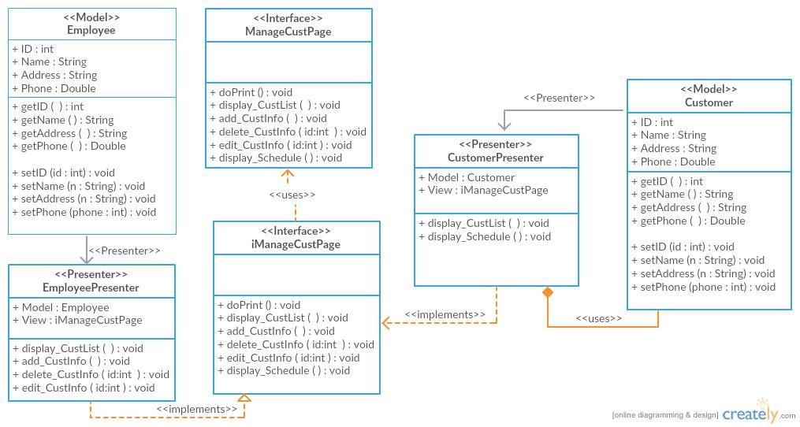

**Figure 4.3 : Manage Customer Info Detail Design**

**4.3.1 Model class design(SDD-REQ-4.3.1)**

This subparagraph specifies the design of model class.

1. Employee
2. Customer

**4.3.1.1 Employee class (SDD-REQ-4.1.1.1)**

1. **Input/output data elements**

List of input and output data elements :

Input : ID, Name, Address, Phone

Output : get employee information

**b) Local data elements**

Table 4.3.1.1.1: Local Data Definition for Data Element

|  |  |
| --- | --- |
| Name | ID |
| Description | Contain employee id |
| Data type | Integer |
| Precision/ resolution | - |

Table 4.3.1.1.2: Local Data Definition for Data Element

|  |  |
| --- | --- |
| Name | Employee Name |
| Description | Contain employee name |
| Data type | String |
| Precision/ resolution | - |

Table 4.3.1.1.3: Local Data Definition for Data Element

|  |  |
| --- | --- |
| Name | Address |
| Description | Contain employee address |
| Data type | String |
| Precision/ resolution | - |

Table 4.3.1.1.4: Local Data Definition for Data Element

|  |  |
| --- | --- |
| Name | Phone |
| Description | Contain employee phone number |
| Data type | Double |
| Precision/ resolution | - |

**c) Algorithms**

The purpose of this class is to allow employee to view customer information.

Class type : Model class

Responsibility : To view customer information

Attributes : ID : Integer

Name : String

Address : String

Phone : Double

Methods : get_ID(), set_ID(), get_Name(),

set­_Name(), get_Address(),set_Address(),

get_Phone(), set­_Phone()

1. getID () and setID ()

Responsibility : get and set employee id

Input parameter : ID

Output parameter : get_ID

Algorithm :

BEGIN

get_ID ();

set_ID (ID);

END

1. getName () and setName ()

Responsibility : get and set employee name

Input parameter : Name

Output parameter :getName

Algorithm :

BEGIN

get_Name ();

set_Name (Name);

END

1. get_Address () and set_Address ()

Responsibility : get and set employee address

Input parameter : Address

Output parameter :get_ Address

Algorithm :

BEGIN

get_Address ();

set_Address (Address)

END

1. get_Phone () and set_Phone ()

Responsibility : get and set employee phone number

Input parameter : Phone

Output parameter :get_ Phone

Algorithm :

BEGIN

get_Phone ();

set_Phone (Phone);

END

**4.3.1.2 Customer class (SDD-REQ-4.3.1.2)**

1. **Input/output data elements**

List of input and output data elements :

Input : Customer_ID, Customer_Name, Customer_Address, Phone_Number

Output : get customer information

**b) Local data elements**

Table 4.3.1.2.1: Local Data Definition for Data Element

|  |  |
| --- | --- |
| Name | Customer_ID |
| Description | Contain customer id |
| Data type | Integer |
| Precision/ resolution | - |

Table 4.3.1.2.2: Local Data Definition for Data Element

|  |  |
| --- | --- |
| Name | Customer_Name |
| Description | Contain customer name |
| Data type | String |
| Precision/ resolution | - |

Table 4.3.1.2.3: Local Data Definition for Data Element

|  |  |
| --- | --- |
| Name | Customer_Address |
| Description | Contain customer address |
| Data type | String |
| Precision/ resolution | - |

Table 4.3.1.2.4: Local Data Definition for Data Element

|  |  |
| --- | --- |
| Name | Phone_Number |
| Description | Contain customer phone number |
| Data type | Double |
| Precision/ resolution | - |

**c) Algorithms**

The purpose of this class is to allow customer to view schedule information.

Class type : Model class

Responsibility : To view schedule information

Attributes : Customer_ID : Integer

Customer_Name : String

Customer_Address : String

Phone_Number : Double

Methods : get_Customer_ID (), set_Customer_ID (),

get_Customer_Name (),set­_Customer_Name (),

get_ Customer_Address(),set_ Customer_Address(),

get_Phone_Number (), set­_Phone_Number ()

1. get_Customer_ID () and set_Customer_ID ()

Responsibility : get and set customer id

Input parameter : Customer_ID

Output parameter : get_Customer_ID

Algorithm :

BEGIN

get_Customer_ID ();

set_Customer_ID (Customer_ID);

END

1. get_Customer_Name () and set_Customer_Name ()

Responsibility : get and set customer name

Input parameter : Customer_Name

Output parameter : get_Customer_Name

Algorithm :

BEGIN

get_Customer_Name ();

set_Customer_Name (Customer_Name);

END

1. get_ Customer_Address () and set_ Customer_Address ()

Responsibility : get and set customer address

Input parameter : Customer_Address

Output parameter :get_Customer_Address

Algorithm :

BEGIN

get_Customer_Address ();

set_Customer_Address (Customer_Address)

END

1. get_Phone_Number () and set_Phone_Number ()

Responsibility : get and set customer phone number

Input parameter : Phone_Number

Output parameter :get_Phone_Number

Algorithm :

BEGIN

get_Phone_Number ();

set_ Phone_Number (Phone_Number);

END

## 4.4 Manage Booking Subsystem (SDD-REQ-S04)

## 

**Figure 4.4 : Manage Booking Detail Design**

**4.4.1 Model class design(SDD-REQ-4.4.1)**

This subparagraph specifies the design of model class.

1. Authentication
2. Car
3. Customer
4. Employee

4.4.1.1 Authentication class (SDD-REQ-4.4.1.1)

1. **Input/output data elements**

List of input and output data elements :-

Input : username, password

Output : verify username and password

1. **Local data elements**

Table 4.4.1.1.1: Local Data Definition for Data Element

|  |  |
| --- | --- |
| Name | Username |
| Description | Contain username for employee and customer |
| Data type | String |
| Precision/ resolution | - |

Table 4.4.1.1.2: Local Data Definition for Data Element

|  |  |
| --- | --- |
| Name | password |
| Description | Contain password for employee and customer |
| Data type | String |
| Precision/ resolution | - |

1. **Algorithms**

The purpose of this class is to store the username and password.

Class type : Model class

Responsibility : To verify username and password

Attributes : username : String

Password : String

Methods : setUsername(), getUsername(), setPassword(), getPassword()

1. getUsername() , setUsername()

Responsibility : get and set username

Input parameter : String username

Output parameter : username

Algorithm :

BEGIN

getUsername();

setUsername( username );

END

1. getPassword(), setPassword()

Responsibility : set and password

Input parameter : String password

Output parameter : password

Algorithm :

BEGIN

getPassword();

setPassword( password );

END

**4.4.1.2 Car class (SDD-REQ-4.4.1.2)**

1. **Input/output data elements**

List of input and output data elements :

Input :Car_ID, Car_Name, Plate_Num , Car_History, Available_Date , Time_Borrowed , Date_Borrowed, No_of_Car_Available

Output : get car information

**b) Local data elements**

Table 4.4.1.2.1: Local Data Definition for Data Element

|  |  |
| --- | --- |
| Name | Car_ID |
| Description | Contain car id |
| Data type | String |
| Precision/ resolution | Alphanumeric |

Table 4.4.1.2.2: Local Data Definition for Data Element

|  |  |
| --- | --- |
| Name | Car_Name |
| Description | Contain car name |
| Data type | String |
| Precision/ resolution | - |

Table 4.4.1.2.3: Local Data Definition for Data Element

|  |  |
| --- | --- |
| Name | Plate_Num |
| Description | Contain car plate number |
| Data type | String |
| Precision/ resolution | - |

Table 4.4.1.2.4: Local Data Definition for Data Element

|  |  |
| --- | --- |
| Name | Car_History |
| Description | Contain car history |
| Data type | String |
| Precision/ resolution | - |

Table 4.4.1.2.5: Local Data Definition for Data Element

|  |  |
| --- | --- |
| Name | Available_Date |
| Description | Contain available date of car |
| Data type | String |
| Precision/ resolution | day/month/year (dd/mm/yy) |

Table 4.4.1.2.6: Local Data Definition for Data Element

|  |  |
| --- | --- |
| Name | Time_Borrowed |
| Description | Contain time borrowed |
| Data type | String |
| Precision/ resolution | - |

Table 4.4.1.2.7: Local Data Definition for Data Element

|  |  |
| --- | --- |
| Name | Date_ Borrowed |
| Description | Contain date borrowed |
| Data type | String |
| Precision/ resolution | day/month/year (dd/mm/yy) |

Table 4.4.1.2.8: Local Data Definition for Data Element

|  |  |
| --- | --- |
| Name | No_of_Car_Available |
| Description | Contain number of car available |
| Data type | Integer |
| Precision/ resolution | - |

**c) Algorithms**

The purpose of this class is to allow tuition staff to input information of teacher into system.

Class type : Model class

Responsibility : To input information of car into system

Attributes : Car_ID : Integer

Car_Name : String

Plate_Num : String

Car_History : String

Available_Date : String

Time_Borrowed : String

Date_ Borrowed : String

No_of_Car_Available : Integer

Methods : getCar_ID(), setCar_ID(), getCar_Name (),setCar_Name (),getPlate_Num (),setPlate_Num (), getCar_History (),setCar_History (),get Available_Date (), set Available_Date, get Time_Borrowed (), set Time_Borrowed (), get Date_ Borrowed (), set Date_ Borrowed (), getNo_of_Car_Available (), set No_of_Car_Available ().

1. getCar_ID () and setCar_ID ()

Responsibility : get and set car id

Input parameter : Car_ID

Output parameter : getCar_ID

Algorithm :

BEGIN

getCar_ID ();

setCar_ID (Car_ID);

END

1. getCar_Name () and setCar_Name ()

Responsibility : get and set car name

Input parameter : Car_Name

Output parameter :getCar_Name

Algorithm :

BEGIN

getCar_Name ();

setCar_Name (Car_Name);

END

1. getPlate_Num () and setPlate_Num ()

Responsibility : get and set car plate number

Input parameter : Plate_Num

Output parameter :getPlate_Num

Algorithm :

BEGIN

getPlate_Num ();

setPlate_Num (Plate_Num)

END

1. getCar_History () and setCar_History ()

Responsibility : get and set Car_History

Input parameter : Car_History

Output parameter :get Car_History

Algorithm :

get Car_History ();

set Car_History (Car_History);

BEGIN

END

1. get Available_Date () and set Available_Date ()

Responsibility : get and set Available_Date

Input parameter : Available_Date

Output parameter :get Available_Date

Algorithm :

BEGIN

get Available_Date ();

set Available_Date (Available_Date);

END

1. get Time_Borrowed () and set Time_Borrowed ()

Responsibility : get and set Time_Borrowed

Input parameter : Time_Borrowed

Output parameter :get Time_Borrowed

Algorithm :

BEGIN

get Time_Borrowed ();

set Time_Borrowed (Time_Borrowed);

END

1. get Date_ Borrowed () and set Date_ Borrowed ()

Responsibility : get and set Date_ Borrowed

Input parameter : Date_ Borrowed

Output parameter :get Date_ Borrowed

Algorithm :

BEGIN

get Date_ Borrowed ();

set Date_ Borrowed (Date_ Borrowed);

END

1. get No_of_Car_Available () and set No_of_Car_Available ()

Responsibility : get and set No_of_Car_Available

Input parameter : No_of_Car_Available

Output parameter :get No_of_Car_Available

Algorithm :

BEGIN

get No_of_Car_Available ();

set No_of_Car_Available (No_of_Car_Available);

END

4.4.1.3 Customer class (SDD-REQ-4.4.1.3)

1. **Input/output data elements**

List of input and output data elements :

Input : id , Name, Address , License_Num , Phone , Collect_Date , Returned_Date

Output : get customer information

**b) Local data elements**

Table 4.4.1.3.1: Local Data Definition for Data Element

|  |  |
| --- | --- |
| Name | id |
| Description | Contain customer id |
| Data type | Integer |
| Precision/ resolution | Alphanumeric |

Table 4.4.1.3.2: Local Data Definition for Data Element

|  |  |
| --- | --- |
| Name | Name |
| Description | Contain customer name |
| Data type | String |
| Precision/ resolution | - |

Table 4.4.1.3.3: Local Data Definition for Data Element

|  |  |
| --- | --- |
| Name | Address |
| Description | Contain customer Address |
| Data type | String |
| Precision/ resolution | - |

Table 4.4.1.3.4: Local Data Definition for Data Element

|  |  |
| --- | --- |
| Name | License_Num |
| Description | Contain customer License_Num |
| Data type | String |
| Precision/ resolution | - |

Table 4.4.1.3.5: Local Data Definition for Data Element

|  |  |
| --- | --- |
| Name | Phone |
| Description | Contain Phone of customer |
| Data type | double |
| Precision/ resolution | - |

Table 4.4.1.3.6: Local Data Definition for Data Element

|  |  |
| --- | --- |
| Name | Collect_Date |
| Description | Contain Collect_Date |
| Data type | String |
| Precision/ resolution | day/month/year (dd/mm/yy) |

Table 4.4.1.3.7: Local Data Definition for Data Element

|  |  |
| --- | --- |
| Name | Returned_Date |
| Description | Contain Returned_Date |
| Data type | String |
| Precision/ resolution | day/month/year (dd/mm/yy) |

**c) Algorithms**

The purpose of this class is to allow staff to retrieve and store input information of customer into system.

Class type : Model class

Responsibility : To input information of customer into system

Attributes : id : Integer

Name : String

Address : String

Phone : Double

License_Num : String

Collect_Date : String

Returned_Date : String

Methods : get_ID(), setID(), getName (),setName (),getAddress (),set Address (), getLicense_Num (),set License_Num (),getPhone (), set Phone, getCollect_Date (), set Collect_Date (), get Returned_Date (), set Returned_Date ().

1. getID () and setID ()

Responsibility : get and set customer id

Input parameter : id

Output parameter : getID

Algorithm :

BEGIN

getID ();

setID (id);

END

1. getName () and setName ()

Responsibility : get and set customer name

Input parameter : Name

Output parameter :getName

Algorithm :

BEGIN

getName ();

setName (Name);

END

1. getAddress () and setAddress ()

Responsibility : get and set customer address

Input parameter : Address

Output parameter : getAddress

Algorithm :

BEGIN

getAddress ();

setAddress (Address)

END

1. getLicense_Num() and setLicense_Num()

Responsibility : get and set License_Num

Input parameter : License_Num

Output parameter : getLicense_Num

Algorithm :

getLicense_Num ();

setLicense_Num (License_Num );

BEGIN

END

1. getPhone () and setPhone ()

Responsibility : get and set Phone

Input parameter : Phone

Output parameter : getPhone

Algorithm :

BEGIN

getPhone ();

setPhone (Phone );

END

1. getCollect_Date () and setCollect_Date ()

Responsibility : get and set Collect_Date

Input parameter : Collect_Date

Output parameter : getCollect_Date

Algorithm :

BEGIN

getCollect_Date ();

setCollect_Date (Collect_Date );

END

1. get Returned_Date () and set Returned_Date ()

Responsibility : get and set Returned_Date

Input parameter : Returned_Date

Output parameter : get Returned_Date

Algorithm :

BEGIN

get Returned_Date();

set Returned_Date ( Returned_Date );

END

4.4.1.4 Employee class (SDD-REQ-4.1.1.4)

1. **Input/output data elements**

List of input and output data elements :

Input : id , Name, car_avaibility , booking_request , customer_info

Output : get employee information

**b) Local data elements**

Table 4.4.1.4.1: Local Data Definition for Data Element

|  |  |
| --- | --- |
| Name | id |
| Description | Contain employee id |
| Data type | Integer |
| Precision/ resolution | Alphanumeric |

Table 4.4.1.4.2: Local Data Definition for Data Element

|  |  |
| --- | --- |
| Name | Name |
| Description | Contain employee name |
| Data type | String |
| Precision/ resolution | - |

Table 4.4.1.4.3: Local Data Definition for Data Element

|  |  |
| --- | --- |
| Name | car_avaibility |
| Description | Contain car_avaibility status |
| Data type | String |
| Precision/ resolution | - |

Table 4.4.1.4.4: Local Data Definition for Data Element

|  |  |
| --- | --- |
| Name | booking_request |
| Description | Contain customer booking_request |
| Data type | String |
| Precision/ resolution | - |

Table 4.4.1.4.5: Local Data Definition for Data Element

|  |  |
| --- | --- |
| Name | customer_info |
| Description | Contain customer_info data |
| Data type | Object |
| Precision/ resolution | - |

**c) Algorithms**

The purpose of this class is to allow employee to manage booking request from customer

Class type : Model class

Responsibility : To input information of customer into system

Attributes : id : Integer

Name : String

car_avaibility : String

booking_request : String

customer_info : customer

Methods : get_ID(), setID(), getName (),setName (),get car_avaibility (),set car_avaibility (), get customer_info (),set customer_info () , get booking_request ( ) , set booking_request ( ) .

1. getID () and setID ()

Responsibility : get and set employee id

Input parameter : id

Output parameter : getID

Algorithm :

BEGIN

getID ();

setID (id);

END

1. getName () and setName ()

Responsibility : get and set employee name

Input parameter : Name

Output parameter :getName

Algorithm :

BEGIN

getName ();

setName (Name);

END

1. get car_avaibility () and set car_avaibility ()

Responsibility : get and set car_avaibility status

Input parameter : car_avaibility

Output parameter : get car_avaibility

Algorithm :

BEGIN

get car_avaibility ();

set car_avaibility (car_avaibility)

END

1. get booking_request () and set booking_request ()

Responsibility : get and set booking_request

Input parameter : booking_request

Output parameter : get booking_request

Algorithm :

get booking_request ();

set booking_request (booking_request);

BEGIN

END

1. get customer_info () and set customer_info ()

Responsibility : get and set customer_info

Input parameter : customer_info

Output parameter : get customer_info

Algorithm :

BEGIN

get customer_info ();

set customer_info(customer_info);

END

4.4.2 Presenter class design (SDD-REQ-4.1.2)

1. Car Presenter
2. Log Presenter
3. Employee Presenter
4. Customer Presenter

4.4.2.1 Car Presenter class

1. **Input/output data elements**

List of input and output data elements :-

Input : none

Output : none

1. **Local data elements**

Not applicable

1. **Algorithms**

The purpose of this class is to display car list , search car list and get booing form request.

Class type : Presenter class

Responsibility : To display car list , search car list and get booing form request

Attributes :

Methods : display_Carlist() :void

Search_Car() :Car

Booking_form() : void

1. display_Carlist ()

Responsibility : allow customer to display car information

Input parameter : none

Output parameter : none

Algorithm :

BEGIN

display_Carlist ();

END

1. Search_Car ()

Responsibility : to search car

Input parameter : car id

Output parameter : data car

Algorithm :

BEGIN

Search_Car (car id);

END

1. Booking_form ()

Responsibility : allow customer to make a booking request

Input parameter : none

Output parameter : none

Algorithm :

BEGIN

Booking_form ();

END

4.4.2.2 Login Presenter class (SDD-REQ-4.4.2.2)

1. **Input/output data elements**

List of input and output data elements :-

Input : none

Output : none

1. **Local data elements**

Not applicable

1. **Algorithms**

The purpose of this class is to verify the username and password.

Class type : Presenter class

Responsibility : To control the login process

Attributes : none

Methods : verify( username: String, password : String)

1. Verify()

Responsibility : to verify username and password

Input parameter : none

Output parameter : none

Algorithm :

BEGIN

Verify(username, password);

END

4.4.2.3 Employee Presenter class

1. **Input/output data elements**

List of input and output data elements :-

Input : none

Output : none

1. **Local data elements**

Not applicable

1. **Algorithms**

The purpose of this class is to display booking list, add , edit and delete record.

Class type : Presenter class

Responsibility : to display booking list, add , edit and delete record.

Attributes :

Methods : display_bookinglist () : void

Delete_record () :void

Add_record () : void

Edit_record () : void

1. display_ bookinglist ()

Responsibility : allow employee to display booking information

Input parameter : none

Output parameter : none

Algorithm :

BEGIN

display_ bookinglist ();

END

1. Add_record ()

Responsibility : allow employee to add a booking request

Input parameter : none

Output parameter : none

Algorithm :

BEGIN

Add_record ();

END

1. Delete_record ()

Responsibility : allow employee to delete a booking request

Input parameter : none

Output parameter : none

Algorithm :

BEGIN

Delete_record ();

END

1. Edit _record ()

Responsibility : allow employee to edit a booking request

Input parameter : none

Output parameter : none

Algorithm :

BEGIN

Edit _record ();

END

4.4.3 View class design

1. Login page
2. Admin manage booking page

4.4.3.1 Login page class (SDD-REQ-4.4.3.1)

1. **Input/output data elements**

List of input and output data elements :-

Input : none

Output : none

1. **Local data elements**

Not applicable

1. **Algorithms**

The purpose of this class is to login into system.

Class type : view class

Responsibility : to create interface for login

Attributes : not applicable

Methods : doLogin()

1. doLogin()

Responsibility : to create interface for login

Input parameter : none

Output parameter : none

Algorithm :

BEGIN

doLogin( username, password);

END

4.4.3.2 Admin manage booking class (SDD-REQ-4.4.3.2)

1. **Input/output data elements**

List of input and output data elements :-

Input : none

Output : none

1. **Local data elements**

Not applicable

1. **Algorithms**

The purpose of this class is to manage booking .

Class type : view class

Responsibility : to create interface for add edit delete display page

Attributes : not applicable

The purpose of this class is to display booking list, add , edit and delete record.

Class type : view class

Responsibility : to display booking list, add , edit and delete record.

Attributes :

Methods : display_bookinglist () : void

Delete_record () :void

Add_record () : void

Edit_record () : void

1. display_ bookinglist ()

Responsibility : none

Input parameter : none

Output parameter : none

Algorithm :

BEGIN

display_ bookinglist ();

END

1. Add_record ()

Responsibility : none

Input parameter : none

Output parameter : none

Algorithm :

BEGIN

Add_record ();

END

1. Delete_record ()

Responsibility : none

Input parameter : none

Output parameter : none

Algorithm :

BEGIN

Delete_record ();

END

1. Edit _record ()

Responsibility : none

Input parameter : none

Output parameter : none

Algorithm :

BEGIN

Edit _record ();

END

# Generate Bill Subsystem (SDD-REQ-S05)



**Figure 4.5 : Generate Bill Detail Design**

**4.5.1 Model class design(SDD-REQ-4.5.1)**

This subparagraph specifies the design of model class.

1. Financial Summary
2. Receipt
3. Report
4. Employee

4.5.1.1 Financial Summary class (SDD-REQ-4.5.1.1)

1. **Input/output data elements**

List of input and output data elements :-

Input : Rent , MaintenanceCost ,OtherCost ,EmployeeSalary

‘Output : get details about all financial costs,DailySummmary ,MonthlySummary

1. **Local data elements**

Table 4.5.1.1.1: Local Data Definition for Data Element

|  |  |
| --- | --- |
| Name | Rent |
| Description | Amount of rent |
| Data type | Double |
| Precision/ resolution | - |

Table 4.5.1.1.2: Local Data Definition for Data Element

|  |  |
| --- | --- |
| Name | MaintenanceCost |
| Description | Cost for car maintenance |
| Data type | Double |
| Precision/ resolution | - |

Table 4.5.1.1.3: Local Data Definition for Data Element

|  |  |
| --- | --- |
| Name | Other Cost |
| Description | Cost spend for other use |
| Data type | Double |
| Precision/ resolution | - |

Table 4.5.1.1.4: Local Data Definition for Data Element

|  |  |
| --- | --- |
| Name | EmployeeSalary |
| Description | Salary given to employee |
| Data type | Double |
| Precision/ resolution | - |

1. **Algorithms**

The purpose of this class is to calculate financial summary.

Class type : Model class

Responsibility : calculate financial summary(monthly and daily )

Attributes : Rent:double

MaintenanceCost:double

OtherCost:double

EmployeeSalary:double

Date:integer

DailySummmary:double

MonthlySummary:double

Methods:getRent(),getMaintenance(),getOther(),getSalary(),getDate,getDSummary(),getMSummary(),setRent(),setMaintenance(),setOther(),setSalary(),setDSummary(),setMSummary()

1. getRent(),setRent();

Responsibility : get and set rent

Input parameter : double rent

Output parameter : rent

Algorithm :

BEGIN

getRent()

setRent(rent);

END

1. getMaintenance(),setMaintenance();

Responsibility : set and get maintenance cost

Input parameter : double maintenance cost

Output parameter : cost

Algorithm :

BEGIN

getMaintenance();

setMaintenance();

END

1. getOther(),setOther(),

Responsibility : set and get other costs

Input parameter : double cost

Output parameter : cost

Algorithm :

BEGIN

getOther(),

setOther();

END

1. getSalary(),setSalary(),

Responsibility : set and get employee salary

Input parameter : double salary

Output parameter : salary

Algorithm :

BEGIN

getSalary()

setSalary();

END

1. getDate

Responsibility : get date

Input parameter : integer date

Output parameter : date

Algorithm :

BEGIN

getDate();

END

getDSummary(),setDSummary()

Responsibility : set and get daily summary

Input parameter : Rent , MaintenanceCost ,OtherCost ,EmployeeSalary

Output parameter : daily financial summary

Algorithm :

BEGIN

getDSummary(),

setDSummary();

END

getMSummary(),setMSummary()

Responsibility : set and get monthly summary

Input parameter : Rent , MaintenanceCost ,OtherCost ,EmployeeSalary

Output parameter : Monthly financial summary

Algorithm :

BEGIN

getDSummary(),

setDSummary();

END

**4.5.1.2 Receipt class (SDD-REQ-4.5.1.2)**

1. **Input/output data elements**

List of input and output data elements :

Input : BookingDetails,ReceiptsNO,CustomerName

Output : create receipt

**b) Local data elements**

Table 4.5.1.2.1: Local Data Definition for Data Element

|  |  |
| --- | --- |
| Name | BookingDetails |
| Description | Contain booking details |
| Data type | String |
| Precision/ resolution | Alphanumeric |

Table 4.5.1.2.2: Local Data Definition for Data Element

|  |  |
| --- | --- |
| Name | ReceiptsNO |
| Description | Contain reciptno |
| Data type | Integer |
| Precision/ resolution | - |

Table 4.5.1.2.3: Local Data Definition for Data Element

|  |  |
| --- | --- |
| Name | CustomerName |
| Description | Contain customer name |
| Data type | String |
| Precision/ resolution | - |

**c) Algorithms**

The purpose of this class is to create receipt

Class type : Model class

Responsibility : To input information and create receipt

Attributes : BookingDetails

ReceiptsNO

CustomerName

Method:getBookingDetails();getreceipt(),setBookingDetails(n:string),setreceipt(n:string),getCustName(),setCustName(n:string),CalculateReceipt(),print_receipt();

1. getBookingDetails(),setBookingDetails()

Responsibility : get and set booking details

Input parameter : BookingDetails

Output parameter : Booking details

Algorithm :

BEGIN

getBookingDetails(),setBookingDetails()

END

1. CalculateReceipt()

Responsibility : create receipt

Input parameter : BookingDetails

Output parameter :Receipt

Algorithm :

BEGIN

CalculateReceipt();

END

1. getCustName(),setCustName(n:string)

Responsibility : get and set customer name

Input parameter : CustName

Output parameter :CustName

Algorithm :

BEGIN

getCustName(),

setCustName(n:string);

END

1. print_receipt();

Responsibility : print receipt

Input parameter : BookingDetails

Output parameter :Receipt

Algorithm :

BEGIN

print_receipt();

END

**4.5.1.3 Report class (SDD-REQ-4.5.1.3)**

1. **Input/output data elements**

List of input and output data elements :

Input : ReceiptsDetails,FinancialDetails,BookingDetails,ReportReference,Date

Output : get customer information

**b) Local data elements**

Table 4.5.1.3.1: Local Data Definition for Data Element

|  |  |
| --- | --- |
| Name | ReceiptsDetails |
| Description | Contain receipt details |
| Data type | string |
| Precision/ resolution | Alphanumeric |

Table 4.5.1.3.2: Local Data Definition for Data Element

|  |  |
| --- | --- |
| Name | FinancialDetails |
| Description | Contain financial details |
| Data type | Double |
| Precision/ resolution | - |

Table 4.5.1.3.3: Local Data Definition for Data Element

|  |  |
| --- | --- |
| Name | BookingDetails |
| Description | Contain booking details |
| Data type | String |
| Precision/ resolution | - |

Table 4.5.1.3.4: Local Data Definition for Data Element

|  |  |
| --- | --- |
| Name | ReportReference |
| Description | Contain report reference number |
| Data type | Integer |
| Precision/ resolution | - |

Table 4.5.1.3.5: Local Data Definition for Data Element

|  |  |
| --- | --- |
| Name | Date |
| Description | Date of the report created |
| Data type | integer |
| Precision/ resolution | - |

**c) Algorithms**

The purpose of this class is to create report

Class type : Model class

Responsibility : To create and store report into system

Attributes :ReceiptsDetails:string

FinancialDetails:string

BookingDetails:string

ReportReference:string

Date:integer

Methods:getReceiptsDetails(),getFinancialDetails(),getBookingDetails(),getDate(),setReceiptsDetails(),setFinancilDetails(),setBookingDetails(),CreateReport(),setReference();

1. getReceiptsDetails,setReceiptsDetails

Responsibility : get details of receipt

Input parameter : ReceiptDetails

Output parameter : details

Algorithm :

BEGIN

getReceiptsDetails(),

setReceiptsDetails();

END

1. getFinancialDetails(),setFinancialDetails(),

Responsibility : get and set financial details

Input parameter : FinancialDetails

Output parameter :details

Algorithm :

BEGIN

getFinancialDetails(),

setFinancialDetails();

END

1. getBookingDetails(),setBookingDetails(),

Responsibility : get and set booking details

Input parameter : BookingDetails

Output parameter : details

Algorithm :

BEGIN

getBookingDetails(),

setBookingDetails();

END

1. getDate(),

Responsibility : get date

Input parameter : Date

Output parameter :Date

Algorithm :

BEGIN

getDate();

END

**4.5.1.4 Employee class (SDD-REQ-4.5.1.4)**

1. **Input/output data elements**

List of input and output data elements :

Input : id

Output : get employee information

**b) Local data elements**

Table 4.5.1.4.1: Local Data Definition for Data Element

|  |  |
| --- | --- |
| Name | Id |
| Description | Contain employee id |
| Data type | Integer |
| Precision/ resolution | Alphanumeric |

**c) Algorithms**

The purpose of this class is to allow employee to create receipt and report

Class type : Model class

Responsibility : To input information of employee into system

Attributes : id : Integer

Methods : get_ID(), setID()

1. getID () and setID ()

Responsibility : get and set employee id

Input parameter : id

Output parameter : getID

Algorithm :

BEGIN

getID ();

setID (id);

END

# Data Dictionary

|  |  |  |  |  |  |
| --- | --- | --- | --- | --- | --- |
| Field Name | Data Type | Key | Reference | Description | |
| EmployeeID | varchar(8) | PK |  | A unique ID to identify each Employee | |
| CustomerID | varchar(8) | PK |  | A unique ID to identify each Customer | |
| Collect_Data | varchar(20) |  |  | A field that indicate customer booking | |
| License_Number | varchar(20) |  |  | A field that indicate customer license | |
| Return_Date | varchar(20) |  |  | A field that indicate customer car return date | |
| Available_Date | varchar(10) |  |  | A field that indicate available date car | |
| Phone_Number | varchar(20) |  |  | A field that indicate customer and employee phone number | |
| Address | varchar(50) |  |  | A field that indicate customer and employee address | |
| ContactNo | varchar(20) |  |  | A field that indicate customer contact number | |
| TotalAmount | varchar(10) |  |  | A field that indicate total amount of packaged | |
| Date_Borrowed | varchar(20) |  |  | | A field that indicate date |
| Time_Borrowed | varchar(10) |  |  | | A field that indicate time |
| ReportID | varchar(10) | PK |  | | A field that indicate report ID |
| Status_Available | varchar(8) |  |  | | A field that indicate the status available of the ca |
| Plate_Num | varchar(10) |  |  | | A field that indicate car plate number |
| Car_History | varchar(20) |  |  | | A field that indicate customer |

1. **SPECIFIC REQUIREMENTS**

|  |  |
| --- | --- |
| SDD-REQ-S01 | Customer should be allowed to register themselves to use the system by choosing a unique id and password during the registration process. |
| SDD-REQ-S02 | Employee should be able to update car information based on customer required |
| SDD-REQ-S03 | Employee should be able to update castomer information based on customer required |
| SDD-REQ-S04 | Employee should be able to manage booking based on customer required |
| SDD-REQ-S05 | Employee should be able to update generate bill based on booking details |

1. **Abbreviation used:**

* UMP Universiti Malaysia Pahang
* OBA On Board Automobile
* OOAD Object Oriented Analysis Design
* SDD Software Development Document
* SDP Software Development Plan
* SRS Software Requirement Specification
* UML Unified Modelling Language