SOFTWARE REQUIREMENT SPECIFICATION (SRS)

HERBAL MOBILE APPS

AHMAD SOLEHIN BIN SHARUDDIN CB15003

KAMAL WAL MUKAMMAL BIN ABD RAHIM CB15015

NUR SYUHAIDAH BT ISMAIL CB16003

GRACE SHEELA A/P MOGAN CB17006

QATHRATUN NADA BT ALI CB16012

2016

SKITZA CORPORATION SDN BHD

To be submitted to the Software Planning & Requirement Workshop

Bachelor of Computer Science (Software Engineering)

# DOCUMENT APPROVAL

|  |  |  |
| --- | --- | --- |
|  | **Name** | **Date** |
| **Authenticated by:**  _______________________  Project Manager | Ahmad Solehin Bin Sharuddin |  |
| **Approved by:**  _______________________    Client |  |  |

Software : Microsoft Word 2013, Rational Software Architecture

Archiving Place : https://www.dropbox.com/s/aqr8xpbvylmf2xs/srs_201516_sem2.docx?dl=0

Copies Available : 1

# TABLE OF CONTENTS

DOCUMENT APPROVAL II

TABLE OF CONTENTS III

LIST OF FIGURES IV

LIST OF TABLES V

LIST OF APPENDIXES VI

1. INTRODUCTION 1-4

1.1 PURPOSE 1

1.2 SYSTEM IDENTIFICATION 1

1.3 SYSTEM OVERVIEW 2

1.4 REFERENCES 3

1.5 DOCUMENT OVERVIEW 4

2. PRODUCT DESCRIPTION 5-8

2.1 PRODUCT PERSPECTIVE 5

2.2 SYSTEM INTERFACES 5

2.3 PRODUCT FUNCTIONS 6

2.4 USER CHARACTERISTICS 7

2.5 CONSTRAINTS 8

2.6 ASSUMPTIONS AND DEPENDENCIES 8

3. SPECIFIC REQUIREMENTS 9-18

3.1 SOFTWARE PRODUCT FEATURES 9

3.1.1 SEARCH HERB USE CASE 9

3.1.2 SEARCH DISEASE USE CASE 11

3.1.3 MANAGE DATA USE CASE 13

3.2 USER INTERFACE REQUIREMENT 15

3.2.1GRAPHICAL USER INTERFACE 15

3.2.1SOFTWARE INTERFACE 17

3.2.1HARDWARE INTERFACE 17

3.3 REQUIREMENTS TRACEBILITY 18

4. ACRONYMS AND ABBREVIATION 20

# LIST OF FIGURES

# Figure 2.1 Context Diagram for Herbal Mobile Apps (HMA) ………….............................. 5

# Figure 2.2 Use Case Diagram for Herbal Mobile Apps (HMA) …………............................ 6 [1]

# Figure 3.1 Use Case for Search Herb…………………………………………….............................. 9 [2]

# Figure 3.2 Decompose Use Case for Search Herb ………………………….............................. 9 [3]

# Figure 3.3 Use Case for Search Disease…………………..…………………….............................. 11[4]

# Figure 3.4 Decompose Use Case for Search Disease …………..………….............................. 11 [5]

# Figure 3.5 Use Case for Manage Data…...……………………………………….............................. 13 [6]

# Figure 3.6 Decompose Use Case for Manage Data ………………..……….............................. 13

# Figure 3.7 Dialog Diagram………………………………….………………..……….............................. 15 [7] [8]

# [9] LIST OF TABLES

# 2.0 System requirement………………..………...…………………………………………….............................. 5

# 2.1 List Of Actor…………………………………………………………………………………….............................. 6

# 2.2 Use Case Description…………...……………………….………………………………….............................. 6

# 3.1 Search Herb Use Case Description…………………………………………....................................... 10

# 3.2 Search Disease Use Case Description…………………..…………………....................................... 12

# 3.3 Manage Data Use Case Description……………………..…………………....................................... 14

# 3.4 Description of user interface component……………….………………....................................... 16

# 3.6 Software Interface……………………………………………….………………....................................... 17

# 3.8 Traceability matrix for a………………….................................................................................. 18

# 3.9 Traceability matrix for Requirement and Use Case…………………....................................... 19

# 4.1 Acronyms and Abbreviations…………………………………………………....................................... 20

# [10][11]

LIST OF APPENDIXES

APPENDIX A (SEQUENCE DIAGRAM) 21

Appendix A-1 Search Herb 21

Appendix A-2 Search Disease 22

Appendix A-3 Manage Data 23

APPENDIX B (GRAPHICAL USER INTERFACE) 24

Appendix B-1 Home Page 24

Appendix B-2 Search Herb 25

Appendix B-3 Search Disease 26

Appendix B-4 View Herb 27

Appendix B-5 Login Interface 28

Appendix B-6 Admin Site 29

Appendix B-7 Add data 30

Appendix B-8 Edit data 31

Appendix B-9 Delete data 32

Appendix C-1 Example of REST API 33

1. INTRODUCTION

## PURPOSE

The purpose of this document is to specify the functions and requirements for the Herbal Mobile Apps (HMA). This document will be used as the based for the developers to acknowledge what to be expected from the system and how the components cooperate with each other in the system environments. Upon completion, this document will be act a common point of reference for system expectation.

The primary audience of this document includes a Project Manager, System Developer and the end user of the system

## SYSTEM IDENTIFICATION

Unique control number is given to each document created during this development of this project. Below shows the schema of the document numbering pattern:

|  |
| --- |
| <COMPANY NAME> - <SYSTEM NAME> - <TYPE OF DOCUMENT><VERSION> |

e.g SKITZA– HMA- SRS- v.1.0

From the example shown above, ‘SKITZA’ is a unique label which refers to our company name. ‘HMA’ refers to system name which is system that was developed by our team. ‘SRS’ refers to the abbreviation of the current type of document which in this case marks Software Requirement Specification. ‘V.1.0’ remarks the versioning control of the document which will increment based on perspective minor and major changes.

|  |
| --- |
| <SYSTEM NAME> - <TYPE OF REQUIREMENT & TYPE OF USER> - <USER IDENTIFIER> |

e.g HMA-FC– 01

From the example shown above,’HMA’ is a unique label which refers the system name.’FC’ refers to type of requirement and user such as F for functional requirement and C for customer.’01’ refers to user identifier which is added to recognize the requirement throughout the system starting by added series of sequence number starting from ‘01’.

|  |
| --- |
| <SYSTEM NAME> - <USE CASE> - <USE CASE IDENTIFIER> |

e.g HMA-UCD-01

From the example shown above,’HMA’ is a unique label which refers the system name. ‘UCD’ refers to use case diagram and ’01’ refers to use case identifier which is added to recognize the use case throughout the system starting by added series of sequence number starting from ‘01’.

|  |
| --- |
| <SYSTEM NAME> - <GUI> - <GUI IDENTIFIER> |

e.g HMA-DD-01

From the example shown above,’HMA’ is a unique label which refers the system name. ‘DD’ refers to dialog diagram and ’01’ refers to dialog diagram identifier which is added to recognize the dialog diagram throughout the system starting by added series of sequence number starting from ‘01’.

## SYSTEM OVERVIEW

Herbal Mobile Apps is a free software that will give some information about traditional herbal and find a way to cure a disease. The purpose of the project is to analyse the requirements of design, implement, and maintain the system according to the requirements specified by the client and also manage the data systematically.

This apps is use RESTFUL API and MVVM Front End Framework which is known as ANGULAR JS. REST is an architecture style for designing networked applications. The idea is that, rather than using complex mechanisms such as CORBA, RPC or SOAP to connect between machines, simple HTTP is used to make calls between machines.

* In many ways, the World Wide Web itself, based on HTTP, can be viewed as a REST-based architecture.

RESTful applications use HTTP requests to post data (create and/or update), read data (e.g., make queries), and delete data. Thus, REST uses HTTP for all four CRUD (Create/Read/Update/Delete) operations.

REST is a lightweight alternative to mechanisms like RPC (Remote Procedure Calls) and Web Services (SOAP, WSDL, et al.). Rest is better and easier rather than soap.

## REFERENCES

|  |  |
| --- | --- |
| Title | IEEE Recommended Practice for Software Requirements Specifications |
| Version Number | Standard 830-1998 |
| Date | 25 June 1998 |
| Author | Publishing organization The Institute of Electrical and Electronics Engineers, Inc. |
| Access Information | http://ieeexplore.ieee.org/stamp/stamp.jsp?tp&arnumber=720574&userType=inst |

|  |  |
| --- | --- |
| Title | Introduction to system analysis and design |
| Version Number | 0.1 |
| Date | 20 Aug 2010 |
| Author | Publishing organization |
| Access Information | http://media.wiley.com/product_data/excerpt/87/04700747/0470074787.pdf |

|  |  |
| --- | --- |
| Title | Process Models in Software Engineering |
| Version Number | 0.1 |
| Date | 18 Aug 2010 |
| Author | Publishing organization |
| Access Information | http://www.ics.uci.edu/~wscacchi/Papers/SE-Encyc/Process-Models-SE-Encyc.pdf |

## 1.5 DOCUMENT OVERVIEW

This document outline is based on the IEE standard 830 – 1998 for Software Requirement Specification. The explanation of this SRS is broken down into 3 chapters.

**Chapter 1 Introduction**

In this chapter it contains an introduction of the documentation such as the purpose, scope, definitions, acronyms, and abbreviations, references.

**Chapter 2 Overall Descriptions**

In this chapter it stated about overall descriptions of this system including product perspective, system interfaces, user interfaces and system interfaces. It also explains on product function, user characteristics, constraints, assumptions and dependencies.

**Chapter 3 Specific Requirements**

This chapter described the details of the software requirements. This will enable designers to design the system according to the specification and testers to test the system whether it follows the requirements or not. It will go through detailed on external interface requirement, software product features and performance requirements.

**Chapter 4 Acronyms and Abbreviation**

This chapter describe all terms, acronyms, and abbreviations that used to help the readers understand the SRS.

# 2. PRODUCT DESCRIPTION

**2.1** **Product Perspective**

**OVERVIEW**

This section of the SRS should describe the general factors that affect the product and its requirements. This section does not state specific requirements. Instead, it provides a background for those requirements, which are defined in detail in Part 3 of the SRS, and makes them easier to understand.

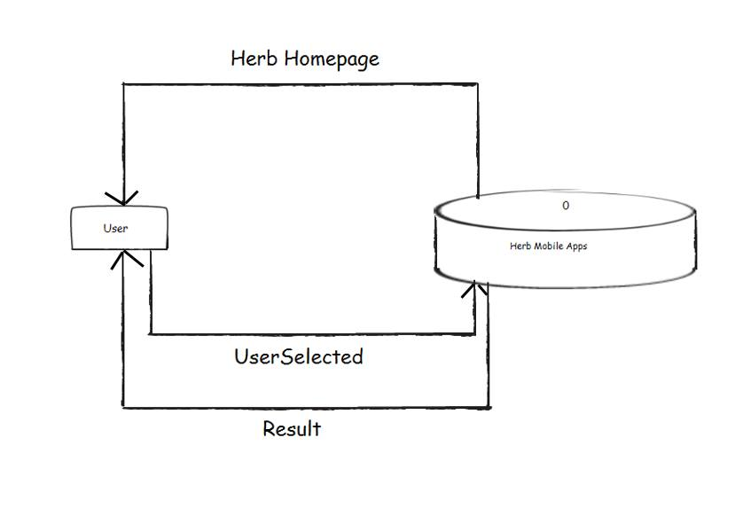

**Figure 2.1: Context Diagram for HMA**

### 2.2 System Interfaces

**Table 2.0: System requirement for HERBAL MOBILE APPS**

|  |  |
| --- | --- |
| HMA-FC-01 | User search herb |
| HMA-FC-02 | User search disease |
| HMA-FC-03 | User can view their herb selection |
| HMA-FC-04 | Admin need to login to access the system |
| HMA-FC-05 | Admin need to add data |
| HMA-FC-06 | Admin need to edit data |
| HMA-FC-07 | Admin need to delete data |

**Table 2.1** List of actor

|  |  |
| --- | --- |
| **Actor** | **Description** |
| User | The user will be able to search for a herbal and disease based on their filtered search options. They can view each type of herbal as well as, any available disease. |
| Admin | The Admin will be able to manage the databases of herbal and disease. |

## 

## 2.3 Product Functions

**Figure 2.2: Use Case Diagram for HMA**

|  |  |
| --- | --- |
| **Use Case** | **Descriptions** |
| Search Herbal Filter | * System allow user to filter desired information about herbal by searching option |
| Search Disease Filter | * System allow user to filter desired information about disease by searching option |
| View Herbal | * Information detail of herbal is shown. |
| Manage Data | * Admin need to add herbal and disease information into the system * Admin edit the current herbal to get new update information about the herbal. |

**Table 2.2** Use Case Description

## 2.4 User Characteristics

## 

1. **Match between system and the real world**

The definition of this heuristic is the system should speak the users' language, with words, phrases and concepts familiar to the user, rather than system-oriented terms. Follow real-world conventions, making information appear in a natural and logical order.

1. **Help users recognize, diagnose, and recover from errors**

Error messages should be expressed in plain language (no codes), precisely indicate the problem, and constructively suggest a solution. In our system the possibility for major error occur is low. The possible error might occur in this system are admin forget to put their information in the edit herb form. For overcome this problem we designed edit button to edit their information.

1. **Error prevention**

Error prevention is one of important heuristics which is explained that even better than good error messages is a careful design which prevents a problem from occurring in the first place. Either eliminate error-prone conditions or check for them and present users with a confirmation option before they commit to the action. Our system provide a confirmation message to confirm that the admin wants to delete the data. It also helps its user to cancel the delete action if they mistakenly clicked the delete button.

1. **Recognition rather than recall**

Minimize the user's memory load by making objects, actions, and options visible. The user should not have to remember information from one part of the dialogue to another. Instructions for use of the system should be visible or easily retrievable whenever appropriate. Our system provide search button for search a particular herb and disease. In case the users forgot to spell the name of that particular herb they can enter the first letter of the herb’s name, system will list down all name start with the letter which the user entered.

.

## 2.5 Constraints

Points below will explain briefly on the constraints which have to be considered during system development process. The constraints stated here are crucial to be taken care of. There are few constraints confronted in order to meet the basic requirement of the system:

* To access the system one must have an internet connection because user need to download the apps in playstore
* To access the application one must have an android platform, not ios platform.
* For the functions to run properly, the internet browser must allow client scripting
* Server must be up and run together with the system for admin.
* Hardware and software must fill the minimum specification to run the system
* The users of the application are not entirely sure what they want or need.

## 2.6 Assumptions and Dependencies

One assumption about the product is that it will always be used on mobile phones that have enough performance. If the phone does not have enough hardware resources available for the application, for example the users might have allocated them with other applications, there may be scenarios where the application does not work as intended or even at all3. SPECIFIC REQUIREMENTS

## 3.1 Software Product Features

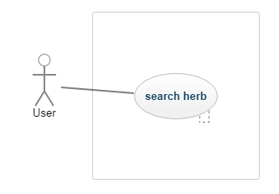

**Figure 3.1:** Use Case for Search Herb.

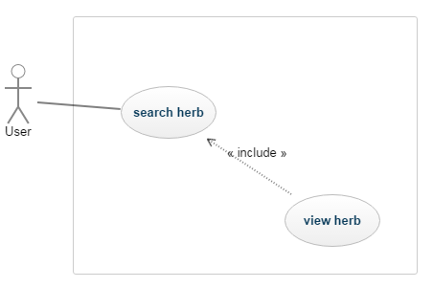

**Figure 3.2:** Decompose Use Case Search Herb

**Table 3.1** Search Herb Use Case Description

|  |  |
| --- | --- |
| **Use Case ID** | HMA-UCD-01 |
| **Brief Description** | Initiated by User and it provided the capability to search the herb |
| **Actor** | User |
| **Pre-Conditions** | User needs to download this apps. |
| **Basic Flow** | User   1. The user input the desired filter for the herb. 2. Available herb will be displayed based on filters. |
| **Alternative Flow** | N/A |
| **Exception Flow** | 1. No available herb based on customer’s search filter. |
| **Post-Conditions** | The system will show the result of the user search filter. |
| **Rules** | N/A |
| **Constraints** | User cannot search any other filters that are not stated in the search filter. |
| **SequenceDiagram** | A-1 : Sequence diagram |

v

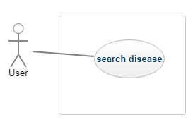

**Figure 3.3:** Use Case for Search Disease.

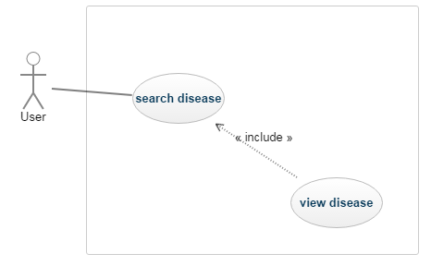

**Figure 3.4:** Decompose Use Case Search Disease

**Table 3.2** Search Disease Use Case Description

|  |  |
| --- | --- |
| **Use Case ID** | HMA-UCD-02 |
| **Brief Description** | Initiated by User and it provided the capability to search the disease |
| **Actor** | User |
| **Pre-Conditions** | User needs to download this apps. |
| **Basic Flow** | User  1. The user input the desired filter for the disease.  2. Available disease will be displayed based on filters. |
| **Alternative Flow** | N/A |
| **Exception Flow** | 1. No available disease based on customer’s search filter. |
| **Post-Conditions** | The system will show the result of the user search filter. |
| **Rules** | N/A |
| **Constraints** | User cannot search any other filters that are not stated in the search filter. |
| **SequenceDiagram** | A-2 : Sequence diagram |

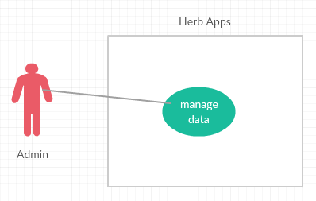

v

**Figure 3.5:** Use Case for Manage Data.

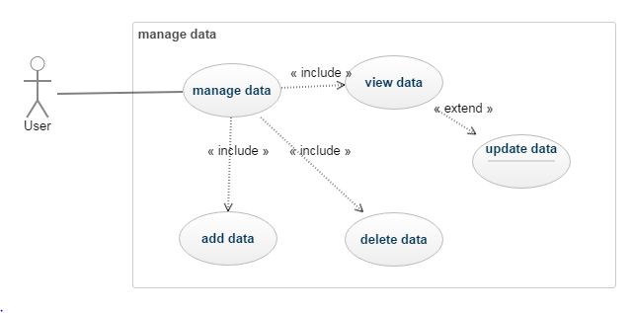

v

**Figure 3.6:** Decompose Use Case Manage Data

**Table 3.3** Manage Data

|  |  |
| --- | --- |
| **Use Case ID** | HMS-UCD-03 |
| **Brief Description** | Initiated by the Admin. It provided the capability to add, edit and delete the data from database |
| **Actor** | Admin |
| **Pre-Conditions** | Admin must login into the system. |
| **Basic Flow** | Admin  1. Admin launches the login screen.  2. enters a combination of username and password.  3. System validates until successfully.  4. After admin login into the system, admin able to add and edit current data.   1. Admin insert data information into the form given before edit current data. 2. Admin able to edit the data either admin want to update or delete the data. 3. Admin must logout from the system using logout button provided. |
| **Alternative Flow** | 1. A.3. System validation of the username/password combination fails due to incorrect entry. 2. A.4. Systems asks the user to re-enter the username/password combination. 3. A.5. Go back to basic flow 2. |
| **Exception Flow** | B.3. System validation finds that the user record does not exist in the database.  B.4. Systems alerts the user that their record does not exist.  B.5. Use case ends. |
| **Post-Conditions** | Admin access the system |
| **Rules** | N/A |
| **Constraints** | Must have an internet connection. |
| **Sequence Diagram** | Refer Appendix  A-3 : Sequence diagram |

## 3.2 User Interfaces Requirements

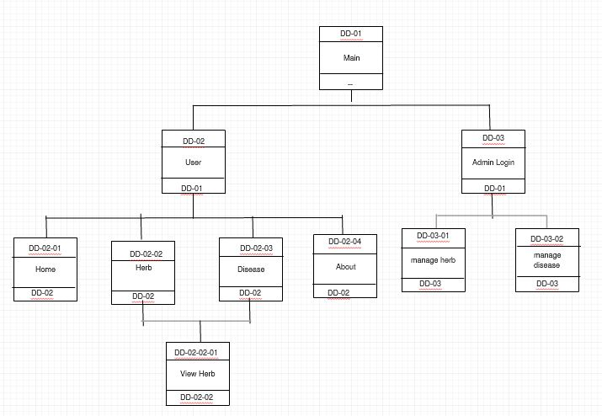3.2.1 Graphical User Interface

**Figure 3.7: Dialogue Diagram for HMA**

**Table 3.5 Description of user interface components**

|  |  |  |
| --- | --- | --- |
| **User Interface Name or Number** | **Description** | **User Interface Layout** |
| Home Page | This homepage provide interface such as page home, herb , disease and about. | Refer Appendix B-1 |
| Search Herb | When user type a certain herb in textfield,it will filter and system will show their result. | Refer Appendix B-2 |
| Search Disease | When user type a certain disease in textfield,it will filter and system will show their result. | Refer Appendix B-3 |
| Herb Page | This page provide user with contain of information herbal that will cure a disease. | Refer Appendix B-4 |
| Admin Login | This page only allow admin to access this site | Refer Appendix B-5 |
| Admin Site | This page only allow admin to access this site | Refer Appendix B-6 |
| Add Data | Dialog Bootstrap Modal will come out when admin click add button. | Refer Appendix B-7 |
| Edit Data | Dialog Bootstrap Modal will come out when admin click edit button | Refer Appendix B-8 |
| Delete Data | Alert box will prompt when admin click the delete button | Refer Appendix B-9 |

3.2.2 Hardware Interface

- mobile phone ( android platform)

3.2.3 Software Interface

The table below indicates all the software that will be used to build the Herbal Mobile Apps (HMA).

|  |  |
| --- | --- |
| **Software** | **Purpose** |
| Microsoft Windows Operating System  • Windows 7 Professional | • As a platform for a system to run  • Operating system which will be used to develop the system |
| Microsoft Office  • Microsoft Word 2007 & 2010  • Microsoft Project 2007  • Microsoft Visio 2010 | • Prepare proposal and documentation  • Create Gantt Chart  • Design and draw chart and diagram |
| Relational Software Architect | • Design and draw use case and sequence diagram |
| Phonegap Cordova, Sublime 3,  Adobe Photoshop, Node Js | • Design interface and generate coding |
| MySQL, PHP myadmin, Cpanel | • Database for the system; generate database, database management and database platform |
| WinRAR | • Compress project files |
| Angular Js 1 | • Front end MVVM Framework |

**Table 3.6** Software Interface

**3.3 Requirements Traceability**

|  |  |  |  |  |  |  |  |  |  |  |
| --- | --- | --- | --- | --- | --- | --- | --- | --- | --- | --- |
| Dialog Diagram  Requirement Id | DD-01 | DD-02 | DD-03 | DD-02-01 | DD-02-02 | DD-02-03 | DD-02-04 | DD-02-02-01 | DD-03-01 | DD-03-02 |
| HMA-FC-01 |  |  |  |  |  |  |  |  |  |  |
| HMA-FC-02 |  |  |  |  |  |  |  |  |  |  |
| HMA-FC-03 |  |  |  |  |  |  |  |  |  |  |
| HMA-FC-04 |  |  |  |  |  |  |  |  |  |  |
| HMA-FC-05 |  |  |  |  |  |  |  |  |  |  |
| HMA-FC-06 |  |  |  |  |  |  |  |  |  |  |
| HMA-FC-07 |  |  |  |  |  |  |  |  |  |  |

**Table 3.8: Traceability matrix for a**

|  |  |  |  |
| --- | --- | --- | --- |
| Use case Diagram  Requirement Id | HMA-UCD-01 | HMA-UCD-02 | HMA-UCD-03 |
| HMA-FC-01 |  |  |  |
| HMA-FC-02 |  |  |  |
| HMA-FC-03 |  |  |  |
| HMA-FC-04 |  |  |  |
| HMA-FC-05 |  |  |  |
| HMA-FC-06 |  |  |  |
| HMA-FC-07 |  |  |  |

**Table 3.9: Traceability matrix for Requirement and Use Case**

4. ACRONYMS AND ABBREVIATION

Table 4.1 shows the acronyms and abbreviation when preparing this software requirement specifications.

**Table 4.1** Acronyms and Abbreviations

|  |  |
| --- | --- |
| **Term** | **Definition** |
| SRS | Software Requirement Specification |
| HMA | Herbal Mobile Apps |
| DD | Dialogue Diagram |
| FRC | Functional Requirement for Customer |
| FSH | Functional Requirement for Search Herb |
| FSD | Functional Requirement for Search Disease |
| FMD | Functional Requirement for Manage Data |
| SQL | Structure Query Language |
| UCD | Use Case Diagram |

**APPENDIX A**

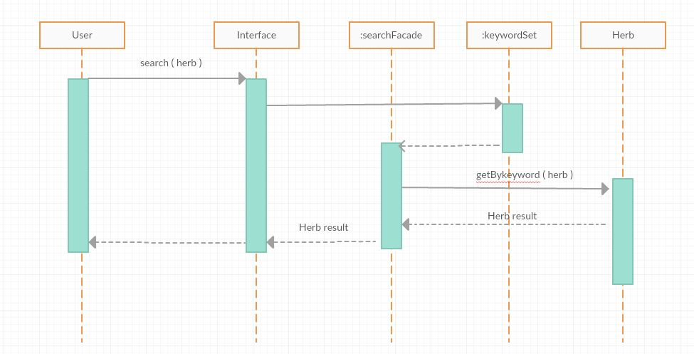**Sequence diagram**

**Appendix A-1** Search Herb

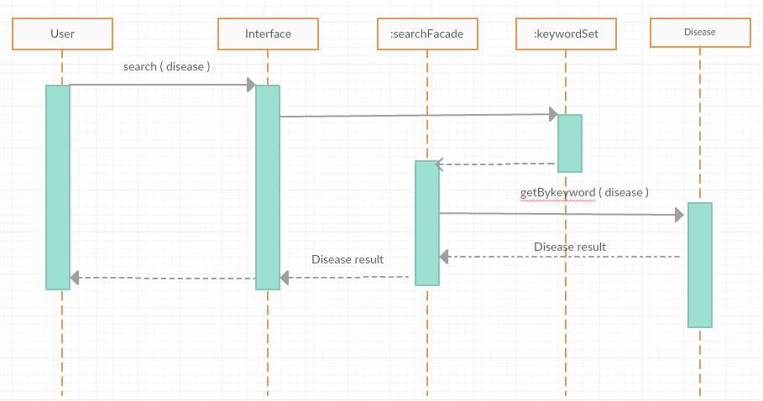

**Appendix A-2** Search Disease

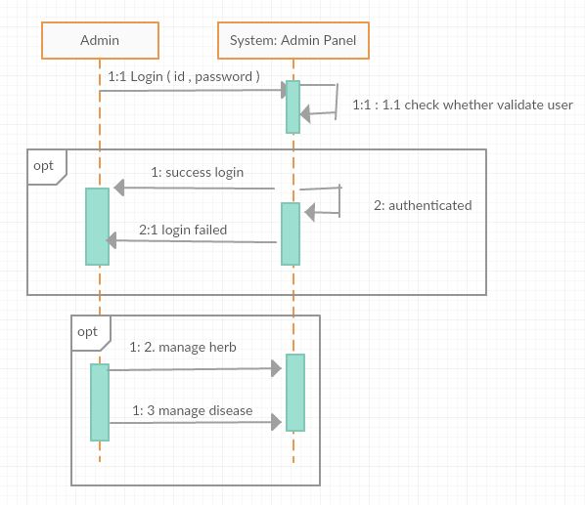

**Appendix A-3** Manage Data

**APPENDIX B**

**User interface**

Navigation menu

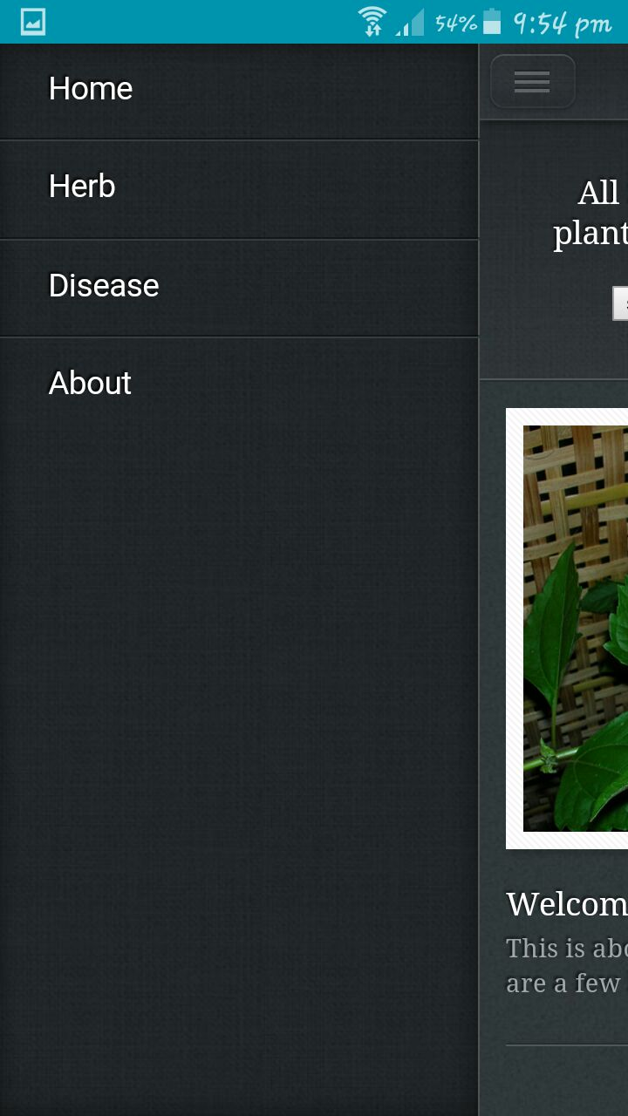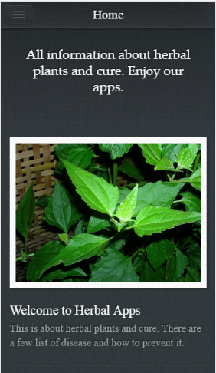

**Appendix B-1** Homepage

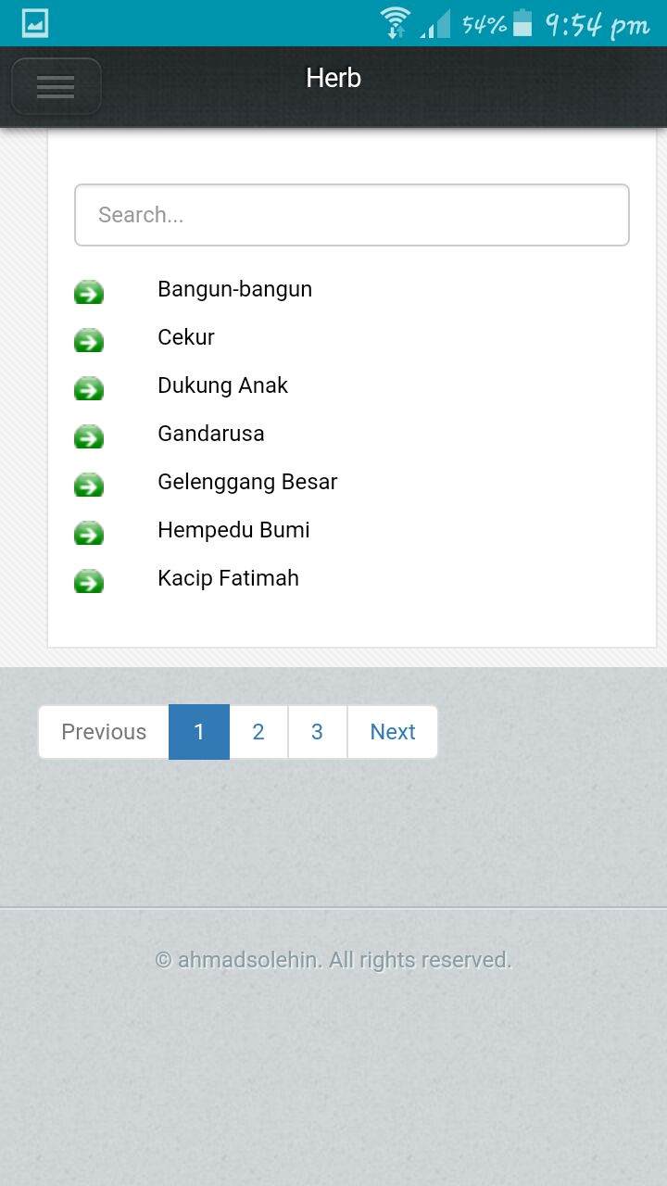

**Appendix B-2** Search Herb

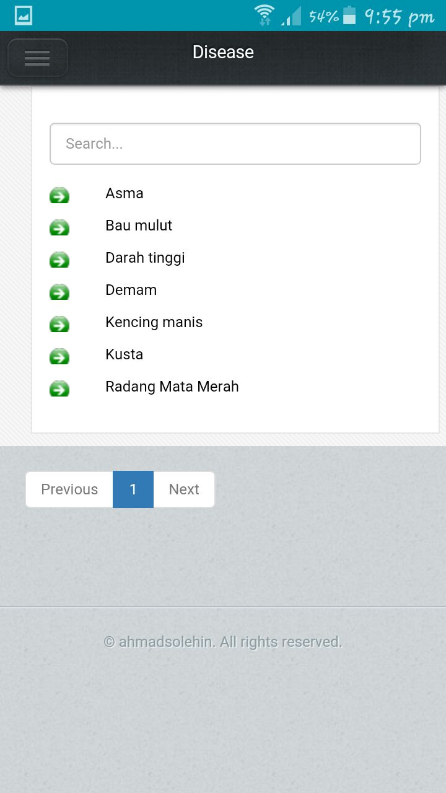

**Appendix B-3** Search Disease

**Appendix B-4** View Herb

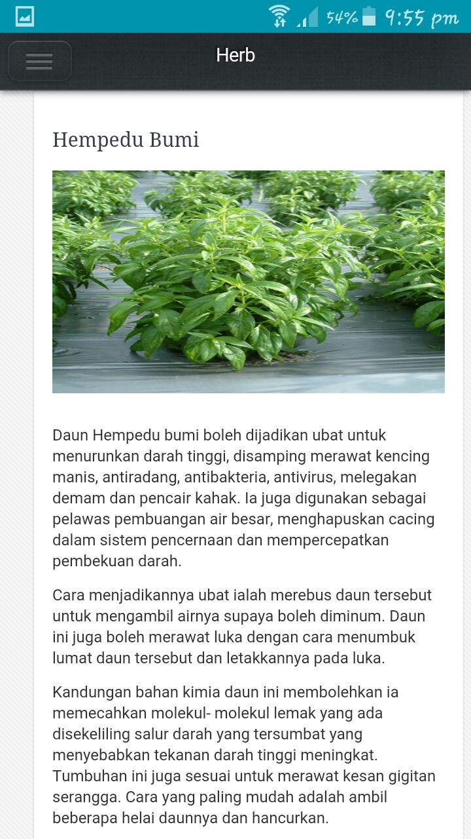

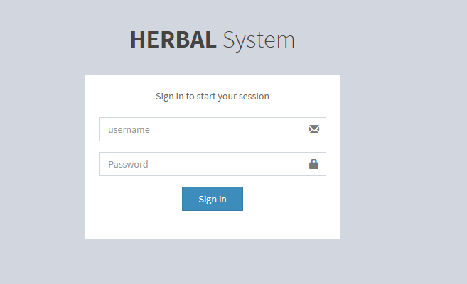

**Appendix B-5** Admin Login

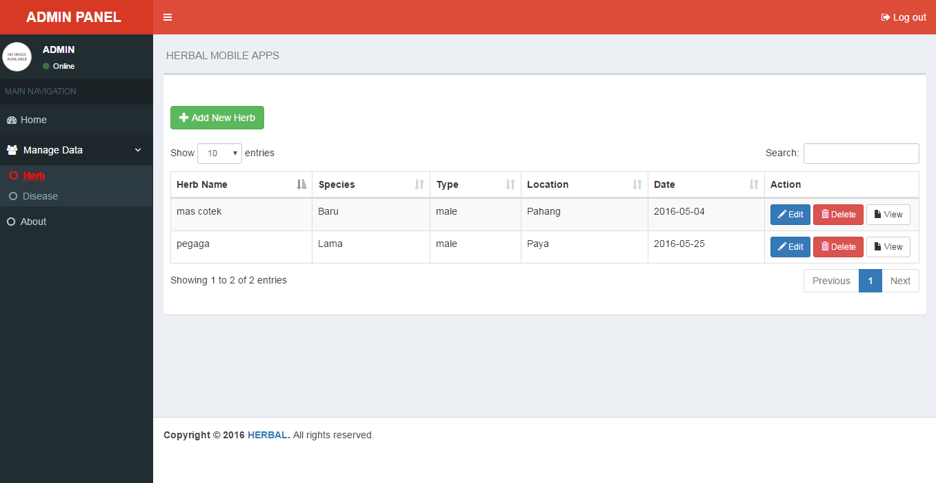

**Appendix B-6** Admin Site

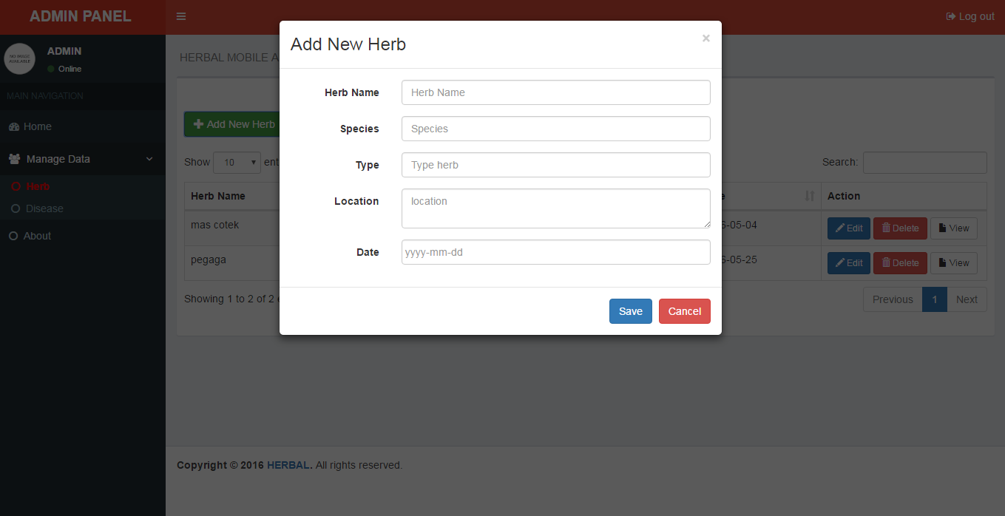

**Appendix B-7** Add data

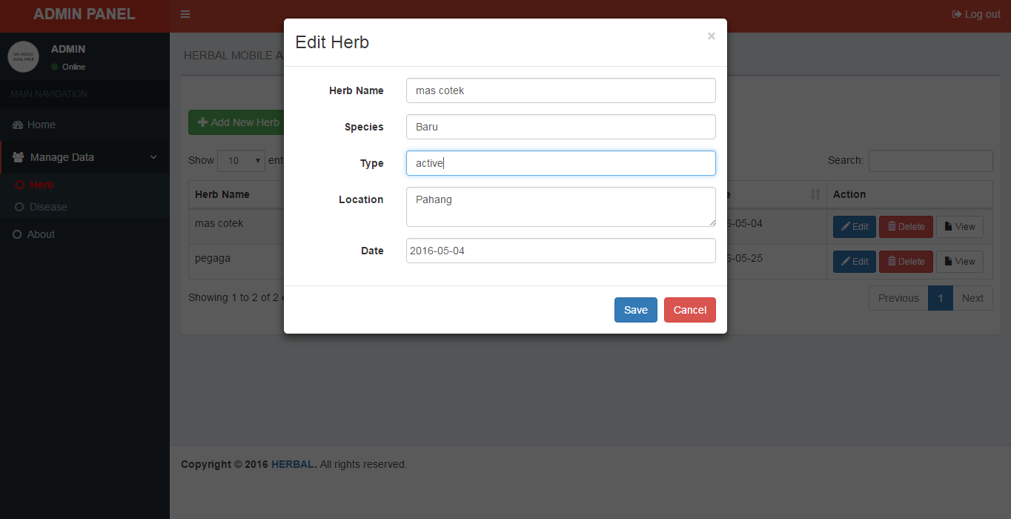

**Appendix B-8** Edit data

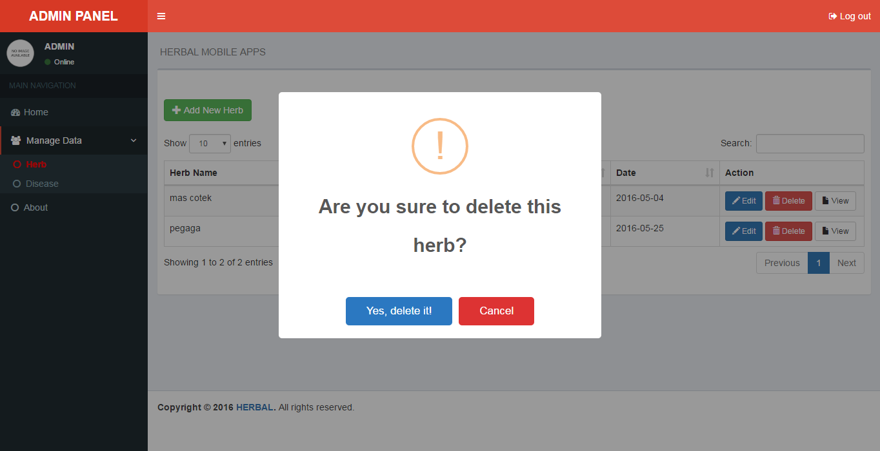

**Appendix B-9** Delete data

**APPENDIX C**

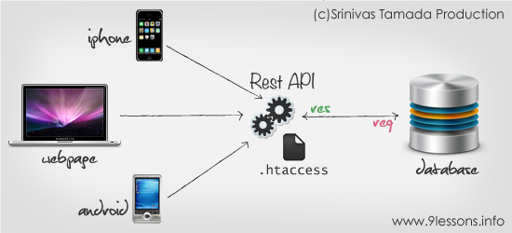**Photo**

**Appendix C-1** Example of REST API Flow

1.
2.
3.
4.
5.
6.
7.
8.
9.
10.
11.