

**BCS 3323 SOFTWARE TESTING & MAINTENANCE**

**LAB 5**

**NAME : SIVAPRIYAN A/L S KUMMAR CB14094**

**: KISHEN KUMAR A/L ARAGENNAN CB14099**

**SECTION : 01 / 01 A**

**SUBJECT** : **SOFTWARE TESTING & MAINTENANCE**

**LECTURER NAME : ABDULRAHMAN AL-SEWARI**

**flt file**

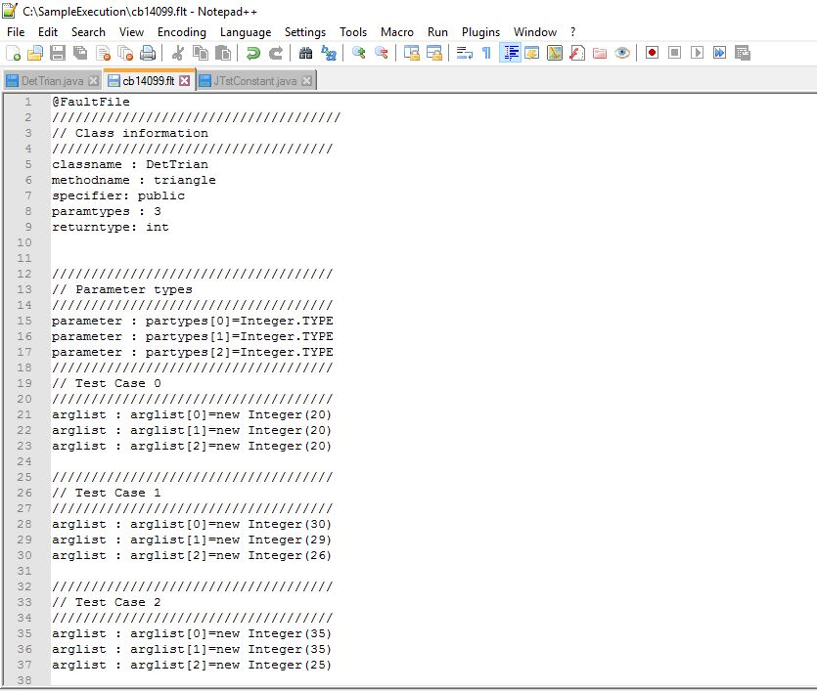

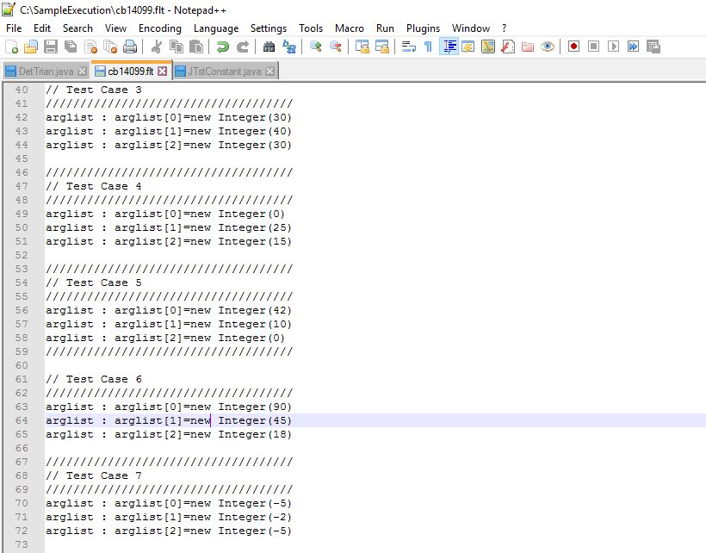

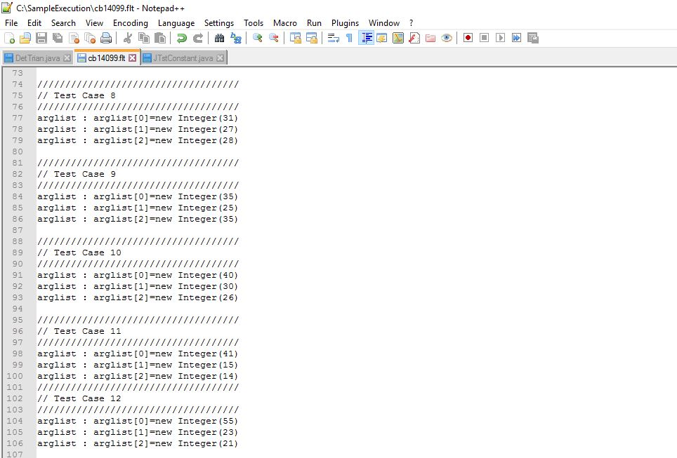

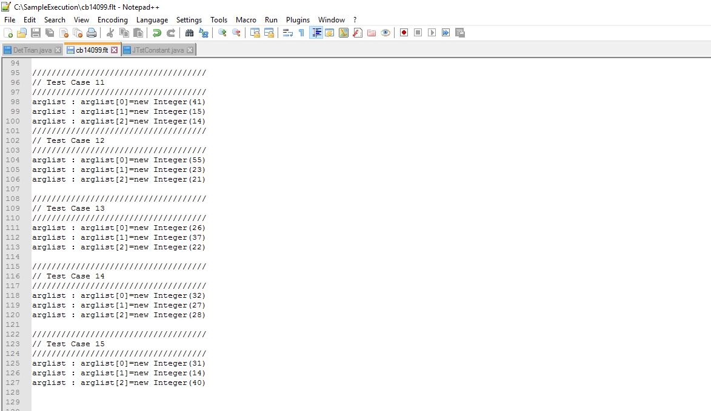

Cmd

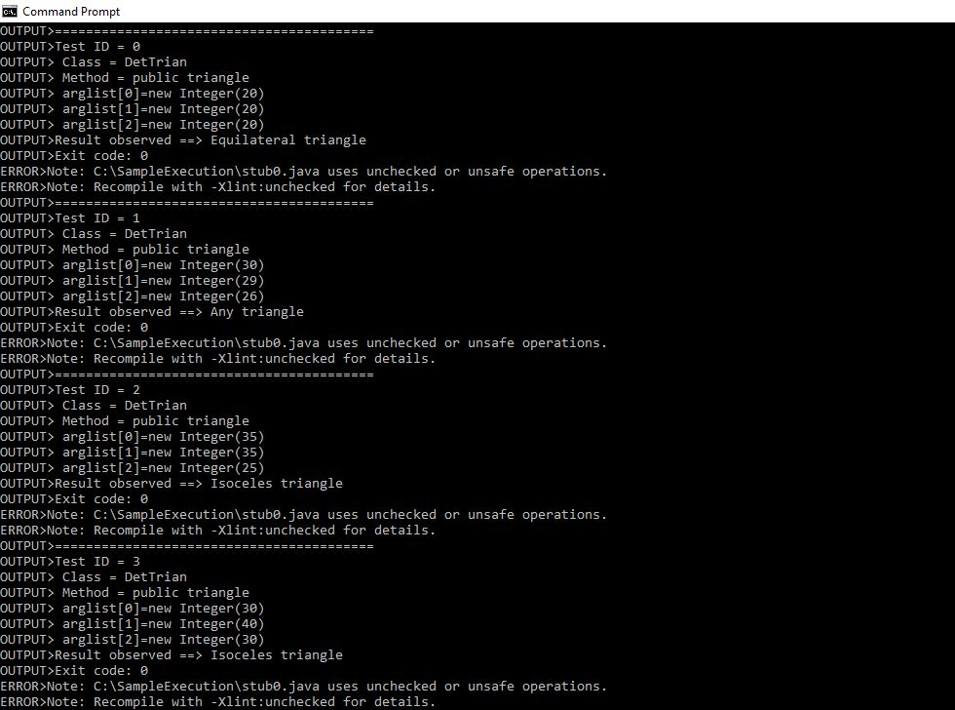

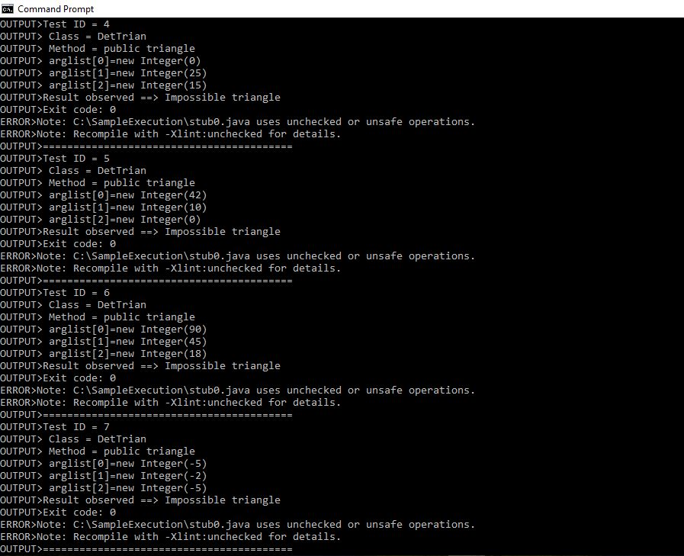

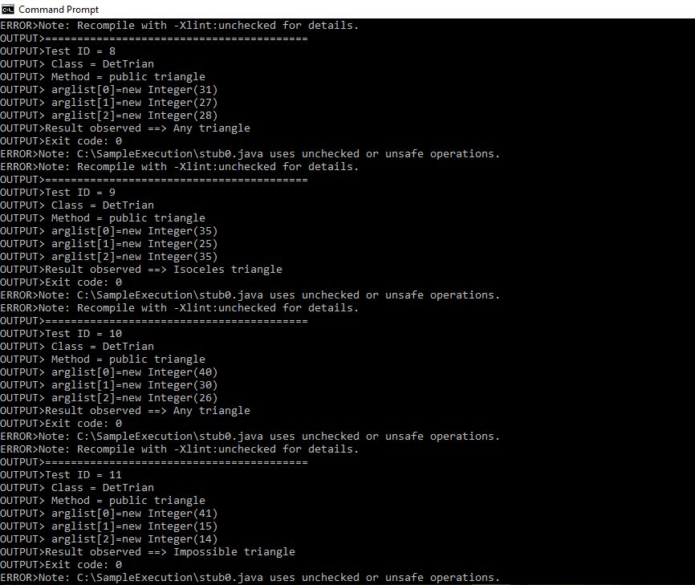

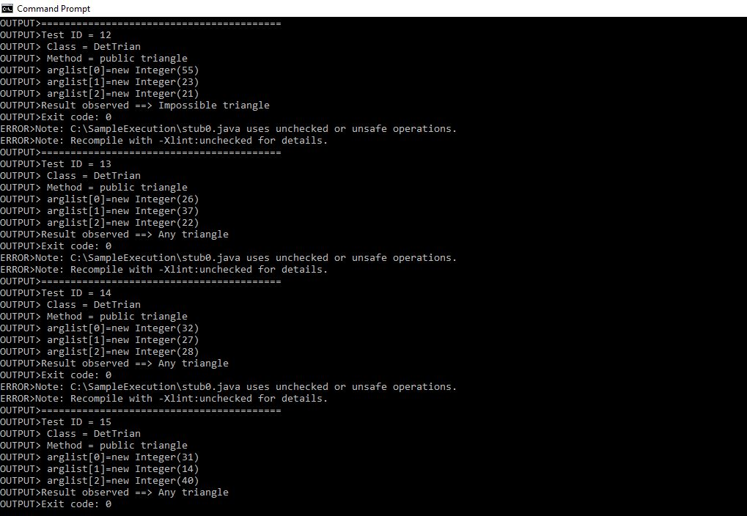

OUTPUT

