

**BCS3323 SOFTWARE TESTING & MAINTENANCE**

**SEMESTER I SESSION 2016/2017**

**LAB 5**

**PREPARED FOR:**

**DR. ABDULRAHMAN AHMED AL-SEWARI**

**PREPARED BY:**

|  |  |  |
| --- | --- | --- |
| **TESTER ID** | **NAME** | **MATRIC NO** |
| **TS03** | **CHAVALIT TAT WI** | **CB14144** |

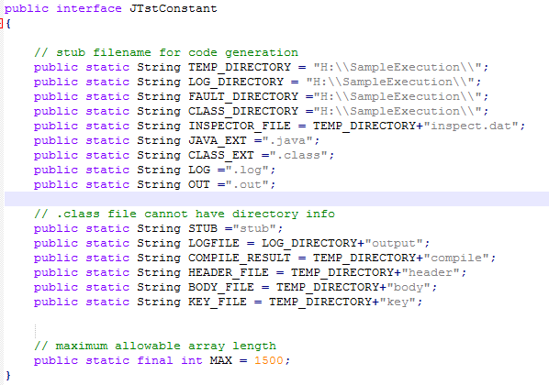

@FaultFile

/////////////////////////////////////

// Class information

////////////////////////////////////

classname : DetTrian

methodname : triangle

specifier: public

paramtypes : 3

returntype: String

////////////////////////////////////

// Parameter types

////////////////////////////////////

parameter : partypes[0]=Integer.TYPE

parameter : partypes[1]=Integer.TYPE

parameter : partypes[2]=Integer.TYPE

////////////////////////////////////

// Test Case 0

////////////////////////////////////

arglist : arglist[0]=new Integer(0)

arglist : arglist[1]=new Integer(10)

arglist : arglist[2]=new Integer(10)

////////////////////////////////////

// Test Case 1

////////////////////////////////////

arglist : arglist[0]=new Integer(11)

arglist : arglist[1]=new Integer(-5)

arglist : arglist[2]=new Integer(50)

////////////////////////////////////

// Test Case 2

////////////////////////////////////

arglist : arglist[0]=new Integer(12)

arglist : arglist[1]=new Integer(35)

arglist : arglist[2]=new Integer(37)

////////////////////////////////////

// Test Case 3

////////////////////////////////////

arglist : arglist[0]=new Integer(12)

arglist : arglist[1]=new Integer(12)

arglist : arglist[2]=new Integer(10)

////////////////////////////////////

// Test Case 4

////////////////////////////////////

arglist : arglist[0]=new Integer(12)

arglist : arglist[1]=new Integer(12)

arglist : arglist[2]=new Integer(12)

////////////////////////////////////

// Test Case 5

////////////////////////////////////

arglist : arglist[0]=new Integer(7)

arglist : arglist[1]=new Integer(-7)

arglist : arglist[2]=new Integer(21)

////////////////////////////////////

// Test Case 6

////////////////////////////////////

arglist : arglist[0]=new Integer(9)

arglist : arglist[1]=new Integer(-6)

arglist : arglist[2]=new Integer(32)

////////////////////////////////////

// Test Case 7

////////////////////////////////////

arglist : arglist[0]=new Integer(-5)

arglist : arglist[1]=new Integer(20)

arglist : arglist[2]=new Integer(30)

////////////////////////////////////

// Test Case 8

////////////////////////////////////

arglist : arglist[0]=new Integer(27)

arglist : arglist[1]=new Integer(27)

arglist : arglist[2]=new Integer(60)

////////////////////////////////////

// Test Case 9

////////////////////////////////////

arglist : arglist[0]=new Integer(19)

arglist : arglist[1]=new Integer(20)

arglist : arglist[2]=new Integer(90)

////////////////////////////////////

// Test Case 10

////////////////////////////////////

arglist : arglist[0]=new Integer(20)

arglist : arglist[1]=new Integer(20)

arglist : arglist[2]=new Integer(20)

////////////////////////////////////

// Test Case 11

////////////////////////////////////

arglist : arglist[0]=new Integer(-9)

arglist : arglist[1]=new Integer(10)

arglist : arglist[2]=new Integer(10)

////////////////////////////////////

// Test Case 12

////////////////////////////////////

arglist : arglist[0]=new Integer(15)

arglist : arglist[1]=new Integer(30)

arglist : arglist[2]=new Integer(40)

////////////////////////////////////

// Test Case 13

////////////////////////////////////

arglist : arglist[0]=new Integer(20)

arglist : arglist[1]=new Integer(25)

arglist : arglist[2]=new Integer(20)

////////////////////////////////////

// Test Case 14

////////////////////////////////////

arglist : arglist[0]=new Integer(11)

arglist : arglist[1]=new Integer(37)

arglist : arglist[2]=new Integer(100)

////////////////////////////////////

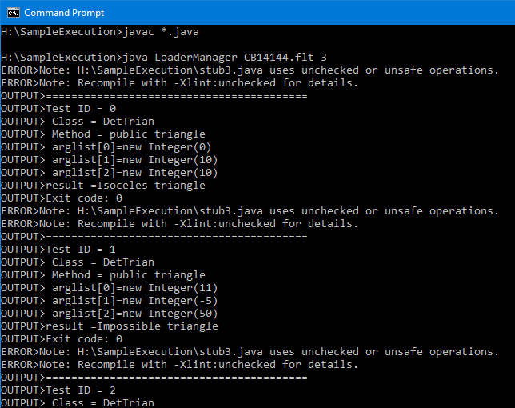

**Command Prompt Output**

**C:\Users\Chava>cd\**

**C:\>h:**

**H:\>cd SampleExecution**

**H:\SampleExecution>dir**

**H:\SampleExecution>javac *.java**

**H:\SampleExecution>java LoaderManager CB14144.flt 3**

ERROR>Note: H:\SampleExecution\stub3.java uses unchecked or unsafe operations.

ERROR>Note: Recompile with -Xlint:unchecked for details.

OUTPUT>=========================================

OUTPUT>Test ID = 0

OUTPUT> Class = DetTrian

OUTPUT> Method = public triangle

OUTPUT> arglist[0]=new Integer(0)

OUTPUT> arglist[1]=new Integer(10)

OUTPUT> arglist[2]=new Integer(10)

OUTPUT>result =Isoceles triangle

OUTPUT>Exit code: 0

ERROR>Note: H:\SampleExecution\stub3.java uses unchecked or unsafe operations.

ERROR>Note: Recompile with -Xlint:unchecked for details.

OUTPUT>=========================================

OUTPUT>Test ID = 1

OUTPUT> Class = DetTrian

OUTPUT> Method = public triangle

OUTPUT> arglist[0]=new Integer(11)

OUTPUT> arglist[1]=new Integer(-5)

OUTPUT> arglist[2]=new Integer(50)

OUTPUT>result =Impossible triangle

OUTPUT>Exit code: 0

ERROR>Note: H:\SampleExecution\stub3.java uses unchecked or unsafe operations.

ERROR>Note: Recompile with -Xlint:unchecked for details.

OUTPUT>=========================================

OUTPUT>Test ID = 2

OUTPUT> Class = DetTrian

OUTPUT> Method = public triangle

OUTPUT> arglist[0]=new Integer(12)

OUTPUT> arglist[1]=new Integer(35)

OUTPUT> arglist[2]=new Integer(37)

OUTPUT>result =Rightangled triangle

OUTPUT>Exit code: 0

ERROR>Note: H:\SampleExecution\stub3.java uses unchecked or unsafe operations.

ERROR>Note: Recompile with -Xlint:unchecked for details.

OUTPUT>=========================================

OUTPUT>Test ID = 3

OUTPUT> Class = DetTrian

OUTPUT> Method = public triangle

OUTPUT> arglist[0]=new Integer(12)

OUTPUT> arglist[1]=new Integer(12)

OUTPUT> arglist[2]=new Integer(10)

OUTPUT>result =Isoceles triangle

OUTPUT>Exit code: 0

ERROR>Note: H:\SampleExecution\stub3.java uses unchecked or unsafe operations.

ERROR>Note: Recompile with -Xlint:unchecked for details.

OUTPUT>=========================================

OUTPUT>Test ID = 4

OUTPUT> Class = DetTrian

OUTPUT> Method = public triangle

OUTPUT> arglist[0]=new Integer(12)

OUTPUT> arglist[1]=new Integer(12)

OUTPUT> arglist[2]=new Integer(12)

OUTPUT>result =Equilateral triangle

OUTPUT>Exit code: 0

ERROR>Note: H:\SampleExecution\stub3.java uses unchecked or unsafe operations.

ERROR>Note: Recompile with -Xlint:unchecked for details.

OUTPUT>=========================================

OUTPUT>Test ID = 5

OUTPUT> Class = DetTrian

OUTPUT> Method = public triangle

OUTPUT> arglist[0]=new Integer(7)

OUTPUT> arglist[1]=new Integer(-7)

OUTPUT> arglist[2]=new Integer(21)

OUTPUT>result =Impossible triangle

OUTPUT>Exit code: 0

ERROR>Note: H:\SampleExecution\stub3.java uses unchecked or unsafe operations.

ERROR>Note: Recompile with -Xlint:unchecked for details.

OUTPUT>=========================================

OUTPUT>Test ID = 6

OUTPUT> Class = DetTrian

OUTPUT> Method = public triangle

OUTPUT> arglist[0]=new Integer(9)

OUTPUT> arglist[1]=new Integer(-6)

OUTPUT> arglist[2]=new Integer(32)

OUTPUT>Exit code: 0

OUTPUT>result =Impossible triangle

ERROR>Note: H:\SampleExecution\stub3.java uses unchecked or unsafe operations.

ERROR>Note: Recompile with -Xlint:unchecked for details.

OUTPUT>=========================================

OUTPUT>Test ID = 7

OUTPUT> Class = DetTrian

OUTPUT> Method = public triangle

OUTPUT> arglist[0]=new Integer(-5)

OUTPUT> arglist[1]=new Integer(20)

OUTPUT> arglist[2]=new Integer(30)

OUTPUT>Exit code: 0

OUTPUT>result =Impossible triangle

ERROR>Note: H:\SampleExecution\stub3.java uses unchecked or unsafe operations.

ERROR>Note: Recompile with -Xlint:unchecked for details.

OUTPUT>=========================================

OUTPUT>Test ID = 8

OUTPUT> Class = DetTrian

OUTPUT> Method = public triangle

OUTPUT> arglist[0]=new Integer(27)

OUTPUT> arglist[1]=new Integer(27)

OUTPUT> arglist[2]=new Integer(60)

OUTPUT>result =Impossible triangle

OUTPUT>Exit code: 0

ERROR>Note: H:\SampleExecution\stub3.java uses unchecked or unsafe operations.

ERROR>Note: Recompile with -Xlint:unchecked for details.

OUTPUT>=========================================

OUTPUT>Test ID = 9

OUTPUT> Class = DetTrian

OUTPUT> Method = public triangle

OUTPUT> arglist[0]=new Integer(19)

OUTPUT> arglist[1]=new Integer(20)

OUTPUT> arglist[2]=new Integer(90)

OUTPUT>result =Impossible triangle

OUTPUT>Exit code: 0

ERROR>Note: H:\SampleExecution\stub3.java uses unchecked or unsafe operations.

ERROR>Note: Recompile with -Xlint:unchecked for details.

OUTPUT>=========================================

OUTPUT>Test ID = 10

OUTPUT> Class = DetTrian

OUTPUT> Method = public triangle

OUTPUT> arglist[0]=new Integer(20)

OUTPUT> arglist[1]=new Integer(20)

OUTPUT> arglist[2]=new Integer(20)

OUTPUT>result =Equilateral triangle

OUTPUT>Exit code: 0

ERROR>Note: H:\SampleExecution\stub3.java uses unchecked or unsafe operations.

ERROR>Note: Recompile with -Xlint:unchecked for details.

OUTPUT>=========================================

OUTPUT>Test ID = 11

OUTPUT> Class = DetTrian

OUTPUT> Method = public triangle

OUTPUT> arglist[0]=new Integer(-9)

OUTPUT> arglist[1]=new Integer(10)

OUTPUT> arglist[2]=new Integer(10)

OUTPUT>Exit code: 0

OUTPUT>result =Impossible triangle

ERROR>Note: H:\SampleExecution\stub3.java uses unchecked or unsafe operations.

ERROR>Note: Recompile with -Xlint:unchecked for details.

OUTPUT>=========================================

OUTPUT>Test ID = 12

OUTPUT> Class = DetTrian

OUTPUT> Method = public triangle

OUTPUT> arglist[0]=new Integer(15)

OUTPUT> arglist[1]=new Integer(30)

OUTPUT> arglist[2]=new Integer(40)

OUTPUT>result =Any triangle

OUTPUT>Exit code: 0

ERROR>Note: H:\SampleExecution\stub3.java uses unchecked or unsafe operations.

ERROR>Note: Recompile with -Xlint:unchecked for details.

OUTPUT>=========================================

OUTPUT>Test ID = 13

OUTPUT> Class = DetTrian

OUTPUT> Method = public triangle

OUTPUT> arglist[0]=new Integer(20)

OUTPUT> arglist[1]=new Integer(25)

OUTPUT>Exit code: 0

OUTPUT> arglist[2]=new Integer(20)

OUTPUT>result =Isoceles triangle

ERROR>Note: H:\SampleExecution\stub3.java uses unchecked or unsafe operations.

ERROR>Note: Recompile with -Xlint:unchecked for details.

OUTPUT>=========================================

OUTPUT>Test ID = 14

OUTPUT> Class = DetTrian

OUTPUT> Method = public triangle

OUTPUT> arglist[0]=new Integer(11)

OUTPUT> arglist[1]=new Integer(37)

OUTPUT> arglist[2]=new Integer(100)

OUTPUT>result =Impossible triangle

OUTPUT>Exit code: 0

H:\SampleExecution>