Version 1.0

Prepared for:
********

Table of Contents

- Document Purpose

- Client Brief

- Objective

- Scope of Work

- Administrative Panel

- Standardizations

- Technology & Performance

- Process Flow

- Requirements from Client

- Commitment

- Location of Work

- Progress Reporting and Communication

- Engagement Model
- Document Purpose

This is the proposal document for Ahmad Solehin ( freelance software developer )service offering in the website design and development and custom web application development space. The document details our understanding of the brief, the objectives of the services suite, the methodology, deliverables and commercials.

- Client Brief

Client desires to develop an corporate ecommerce website

- Customers will be able to login/register into the website.

- Customers will be able to create an account after submitting their email id, name, address, etc on the website.

- Customers will also be able to easily search for products by using different keywords like

name, category wise etc and will be able to refine their results by using filters such as price, product type etc. on the website.

- Customers will be able to view the products with details, images, zoom in option etc. on the website.

- Customers will have the ability to customize their products by submitting the information on the website.

- Customers can view the events posted by the admin on the website.

- Customers can submit their reviews on the products listed on the website.

- Customers will be able to place orders on the website.

- Customers will be able to check their order status on the website.

- Customers will be able to use the facility of shopping cart on the website.

- Customers will be able to make payments for their orders by using integrated payment gateway given by the Client.

- Customers will be able to choose their mode of shipping using integrated shipping gateway on the website.

- Customers will be able to view the shipping details on the website.

- Customers will be able to provide delivery address for each order made on the website.

- Customers will be able to receive an email for confirmation after an order placed on the website.

- Customers will be able to receive newsletter after submitting their name and email id on the website and this section will be managed by admin.

- Customers will be able to share the link of the website on the social networking website like facebook, twitter etc.

- Customers will be able to view FAQ on the website.

- Admin will be able to manage the customers, products, orders etc on the website from the backend.

- Provide the basic pages (i.e., about us, Contact Us, FAQ, help) for company information.

3. Objective

With a rich and varied experience in providing software development, project management capabilities and stringent quality standards ensure to develop solutions that give your business an edge over your competitors. We are experts at developing and implementing applications for mission-critical and enterprise-wide projects. We specialize in webbased and apps wherein we undertake designing, development, maintenance and promotion of Web Sites coupled with any other Web Applications. With our resource pool of experienced professionals coupled with state-of-the-art technology and industry best practices, it is our vision to make our customers the best in the industry offering best of the breed solutions.

4.Scope of Work

Page Templates

- Design Templates

- User Visibility research and Layout Engineering

- Logos

Template Layout
Banner

- Size according to specifications

- Logo Placement

- Text

- Graphics

User Visibility Content

- Information bar

- Menu Bar

- Tool bar

- Side Bar

- Header and Footer

- Text and Graphics

Design Specifications

Design tools and technologies The design and layout of the application will be SEO friendly constructed using Bootstrap CSS and HTML along with use of AJAX and keeping in mind the latest web 2.0 trends. The application upon completion will be integrated with Google analytics for keeping an eye on the statistics of the site. It will carry tell a friend and printer friendly version at all pages. To help people bookmark the site easily; add this widget will be embedded at the top of the homepage.

Front End

The front end will have following features:-

Header Pages

- Home

- Login/Sign up

- Search

- About Us
Footer Pages

- Contact Us

- Sitemap

- Terms and Conditions

- Privacy Policy

- FAQ

Website Content Page

- Home

- My Account Control Panel for Customers

- Search

- Advanced Search

- Products

- Products Catalog

- Products Information

- Customize

- Reviews

- Events

- Shopping Cart

- Check Out

- Shipping

- Payments

- Social Media Integration

- Newsletters

- Contact Us
- FAQ

Customer Registration

This is the section where customer will be able to register t o the site as member. Once customer shows interest and wants to get an account then he will be taken to a page where he will be asked to submit a form that would have various fields for the customer to enter their personal details creating a profile of their own. They will be able to submit captcha at the time of registration. This customer will automatically be assigned the account manager role for this particular account.

Existing Customer

After the account is activated the customer will be able to perform the following basic tasks in account settings:

- Customers would be able to Login

- Customers would be able to view their account after successful Login.

- Customers would be able to add/edit/delete all their details.

- Customers would be able to request for their user name in case they forgets their user name Login (Details will be mailed to the Customer)

- Customers would be able to request for their password in case they forgets their password (Login Details will be mailed to the Customer)

- Customers would be able to change the password (Login Details will be mailed to the Customer)

Function of Customers

- Customers will be able to login/register into the website.

- Customers will be able to create an account after submitting their email id, nam e, address, etc on the website.

- Customers will also be able to easily search for products by using different keywords like name, category wise etc and will be able to refine their results by using filters such as price, product type etc. on the website.

- Customers will be able to view the products with details, images, zoom in option etc. on the website.
- Customers will have the ability to customize their products by submitting the information on the website.

- Customers can view the events posted by the admin on the website.

- Customers can submit their reviews on the products listed on the website.

- Customers will be able to place orders on the website.

- Customers will be able to check their order status on the website.

- Customers will be able to use the facility of shopping cart on the website.

- Customers will be able to make payments for their orders by using integrated payment gateway given by the Client.

- Customers will be able to choose their mode of shipping using integrated shipping gat eway on the website.

- Customers will be able to view the shipping details on the website.

- Customers will be able to provide delivery address for each order made on the website.

- Customers will be able to receive an email for confirmation after an order placed on the website.

- Customers will be able to receive newsletter after submitting their name and email id on the website and this section will be managed by admin.

- Customers will be able to share the link of the website on the social networking website like facebook, twitter etc.

- Customers will be able to view FAQ on the website.

My Account Control Panel for Customers
Customers will be able to operate a host of functions from their

Account control panel. The control panel will carry the following modules:

My Details

- Customers can fill in details about them

- Customers can change any information anytime

- My Orders

- Customers can check status of their instant orders
- Customers can check past purchases

- Customers can print the orders

- Customers can review active orders

- Payments

- Customers can view all their old payment transactions

- Customers can make payment for new orders

Search

Customers will also be able to easily search for products by using different keywords like name, category etc and will be able to refine their results by using filters such as price etc. on the website. They will be able to view list of content that match to their searched criteria.

Advanced Search

In this section customers will be able to customize the search based on their choice. Customers will be able to select preference and will be able to view the list that matches with their searched criteria

Products

Products will also be sorted according to the categories and sub categories. Once a category is selected all the products will come out listed along with the image and other necessary details. If a customer clicks on the product he will be taken to a page where the complete details about the product is listed. They can view different images of the particular product, read specifications about it and can add that product to the shopping cart. Admin will be able to manage this section from the backend.

Products Catalog

The site will have the following categories and sub categories listed which will be modifiable form the back end.

- Product image

- Price

- Specifications

- Ratings
- Add to cart

Products Information

Products page will carry information about the product being displayed. The page will carry:

- Product information

- Product images

- Product Price

- View Full Size

- Zoom

- Price

- Add to cart

Customize

In this section customers will be able to make their customization on the listed products by submitting their information on the website.

Events

In this section customers will be able to view the various events details posted by the admin on the website. Admin can manage this section from backend.

Review

In this section customers can submit their reviews on the website. Admin can manage this section from backend.

Shopping Cart

The shopping cart will allow the customers to manage their shopping in an easy and convenient way. The shopping cart will carry the following features:

- Customers can view their order history and order statuses

- All orders will be stored in the database for fast and efficient retrieval

- Temporary shopping cart for guests and permanent shopping cart for customers

- Foreseen checkout procedure

- Add/Update carts in real time

- Shipping options
- Full product stock control

- Bulk product addition/modifying

- Bulk category addition/modifying

- Enabling/disabling products and categories with one click

- Mini-cart presence on all pages

- Payment options

- Shipping and billing address

- Recalculate the total value

Check out

Check out will allow the customers to carry the following features:

- Login or register

- Choose delivery options

- Order summary

- Enter billing and payment details

- Select Shipping options

- Complete order

Shipping

Customers will be able to view shipping prices for their purchased products on the website. Shipping will be according to zip code address of the customers. After payment paid by the customers, admin will be able to ship the products to the customers. Website will be integrated to the shipping gateway provided by the Client. Admin will be able to manage this section from the backend.

Payment gateway

Customers will be able to make payments for the purchased products on the website by using integrated payment gateway given by the Client. Admin will be able to manage this section from the backend.

Social Media Integration

The website will be integrated with various social networking websites like facebook, Twitter etc.
Customers can only share the link of the website on these social networking sites.

Newsletter
Customers will be able to subscribe for the newsletter on the website by submitting e-mail id and name on the website. This section will be managed by admin from the backend.

Contact us

The contact us page will list contact details of the Client along with a contact us from and FAQ search option. Features include:

- Contact us form

- Contact Us Form Fields

- First Name

- Last name

- Email

- Contact (Drop down menu options)

- Message

Contact options: General Enquiry and other enquiry. Others will follow Contact form will be shown to the customers in all the pages of the website.

FAQ

This section will list out the FAQ’s listed on the site. The FAQ’s will be maintained by the

administrator. In this section all the questions will appear category vise for the ease of customers.

Email Notifications

- Customers will receive a notification after registration.

- Customers will receive notification after newsletter subscription.

- Customers will receive a notification after confirmation of order.

- Customers will receive a notification after payment

5.Administrative Panel

The back end of the website will be power packed with an administrative panel to manage the updation of data at the front as well as back end . Following are the key functionalities

- Customers Management

- Product Management
- General Management

- Order Management

- Content Management

- Reports Management

Customers Management

- Admin will be able to Manage the customers of the site

- Admin will be able to Add / Delete customers of the site

- Admin will be able to approve / reject the registration of the customers

- Admin will be able to View the list of all customers of the site

- Admin will be able to Search the list of all customers of the site

- Admin will be able to Activate or Deactivate the customers of the site

Products Management

- Admin will be able to manage the Categories and Sub Categories of products on the website.

- Admin will be able to add / Edit / Delete the Categories and the Sub Categories of products with codes of the website.

- Admin will be able to View the list of all Categories and the Sub Categories of products of the website.

- Admin will be able to Activate / Deactivate the Categories and the Sub Categories of products of the website.

- Admin will be able to add / Edit / Delete products on the website.

General Management

- Manage Shipping

- Manage reviews
- Manage Events

- Manage Inventory

Order Management

- Admin can Manage the orders received by the Site

- Admin can Add / Delete the orders received by the Site

- Admin can View the List of all orders received by the Site

- Admin can Search the orders received by the Site

- The customer will get notified via email once the order is confirmed with all t he relevant details of the products purchased in that order.

Content Management

Admin will be able to add/delete text/images/videos of the items on the site. The admin will be provided a rich interface editor which will enable him to create as many pag es as required. Admin will be able to add text, images, links etc to the pages and those pages can be linked to any other pages on the same site.

Reports Management

Admin will be able to generate reports in a printable format for the following:

- List of Customers

- Payment Reports

- Sales Reports

- Inventory Reports

The admin will be able to apply filters date wise, name wise etc
The admin will be able to export the reports in other formats like excel, csv etc

6. Standardizations

Design Standards

Contrary to the general perception designing web applications is much more than just putting in good looking graphics and flash components. It requires much expertise to able it to run smoothly. We ensure that by:
- Designing the web application to make sure that the web pages will appear without horizontal scroll bar in all resolutions.
- Also, in a mobile, it will be responsive.

- The web site can be viewed on all the four popular browsers i.e.

- Internet Explorer

- Firefox Mozilla

- Safari

- Chrome

- Uniform Navigations in all the web pages of the application.

Testing Standards

We make sure each of our services undergoes rigorous testing so that it becomes 100% free of bugs. All the standard methods of white and black box testing are in place to achieve this feat. We:

- Prepare the test cases based on design and functionality.

- Ensure a cosmetic bug test before delivery.

- Test the embedded links exhaustively to make sure no errors are there.

- Validate all web applications

- Implementing Cascading Style Sheets (CSS) for each of the application.

- All code will be compliant to W3C

Delivery Standards

I would promise to deliver the final project in the following ways

- Directly hosting on to servers mentioned by Client and deploys the application and database.

- A document briefing all details of the files and Database structure will be released after the final payment.

- Deliver the complete source code, with the database scripts in form of “PATCH” for delivering source code).

- All copyrights to the website will be held by Client.

8. Delivery Schedule
Weeks | Key Deliverables (Modules)
 | Knowledge transfer, Working on the layout, Working on the functional
1 , 2 | requirements, Locking in the database design, Workings on Specific
 | requirements
 | Development of module for customer’s registration, my account panel,
3 , 4 | search, advanced search with corresponding admin panel.
 | Development of module for products information, products catalogue,
5 | Customize, Events, shopping cart, and check out with corresponding
 | admin panel.
 | Development of module for payment gateway integration, shipping
6 | gateway integration, reviews and with corresponding admin panel.
 | Development of module for social media integration, newsletter, static
7 | pages and contact us page with corresponding admin panel.
8 | Exhaustive testing, Ensuring Browser compatibility, Final delivery.

9. Process Flow
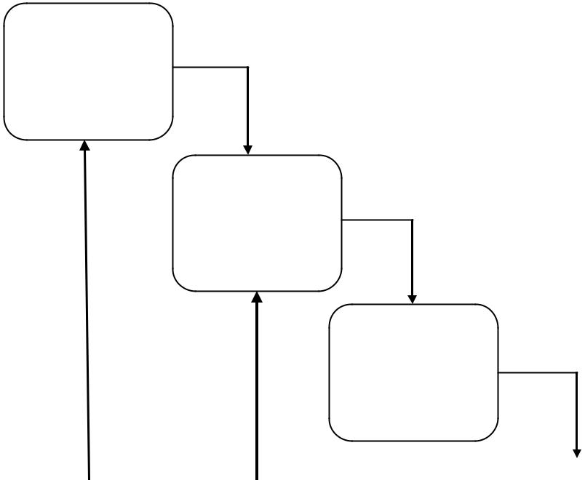

Analysis
A

Design

Review
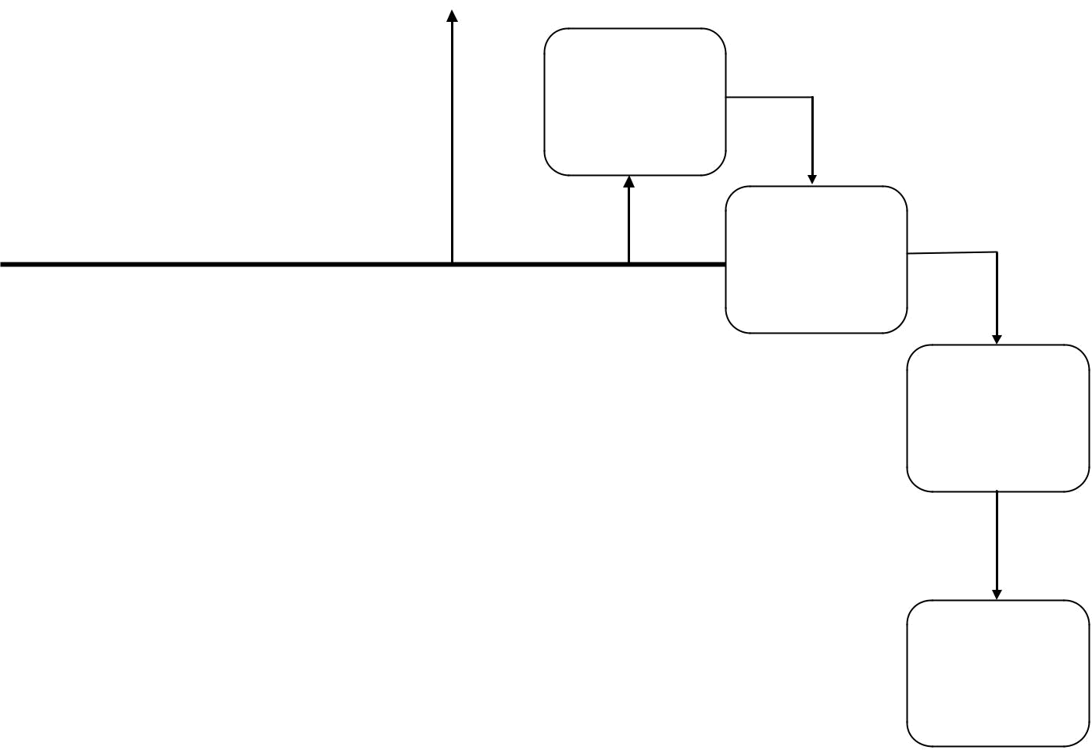

Implement

Testing

Project

Delivery

Our Methodology… Best quality with the best design

Support

10. Requirements from Client

I would require the following from Client. This information would be solely used for the project purpose.

- Detailed document in case any more features need to be added on the website.

- Point of contact to discuss the updates on a daily or a weekly basis as preferred by Client.

- Details like address, telephone numbers, website, photos etc pertaining to all the categories mentioned in the methodology.

11. Commitment

Deliverables catering to website design and development and custom web applications development space are as follows:

• Fully functional site with the aforementioned deliverables.
- project would be 8 weeks. Further changes in the deliverables may extend if something happen.

- works on a strict schedule and promises to deliver as per the agreed time frame. However, we take a standard deviation of 10% due to force majeure.

12. Location of Work

The complete development process will be carried out in Kuantan , Pahang.

13. Progress Reporting and Communication

We will be available for conference with you anytime and you can reach us to discuss regarding the project through any means apart from this we will be giving a formal weekly report on the progress of the project and the status via e-mail.

|| Payment Schedule ||

 | Amount | Percentage | Time
no

1 | RM15000 | 30 % | Immediate
2 | RM12500 | 25 % | 3 Weeks
 |  |  | from start
 |  |  | 6 Weeks
3 | RM22,500 | 45 % | from start

- Client will release the payment after the milestones have been completely tested on’ test servers. Total is RM50000.

Source Code

We will transfer all the rights of the source code, artifacts and intellectual property to the owner once the website is completed.

Looking Forward To Work With You.

