AHMAD SOLEHIN BIN SHARUDDIN CB15003

ASSIGNMENT.aspx

<%@ Page Language="C#" AutoEventWireup="true" CodeFile="ASSIGNMENT.aspx.cs" Inherits="ASSIGNMENT" %>

<!DOCTYPE html PUBLIC "-//W3C//DTD XHTML 1.0 Transitional//EN" "http://www.w3.org/TR/xhtml1/DTD/xhtml1-transitional.dtd">

<html xmlns="http://www.w3.org/1999/xhtml">

<head runat="server">

<title>Bootstrap Example</title>

<meta charset="utf-8">

<meta name="viewport" content="width=device-width, initial-scale=1">

<link rel="stylesheet" href="https://maxcdn.bootstrapcdn.com/bootstrap/3.3.7/css/bootstrap.min.css">

<script src="https://ajax.googleapis.com/ajax/libs/jquery/1.12.4/jquery.min.js"></script>

<script src="https://maxcdn.bootstrapcdn.com/bootstrap/3.3.7/js/bootstrap.min.js"></script>

<style type="text/css">

.style2

{

width: 266px;

}

</style>

</head>

<body>

<form id="form1" runat="server">

<div class="container">

<h2>Car Loan Calculator</h2>

<br />

<br />

<div class="form-group">

<label for="sel1">Select Cars (select one):</label>

<asp:DropDownList ID="DropDownList2" class="form-control" runat="server" Width="278px">

<asp:ListItem>VIOS J (MT)</asp:ListItem>

<asp:ListItem>ALTIS 1.8 E</asp:ListItem>

<asp:ListItem Value="CAMRY">CAMRY</asp:ListItem>

<asp:ListItem>HILUX SC (MT)</asp:ListItem>

</asp:DropDownList>

<br>

</div>

<div class="form-group">

<label for="pwd">Down Payment

</label>

&nbsp;<asp:TextBox class="form-control" ID="TextBox1" runat="server"></asp:TextBox>

</div>

<div class="form-group">

<label for="d">Duration</label>

<asp:RadioButtonList ID="RadioButtonList1" runat="server">

<asp:ListItem>5</asp:ListItem>

<asp:ListItem>7</asp:ListItem>

<asp:ListItem>9</asp:ListItem>

</asp:RadioButtonList>

</div>

<div class="form-group">

<label for="pwd">OPINION ABOUT THIS APPLICATION</label>

<asp:TextBox class="form-control" ID="TextBox2" runat="server"></asp:TextBox>

</div>

<asp:Button ID="Button1" class="btn btn-default" runat="server" Text="Submit"

onclick="Button1_Click" />

<br />

<br /> <br />

<br /> <br />

<br />

<table class="table">

<tr>

<td class="style2">

<asp:Label ID="Label1" runat="server" Text="MODEL"></asp:Label>

</td>

<td class="warning">

<asp:Label ID="Label2" runat="server" Text=""></asp:Label>

</td>

</tr>

<tr>

<td class="style2">

<asp:Label ID="Label3" runat="server" Text="DOWN PAYMENT"></asp:Label>

</td>

<td class="warning">

<asp:Label ID="Label4" runat="server" Text="">RM</asp:Label>

</td>

</tr>

<tr>

<td class="style2">

<asp:Label ID="Label5" runat="server" Text="INTEREST (%)"></asp:Label>

</td>

<td class="warning">

<asp:Label ID="Label6" runat="server" Text=""></asp:Label>

</td>

</tr>

<tr>

<td class="style2">

<asp:Label ID="Label7" runat="server" Text="MONTHLY INSTALLMENT ( YEARS )"></asp:Label>

</td>

<td class="warning">

<asp:Label ID="Label8" runat="server" Text=""></asp:Label>

</td>

</tr>

<tr>

<td class="style2">

<asp:Label ID="Label9" runat="server" Text="LOAN AMOUNT "></asp:Label>

</td>

<td class="warning">

<asp:Label ID="Label10" runat="server" Text="">RM</asp:Label>

</td>

</tr>

<tr>

<td class="style2">

<asp:Label ID="Label11" runat="server" Text="MONTHLY INSTALLMENT "></asp:Label>

</td>

<td class="warning">

<asp:Label ID="Label12" runat="server" Text="">RM</asp:Label>

</td>

</tr>

<tr>

<td class="style2">

<asp:Label ID="Label13" runat="server" Text="WHAT DO YOU THINK OF THIS APPLICATION "></asp:Label>

</td>

<td class="warning">

<asp:Label ID="Label14" runat="server" Text=""></asp:Label>

</td>

</tr>

</table>

</form>

</div>

</body>

</html>

<script type="text/javascript">

//datepicker

$(document).ready(function () {

$('#DropDownList2').change(function () {

var itik = $('#DropDownList2').val();

if (itik == "CAMRY") {

}

});

})

</script>

ASSIGNMENT.aspx.cs

using System;

using System.Collections.Generic;

using System.Linq;

using System.Web;

using System.Web.UI;

using System.Web.UI.WebControls;

public partial class ASSIGNMENT : System.Web.UI.Page

{

String model = "";

int interest = 0;

double carprice = 0;

double loanamount = 0;

double monthlyinstall = 0;

int numofmonth = 0;

protected void Page_Load(object sender, EventArgs e)

{

}

protected void Button1_Click(object sender, EventArgs e)

{

if (RadioButtonList1.SelectedItem.Text == "5")

{

numofmonth = 60;

}

else if (RadioButtonList1.SelectedItem.Text == "7")

{

numofmonth = 84;

}

else if (RadioButtonList1.SelectedItem.Text == "9")

{

numofmonth = 108;

}

if (DropDownList2.SelectedItem.Text == "VIOS J (MT)")

{

interest = 4;

model = "VIOS J (MT)";

carprice = 74700.00;

loanamount = carprice - Int32.Parse(TextBox1.Text);

monthlyinstall = ((0.04 * loanamount) + loanamount) / numofmonth;

Label2.Text = model;

Label4.Text = TextBox1.Text;

Label6.Text = interest.ToString();

Label8.Text = RadioButtonList1.SelectedItem.Text;

Label10.Text = loanamount.ToString();

Label12.Text = monthlyinstall.ToString("0.00");

Label14.Text = TextBox2.Text;

Response.Write("<script>alert('Data inserted successfully')</script>");

}

else if (DropDownList2.SelectedItem.Text == "ALTIS 1.8 E")

{

interest = 4;

model = "ALTIS 1.8 E";

carprice = 113000.00;

loanamount = carprice - Int32.Parse(TextBox1.Text);

monthlyinstall = ((0.04 * loanamount) + loanamount) / numofmonth;

Label2.Text = model;

Label4.Text = TextBox1.Text;

Label6.Text = interest.ToString();

Label8.Text = RadioButtonList1.SelectedItem.Text;

Label10.Text = loanamount.ToString();

Label12.Text = monthlyinstall.ToString("0.00");

Label14.Text = TextBox2.Text;

Response.Write("<script>alert('Data inserted successfully')</script>");

}

else if (DropDownList2.SelectedItem.Text == "CAMRY")

{

interest = 4;

model = "CAMRY";

carprice = 149900.00;

loanamount = carprice - Int32.Parse(TextBox1.Text);

monthlyinstall = ((0.04 * loanamount) + loanamount) / numofmonth;

Label2.Text = model;

Label4.Text = TextBox1.Text;

Label6.Text = interest.ToString();

Label8.Text = RadioButtonList1.SelectedItem.Text;

Label10.Text = loanamount.ToString();

Label12.Text = monthlyinstall.ToString("0.00");

Label14.Text = TextBox2.Text;

Response.Write("<script>alert('Data inserted successfully')</script>");

}

else if (DropDownList2.SelectedItem.Text == "HILUX SC (MT)")

{

interest = 4;

model = "HILUX SC (MT)";

carprice = 76300.00;

loanamount = carprice - Int32.Parse(TextBox1.Text);

monthlyinstall = ((0.04 * loanamount) + loanamount) / numofmonth;

Label2.Text = model;

Label4.Text = TextBox1.Text;

Label6.Text = interest.ToString();

Label8.Text = RadioButtonList1.SelectedItem.Text;

Label10.Text = loanamount.ToString();

Label12.Text = monthlyinstall.ToString("0.00");

Label14.Text = TextBox2.Text;

Response.Write("<script>alert('Data inserted successfully')</script>");

}

}

}

Before button is clicked

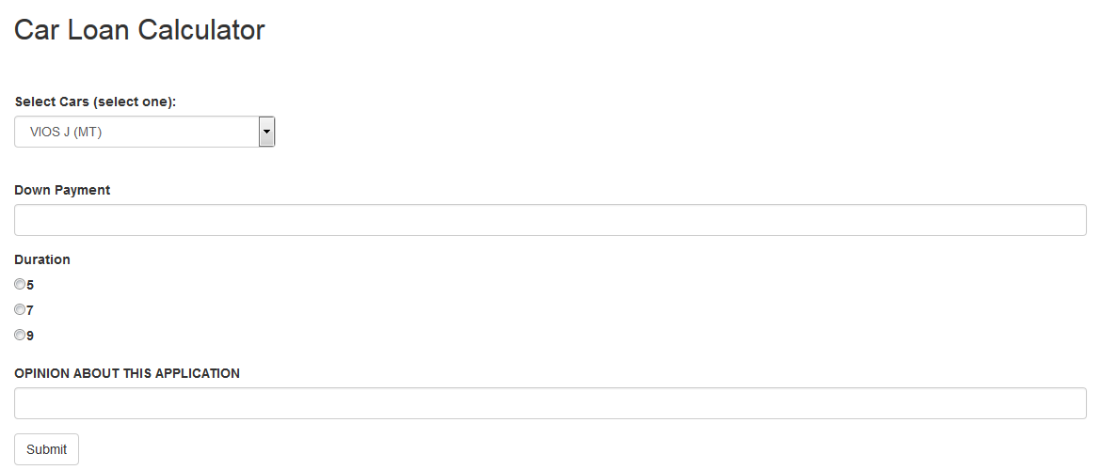

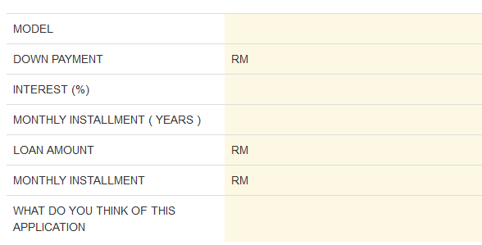

After button is clicked

