Before click

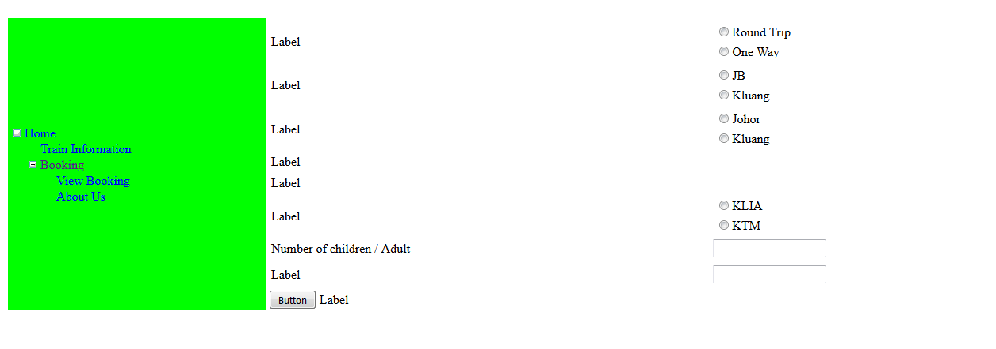

After click button

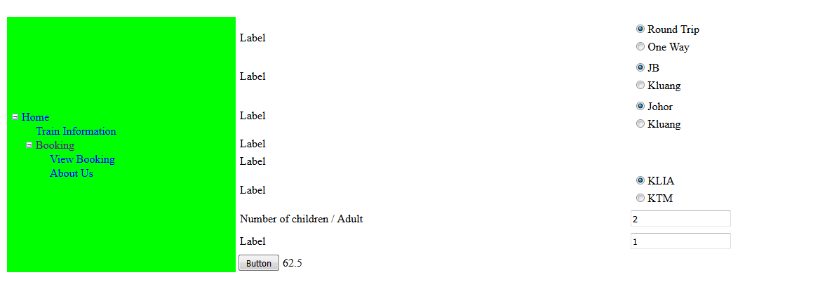

using System;

using System.Collections.Generic;

using System.Linq;

using System.Web;

using System.Web.UI;

using System.Web.UI.WebControls;

public partial class Booking : System.Web.UI.Page

{

double total = 0;

protected void Page_Load(object sender, EventArgs e)

{

}

protected void Button1_Click(object sender, EventArgs e)

{

string selectedValue = RadioButtonList1.SelectedValue;

string ayam = RadioButtonList2.SelectedValue;

string itik = RadioButtonList4.SelectedValue;

double x = double.Parse(TextBox1.Text);

double tua = double.Parse(TextBox2.Text);

if (selectedValue == "Round Trip")

{

Response.Write("<script>alert('round trip')</script>");

if (ayam == "JB")

{

Response.Write("<script>alert('johor')</script>");

if (itik == "KLIA")

{

Response.Write("<script>alert('klia')</script>");

total += 25.00 * x;

if (tua > 0)

{

total += 25.00 - (0.50 * 25.00);

Label9.Text = total.ToString();

}

}

else if (itik == "KTM")

{

total += 20.00 * x;

if (tua > 0)

{

total += 25.00 - (0.50 * 25.00);

Label9.Text = total.ToString();

}

}

}

else if (ayam == "Kluang")

{

}

Response.Write("<script>alert('Data v successfully')</script>");

}

else if (selectedValue == "One Way")

{

if (ayam == "Johor")

{

}

else if (ayam == "Kluang")

{

}

Response.Write("<script>alert('Data fd successfully')</script>");

}

}

}

Website map

<?xml version="1.0" encoding="utf-8" ?>

<siteMap xmlns="http://schemas.microsoft.com/AspNet/SiteMap-File-1.0" >

<siteMapNode url="~/Default.aspx" title="Home" description="">

<siteMapNode url="TrainInformation.aspx" title="Train Information" description="" />

<siteMapNode url="Booking.aspx" title="Booking" description="" >

<siteMapNode url="ViewBooking.aspx" title="View Booking" description="" />

<siteMapNode url="AboutUs.aspx" title="About Us" description="" />

</siteMapNode>

</siteMapNode>

</siteMap>

Booking.aspx

<%@ Page Title="" Language="C#" MasterPageFile="~/MainPage.master" AutoEventWireup="true" CodeFile="Booking.aspx.cs" Inherits="Booking" %>

<asp:Content ID="Content1" runat="server"

contentplaceholderid="ContentPlaceHolder1">

<table class="style1">

<tr>

<td>

<asp:Label ID="Label1" runat="server" Text="Label"></asp:Label>

</td>

<td>

<asp:RadioButtonList ID="RadioButtonList1" runat="server">

<asp:ListItem>Round Trip</asp:ListItem>

<asp:ListItem>One Way</asp:ListItem>

</asp:RadioButtonList>

</td>

</tr>

<tr>

<td>

<asp:Label ID="Label2" runat="server" Text="Label"></asp:Label>

</td>

<td>

<asp:RadioButtonList ID="RadioButtonList2" runat="server">

<asp:ListItem>JB</asp:ListItem>

<asp:ListItem>Kluang</asp:ListItem>

</asp:RadioButtonList>

</td>

</tr>

<tr>

<td style="height: 23px">

<asp:Label ID="Label3" runat="server" Text="Label"></asp:Label>

</td>

<td style="height: 23px">

<asp:RadioButtonList ID="RadioButtonList3" runat="server" Height="52px">

<asp:ListItem>Johor </asp:ListItem>

<asp:ListItem>Kluang</asp:ListItem>

</asp:RadioButtonList>

</td>

</tr>

<tr>

<td style="height: 23px">

<asp:Label ID="Label4" runat="server" Text="Label"></asp:Label>

</td>

<td style="height: 23px">

</td>

</tr>

<tr>

<td style="height: 23px">

<asp:Label ID="Label5" runat="server" Text="Label"></asp:Label>

</td>

<td style="height: 23px">

</td>

</tr>

<tr>

<td style="height: 23px">

<asp:Label ID="Label6" runat="server" Text="Label"></asp:Label>

</td>

<td style="height: 23px">

<asp:RadioButtonList ID="RadioButtonList4" runat="server" Height="52px">

<asp:ListItem>KLIA</asp:ListItem>

<asp:ListItem>KTM</asp:ListItem>

</asp:RadioButtonList>

</td>

</tr>

<tr>

<td style="height: 23px">

<asp:Label ID="Label7" runat="server" Text="Number of children / Adult"></asp:Label>

</td>

<td style="height: 23px">

<asp:TextBox ID="TextBox1" runat="server"></asp:TextBox>

</td>

</tr>

<tr>

<td style="height: 34px">

<asp:Label ID="Label8" runat="server" Text="Label"></asp:Label>

</td>

<td style="height: 34px">

<asp:TextBox ID="TextBox2" runat="server"></asp:TextBox>

</td>

</tr>

</table>

<asp:Button ID="Button1" runat="server" Text="Button" onclick="Button1_Click" />

<asp:Label ID="Label9" runat="server" Text="Label"></asp:Label>

</asp:Content>