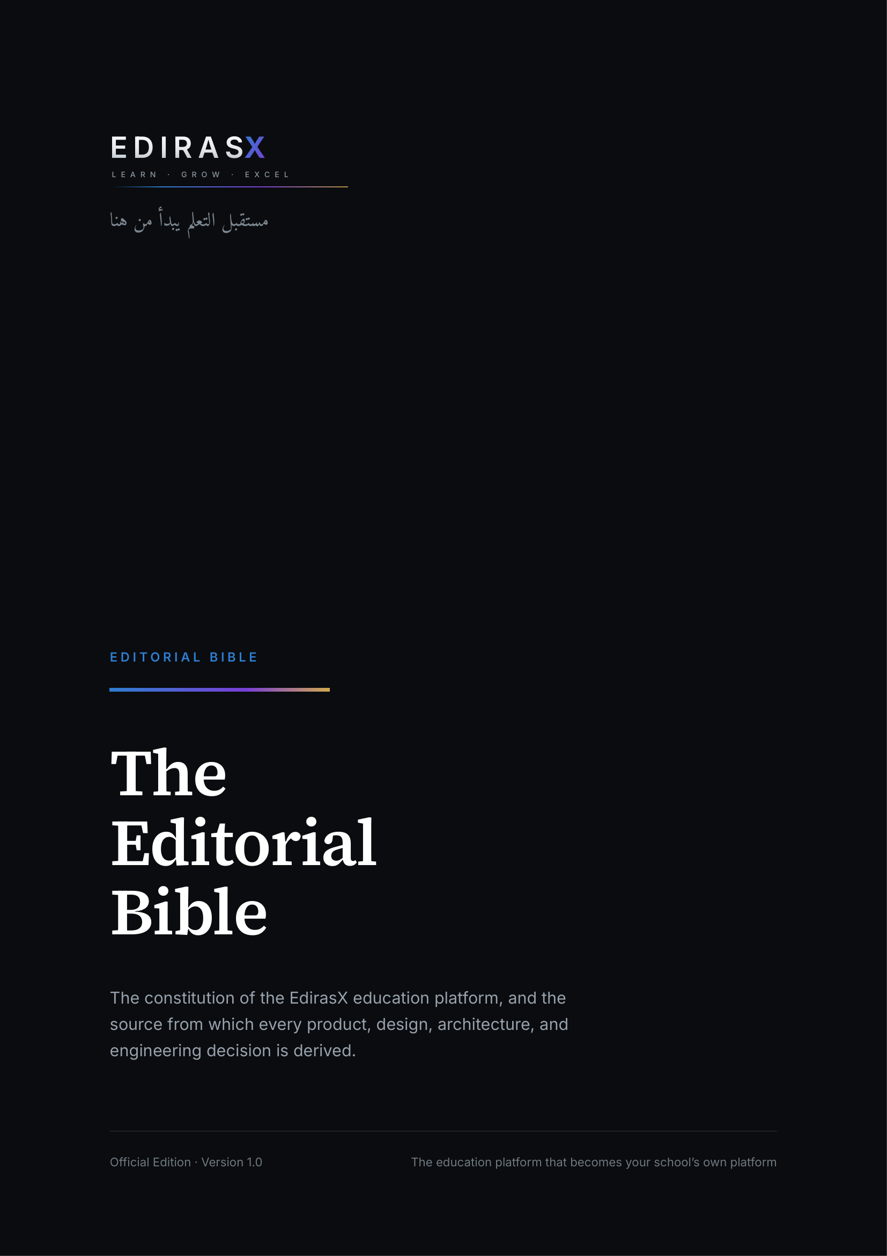

DOCUMENT CONTROL
Document | The EdirasX Editorial Bible
Edition | Official Edition · Version 1.0
Status | Living document — the constitution of EdirasX
Canonical source | docs/edtechx/EDTECHX_EDITORIAL_BIBLE.md
Authority | Supreme. Where any document, design, or code conflicts with this Bible, the Bible wins until formally amended.
Amendment | By entry in EDTECHX_DECISIONS.md, stating the principle changed, the reason, and the consequences.
Typography | Set in Source Serif 4 and Inter. Both are open-licence; Word will substitute if they are not installed.
Contents | The table below is a live field. Press Ctrl+A then F9 (or right-click → Update Field) to populate page numbers.

Contents
Right-click here and choose “Update Field” to build the contents.

Executive statement
Schools do not lack software. They lack software that feels like theirs.
The market has settled into two disappointing shapes. On one side, learning platforms with genuine depth and an interface no institution would present with pride. On the other, school-management systems that run the operation competently and leave teaching to a second, disconnected product. Between them sits a seam that every school reconciles by hand, every term, forever.
EdirasX is built on a single conviction: the education platform should become your school’s own platform. Not a system a school adopts, but the environment in which a school becomes itself. Its mark, its colours, its vocabulary, its academic structure, its documents, its address. EdirasX is the engine underneath; the school owns the experience.
That conviction is not a marketing position. It is an architectural constraint, and it decides things. It is why every visual value is a tenant-resolvable token rather than a constant. It is why a class may be called a form and a grade a year, and why no domain noun is ever a literal in the interface. It is why terms, levels, grading scales, attendance codes, and promotion rules are data rather than code — and why the test of that claim is four genuinely different institutions configured without a single line changed.
Three further commitments shape everything that follows.
Isolation is structural. A school’s data must be unreachable from another school, and that guarantee cannot rest on a developer remembering a condition. It is enforced in the database itself, and proven by a test suite generated from the schema so that new tables are covered by existing rather than by diligence.
Intelligence assists; it does not decide. No artificial intelligence in EdirasX writes to a grade, an attendance mark, an invoice, or a published result without a persisted proposal and an attributed human approval. This is enforced in code, with a test that attempts the bypass and must fail. The moment a school cannot trust that its records were changed by a person, the product is finished, and no amount of accuracy recovers it.
Prestige is precision, not decoration. It is typography, proportion, restraint, and alignment — not gradients, shadows, and motion. The standard is that a prestigious institution would project a screen in a board meeting, and a teacher would be content to use it every day for a year. Both halves must hold.
What follows is the constitution of the product. It is written to be used, not admired: every principle is stated so that it can be applied as a test, and any principle that cannot be used to reject something does not belong in this document.

A note on the name
This document is published under the name EdirasX.
The name derives from the Arabic root of study and learning — الدراسة (al-dirāsa, “study”) and ادرس (idrus, “study!”) — with the X carrying the meaning it has always carried in this product: the variable each school fills in with its own identity. The platform was developed under the working name EdirasX, which named a category rather than a company; EdirasX names what the product is for.
One inconsistency, stated rather than hidden. The repository, package names, documentation filenames, configuration prefix, and database roles still use the earlier edtechx namespace. That migration is scheduled separately and deliberately: renaming those identifiers touches the database roles and grants that tenant isolation depends on, and that work belongs in its own change, with the isolation suite as its gate — not folded into a branding commit whose review attention is on wording.
Product-facing text uses EdirasX without exception. The decision, its reasoning, and the migration it still owes are recorded in EDTECHX_DECISIONS.md as ADR-017, which is authoritative wherever the two names appear together.

About this document
This is the official publication edition of the EdirasX Editorial Bible.
The canonical, editable source is docs/edtechx/EDTECHX_EDITORIAL_BIBLE.md in the EdirasX repository. This edition is generated from that file by tools/publisher, which builds one document model and renders it to both PDF and Word. Content parity between the two formats is therefore a property of how they are produced, not a claim made after the fact — and it is verified independently on every build.
What is faithful to the source. Every numbered chapter. Every principle, requirement, constraint, table, and acceptance criterion.
What is publication apparatus. This colophon, the note on the name, the executive statement, the part dividers and their standfirsts, the table of contents, running heads, page numbers, the promotion of certain paragraphs into callout boxes, two explanatory diagrams, and the closing declaration. These change how the document is presented. They do not change what it says.
Amendment. Amending this Bible means amending the Markdown source and recording the change in EDTECHX_DECISIONS.md. Editing this PDF or Word file amends nothing. Silent divergence between this document and the product is a defect — in the product or in this document — never an acceptable steady state.

Status and authority
Status: Living document — the constitution of EdirasX Custodian: Imam Ahmad Sulaimiy, Senior Developer — the expert behind the development of EdirasX Version: 1.0 Supremacy clause: Where any other document, design, or line of code conflicts with this Bible, the Bible wins until formally amended here.

PART I
Foundation
What EdirasX is, what it believes, and the consequences those beliefs have for the engineering.

CHAPTER 0

How to use this document
This is not marketing copy. It is a decision instrument. When an engineer, designer, or AI agent faces a choice that the specification does not settle, the answer is derived here — from the principles, not from taste.
Every section is written so that it can be applied as a test. If a principle cannot be used to reject something, it is not a principle; it is a slogan, and it does not belong in this document.

CHAPTER 1

Brand foundation

1.1 Name
EdirasX.
Written as one word: capital E, lowercase diras, capital X. Never “Edirasx”, “Ediras X”, “EDIRASX” in running prose, “Ediras-X”, or “EX”. The uppercase logotype EDIRASX is a logo treatment, not a spelling.
The name derives from the Arabic root of study and learning — الدراسة (al-dirāsa, “study”) and ادرس (idrus, “study!”). The X carries the same meaning it always did: the variable a school fills in with its own identity.
Pronounced ed-EE-ras-ex.
Technical namespace. The repository, package names, and documentation filenames presently use the earlier edtechx / EDTECHX_ namespace. That is a deliberate, temporary divergence from the product name, recorded as ADR-017, and it is a migration to be scheduled rather than a naming inconsistency to be tolerated indefinitely. Product-facing text uses EdirasX without exception.

1.2 Positioning
The education platform that becomes your school’s own platform.
This is the single sentence from which the entire product derives. It contains a promise and a constraint:
— The promise: a school does not adopt EdirasX; a school becomes itself on EdirasX.
— The constraint: any feature that makes EdirasX more visible to the end user at the expense of the school’s identity is, by definition, working against the positioning.

1.3 Mission
To provide a world-class, intelligent, customizable education operating system that prestigious institutions worldwide are proud to deploy — one that adapts to each school’s identity rather than imposing a generic experience.

1.4 Vision
A future in which every educational institution has a digital environment that feels authentically its own, powered by technology that understands educational context rather than merely storing educational data.

1.5 Promise
Institutional-grade technology with consumer-grade elegance, so that schools spend their attention on education rather than on fighting their platform.

1.6 Personality
We are | We are not
Confident | Arrogant
Prestigious | Elitist
Intelligent | Cold
Professional | Sterile
Innovative | Gimmicky
Supportive | Intrusive

Each pair is a live editorial test. “Confident, not arrogant” means: state what the product does without superlatives about ourselves. “Supportive, not intrusive” means: the assistant waits to be asked, except where waiting would cause harm.

1.7 Tone
Respectful of educational professionals. Clear and concise. Warm where warmth is earned, professional everywhere. Reassuring in moments of uncertainty. Encouraging without flattery.
TONE FLOOR
The tone floor: a teacher reading our interface copy at 07:50, four minutes before a lesson, must not feel talked down to and must not have to read anything twice.

1.8 Voice
— Authoritative about education technology.
— Humble about the importance of teachers. We do not claim to teach; we claim to remove obstacles to teaching.
— Progressive about educational innovation, practical about institutional reality.
— Visionary about learning, never speculative about a school’s own data.

1.9 Vocabulary
Use educational terminology precisely. Avoid jargon where a plain word serves.
Prefer | Over | Why
school, institution | organization, org, company | Schools are not businesses first
learners, students | users, end users | Never call a child a “user” in the UI
educators, teachers | instructors, content providers | Teaching is a profession, not a role in a workflow
families, parents | guardians (in UI copy) | “Guardian” is correct in data models, cold in interface copy
enrolled | onboarded, provisioned | Enrolment is the school’s word
record, register | log, entry | Academic records carry weight

RULE
The Terminology Rule: every noun in the list above is also configurable by the school (see EDTECHX_CUSTOMIZATION_ENGINE.md). The table defines EdirasX’s defaults, not the platform’s assumptions. A school that calls a class a “form” and a grade a “year” must never see our defaults leak through.

1.10 Messaging principles
1 Lead with outcomes, not features.
2 Emphasize institutional ownership over platform capability.
3 Highlight flexibility as a property of the architecture, never as a list of settings.
4 Present intelligence as assistance, never as authority.
5 Celebrate educational excellence; never imply we are the source of it.

1.11 What EdirasX will never say
— That it improves learning outcomes. We enable the people who do.
— That its AI knows a student. It observes records; educators know students.
— That a school “runs on EdirasX.” Schools run on teaching. EdirasX runs underneath.

CHAPTER 2

Product philosophy
Eleven beliefs. Each is stated as a claim, then as an engineering consequence, because a belief with no consequence is decoration.
1. Technology serves pedagogy; it does not define it. Consequence: no academic structure may be hard-coded. Terms, grading scales, promotion rules, attendance models, and assessment structures are data, not enums baked into application logic.
2. Simplicity is sophistication. Consequence: a feature that requires training to discover has failed. Depth is reached through progressive disclosure, not through density.
3. Institutions deserve ownership. Consequence: white-labelling, custom domains, and full theming are architecture, not upsell decorations bolted on later. Data export is a right, not a retention lever.
4. Personalization is not optional. Consequence: six distinct primary experiences (admin, teacher, student, parent, principal, platform operator) with genuinely different information architecture — not one dashboard with the heading swapped.
5. AI assists; it does not replace. Consequence: no AI output may mutate an official academic record without an explicit, attributable human approval step. This is enforced in code, not in policy. See §7.
6. Accessibility is a right, not a feature. Consequence: WCAG 2.2 AA is a merge requirement, not a backlog item.
7. Teacher experience is paramount. Consequence: teacher-facing flows are optimized for elapsed time and click count, measured. Attendance for a class of forty must be markable in under thirty seconds on a phone.
8. Student experience drives engagement. Consequence: students see clarity — what is due, what is expected, how they are doing — before they see anything else.
9. Parent experience builds trust. Consequence: the parent portal is designed for the least technically confident parent in the school, on the cheapest phone, on the worst connection.
10. Administrator experience enables excellence. Consequence: administrators get insight and bulk operations, not spreadsheets rendered as HTML.
11. Prestige is earned through quality. Consequence: we do not ship a screen we would be embarrassed to project in a board meeting.

PART II
Experience
How the product behaves, how it looks, and for whom — the six people whose working lives it touches.

CHAPTER 3

UX philosophy
Hierarchy. Every screen has exactly one primary thing. If two things compete, one of them is wrong.
Simplicity. Every element justifies its presence or is removed. “It might be useful” is not a justification.
Discoverability. Features are found when needed, without documentation. The test: a competent teacher who has never seen the screen completes the task without asking anyone.
Progressive disclosure. Show what is needed now. Advanced capability is one deliberate step away, never zero (clutter) and never three (buried).
Consistency. Established patterns beat clever ones. A user’s prediction about behaviour must be correct.
Feedback. Every action produces a response within 100ms, even if the response is only acknowledgement. Users must never wonder whether something happened.
Error prevention. Design out the error first. Constrain inputs, default sensibly, confirm destructively. When errors happen, provide the recovery path in the error itself.
Accessibility. WCAG 2.2 AA minimum: keyboard operation of every flow, screen-reader semantics, visible focus, 4.5:1 text contrast, respect for reduced-motion.
Responsiveness. The experience works on a 360px phone over a throttled 3G connection. That is the design target, not the degraded case.
Cognitive load. Minimize what the user must hold in their head. Never require a user to remember something the system already knows.
Information density. Balance. Neither a wall of data nor a page with four numbers on it. Density is a setting the school can adjust (comfortable / compact), because a registrar and a parent want different things.
Navigation. The user always knows where they are, how they got there, and how to leave.
Onboarding. Welcoming, educational, and respectful of time. Never a mandatory tour.
Empty states. Informative, encouraging, actionable. An empty state is a teaching opportunity, not a blank rectangle.
Loading states. Honest. Skeletons that match the shape of what is coming. Never a spinner where a skeleton would inform.
Error states. Clear, actionable, blameless. Never “an error occurred.”
Success states. Confirm plainly, and offer the natural next action.

CHAPTER 4

Visual philosophy — what “prestigious” means here

4.1 Prestige is not
PRESTIGE IS NOT | PRESTIGE IS
· Excessive gradients  · Excessive glassmorphism  · Giant cards and cavernous whitespace  · Heavy or stacked shadows  · Animation without purpose  · Visual noise  · Trend-chasing  · Hype aesthetics | · Typography  · Proportion  · Spacing  · Restraint  · Hierarchy  · Visual rhythm  · Precision  · Imagery  · Motion  · Composition  · Intelligent colour  · Excellent information design

These are the visual language of products that need to look expensive. EdirasX serves institutions that already are.

4.2 Prestige is
Typography. Professional typefaces. Excellent hierarchy. Restrained sizes. Generous but not loose line height. Consistent weights. Never more than three families (heading, body, and optionally a script/regional face).
Proportion. Balanced composition. Harmonious spacing. Element sizes that reflect importance.
Spacing. A consistent 4px base grid. Breathing room around content. Purposeful padding. Clear grouping by proximity.
Restraint. Knowing when to stop. Colour used sparingly. Emphasis reserved for what matters. Motion for meaning, not for show.
Hierarchy. Obvious primary action. Supporting secondary. Quiet tertiary. Nothing shouting.
Visual rhythm. Predictable patterns; repetition of a small set of elements; variation only for emphasis.
Precision. Pixel alignment. Consistent borders. Exact spacing. Zero visual artefacts. Precision is the single most reliable signal of care.
Imagery. Professional or none. A missing image beats a stock image of smiling models.
Motion. Purposeful, fast (150–250ms), interruptible, and fully disabled under prefers-reduced-motion.
Composition. Grid-based. Clear focal points. Deliberate asymmetry only where it serves.
Intelligent colour. Brand colour carries meaning consistently; contrast is verified, not assumed; cultural connotation is considered.
Excellent information design. Data presented so the reader draws the correct conclusion quickly. Readable tables. Forms that guide. Charts that inform rather than decorate.

4.3 The standard
A screen is finished when a prestigious institution would be proud to project it in a board meeting, and a teacher would be happy to use it every day for a year.
Both halves must be true. Prestige without daily usability is a brochure; usability without prestige is the market we are displacing.

CHAPTER 5

The six humans
EdirasX does not have “users.” It has six people with materially different jobs. Each gets its own information architecture. Full IA specifications live in EDTECHX_PRODUCT_SPEC.md §4; the essence is here because it is editorial, not merely functional.
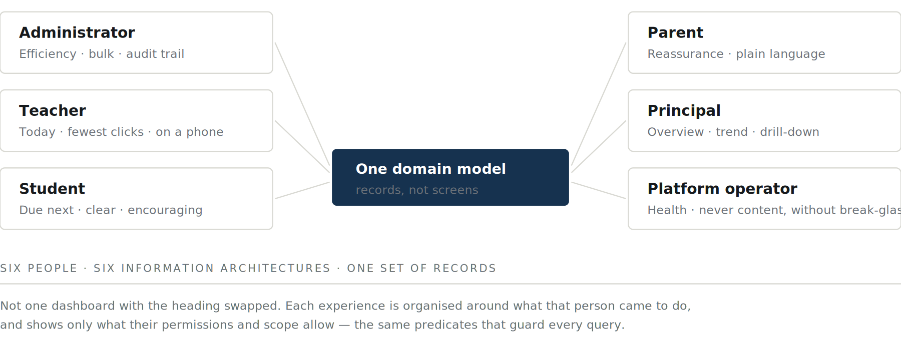
Figure 5.1 — Six people, six information architectures, one domain model.

5.1 School administrator / registrar
Job: keep the institution running correctly. Emotional state: responsible, interrupted, accountable. Design posture: efficiency-first. Data-rich. Bulk operations. Clear action paths. Audit trail always reachable. Failure mode to avoid: making them do one-at-a-time what should be done in bulk.

5.2 Teacher
Job: teach; record the minimum necessary; be left alone. Emotional state: time-poor, often standing, often on a phone. Design posture: task-focused, minimum clicks, mobile-first, no distraction. Failure mode to avoid: any flow that costs more time than the paper process it replaced.

5.3 Student
Job: know what is expected and how they are doing. Emotional state: variable; sometimes anxious about grades. Design posture: encouraging, clear next steps, honest feedback, mobile-first. Failure mode to avoid: gamification that trivializes, or ranking that shames.

5.4 Parent / family
Job: be reassured, and know when to act. Emotional state: caring, busy, sometimes unfamiliar with software. Design posture: reassuring, plain language, low density, unmistakable next steps. Failure mode to avoid: presenting raw academic data without interpretation.

5.5 Principal / school owner
Job: understand institutional health and decide. Emotional state: strategic, sceptical of dashboards. Design posture: high-level with drill-down, visual, trustworthy, comparative over time. Failure mode to avoid: vanity metrics; numbers with no decision attached.

5.6 Platform operator (EdirasX staff)
Job: keep every tenant healthy. Emotional state: operational, alert-driven. Design posture: system-wide perspective, actionable alerts, technical detail one click away. Failure mode to avoid: any operator tool that can read tenant academic content without an audited, justified break-glass action.

CHAPTER 6

The “it should feel like our school” principle
The most important UX principle in this document.
Not: “We use EdirasX.” But: “This is our school’s digital environment.”
EdirasX is the engine underneath. The school owns the experience.
Operationally this means:
— The school’s name, mark, colours, and typography are what users see. Ours are not.
— Every user-facing term is the school’s term.
— The URL can be the school’s own.
— Documents (report cards, certificates, transcripts, emails) carry the school’s identity, not ours.
— EdirasX attribution appears only where commercially required by plan (Free tier), and even then quietly, in one place.
THE TEST
The test: show a screenshot to a parent at that school. If their first reaction is anything other than recognizing their own school, we have failed.

PART III
Constitutions
Three commitments that bind every future decision: about intelligence, about flexibility, and about culture.

CHAPTER 7

AI constitution
AI in EdirasX is bound by five rules. These are enforced in code (EDTECHX_AI_ARCHITECTURE.md §6), not merely stated.
1 No silent mutation of the record. AI may draft, suggest, summarize, and analyse. It may never write to an academic record — a grade, an attendance mark, a promotion decision, a disciplinary entry — without an explicit human approval that is attributed and audited.
2 Provenance is mandatory. Any AI-generated content shown to a user is labelled as such, and its origin (provider, model, prompt version, timestamp) is retrievable.
3 Tenant data does not cross tenants, and does not train anyone’s model. Provider selection must respect a no-training guarantee; providers without one are unavailable for tenant content by default.
4 Human judgement outranks the model. Where AI output and an educator disagree, the interface presents the educator’s view as authoritative.
5 Cost and usage are visible to the school. No school is surprised by an AI bill or a quota wall.
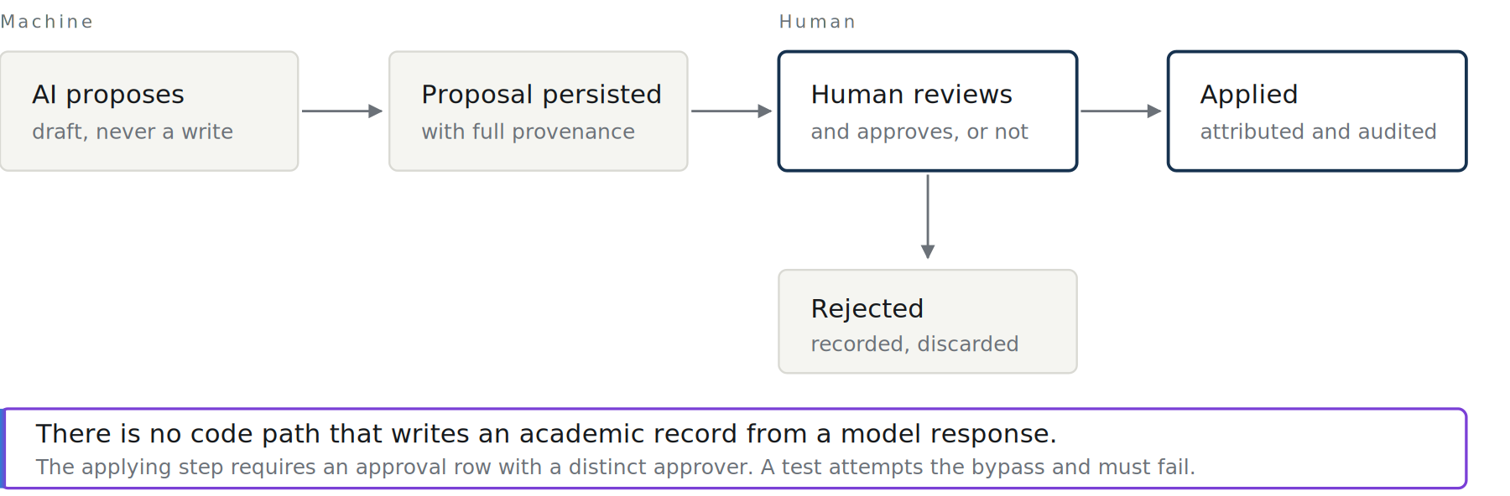
Figure 7.1 — The approval gate, as it applies to every assistant in the product.

CHAPTER 8

Flexibility constitution
EdirasX must not encode assumptions about how a school works. The following are data, never code:
grades · terms · semesters · houses · departments · campuses · grading scales · attendance methods · examination structures · promotion rules · academic calendars · terminology · curriculum · organizational hierarchy · report-card format · roles and permissions
ACCEPTANCE TEST
The Four Schools test. Any change to academic structure must be checked against four real shapes:
School | Structure
A | Primary / Secondary; three terms; A–F grades; house system
B | Elementary / Middle / High; two semesters; 4.0 GPA; no houses
C | Nursery / Primary / College; three terms; percentage + position in class
D | Foundation / Undergraduate / Postgraduate; modular credits; continuous assessment

If a proposed feature requires a code change to support any of these four, the design is wrong.

CHAPTER 9

Cultural constitution
EdirasX serves secular, Islamic, Christian, international, public, private, and boarding schools; universities, colleges, academies, and training institutions — across Nigeria, wider Africa, the GCC and Middle East, the UK, Europe, and the USA.
Therefore:
— No cultural or religious assumption ships as a default. Religious features exist as installable configurations, never as baked-in structure.
— The calendar system, week start, weekend days, date format, number format, and name order are configuration.
— Right-to-left layout is a first-class rendering mode, not a stylesheet patch.
— Translation is a platform capability; the interface is authored to be translatable (no concatenated sentences, no baked-in plurals).
— No cheap regional edition. Product quality is identical in every market. Pricing varies; the product does not.

PART IV
Standards
The lines that are not crossed, the bar that must be met, and how this document itself is changed.

CHAPTER 10

Non-negotiables
The following are grounds to block a release, regardless of schedule:
1 A cross-tenant data access path.
2 A privilege-escalation path.
3 AI writing to an academic record without human approval.
4 A WCAG 2.2 AA failure on a critical journey.
5 A screen that ships with placeholder or fabricated data presented as real.
6 A destructive action without confirmation and an audit entry.
7 Secrets reachable from a browser, or written to logs.
8 A required flow that is unusable on a 360px viewport.

CHAPTER 11

Definition of done
A feature is done when all of the following are true. “The code works” is one of thirteen.
☐ Implementation is functionally complete
☐ UI is polished to the §4 standard
☐ Backend is real (no stub outside a marked development adapter)
☐ Input validation is enforced server-side
☐ Authorization is enforced server-side, including tenant scope
☐ Tests pass, including an authorization test and a tenant-isolation test where applicable
☐ Responsive behaviour verified at 360 / 768 / 1280
☐ Accessibility verified: keyboard path, focus order, labels, contrast
☐ Error handling is comprehensive and actionable
☐ Loading states present
☐ Empty states designed
☐ Security considerations reviewed against EDTECHX_SECURITY.md
☐ Documentation updated, including this Bible if a principle changed

CHAPTER 12

Amendment
This Bible is amended by an entry in EDTECHX_DECISIONS.md that states the principle being changed, the reason, and the consequences. Silent divergence between this document and the product is a defect in the product or in this document — never an acceptable steady state.

IN CLOSING

Closing declaration
This Bible is the supreme governing authority of the EdirasX product.
Where any specification, design, roadmap, or line of code conflicts with what is written here, this document wins — until it is formally amended by the procedure in Chapter 12.
It exists because the alternative is worse. A product built without a constitution accumulates decisions nobody made deliberately: a colour chosen because it was to hand, a hard-coded term because one school used it, an authorization check placed where it was convenient. Those decisions do not announce themselves. They surface years later as the reason a school cannot be served, an audit cannot be passed, or a rewrite cannot be avoided.
Every principle here has therefore been written so that it can be used to say no. That is the test of a principle, and it is why this document is shorter and more specific than it could have been.
Three obligations follow for anyone building on it.
Read it before deciding, not after. When the specification is silent, the answer is derived here — from the principles, not from preference. That is what makes a distributed team, over years, produce a coherent product rather than an assortment of reasonable choices.
Amend it rather than diverge from it. A principle that no longer serves the product should be changed openly, with its reasoning and its cost recorded. Quietly building against it is how a constitution becomes decoration.
Hold the standard when it is inconvenient. The non-negotiables in Chapter 10 and the definition of done in Chapter 11 are worth precisely what they cost on the day they are expensive. Every one of them exists because the alternative was tried somewhere and failed.
EdirasX is built for institutions that will hold it to a standard, on behalf of students who did not choose it, in places where the connection is poor and the device is old and the stakes are somebody’s education.
Build it as though responsible for its reputation for the next ten years. Because someone will be.

IN CLOSING

Credits and custody
Imam Ahmad Sulaimiy — Senior Developer, and the expert behind the development of EdirasX. The product’s architecture, its engineering standards, and the principles set out in this Bible are held to his direction.
Custodian of this document. Amendments to the EdirasX Editorial Bible are made under his authority, by the procedure in Chapter 12: an amendment to the canonical Markdown source, accompanied by an entry in the decision record stating the principle changed, the reason, and the consequences.
How this edition was produced. Rendered from docs/edtechx/EDTECHX_EDITORIAL_BIBLE.md by tools/publisher, which builds a single document model and renders it to both PDF and Word. Content parity between the two formats is a property of that build rather than a claim made after the fact, and it is re-verified against the finished files on every release: every chapter, every substantial line of source prose, and every sentence of the document is confirmed present in both.
Typeset in Source Serif 4 and Inter, with IBM Plex Mono for identifiers and Amiri for Arabic. All four are open-licence.
Generated from docs/edtechx/EDTECHX_EDITORIAL_BIBLE.md by tools/publisher. The Markdown source is canonical; this document is a publication artefact of it.

