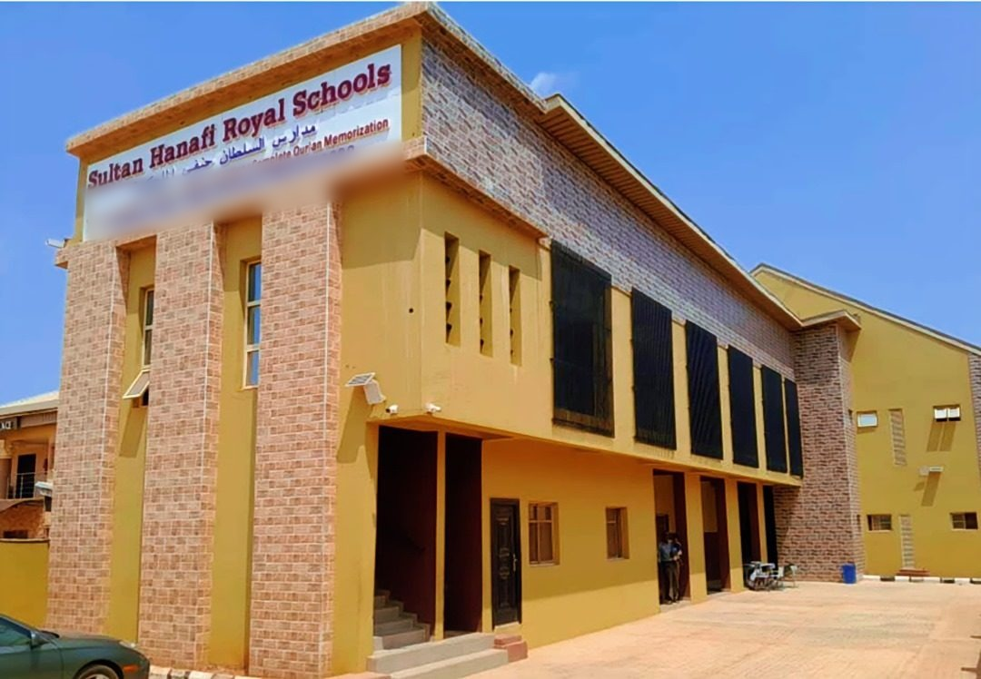
Sultan Hanafi Royal Schools · Imowonla Road
Sultan Hanafi Royal Schools
A Word of Welcome

On behalf of the Board of Trustees and every member of the Sultan Hanafi Royal Schools community, it is our honour to welcome you to this Combined Graduation Ceremony for the Class of 2026. Since our doors opened in Ikorodu in December 2017, we have held to a single conviction: that a child’s secular education and their grounding in Islamic and Arabic learning need not stand apart.
Building the Future Ummah Through Holistic Education
Today’s graduates — from our youngest Primary School leavers to our Qur’an College ḥuffāẓ — represent the full breadth of that vision. To our parents, guardians and distinguished guests: thank you for entrusting us with these years, and for joining us as we celebrate them.
The Board of Trustees

2017  Founded and registered | 4  Integrated schools
1  Unified academic project | 2026  First combined ceremony

A Word from the Chief Executive Director
A combined ceremony such as this is also, I think, a statement about who we are. We have always resisted the idea that a strong Qur’an memorisation pathway and a rigorous secular curriculum are two different projects running side by side.
At Sultan Hanafi Royal Schools they are one project, and today’s graduates are its clearest evidence.
Dr. Zakariya Olanrewaju Anofi
Chief Executive Director

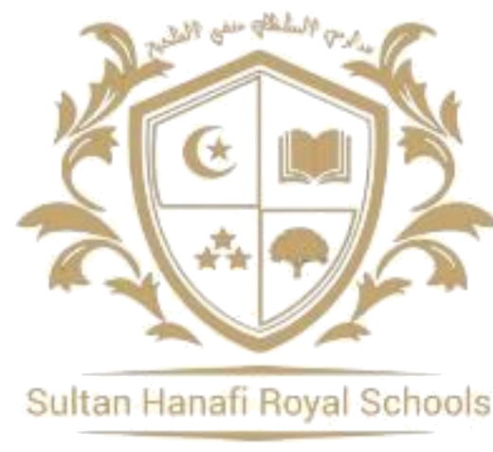
مدارس السلطان حنفي الملكية
Sultan Hanafi Royal Schools
Established MMXVII · Ikorodu · Lagos State

Learning Today, Leading Tomorrow
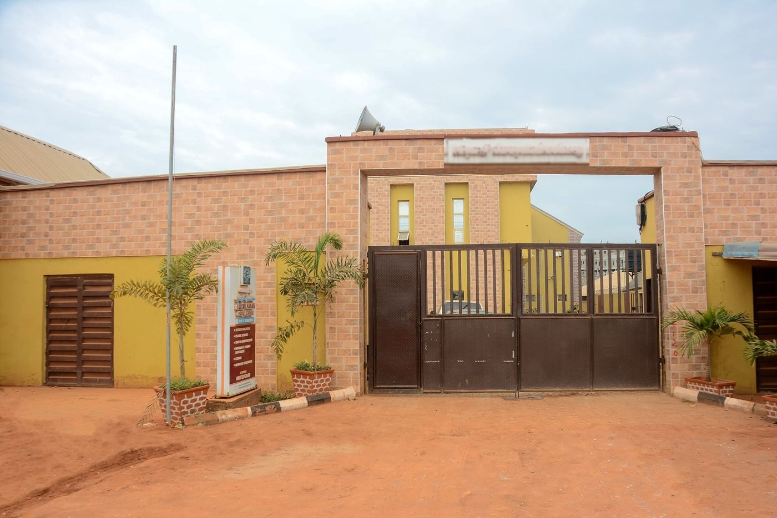
The Campus Gate
The Four Schools
Nursery and Primary School
Ages 2 to 10
Royal College
Junior and Senior Secondary
School of Islamic and Arabic Studies
قسم الدراسات الإسلامية والعربية
Qur’an College
كلية السلطان حنفي للقرآن

Every certificate is verifiable.
Each carries a certificate number, a verification code and a QR code registered with the Office of the Registrar — scan the code, or enter the number at shroyalschools.com/verify-certificate.
15 Imowonla Road, AP Bus Stop, Off Gberigbe Agura Road, Ikorodu, Lagos State
shroyalschools.com · shroyalschools@gmail.com · +234 (0) 807 374 7650
القرآن يعلو ولا يعلى
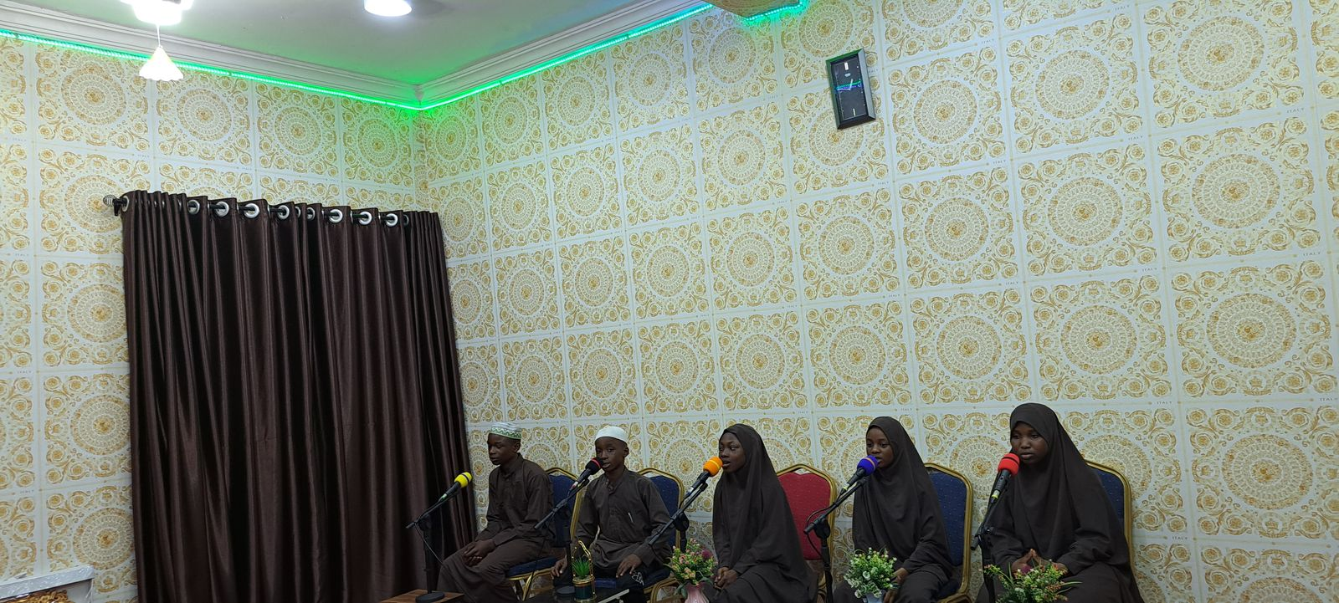
The School Studio

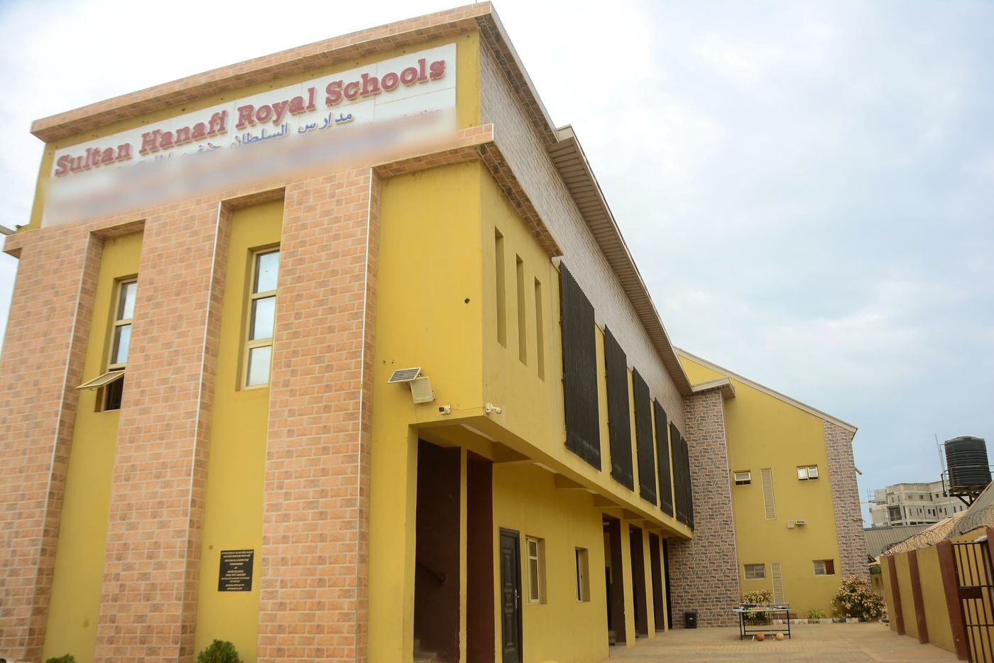
The campus at Imowonla Road

مدارس السلطان حنفي الملكية
Sultan Hanafi Royal Schools
Established MMXVII · Ikorodu · Lagos

The First Combined
Graduation
Ceremony
Class of 2026

Saturday, 8 August 2026
٢٥ صفر ١٤٤٨هـ
10:00 a.m. – 3:00 p.m. · School Hall
Celebrating Achievement, Inspiring Futures
45 awards · 32 graduands · four schools


The Chief Host

د. زكريا أولانريوجو حنفي
Dr. Zakariya Olanrewaju Anofi
Chief Executive Director
Chairman, Board of Governors

Presiding over the first combined convocation of the four schools, and conferring every award named in this programme.

The Campus at Imowonla Road

The Lecture of the Day

Building the Future Ummah Through Holistic Education

Delivered by
Dr. Misbahudeen Dosumu
12:00 – 12:45 · Saturday, 8 August 2026
The School Hall · Ikorodu, Lagos State
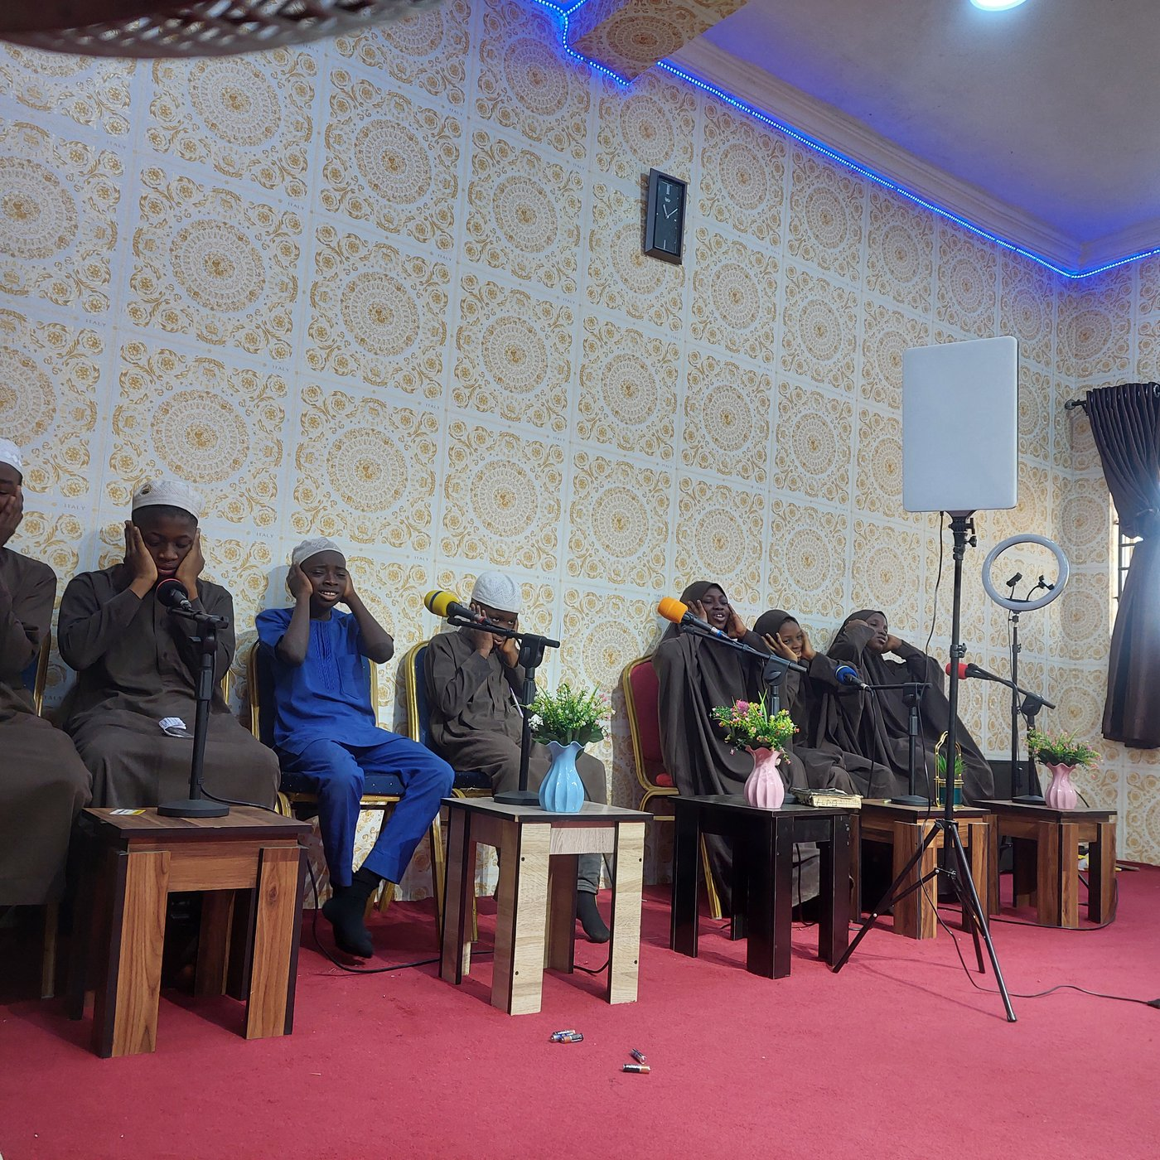
The Assembly Hall

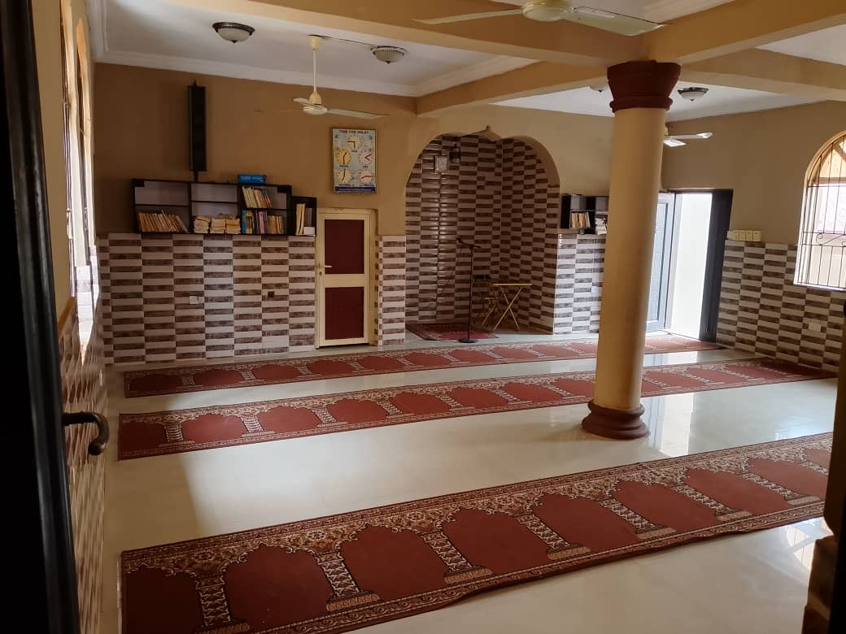
The Prayer Hall
The Order of the Day
Order of Proceedings

10:05–10:10 | Recitation from the Glorious Qur’an  تلاوة من القرآن الكريم
10:10–10:15 | National Anthem and School Anthem
10:15–10:30 | Introduction of Key Guests
10:30–10:45 | Introduction of the Graduands
10:45–11:30 | Welcome Address by the School Heads
11:30–11:40 | Chairman’s Opening Speech
11:40–11:50 | Primary Pupils’ Presentations
11:50–12:00 | Graduands’ Presentations  Secular · Islāmiyyah · Arabic
12:00–12:45 | Lecture  Building the Future Ummah Through Holistic Education
12:45–13:20 | Ṣolātu Ẓuhr  صلاة الظهر
13:20–13:35 | Royal Students’ Presentation  All Units
13:35–13:40 | Donation
13:40–13:45 | Goodwill Message
13:45–14:00 | Light Refreshments
Programme Coordinators
Mr. Shola · Ustādh Shereef Alwaafir

In Attendance
Distinguished Guests

Mr. Ismail Adebisi
Chairman, Olaife Estate CDA
Mr. Abdullah Ibrahim
Chairman, Bagidan Unity Estate CDA
Shaykh Habeeb Adewuyi
Founder, Manaar-ul-Huda International Schools
Imam Sanni K. Yusuf
Chief Imam, Alfawz Central Mosque
Alfa Nurudeen
Imam, Anwarul Islam Mosque
Mr. Busari
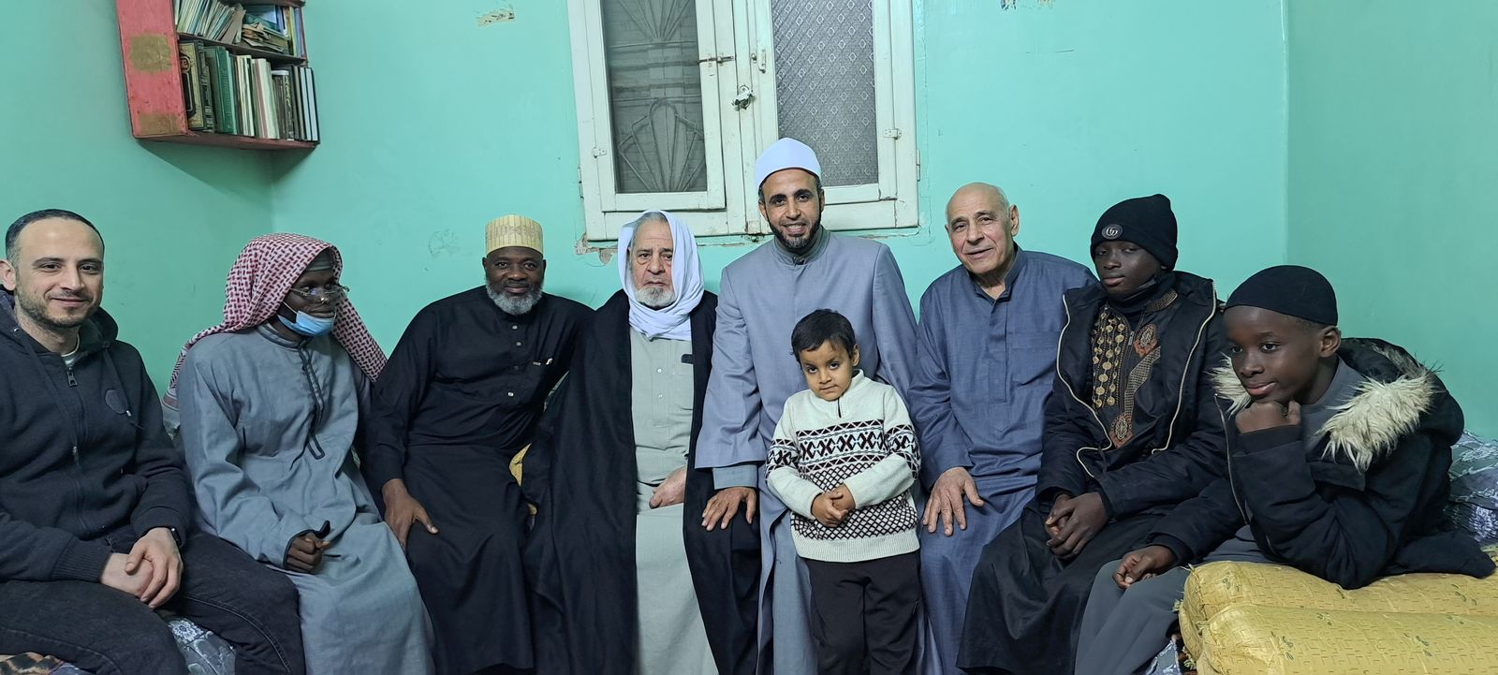
A Scholarly Visit
The Presiding Officers
The Board of Governors, the Principals of the Royal College and of the School of Islamic and Arabic Studies, the Mudeer of the Qur’an College and the Head Teacher of the Nursery and Primary School present the graduands named in this programme.
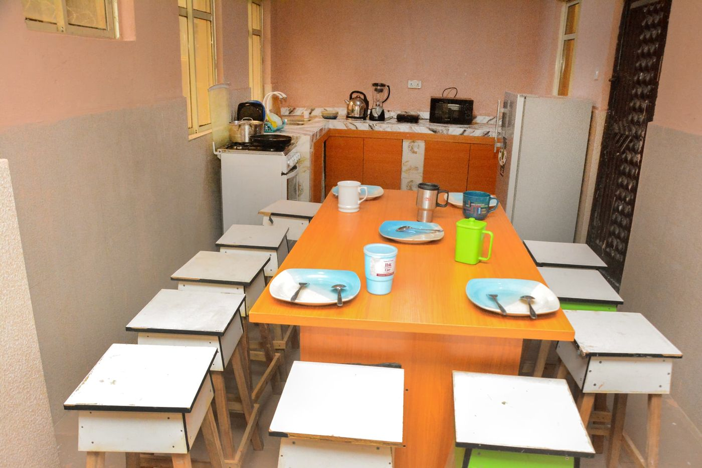
The Dining Hall

Technology and the Record
The Digital Campus

Alongside its classrooms Sultan Hanafi Royal Schools maintains an institutional digital campus. Every certificate conferred today carries a unique certificate number, a verification code and a QR code entered in the register of the Office of the Registrar, and may be authenticated from any device by any holder or employer, without contacting the school.
The same registry issues institutional identity numbers to students and to staff, each independently verifiable; guardians, students and officers hold distinct portals secured by one-time verification at sign-in; and the Office of Finance issues invoices and receipts that verify publicly against their own record.
Verifiable certificates
Number, code and QR, registered at issue
Institutional identity
Numbered and verifiable for student and officer
Guardian and student portals
Distinct access, one-time verification
The Registrar’s Office
Promotion, graduation, transfer, certification
Public receipt verification
Every invoice and receipt checkable
An installable campus
The school as an application, on any device
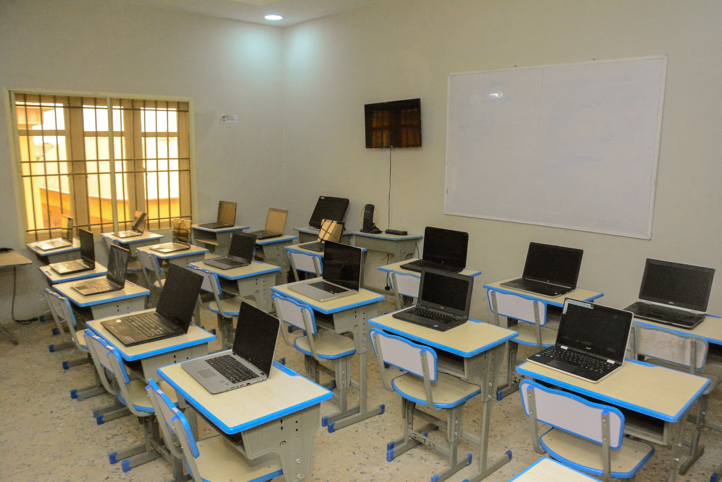
ICT Laboratory
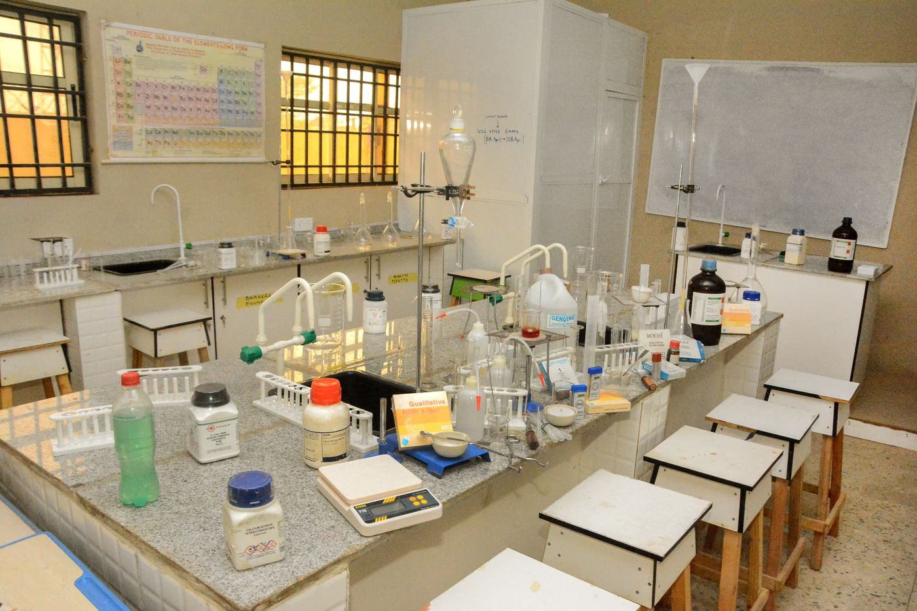
Chemistry Laboratory


The Roll of
The Graduands

45  Awards conferred | 32  Graduands
7  Award rolls | 4  Schools

Class of 2026
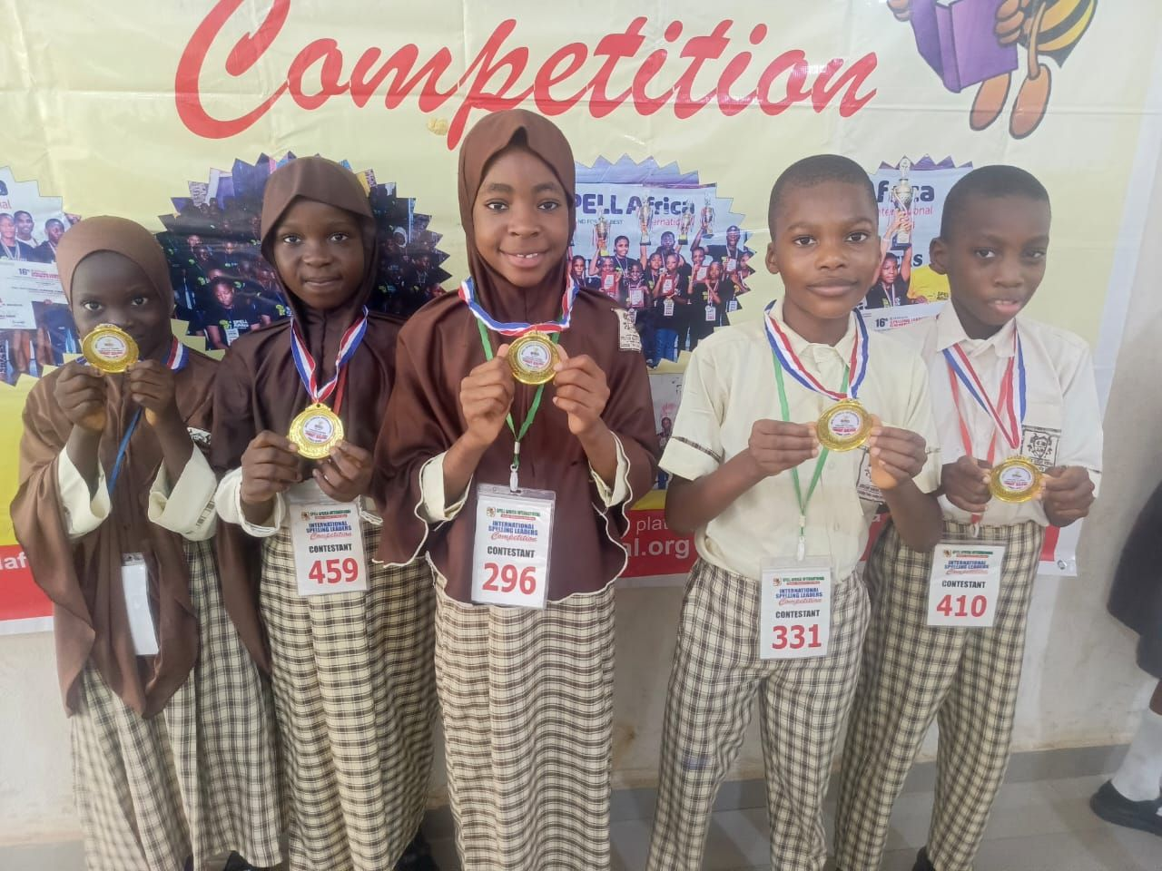
Spelling Competition

Class of 2026
The Graduands

Each graduand named here has completed the requirements of their programme and is admitted to the award beneath their school. One who has completed two programmes is named under each.
حفظ القرآن الكريم
Ḥifẓ of the Glorious Qur’an
Sultan Hanafi Qur’an College
1. Aisha Omoshalewa Anofi
2. Baqi Olamiposi Anofi
3. Sofiah Anofi
4. Zaynab Zakariya Anofi
المرحلة التمهيدية
Tamhīdiyyah
Sultan Hanafi School of Islamic and Arabic Studies
1. Abdulbasit Adedokun
2. Muhammad Fatih
المرحلة الابتدائية
Ibtidā’iyyah
Sultan Hanafi School of Islamic and Arabic Studies
1. Abdulateef Adedokun
2. Aisha Omoshalewa Anofi
3. Ameerah Abdulhafeez
4. Ashraf Korede Ojewumi
5. Faridah Ayomide Aliu
6. Hameedah Adebimpe Ojewumi
7. Imran Iremide Adegoke
8. Muhammad Ismail Seriki
9. Naheemah Ismail Seriki

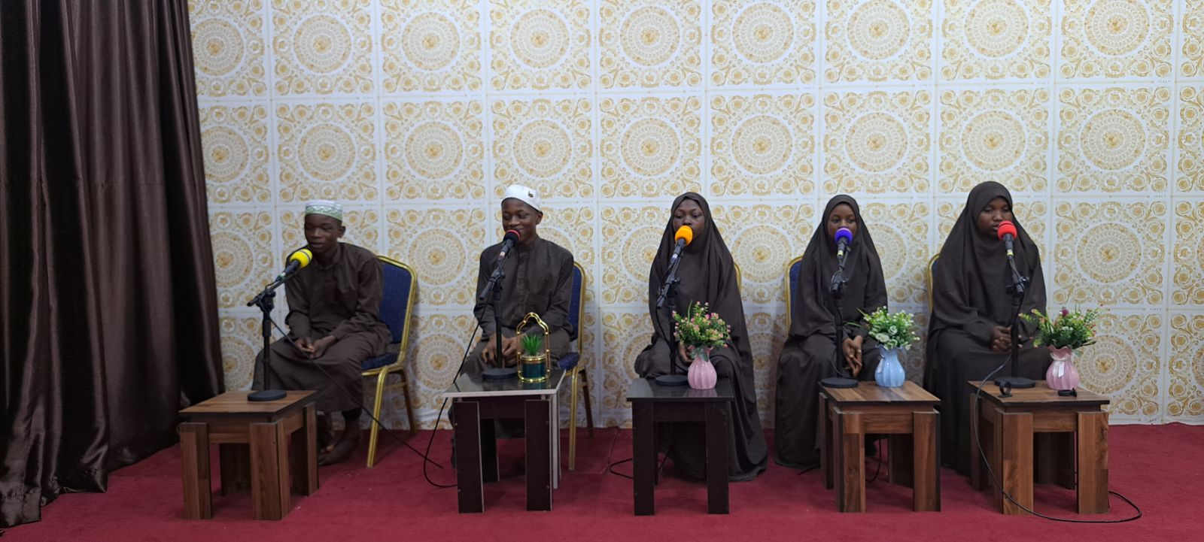
Qur’an Recitation

Class of 2026
The Graduands · continued

المرحلة الإعدادية
I‘dādiyyah
Sultan Hanafi School of Islamic and Arabic Studies
1. Abdullah Oladimeji Anofi
2. Yaseer Balogun
3. Baqi Olamiposi Anofi
4. Abdulbasit Amobi Jabarr
5. Thoirah Makinde
Primary School Graduation
Sultan Hanafi Nursery and Primary School
1. Aisha Lawal
2. Al-ameen Okoh
3. Ashraf Korede Ojewumi
4. Daud Aliu
5. Imran Iremide Adegoke
6. Naheemah Ismail Seriki

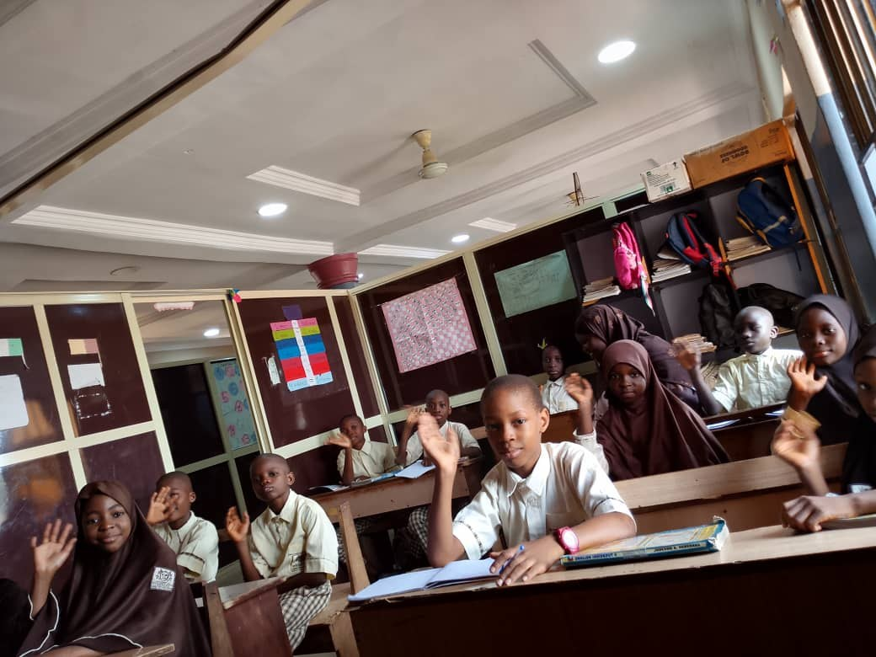
A Classroom in Session

Class of 2026
The Graduands · continued

Junior Secondary School Graduation
Sultan Hanafi Royal College
1. Abdulrahman Abdullah
2. Aisha Omoshalewa Anofi
3. Allison Ganiyah
4. Ameerah Abdulhafeez
5. Ameerah Durodola
6. Anisa Opeyemi Jokomba
7. Baqi Olamiposi Anofi
8. Faridah Ayomide Aliu
9. Fatimah Desire Ibrahim
10. Fawaz Owolabi
11. Hameedah Adebimpe Ojewumi
12. Jubril Lawal
13. Muhammad Ismail Seriki
14. Radiah Apatira
15. Sa'ad Sanusi
Senior Secondary School Graduation
Sultan Hanafi Royal College
1. Abdulbasit Amobi Jabarr
2. Aisha Shode
3. Mazeed Hassan-Murtala
4. Thoirah Makinde

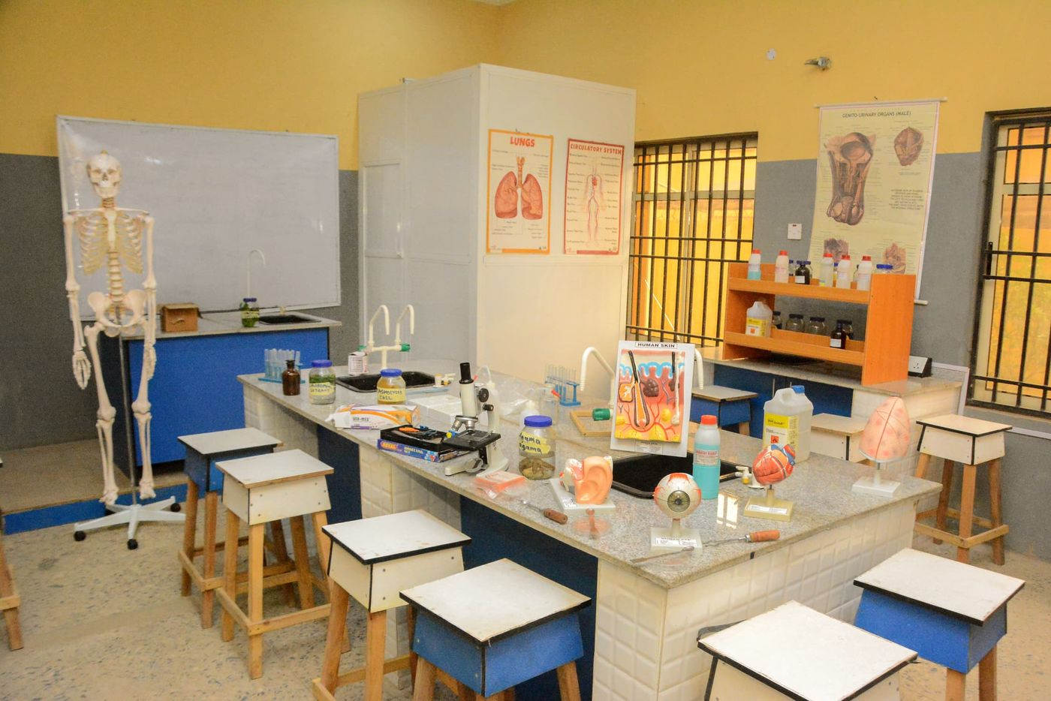
The Biology Laboratory

