
Office Of Institutional Planning · Restricted · Senate & Board Distribution
Al-Mulk International University
COMPENDIUM
Institutional Governance Compendium
Version 4.0 · Final Edition
Document Reference AMIU-IGC-004
edu.amiu.com · Texas-Domiciled, Religiously Exempt · Incorporated 6 December 2027

Document Control
Document Control No. | AMIU-IGC-004
Version | 4.0 (Final Edition)
Effective Date | 1 January 2028
Classification | Restricted — Senate & Board Distribution
Prepared By | Office of Institutional Planning
Approved By | University Senate
Companion Volumes | Constitution (AMIU-CON-001); Strategic Implementation Blueprint 2028–2050 (AMIU-SB-002); Academic Handbook (AMIU-ACAH-001); Student Policies Handbook (AMIU-STUH-001); Operations Handbook (AMIU-OPSH-001); Legal & Compliance Handbook (AMIU-LEGH-001); Marketing & Communications Handbook (AMIU-MKTH-001); Waqf & Research Handbook (AMIU-WAQH-001)
This Compendium is the definitive policy and procedural framework of Al-Mulk International University. It operationalizes the governance architecture the Constitution establishes; where any provision of this Compendium conflicts with the Constitution, the Constitution governs.
Typesetting and Publication Design: this Compendium is set in the same three-role editorial system as the University’s Constitution and Strategic Implementation Blueprint — Fraunces display, Source Serif 4 reading, Archivo structural — so that every AMIU governing and planning publication reads as one institutional family, produced under one publication standard.

Governance Declaration
Presented for endorsement by the University Senate
This Institutional Governance Compendium constitutes the definitive governance and policy framework of Al-Mulk International University. It establishes the institutional structure, articulates the core values, defines the roles and responsibilities of all governing bodies, and provides a comprehensive inventory of the 108 policies, procedures, and governance instruments required for the operation of the University.
Where the Constitution (AMIU-CON-001) sets the University’s supreme legal architecture, this Compendium sets the operational detail beneath it: who is responsible for each policy, who approves it, and on what schedule it is to be developed. Twenty-five Sections, organized across institutional identity, governance hierarchy, phased growth, compensation philosophy, and the complete document registry, make up its full architecture.
Certified for Executive Release — Founding-Decade Edition

Preamble
In the Name of Allah, the Most Gracious, the Most Merciful.
Al-Mulk International University (AMIU) is established as a Texas-registered, religiously-exempt institution of higher Islamic learning. Its founding purpose is the dissemination of authentic Islamic knowledge across the globe at the minimum possible cost, ensuring that no sincere seeker of knowledge is turned away due to financial constraint.
The University operates primarily as an online and distance learning institution, serving students across all time zones and continents. This mode of delivery is integral to the University’s mission of spreading Islamic education worldwide without barriers.
This Compendium serves as the authoritative reference for all institutional governance and policy matters. It articulates the University’s mission, vision, and core values; establishes the institutional governance structure; defines the roles and responsibilities of all governing bodies; lists all 108 institutional policies, procedures, and governance instruments; assigns clear accountability for each document; provides a phased growth framework for offices and committees; sets forth the compensation philosophy and framework; and establishes governance provisions for online and distance learning.

Governance Architecture
How authority is divided between the Board, the President, and the University’s two parallel operating chambers.
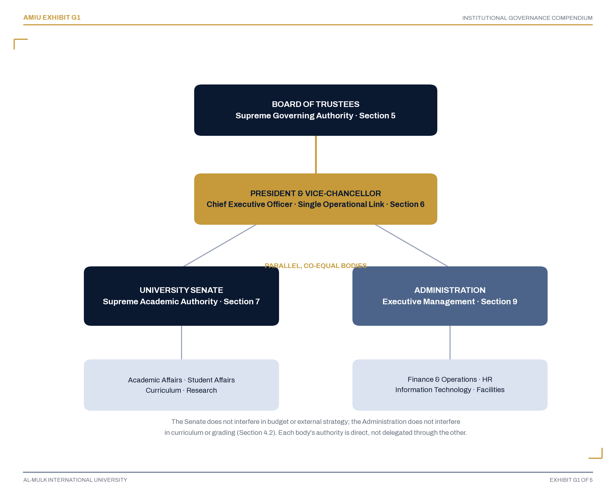
Governance Hierarchy: Parallel Chambers Under a Single Executive Link
Exhibit G1. AMIU Governance Hierarchy (Section 4)
The University Senate and the Administration are parallel, co-equal bodies, each supreme within its own domain, reporting through the President & Vice-Chancellor as the single operational link to the Board of Trustees. Section 4.2 governs the non-interference principle between them in full.

Institutional Growth
How AMIU’s offices and committees expand in step with enrollment, from a lean 15-unit launch structure to a 48-unit mature institution.
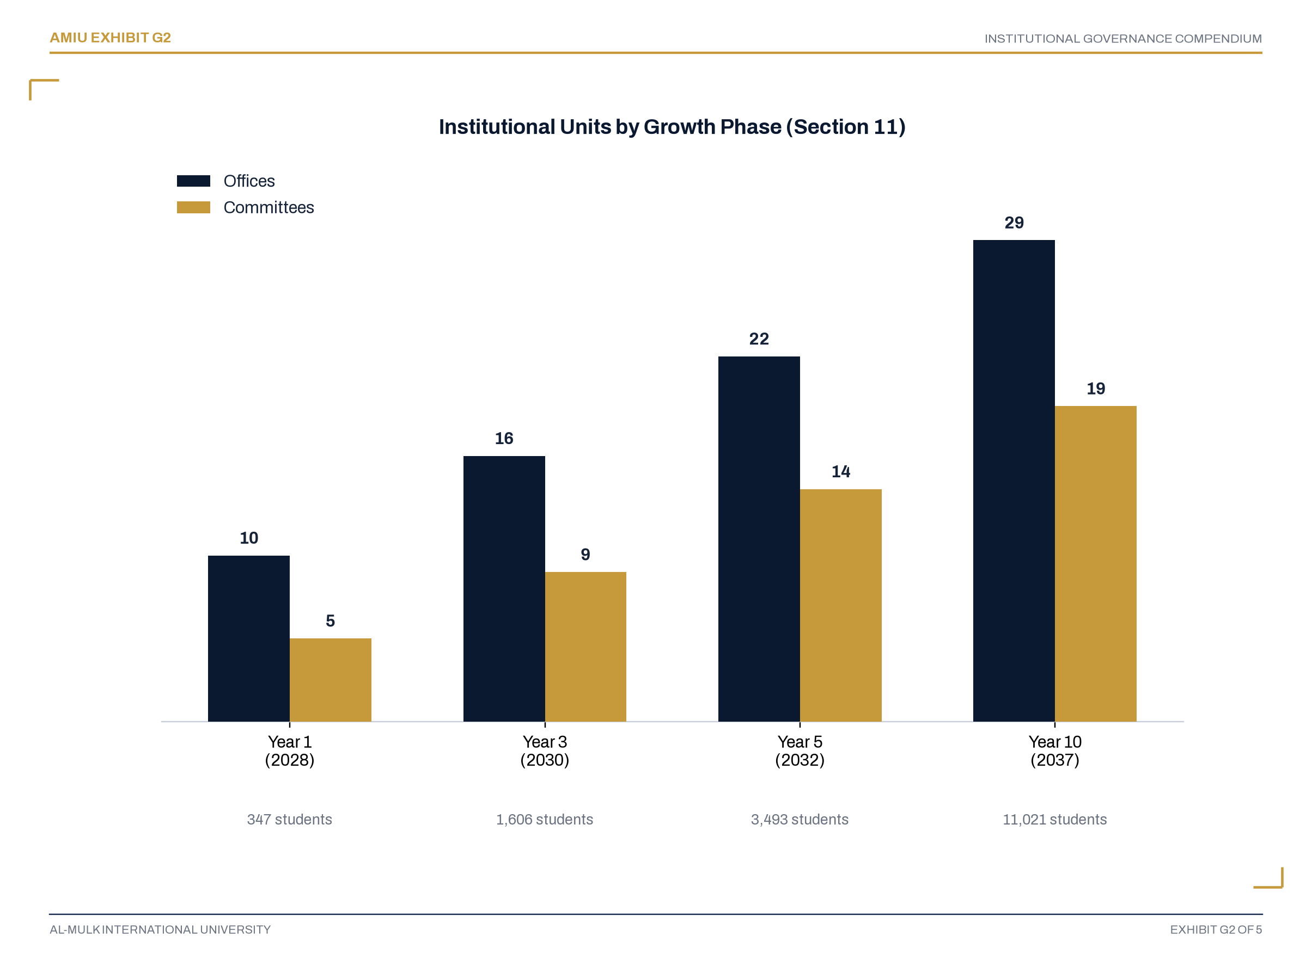
Institutional Units by Growth Phase
Exhibit G2. Phased Institutional Growth, Year 1 through Year 10 (Section 11)
Every office and committee added at Year 3, Year 5, and Year 10 is additive to the prior phase’s structure — nothing is restructured or replaced, only expanded. Section 11.4 governs the enrollment and faculty thresholds that trigger each expansion.

Document Registry
The complete inventory of policies, procedures, and governance instruments this Compendium assigns, tracks, and schedules.
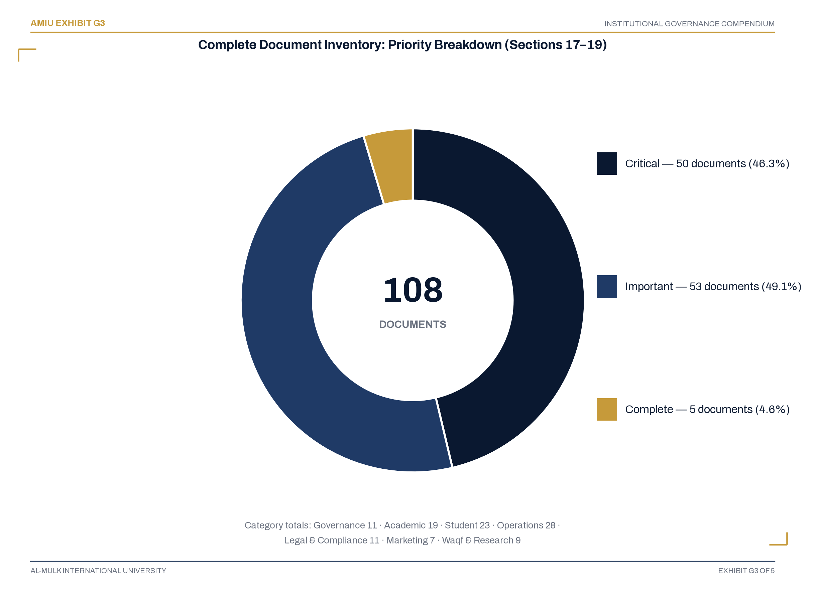
Complete Document Inventory: Priority Breakdown
Exhibit G3. The 108-Document Registry by Priority (Sections 17–19)
Five documents are already complete; the remaining 103 are scheduled across four development phases in Section 22. The priority counts shown here are generated directly from the itemized registry in Section 17, so they can never diverge from it.

Table of Contents
Document Control | 2
Governance Declaration | 4
Preamble | 5
Governance Architecture | 3
Institutional Growth | 7
Document Registry | 4
Section 1 — Introduction & Purpose | 13
Section 2 — Institutional Identity | 18
Section 3 — The ISLAMIC Framework: Core Values | 24
Section 4 — Governance Hierarchy & Roles | 28
Section 5 — Board of Trustees: Composition, Roles & Requirements | 33
Section 6 — President & Vice-Chancellor: Role & Authority | 39
Section 7 — University Senate: Composition, Rules & Procedures | 43
Section 8 — Advisory & Proposing Framework | 52
Section 9 — Administration: Deputy Vice-Chancellors, Deans & Directors | 56
Section 10 — Online & Distance Learning Governance | 63
Section 11 — Phased Institutional Growth Framework | 66
Section 12 — Year 1: Core Institutional Structure | 70
Section 13 — Year 3: Expanded Structure | 75
Section 14 — Year 5: Mature Structure | 79
Section 15 — Year 10: Full Institutional Structure | 83
Section 16 — Compensation Philosophy & Framework | 88
Section 17 — Complete Document Inventory | 94
Section 18 — Document Registry by Category | 107
Section 19 — Priority Ranking & Development Urgency | 122
Section 20 — Responsibility Assignment Matrix | 125
Section 21 — Cross-Reference Matrix | 143
Section 22 — Implementation Roadmap | 147
Section 23 — Senate Resolution & Endorsement | 151
Section 24 — Glossary of Terms | 156
Section 25 — List of Acronyms | 159
Adoption | 161
Publication Certification Statement | 162

Main Contents

Section 1 of 25
01
Introduction & Purpose
Subsections 1.1–1.5
“One authoritative reference for every institutional governance and policy matter the University will face.”
Subsections
1.1 Preamble
1.2 Purpose of This Compendium
1.3 Scope of This Compendium
1.4 Governance Principles
1.5 Document Numbering System

Section 1 · 1.1

1.1 Preamble
In the Name of Allah, the Most Gracious, the Most Merciful.
Al-Mulk International University (AMIU) is established as a Texas-registered, religiously-exempt institution of higher Islamic learning. Its founding purpose is the dissemination of authentic Islamic knowledge across the globe at the minimum possible cost, ensuring that no sincere seeker of knowledge is turned away due to financial constraint.
The University operates primarily as an online and distance learning institution, serving students across all time zones and continents. This mode of delivery is integral to the University’s mission of spreading Islamic education worldwide without barriers.
This Institutional Governance Compendium constitutes the definitive governance and policy framework for the University. It establishes the institutional structure, articulates the core values, defines the roles and responsibilities of all governing bodies, and provides a comprehensive inventory of all policies, procedures, and governance instruments required for the operation of the University.
Section 1 · 1.2

1.2 Purpose of This Compendium
This Compendium serves as the authoritative reference for all institutional governance and policy matters. It:
1.2.1 Articulates the University’s mission, vision, and core values;
1.2.2 Establishes the institutional governance structure;
1.2.3 Defines the roles and responsibilities of all governing bodies;
1.2.4 Lists all 108 institutional policies, procedures, and governance instruments;
1.2.5 Assigns clear accountability for each document;
1.2.6 Provides a phased growth framework for offices and committees;
1.2.7 Sets forth the compensation philosophy and framework;
1.2.8 Establishes governance provisions for online and distance learning.
Section 1 · 1.3

1.3 Scope of This Compendium
1.3.1 This Compendium applies to all institutional documents, policies, procedures, and governance instruments of Al-Mulk International University.
1.3.2 This Compendium covers documents across all seven handbook categories as approved by the University Senate.
1.3.3 This Compendium is effective as of 1 January 2028 and shall be reviewed annually by the University Senate.
1.3.4 This Compendium is the authoritative source for institutional governance, policy status, and responsibility assignment.
Section 1 · 1.4

1.4 Governance Principles
This Compendium is founded upon the following governance principles:
Principle | Application
Phased Growth | Institutional structure expands strategically as enrollment and faculty grow.
Separation of Powers | No single individual serves as both Policy Steward and sole Approval Authority.
Accountability | Every document has a clearly designated steward.
Transparency | All documents are publicly available, except where legally restricted.
Mission-Driven Service | All contributions are framed as service to the Ummah.
Revenue-Linked Sustainability | Compensation and operations scale with institutional revenue.
Online-First Delivery | All governance and operations assume a primarily online delivery model.
Global Accessibility | All policies accommodate students across time zones and regions.
Knowledge Without Barriers | The University is committed to removing all barriers to Islamic education.
Section 1 · 1.5

1.5 Document Numbering System
Each document is assigned a unique identifier following this convention:
Element | Format | Example
Prefix | AMIU | AMIU
Category Code | GOV, ACA, STU, OPS, LEG, MKT, WAQ | AMIU-GOV
Sequential Number | 001-999, counted within its own category | AMIU-GOV-001
Version | V-1.0 | AMIU-GOV-001-V1.0
Category Codes
Code | Category | Description
GOV | Governance | Board, Senate, and institutional governance documents
ACA | Academic | Program, curriculum, faculty, and academic policy documents
STU | Student | Student conduct, services, and support documents
OPS | Operations | Finance, HR, IT, facilities, and operational documents
LEG | Legal & Compliance | Legal, regulatory, and compliance documents
MKT | Marketing | Brand, communications, and marketing documents
WAQ | Waqf & Research | Endowment, fundraising, research, and risk documents
Note: the Sequential Number in a document’s code (e.g. the “003” in AMIU-GOV-003) counts only within that document’s own category — it is not the same as the flat 1-108 numbering used for reference in Sections 17 and 20. Section 17’s “Doc Code” column gives both side by side for every document, so the two schemes are never in doubt.

Section 2 of 25
02
Institutional Identity
Subsections 2.1–2.7
“A Texas-domiciled religious university built on a seven-tier academic ladder and six founding colleges.”
Subsections
2.1 Legal Identity
2.2 Mission
2.3 Vision (2037)
2.4 Tagline
2.5 The AMIU Commitment
2.6 The Academic Ladder
2.7 The Six Colleges

Section 2 · 2.1

2.1 Legal Identity
Attribute | Detail
Legal Name | Al-Mulk International University
Acronym | AMIU
Tagline | Knowledge Without Barriers
Legal Status | Texas Nonprofit Religious Educational Corporation
Legal Domicile | State of Texas, United States of America
Date of Incorporation | 6 December 2027
Academic Operations Commence | 1 January 2028
Primary Mode of Delivery | Online and Distance Learning
Section 2 · 2.2

2.2 Mission
“To spread Islamic education all over the world at the minimum possible cost, covering the needy without condition, through a rigorous, stackable, seven-tier credential ladder that never sacrifices academic seriousness for accessibility, and never sacrifices financial self-sufficiency for good intentions.”
Section 2 · 2.3

2.3 Vision (2037)
“For Al-Mulk International University to be internationally recognized as a leading English-medium Islamic university — financially independent, fully accredited in every jurisdiction in which it operates, and proof that a religious university can serve the poorest students in the world at near-zero cost while remaining permanently self-sustaining.”
Section 2 · 2.4

2.4 Tagline
“Knowledge Without Barriers”
Section 2 · 2.5

2.5 The AMIU Commitment
“AMIU is not a commercial institution. Its aim is not money. It is a vehicle for spreading Islamic education worldwide without barriers. Those who serve AMIU do so as a contribution to the Ummah — a form of Jihad through knowledge. Compensation is provided as a means of sustaining service, not as a market-driven wage. The University grows with its mission, and its people grow with it.”
Section 2 · 2.6

2.6 The Academic Ladder
AMIU offers a fully stacked seven-tier academic ladder, with every credential stacking directly into the next:
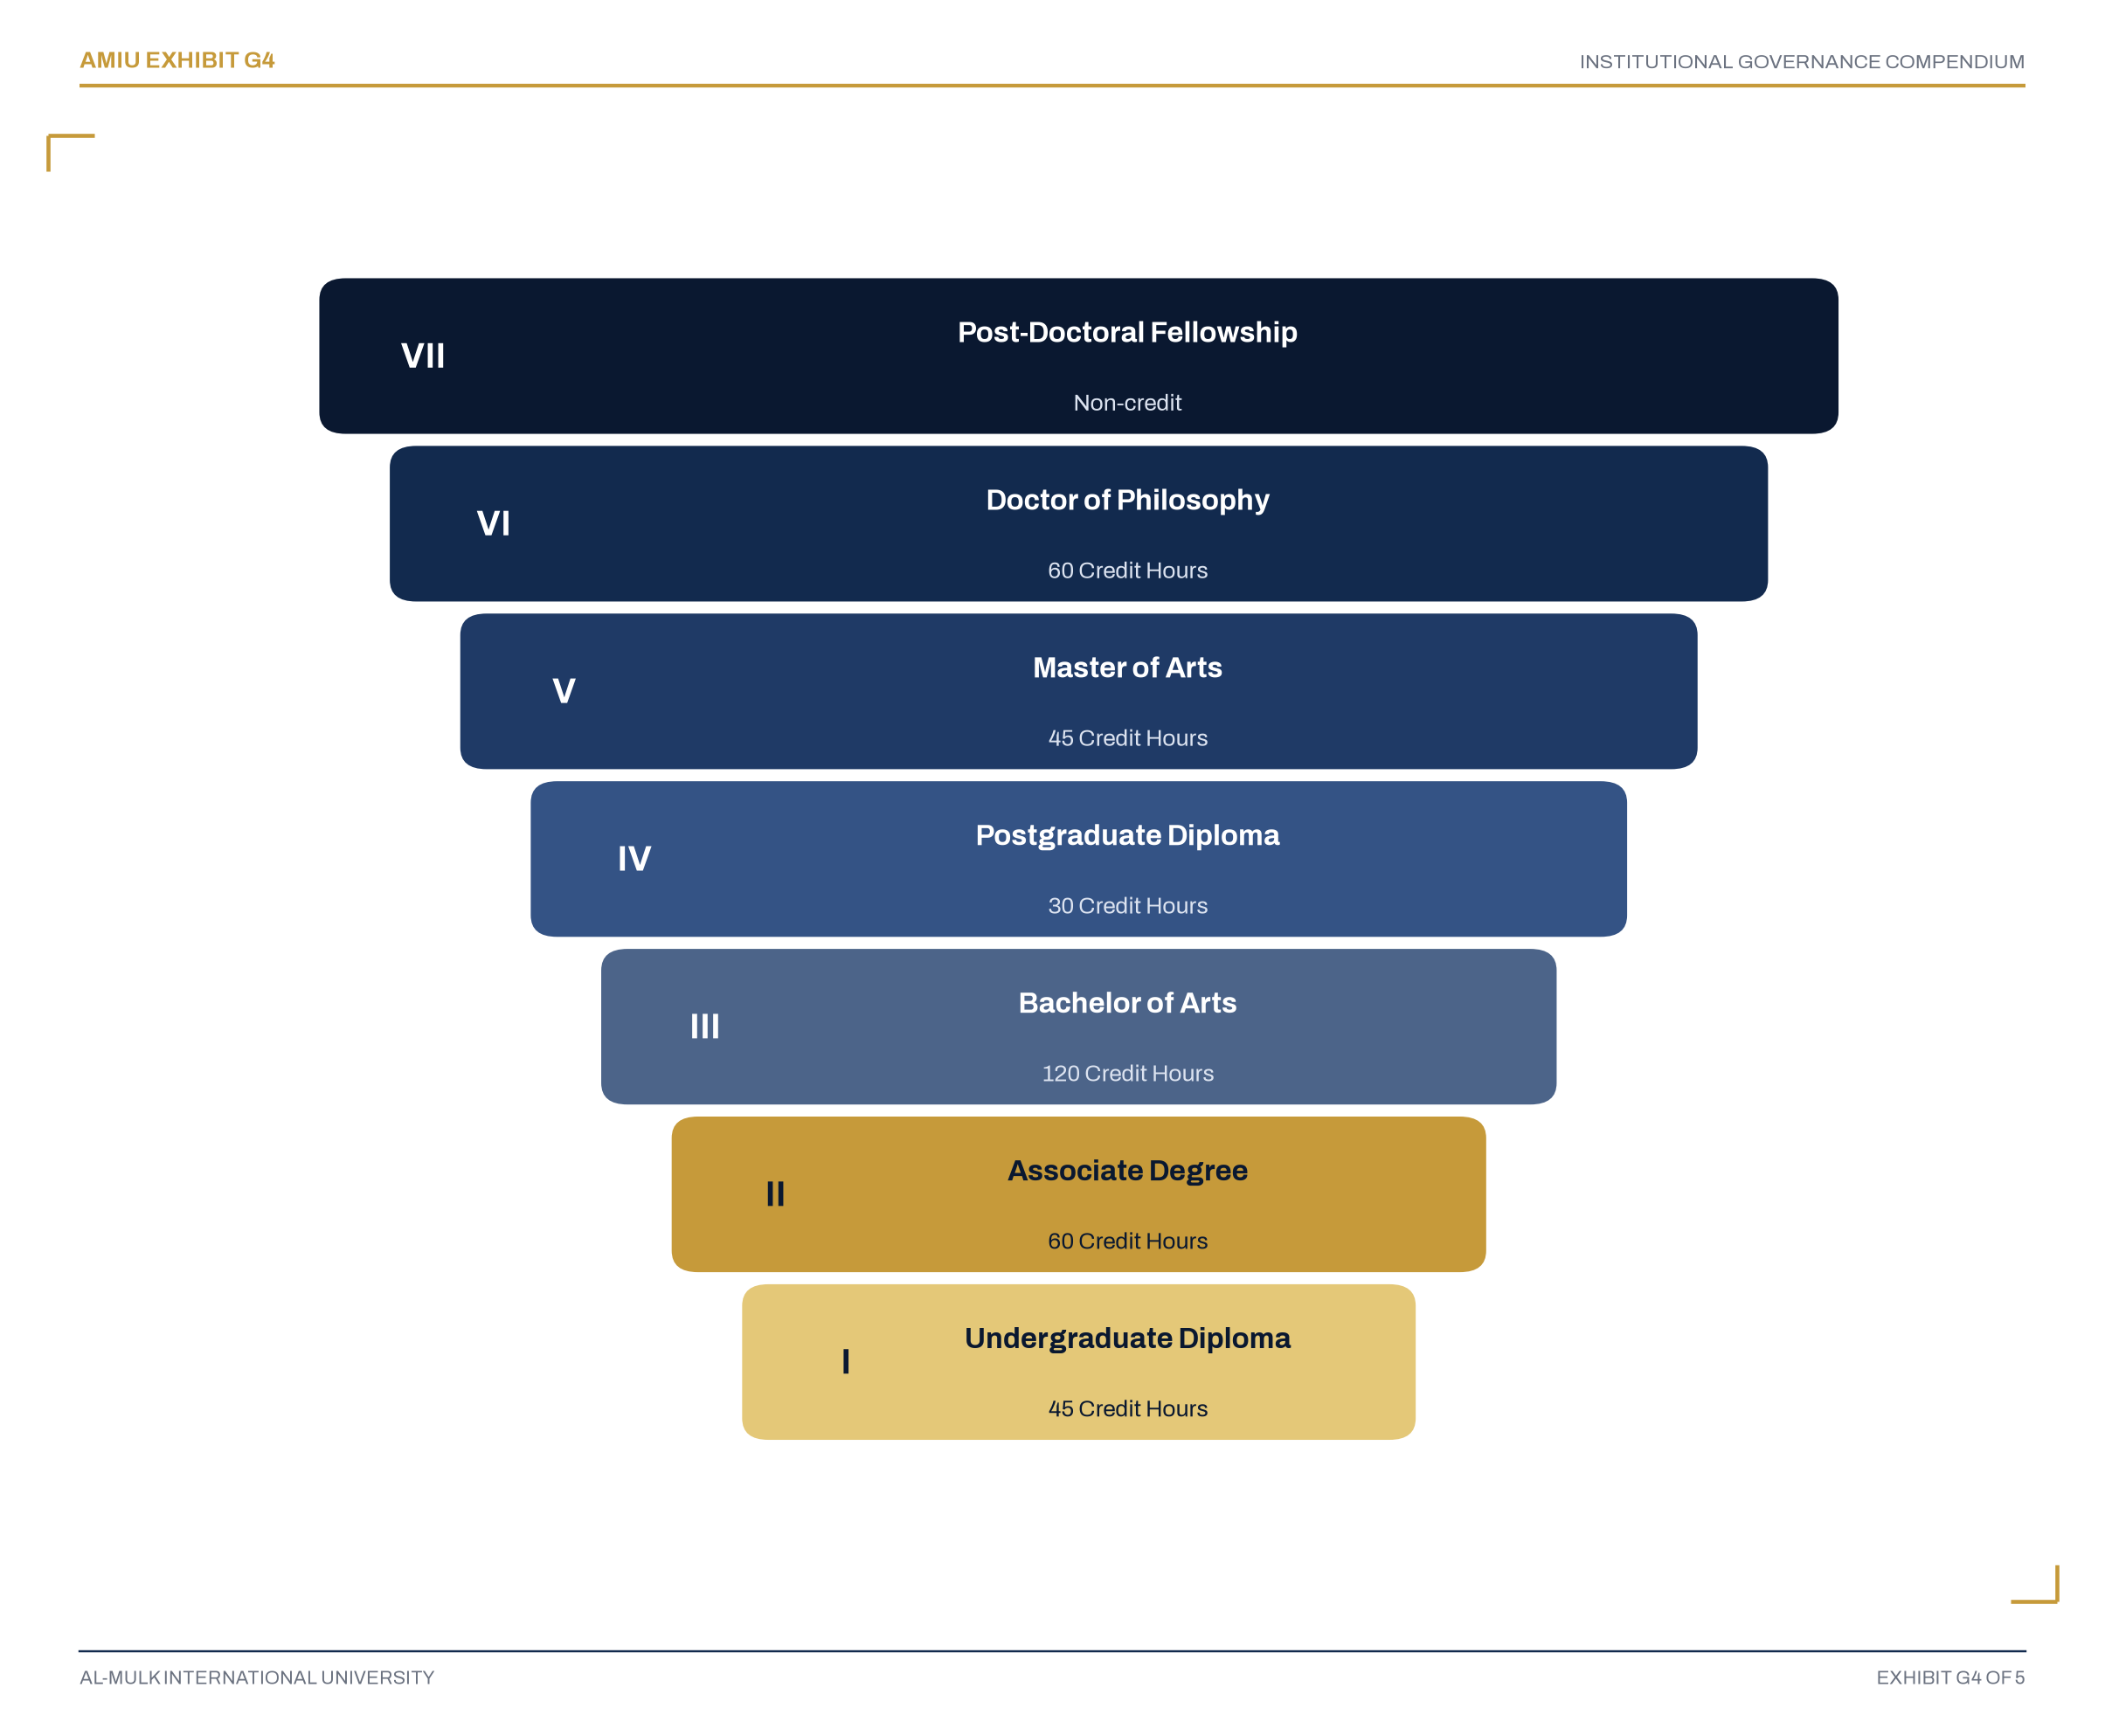
The Seven-Tier Stackable Academic Ladder
Exhibit G4. The Academic Ladder
Every credential stacks directly into the next tier with no credit lost in the climb — from the Undergraduate Diploma at the entry point to the Post-Doctoral Fellowship at its summit. This is the same ladder governed in full by Article X of the Constitution (AMIU-CON-001).
Section 2 · 2.7

2.7 The Six Colleges
Number | College
1 | College of Qur’anic & Hadith Sciences
2 | College of Shari’ah & Islamic Law
3 | College of Islamic Theology & Philosophy (Aqeedah)
4 | College of Arabic Language & Linguistics
5 | College of Da’wah, Islamic Communication & Chaplaincy
6 | College of Islamic Finance, Economics & Waqf Administration

Section 3 of 25
03
The ISLAMIC Framework — Core Values
Subsections 3.1–3.4
“Illumination, Sanad, Love, Access, Morality, Inquiry, Calling — seven values, one binding pledge.”
Subsections
3.1 Introduction
3.2 The ISLAMIC Framework
3.3 The ISLAMIC Framework — Detailed
3.4 The ISLAMIC Pledge

Section 3 · 3.1

3.1 Introduction
The University is guided by the ISLAMIC framework — a foundation upon which all institutional decisions, policies, and practices are built.
Section 3 · 3.2

3.2 The ISLAMIC Framework
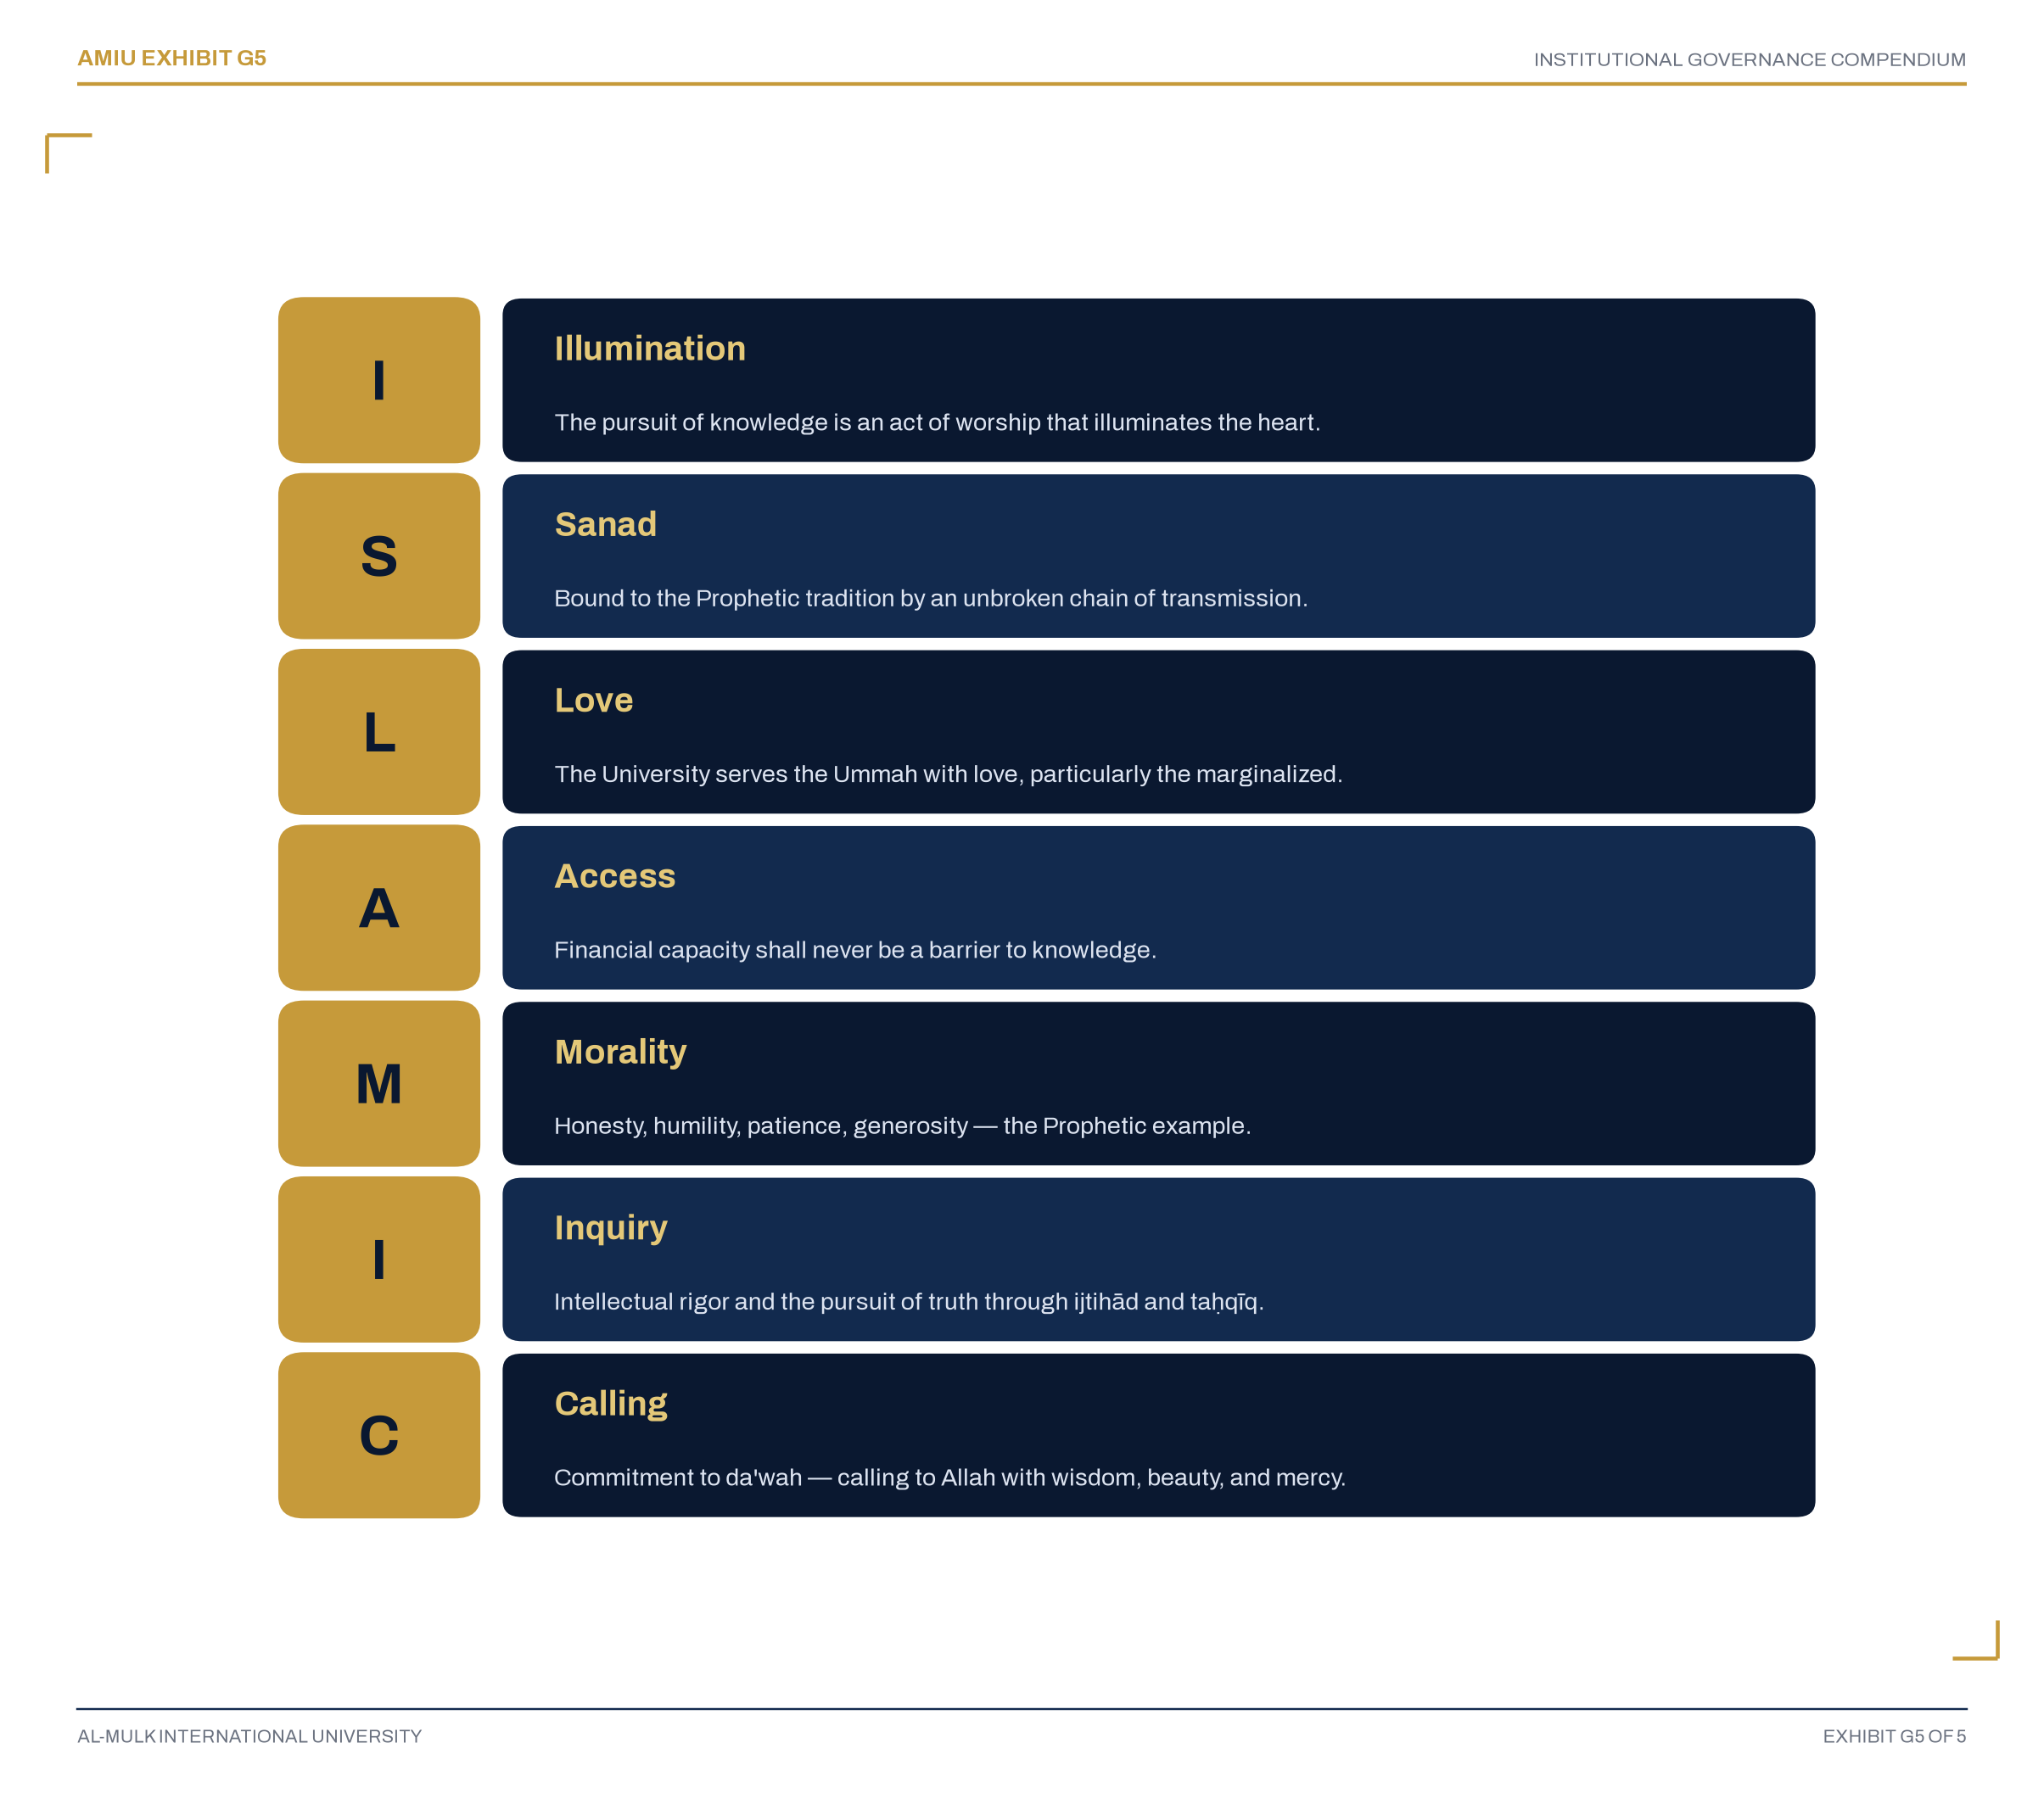
The ISLAMIC Values Framework
Exhibit G5. The ISLAMIC Framework
Illumination, Sanad, Love, Access, Morality, Inquiry, Calling — the same seven values Article III of the Constitution (AMIU-CON-001) makes binding on every person acting in the University’s name. Section 3.3 below sets out each in full.
Section 3 · 3.3

3.3 The ISLAMIC Framework — Detailed
I — Illumination. The pursuit of knowledge is an act of worship that illuminates the heart and draws the seeker closer to Allah. At AMIU, education is not merely the acquisition of information; it is the cultivation of faith, the refinement of the soul, and the awakening of the intellect to the signs of Allah. All academic pursuits are grounded in the Qur’an and Sunnah, and all scholarship is directed toward the service of Allah and the betterment of humanity.
S — Sanad. AMIU is bound to the Prophetic tradition by an unbroken golden chain of transmission (sanad). Every faculty appointment is traceable to a documented chain of study, training, and authorization. This sacred chain ensures that the knowledge imparted is authentic, trustworthy, and rooted in the tradition.
L — Love. The University exists to serve the Ummah with love and dedication. Its primary purpose is the dissemination of Islamic knowledge to every corner of the world, with particular attention to those who are marginalized, impoverished, or otherwise deprived of access to authentic Islamic education.
A — Access. Guided by the Qur’anic principles of compassion (rahmah) and justice (ʿadl), AMIU ensures that financial capacity shall never be a barrier to knowledge. The University opens its doors to all, regardless of economic status, nationality, or circumstance.
M — Morality. AMIU cultivates not only knowledgeable scholars but also virtuous human beings. The University is committed to the purification of character (tazkiyah) and the inculcation of noble virtues (akhlāq) — honesty, humility, patience, generosity, and compassion.
I — Inquiry. AMIU encourages intellectual rigor, critical inquiry, and the pursuit of truth. The University cultivates scholars who are both deeply rooted in the Islamic tradition and equipped to engage with contemporary challenges through ijtihād (independent reasoning) and taḥqīq (critical investigation).
C — Calling. AMIU is committed to the noble mission of da’wah — calling to Allah with wisdom, beauty, and mercy. Through its graduates, publications, and outreach programs, the University spreads the message of Islam with compassion, excellence, and profound respect for all humanity.
Section 3 · 3.4

3.4 The ISLAMIC Pledge
“As members of Al-Mulk International University, we commit ourselves to:
Illumination — that our knowledge may be light; Sanad — that our scholarship may be authentic; Love — that our service may be devoted; Access — that no soul may be denied; Morality — that our character may reflect the Prophet, peace be upon him; Inquiry — that our thought may be rigorous; Calling — that our da’wah may be with wisdom.
These are our values. This is our promise to the Ummah.”

Section 4 of 25
04
Governance Hierarchy & Roles
Subsections 4.1–4.4
“The Senate teaches and the Administration executes — parallel authorities, not a chain of command.”
Subsections
4.1 The Governance Hierarchy
4.2 The Board-Senate Relationship
4.3 Senate Authority — Defined
4.4 Governance Structure — Exhibit G1

Section 4 · 4.1

4.1 The Governance Hierarchy
The University operates under a clear governance hierarchy, reflecting the standard bicameral model of higher education. The Board and Senate are supreme in their own domains rather than ranked one above the other — Exhibit G1 and Section 4.2 govern how the two chambers relate in full.
Tier | Body | Role
1 | Board of Trustees | Supreme Governing Authority — responsible for the long-term strategy, financial health, and legal integrity of the University.
2 | President & Vice-Chancellor | Chief Executive Officer — the single operational link between the Board and the Senate.
3 | University Senate | Supreme Academic Authority — responsible for curriculum, standards, examinations, and degrees.
3 | Administration | Executive Management — the administrative arm that implements policies under the leadership of the President.
Note: the Senate and the Administration are placed at the same Tier 3 deliberately. Both report through the President as Tier 2, but neither is subordinate to the other — Section 4.2’s non-interference principle and Exhibit G1’s diagram both establish them as parallel, co-equal bodies, not a fourth link in a single chain.
Section 4 · 4.2

4.2 The Board-Senate Relationship
The Board and Senate maintain a relationship of mutual respect and separation of powers:
Principle | Application
Strategic vs. Academic | The Board governs; the Senate teaches.
Non-Interference | The Board shall not interfere in curriculum or grading. The Senate shall not interfere in budget allocation or external strategy.
Advisory Role | The Senate advises the Board on academic matters. The Board consults the Senate on financial matters affecting academic quality.
The President as Link | The President ensures the Board’s vision and the Senate’s standards are executed efficiently.
Section 4 · 4.3

4.3 Senate Authority — Defined
Area | Authority
Academic Programs | Full authority to approve, modify, or discontinue academic programs.
Academic Standards | Full authority to set and enforce academic standards.
Faculty Appointments | Full authority to approve faculty appointments through the Faculty Affairs Committee.
Faculty Promotions | Full authority to approve faculty promotions through the Faculty Affairs Committee.
Degree Conferrals | Full authority to ratify all degrees and certificates.
Academic Budget | Advisory authority — recommends allocation to the Board through the President.
Tuition Setting | No authority — this is the Board’s exclusive responsibility.
Staff Hiring | No authority — this is the Administration’s responsibility.
Non-Academic Budget | No authority — this is the Board’s and Administration’s responsibility.
Section 4 · 4.4

4.4 Governance Structure — Exhibit G1
The University’s governance structure is presented in full in Exhibit G1 (Governance Architecture, preceding the Table of Contents): the Board of Trustees at the apex, the President & Vice-Chancellor as the single operational link beneath it, and the University Senate and Administration as parallel, co-equal bodies beneath the President — each supreme within its own domain, neither subordinate to the other.

Section 5 of 25
05
Board of Trustees — Composition, Roles & Requirements
Subsections 5.1–5.6
“Five to nine Trustees, three-year terms, and fiduciary responsibility for the institution's long-term health.”
Subsections
5.1 Role & Authority
5.2 Composition
5.3 Chairperson of the Board
5.4 Trustee Requirements
5.5 Board of Trustees Key Responsibilities
5.6 Board of Trustees — Summary

Section 5 · 5.1

5.1 Role & Authority
The Board of Trustees is the supreme governing authority of Al-Mulk International University. It holds fiduciary responsibility for the institution’s long-term health, strategic direction, and legal compliance.
Section 5 · 5.2

5.2 Composition
Category | Number | Description
Trustees | 5-9 | External members with expertise in finance, law, education, business, and community leadership
Ex-Officio Members | 2 | President & Vice-Chancellor; Secretary to the Board
Total | 7-11
Section 5 · 5.3

5.3 Chairperson of the Board
Attribute | Detail
Role | The Chairperson is the principal officer of the Board and the highest-ranking governance official of the University.
Appointment | Elected by the Board of Trustees from among its members.
Term | Three years, renewable once.
Responsibilities | Presides over Board meetings; sets Board agenda; represents the Board externally; ensures Board effectiveness; leads Board evaluation.
Succession | Vice-Chairperson assumes role in case of vacancy until election.
Section 5 · 5.4

5.4 Trustee Requirements
Requirement | Detail
Qualification | Demonstrated expertise in at least one of: finance, law, education, business, nonprofit governance, or community leadership.
Faith Commitment | Must be a practicing Muslim with commitment to the University’s Islamic mission. This is permitted under Texas religious exemption and ensures spiritual alignment with the University’s purpose.
Term | Three years, renewable once, for a maximum of six years.
Age | Minimum 30 years.
Residency | No residency requirement; meetings may be held virtually.
Conflict of Interest | Must disclose all potential conflicts annually.
Attendance | Must attend at least 75% of Board meetings annually.
Section 5 · 5.5

5.5 Board of Trustees Key Responsibilities
Responsibility | Detail
Appointment | Appoints and evaluates the President & Vice-Chancellor
Budget | Approves the annual budget and major financial decisions
Strategy | Sets institutional strategy and long-term vision
Sustainability | Ensures financial sustainability and legal compliance
Policy Approval | Approves major policies and governance documents
Oversight | Oversees the University Senate through the President
Audit | Ensures proper financial audit and internal controls
Section 5 · 5.6

5.6 Board of Trustees — Summary
Attribute | Detail
Chairperson | Elected from among Trustees; 3-year term; renewable once
Members | 5-9 Trustees plus 2 Ex-Officio
Term | 3 years; renewable once, maximum 6 years
Meeting Frequency | Quarterly, minimum
Meeting Format | In-person or virtual

Section 6 of 25
06
President & Vice-Chancellor — Role & Authority
Subsections 6.1–6.3
“The single operational link between the Board's strategy and the Senate's standards.”
Subsections
6.1 Role & Authority
6.2 President Requirements
6.3 President Key Responsibilities

Section 6 · 6.1

6.1 Role & Authority
The President & Vice-Chancellor is the chief executive officer of the University, responsible for the overall leadership, administration, and execution of the Board’s strategic vision.
Section 6 · 6.2

6.2 President Requirements
Requirement | Detail
Qualification | Doctoral degree (Ph.D. or equivalent) from a recognized university.
Experience | Minimum 10 years of senior leadership experience in higher education or a related field.
Faith Commitment | Practicing Muslim with demonstrated commitment to Islamic education.
Term | Five years, renewable once, for a maximum of ten years.
Age | Minimum 40 years.
Residency | Must reside in the United States or be willing to relocate.
Accountability | Reports to the Board of Trustees.
Section 6 · 6.3

6.3 President Key Responsibilities
Responsibility | Detail
Implementation | Implements Board decisions and policies
Leadership | Leads the University’s administration
Senate | Chairs the University Senate
Representation | Represents the University externally
Effectiveness | Ensures institutional effectiveness and efficiency

Section 7 of 25
07
University Senate — Composition, Rules & Procedures
Subsections 7.1–7.9
“Eighteen voting seats across four groups, meeting monthly, deciding by simple majority.”
Subsections
7.1 Role & Authority
7.2 Senate Composition (18 Voting Seats)
7.3 Senate Member Requirements
7.4 Senate Officers
7.5 Senate Key Responsibilities
7.6 Senate Ex-Officio Members (Non-Voting)
7.7 Senate Meetings
7.8 Quorum
7.9 Voting Procedures

Section 7 · 7.1

7.1 Role & Authority
The University Senate is the supreme academic authority of the University, responsible for all matters relating to curriculum, instruction, examinations, and the ratification of all degree programs.
Section 7 · 7.2

7.2 Senate Composition (18 Voting Seats)
Group I — Executive Leadership (3 Seats)
Seat | Role | Appointment
1 | President & Vice-Chancellor (Chairperson) | Ex-Officio
2 | Deputy Vice-Chancellor, Academic Affairs (Vice-Chairperson) | Appointed by President
3 | Deputy Vice-Chancellor, Administration & Finance (Secretary) | Appointed by President
Group II — Academic Operations (5 Seats)
Seat | Role | Appointment
4 | Dean, Qur’anic & Hadith Sciences / Shari’ah & Islamic Law | Appointed by President
5 | Dean, Islamic Theology & Philosophy / Da’wah, Communication & Chaplaincy | Appointed by President
6 | Dean, Arabic Language & Linguistics | Appointed by President
7 | Dean, Islamic Finance, Economics & Waqf Administration | Appointed by President
8 | University Librarian | Appointed by President
Group III — Frontline Instructional Management (6 Seats)
Seat | Role | Appointment
9 | Head of Department, Qur’anic Studies & Tafsir | Appointed by DVC Academic
10 | Head of Department, Hadith Sciences | Appointed by DVC Academic
11 | Head of Department, Shari’ah & Fiqh | Appointed by DVC Academic
12 | Head of Department, Aqeedah & Islamic Philosophy | Appointed by DVC Academic
13 | Head of Department, Arabic Language & Linguistics | Appointed by DVC Academic
14 | Head of Department, Da’wah & Islamic Communication | Appointed by DVC Academic
Group IV — Institutional & Digital Strategy (4 Seats)
Seat | Role | Appointment
15 | Director of Academic Planning & LMS Infrastructure | Appointed by President
16 | Elected Faculty Representative | Elected by Faculty
17 | Elected Faculty Representative | Elected by Faculty
18 | Elected Faculty Representative | Elected by Faculty
Section 7 · 7.3

7.3 Senate Member Requirements
Requirement | Detail
Qualification | Must hold a doctoral degree (Ph.D. or equivalent) or have equivalent scholarly achievement.
Faith Commitment | Practicing Muslim with commitment to Islamic scholarship.
Term | Three years for appointed members; two years for elected faculty representatives.
Renewal | Appointed members may be reappointed; elected members may seek re-election.
Attendance | Must attend at least 75% of Senate meetings annually.
Disqualification | Members who fail to meet attendance requirements may be removed by Senate resolution.
Section 7 · 7.4

7.4 Senate Officers
Officer | Role | Appointment
Chairperson | President & Vice-Chancellor | Ex-Officio
Vice-Chairperson | Deputy Vice-Chancellor, Academic Affairs | Appointed by President
Secretary | Deputy Vice-Chancellor, Administration & Finance | Appointed by President
Section 7 · 7.5

7.5 Senate Key Responsibilities
Responsibility | Detail
Academic Programs | Approves all academic programs and courses
Academic Standards | Sets academic standards and policies
Degree Ratification | Ratifies all degrees and certificates
Faculty Quality | Oversees faculty quality and development
Advice | Advises the President on academic matters
Section 7 · 7.6

7.6 Senate Ex-Officio Members (Non-Voting)
Member | Role
Undergraduate Student Representative | Appointed by Student Council
Postgraduate Student Representative | Appointed by Graduate Student Association
Staff Representative | Appointed by Staff Council
Section 7 · 7.7

7.7 Senate Meetings
7.7.1 The Senate shall meet at least once per month during the academic semester.
7.7.2 Special meetings may be called by the Chairperson or by written request of any five voting members.
7.7.3 Notice of meetings shall be sent at least seven days in advance.
7.7.4 Meetings may be conducted virtually or in person.
7.7.5 Minutes of all meetings shall be maintained by the Secretary to the Senate.
Section 7 · 7.8

7.8 Quorum
7.8.1 A quorum shall consist of a simple majority of ten of the eighteen voting members.
7.8.2 Ex-officio and observer members do not count toward the quorum requirement.
Section 7 · 7.9

7.9 Voting Procedures
7.9.1 All decisions shall be made by a simple majority of voting members present, provided a quorum exists.
7.9.2 Voting may be conducted by voice vote, show of hands, roll call vote, or secret ballot.
7.9.3 Voting may also be conducted electronically in virtual meetings.
7.9.4 The Chairperson shall vote only in the case of a tie.
7.9.5 Proxy voting is not permitted.

Section 8 of 25
08
Advisory & Proposing Framework
Subsections 8.1–8.3
“Every stakeholder, from Trustee to student, has a defined channel to advise and to propose.”
Subsections
8.1 Purpose
8.2 Advisory and Proposing Framework
8.3 The Governance Principle

Section 8 · 8.1

8.1 Purpose
The University operates on the principle that informed decisions require input from all stakeholders. This section establishes the advisory and proposing framework through which expertise is channeled to decision-making bodies.
Section 8 · 8.2

8.2 Advisory and Proposing Framework
Body | Can Advise? | Can Propose? | To Whom?
Board of Trustees | Yes | Yes | To itself, for internal deliberation
President & Vice-Chancellor | Yes | Yes | To the Board
University Senate | Yes | Yes | To the Board, through the President
Deputy Vice-Chancellors | Yes | Yes | To the President
College Deans | Yes | Yes | To the DVC, Academic Affairs
Faculty | Yes | Yes | To the Senate or Deans
Students | Yes | Yes | To the Senate or Student Affairs
Staff | Yes | Yes | To the Administration
Section 8 · 8.3

8.3 The Governance Principle
“The Senate advises the Board on all matters affecting academic quality and proposes academic initiatives through the President. The Board, in turn, consults the Senate on financial decisions that affect academic delivery. This ensures that academic expertise informs strategic decisions, and strategic decisions support academic excellence.”

Section 9 of 25
09
Administration — Deputy Vice-Chancellors, Deans & Directors
Subsections 9.1–9.7
“Two Deputy Vice-Chancellors, six College Deans, and ten functional Directors execute the University's daily operations.”
Subsections
9.1 DVC, Academic Affairs
9.2 DVC, Administration & Finance
9.3 College Deans
9.4 University Registrar
9.5 Dean of Students
9.6 Directors (Functional Areas)
9.7 Summary Table — All Key Roles

Section 9 · 9.1

9.1 Deputy Vice-Chancellor, Academic Affairs
Attribute | Detail
Role | Chief Academic Officer
Qualification | Doctoral degree (Ph.D. or equivalent)
Experience | Minimum 7 years of academic leadership experience
Term | Five years, renewable
Key Responsibilities | Academic strategy, curriculum, faculty affairs, quality assurance
Reports To | President & Vice-Chancellor
Section 9 · 9.2

9.2 Deputy Vice-Chancellor, Administration & Finance
Attribute | Detail
Role | Chief Operating Officer
Qualification | Master’s degree, minimum; professional certification preferred
Experience | Minimum 7 years of administrative and financial leadership experience
Term | Five years, renewable
Key Responsibilities | Finance, HR, operations, facilities, risk management
Reports To | President & Vice-Chancellor
Section 9 · 9.3

9.3 College Deans
Dean Requirements
Requirement | Detail
Qualification | Doctoral degree (Ph.D. or equivalent) in a relevant field
Experience | Minimum 5 years of academic or administrative experience
Faith Commitment | Practicing Muslim with demonstrated commitment to Islamic scholarship
Term | Four years, renewable
Key Responsibilities | College leadership, faculty management, program quality
Reports To | Deputy Vice-Chancellor, Academic Affairs
College Deans (6 Colleges)
Number | College | Dean
1 | College of Qur’anic & Hadith Sciences | To be appointed
2 | College of Shari’ah & Islamic Law | To be appointed
3 | College of Islamic Theology & Philosophy | To be appointed
4 | College of Arabic Language & Linguistics | To be appointed
5 | College of Da’wah, Islamic Communication & Chaplaincy | To be appointed
6 | College of Islamic Finance, Economics & Waqf Administration | To be appointed
Section 9 · 9.4

9.4 University Registrar
Attribute | Detail
Role | Chief Academic Records Officer
Qualification | Master’s degree, minimum
Experience | Minimum 5 years of academic records or registry experience
Term | Four years, renewable
Key Responsibilities | Student records, enrollment, examinations, graduation
Reports To | Deputy Vice-Chancellor, Academic Affairs
Section 9 · 9.5

9.5 Dean of Students
Attribute | Detail
Role | Chief Student Affairs Officer
Qualification | Master’s degree, minimum
Experience | Minimum 5 years of student affairs or counseling experience
Term | Four years, renewable
Key Responsibilities | Student conduct, welfare, support services
Reports To | Deputy Vice-Chancellor, Academic Affairs
Section 9 · 9.6

9.6 Directors (Functional Areas)
Number | Position | Reports To
1 | Director of Human Resources | DVC, Administration & Finance
2 | Director of Information Technology | DVC, Administration & Finance
3 | Director of Facilities | DVC, Administration & Finance
4 | Director of Admissions | DVC, Academic Affairs
5 | Director of Communications | DVC, Academic Affairs
6 | Director of Waqf & Philanthropy | DVC, Administration & Finance
7 | Director of Institutional Research | DVC, Academic Affairs
8 | Director of Career Services | Dean of Students
9 | Director of International Operations | DVC, Administration & Finance
10 | Director of Internal Audit & Risk | Board of Trustees, functionally
Section 9 · 9.7

9.7 Summary Table — All Key Roles
Number | Role | Qualification | Term | Reports To
1 | Chairperson, Board of Trustees | Trustee; elected by Board | 3 years | Board
2 | Trustee | Expertise in finance, law, education, or leadership | 3 years | Board
3 | President & Vice-Chancellor | Ph.D.; 10+ years leadership | 5 years | Board
4 | DVC, Academic Affairs | Ph.D.; 7+ years academic leadership | 5 years | President
5 | DVC, Administration & Finance | Master’s; 7+ years admin leadership | 5 years | President
6 | College Dean | Ph.D.; 5+ years academic experience | 4 years | DVC Academic
7 | University Registrar | Master’s; 5+ years registry experience | 4 years | DVC Academic
8 | Dean of Students | Master’s; 5+ years student affairs experience | 4 years | DVC Academic
9 | Director | Master’s or Bachelor’s; 5+ years experience | 4 years | Respective DVC

Section 10 of 25
10
Online & Distance Learning Governance
Subsections 10.1–10.4
“The University's primary mode of delivery, governed as a first-class discipline, not an afterthought.”
Subsections
10.1 Purpose
10.2 Technology Governance
10.3 Virtual Governance Provisions
10.4 Global Accessibility

Section 10 · 10.1

10.1 Purpose
This section establishes the governance framework for the University’s primary mode of delivery: online and distance learning.
Section 10 · 10.2

10.2 Technology Governance
10.2.1 The University shall maintain a robust Learning Management System (LMS) as the primary platform for all academic activities.
10.2.2 The Director of Information Technology shall oversee the LMS and ensure its reliability, security, and accessibility.
10.2.3 The University shall maintain data privacy and security standards in accordance with applicable laws.
10.2.4 The University shall provide technology support to students and faculty.
Section 10 · 10.3

10.3 Virtual Governance Provisions
10.3.1 All meetings of the Board of Trustees, University Senate, and committees may be conducted virtually.
10.3.2 Virtual meetings shall be conducted using secure video conferencing technology.
10.3.3 Notice of virtual meetings shall be sent at least seven days in advance, with the meeting link included.
10.3.4 Voting in virtual meetings shall be conducted using secure electronic voting systems.
10.3.5 Minutes of virtual meetings shall be recorded and maintained in the same manner as in-person meetings.
10.3.6 All participants in virtual meetings must have their cameras on unless excused for exceptional circumstances.
Section 10 · 10.4

10.4 Global Accessibility
10.4.1 All policies and procedures shall accommodate students across all time zones.
10.4.2 Course materials shall be accessible to students with low bandwidth.
10.4.3 Recorded sessions shall be available within 24 hours of live sessions.
10.4.4 Students shall have access to resources regardless of their location.

Section 11 of 25
11
Phased Institutional Growth Framework
Subsections 11.1–11.4
“Fifteen institutional units at launch, forty-eight a decade later — growth that is triggered, not guessed at.”
Subsections
11.1 Overview
11.2 Office Growth Projection
11.3 Committee Growth Projection
11.4 Growth Triggers

Section 11 · 11.1

11.1 Overview
AMIU’s institutional structure grows strategically over ten years in proportion to enrollment, faculty, and operational complexity.
Growth Summary
Phase | Year | Enrollment | Offices | Committees | Total Units | Faculty (Est.)
Launch | 1 | 347 | 10 | 5 | 15 | 15-20
Growth | 3 | 1,606 | 16 | 9 | 25 | 40-50
Mature | 5 | 3,493 | 22 | 14 | 36 | 70-90
Full | 10 | 11,021 | 29 | 19 | 48 | 150-200
Section 11 · 11.2

11.2 Office Growth Projection
Category | Year 1 | Year 3 | Year 5 | Year 10
Executive Offices | 4 | 5 | 5 | 6
Academic Offices | 3 | 5 | 6 | 8
Student Affairs Offices | 2 | 3 | 4 | 5
Administrative & Operational Offices | 1 | 3 | 4 | 5
Institutional Advancement Offices | 0 | 0 | 3 | 5
TOTAL OFFICES | 10 | 16 | 22 | 29
Section 11 · 11.3

11.3 Committee Growth Projection
Category | Year 1 | Year 3 | Year 5 | Year 10
Board-Level Committees | 2 | 3 | 3 | 4
Senate-Level Committees | 3 | 5 | 9 | 11
Administrative Committees | 0 | 1 | 2 | 4
TOTAL COMMITTEES | 5 | 9 | 14 | 19
Section 11 · 11.4

11.4 Growth Triggers
Trigger | Condition | Action
Enrollment Growth | Enrollment exceeds 1,500 | Expand from Year 1 to Year 3 structure
Enrollment Growth | Enrollment exceeds 3,000 | Expand from Year 3 to Year 5 structure
Enrollment Growth | Enrollment exceeds 10,000 | Expand from Year 5 to Year 10 structure
Faculty Growth | Faculty exceeds 30 | Add appropriate committees
Program Growth | New colleges established | Add appropriate deans and committees
The Senate shall review institutional structure annually and recommend adjustments. Any expansion requires approval by the University Senate.

Section 12 of 25
12
Year 1 — Core Institutional Structure
Subsections 12.1–12.3
“Ten offices, five committees, and 347 students — the lean structure the University actually launches with.”
Subsections
12.1 Overview
12.2 Year 1 Offices (10)
12.3 Year 1 Committees (5)

Section 12 · 12.1

12.1 Overview
Metric | Year 1 Value
Academic Year | 2028
Projected Enrollment | 347 students
Projected Faculty | 15-20
Offices | 10
Committees | 5
Total Units | 15
Rationale | Lean structure focused on essential operations only
Section 12 · 12.2

12.2 Year 1 Offices (10 Offices)
Number | Office | Head Title | Primary Function
1 | Office of the President & Vice-Chancellor | President & Vice-Chancellor | Chief Executive Officer; overall institutional leadership
2 | Office of Academic Affairs | Deputy Vice-Chancellor, Academic Affairs | Academic strategy, curriculum, faculty affairs
3 | Office of Administration & Finance | Deputy Vice-Chancellor, Administration & Finance | Financial management, HR, operations
4 | Office of the Registrar | University Registrar | Student records, enrollment, examinations, graduation
5 | Office of Student Affairs | Dean of Students | Student conduct, welfare, support services
6 | Office of Admissions | Director of Admissions | Student recruitment, application processing, enrollment
7 | Office of Information Technology | Director, IT | LMS, systems, data security, technical support
8 | Office of Waqf & Philanthropy | Director | Fundraising, donor relations, Waqf endowment management
9 | Office of Communications | Director, Communications | Brand management, media relations, marketing
10 | Office of Legal Counsel | General Counsel | Legal advisory, compliance, regulatory affairs
Total: 10 Offices
Section 12 · 12.3

12.3 Year 1 Committees (5 Committees)
Number | Committee | Chair | Function | Members
1 | University Senate | President & Vice-Chancellor | Supreme academic authority; curriculum, instruction, degrees (18 seats) | 18 Seats
2 | Academic Standards Committee | Dean | Curriculum quality, academic policies, student standards | 5 Faculty
3 | Curriculum Committee | Dean | New course and program approval; curriculum review | 5 Faculty
4 | Student Affairs Committee | Dean of Students | Student conduct, welfare, extracurricular activities | 3 Faculty + Staff
5 | Audit & Risk Committee | Trustee (External) | Financial audits, internal controls, risk oversight | 3 Trustees
Total: 5 Committees

Section 13 of 25
13
Year 3 — Expanded Institutional Structure
Subsections 13.1–13.3
“Sixteen offices and nine committees, expanded to match 1,606 students and the University's first two colleges.”
Subsections
13.1 Overview
13.2 Year 3 Offices (16)
13.3 Year 3 Committees (9)

Section 13 · 13.1

13.1 Overview
Metric | Year 3 Value
Academic Year | 2030
Projected Enrollment | 1,606 students
Projected Faculty | 40-50
Offices | 16
Committees | 9
Total Units | 25
Section 13 · 13.2

13.2 Year 3 Offices (16 Offices)
Retain all Year 1 Offices (10) and add the following 6:
Number | New Office | Head Title | Primary Function
11 | Office of Institutional Research & Accreditation | Director | Data management, institutional research, accreditation preparation
12 | Office of Career Services | Director | Career counseling, job placement, alumni engagement
13 | Office of International Student Services | Director | Visa support, orientation, international student support
14 | Office of Human Resources | Director of Human Resources | Staff recruitment, compensation, benefits, policy administration
15 | College of Qur’anic & Hadith Sciences | Dean | Academic programs in Qur’anic and Hadith disciplines
16 | College of Shari’ah & Islamic Law | Dean | Academic programs in Islamic law and jurisprudence
Total: 16 Offices
Section 13 · 13.3

13.3 Year 3 Committees (9 Committees)
Retain all Year 1 Committees (5) and add the following 4:
Number | New Committee | Chair | Function | Members
6 | Faculty Affairs Committee | Dean | Faculty evaluation, promotion, professional development | 5 Faculty
7 | Admissions & Scholarships Committee | Director of Admissions | Admissions policies and scholarship awards | 3 Faculty + Staff
8 | Waqf & Endowment Committee | Director, Waqf & Philanthropy | Waqf governance, donor stewardship, fund allocation | 5 Members
9 | Finance & Investment Committee | Trustee | Budget oversight, investment policy, financial sustainability | 3 Trustees
Total: 9 Committees

Section 14 of 25
14
Year 5 — Mature Institutional Structure
Subsections 14.1–14.3
“All six colleges seated, 3,493 students enrolled, and international operations formally established.”
Subsections
14.1 Overview
14.2 Year 5 Offices (22)
14.3 Year 5 Committees (14)

Section 14 · 14.1

14.1 Overview
Metric | Year 5 Value
Academic Year | 2032
Projected Enrollment | 3,493 students
Projected Faculty | 70-90
Offices | 22
Committees | 14
Total Units | 36
Section 14 · 14.2

14.2 Year 5 Offices (22 Offices)
Retain all Year 3 Offices (16) and add the following 6:
Number | New Office | Head Title | Primary Function
17 | College of Islamic Theology & Philosophy | Dean | Academic programs in Aqeedah and Islamic philosophy
18 | College of Arabic Language & Linguistics | Dean | Academic programs in Arabic language and literature
19 | College of Da’wah, Islamic Communication & Chaplaincy | Dean | Academic programs in Da’wah, communication, and chaplaincy
20 | College of Islamic Finance, Economics & Waqf Administration | Dean | Academic programs in Islamic finance, economics, and Waqf
21 | Office of Facilities & Operations | Director of Facilities | Campus maintenance, health, safety, emergency preparedness
22 | Office of International Operations | Director | International partnerships and branch campus coordination
Total: 22 Offices
Section 14 · 14.3

14.3 Year 5 Committees (14 Committees)
Retain all Year 3 Committees (9) and add the following 5:
Number | New Committee | Chair | Function | Members
10 | Research & Publication Committee | Dean of Graduate Studies | Research policy, ethics, and publication support | 5 Faculty
11 | Library & Learning Resources Committee | University Librarian | Library services, digital resources, LMS oversight | 3 Faculty
12 | Information Technology Committee | Director, Information Technology | IT strategy, LMS, data security oversight | 5 Members
13 | Health, Safety & Emergency Response Committee | Director of Facilities | Campus safety, health standards, emergency planning | Multi-departmental
14 | Internationalization Committee | Director, International Operations | International partnerships and branch campus strategy | 5 Members
Total: 14 Committees

Section 15 of 25
15
Year 10 — Full Institutional Structure
Subsections 15.1–15.3
“Twenty-nine offices, nineteen committees, 11,021 students — the full institutional structure this Compendium plans toward.”
Subsections
15.1 Overview
15.2 Year 10 Offices (29)
15.3 Year 10 Committees (19)

Section 15 · 15.1

15.1 Overview
Metric | Year 10 Value
Academic Year | 2037
Projected Enrollment | 11,021 students
Projected Faculty | 150-200
Offices | 29
Committees | 19
Total Units | 48
Section 15 · 15.2

15.2 Year 10 Offices (29 Offices)
Retain all Year 5 Offices (22) and add the following 7:
Number | New Office | Head Title | Primary Function
23 | AMIU Graduate School | Dean of Graduate Studies | Coordination of all postgraduate programs
24 | Office of Institutional Planning | Director | Strategic planning, policy coordination, performance monitoring
25 | Office of Internal Audit & Risk | Chair, Audit & Risk Committee | Risk management, internal audit, compliance monitoring
26 | Office of Procurement & Contracts | Director | Purchasing, vendor management, contract administration
27 | Office of Student Support Services | Director | Student counseling, mental health, disability services
28 | Office of the University Secretary | Secretary to the Senate | Governance support; secretariat to the Senate and Board
29 | Office of the Deputy Vice-Chancellor, Administration & Finance | Deputy Vice-Chancellor, Administration & Finance | Full financial and administrative leadership
Total: 29 Offices
Section 15 · 15.3

15.3 Year 10 Committees (19 Committees)
Retain all Year 5 Committees (14) and add the following 5:
Number | New Committee | Chair | Function | Members
15 | Accreditation & Quality Assurance Committee | Director, Institutional Research | Accreditation readiness and institutional quality enhancement | 5 Members
16 | Executive Committee | Chair, Board of Trustees | Acts on behalf of the Board between meetings | Board Officers
17 | Governance & Nominating Committee | Trustee | Board governance, trustee nomination, policy review | 3 Trustees
18 | Staff Welfare Committee | Director of Human Resources | Staff wellness, professional development, engagement | Staff Representatives
19 | Budget & Planning Committee | Deputy Vice-Chancellor, Administration & Finance | Budget planning, resource allocation, financial reporting | Multi-departmental
Total: 19 Committees

Section 16 of 25
16
Compensation Philosophy & Framework
Subsections 16.1–16.8
“Compensation as service to the Ummah, not a market wage — and growing only as revenue grows.”
Subsections
16.1 Purpose
16.2 Guiding Principles
16.3 Compensation Components
16.4 Revenue Allocation for Compensation
16.5 Compensation Philosophy
16.6 Incentive & Award Framework
16.7 Governance Oversight
16.8 Annual Review

Section 16 · 16.1

16.1 Purpose
This section establishes the guiding principles for compensation, incentives, and awards at Al-Mulk International University. It reflects the University’s commitment to mission-driven service while ensuring fair and sustainable compensation for all contributors.
Section 16 · 16.2

16.2 Guiding Principles
Principle | Description
1. Mission-Driven Service | The University’s primary mission is the dissemination of Islamic knowledge. All compensation is framed as a contribution to this noble cause rather than market maximization.
2. Revenue-Linked Growth | Compensation grows directly with institutional revenue, ensuring sustainability and alignment.
3. Fairness & Transparency | Compensation is transparent and published annually.
4. Sustainability | Compensation structures are designed to be sustainable over the long term.
5. Recognition | Incentives and awards recognize exceptional contributions.
Section 16 · 16.3

16.3 Compensation Components
Compensation at AMIU consists of the following components:
Component | Description
Base Honoraria | Monthly stipend for foundational contributions
Semester Incentives | Additional compensation for exceptional performance
Annual Awards | Recognition for outstanding service
Grants & Offers | Project-specific funding for academic initiatives
Service Opportunities | Compensation for specific service roles
Promotions | Advancement through academic ranks
Section 16 · 16.4

16.4 Revenue Allocation for Compensation
Component | Percentage | Source
Payroll Allocation | 20% of Gross Revenue | Tuition Revenue
Faculty Honoraria | 40% of Payroll | Tuition Revenue
Founders’ Compensation | 24% of Payroll | Tuition Revenue
Senate Stipends | 18% of Payroll | Tuition Revenue
Core Administration | 18% of Payroll | Tuition Revenue
Note: Compensation may be supplemented by revenue from the Independent Commercial Engine (AMIU Global Services LLC) at the discretion of the Board, subject to governance approval.
Section 16 · 16.5

16.5 Compensation Philosophy
Mission-Driven Approach
“AMIU is not a commercial institution. Its aim is not money. It is a vehicle for spreading Islamic education worldwide without barriers. Those who serve AMIU do so as a contribution to the Ummah — a form of Jihad through knowledge.”
Element | Application
Founding Faculty | Serves initially with nominal honoraria, motivated by the mission
Mission-Aligned Scholars | Prioritized in recruitment
Compensation as Service | Framed as acknowledgment of service, not market wage
Growth-Linked | Compensation increases with institutional revenue
Section 16 · 16.6

16.6 Incentive & Award Framework
Type | Purpose | Frequency
Semester Incentives | Recognize exceptional teaching or service | Per Semester
Annual Awards | Distinguished contributions | Annually
Service Grants | Project-based funding for initiatives | As Needed
Promotion Awards | Recognition of advancement through ranks | As Needed
Section 16 · 16.7

16.7 Governance Oversight
Body | Role
University Senate | Approves compensation philosophy and major adjustments
Board of Trustees | Approves overall compensation framework
Deputy Vice-Chancellor, Administration & Finance | Oversees implementation
Section 16 · 16.8

16.8 Annual Review
Compensation structures shall be reviewed annually by the Deputy Vice-Chancellor, Administration & Finance, with recommendations submitted to the University Senate for approval.

Section 17 of 25
17
Complete Document Inventory
Subsection 17.1
“One hundred and eight documents, each with a category, a priority, a status, and a named steward.”
Subsections
17.1 All 108 Documents at a Glance

Section 17 · 17.1

17.1 All 108 Documents at a Glance
The “Doc Code” column gives each document’s category-relative identifier under the Section 1.5 numbering convention (e.g. GOV-003), alongside the flat 1-108 reference number used throughout this Compendium in Sections 17, 20, and 22.
# | Doc Code | Document | Category | Priority | Policy Steward
1 | GOV-001 | Strategic Plan | GOV | Complete | President & Vice-Chancellor
2 | GOV-002 | Strategic Plan Implementation Roadmap | GOV | Critical | DVC, Administration & Finance
3 | GOV-003 | Bylaws | GOV | Critical | Secretary to the Board
4 | GOV-004 | Certificate of Formation | GOV | Complete | Office of Legal Counsel
5 | GOV-005 | Board of Trustees Charter | GOV | Critical | Chair, Board of Trustees
6 | GOV-006 | Annual Report Template | GOV | Important | President & Vice-Chancellor
7 | GOV-007 | Senate Standing Rules | GOV | Critical | Secretary to the Senate
8 | GOV-008 | Succession Planning Policy | GOV | Important | DVC, Administration & Finance
9 | GOV-009 | Committee Charters | GOV | Critical | Secretary to the Senate
10 | GOV-010 | Conflict of Interest Policy | GOV | Critical | Office of Legal Counsel
11 | GOV-011 | Whistleblower Policy | GOV | Important | Chair, Audit & Risk Committee
12 | ACA-001 | Academic Catalog | ACA | Complete | DVC, Academic Affairs
13 | ACA-002 | Curriculum Development Process | ACA | Critical | DVC, Academic Affairs
14 | ACA-003 | Program Assessment & Review Policy | ACA | Critical | DVC, Academic Affairs
15 | ACA-004 | Course Syllabi Template | ACA | Critical | DVC, Academic Affairs
16 | ACA-005 | Faculty Evaluation System | ACA | Critical | DVC, Academic Affairs
17 | ACA-006 | Course Evaluation System | ACA | Critical | DVC, Academic Affairs
18 | ACA-007 | Academic Standards Committee Charter | ACA | Critical | Chair, Academic Standards Committee
19 | ACA-008 | Accreditation Preparation Plan | ACA | Important | DVC, Academic Affairs
20 | ACA-009 | Transfer Credit Policy | ACA | Important | University Registrar
21 | ACA-010 | Credit-Hour Definition Policy | ACA | Important | University Registrar
22 | ACA-011 | Academic Calendar Policy | ACA | Important | University Registrar
23 | ACA-012 | Graduation Requirements Policy | ACA | Important | University Registrar
24 | ACA-013 | Academic Integrity Policy | ACA | Important | DVC, Academic Affairs
25 | ACA-014 | Program Learning Outcomes Assessment Policy | ACA | Important | DVC, Academic Affairs
26 | ACA-015 | Online Attendance Policy | ACA | Critical | DVC, Academic Affairs
27 | ACA-016 | Remote Proctoring & Online Examinations Policy | ACA | Critical | DVC, Academic Affairs
28 | ACA-017 | Technology Requirements Policy | ACA | Critical | Director, IT
29 | ACA-018 | Synchronous/Asynchronous Learning Policy | ACA | Critical | DVC, Academic Affairs
30 | ACA-019 | Virtual Faculty & Student Support Policy | ACA | Important | DVC, Academic Affairs
31 | STU-001 | Student Code of Conduct | STU | Critical | Dean of Students
32 | STU-002 | Student Grievance Policy | STU | Critical | Dean of Students
33 | STU-003 | Student Recruitment Plan | STU | Important | DVC, Academic Affairs
34 | STU-004 | Student Orientation Program | STU | Important | Dean of Students
35 | STU-005 | Student Retention Strategy | STU | Important | Dean of Students
36 | STU-006 | Attendance Policy | STU | Critical | Dean of Students
37 | STU-007 | Academic Probation & Dismissal Policy | STU | Critical | Dean of Students
38 | STU-008 | Grade Appeal Policy | STU | Critical | Dean of Students
39 | STU-009 | Mental Health Support Policy | STU | Important | Dean of Students
40 | STU-010 | Career Services Policy | STU | Important | Dean of Students
41 | STU-011 | Disability Services Policy | STU | Important | Dean of Students
42 | STU-012 | Student Activities Policy | STU | Important | Dean of Students
43 | STU-013 | International Student Support Policy | STU | Important | Dean of Students
44 | STU-014 | Digital Citizenship & Online Conduct Policy | STU | Critical | Dean of Students
45 | STU-015 | Islamic Dress Code Policy for Online Learning | STU | Critical | Dean of Students
46 | STU-016 | Online Classroom Etiquette & Noise Policy | STU | Critical | Dean of Students
47 | STU-017 | International Time Zone Policy | STU | Important | Dean of Students
48 | STU-018 | Virtual Campus Life Policy | STU | Important | Dean of Students
49 | STU-019 | Digital Accessibility Policy | STU | Important | Dean of Students
50 | STU-020 | Student ID Card Policy | STU | Important | University Registrar
51 | STU-021 | Virtual Graduation Policy | STU | Important | University Registrar
52 | STU-022 | Faculty-Student Relationship Policy | STU | Critical | DVC, Academic Affairs
53 | STU-023 | Comprehensive Disciplinary & Negative Reinforcement Policy | STU | Critical | Dean of Students
54 | OPS-001 | Financial Model | OPS | Complete | DVC, Administration & Finance
55 | OPS-002 | Financial Operations Manual | OPS | Critical | DVC, Administration & Finance
56 | OPS-003 | Budgeting Policy | OPS | Important | DVC, Administration & Finance
57 | OPS-004 | Procurement Policy | OPS | Important | DVC, Administration & Finance
58 | OPS-005 | Tuition Collection & Refund Policy | OPS | Critical | DVC, Administration & Finance
59 | OPS-006 | Payroll Policy | OPS | Critical | DVC, Administration & Finance
60 | OPS-007 | HR Policies & Procedures Manual | OPS | Critical | DVC, Administration & Finance
61 | OPS-008 | Recruitment & Hiring Policy | OPS | Critical | Director, Human Resources
62 | OPS-009 | Employee Contract Template | OPS | Important | Director, Human Resources
63 | OPS-010 | Compensation Policy | OPS | Important | Director, Human Resources
64 | OPS-011 | Leave Policy | OPS | Important | Director, Human Resources
65 | OPS-012 | Performance Review Policy | OPS | Important | Director, Human Resources
66 | OPS-013 | Termination Policy | OPS | Important | Director, Human Resources
67 | OPS-014 | IT Infrastructure Plan | OPS | Important | Director, Information Technology
68 | OPS-015 | LMS Technical Specifications | OPS | Important | Director, Information Technology
69 | OPS-016 | Data Privacy & Security Policy | OPS | Critical | Director, Information Technology
70 | OPS-017 | Backup & Disaster Recovery Plan | OPS | Important | Director, Information Technology
71 | OPS-018 | IT Support Policy | OPS | Important | Director, Information Technology
72 | OPS-019 | Acceptable Use Policy | OPS | Important | Director, Information Technology
73 | OPS-020 | Facilities Management Policy | OPS | Important | Director, Facilities
74 | OPS-021 | Health & Safety Policy | OPS | Important | Director, Facilities
75 | OPS-022 | Emergency Response Plan | OPS | Important | Director, Facilities
76 | OPS-023 | Learning Management System (LMS) Policy | OPS | Critical | Director, Information Technology
77 | OPS-024 | Online Pedagogy Training Policy | OPS | Critical | DVC, Academic Affairs
78 | OPS-025 | Virtual Office Hours Policy | OPS | Important | DVC, Academic Affairs
79 | OPS-026 | Digital Resources & Library Policy | OPS | Important | University Librarian
80 | OPS-027 | Social Media & Student Communication Policy | OPS | Important | Director, Communications
81 | LEG-001 | FERPA Compliance Policy | LEG | Critical | University Registrar
82 | LEG-002 | GDPR Compliance Policy | LEG | Critical | Director, Information Technology
83 | LEG-003 | Texas State Regulatory Filings Policy | LEG | Critical | Office of Legal Counsel
84 | LEG-004 | Intellectual Property Policy | LEG | Critical | Office of Legal Counsel
85 | LEG-005 | Non-Discrimination & Title IX Policy | LEG | Important | DVC, Administration & Finance
86 | LEG-006 | Gambia Branch Operational Plan | LEG | Critical | DVC, Administration & Finance
87 | LEG-007 | Nigeria Campus Development Plan | LEG | Critical | DVC, Administration & Finance
88 | LEG-008 | Country-Specific Regulatory Compliance | LEG | Critical | Office of Legal Counsel
89 | LEG-009 | Cross-Border Payment Systems Policy | LEG | Critical | DVC, Administration & Finance
90 | LEG-010 | International Faculty Recruitment Policy | LEG | Important | Director, Human Resources
91 | LEG-011 | International Student Support Policy | LEG | Important | Dean of Students
92 | MKT-001 | Brand Style Guide | MKT | Critical | Director, Communications
93 | MKT-002 | Website Content Plan | MKT | Critical | Director, Communications
94 | MKT-003 | Content Creation Policy | MKT | Important | Director, Communications
95 | MKT-004 | Social Media Policy | MKT | Important | Director, Communications
96 | MKT-005 | Media Relations Policy | MKT | Important | Director, Communications
97 | MKT-006 | Crisis Communications Plan | MKT | Important | Director, Communications
98 | MKT-007 | Marketing Plan | MKT | Critical | Director, Communications
99 | WAQ-001 | Waqf & Endowment Board Charter | WAQ | Critical | Chair, Waqf & Endowment Board
100 | WAQ-002 | Donor Stewardship Plan | WAQ | Critical | Chair, Waqf & Endowment Board
101 | WAQ-003 | Fundraising Campaign Plan | WAQ | Critical | Chair, Waqf & Endowment Board
102 | WAQ-004 | Research Policy | WAQ | Important | DVC, Academic Affairs
103 | WAQ-005 | Publication & Conference Policy | WAQ | Important | DVC, Academic Affairs
104 | WAQ-006 | Research Ethics Policy | WAQ | Important | DVC, Academic Affairs
105 | WAQ-007 | Risk Register | WAQ | Complete | Chair, Audit & Risk Committee
106 | WAQ-008 | Crisis Management Policy | WAQ | Critical | Chair, Audit & Risk Committee
107 | WAQ-009 | Business Continuity & Insurance Policy | WAQ | Important | DVC, Administration & Finance
108 | OPS-028 | Institutional Effectiveness & Administrative Unit Assessment Framework | OPS | Critical | DVC, Administration & Finance

Section 18 of 25
18
Document Registry by Category
Subsections 18.1–18.7
“The same 108 documents, regrouped into the seven handbook categories the Senate has approved.”
Subsections
18.1 Governance Handbook (11)
18.2 Academic Handbook (19)
18.3 Student Handbook (23)
18.4 Operations Handbook (28)
18.5 Legal & Compliance Handbook (11)
18.6 Marketing & Communications Handbook (7)
18.7 Waqf & Research Handbook (9)

Section 18 · 18.1

18.1 Governance Handbook (11 Documents)
# | Doc Code | Document | Priority | Policy Steward
1 | GOV-001 | Strategic Plan | Complete | President & Vice-Chancellor
2 | GOV-002 | Strategic Plan Implementation Roadmap | Critical | DVC, Administration & Finance
3 | GOV-003 | Bylaws | Critical | Secretary to the Board
4 | GOV-004 | Certificate of Formation | Complete | Office of Legal Counsel
5 | GOV-005 | Board of Trustees Charter | Critical | Chair, Board of Trustees
6 | GOV-006 | Annual Report Template | Important | President & Vice-Chancellor
7 | GOV-007 | Senate Standing Rules | Critical | Secretary to the Senate
8 | GOV-008 | Succession Planning Policy | Important | DVC, Administration & Finance
9 | GOV-009 | Committee Charters | Critical | Secretary to the Senate
10 | GOV-010 | Conflict of Interest Policy | Critical | Office of Legal Counsel
11 | GOV-011 | Whistleblower Policy | Important | Chair, Audit & Risk Committee
Section 18 · 18.2

18.2 Academic Handbook (19 Documents)
# | Doc Code | Document | Priority | Policy Steward
12 | ACA-001 | Academic Catalog | Complete | DVC, Academic Affairs
13 | ACA-002 | Curriculum Development Process | Critical | DVC, Academic Affairs
14 | ACA-003 | Program Assessment & Review Policy | Critical | DVC, Academic Affairs
15 | ACA-004 | Course Syllabi Template | Critical | DVC, Academic Affairs
16 | ACA-005 | Faculty Evaluation System | Critical | DVC, Academic Affairs
17 | ACA-006 | Course Evaluation System | Critical | DVC, Academic Affairs
18 | ACA-007 | Academic Standards Committee Charter | Critical | Chair, Academic Standards Committee
19 | ACA-008 | Accreditation Preparation Plan | Important | DVC, Academic Affairs
20 | ACA-009 | Transfer Credit Policy | Important | University Registrar
21 | ACA-010 | Credit-Hour Definition Policy | Important | University Registrar
22 | ACA-011 | Academic Calendar Policy | Important | University Registrar
23 | ACA-012 | Graduation Requirements Policy | Important | University Registrar
24 | ACA-013 | Academic Integrity Policy | Important | DVC, Academic Affairs
25 | ACA-014 | Program Learning Outcomes Assessment Policy | Important | DVC, Academic Affairs
26 | ACA-015 | Online Attendance Policy | Critical | DVC, Academic Affairs
27 | ACA-016 | Remote Proctoring & Online Examinations Policy | Critical | DVC, Academic Affairs
28 | ACA-017 | Technology Requirements Policy | Critical | Director, IT
29 | ACA-018 | Synchronous/Asynchronous Learning Policy | Critical | DVC, Academic Affairs
30 | ACA-019 | Virtual Faculty & Student Support Policy | Important | DVC, Academic Affairs
Section 18 · 18.3

18.3 Student Handbook (23 Documents)
# | Doc Code | Document | Priority | Policy Steward
31 | STU-001 | Student Code of Conduct | Critical | Dean of Students
32 | STU-002 | Student Grievance Policy | Critical | Dean of Students
33 | STU-003 | Student Recruitment Plan | Important | DVC, Academic Affairs
34 | STU-004 | Student Orientation Program | Important | Dean of Students
35 | STU-005 | Student Retention Strategy | Important | Dean of Students
36 | STU-006 | Attendance Policy | Critical | Dean of Students
37 | STU-007 | Academic Probation & Dismissal Policy | Critical | Dean of Students
38 | STU-008 | Grade Appeal Policy | Critical | Dean of Students
39 | STU-009 | Mental Health Support Policy | Important | Dean of Students
40 | STU-010 | Career Services Policy | Important | Dean of Students
41 | STU-011 | Disability Services Policy | Important | Dean of Students
42 | STU-012 | Student Activities Policy | Important | Dean of Students
43 | STU-013 | International Student Support Policy | Important | Dean of Students
44 | STU-014 | Digital Citizenship & Online Conduct Policy | Critical | Dean of Students
45 | STU-015 | Islamic Dress Code Policy for Online Learning | Critical | Dean of Students
46 | STU-016 | Online Classroom Etiquette & Noise Policy | Critical | Dean of Students
47 | STU-017 | International Time Zone Policy | Important | Dean of Students
48 | STU-018 | Virtual Campus Life Policy | Important | Dean of Students
49 | STU-019 | Digital Accessibility Policy | Important | Dean of Students
50 | STU-020 | Student ID Card Policy | Important | University Registrar
51 | STU-021 | Virtual Graduation Policy | Important | University Registrar
52 | STU-022 | Faculty-Student Relationship Policy | Critical | DVC, Academic Affairs
53 | STU-023 | Comprehensive Disciplinary & Negative Reinforcement Policy | Critical | Dean of Students
Section 18 · 18.4

18.4 Operations Handbook (28 Documents)
# | Doc Code | Document | Priority | Policy Steward
54 | OPS-001 | Financial Model | Complete | DVC, Administration & Finance
55 | OPS-002 | Financial Operations Manual | Critical | DVC, Administration & Finance
56 | OPS-003 | Budgeting Policy | Important | DVC, Administration & Finance
57 | OPS-004 | Procurement Policy | Important | DVC, Administration & Finance
58 | OPS-005 | Tuition Collection & Refund Policy | Critical | DVC, Administration & Finance
59 | OPS-006 | Payroll Policy | Critical | DVC, Administration & Finance
60 | OPS-007 | HR Policies & Procedures Manual | Critical | DVC, Administration & Finance
61 | OPS-008 | Recruitment & Hiring Policy | Critical | Director, Human Resources
62 | OPS-009 | Employee Contract Template | Important | Director, Human Resources
63 | OPS-010 | Compensation Policy | Important | Director, Human Resources
64 | OPS-011 | Leave Policy | Important | Director, Human Resources
65 | OPS-012 | Performance Review Policy | Important | Director, Human Resources
66 | OPS-013 | Termination Policy | Important | Director, Human Resources
67 | OPS-014 | IT Infrastructure Plan | Important | Director, Information Technology
68 | OPS-015 | LMS Technical Specifications | Important | Director, Information Technology
69 | OPS-016 | Data Privacy & Security Policy | Critical | Director, Information Technology
70 | OPS-017 | Backup & Disaster Recovery Plan | Important | Director, Information Technology
71 | OPS-018 | IT Support Policy | Important | Director, Information Technology
72 | OPS-019 | Acceptable Use Policy | Important | Director, Information Technology
73 | OPS-020 | Facilities Management Policy | Important | Director, Facilities
74 | OPS-021 | Health & Safety Policy | Important | Director, Facilities
75 | OPS-022 | Emergency Response Plan | Important | Director, Facilities
76 | OPS-023 | Learning Management System (LMS) Policy | Critical | Director, Information Technology
77 | OPS-024 | Online Pedagogy Training Policy | Critical | DVC, Academic Affairs
78 | OPS-025 | Virtual Office Hours Policy | Important | DVC, Academic Affairs
79 | OPS-026 | Digital Resources & Library Policy | Important | University Librarian
80 | OPS-027 | Social Media & Student Communication Policy | Important | Director, Communications
108 | OPS-028 | Institutional Effectiveness & Administrative Unit Assessment Framework | Critical | DVC, Administration & Finance
Section 18 · 18.5

18.5 Legal & Compliance Handbook (11 Documents)
# | Doc Code | Document | Priority | Policy Steward
81 | LEG-001 | FERPA Compliance Policy | Critical | University Registrar
82 | LEG-002 | GDPR Compliance Policy | Critical | Director, Information Technology
83 | LEG-003 | Texas State Regulatory Filings Policy | Critical | Office of Legal Counsel
84 | LEG-004 | Intellectual Property Policy | Critical | Office of Legal Counsel
85 | LEG-005 | Non-Discrimination & Title IX Policy | Important | DVC, Administration & Finance
86 | LEG-006 | Gambia Branch Operational Plan | Critical | DVC, Administration & Finance
87 | LEG-007 | Nigeria Campus Development Plan | Critical | DVC, Administration & Finance
88 | LEG-008 | Country-Specific Regulatory Compliance | Critical | Office of Legal Counsel
89 | LEG-009 | Cross-Border Payment Systems Policy | Critical | DVC, Administration & Finance
90 | LEG-010 | International Faculty Recruitment Policy | Important | Director, Human Resources
91 | LEG-011 | International Student Support Policy | Important | Dean of Students
Section 18 · 18.6

18.6 Marketing & Communications Handbook (7 Documents)
# | Doc Code | Document | Priority | Policy Steward
92 | MKT-001 | Brand Style Guide | Critical | Director, Communications
93 | MKT-002 | Website Content Plan | Critical | Director, Communications
94 | MKT-003 | Content Creation Policy | Important | Director, Communications
95 | MKT-004 | Social Media Policy | Important | Director, Communications
96 | MKT-005 | Media Relations Policy | Important | Director, Communications
97 | MKT-006 | Crisis Communications Plan | Important | Director, Communications
98 | MKT-007 | Marketing Plan | Critical | Director, Communications
Section 18 · 18.7

18.7 Waqf & Research Handbook (9 Documents)
# | Doc Code | Document | Priority | Policy Steward
99 | WAQ-001 | Waqf & Endowment Board Charter | Critical | Chair, Waqf & Endowment Board
100 | WAQ-002 | Donor Stewardship Plan | Critical | Chair, Waqf & Endowment Board
101 | WAQ-003 | Fundraising Campaign Plan | Critical | Chair, Waqf & Endowment Board
102 | WAQ-004 | Research Policy | Important | DVC, Academic Affairs
103 | WAQ-005 | Publication & Conference Policy | Important | DVC, Academic Affairs
104 | WAQ-006 | Research Ethics Policy | Important | DVC, Academic Affairs
105 | WAQ-007 | Risk Register | Complete | Chair, Audit & Risk Committee
106 | WAQ-008 | Crisis Management Policy | Critical | Chair, Audit & Risk Committee
107 | WAQ-009 | Business Continuity & Insurance Policy | Important | DVC, Administration & Finance

Section 19 of 25
19
Priority Ranking & Development Urgency
Subsections 19.1–19.3
“Fifty Critical, fifty-three Important, five already Complete — recomputed directly from the registry.”
Subsections
19.1 Priority Definitions
19.2 Summary by Priority
19.3 Pre-Launch Essentials (9)

Section 19 · 19.1

19.1 Priority Definitions
Priority | Definition | Timeline
Critical | Must be developed before launch or within Year 1 | Pre-Launch to Year 1
Important | Should be developed within Years 2-3 | Year 2-3
Complete | Already developed and approved | Done
Section 19 · 19.2

19.2 Summary by Priority
Generated directly from the itemized registry in Section 17, so this summary and that registry can never diverge.
Priority | Count | Percentage
Critical | 50 | 46.3%
Important | 53 | 49.1%
Complete | 5 | 4.6%
TOTAL | 108 | 100.0%
Section 19 · 19.3

19.3 Pre-Launch Essentials (9 Documents)
Number | Document | Category | Policy Steward
3 | Bylaws | Governance | Secretary to the Board
5 | Board of Trustees Charter | Governance | Chair, Board of Trustees
10 | Conflict of Interest Policy | Governance | Office of Legal Counsel
55 | Financial Operations Manual | Operations | DVC, Administration & Finance
60 | HR Policies & Procedures Manual | Operations | DVC, Administration & Finance
69 | Data Privacy & Security Policy | Operations | Director, Information Technology
31 | Student Code of Conduct | Student | Dean of Students
36 | Attendance Policy | Student | Dean of Students
58 | Tuition Collection & Refund Policy | Operations | DVC, Administration & Finance

Section 20 of 25
20
Responsibility Assignment Matrix
Subsections 20.1–20.7
“For every document: who stewards it, who implements it, and who has final authority to approve it.”
Subsections
20.1 Governance Documents
20.2 Academic Documents
20.3 Student Documents
20.4 Operations Documents
20.5 Legal & Compliance Documents
20.6 Marketing & Communications Documents
20.7 Waqf & Research Documents

Section 20 · 20.1

20.1 Governance Documents
# | Doc Code | Document | Policy Steward | Implementation Owner | Approval Authority
1 | GOV-001 | Strategic Plan | President & Vice-Chancellor | Office of Institutional Planning | Board of Trustees
2 | GOV-002 | Strategic Plan Implementation Roadmap | DVC, Administration & Finance | Office of Institutional Planning | University Senate
3 | GOV-003 | Bylaws | Secretary to the Board | Office of Legal Counsel | Board of Trustees
4 | GOV-004 | Certificate of Formation | Office of Legal Counsel | Office of Legal Counsel | Board of Trustees
5 | GOV-005 | Board of Trustees Charter | Chair, Board of Trustees | Secretary to the Board | Board of Trustees
6 | GOV-006 | Annual Report Template | President & Vice-Chancellor | Office of Communications | Board of Trustees
7 | GOV-007 | Senate Standing Rules | Secretary to the Senate | Secretary to the Senate | University Senate
8 | GOV-008 | Succession Planning Policy | DVC, Administration & Finance | Office of Human Resources | Board of Trustees
9 | GOV-009 | Committee Charters | Secretary to the Senate | Secretary to the Senate | University Senate
10 | GOV-010 | Conflict of Interest Policy | Office of Legal Counsel | Office of Legal Counsel | Board of Trustees
11 | GOV-011 | Whistleblower Policy | Chair, Audit & Risk Committee | Office of Internal Audit | Board of Trustees
Section 20 · 20.2

20.2 Academic Documents
# | Doc Code | Document | Policy Steward | Implementation Owner | Approval Authority
12 | ACA-001 | Academic Catalog | DVC, Academic Affairs | Office of the Registrar | University Senate
13 | ACA-002 | Curriculum Development Process | DVC, Academic Affairs | Office of Academic Affairs | University Senate
14 | ACA-003 | Program Assessment & Review Policy | DVC, Academic Affairs | Office of Institutional Research | University Senate
15 | ACA-004 | Course Syllabi Template | DVC, Academic Affairs | Office of Academic Affairs | Academic Standards Committee
16 | ACA-005 | Faculty Evaluation System | DVC, Academic Affairs | College Deans | University Senate
17 | ACA-006 | Course Evaluation System | DVC, Academic Affairs | Office of Institutional Research | University Senate
18 | ACA-007 | Academic Standards Committee Charter | Chair, Academic Standards Committee | Secretary to the Senate | University Senate
19 | ACA-008 | Accreditation Preparation Plan | DVC, Academic Affairs | Office of Institutional Research | University Senate
20 | ACA-009 | Transfer Credit Policy | University Registrar | Office of the Registrar | University Senate
21 | ACA-010 | Credit-Hour Definition Policy | University Registrar | Office of the Registrar | University Senate
22 | ACA-011 | Academic Calendar Policy | University Registrar | Office of the Registrar | University Senate
23 | ACA-012 | Graduation Requirements Policy | University Registrar | Office of the Registrar | University Senate
24 | ACA-013 | Academic Integrity Policy | DVC, Academic Affairs | College Deans | University Senate
25 | ACA-014 | Program Learning Outcomes Assessment Policy | DVC, Academic Affairs | Office of Institutional Research | University Senate
26 | ACA-015 | Online Attendance Policy | DVC, Academic Affairs | Office of Academic Affairs | University Senate
27 | ACA-016 | Remote Proctoring & Online Examinations Policy | DVC, Academic Affairs | Office of Academic Affairs | University Senate
28 | ACA-017 | Technology Requirements Policy | Director, IT | Office of IT | DVC, Academic Affairs
29 | ACA-018 | Synchronous/Asynchronous Learning Policy | DVC, Academic Affairs | Office of Academic Affairs | University Senate
30 | ACA-019 | Virtual Faculty & Student Support Policy | DVC, Academic Affairs | Office of Student Affairs | University Senate
Section 20 · 20.3

20.3 Student Documents
# | Doc Code | Document | Policy Steward | Implementation Owner | Approval Authority
31 | STU-001 | Student Code of Conduct | Dean of Students | Office of Student Affairs | University Senate
32 | STU-002 | Student Grievance Policy | Dean of Students | Office of Student Affairs | University Senate
33 | STU-003 | Student Recruitment Plan | DVC, Academic Affairs | Office of Admissions | University Senate
34 | STU-004 | Student Orientation Program | Dean of Students | Office of Student Affairs | DVC, Academic Affairs
35 | STU-005 | Student Retention Strategy | Dean of Students | Office of Student Affairs | University Senate
36 | STU-006 | Attendance Policy | Dean of Students | Office of the Registrar | University Senate
37 | STU-007 | Academic Probation & Dismissal Policy | Dean of Students | Office of the Registrar | University Senate
38 | STU-008 | Grade Appeal Policy | Dean of Students | Office of the Registrar | University Senate
39 | STU-009 | Mental Health Support Policy | Dean of Students | Office of Student Affairs | DVC, Administration & Finance
40 | STU-010 | Career Services Policy | Dean of Students | Office of Career Services | University Senate
41 | STU-011 | Disability Services Policy | Dean of Students | Office of Student Affairs | University Senate
42 | STU-012 | Student Activities Policy | Dean of Students | Office of Student Affairs | DVC, Academic Affairs
43 | STU-013 | International Student Support Policy | Dean of Students | Office of Student Affairs | University Senate
44 | STU-014 | Digital Citizenship & Online Conduct Policy | Dean of Students | Office of Student Affairs | University Senate
45 | STU-015 | Islamic Dress Code Policy for Online Learning | Dean of Students | Office of Student Affairs | University Senate
46 | STU-016 | Online Classroom Etiquette & Noise Policy | Dean of Students | Office of Student Affairs | University Senate
47 | STU-017 | International Time Zone Policy | Dean of Students | Office of Student Affairs | University Senate
48 | STU-018 | Virtual Campus Life Policy | Dean of Students | Office of Student Affairs | DVC, Academic Affairs
49 | STU-019 | Digital Accessibility Policy | Dean of Students | Office of Student Affairs | University Senate
50 | STU-020 | Student ID Card Policy | University Registrar | Office of the Registrar | DVC, Academic Affairs
51 | STU-021 | Virtual Graduation Policy | University Registrar | Office of Communications | University Senate
52 | STU-022 | Faculty-Student Relationship Policy | DVC, Academic Affairs | Office of Human Resources | University Senate
53 | STU-023 | Comprehensive Disciplinary & Negative Reinforcement Policy | Dean of Students | Office of Student Affairs | University Senate
Section 20 · 20.4

20.4 Operations Documents
# | Doc Code | Document | Policy Steward | Implementation Owner | Approval Authority
54 | OPS-001 | Financial Model | DVC, Administration & Finance | Office of Finance | Board of Trustees
55 | OPS-002 | Financial Operations Manual | DVC, Administration & Finance | Office of Finance | DVC, Administration & Finance
56 | OPS-003 | Budgeting Policy | DVC, Administration & Finance | Office of Finance | Board of Trustees
57 | OPS-004 | Procurement Policy | DVC, Administration & Finance | Office of Procurement | University Senate
58 | OPS-005 | Tuition Collection & Refund Policy | DVC, Administration & Finance | Office of Finance | University Senate
59 | OPS-006 | Payroll Policy | DVC, Administration & Finance | Office of Human Resources | University Senate
60 | OPS-007 | HR Policies & Procedures Manual | DVC, Administration & Finance | Office of Human Resources | University Senate
61 | OPS-008 | Recruitment & Hiring Policy | Director, Human Resources | Office of Human Resources | DVC, Administration & Finance
62 | OPS-009 | Employee Contract Template | Director, Human Resources | Office of Human Resources | DVC, Administration & Finance
63 | OPS-010 | Compensation Policy | Director, Human Resources | Office of Human Resources | University Senate
64 | OPS-011 | Leave Policy | Director, Human Resources | Office of Human Resources | University Senate
65 | OPS-012 | Performance Review Policy | Director, Human Resources | Office of Human Resources | University Senate
66 | OPS-013 | Termination Policy | Director, Human Resources | Office of Human Resources | University Senate
67 | OPS-014 | IT Infrastructure Plan | Director, Information Technology | Office of Information Technology | DVC, Administration & Finance
68 | OPS-015 | LMS Technical Specifications | Director, Information Technology | Office of Information Technology | DVC, Academic Affairs
69 | OPS-016 | Data Privacy & Security Policy | Director, Information Technology | Office of Information Technology | University Senate
70 | OPS-017 | Backup & Disaster Recovery Plan | Director, Information Technology | Office of Information Technology | Director, Information Technology
71 | OPS-018 | IT Support Policy | Director, Information Technology | Office of Information Technology | Director, Information Technology
72 | OPS-019 | Acceptable Use Policy | Director, Information Technology | Office of Information Technology | University Senate
73 | OPS-020 | Facilities Management Policy | Director, Facilities | Office of Facilities | DVC, Administration & Finance
74 | OPS-021 | Health & Safety Policy | Director, Facilities | Office of Facilities | University Senate
75 | OPS-022 | Emergency Response Plan | Director, Facilities | Office of Facilities | DVC, Administration & Finance
76 | OPS-023 | Learning Management System (LMS) Policy | Director, Information Technology | Office of Information Technology | DVC, Academic Affairs
77 | OPS-024 | Online Pedagogy Training Policy | DVC, Academic Affairs | Office of Academic Affairs | University Senate
78 | OPS-025 | Virtual Office Hours Policy | DVC, Academic Affairs | College Deans | DVC, Academic Affairs
79 | OPS-026 | Digital Resources & Library Policy | University Librarian | Library | DVC, Academic Affairs
80 | OPS-027 | Social Media & Student Communication Policy | Director, Communications | Office of Communications | DVC, Academic Affairs
108 | OPS-028 | Institutional Effectiveness & Administrative Unit Assessment Framework | DVC, Administration & Finance | Office of Institutional Research | Board of Trustees
Section 20 · 20.5

20.5 Legal & Compliance Documents
# | Doc Code | Document | Policy Steward | Implementation Owner | Approval Authority
81 | LEG-001 | FERPA Compliance Policy | University Registrar | Office of the Registrar | University Senate
82 | LEG-002 | GDPR Compliance Policy | Director, Information Technology | Office of Information Technology | University Senate
83 | LEG-003 | Texas State Regulatory Filings Policy | Office of Legal Counsel | Office of Legal Counsel | Board of Trustees
84 | LEG-004 | Intellectual Property Policy | Office of Legal Counsel | Office of Legal Counsel | University Senate
85 | LEG-005 | Non-Discrimination & Title IX Policy | DVC, Administration & Finance | Office of Human Resources | University Senate
86 | LEG-006 | Gambia Branch Operational Plan | DVC, Administration & Finance | Office of International Operations | Board of Trustees
87 | LEG-007 | Nigeria Campus Development Plan | DVC, Administration & Finance | Office of International Operations | Board of Trustees
88 | LEG-008 | Country-Specific Regulatory Compliance | Office of Legal Counsel | Office of International Operations | University Senate
89 | LEG-009 | Cross-Border Payment Systems Policy | DVC, Administration & Finance | Office of Finance | University Senate
90 | LEG-010 | International Faculty Recruitment Policy | Director, Human Resources | Office of Human Resources | University Senate
91 | LEG-011 | International Student Support Policy | Dean of Students | Office of Student Affairs | University Senate
Section 20 · 20.6

20.6 Marketing & Communications Documents
# | Doc Code | Document | Policy Steward | Implementation Owner | Approval Authority
92 | MKT-001 | Brand Style Guide | Director, Communications | Office of Communications | DVC, Academic Affairs
93 | MKT-002 | Website Content Plan | Director, Communications | Office of Communications | Director, Communications
94 | MKT-003 | Content Creation Policy | Director, Communications | Office of Communications | DVC, Academic Affairs
95 | MKT-004 | Social Media Policy | Director, Communications | Office of Communications | DVC, Academic Affairs
96 | MKT-005 | Media Relations Policy | Director, Communications | Office of Communications | DVC, Academic Affairs
97 | MKT-006 | Crisis Communications Plan | Director, Communications | Office of Communications | DVC, Academic Affairs
98 | MKT-007 | Marketing Plan | Director, Communications | Office of Communications | DVC, Academic Affairs
Section 20 · 20.7

20.7 Waqf & Research Documents
# | Doc Code | Document | Policy Steward | Implementation Owner | Approval Authority
99 | WAQ-001 | Waqf & Endowment Board Charter | Chair, Waqf & Endowment Board | Secretary, Waqf & Endowment Board | Board of Trustees
100 | WAQ-002 | Donor Stewardship Plan | Chair, Waqf & Endowment Board | Office of Waqf & Philanthropy | Waqf & Endowment Board
101 | WAQ-003 | Fundraising Campaign Plan | Chair, Waqf & Endowment Board | Office of Waqf & Philanthropy | Waqf & Endowment Board
102 | WAQ-004 | Research Policy | DVC, Academic Affairs | Office of Research | University Senate
103 | WAQ-005 | Publication & Conference Policy | DVC, Academic Affairs | Office of Research | DVC, Academic Affairs
104 | WAQ-006 | Research Ethics Policy | DVC, Academic Affairs | Office of Research | University Senate
105 | WAQ-007 | Risk Register | Chair, Audit & Risk Committee | Office of Internal Audit | Board of Trustees
106 | WAQ-008 | Crisis Management Policy | Chair, Audit & Risk Committee | Office of Internal Audit | University Senate
107 | WAQ-009 | Business Continuity & Insurance Policy | DVC, Administration & Finance | Office of Finance | University Senate

Section 21 of 25
21
Cross-Reference Matrix
Subsections 21.1–21.2
“Which documents depend on which — so no policy is drafted before its own foundation exists.”
Subsections
21.1 Document Dependencies
21.2 Dependency Levels

Section 21 · 21.1

21.1 Document Dependencies
Document | Depends On | Referenced By
Bylaws (GOV-003) | Certificate of Formation | All Documents
Board Charter (GOV-005) | Bylaws | Committee Charters
Senate Rules (GOV-007) | Bylaws | All Academic Policies
Conflict of Interest (GOV-010) | Bylaws | All Policies
Academic Catalog (ACA-001) | Academic Policies | Student Handbook
Student Code (STU-001) | Academic Integrity | All Student Policies
Financial Model (OPS-001) | Strategic Plan | All Financial Policies
Data Privacy (OPS-016) | FERPA, GDPR | All IT Policies
Waqf Charter (WAQ-001) | Bylaws | Donor Stewardship
Institutional Effectiveness Framework (OPS-028) | Program Assessment & Review Policy (ACA-003) | All Administrative Units
Section 21 · 21.2

21.2 Dependency Levels
The Certificate of Formation’s Doc Code is GOV-004, its category-relative position per Section 17.
Level 1: Foundation Documents
- Certificate of Formation (GOV-004)
- Bylaws (GOV-003)
- Strategic Plan (GOV-001)
- Financial Model (OPS-001)
Level 2: Governance Documents
- Board Charter (GOV-005)
- Senate Rules (GOV-007)
- Committee Charters (GOV-009)
- Conflict of Interest (GOV-010)
- HR Policies (OPS-007)
Level 3: Operational Documents
- Financial Operations Manual (OPS-002)
- Tuition Collection Policy (OPS-005)
- Payroll Policy (OPS-006)
- IT Infrastructure Plan (OPS-014)
- Data Privacy Policy (OPS-016)
- Facilities Management (OPS-020)
- Institutional Effectiveness Framework (OPS-028)
Level 4: Academic Documents
- Academic Catalog (ACA-001)
- Curriculum Development (ACA-002)
- Faculty Evaluation (ACA-005)
- Student Code (STU-001)
- Attendance Policy (STU-006)
- Graduation Requirements (ACA-012)
Level 5: Student Support Documents
- Student Grievance (STU-002)
- Mental Health Support (STU-009)
- Disability Services (STU-011)
- International Student Support (STU-013)
Level 6: International & Marketing
- Gambia Operational Plan (LEG-006)
- Nigeria Development Plan (LEG-007)
- Brand Style Guide (MKT-001)
- Marketing Plan (MKT-007)
- Waqf Charter (WAQ-001)
Level 7: Risk & Compliance
- Risk Register (WAQ-007)
- Crisis Management (WAQ-008)
- FERPA Compliance (LEG-001)
- GDPR Compliance (LEG-002)
- Business Continuity (WAQ-009)

Section 22 of 25
22
Implementation Roadmap
Subsections 22.1–22.5
“Nine documents before launch, 103 more across three phases that follow — every document scheduled exactly once.”
Subsections
22.1 Phased Development Schedule
22.2 Phase 1: Pre-Launch Essentials (9)
22.3 Phase 2: Year 1 Critical Documents (41)
22.4 Phase 3: Year 2 Important Documents (46)
22.5 Phase 4: Year 3+ Documents (7)

Section 22 · 22.1

22.1 Phased Development Schedule
Phase 2 and Phase 3’s document counts are generated directly from the itemized lists in Sections 22.3–22.4, so this summary and those lists can never diverge.
Phase | Description | Documents | Timeline
Phase 1 | Pre-Launch Essentials | 9 | 4-6 Weeks
Phase 2 | Year 1 Critical Documents | 41 | 3-4 Months
Phase 3 | Year 2 Important Documents | 46 | 4-5 Months
Phase 4 | Year 3+ Documents | 7 | 6-8 Months
TOTAL requiring development |  | 103 | 18-24 Months
Section 22 · 22.2

22.2 Phase 1: Pre-Launch Essentials (9 Documents)
Number | Document | Policy Steward | Timeline
3 | Bylaws | Secretary to the Board | Week 1-2
5 | Board of Trustees Charter | Chair, Board of Trustees | Week 1-2
10 | Conflict of Interest Policy | Office of Legal Counsel | Week 2-3
55 | Financial Operations Manual | DVC, Administration & Finance | Week 2-4
60 | HR Policies & Procedures Manual | DVC, Administration & Finance | Week 2-4
69 | Data Privacy & Security Policy | Director, Information Technology | Week 3-4
31 | Student Code of Conduct | Dean of Students | Week 3-4
36 | Attendance Policy | Dean of Students | Week 4-5
58 | Tuition Collection & Refund Policy | DVC, Administration & Finance | Week 4-6
Section 22 · 22.3

22.3 Phase 2: Year 1 Critical Documents (41 Documents)
Document numbers: 2, 7, 9, 13-18, 26-29, 32, 37-38, 44-46, 52-53, 59, 61, 76-77, 81-84, 86-89, 92-93, 98-101, 106, 108 (every Critical-priority document not already scheduled in Phase 1). Timeline: Months 2-5.
Section 22 · 22.4

22.4 Phase 3: Year 2 Important Documents (46 Documents)
Document numbers: 6, 8, 11, 19-25, 30, 33-35, 39-43, 47-51, 56-57, 62-66, 68, 78-80, 85, 90-91, 94-97, 102-104, 107 (every Important-priority document not deferred to Phase 4). Timeline: Months 6-10.
Section 22 · 22.5

22.5 Phase 4: Year 3+ Documents (7 Documents)
Number | Document | Policy Steward | Timeline
73 | Facilities Management Policy | Director, Facilities | Month 17-18
74 | Health & Safety Policy | Director, Facilities | Month 18-19
75 | Emergency Response Plan | Director, Facilities | Month 18-19
70 | Backup & Disaster Recovery Plan | Director, IT | Month 19-20
71 | IT Support Policy | Director, IT | Month 20-21
72 | Acceptable Use Policy | Director, IT | Month 21-22
67 | IT Infrastructure Plan | Director, IT | Month 22-23

Section 23 of 25
23
Senate Resolution & Endorsement
Subsections 23.1–23.4
“Resolution 2028-001: the University Senate's formal endorsement of this Compendium as governing framework.”
Subsections
23.1 Senate Resolution
23.2 Approval Signatures
23.3 Document Control
23.4 Amendment Record

Section 23 · 23.1

23.1 Senate Resolution
Resolution No. 2028-001
Subject: Approval of the AMIU Institutional Governance Compendium
Date: 1 January 2028
Moved By: ______________________ Seconded By: ______________________
Whereas, the Al-Mulk International University Senate has reviewed the AMIU Institutional Governance Compendium, a comprehensive governance and policy framework for the University;
Whereas, the Compendium establishes the institutional structure, articulates the core values, defines the roles and responsibilities of all governing bodies, and provides a comprehensive inventory of all policies, procedures, and governance instruments;
Whereas, the Compendium provides a phased implementation roadmap for the development of all documents;
Now, Therefore, Be It Resolved, that the University Senate:
1. Approves the AMIU Institutional Governance Compendium as the definitive governance and policy framework;
2. Endorses the phased implementation roadmap for document development;
3. Authorizes the Office of Institutional Planning to proceed with document development;
4. Requires that all Policy Stewards complete their assigned documents in accordance with the phased schedule;
5. Requires that the Compendium be reviewed annually by the Senate.
Section 23 · 23.2

23.2 Approval Signatures
Capacity | Name | Signature | Date
President & Vice-Chancellor | ______________________ | ______________________ | _________
Deputy Vice-Chancellor, Academic Affairs | Muhammad Al-Qumash, Ph.D. | ______________________ | _________
Deputy Vice-Chancellor, Administration & Finance | Abdullah Turki, Ph.D. | ______________________ | _________
Secretary to the Senate | ______________________ | ______________________ | _________
Chair, Academic Standards Committee | ______________________ | ______________________ | _________
Dean of Students | ______________________ | ______________________ | _________
University Registrar | ______________________ | ______________________ | _________
Section 23 · 23.3

23.3 Document Control
Field | Value
Document | AMIU Institutional Governance Compendium
Document Control No. | AMIU-IGC-004
Version | 4.0 (Final Edition)
Effective Date | 1 January 2028
Review Date | Annually
Classification | Restricted - Senate & Board Distribution
Prepared By | Office of Institutional Planning
Approved By | University Senate
Section 23 · 23.4

23.4 Amendment Record
Version | Date | Amendment | Approved By
1.0 | 1 January 2028 | Initial Release | University Senate
2.0 | 1 January 2028 | Online-Ready Edition | University Senate
3.0 | 1 January 2028 | Final Edition with Tagline | University Senate
4.0 | 1 January 2028 | Final Edition with Full Framework | University Senate

Section 24 of 25
24
Glossary of Terms
No subsections
“Eleven terms, defined once, used consistently across every AMIU governing publication.”
Subsections

Term | Definition
Academic Year | The period from 1 August to 31 July of the following year.
Board of Trustees | The governing body responsible for the overall direction and oversight of the University.
DVC | Deputy Vice-Chancellor.
Grand Total | The sum of all mandatory fees payable by a student, as published in the Academic Catalog.
ISLAMIC Framework | The University’s core values framework: Illumination, Sanad, Love, Access, Morality, Inquiry, Calling.
LMS | Learning Management System — the digital platform for course delivery and management.
Policy Steward | The senior executive responsible for ensuring a policy is current, accurate, and aligned with strategy.
Sanad | A documented chain of study and training tracing a scholar’s academic lineage.
Senate | The University Senate — the supreme academic authority responsible for curriculum, instruction, and degrees.
Tuition Tier | Regional pricing classification based on World Bank income classifications.
Waqf | An Islamic charitable endowment established for educational or humanitarian purposes.

Section 25 of 25
25
List of Acronyms
No subsections
“Fifteen acronyms, spelled out once, so no reader is ever left guessing.”
Subsections

Acronym | Full Term
ACA | Academic
AMIU | Al-Mulk International University
DVC | Deputy Vice-Chancellor
FERPA | Family Educational Rights and Privacy Act
GDPR | General Data Protection Regulation
GOV | Governance
HR | Human Resources
IGC | Institutional Governance Compendium
IT | Information Technology
LEG | Legal
LMS | Learning Management System
MKT | Marketing
OPS | Operations
STU | Student
WAQ | Waqf

Adoption
This Institutional Governance Compendium was endorsed by the University Senate of Al-Mulk International University on _______________, per Senate Resolution No. 2028-001 (Section 23.1).
Capacity | Name | Signature | Date
President & Vice-Chancellor | _________________________ | _________________________ | _________
Secretary to the Senate | _________________________ | _________________________ | _________
Chair, Board of Trustees | _________________________ | _________________________ | _________

Publication Certification Statement
This Institutional Governance Compendium is certified by the AMIU Office of Institutional Planning as the authoritative and current statement of the University’s complete document registry, governance hierarchy, and phased institutional growth framework, effective as of the date shown on the Document Control page. It supersedes all prior drafts and non-final versions.
The registry in Section 17 is the single source from which every summary and roadmap table in Sections 18 through 22 is generated — the priority summary, the category breakdowns, and the phased development roadmap cannot drift out of agreement with the itemized rows they describe, because each is produced directly from the same underlying data. Section 17’s “Doc Code” column gives every document’s category-relative identifier (e.g. GOV-003) alongside its flat reference number, so the two numbering schemes used elsewhere in this Compendium are never in doubt.
A reader who identifies an issue is asked to report it to info@edu.amiu.com for consideration in the next revision.
Certified for Executive Release — AMIU Office of Institutional Planning, Founding-Decade Edition.

AL-MULK INTERNATIONAL UNIVERSITY
“Knowledge Without Barriers”
Institutional Governance Compendium · AMIU-IGC-004
edu.amiu.com · Texas-Domiciled, Religiously Exempt · Incorporated 6 December 2027
This document is the property of Al-Mulk International University and is intended for internal use by
the Board of Trustees and University Senate. Unauthorized distribution is prohibited.

