**TUGAS #6** <include TUGAS #5>

**Sequence, State & Activity Diagram­ Restoran Pizza**



Kelas A

1147050013

Ahmad Tantowi

**TEKNIK INFORMATIKA**

**TAHUN 2016**

**USE CASE DIAGRAM**

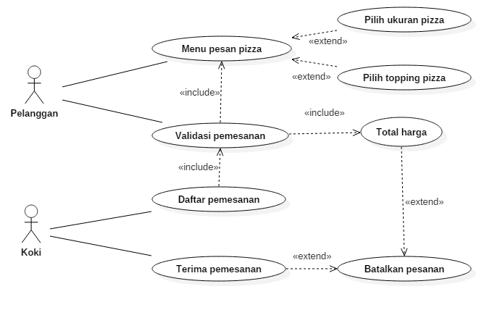

**CLASS DIAGRAM**

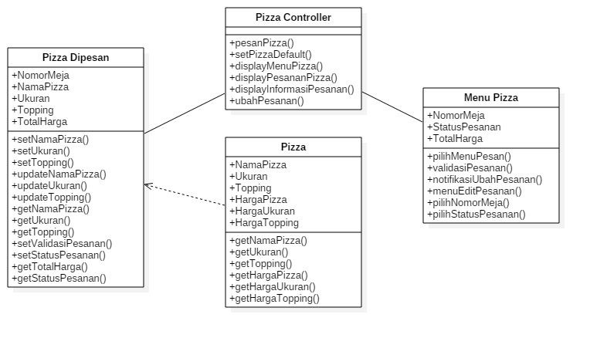

**SEQUENCE DIAGRAM**

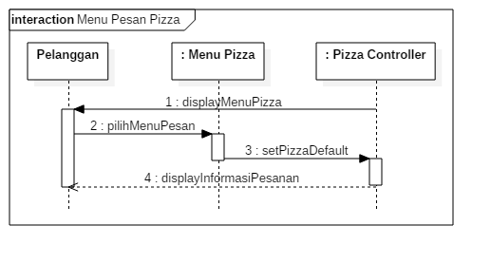

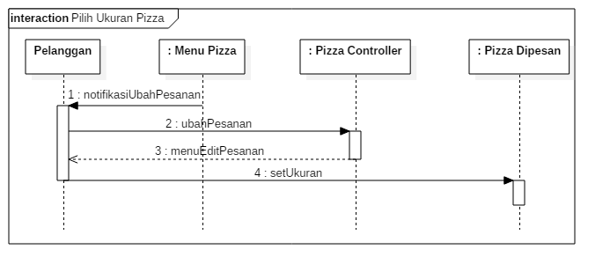

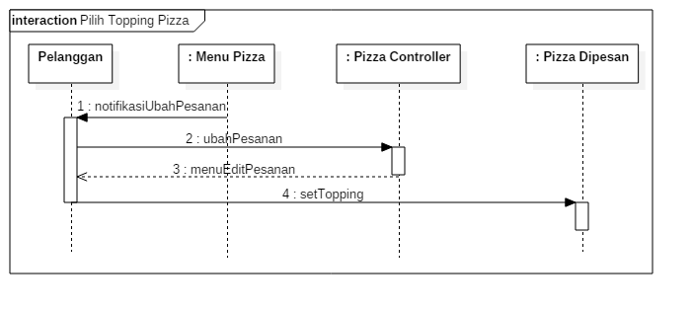

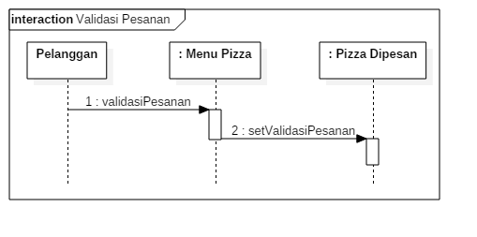

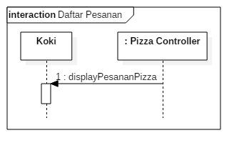

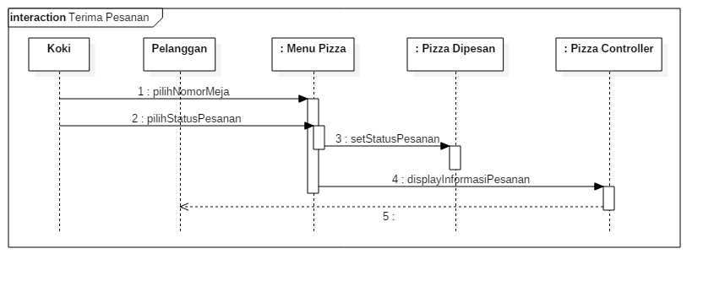

**STATE DIAGRAM**

*State diagram Menu Pizza*

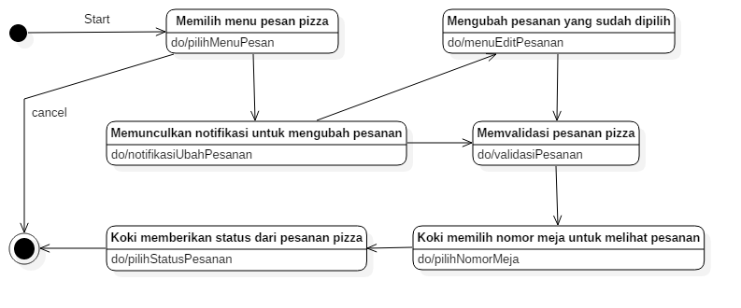

*State diagram Pizza Controller*

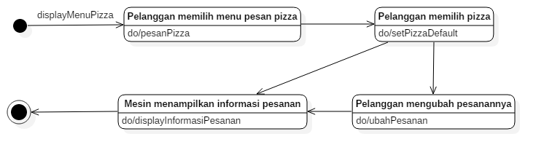

*State diagram Pizza Dipesan*

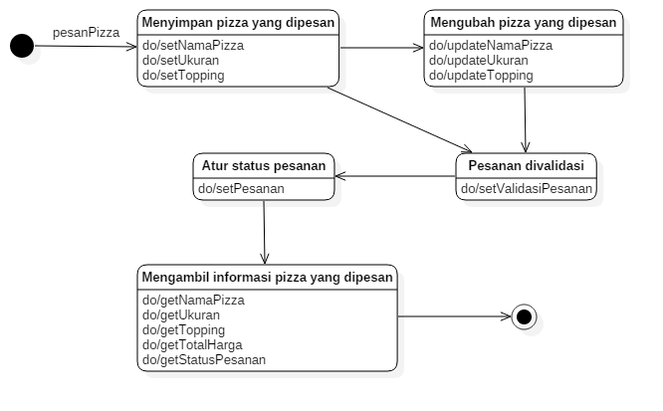

**ACTIVITY DIAGRAM**

*Activity diagram Menu Pesan Pizza*

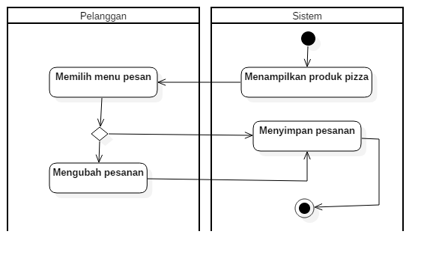

*Activity diagram Validasi Pesanan*

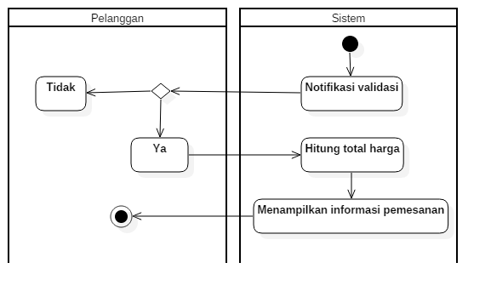

*Activity diagram Daftar Pemesanan*

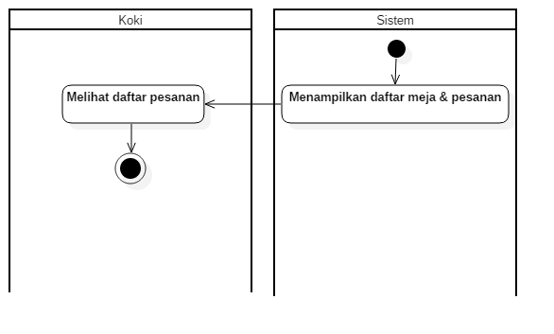

*Activity diagram Terima Pesanan*

