Cairo University  
Faculty of Computers and Artificial Intelligent

Software Design

Month & Year

May 2022

Contents

Instructions [To be removed] 3

Team 3

Document Purpose and Audience 3

System Models 3

I. Class diagrams 3

Important Algorithm 4

II. Sequence diagrams 5

Class - Sequence Usage Table 6

Ownership Report 6

Policy Regarding Plagiarism: 7

# 

# Document Purpose and Audience

* This document displays a software design specification for a garage parking application.
* Audience:(garage owner)

# System Models

## I. Class diagrams

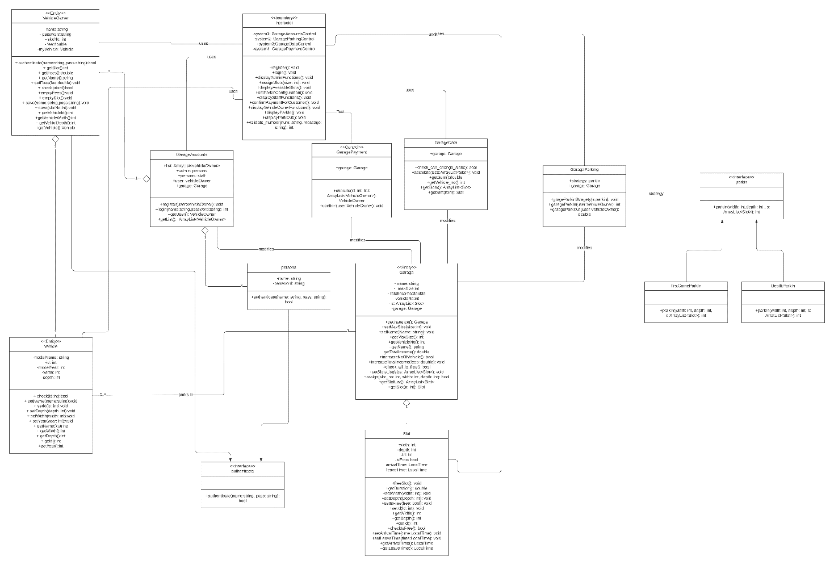

| **Class ID** | **Class Name** | **Description & Responsibility** |
| --- | --- | --- |
| 1 | Persons | Stores user name and password that are used to differentiate between garage owner and staff |
| 2 | Vehicle_owner | Identifies a customer with user name and password he uses to access application and stores the slot number he park in and the amount of fees he have to pay. |
| 3 | Vehicle | Stores information about user's vehicle. |
| 4 | Garage | Stores list of slots to be used by the system and stores Garage data like total income and total number of cars |
| 5 | Slot | Stores information about the slot in the garage and stores arrival and departure time of each user. |
| 6 | Interpreter | Is the link between the user and the program handle input and output. |
| 7 | GarageAccounts | Used to store lists of vehicle owners and persons account used to perform login and register operations. |
| 8 | GarageParking | Performs the task to park in the garage and park out users. |
| 9 | GarageData | Used to set and get the data stored in the garage. |
| 10 | GaragePayment | Used to perform payment operation and increasing the garage total income |
| 11 | FirstComeParkin | Used to park in users using first come first served method |
| 12 | BestFitParkin | Used to parkin users by searching the best slot that can hold the vehicle |

### Important Algorithm

find_suitable_slot()

check config type

if(config==0)

use random_search() function to get slot_no

else

use best_fit_search() function

if if finds a free slot return slot number

else it return -1 if there is no free slots

or -2 if there are slots but its dimensions is smaller than vehicle dimensions

## II. Sequence diagrams

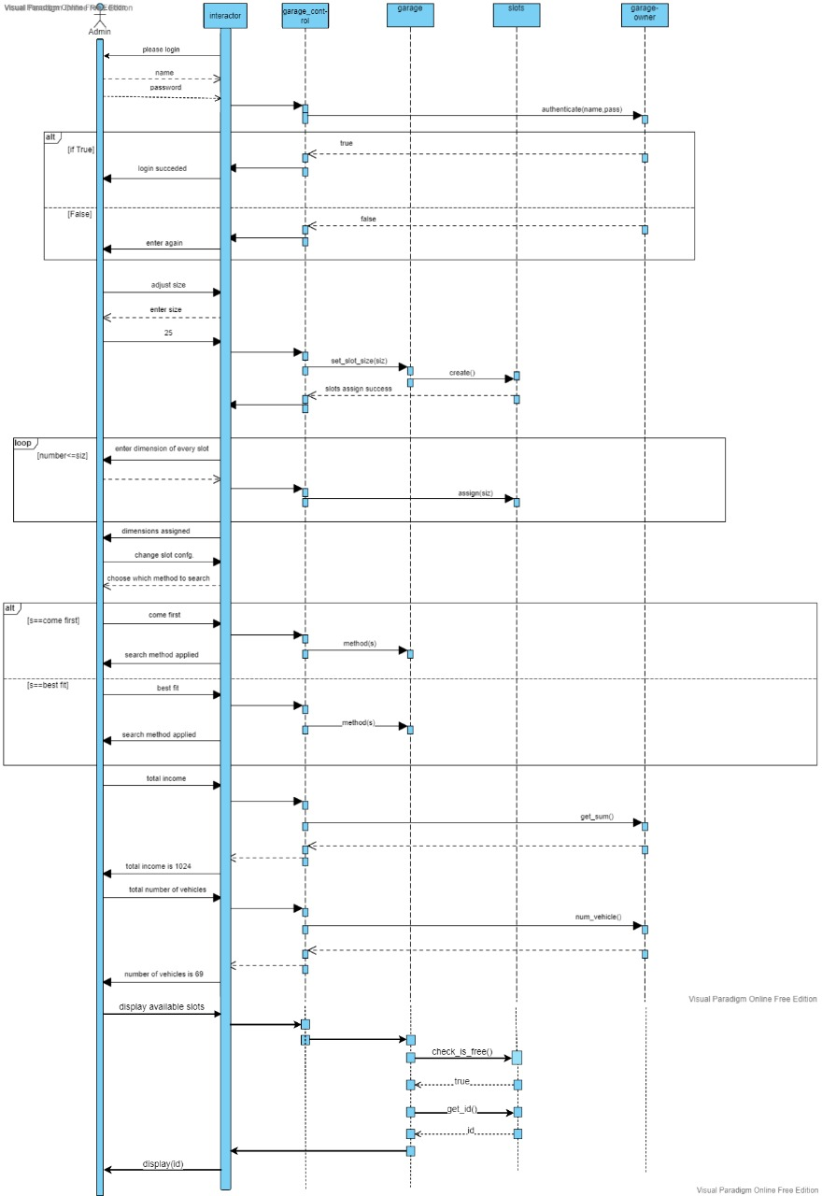

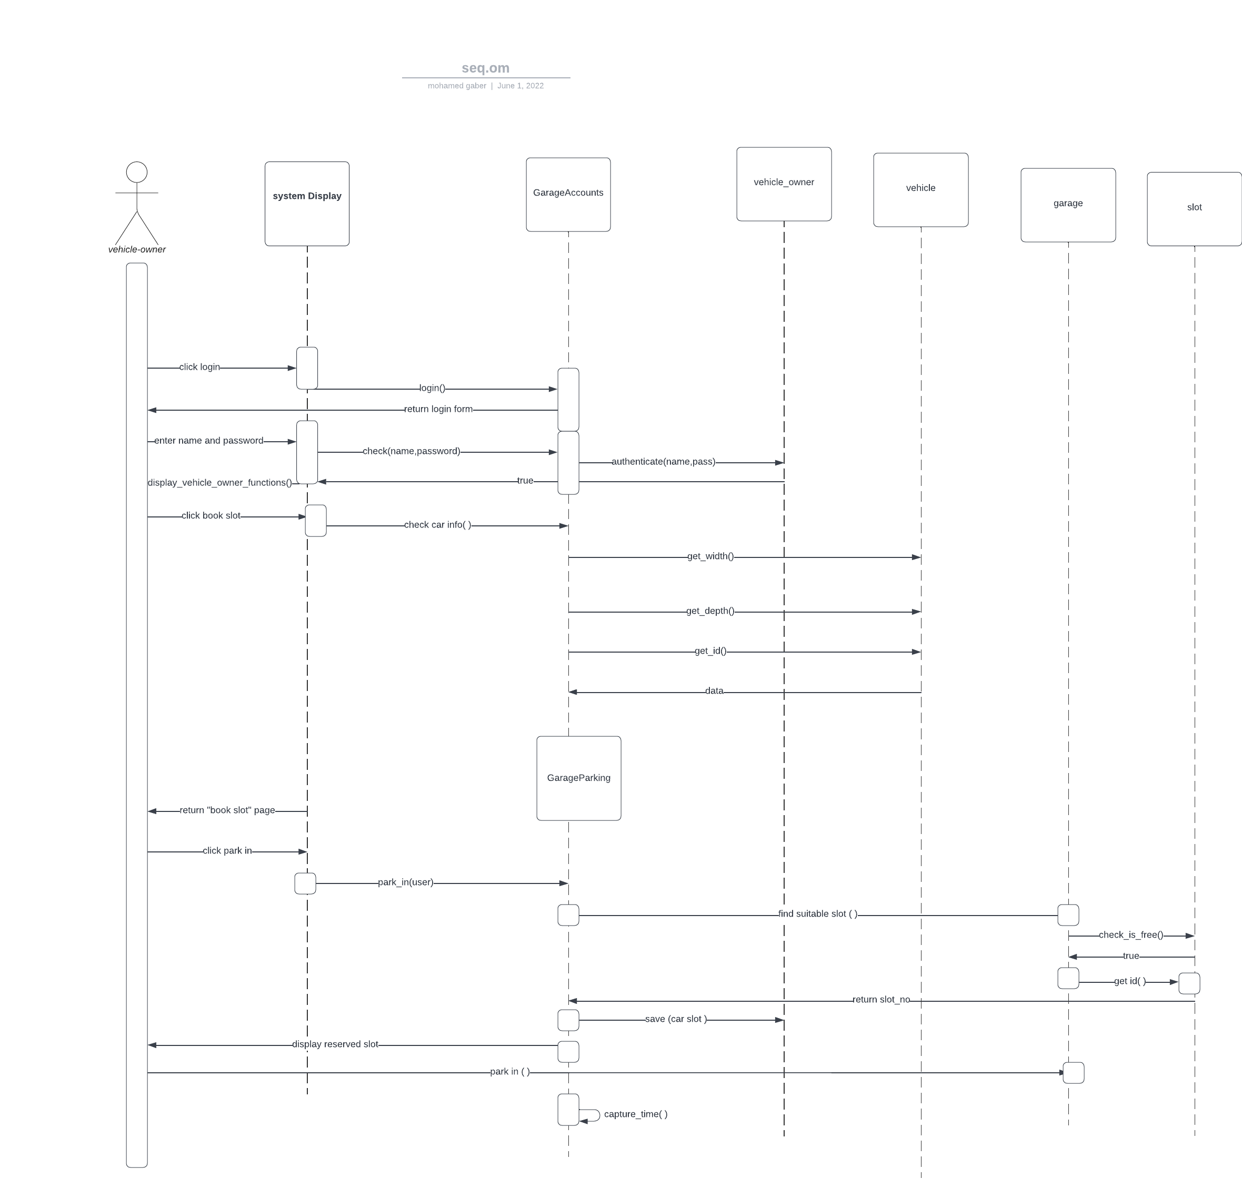

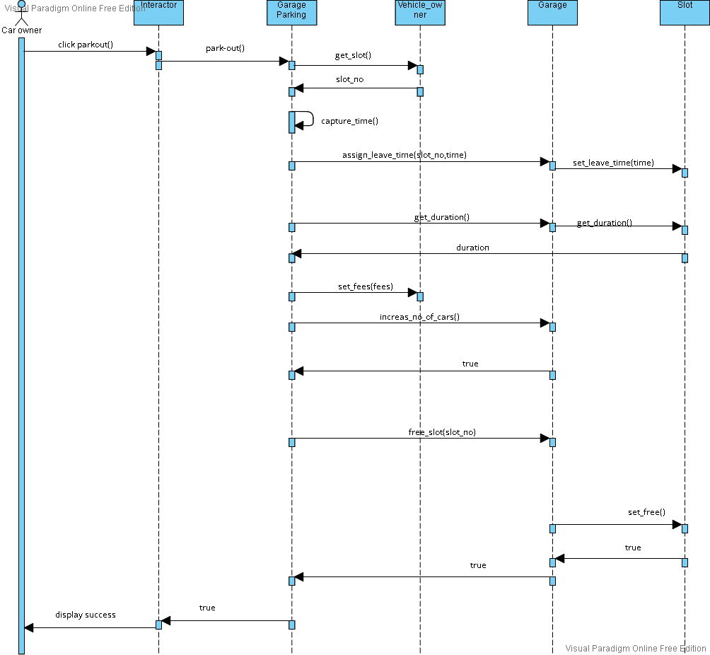

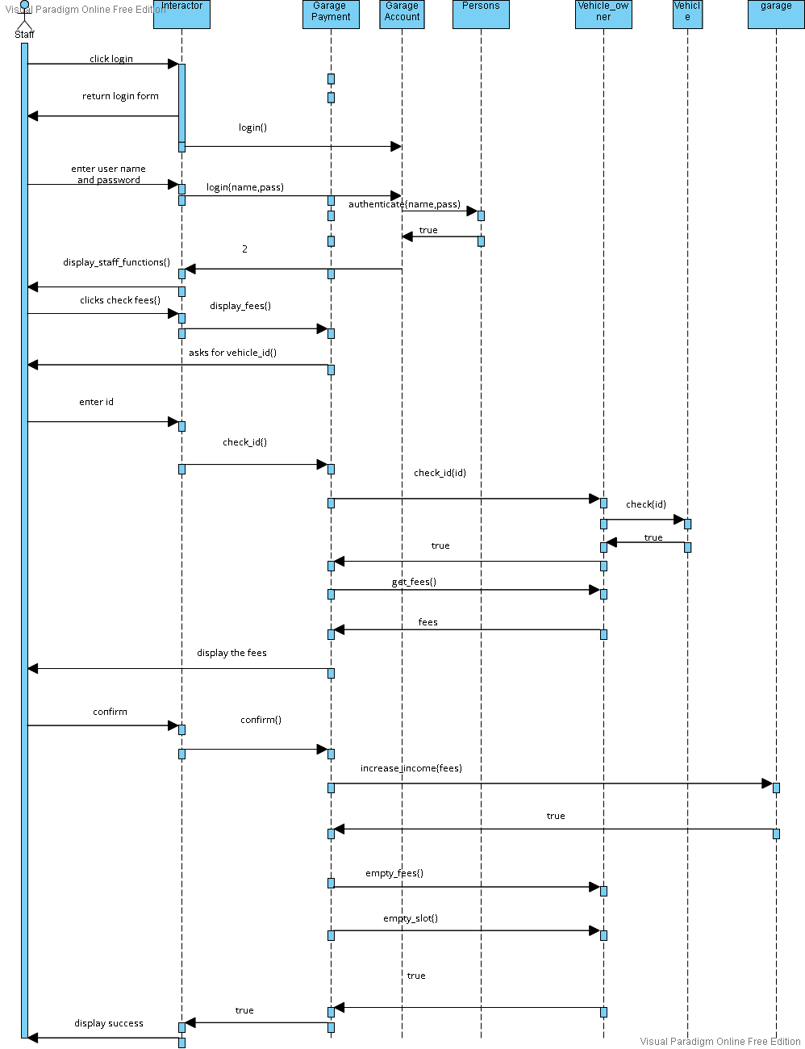

### E:\الترم التانى\Software Engineering\Lastassign\sequence 3.vpd.png

### Class - Sequence Usage Table

| **Class Name** | **Sequence Diagrams** | **Overall used methods** |
| --- | --- | --- |
| Slot | 1,3,4 | set_arrival_time(), set_leave_time(),calculate_fees(),set_free(),set_width(),set_depth(),get_width(),get_depth(),check_is_free() |
| Garage_owner | 1,2 | authenticate() |
| Veicle_owner | 5,4,3,2 | authenticate(),get_fees(),set_slot() set_fees(),check(),empty_fees(),empty_slot(),save() |
| Staff | 2,5 | authenticate() |
| Vehicle | 2,3,5 | set_name(),set_data(),get_name(),get_depth(),get_width ,check() |
| Garage | 1,3,4,5 | assign_leave_time(),get_fees(),increas_no_of_vehicles(),free_slot(),increase_income(),set_slot_size(),assign(),set_config(),park_in(),find_suitable_slot() |
| GarageAccounts | 1,2,3,4,5 | Register() Login() getUser()  getList() |
| Interactor | 1,2,3,4,5 | park_out() confirm() check_fees() register() display_vehicle_owner_functions():display_admin_functions() display_staff_functions() park_in() book_slot() adjust_size() change_slot_config():void get_total_income() get_total_number() |
| GarageParking | 2,4 | park_out() captureTime() parkIn() garage_search_strategy() |
| GarageData | 1,2,4 | Setfees()  Get_fees()  Getslot()  Getslots()  Set_vehicleno() |
| GaragePayemnt | 4 | confirmPayment() |