**Final Year Project**

**IGAT**

**Internet Gaming Analysis & Trends**

**FYP Team**

**Ahmad Waseem 128209**

**Muneeb Zia 128241**

**Kainat Sheikh 128155**

**Supervised by**

**Ms. Asma Sattar**

**Department of Computer Science**

**FAST – National University of Computer & Emerging Sciences**

**Chiniot Faisalabad Campus**

**February 10, 2016**

**Project Description**

Gaming is a growing trend in the 21st century learning paradigm. Digital and video games take up a big part of the lives of our digital natives, and of course, as is the case with every new technology doubtful and cynical voices are the first to be heard. Entertainment through games used to be treated as an activity specific to children not long ago. Nowadays more and more adults are enjoying these games and sharing such interests on social media. However users are finding it difficult to find the exact information about gaming trends that which game genre is famous among all games and which game have better graphics and which one have a better story. It is very difficult for a user to distinguish between a good story game and a fine graphics game because already available platforms informs only about gaming latest news and reviews in paragraph form but there are no rating or trends available to judge a game in less time without reading a stuffy reviews of thousands words.

Taking care of gaming industry and a video gamer needs we are aiming to make a web based portal which will provide a user gaming trends based on genre and gaming categories and sub-categories. A user can search a game and can see its rating based upon categories. He can see the information about game. Overall performance of game will also be shown there. Top games with respect to categories will be available. There will be recommendations of similar games based on user searches and interests.

**Related Projects**

Some related projects are given below.

**Opinion mining**

This work is in the area of sentiment analysis and opinion mining from social media, e.g., reviews, forum discussions, and blogs. They proposed the Feature-Based Opinion Mining model, which is now also called Aspect-Based Opinion Mining. The output of such opinion mining is a feature-based opinion summary or aspect-based opinion summary. The commonly known sentiment classification is a sub-task. Their current work is in two main areas, which reflect two kinds of opinions (or evaluations)

* Mining regular opinions. Ex: (1). this camera is great. (2). after taking the drug, I got stomach pain.
* Mining comparative opinions. Ex: Coke tastes better than Pepsi.[1]

**Opinion Crawl**

Opinion Crawl allows visitors to assess Web sentiment on a topic - a person, an event, a company or a product. You can enter a topic and get an ad-hoc sentiment assessment of it. For each topic you get a pie chart showing current real-time sentiment, a list of the latest news headlines, a few thumbnail images, and a tag cloud of key semantic concepts that the public associates with the subject. The concepts allow you to see what issues or events drive the sentiment in a positive or negative way. [2]

**Summary**

Our project is working on a specific technology which is gaming. First project is working on blogs and discussion from social media websites. We are working on top two gaming reviews websites. Ratings and trends based on user reviews and comments will be available on our portal. In second project, there are multiple but limited topics and there is no detail information, there is analysis on current events that just shows a graph and news links to searching topics. We are providing latest trends and yearly and monthly, ratings and suggestions with every sub-category of games basis on user search.

**Project Features**

Two major techniques web crawling and sentimental analysis will be used in this project. Web crawler will be made for crawling the comments and reviews from different websites and then data will be available in portal. When portal will be opened top trending games will be available there. A user can search any game and then he can see its overall rating, its specialty rating that whether this game is good in story or something else and its bad reviews rating along complete information of game. When a user will click on desired game or search a sentimental analysis algorithm runs over the comments and reviews of users they add. This analysis will evaluate the comments of user as positive or negative and the product will be rated which will depict original user reviews. It takes a lot of time to read every comment of user so we are providing ratings based on user reviews and comments. The complete information and such ratings will help a user to find his favorite category game without any challenge or overhead. There will be no need to browse many sites to check reviews about game. There will be a suggestion window that shows that games of user interest similar to the games that a user has liked before. An interactive user interface will be made so it can be very easy to find and see the results about his desired game search. Category trending will also be available.

**Project Scope**

* The system will be online.
* The system will work on video games specially console and PC games.
* The system will use web crawlers to fetch and maintain datasets for further analysis.
* The system will show detailed information of product as well reviews/comments based rating.

**Project Deliverables**

|  |  |
| --- | --- |
| **Proposal Defense**  Project Vision Document | 3rd week |
| **System Requirement Definition and Iteration Plan**  System functions and features | 5th week |
| **Poster Submission** | 29th February |
| High level Use cases, Use case diagram, Expanded use cases, Domain model, System sequence diagram, Sequence diagram, Class diagram, ERD | 30th March |
| **Mid Semester Evaluation** | 1st April |
| **Report and working demo** | 14th week |
| **FYP-I Final Evaluation**  40% of project work | 16th week |

**Tools**

* Visual Studio
* Wamp Server

**Technologies**

* C#

**Techniques**

**Web Crawling**

* HITS Algorithm
* Breadth First Crawler

**Sentiment Analysis**

* Latent Semantic Analysis algorithm
* Parsing
* Term reduction
* Factor Analysis

**High-level System Design Diagram**

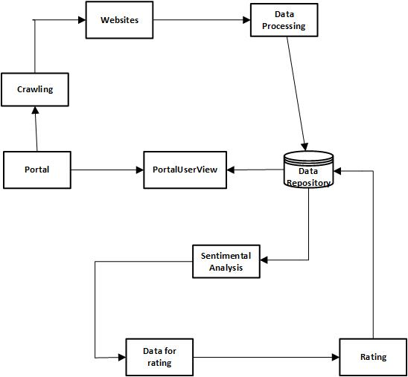

1. “Opinion mining, [Bing Liu,](http://www.cs.uic.edu/~liub)” 05 May 2013. [Online]. Avaiable:

   https://www.cs.uic.edu/~liub/FBS/fake-reviews.html
2. “Opinion Crawl, Semantic Engines LLC develops” March 2012 [Online]. Available:

   http://www.opinioncrawl.com/aboutOpinionCrawl.htm