Muhammad Waheed

912741428

LIN 177

Homework 2

1. **How does the first item in each pair above differ from the second?**

p, t and s are voiceless consonants and they do not vibrate the vocal chords when a sound is made with these characters. On the other hand, b, d and z are voiced consonants which vibrates the vocal chords when a sound is made using these characters.

Question 2:

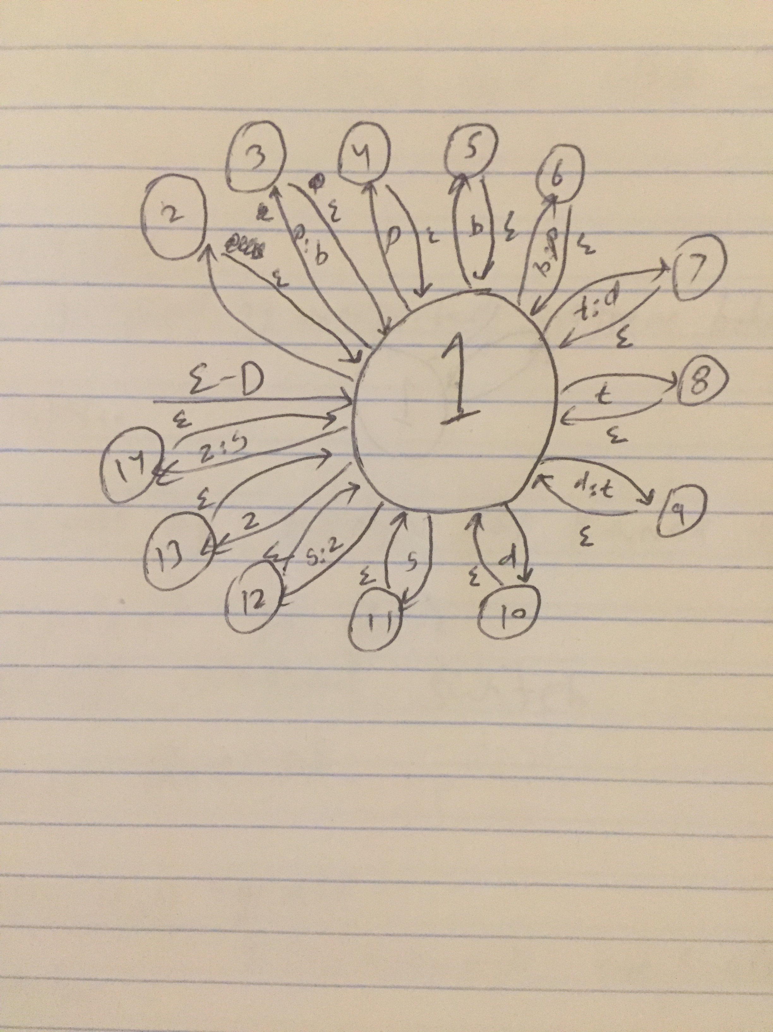

Question 3: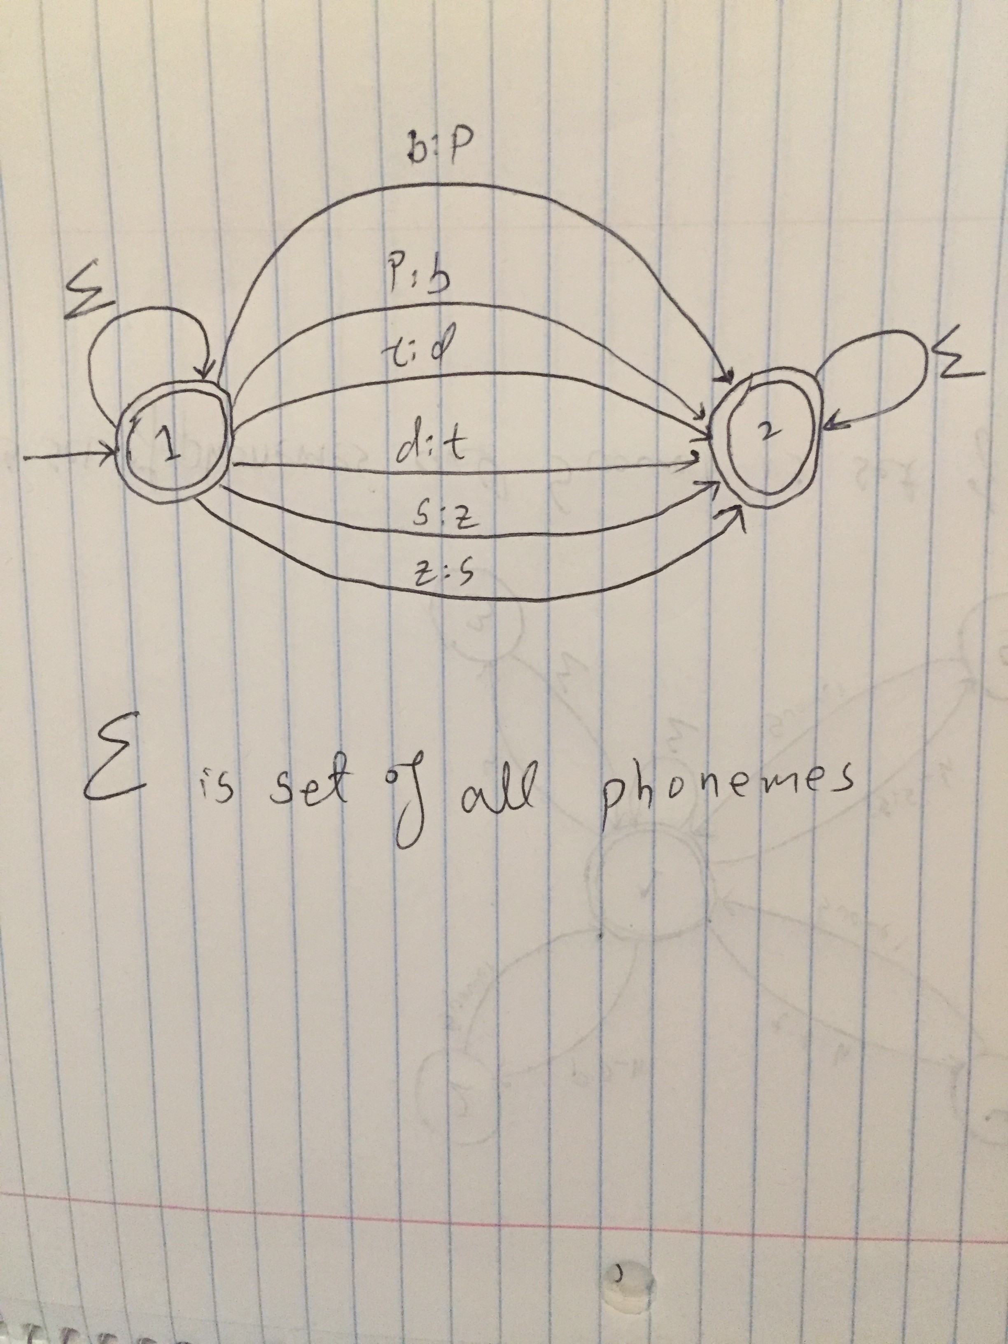

Question 4: