# ARRAY

**Lab Report # 8**

**ME-XXX Computer Systems And Programming**



## Submitted by:

**Muhammad Hamza (467023)**

**DEPARTMENT OF MECHANICAL ENGINEERING**

**NATIONAL UNIVERSITY OF SCIENCES AND TECHNOLOGY,H12**

1. **Write a C++ program to calculate average of numbers of array.**

**Code:**



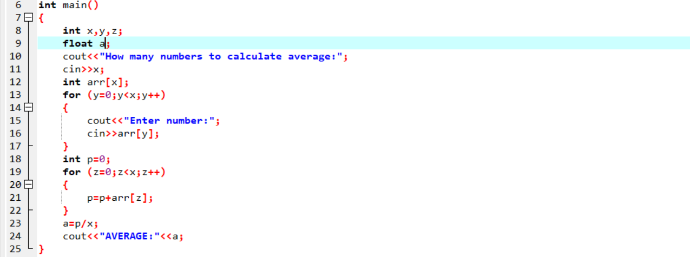

**Output:**

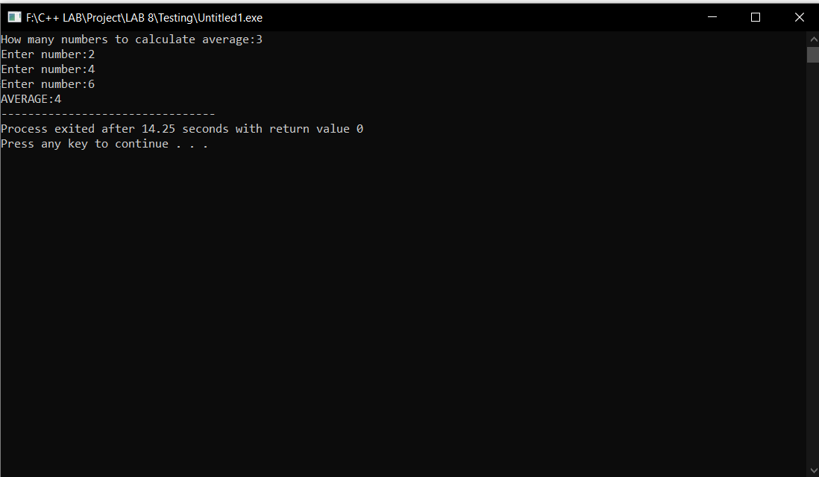

1. **Implement Bubble sort on an array of 5 integers.**

**Code:**



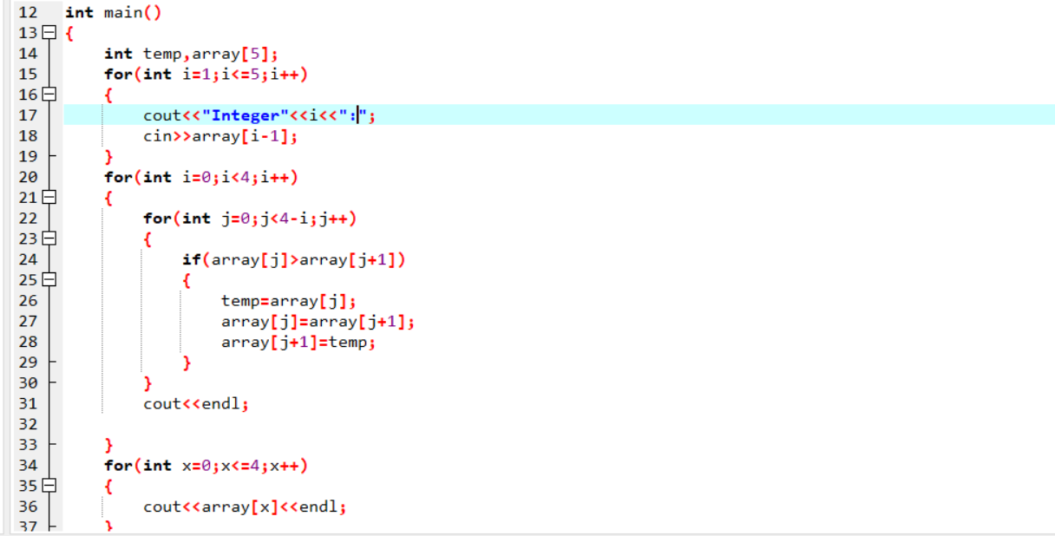**Output:**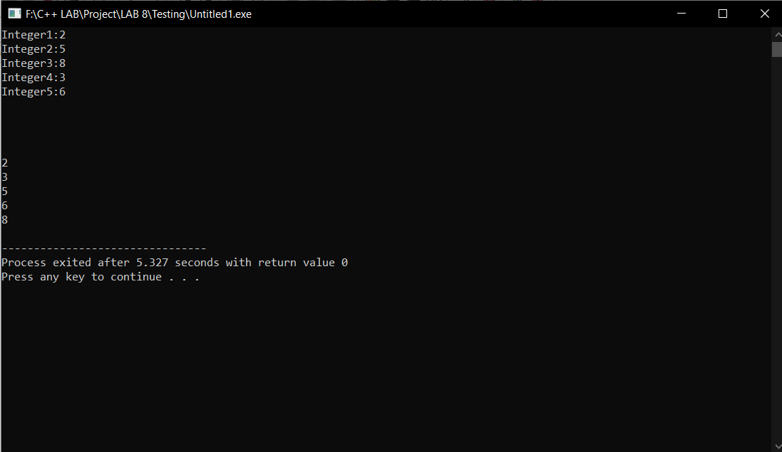

1. **Implement Selection Sort on an array of 5 integers.**

**Code:**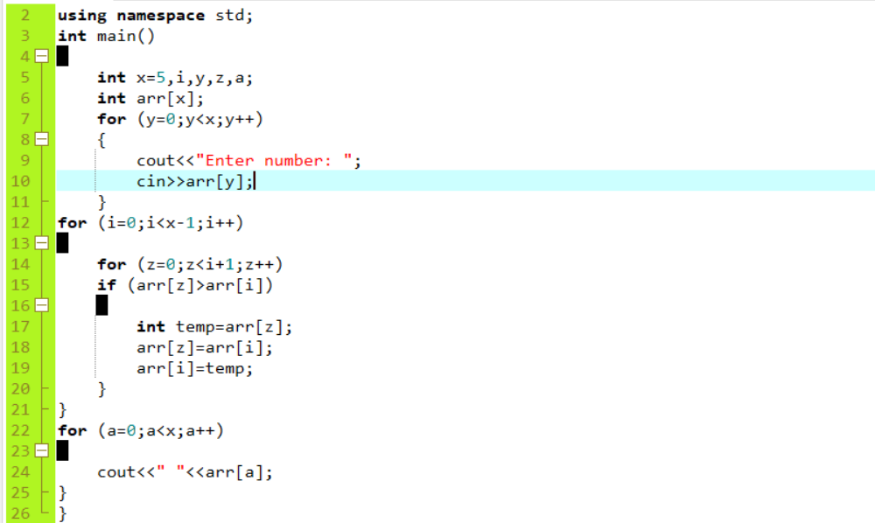

**Ouput:**

