MOBILE COMPUTING

Bag Catalog



Oleh
Ahmad Yori Januari | 1715061021
Nadya Merdeka Wati | 1715061010

PROGRAM STUDI TEKNIK INFORMATIKA

JURUSAN TEKNIK ELEKTRO

FAKULTAS TEKNIK

UNIVERSITAS LAMPUNG

2020
MOCKUP APLIKASI BAG CATALOG

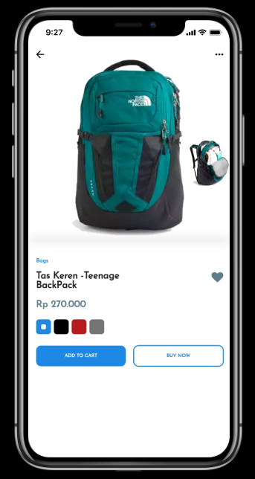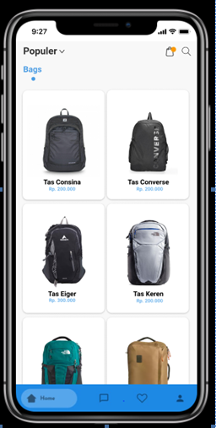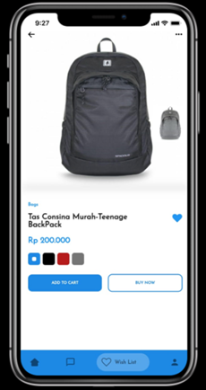

Bag catalog is an application that can help buyer to comparing bags. In this application provide many brand of bags. So we hope this application could help buyer to choosing and buy a bag that they want. who contribute on this project is : Ahmad Yori Januari (1715061021) and Nadya Merdeka Wati (1715061010)

Github link:
https://github.com/ahmadyori1021/mocomTB

Mock-up link:
https://www.figma.com/proto/OcXovAyKpbo8BxfDvGQ831/Prototyping-in-Figma-Copy?node-id=77%3A601&scaling=scale-down

