Findings of ICN Monitoring Reported through ODK

UNICEF Afghanistan / Polio - Immunization Communication Network (ICN)

Wazir Khan Ahmadzai, M&E Officer, UNICEF Polio

23/12/2018

Table of Contents

# Key figures

* **Start date of this report**: 01 of November 2018
* **End date of this report**: 27 of November 2018
* **Numbers of provinces in this report**: 1 province.
* **Numbers of districts in this report**: 1 district.
* **Number of clusters in this report**: 8 clusters
* **Number of submissions**: 27 submissions
* **Total respondents in household group interviews**: 73 respondents.
* **Total number of respondents in individual and group interviews**: 85 respondents.

###### 

# Overall monitoring results

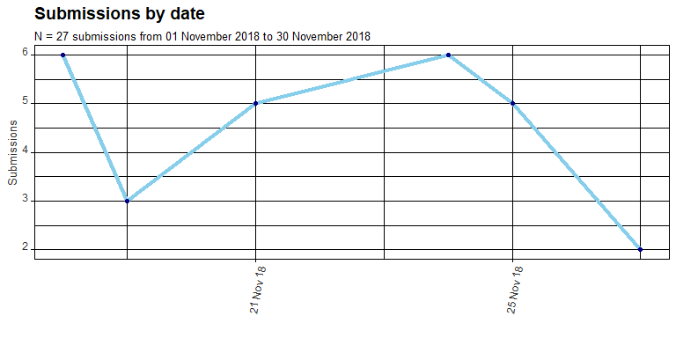

The line plot above shows submissions by date for the time period of this report (from 01 November 2018 to 30 November 2018). The dataset includes 27 submissions with a total of 57 interviews with social mobilisers (SM), community influential people (CIP), households (HH) and supervisors (SUP). Each submission includes on average 2 interviews (min.: 1 interview / max.: 3 interviews per submission). Interviews with household representatives are group interviews (15 household interviews) with a total of 73 household representatives (on average 5 participants per household group interview). All the interviews with other key stakeholders were individual interviews (12 individual interviews). Considering both individual and group interviews, a total of 85 respondents have been consulted including monitors (observation reports).

The following table presents a summary of key figures for this report. The column *Indicators of problems* presents how many indicators of those available for the selected data range suggest the existence of problems (not meeting the standards of the ICN Key Performance Indicators). The table includes number of interviews with the key stakeholders and number of indicators with problems (Problems).

##### 

**Table 1: Number of interviews by respondent category and number of problems by district and cluster (from 01 November 2018 to 30 November 2018)**

| **Province** | **District** | **Subdistrict** | **Cluster** | **SM** | **Monitor** | **CIP** | **HH** | **SUP** | **Core Prob** |
| --- | --- | --- | --- | --- | --- | --- | --- | --- | --- |
| Kabul | Kabul | Kabul Part12 | 259 | 4 | 4 | 0 | 4 | 0 | 0 |
| Kabul | Kabul | Kabul Part12 | 260 | 4 | 4 | 0 | 4 | 0 | 0 |
| Kabul | Kabul | Kabul Part12 | 264 | 5 | 5 | 0 | 5 | 0 | 0 |
| Kabul | Kabul | Kabul Part8 | 146 | 2 | 0 | 0 | 0 | 0 | 0 |
| Kabul | Kabul | Kabul Part8 | 148 | 1 | 1 | 0 | 2 | 0 | 0 |
| Kabul | Kabul | Kabul Part8 | 166 | 3 | 0 | 0 | 0 | 0 | 1 |
| Kabul | Kabul | Kabul Part8 | 170 | 3 | 0 | 0 | 0 | 1 | 2 |
| Kabul | Kabul | Kabul Part8 | 177 | 3 | 1 | 0 | 0 | 1 | 2 |

**Table 2: Number of clusters and problems by district (from 01 November 2018 to 30 November 2018)**

|  | **Province** | **District** | **No. Reported Clusters** | **Sum. Indicators with Problems** | **No. Clusters with Problems** | **Per. Clusters with Problems** |
| --- | --- | --- | --- | --- | --- | --- |
|  | Kabul | Kabul | 8 | 5 | 3 | 38 % |
| Total |  |  | 8 | 5 | 3 | 38 % |

The monitoring dataset includes information concerning 20 core key performance indicators (KPIs) related to the following areas:

* Presence in the field
* Profile
* Preparedness
* Documentation
* Mobilisation
* Community work
* Results
* Challenges
* Operations

For each core indicator, objectively verifiable standards (threshold values) have been defined in a [table with metadata about composite indexes, indicator definitions, qualifiers for blue status and related database variables](https://wferreira.teamwork.com/#files/5449521). These predefined standards (see Annex 1 with full list of KPIs) have been coded in RMarkdown syntax for automated processing, full transparency and reproducibility.

The plot below shows the estimation of the mean value (average) concerning the number of indicators suggesting problems by cluster. This can be a proxy of the overall programme performance. The estimation took place with a [Bayesian bootstrap method](http://www.sumsar.net/blog/2016/02/bayesboot-an-r-package/) considering 4,000 sampling repetitions of the data subset from 01 November 2018 to 30 November 2018 (reporting reference dates[1]). The plot includes the estimation of the HDI (Bayesian highest density interval) indicating the confidence interval at 95% confidence level.

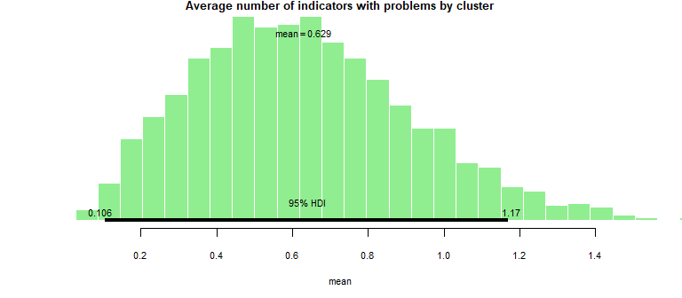

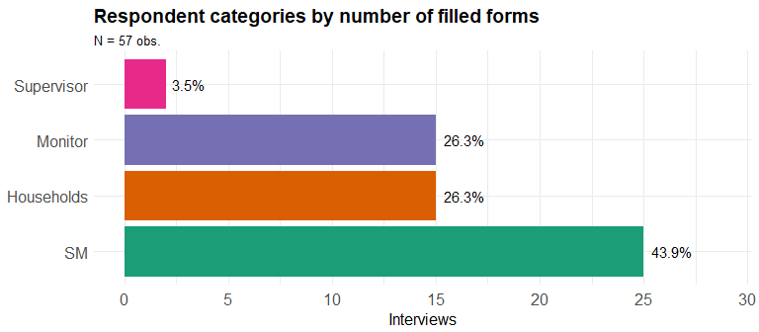

##### 

# Results by core key performance indicator (KPIs) suggesting problems

The following table presents the core KPIs suggesting problems as from the submitted data. The table includes the performance area, the core indicator definition and code. For simplicity, the report presents results only for the core KPIs and some of the following plots refer to the core indicators only by their code.

**Table 3: Description of core indicators suggesting problems (from 01 November 2018 to 30 November 2018)**

| **Composite indicator** | **Indicator   (Subcomponent of composite indicator)** | **Shortname** |
| --- | --- | --- |
| Supportive supervision | SM reporting on-the-job support in last two weeks. | Support |
| Supportive supervision | Number of supportive supervision days in the last 30 days by CCS. | Support days |

The following plots present heat maps of indicators aggregated at different geographic levels. Red cells indicate indicators with problems. White cells indicate missing data. This can happen when submissions for the chosen date range do not include interviews of the required respondents whose answers should inform the respective indicator.

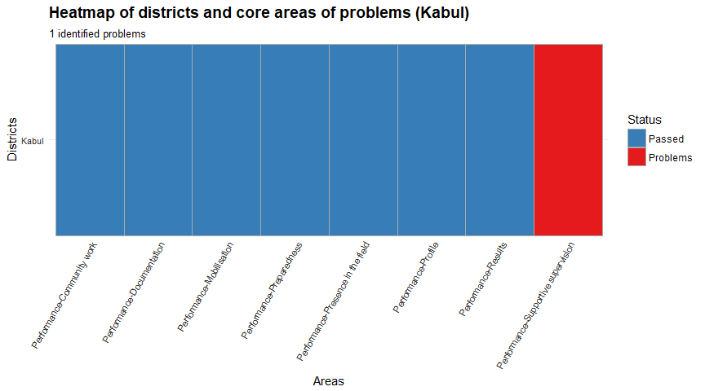

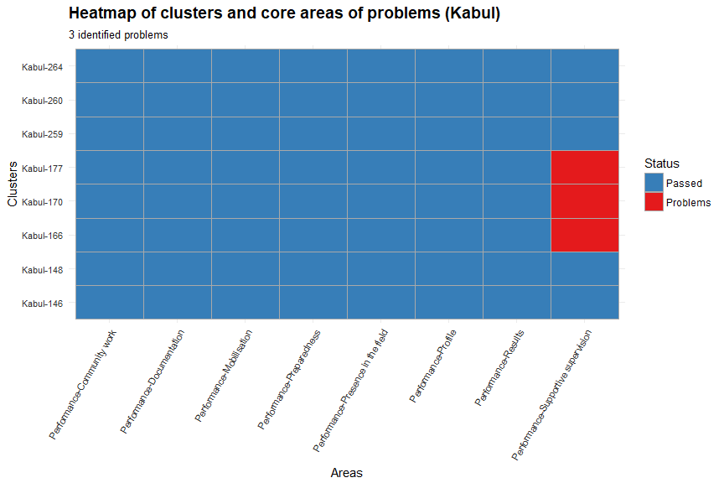

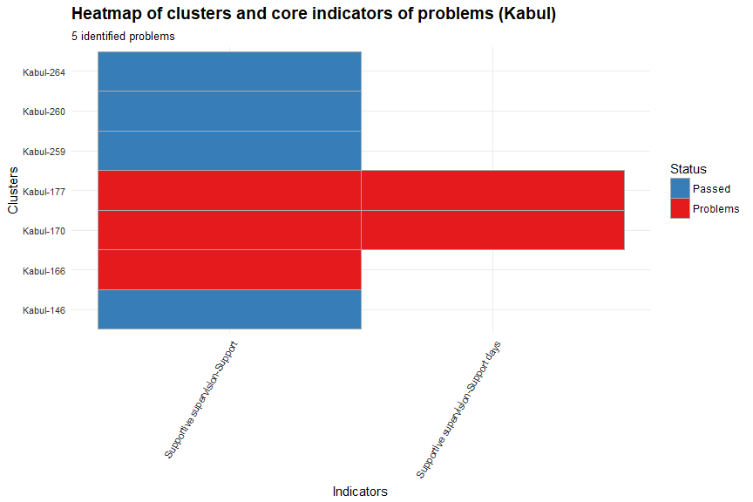

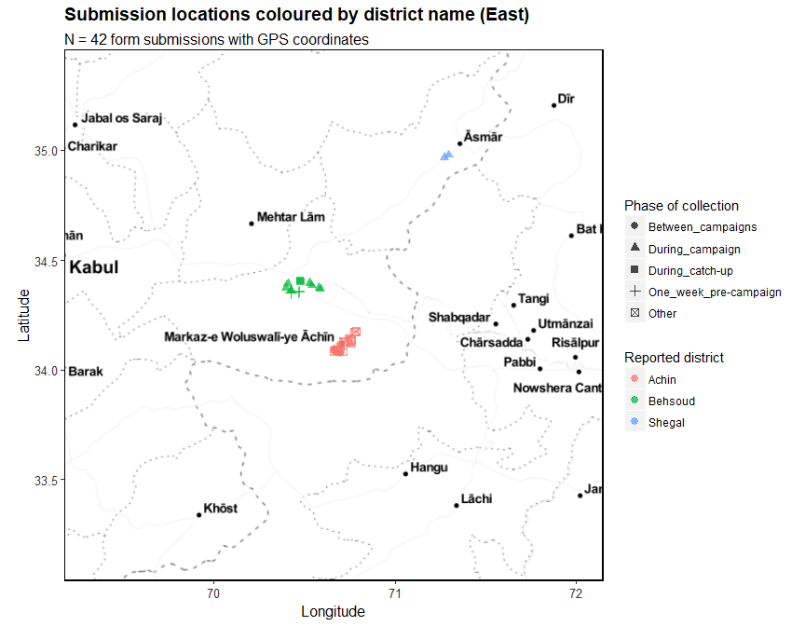

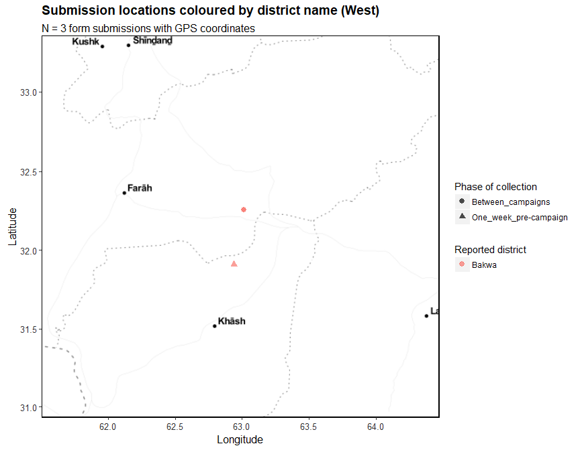

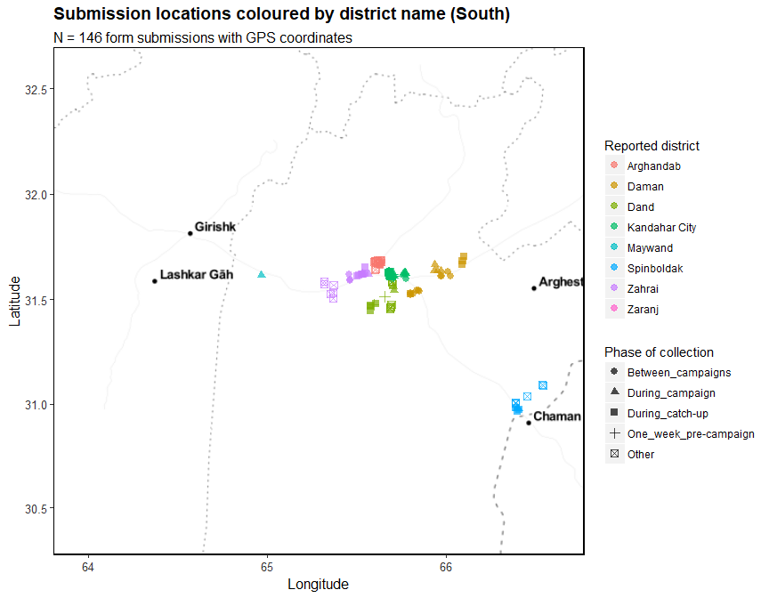

# Complementary plots

This section presents complementary plots underlying the summarised results presented above.

## Monitors

This section presents the results for the selected data range coming from the digital reporting form. Monitor reporting forms attempted to collect data resulting from field monitoring visits, particularly from observation of tasks performed by social mobilizers.

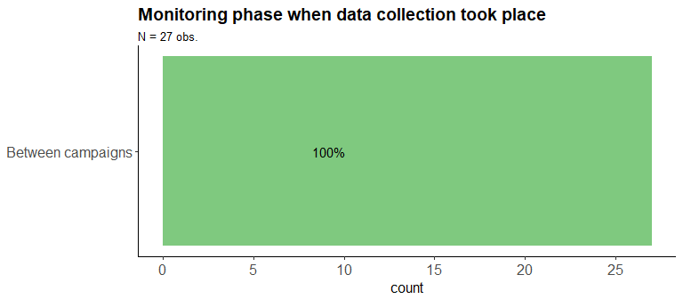

**Table 4: Monitor submissions by village (from 01 November 2018 to 30 November 2018)**

| **Province** | **District** | **Subdistrict** | **Cluster** | **Village** | **Team No.** | **No. Interviews** |
| --- | --- | --- | --- | --- | --- | --- |
| Kabul | Kabul | Kabul Part12 | 259 | سلیم کاروان دولت آباد | 1 | 3 |
| Kabul | Kabul | Kabul Part12 | 259 | سلیم کاروان دولت آباد | 2 | 3 |
| Kabul | Kabul | Kabul Part12 | 259 | سلیم کاروان دولت آباد | 3 | 3 |
| Kabul | Kabul | Kabul Part12 | 259 | سلیم کاروان دولت آباد | 4 | 3 |
| Kabul | Kabul | Kabul Part12 | 260 | دریم بلاک | 1 | 3 |
| Kabul | Kabul | Kabul Part12 | 260 | دریم بلاک | 3 | 3 |
| Kabul | Kabul | Kabul Part12 | 260 | نوروز اباد | 4 | 3 |
| Kabul | Kabul | Kabul Part12 | 260 | دریم بلاک | 2 | 3 |
| Kabul | Kabul | Kabul Part12 | 264 | پلچرخی بازار | 1 | 3 |
| Kabul | Kabul | Kabul Part12 | 264 | پلچرخی نصرت اباد | 2 | 3 |
| Kabul | Kabul | Kabul Part12 | 264 | پلچرخی نصرت اباد | 3 | 3 |
| Kabul | Kabul | Kabul Part12 | 264 | پلچرخی صدیق اباد | 5 | 3 |
| Kabul | Kabul | Kabul Part12 | 264 | پلچرخی صدیق اباد | 4 | 3 |
| Kabul | Kabul | Kabul Part8 | 146 | Tape kamawal | 4 | 1 |
| Kabul | Kabul | Kabul Part8 | 146 | Tape dastakhel | 3 | 1 |
| Kabul | Kabul | Kabul Part8 | 148 | Camp helmandya | 1 | 2 |
| Kabul | Kabul | Kabul Part8 | 148 | Nasaji bagrami | 2 | 1 |
| Kabul | Kabul | Kabul Part8 | 148 | Nasaji bagrami | 3 | 1 |
| Kabul | Kabul | Kabul Part8 | 166 | Shame roshan area | 2 | 1 |
| Kabul | Kabul | Kabul Part8 | 166 | Kim hospital | 1 | 1 |
| Kabul | Kabul | Kabul Part8 | 166 | Qale zamankhan | 3 | 1 |
| Kabul | Kabul | Kabul Part8 | 170 | Shah rake vahdak | 1 | 1 |
| Kabul | Kabul | Kabul Part8 | 170 | Shahrak vahdat | 2 | 2 |
| Kabul | Kabul | Kabul Part8 | 170 | Shahrak wahdat | 3 | 1 |
| Kabul | Kabul | Kabul Part8 | 177 | Qale khandar | 3 | 2 |
| Kabul | Kabul | Kabul Part8 | 177 | Qale khandar | 2 | 1 |
| Kabul | Kabul | Kabul Part8 | 177 | Qale khandar | 1 | 2 |

**Table 5: Interviews by monitor (from 01 November 2018 to 30 November 2018)**

| **Province** | **District** | **Sex** | **Name** | **No. Forms Sub.** | **No. Interv. Conducted** | **No. Teams Visited** | **Avg. Interv./Team** | **Avg. Interv./Form** | **Perform** | **Month** |
| --- | --- | --- | --- | --- | --- | --- | --- | --- | --- | --- |
| Kabul | Kabul | Female | Drs Shaheen | 14.0 | 18 | 14 | 1.3 | 1.3 | Poor | Nov 2018 |
| Kabul | Kabul | Female | Pakhtana | 13.0 | 39 | 13 | 3.0 | 3.0 | Okay | Nov 2018 |

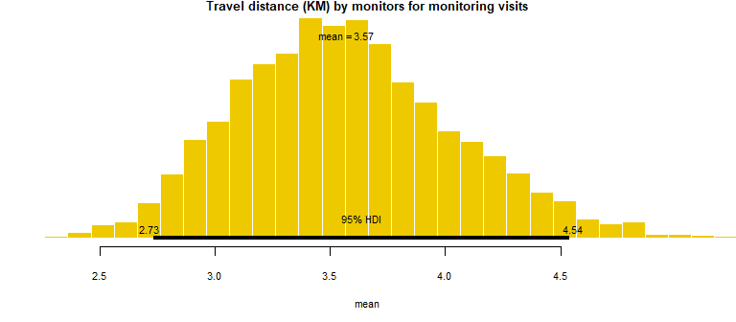

**Table 6: Total travelled distance in kilometers by month and district (from 01 November 2018 to 30 November 2018)**

| **Province** | **District** | **Name** | **No. Days Worked** | **KM Traveled** | **KM/Day** | **Month** |
| --- | --- | --- | --- | --- | --- | --- |
| Kabul | Kabul | Drs Shaheen | 5 | 41.0 | 8.2 | Nov 2018 |
| Kabul | Kabul | Pakhtana | 5 | 55.0 | 11.0 | Nov 2018 |

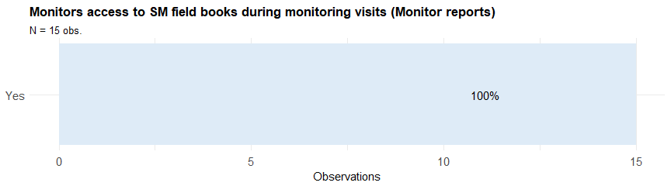

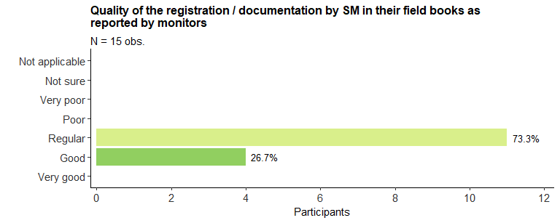

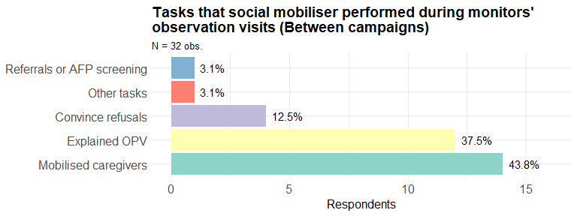

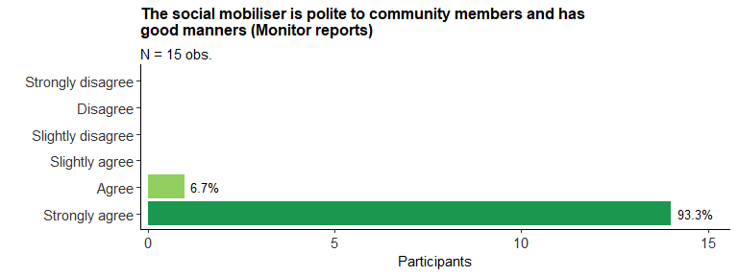

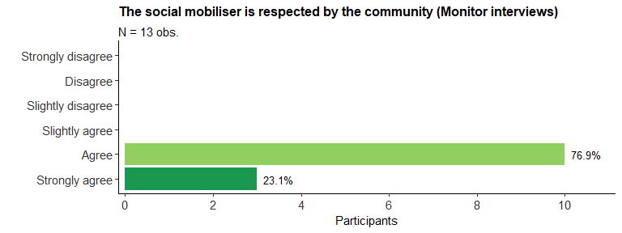

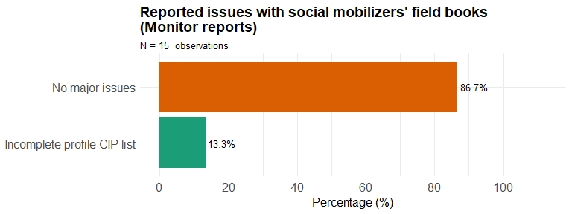

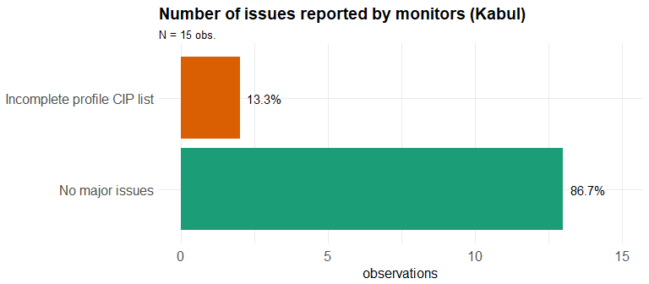

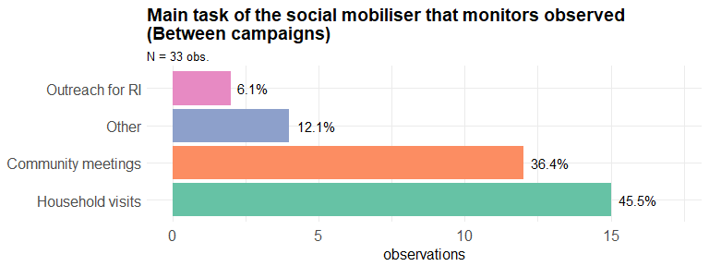

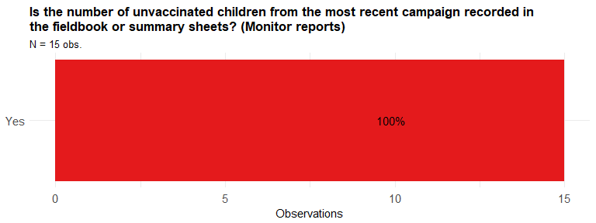

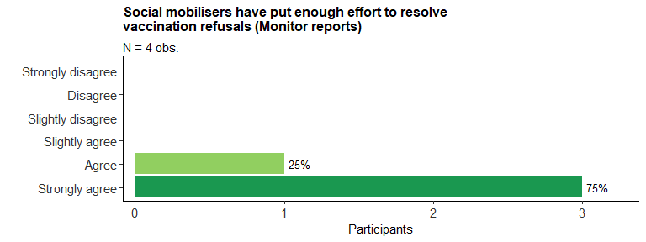

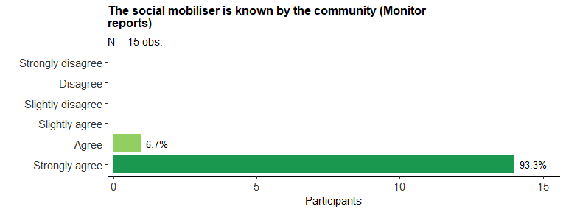

## Social Mobilizers

This sections presents the results concerning interviews of social mobilizers. The form was designed so that monitors could simply read out the questions and answer options verbatim. This aimed at minimising interviewer bias with minimal training requirements.

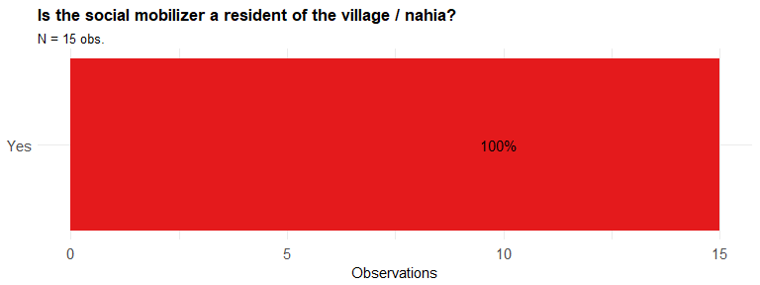

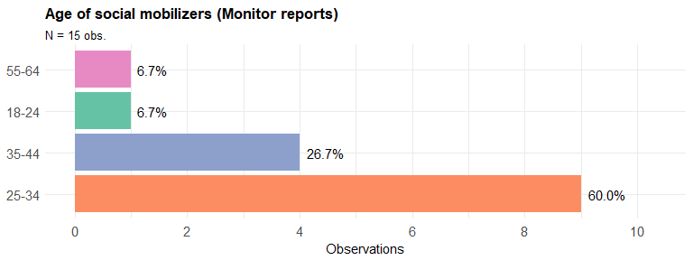

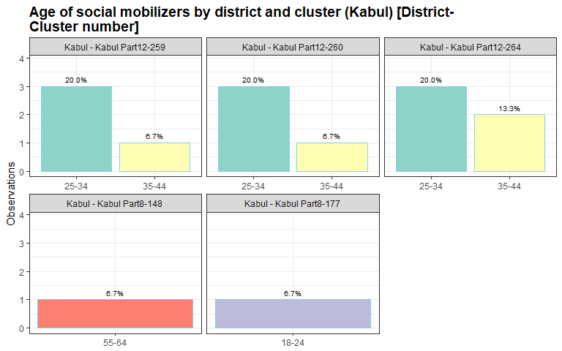

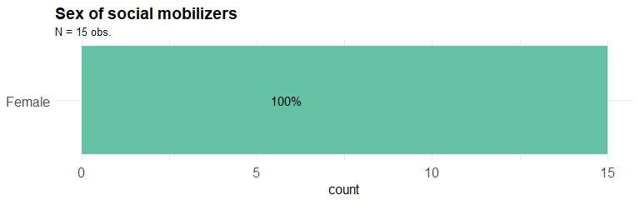

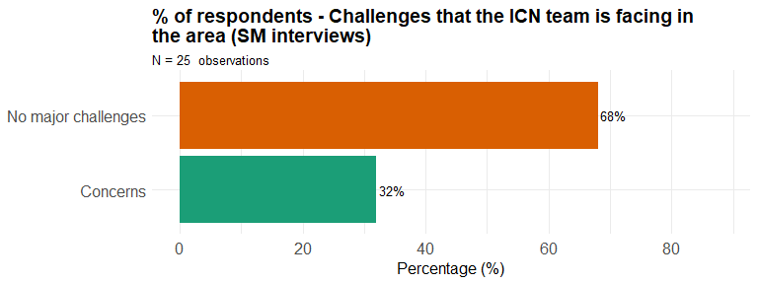**Table below shows 8 cases of problems: Challenges that the ICN team is facing in the area (SM interviews)**

| **Region** | **Province** | **District** | **Subdistrict** | **Cluster** | **Team** | **Freq. Reported** |
| --- | --- | --- | --- | --- | --- | --- |
| Central | Kabul | Kabul | Kabul Part12 | 264 | 4 | 1 |
| Central | Kabul | Kabul | Kabul Part8 | 146 | 3 | 1 |
| Central | Kabul | Kabul | Kabul Part8 | 166 | 2 | 1 |
| Central | Kabul | Kabul | Kabul Part8 | 170 | 2 | 1 |
| Central | Kabul | Kabul | Kabul Part8 | 170 | 3 | 1 |
| Central | Kabul | Kabul | Kabul Part8 | 177 | 1 | 1 |
| Central | Kabul | Kabul | Kabul Part8 | 177 | 2 | 1 |
| Central | Kabul | Kabul | Kabul Part8 | 177 | 3 | 1 |

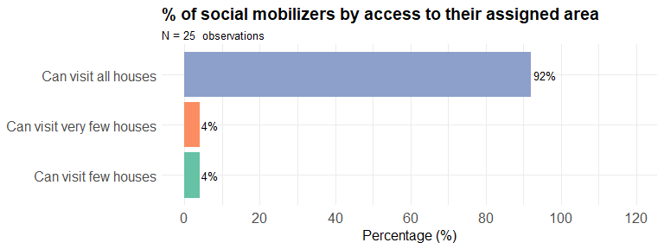**Table below shows 2 cases that social mobilizers can visit few or very few houses in their assigned area**

| **Region** | **Province** | **District** | **Subdistrict** | **Cluster** | **Team** | **Freq. Reported** |
| --- | --- | --- | --- | --- | --- | --- |
| Central | Kabul | Kabul | Kabul Part12 | 264 | 1 | 1 |
| Central | Kabul | Kabul | Kabul Part12 | 264 | 4 | 1 |

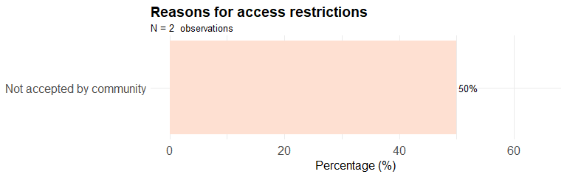**Table below shows 1 critical cases of access problems**

| **Region** | **Province** | **District** | **Subdistrict** | **Cluster** | **Team** | **Freq. Reported** |
| --- | --- | --- | --- | --- | --- | --- |
| Central | Kabul | Kabul | Kabul Part12 | 264 | 4 | 1 |

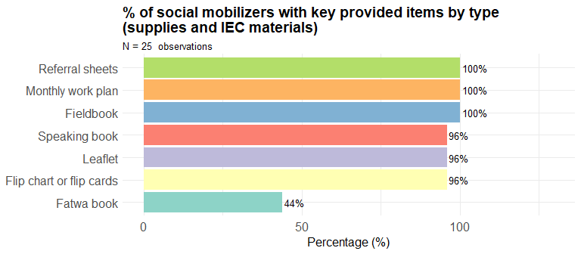

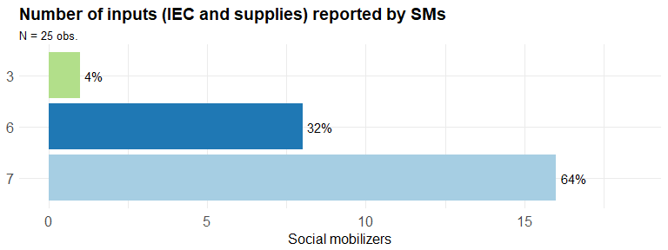

**Table below shows 1 cases where number of reported inputs is three or less (SM interviews)**

| **Province** | **District** | **Subdistrict** | **Cluster** | **Team** | **Freq. Reported** |
| --- | --- | --- | --- | --- | --- |
| Kabul | Kabul | Kabul Part8 | 170 | 1 | 1 |

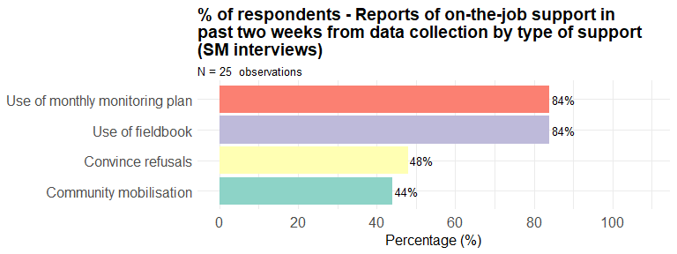

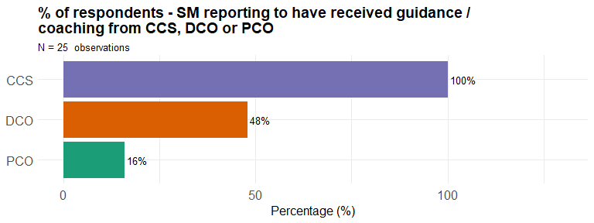

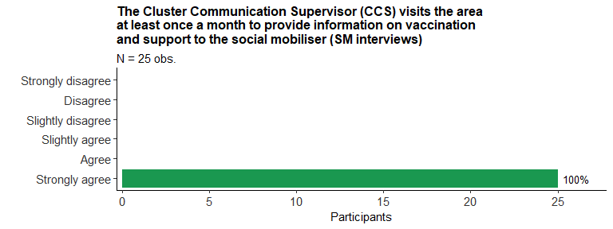

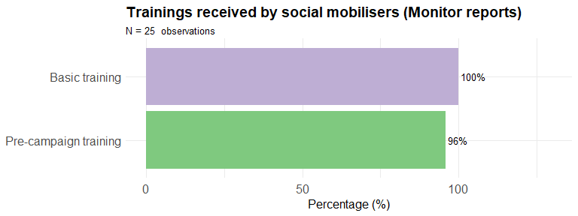

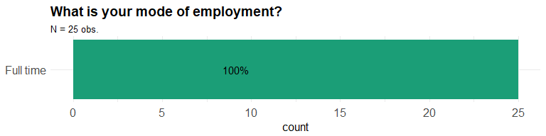

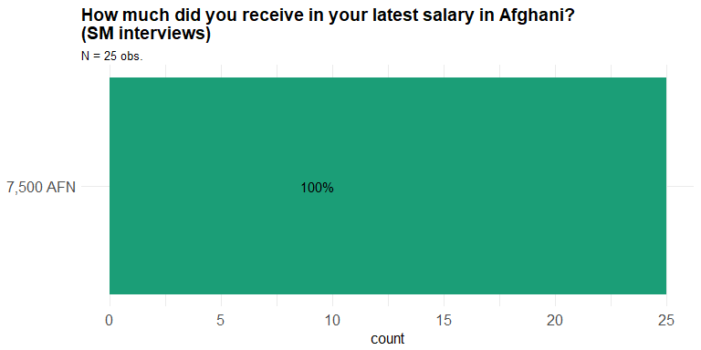

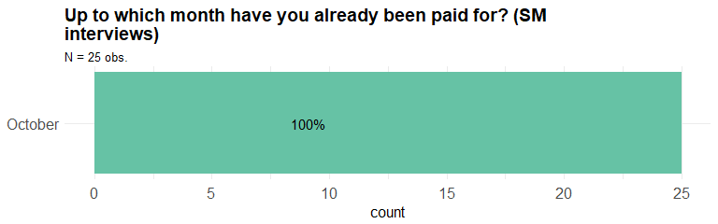

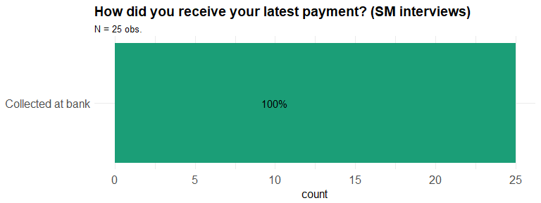

**Table below shows: Summary statistics - Days between date of data collection and last payment to SM (from 01 November 2018 to 30 November 2018)**

|  |  |  |  |  |  |
| --- | --- | --- | --- | --- | --- |
| Min. | 1st Qu. | Median | Mean | 3rd Qu. | Max. |
| 48 | 49 | 54 | 52.28 | 55 | 57 |

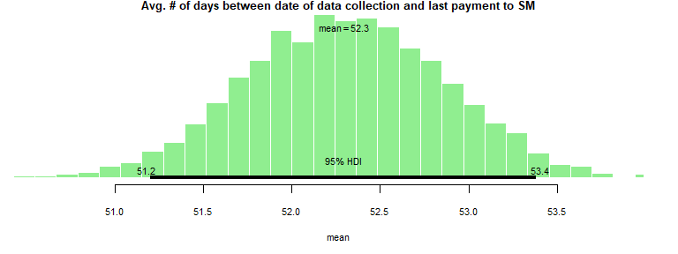

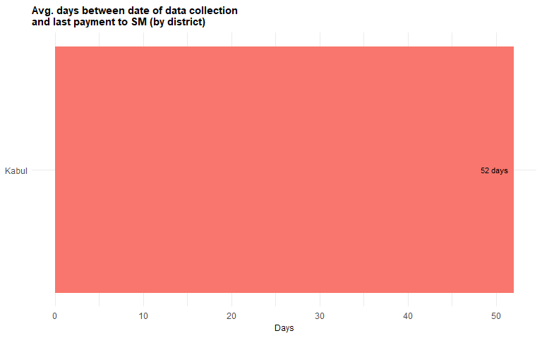

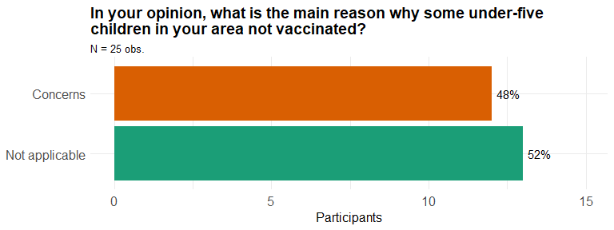

## CIPs (Community Influencer People)

This section presents the results of interviews with CIPs (Community Influencer People). These are opinion makers who should help promoting vaccination campaigns in their communities.

## Households

This section presents the results of 15 group interviews conducted in the period. Monitors conducted these interviews which had on average 5 participants each. Participants have been asked to discuss and so as to reach a consensus concerning the answers to the form questions (most of them were select one or select multiple question types). At the same time that this helps improving the programme, it contributes to promote participation, consultation and accountability towards beneficiaries while supporting awareness raising about Polio vaccination and other health-related issues at community level.

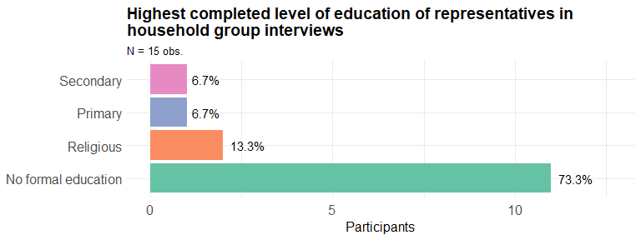

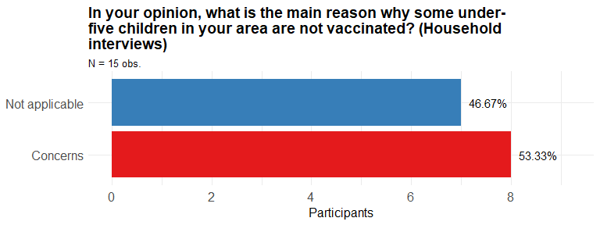

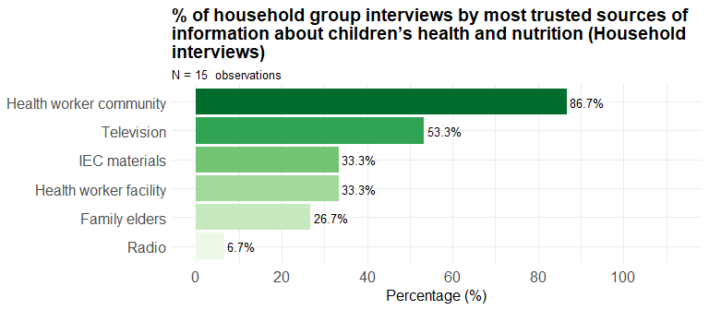

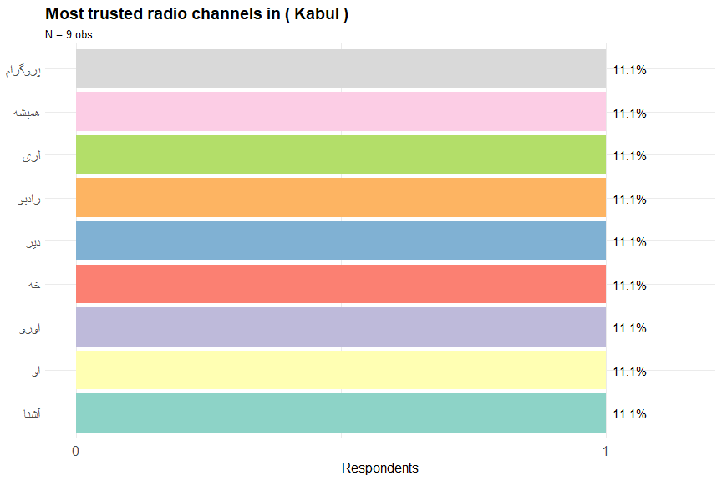

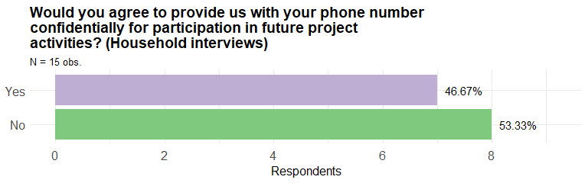

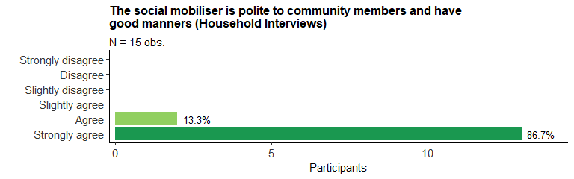

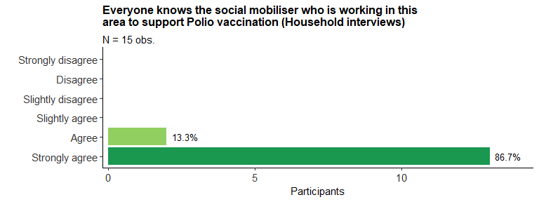

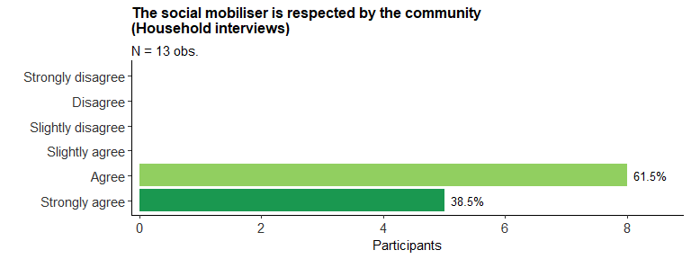

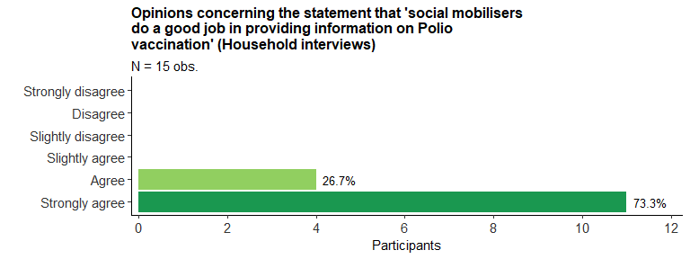

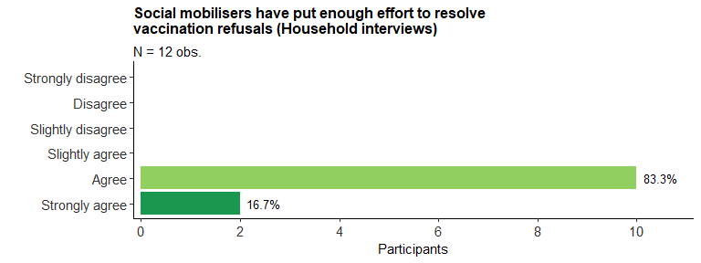

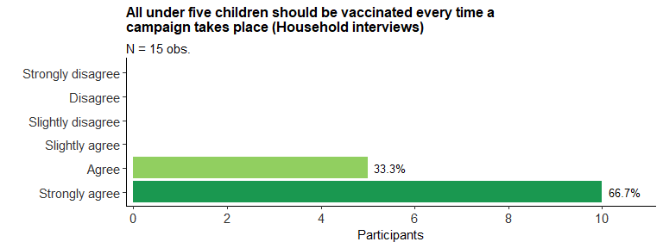

##### 

## Cluster Communication Supervisors (CCS)

This section presents the results from interviews by monitors with Cluster Communication Supervisors (CCS).

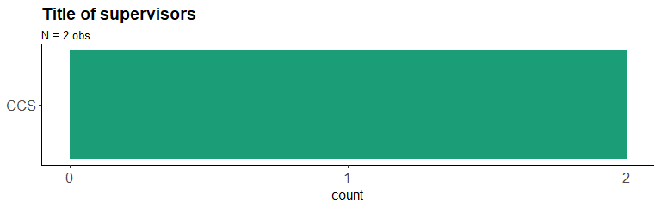

**Table below shows 2 cases where number of supportive supervision days in the last 30 days by CCS and DCO is less than 5 days (Supervisor interviews)**

| **Province** | **District** | **Subdistrict** | **Cluster** | **Team** | **Freq. Reported** |
| --- | --- | --- | --- | --- | --- |
| Kabul | Kabul | Kabul Part8 | 170 | 2 | 1 |
| Kabul | Kabul | Kabul Part8 | 177 | 1 | 1 |

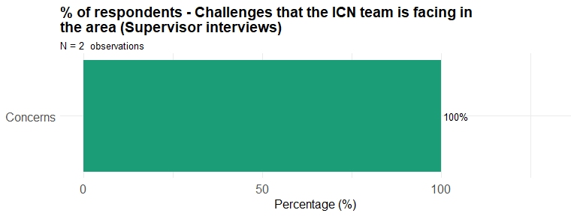**Table below shows 2 cases of problem: Challenges that the ICN team is facing in the area (Supervisor interviews)**

| **Region** | **Province** | **District** | **Subdistrict** | **Cluster** | **Team** | **Freq. Reported** |
| --- | --- | --- | --- | --- | --- | --- |
| Central | Kabul | Kabul | Kabul Part8 | 170 | 2 | 1 |
| Central | Kabul | Kabul | Kabul Part8 | 177 | 1 | 1 |

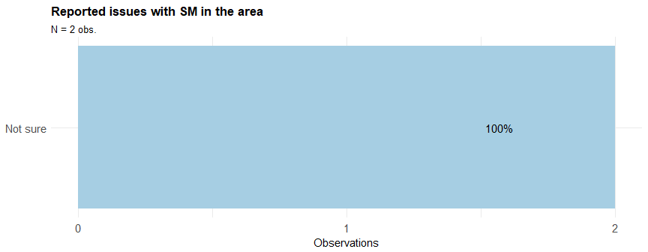

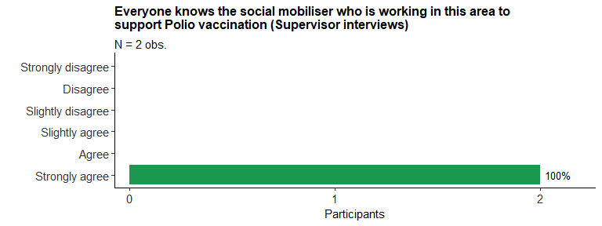

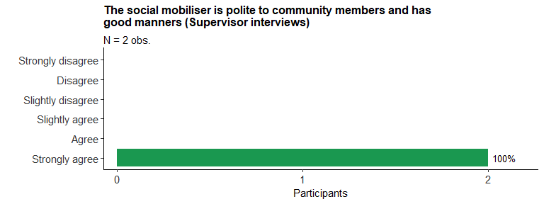

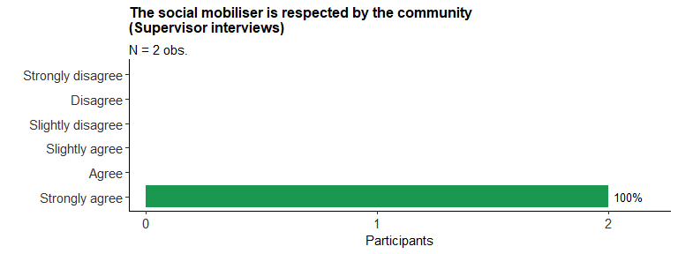

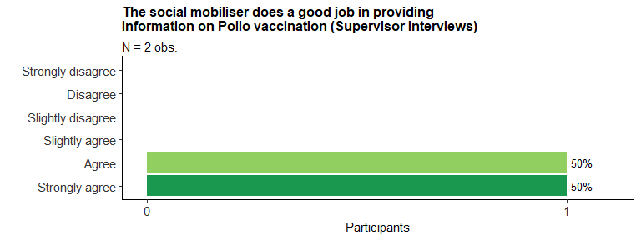

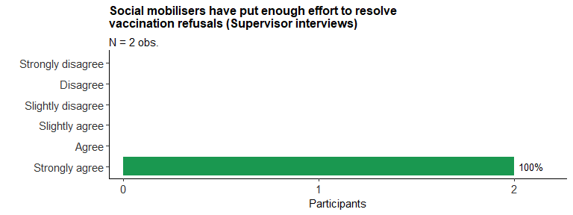

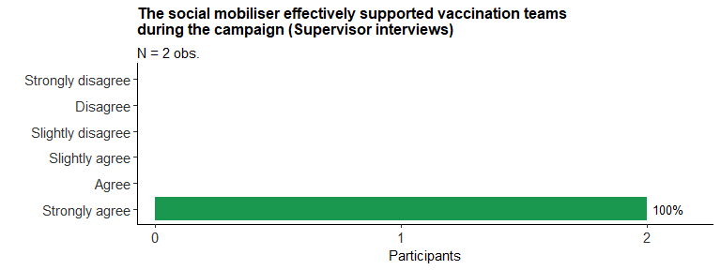

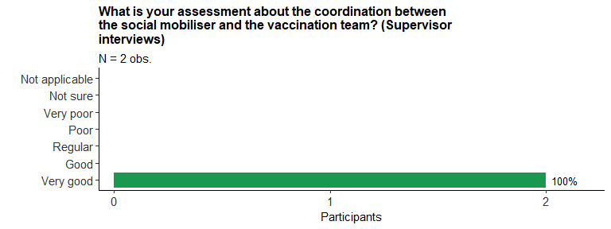

##### 

# Results of key questions with qualitative data

This section presents samples of responses to open-ended questions. In this questions, respondents could freely provide their responses as text. These questions were presented to respondents as closing questions for interviews and observation reports.

## Suggestions and comments from respondents

The following plot presents a word cloud with the most frequent keywords used by respondents in the optional question about comments or suggestions in the end of each interview application. Text data was translated automatically using the Google Cloud Translate API. Therefore, translation should be taken as indicative only. More detailed analysis requires examination of text in original language. Words with the same frequency have the same colours. After the plot, a random sample of answers is provided.

### Word cloud of suggestions and comments

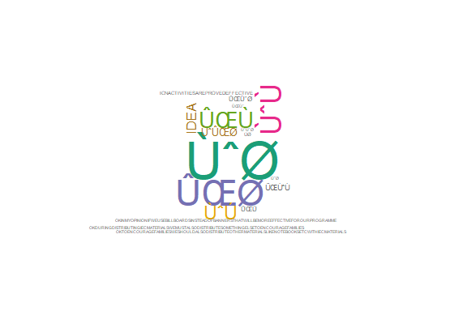

### Sample of comments and suggestions

A reproducible random sample of 30% of the received answers is presented below with indication of the location of the activity. Answers have not been edited in order to preserve their original version.

| **Cluster** | **Comment** |
| --- | --- |
| Kabul - Kabul Part12-264 | بل نظر نلری صرف دراجستر کوم مخکنی کتابونه چی وه خه وه اوسنی کتابونه بعضی مشکلات لری لکه په یوه صفحه کی د سو کورنیو ثبتول . |
| Kabul - Kabul Part12-259 | کوم خاص نظر نلری که دا پروسه همداسی دوام پیدا کری ان شالله دا ویروس به نابود شی |
| Kabul - Kabul Part8-170 | Ok to encourage families we should also distribute other materials like notebooks etc with IEC materials. |
| Kabul - Kabul Part12-264 | که چیری دخلکو سره دیر کار وشی همدا پروسه به هم کامیاب وی په کوشش کولو موگ کولی شو کوم یوه کورنی چی انکار هم کوی رضا کرو تر سو خپلو ماشومانو ته واکسین تطبیق کری |
| Kabul - Kabul Part8-148 | Social mobilisations is effective way and other than this has no idea. She offers to decrease social mobilisations days like she says that the pre campaign and campaigns days are effective for people but days between two campaign are not that much effective cause families become bored from us. |
| Kabul - Kabul Part12-259 | نظر نلری |

## Final notes from monitors

The following plot presents a word cloud with the most frequent keywords used by monitors in the optional field “Final notes” in the end of each interview application. Text data was translated automatically using the Google Cloud Translate API. Therefore, translation should be taken as indicative only. More detailed analysis requires examination of text in original language. Words with the same frequency have the same colours. After the plot, a random sample of answers is provided.

### Word cloud of final notes

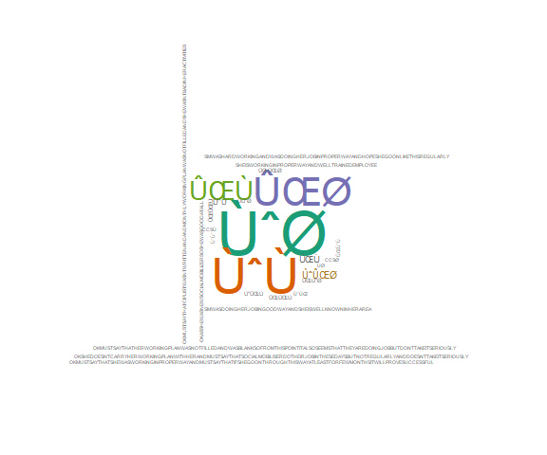

### Sample of monitors’ final notes

A reproducible random sample of 30% of the received answers is presented below with indication of the location of the activity. Answers have not been edited in order to preserve their original version.

| **Cluster** | **Comment** |
| --- | --- |
| Kabul - Kabul Part12-259 | دمبلغ کار خه و کوم خاص مشکل نه لیدل کیدو |
| Kabul - Kabul Part8-170 | Ok as she was a new social mobilizer so she was good at all. |
| Kabul - Kabul Part8-148 | Ok as sm wasn't in area so families says that sm visit houses twice a month first during campaign and other during distributing IEC materials but between two campaign she doesn't work as she should done. |
| Kabul - Kabul Part8-170 | Sm was hardworking and was doing her job in a proper way and hope she go on like this regularly. |
| Kabul - Kabul Part8-170 | Ok must say that she was working in a proper way and I must say that if she go on through this way at least for few months it will prove successful. |
| Kabul - Kabul Part12-260 | په دی ساحه کی دمبلغ کار خه په مخ تلو خو په ساحه کی ccs دبل تیم و چی ددی تیم سره هم همکاری کوی مگر خپله داتیم ccs نه لری. |
| Kabul - Kabul Part12-259 | دمبلغ کار خه و کورنیو ته یی دیر په نرمی سره د واکسینو دفوایدو په هکله معلومات ورکول |

##### 

# Annex - Indicator metadata and minimum standards

| **Indicator** | **Minimum Standard for Greem Status** | **Short Name** |
| --- | --- | --- |
| Monitor confirms the social mobiliser was present / could be found during the monitoring visit. | Yes | SM available |
| Supervisors, CIP and community members report knowing social mobilisers working in the area. | None of the following options selected (Strongly_disagree or Disagree) | SM is known |
| Community Influencing People (CIPs) reports knowing Cluster Communication Supervisor (CCS). | Yes | CCS is known |
| SM is resident of the village / Nahia. | Yes | SM resident |
| SM age. | Between 18 and 50 | SM age |
| SM reporting to have received both the basic training for social mobilisers (2 days) and the Pre-campaign training. | Yes | SM training |
| SM reporting having received inputs (supplies and IEC materials). | At least 3 out of the 7 answer options (Fieldbook, Referral_sheets, Speaking_book, Monthly_work_plan, Leaflet, Flip_chart_or_flip_cards, Fatwa_book) | Inputs |
| Level of coordination between social mobilisers and the vaccination team. | None of the following options selected (Very_poor or Poor) | Coordination |
| Monitoring visit have accessed SM field books. | Yes | Fieldbook available |
| Quality of the registration / documentation by social mobiliser in their field books as reported by monitors. | None of the following options selected (Very_poor or Poor) | Reg. Quality |
| Is the number of unvaccinated children from the most recent campaign recorded in the fieldbook or summary sheets? | Yes | Recorded children |
| Reported issues with field book in the area. | None of the following options selected (OPV_not_updated_or_incomplete; Incorrect_use_of_symbols; Incomplete_camp_summ_sheet) | Fieldbook issue |
| Frequency that social mobilisers conduct house by house visits as reported by CIPs. | One of the following options selected ("At_least_once_a_week" or "Once_in_two_weeks") | Household visits |
| Opinions concerning the statement that "social mobilisers do a good job in providing information on Polio vaccination". | None of the following options selected (Strongly_disagree or Disagree) | SM job |
| Opinions concerning the statement that "social mobiliser effectively supported vaccination teams during the campaign". | None of the following options selected (Strongly_disagree or Disagree) | SM vaccin. support |
| Reported issues with SM in the area. | None of the following options are selected (Inadequate_behaviour, Low_presence, Low_mobilisation, Not_accepted) | SM issues |
| Opinions concerning the statement "social mobiliser is respected by the community" . | None of the following options selected (Strongly_disagree or Disagree) | SM respected |
| Opinions concerning the statement that "social mobiliser is polite to community members and have good manners" . | None of the following options selected (Strongly_disagree or Disagree) | SM manners |
| The CIP indeed has the potential to influence the community in supoprt of the programme. | Strongly Agree and agree | CIP influential |
| Opinions by CIPs concerning the statement "You feel that your are sufficiently involved and consulted in discussions related to Polio and health in this area". | None of the following options selected (Strongly_disagree or Disagree) | CIP involvement |
| Opinions concerning the statement "All under five children should be vaccinated every time a campaign takes place". | None of the following options selected (Strongly_disagree or Disagree) | Vacc. U5 every time |
| Opinions concerning the statement that "social mobilisers have put enough effort to resolve vaccination refusals (e.g. repeat visits, seek support from influencers and supervisors)". | None of the following options selected (Strongly_disagree or Disagree) | SM resolve refusals |
| SM reporting to have received guidance / coaching from CCS, DCO or PCO. | At least one of the following options selected (CCS, DCO or PCO) | Supporter |
| SM reporting on-the-job support in last two weeks. | At least 2 out of the 4 main answer options (Use_of_fieldbook, Use_of_monthly_monitoring_plan, Community_mobilisation, Convince_refusals) | Support |
| Number of supportive supervision days in the last 30 days by CCS. | Sum of supportive supervision days >= 3 days | Support days |
| The CCS visits this area at least once a month. | None of the following options selected (Strongly_disagree or Disagree) | CCS present |
| Opinions concerning the statement "There are community influencers in this area who do not think that under-five children should be vaccinated every time". | None of the following options selected (Strongly_disagree or Disagree) | CIP vacc. U5 not every time |
| Opinions concerning challenges that the ICN team faces in the area. | None of the following options selected (Concerns, Opposition, Tough_refusals, Mobile_populations, CIP_not_supportive) | Challenges |
| Reported access restrictions due to external factors. | None of the following options selected (Can_visit_few_houses, Can_visit_very_few_houses, Cannot_undertake_visits_at_all) | Access |
| Reasons for access restrictions is not insecurity. | None of the following options selected   (Security_risk,   Not_accepted_by_community) | Restricted access |
| Social mobilisers reporting delay in payments (Up to which month have you already been paid for?). | Difference between month of data-collection and reported month <= 2 months | Last pay |
| Payment amount reported by social mobilisers. | Reported payment is at least 7,500 AFN | Salary |
| Quality of monitoring – mobile phone data. | Monitoring data contains respondents' mobile number | Phone |

# References

* Achim Zeileis and Gabor Grothendieck (2005). zoo: S3 Infrastructure for Regular and Irregular Time Series. Journal of Statistical Software, 14(6), 1-27. <doi:10.18637/jss.v014.i06>
* Alboukadel Kassambara (2018). ggpubr: ‘ggplot2’ Based Publication Ready Plots. R package version 0.1.8. <https://CRAN.R-project.org/package=ggpubr>
* D. Kahle and H. Wickham. ggmap: Spatial Visualization with ggplot2. The R Journal, 5(1), 144-161. URL <http://journal.r-project.org/archive/2013-1/kahle-wickham.pdf>
* David Gohel (2018). flextable: Functions for Tabular Reporting. R package version 0.4.6. <https://CRAN.R-project.org/package=flextable>
* David Gohel (2018). officer: Manipulation of Microsoft Word and PowerPoint Documents. R package version 0.3.2. <https://CRAN.R-project.org/package=officer>
* David Wilkins (2018). treemapify: Draw Treemaps in ‘ggplot2’. R package version 2.5.0. <https://CRAN.R-project.org/package=treemapify>
* Frank E Harrell Jr, with contributions from Charles Dupont and many others. (2018). Hmisc: Harrell Miscellaneous. R package version 4.1-1. <https://CRAN.R-project.org/package=Hmisc>
* Garrett Grolemund, Hadley Wickham (2011). Dates and Times Made Easy with lubridate. Journal of Statistical Software, 40(3), 1-25. URL <http://www.jstatsoft.org/v40/i03/>.
* Gergely Daróczi and Roman Tsegelskyi (2017). pander: An R ‘Pandoc’ Writer. R package version 0.6.1. <https://CRAN.R-project.org/package=pander>
* Hadley Wickham (2007). Reshaping Data with the reshape Package. Journal of Statistical Software, 21(12), 1-20. URL <http://www.jstatsoft.org/v21/i12/>.
* Hadley Wickham (2017). httr: Tools for Working with URLs and HTTP. R package version 1.3.1. <https://CRAN.R-project.org/package=httr>
* Hadley Wickham (2017). lazyeval: Lazy (Non-Standard) Evaluation. R package version 0.2.1. <https://CRAN.R-project.org/package=lazyeval>
* Hadley Wickham (2017). scales: Scale Functions for Visualization. R package version 0.5.0. <https://CRAN.R-project.org/package=scales>
* Hadley Wickham (2017). tidyverse: Easily Install and Load the ‘Tidyverse’. R package version 1.2.1. <https://CRAN.R-project.org/package=tidyverse>
* Hadley Wickham (2018). stringr: Simple, Consistent Wrappers for Common String Operations. R package version 1.3.1. <https://CRAN.R-project.org/package=stringr>
* Hadley Wickham and Jennifer Bryan (2018). readxl: Read Excel Files. R package version 1.1.0. <https://CRAN.R-project.org/package=readxl>
* Ian Fellows (2018). wordcloud: Word Clouds. R package version 2.6. <https://CRAN.R-project.org/package=wordcloud>
* Ingo Feinerer and Kurt Hornik (2018). tm: Text Mining Package. R package version 0.7-5. <https://CRAN.R-project.org/package=tm>
* JJ Allaire, Yihui Xie, Jonathan McPherson, Javier Luraschi, Kevin Ushey, Aron Atkins, Hadley Wickham, Joe Cheng and Winston Chang (2018). rmarkdown: Dynamic Documents for R. R package version 1.9. <https://CRAN.R-project.org/package=rmarkdown>
* John Fox, Bill Venables and Anthony Damico (2018). english: Translate Integers into English. R package version 1.1-4. <https://CRAN.R-project.org/package=english>
* Kenneth Benoit, David Muhr and Kohei Watanabe (2017). stopwords: Multilingual Stopword Lists. R package version 0.9.0. <https://CRAN.R-project.org/package=stopwords>
* Marc Schwartz and various authors for Perl modules listed in each .pm file. (2015). WriteXLS: Cross-Platform Perl Based R Function to Create Excel 2003 (XLS) and Excel 2007 (XLSX) Files. R package version 4.0.0. <https://CRAN.R-project.org/package=WriteXLS>
* Mark Edmondson (2018). googleLanguageR: Call Google’s ‘Natural Language’ API, ‘Cloud Translation’ API, ‘Cloud Speech’ API and ‘Cloud Text-to-Speech’ API. R package version 0.2.0. <https://CRAN.R-project.org/package=googleLanguageR>
* Michael Friendly (2017). vcdExtra: ‘vcd’ Extensions and Additions. R package version 0.7-1. <https://CRAN.R-project.org/package=vcdExtra>
* Rasmus Bååth (2018). bayesboot: An Implementation of Rubin’s (1981) Bayesian Bootstrap. R package version 0.2.2. <https://CRAN.R-project.org/package=bayesboot>
* Yihui Xie (2018). knitr: A General-Purpose Package for Dynamic Report Generation in R. R package version 1.20.

**Time elapsed to generate this report**: 56.7 minutes.

1. Reference dates can be changed in the report source code, if necessary.