إضافة الشكاوى

URL
nchrtest.es.jo | Test
nchr.es.jo | Live

- هل المتضرر نفسه المشتكي ؟ نعم

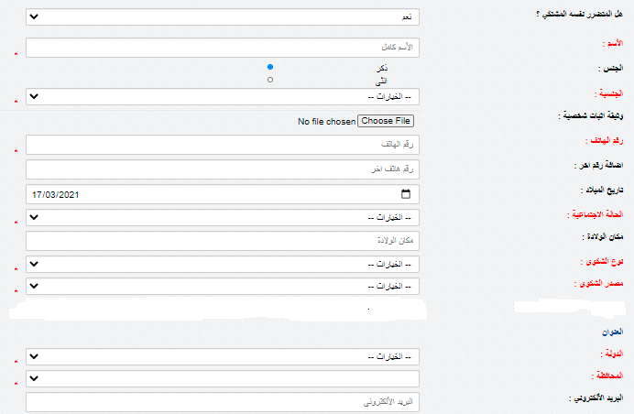

Endpoint
POST https://******/AddComplaint.ashx

Request Headers
Content-Type: application/json

JSON Request Body
{
"action": "InsertComplaint_same_complainant", // Required
"FullName": "احمد علي", // Required
"GenderID": 1, // Required
"NationalityID": 1, // Required
"IDNumber": "123456789", // Required if Jordanian (if NationalityID = 1)
"NationalityName": "", // Required if not Jordanian (if NationalityID = 2)
"PassportNumber": "123456789", // Required if not Jordanian (if NationalityID = 2)
"PhoneNumber": "07*******", // Required
"OtherPhoneNumber": "07*******",
"SocialStatusID": 1, // Required
"PlaceofBirth": "الاردن", // Required
"DateofBirth": "15/01/1986", // Required
"TypeOfComplaintID": 1, // Required
"CountryID": 3, // Required
"CityID": 2, // Required default(set value:0 if not Jordan)
"Email": "ahmad@example.com",
"PersonalIdentificationUrl": "https://yourdomain.com/uploads/id_ahmad.jpg",
"SourceOfComplaint": "هاتف", // Required
"SourceOfComplaintText": "الخط الساخن",
"ComplaintText": "........", // Required
"AttachmentsUrl": "https://yourdomain.com/uploads/attachment1.pdf"
}

Field | Required | Description / Condition | Example Value
action | Yes | Operation to perform | "InsertComplaint_same_complainant"
FullName | Yes | Full name of complainant | "احمد علي"
GenderID | Yes | Gender ID (1=Male, 2=Female) | 1
NationalityID | Yes | Nationality ID (1=Jordanian, 2=Other) | 1
IDNumber | Conditional | Required if Jordanian (NationalityID = 1) | "123456789"
NationalityName | Conditional | Required if not Jordanian (NationalityID = 2) | ""
PassportNumber | Conditional | Required if not Jordanian (NationalityID = 2) | "123456789"
PhoneNumber | Yes | Primary phone number | "07*******"
OtherPhoneNumber | No | Optional secondary phone number | "07*******"
SocialStatusID | Yes | Marital / social status ID | 1
PlaceofBirth | Yes | Place of birth | "الاردن"
DateofBirth | Yes | Format: dd/MM/yyyy | "15/01/1986"
TypeOfComplaintID | Yes | Complaint type ID | 1
CountryID | Yes | Country of complaint | 3
CityID | Yes | City ID (set 0 if not Jordan) | 2
Email | No | Optional email | "ahmad@example.com"
PersonalIdentificationUrl | No | URL to ID image | "https://yourdomain.com/uploads/id_ahmad.jpg"
SourceOfComplaint | Yes | How complaint was received | "هاتف"
SourceOfComplaintText | No | Details of source | "الخط الساخن"
ComplaintText | Yes | Complaint content | "........"
AttachmentsUrl | No | URL to any attachments | "https://yourdomain.com/uploads/attachment1.pdf"

Example JSON Response
{
"success": true
}
or
{
"success": false,
"error": "Invalid action parameter."
}

- هل المتضرر نفسه المشتكي ؟ لا

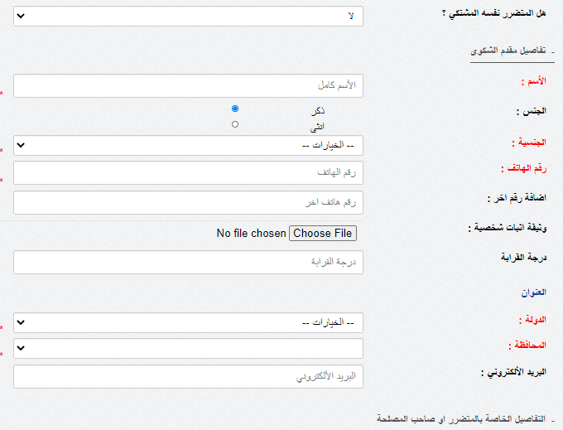

- هل المتضرر نفسه المشتكي ؟ لا
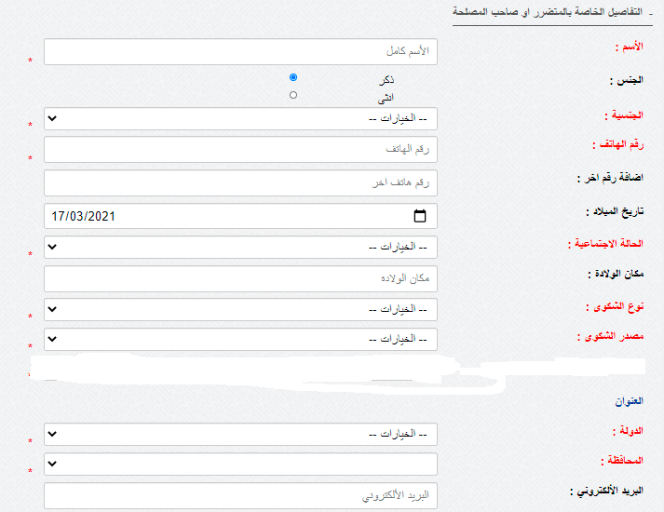

Endpoint
POST https:// ******/AddComplaint.ashx

Request Headers
Content-Type: application/json

JSON Request Body

{
"action": "InsertComplaint_Not_same_complainant", // Required
"FullName": "احمد علي", // Required
"GenderID": 1, // Required
"NationalityID": 1, // Required
"IDNumber": "123456789", // Required if Jordanian (if NationalityID = 1)
"NationalityName": "", // Required if not Jordanian (if NationalityID = 2)
"PassportNumber": "123456789", // Required if not Jordanian (if NationalityID = 2)
"PhoneNumber": "07*******", // Required
"OtherPhoneNumber": "07*******",
"SocialStatusID": 1, // Required
"PlaceofBirth": "الاردن", // Required
"DateofBirth": "15/01/1986", // Required
"TypeOfComplaintID": 1, // Required
"CountryID": 3, // Required
"CityID": 2, // Required default(set:0)
"Email": "mohammad@example.com",
"SourceOfComplaint": " هاتف", // Required
"SourceOfComplaintText": "الخط الساخن",
"ComplaintText": "********", // Required
"AttachmentsUrl": "https://yourdomain.com/uploads/file123.pdf",
"ComplainantFullName": "محمد علي", // Required
"ComplainantGenderID": 1, // Required
"ComplainantNationalityID": 1, // Required
"ComplainantIDnumber": "123456789", // Required if Jordanian (if NationalityID = 1)
"ComplainantNationalityName": "", // Required if not Jordanian (if NationalityID = 2)
"ComplainantPassportNumber": "123456789", // Required if not Jordanian (if NationalityID = 2)
"ComplainantPhoneNumber": "07*******", // Required
"ComplainantOtherPhoneNumber": "07*******",
"ComplainantPersonalIdentificationUrl": "https://yourdomain.com/uploads/id_m.jpg",
"ComplainantDegreeOfKinship": "ابن عم", // Required
"ComplainantCountryID": 3, // Required
"ComplainantCityID": 2, // Required default(set value:0 if not Jordan)
"ComplainantEmail": "mohammad@example.com"
}

Field | Required | Description / Condition | Example Value
action | Yes | Operation to perform | "InsertComplaint_Not_same_complainant"
FullName | Yes | Full name of the person submitting the complaint | "احمد علي"
GenderID | Yes | Gender ID (1=Male, 2=Female) | 1
NationalityID | Yes | Nationality ID (1=Jordanian, 2=Other) | 1
IDNumber | Conditional | Required if Jordanian (NationalityID = 1) | "123456789"
NationalityName | Conditional | Required if not Jordanian (NationalityID = 2) | ""
PassportNumber | Conditional | Required if not Jordanian (NationalityID = 2) | "123456789"
PhoneNumber | Yes | Primary phone number | "07*******"
OtherPhoneNumber | No | Optional secondary phone number | "07*******"
SocialStatusID | Yes | Marital / social status ID | 1
PlaceofBirth | Yes | Place of birth | "الاردن"
DateofBirth | Yes | Format: dd/MM/yyyy | "15/01/1986"
TypeOfComplaintID | Yes | Complaint type ID | 1
CountryID | Yes | Country of complaint | 3
CityID | Yes | City ID (set 0 if not Jordan) | 2
Email | No | Optional email | "mohammad@example.com"
SourceOfComplaint | Yes | How complaint was received | "هاتف"
SourceOfComplaintText | No | Details of source | "الخط الساخن"
ComplaintText | Yes | Complaint content | "********"
AttachmentsUrl | No | URL to any attachments | "https://yourdomain.com/uploads/file123.pdf"
ComplainantFullName | Yes | Full name of the person about whom the complaint is filed | "محمد علي"
ComplainantGenderID | Yes | Gender ID (1=Male, 2=Female) | 1
ComplainantNationalityID | Yes | Nationality ID | 1
ComplainantIDnumber | Conditional | Required if Jordanian (ComplainantNationalityID = 1) | "123456789"
ComplainantNationalityName | Conditional | Required if not Jordanian (ComplainantNationalityID = 2) | ""
ComplainantPassportNumber | Conditional | Required if not Jordanian (ComplainantNationalityID = 2) | "123456789"
ComplainantPhoneNumber | Yes | Primary phone of complainant | "07*******"
ComplainantOtherPhoneNumber | No | Optional secondary phone | "07*******"
ComplainantPersonalIdentificationUrl | No | URL to complainant ID | "https://yourdomain.com/uploads/id_m.jpg"
ComplainantDegreeOfKinship | Yes | Relation of complainant to the person filing complaint | "ابن عم"
ComplainantCountryID | Yes | Country ID of complainant | 3
ComplainantCityID | Yes | City ID (set 0 if not Jordan) | 2
ComplainantEmail | No | Optional email of complainant | "mohammad@example.com"

Example JSON Response
{
"success": true
}
or
{
"success": false,
"error": "Invalid action parameter."
}

البند | الاختيار | ملاحظات
الجنسية | 1. أردني  2. أخرى
الحالة الاجتماعية | 1. أعزب  2. متزوج  3. أرمل  4. مطلق  5. غير مدرج
نوع الشكوى | 1. شكوى  2. طلب مساعدة
مصدر الشكوى | هاتف  إيميل  فاكس  موقع إلكتروني  زيارة مباشرة  رصد | إذا كان الاختيار هاتف أو إيميل أو فاكس أو موقع إلكتروني يجب الإدخال  الدولة والمدينة
الدولة | 3 - الأردن  1069 - السعودية  1116 - قطر  2137 - روسيا/أوكرانيا/دونتيسك  4202 - ليبيا  4226 - الإمارات العربية المتحدة  4223 - الولايات المتحدة الأمريكية
المدينة | 2 - عمان  3 - الزرقاء  24 - السلط  25 - المفرق  26 - الكرك  27 - مادبا  28 - جرش  29 - عجلون  30 - العقبة  31 - معان  32 - الطفيلة  17 - إربد | ملاحظة: إذا كانت الدولة غير الأردن، يتم إخفاء المدينة  القيمة للمدينة 0

