FINANCIAL ANALYSIS REPORT · GROUP 9226 · TEAM 3 · VERSION 2 (ALIGNED WITH POWER BI DASHBOARD)
Maintenance Spend against the Cost of Downtime
Cost Structure and Production-Loss Exposure of the Asset Fleet, January 2024 – December 2026
Prepared for: Finance and the Maintenance & Reliability Director · Prepared by: Team 3 Executive Analytics Advisory Group · October 2026
Alignment note. This version adopts the measure names, denominators and age bands used in the team’s Power BI dashboard (Group_9226_Team_3_Dashboard.pbix) so that the report, dashboard and presentation reconcile. Bracketed green references, e.g. [Dashboard: Cost & Loss], identify the dashboard page that shows the same figure. Figures that appear only in this report are marked [Report only]. Appendix C provides the full reconciliation.

1. Executive Summary
This report evaluates whether the enterprise’s maintenance expenditure is proportionate to the economic cost of the downtime it is intended to prevent. Over the 36-month panel the fleet incurred $50.4M of maintenance cost and $228.9M of production loss, an economic exposure of $279.3M. Production loss is 4.5× the repair spend (4.54× unrounded), and every downtime hour costs $2,513.
$50.4M  Maintenance Cost  Dashboard card: $50M | $228.9M  Production Loss  Dashboard card: $229M | 4.5×  Loss to Maintenance Ratio  4.54× unrounded | $2,513  Downtime Cost Rate  loss ÷ downtime h

$279.3M  Economic Exposure  maintenance + loss | $45,776  Loss per Record  5,000 records | $21.19  Cost per Operating Hour  maintenance ÷ operating h | 97.0% · 12.0 h  Availability · MTTR  MTBF 313.3 h

Key findings
- The financial problem is downtime, not maintenance cost. Maintenance is the smaller cost pool by a factor of 4.5. Loss accrues at an almost uniform $2,513 per downtime hour, so the value of any decision equals the downtime hours it changes. [Dashboard: Summary, Cost & Loss]
- The exposure is structural. Loss per record stayed between $41,478 and $49,955 in every quarter around a 36-month mean of $45,776, with no sustained trend. [Dashboard: Cost & Loss]
- Critical assets carry disproportionate loss. They lose $61,015 per record against $42,602 for other tiers, take 16.3 h to restore against about 11 h, and meet SLA on only 29.1% of records. Their loss-to-maintenance ratio is 6.02× against 4.23×. [Dashboard: Summary, Work Orders; ratio: Report only]
- Reactive maintenance is the costliest strategy. Reactive records lose $62,030 each against $40,216 for predictive records (35.2% lower) and fail 2.09 times per record against 1.34. [Dashboard: Summary, Reliability]
- Exposure rises with age and deteriorating condition. Downtime per record rises from 9.1 h for assets under 4 years to 28.6 h for assets of 12 years and over, and loss per record from $22,802 to $73,182. [Dashboard: Reliability]
Recommendation in brief. The report supports the four decisions requested on the dashboard’s Summary page — restore critical assets faster, pilot condition-based care on ageing and degraded assets, trial the risk watchlist as a ranking aid, and fix data definitions — and adds two Finance actions: budget against downtime exposure, and fund a spare-parts uplift for critical assets that breaks even at 3.6% of their downtime.

2. Scope, Data and Methodology
The analysis covers all 5,000 records in the Group 9226 Team 3 Enterprise Dataset (v1.0), dated 5 January 2024 to 25 December 2026. The data are a synthetic educational panel; results describe a simulated fleet, relationships are associations rather than demonstrated causes, and monetary scenarios are illustrative.
Measures follow the dashboard’s Method page: every rate is a sum of numerators over a sum of denominators (e.g. MTBF = Σ operating hours ÷ Σ failures; Downtime Cost Rate = Σ production loss ÷ Σ downtime hours), and row-level rate columns are never averaged. “Per record” measures divide by all records in the selection, as on the dashboard. The principal qualifications, also listed on the dashboard’s Method page, are:
- Other Maintenance Cost — maintenance cost not itemised as parts or labour — is $9,187,712 (18.2%).
- 2026 contains 996 records against about 2,000 in each prior year; years are compared by rate, never by total. Annualised figures use the 2024–2025 average.
- All loss sits on the 4,015 corrective records; the 985 preventive records carry no downtime or loss. Per-record measures therefore include zero-loss records.
- Asset_ID, Site and Region are not stable entity identifiers, so no per-asset or per-site conclusions are drawn.

3. Cost Structure
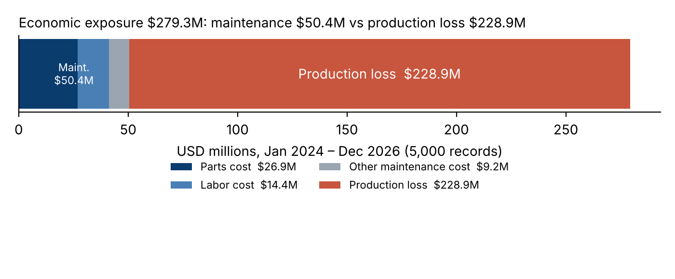
Figure 1. Composition of economic exposure, 2024–2026. Dashboard: Cost & Loss — “Maintenance cost components by asset class”.
Component | USD | % of maintenance | % of economic exposure
Parts Cost | $26,888,677 | 53.3% | 9.6%
Labor Cost | $14,354,056 | 28.5% | 5.1%
Other Maintenance Cost | $9,187,712 | 18.2% | 3.3%
Maintenance Cost | $50,430,446 | 100.0% | 18.1%
Production Loss | $228,881,052 | — | 81.9%
Economic Exposure | $279,311,498 | — | 100.0%
Table 1. Cost structure, using the dashboard’s component names.
Maintenance expenditure is material-led: parts account for 53.3% and labour for 28.5%, at an effective $52.69 per technician hour. Corrective records carry 92.0% of maintenance cost (average $11,559 per record against $4,081 for a preventive record). In financial terms the budget behaves as a variable cost of failure rather than as a planned investment in reliability.
Measure | Value | Definition | Dashboard
Downtime Cost Rate | $2,513.14 | Σ loss ÷ Σ downtime h | Scorecard, Cost & Loss
Cost per Operating Hour | $21.19 | Σ maintenance ÷ Σ operating h | Scorecard, Cost & Loss
Loss per Record | $45,776 | Σ loss ÷ records | Cost & Loss
MTTR (downtime per failure) | 12.0 h | Σ downtime ÷ Σ failures | Scorecard, Reliability
Downtime per Record | 18.2 h | Σ downtime ÷ records | Reliability
Failures per Record | 1.52 | Σ failures ÷ records | Scorecard, Reliability
Production loss per failure | $30,128 | Σ loss ÷ Σ failures | Report only
Maintenance cost per failure | $6,638 | Σ maintenance ÷ Σ failures | Report only
Table 2. Unit economics. Note that downtime is quoted per failure (MTTR, 12.0 h) and per record (18.2 h); both appear on the dashboard and must be labelled when cited.
An average failure costs $6,638 to repair but $30,128 in lost output, so each avoided failure is worth roughly $36,766 of economic exposure — the hurdle any preventive or predictive spend must clear.
Asset class | Maintenance | Production Loss | Loss per Record | Cost per Op. Hour | Loss ÷ Maint.
Railway Signalling | $10.71M | $54.26M | $55,991 | $22.98 | 5.07×
Industrial Pump | $10.36M | $49.61M | $48,777 | $21.33 | 4.79×
Heavy Equipment | $10.45M | $49.74M | $48,101 | $21.26 | 4.76×
Power System | $9.44M | $38.78M | $40,484 | $20.84 | 4.11×
Biomedical Equipment | $9.48M | $36.50M | $35,714 | $19.56 | 3.85×
Table 3. Spend and loss by asset class. Dashboard: Summary — “Production loss per record by asset class”; Cost & Loss — “Cost per operating hour by asset class” and “Total production loss by asset class”.
Maintenance spend is spread almost evenly across classes (18.7%–21.2% each), yet loss per record ranges from $35,714 for biomedical equipment to $55,991 for railway signalling — the highest-exposure class on the dashboard. An equal allocation of spend across unequal exposures is the first sign of misallocation.

4. The Cost of Downtime
Production loss equals downtime hours multiplied by an hourly rate that is close to uniform: $2,513 for the portfolio, between $2,456 and $2,562 across asset classes, and stable across years ($2,513, $2,528, $2,484). The dashboard’s scatter of downtime hours against production loss shows the same near-linear relationship. Differences in loss between segments therefore come from how many hours each segment loses, not from the value of those hours.
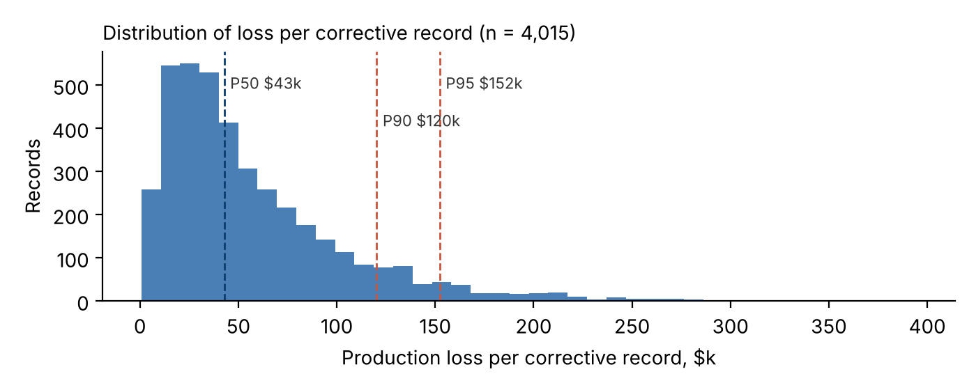
Figure 2. Distribution of production loss per corrective record [Report only].
The distribution is right-skewed: among corrective records the median loss is $42,832 and the P90 is $120,322, and the costliest 10% account for 29.1% of all loss. Reserves and service commitments should be sized on the P90–P95 range ($120,322–$152,352 per event) rather than on averages.

5. Maintenance Spend against Loss over Time
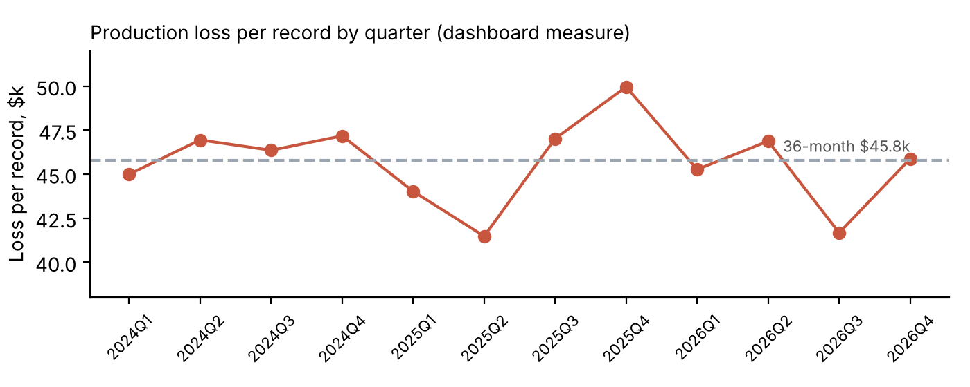
Figure 3. Production loss per record by quarter. Dashboard: Cost & Loss — “Production loss per record by quarter”.
Year | Records | Maintenance | Production Loss | Loss per Record | Loss ÷ Maint.
2024 | 2,004 | $20.36M | $92.92M | $46,367 | 4.56×
2025 | 2,000 | $19.99M | $91.22M | $45,611 | 4.56×
2026 | 996 | $10.08M | $44.74M | $44,920 | 4.44×
Table 4. Annual view. 2026 totals reflect half the record volume; compare years by the per-record and ratio columns only.
On a per-record basis the fleet’s exposure is flat: loss per record is $46,367 in 2024, $45,611 in 2025 and $44,920 in 2026, and the quarterly loss-to-maintenance ratio stays between 4.2× and 5.0×. The current level of exposure is therefore the baseline any new programme must improve upon.
Corrective records by maintenance-cost quartile | Mean maintenance | Mean loss | Failures / record | Downtime / record
Q1 (lowest) | $5,752 | $38,809 | 1.30 | 15.2 h
Q2 | $8,853 | $47,765 | 1.59 | 18.9 h
Q3 | $12,318 | $60,067 | 1.99 | 23.9 h
Q4 (highest) | $19,315 | $81,388 | 2.70 | 32.7 h
Table 5. Spend and loss move together because both follow the failure [Report only].
This pattern must not be read as “maintenance causes loss”. Corrective spend is incurred after a failure, so a severe failure produces both a large repair bill and a large loss. Only spend that occurs before failure — preventive, predictive, condition-based care and spares availability — can reduce loss.

6. Production-Loss Exposure

6.1 Criticality
Criticality | Records | Production Loss | Loss per Record | MTTR | SLA On-Target | Loss ÷ Maint. (95% CI)
Critical | 862 | $52.6M | $61,015 | 16.3 h | 29.1% | 6.02× (5.68×–6.35×)
High | 1,535 | $63.7M | $41,494 | 11.0 h | 49.9% | 4.18× (4.00×–4.37×)
Medium | 1,838 | $80.1M | $43,559 | 11.2 h | 50.2% | 4.26× (4.10×–4.43×)
Low | 765 | $32.5M | $42,524 | 11.1 h | 47.8% | 4.23× (3.96×–4.51×)
Table 6. Exposure by criticality. Dashboard: Cost & Loss — “Production loss by criticality” ($33M / $80M / $64M / $53M); Work Orders — “SLA on-target share by criticality”; Summary — Decision 1 (MTTR 16.3 h, 29% SLA). The ratio column is Report only.
On the dashboard, critical assets show the third-largest total loss ($53M) because they are the smallest tier (862 records). Normalised, they are the most exposed: $61,015 of loss per record against $42,602 for all other tiers, restoration time of 16.3 h against 11.0–11.2 h, SLA on-target of 29.1% against 47.8%–50.2%, and 6.02× of loss per dollar of maintenance against 4.23×. Because their downtime cost rate ($2,503) is in line with the portfolio, the excess reflects longer outages, consistent with the dashboard’s first requested decision.
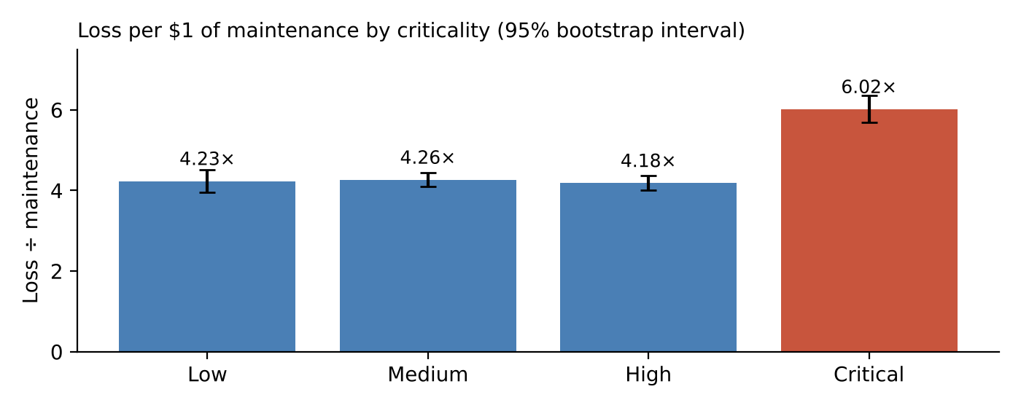
Figure 4. Loss per $1 of maintenance by criticality with 95% bootstrap intervals [Report only — recommended addition to the dashboard].

6.2 Maintenance strategy
Strategy | Records | Loss per Record | Failures per Record | MTBF (h) | Cost per Op. Hour | Total cost / planned h
Reactive | 798 | $62,030 | 2.09 | 219.0 | $27.03 | $124.46
Preventive | 1,754 | $46,658 | 1.53 | 311.8 | $21.15 | $94.77
Condition Based | 1,345 | $39,543 | 1.32 | 363.2 | $19.56 | $81.71
Predictive | 1,103 | $40,216 | 1.34 | 362.6 | $19.22 | $82.02
Table 7. Strategy economics. Dashboard: Summary — “Loss per record: criticality × strategy” (Total row) and “Failures per record by strategy”. The planned-hour column is Report only and confirms the same ranking.
Reactive maintenance is the costliest strategy on every measure: $62,030 of loss per record against $39,543 for condition-based and $40,216 for predictive care (35.2% lower), 2.09 failures per record against 1.34, and $27.03 of maintenance per operating hour against $19.22. On a total-cost-per-planned-hour basis the gap is 34.1%, so the conclusion does not depend on the choice of denominator.
Criticality | Reactive | Preventive | Condition Based | Predictive
Critical | $89,774 | $56,935 | $55,054 | $54,621
High | $49,712 | $43,041 | $37,846 | $37,170
Medium | $59,504 | $45,699 | $36,935 | $37,250
Low | $62,325 | $44,789 | $32,117 | $36,356
Table 8. Loss per record by criticality × strategy. Dashboard: Summary — same matrix (the Critical and High rows require scrolling in the exported PDF).
The intersection of the two drivers is the single most exposed segment: critical assets under reactive maintenance lose $89,774 per record — about twice the portfolio mean of $45,776.

6.3 Asset age and condition
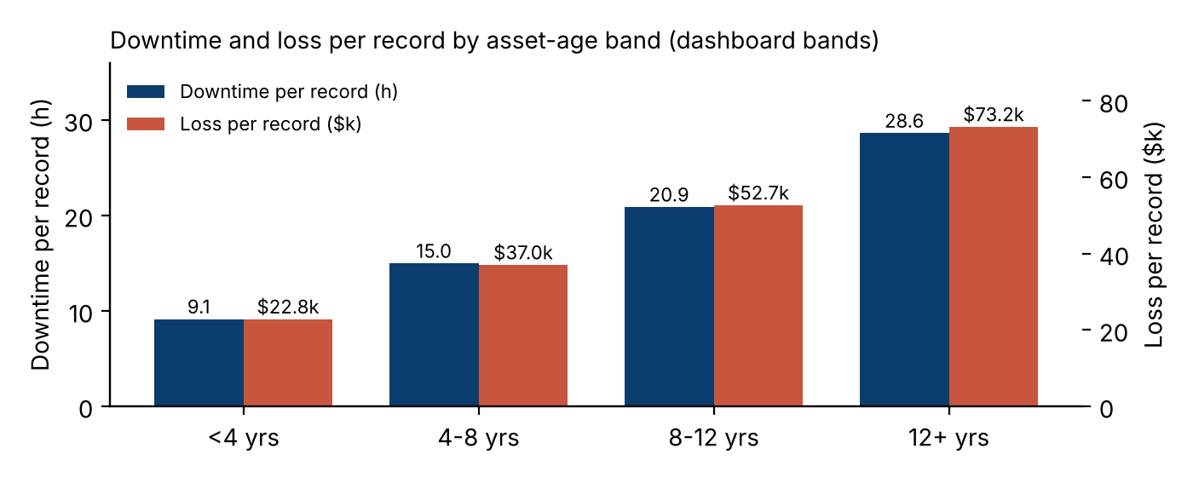
Figure 5. Downtime and loss per record by age band. Dashboard: Reliability — “Downtime per record by age band” (9.1 / 15.0 / 20.9 / 28.6 h).
Age band | Records | Downtime per Record | Loss per Record | Maintenance per Record | Failures per Record
<4 yrs | 565 | 9.1 h | $22,802 | $7,753 | 0.94
4-8 yrs | 1,886 | 15.0 h | $37,007 | $9,487 | 1.35
8-12 yrs | 1,965 | 20.9 h | $52,654 | $10,723 | 1.69
12+ yrs | 584 | 28.6 h | $73,182 | $12,135 | 2.06
Table 9. Exposure by asset-age band, using the dashboard’s bands.
Loss per record rises from $22,802 for assets under 4 years to $73,182 for assets of 12 years and over (+221%), while maintenance per record rises only 57%. Condition score shows the same gradient on the dashboard: downtime per record falls from 29.5 h for scores below 60 to 8.7 h for scores of 90 and above, with loss per record falling from $76,437 to $20,444. Spending on ageing and degraded assets does not keep pace with the loss they generate, which supports the dashboard’s second requested decision.

6.4 Spare parts
Criticality | Parts Cost | Production Loss | Parts per $1 of loss | Stockout records
Critical | $4.71M | $52.59M | 9.0¢ | 15
High | $8.00M | $63.69M | 12.6¢ | 22
Medium | $10.12M | $80.06M | 12.6¢ | 31
Low | $4.05M | $32.53M | 12.5¢ | 16
Table 10. Spare-parts expenditure relative to loss [Report only]. The dashboard Method page confirms 84 stockouts.
Critical assets receive 9.0¢ of parts per $1 of loss against 12.6¢ elsewhere. Stockouts are rare (84 records) but coincide with mean loss of $118,478 against $55,693; on a like-for-like comparison of busy assets the effect is about +17%.

6.5 Predictive exposure: the risk watchlist
The dashboard’s Risk page applies a logistic-regression model to flag records likely to fall in the top 20% of production loss. The model was re-built independently for this report and its published results reproduced (test AUC 0.727 against 0.73 published; baseline 0.612 against 0.61; top-decile lift 2.5×). For Finance, the relevant figures are that the 1,418 watchlist records (28.4% of records) hold 43.6% of production loss, and the Critical-watch tier has a 52.9% high-loss rate against 20.3% overall. The watchlist is a ranking aid for directing inspection spend, not evidence of savings. [Dashboard: Risk]

6.6 Dimensions that do not explain exposure
Region (4.49×–4.60×), shift (4.48×–4.60×), technician team (4.48×–4.66×), manufacturer (4.37×–4.69×) and failure mode (4.81×–5.04×) show little variation in the loss-to-maintenance ratio. The dashboard’s team × shift tables show the same uniformity for first-time fix (76.2%–77.0% by shift) and overdue rate (14.0%–14.3%). Budget decisions should be made on criticality, strategy, age and condition, not on geography, team or vendor.

7. Scenario and Sensitivity Analysis
Because loss is proportional to downtime at a near-constant Downtime Cost Rate, the value of an operational improvement can be sized directly. The scenarios below are arithmetic illustrations on the 36-month panel; annual equivalents use the 2024–2025 run-rate of $92.1M of loss per year. They overlap and must not be summed. These scenarios are not shown on the dashboard.
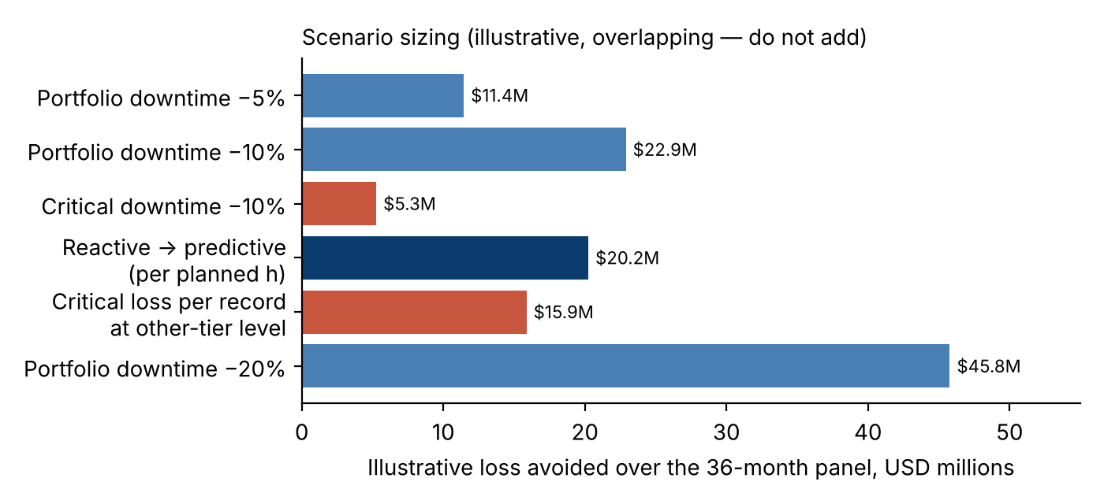
Figure 6. Illustrative loss avoided under alternative scenarios, 36-month basis [Report only].
Scenario | Mechanism | 36-month value | Annual equivalent
Portfolio downtime −5% | 4,554 h × $2,513 | $11.4M | $4.6M
Portfolio downtime −10% | 9,107 h × $2,513 | $22.9M | $9.2M
Portfolio downtime −20% | 18,215 h × $2,513 | $45.8M | $18.4M
Critical downtime −10% | 2,102 h × $2,503 | $5.3M | —
Critical loss per record at other-tier level | ($61,015 − $42,602) × 862 | $15.9M | —
Reactive → predictive (total cost per planned h) | $42.45 × 476,860 h | $20.2M | —
Table 11. Scenario sizing. The critical-asset scenario now uses the dashboard’s loss-per-record measure.

7.1 Break-even of a critical-asset spare-parts uplift
Raising critical-asset parts cover from 9.0¢ to the 12.6¢ level of other tiers would cost about $1.90M over 36 months. At $2,503 per critical downtime hour it breaks even if it avoids 760 hours, or 3.6% of critical-asset downtime — a low hurdle that justifies a controlled pilot.

7.2 Note on the briefing estimate
The draft briefing values the reactive-to-predictive shift at about $22M using operating hours, which are themselves reduced by downtime. The planned-hour basis gives $20.2M; the dashboard’s per-record measure gives a consistent 35.2% loss gap. The team should cite one basis in the presentation.

8. Recommendations
Recommendations 1–4 correspond to the “Decisions requested” panel on the dashboard’s Summary page; recommendations 5–6 are Finance additions from this report.
# | Recommendation | Evidence | Owner | KPI to track
1 | Review critical-asset restoration: priority in the repair queue and protected spares | MTTR 16.3 h; SLA 29.1%; loss/record $61,015 | Maintenance planners; Procurement | Critical MTTR; SLA on-target; loss per record
2 | Pilot condition-based care on ageing, degraded assets, with a matched control group | Loss/record $73,182 at 12+ yrs; reactive $62,030 vs condition-based $39,543 | Reliability engineers | Loss per record; failures per record, pilot vs control
3 | Trial the risk watchlist as a ranking aid, with human approval | 1,418 records hold 43.6% of loss; AUC 0.73 vs 0.61 | Reliability; Maintenance Director | Watchlist loss share; high-loss rate
4 | Fix data definitions before roll-out, including itemising Other Maintenance Cost | 18.2% of cost unitemised; unstable asset IDs | Finance controller; KPI lead | Other Maintenance Cost %
5 | Re-base the maintenance budget on downtime exposure (hours × Downtime Cost Rate) | Ratio 4.5×, flat over time; $2,513 per downtime hour | Finance with Maintenance Director | Loss to Maintenance Ratio; loss per record
6 | Set reserves on P90 event loss rather than the average | P90 $120,322 vs mean $57,006 per corrective record | Finance controller | Event-loss percentiles
Table 12. Prioritised recommendations. Recommendations 1, 4 and 6 need little capital and can start immediately; 2 and 3 require a measured pilot before budget commitment.
Expected benefits are not realised gains. Each recommendation should be implemented with a control group or before-and-after baseline so that Finance can verify the downtime reduction before releasing further budget.

9. Risks and Limitations
- Synthetic data: relationships reflect embedded generation rules and cannot be generalised without validation on operational records.
- Association, not causation: strategy, criticality, age and condition are not randomly assigned; residual confounding may affect scenario values.
- Production loss is derived from downtime at an hourly rate, so it cannot independently confirm downtime-based conclusions.
- Per-record measures include the 985 zero-loss preventive records; per-corrective-record figures (e.g. mean loss $57,006) are higher and must be labelled if cited.
- Scenario values overlap, are on a 36-month basis and exclude implementation costs other than the parts uplift.

10. Conclusion
The fleet’s financial exposure lies overwhelmingly in lost output rather than in maintenance expenditure: production loss is 4.5× the repair spend, and each downtime hour costs $2,513. The dashboard and this report agree on where that exposure concentrates — critical assets, reactive maintenance, ageing and degraded equipment — and on the decisions it supports. Finance can therefore evaluate maintenance proposals in a single currency, hours of downtime avoided, and should release budget for each change only after a controlled pilot confirms it.

Appendix A. Measure Definitions and DAX
Measure (dashboard name) | Definition (sum ÷ sum) | Portfolio value
Maintenance Cost | Σ Maintenance_Cost_USD | $50,430,446
Production Loss | Σ Production_Loss_USD | $228,881,052
Economic Exposure | Maintenance + loss | $279,311,498
Loss to Maintenance Ratio | Σ loss ÷ Σ maintenance | 4.5385×
Downtime Cost Rate | Σ loss ÷ Σ Downtime_Hours | $2,513.14
Cost per Operating Hour | Σ maintenance ÷ Σ Operating_Hours | $21.19
Loss per Record | Σ loss ÷ COUNTROWS | $45,776.21
Other Maintenance Cost | Maint. − parts − labour | $9,187,712
Availability | 1 − Σ downtime ÷ Σ planned h | 96.96%
MTBF / MTTR | Σ operating h ÷ Σ failures / Σ downtime ÷ Σ failures | 313.3 h / 12.0 h
Total cost per planned hour (report only) | (Σ maint. + Σ loss) ÷ Σ Planned_Operating_Hours | $93.16
Parts per $ of loss (report only) | Σ Spare_Parts_Cost_USD ÷ Σ loss | 11.75¢
Table A1. Measure register aligned with the dashboard’s Method page.
Loss to Maint = DIVIDE ( SUM ( Fact[Production_Loss_USD] ), SUM ( Fact[Maintenance_Cost_USD] ) )
Loss per Record = DIVIDE ( SUM ( Fact[Production_Loss_USD] ), COUNTROWS ( Fact ) )
Cost per Planned h = DIVIDE ( SUM ( Fact[Maintenance_Cost_USD] ) + SUM ( Fact[Production_Loss_USD] ), SUM ( Fact[Planned_Operating_Hours] ) )
Parts per $ Loss = DIVIDE ( SUM ( Fact[Spare_Parts_Cost_USD] ), SUM ( Fact[Production_Loss_USD] ) )
The first two measures already exist on the dashboard; the last two are proposed additions so that the report-only findings can be shown on the Cost & Loss page.

Appendix B. Method, Reproducibility and AI Disclosure
Computation was performed in Python (pandas, NumPy, scikit-learn) on a read-only copy of the master CSV. Bootstrap intervals use 2,000 record-level resamples (seed 42). Every figure in this report was recomputed independently and every figure shared with the dashboard was matched to the exported dashboard (Group_9226_Team_3_Dashboard.pdf). Draft text, calculations and charts were prepared with the assistance of a generative AI tool (Claude); the team must review the content and remains responsible for the final analytical judgement.

Appendix C. Reconciliation with the Power BI Dashboard
Figure in this report | Report value | Dashboard value | Dashboard page | Status
Maintenance Cost | $50.4M | $50M | Scorecard, Cost & Loss | Match (rounding)
Production Loss | $228.9M | $229M | Summary, Scorecard, Cost & Loss | Match (rounding)
Economic Exposure | $279.3M | $279M / $279.3M | Scorecard, Cost & Loss | Match
Loss to Maintenance Ratio | 4.5× (4.54×) | 4.5x | Summary, Scorecard | Match
Downtime Cost Rate | $2,513 | $2,513 | Scorecard, Cost & Loss | Match
Cost per Operating Hour | $21.19 | $21.19 | Scorecard, Cost & Loss | Match
Loss per Record | $45,776 | $45,776 | Cost & Loss, Drill-through | Match
Availability / MTBF / MTTR | 97.0% / 313.3 / 12.0 | 97.0% / 313.3 / 12.0 | Summary, Scorecard | Match
Loss per record — Railway Signalling | $55,991 | $55,991 | Summary | Match
Production loss by criticality | $32.5M / $80.1M / $63.7M / $52.6M | $33M / $80M / $64M / $53M | Cost & Loss | Match (rounding)
Critical MTTR / SLA | 16.3 h / 29.1% | 16.3 h / 29.1% | Summary, Work Orders | Match
Loss per record by strategy | $62,030 / $46,658 / $39,543 / $40,216 | $62,030 / $46,658 / $39,543 / $40,216 | Summary | Match
Failures per record by strategy | 2.09 / 1.53 / 1.32 / 1.34 | 2.09 / 1.53 / 1.32 / 1.34 | Summary | Match
Downtime per record by age band | 9.1 / 15.0 / 20.9 / 28.6 | 9.1 / 15.0 / 20.9 / 28.6 | Reliability | Match
Downtime per record by condition | 29.5 / 23.7 / 19.2 / 14.1 / 8.7 | 29.5 / 23.7 / 19.2 / 14.1 / 8.7 | Summary, Reliability | Match
Cost per operating hour — Railway Signalling | $22.98 | $22.98 | Cost & Loss | Match
Watchlist records / loss share | 1,418 / 43.6% | 1,418 / 43.6% | Risk | Match (model reproduced)
Other Maintenance Cost | 18.2% | “about 18%” | Method | Match
Loss ÷ maint. by criticality (6.02×) | 6.02× | — | — | Report only: add to dashboard
Parts per $1 of loss (9.0¢ vs 12.6¢) | 8.96¢ | — | — | Report only: add to dashboard
Scenarios and break-even | Section 7 | — | — | Report only (by design)
Table C1. Every figure shared by the report and the dashboard reconciles. Two report-only findings are recommended additions to the dashboard’s Cost & Loss page.

