Title: Web_Assignment2 of CRUD Apis

1. A. A database by name Marketplace :

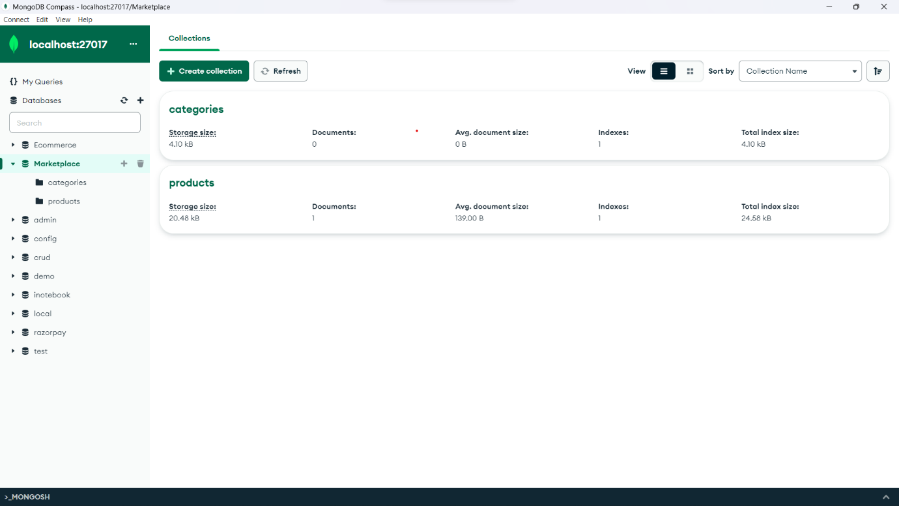

B. Products and Categories collection with given property :

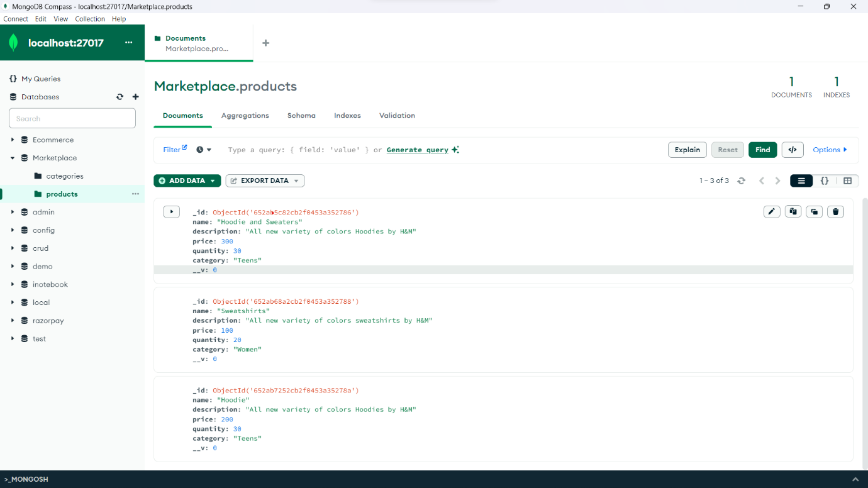

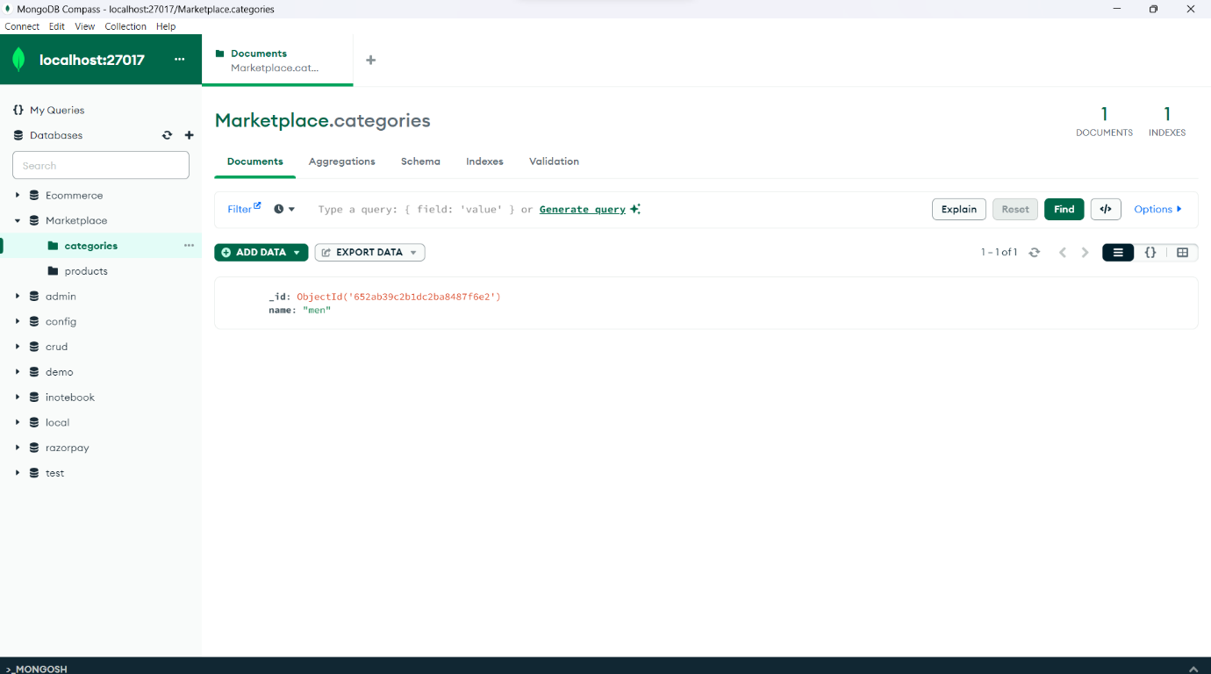

C. MongoDB URI connection String :

mongodb://127.0.0.1:27017/Marketplace?readPreference=primary&appname=MongoDB%20Compass&directConnection=true&ssl=false

1. 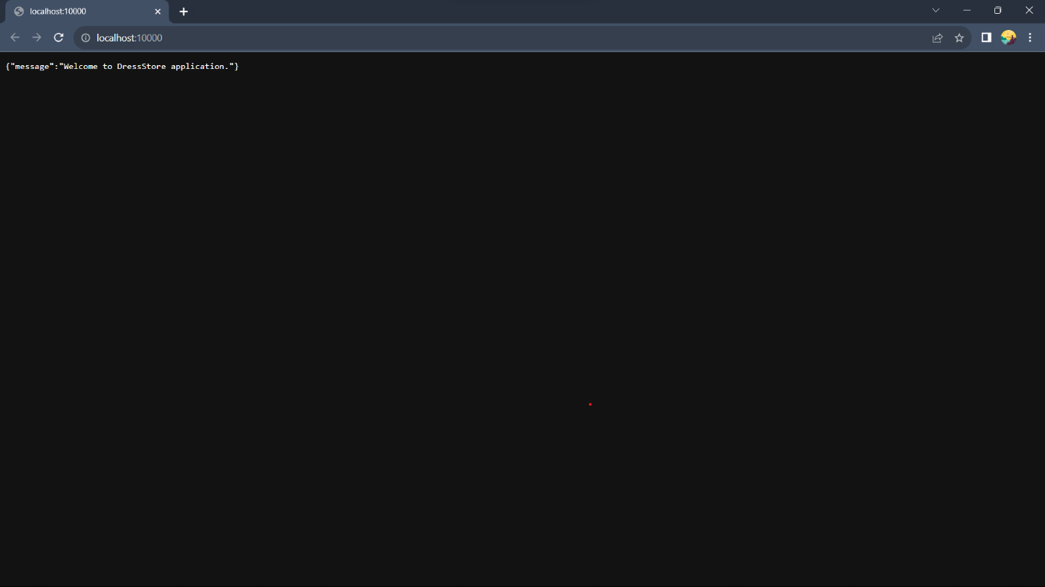Screenshot of browser with message :
2. A. Get all the products

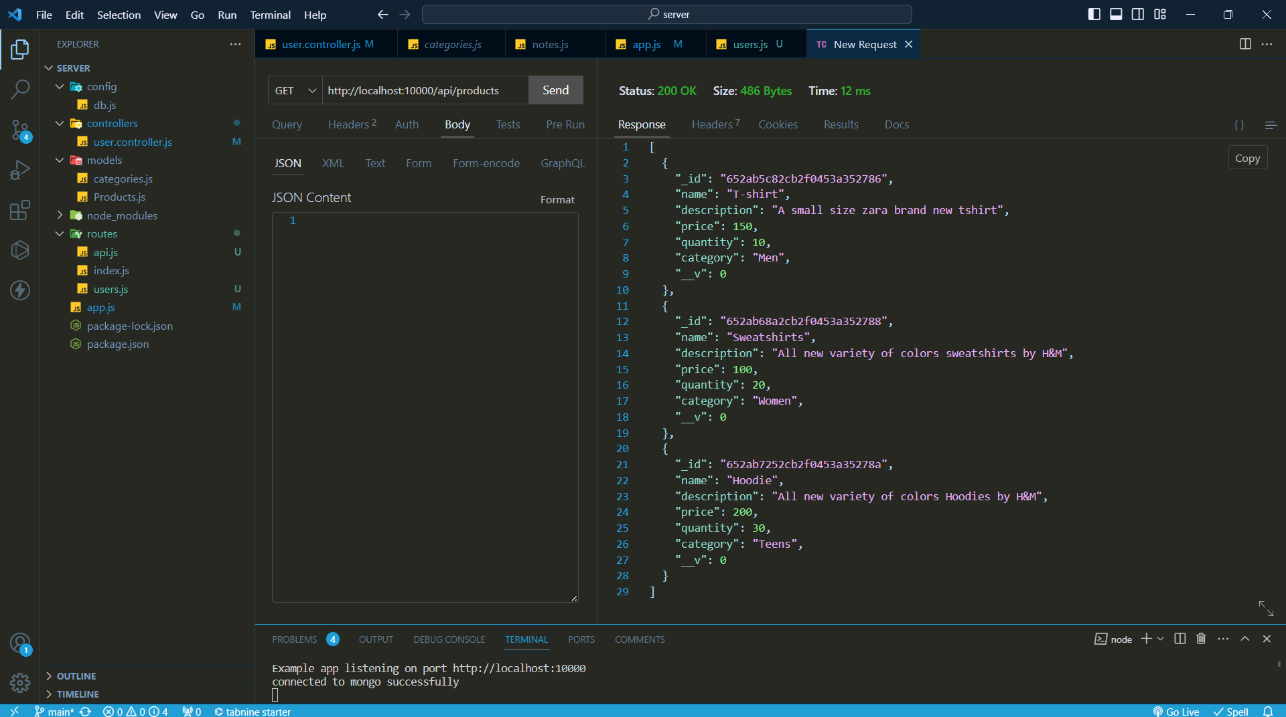

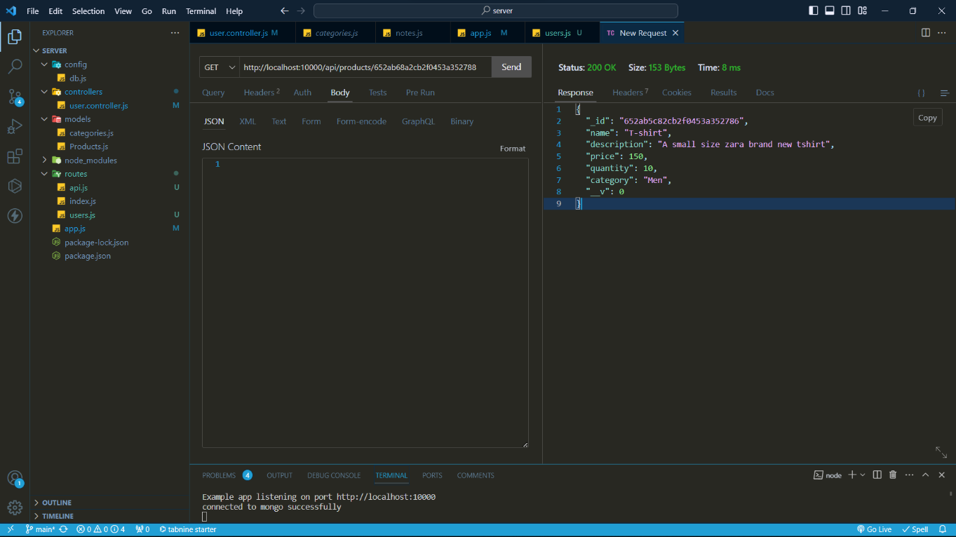B. Get product by id

C. Add product using POST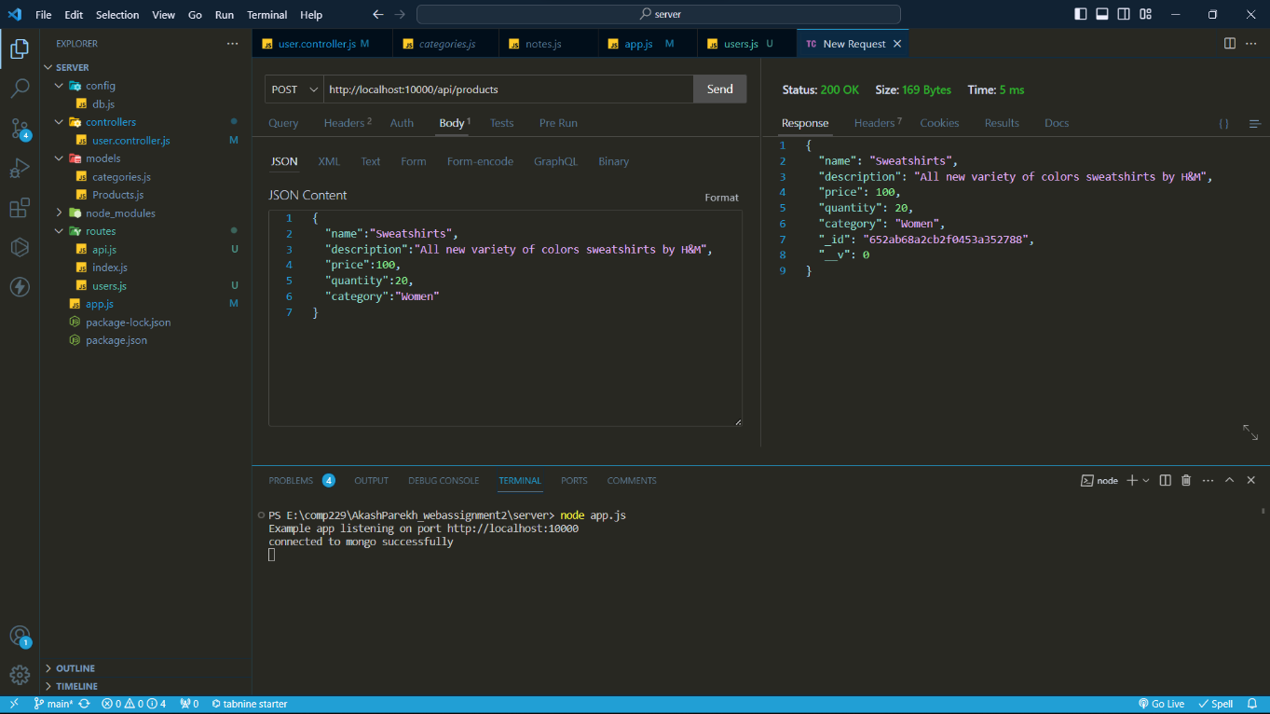

D. Remove product by id using DELETE

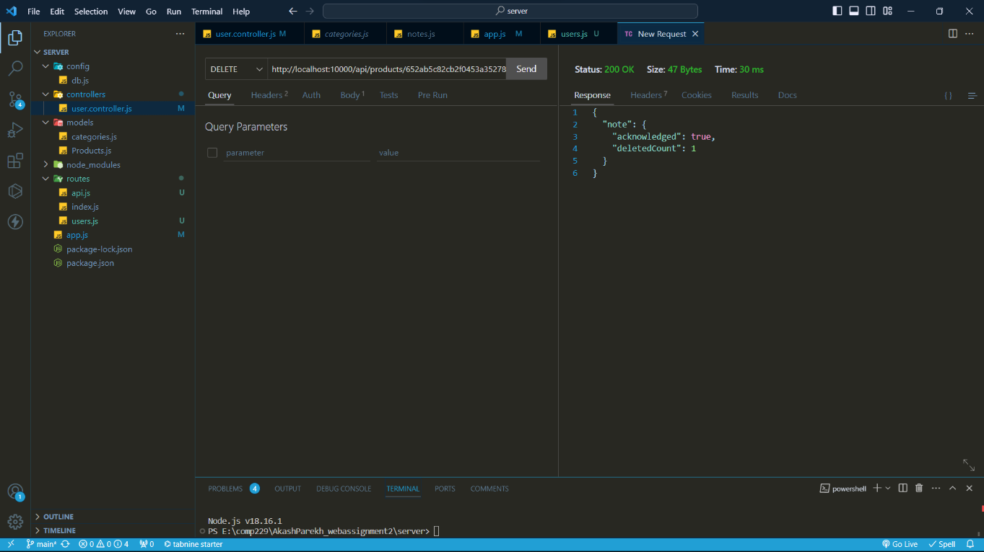

E. Remove all Products

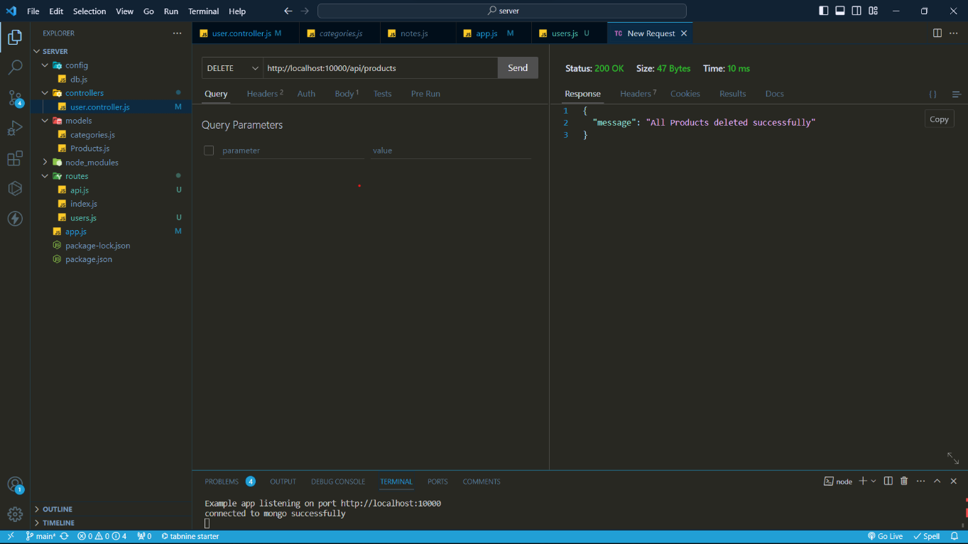

F. Find all products which contain “Hoo”

