Change request log

# Team

CSRAMS - Ahmar Aftab and Anurag Kumar

# Change Request

Change Request# 3: The Merge module throws an exception upon attempting to merge page ranges that intersect. You are requested to fix this issue by allowing intersection of ranges during the merging operation.

*Change Owner:* Implemented and documented by Ahmar Aftab.

# Concept Location

|  |  |  |
| --- | --- | --- |
| Step # | Description | Rationale |
| 1 | *Firstly, we needed to determine the starting point of the code related to merge operation and so we started with debugging it.* | *This gave us idea how the code works and where the system leads to when we click on Merge button on the home screen.* |
| 2 | *We searched for the instructions which were displayed when we hover the mouse on some options in the UI. In this case, we searched for “Double click to set pages you want to merge (ex: 2 or 5-23 or 2,5-7,12-)” using instaSearch.* | *This proved really helpful as we were able to put the debug points at the right locations. And further debugging lead us to where we wanted to go.* |
| 3 | *We found when we hit run button after adding the page ranges a function ConversionUtils. toPageRangeSet() is called, which throws an exception if the pages intersect.* | *This step help us in emulating the error scenario and further investigating the root cause.* |
| 4 | *Therefore, we found our class in which we have to make the change and marked it as “located”.* | *We confirmed this class had to be modified.* |

**Time spent (in minutes):** 45

# Impact Analysis

|  |  |  |
| --- | --- | --- |
| Step # | Description | Rationale |
| 1 | *We looked for dependencies in class ConversionUtils to find what all classes are making a call to toPageRangeSet() and expecting values from that function.* | *To track the classes that could be impacted by the change.* |
| 2 | *We did a search for the toPageRangeSet method using file search and found many 38 matches.* | *To determine how many places are utilizing value from the function.* |
| 3 | *Now, we used Jripples to determine the Impact Analysis and it didn’t turn up any result and we were confident of carrying out the change in the method.* | *This was done to ensure how many places will be impacted due to the change we are going to implement.* |

**Time spent (in minutes):** 30

# Actualization

|  |  |  |
| --- | --- | --- |
| Step # | Description | Rationale |
| 1 | *We created a method ConversionUtils. mergeIntervals()* | *This method used the values generated in the toPageRangeSet function to generate a list of values after merging the intersections.* |
| 2 | *Changed the function toPageRangeSet, and made a call to the mergeIntervals before returning.* | *This was done because we get the exception as soon as the value is returned from the toPageRangeSet function and merging the values before returning would eliminate the error.* |
| 3 | *We created unit tests for the new method and added some intersecting values to carry on the test.* | *To make sure everything works in different scenarios.* |

**Time spent (in minutes):** 75

# Validation

|  |  |  |
| --- | --- | --- |
| Step # | Description | Rationale |
| 1 | *Test case defined:*  *Inputs: Added page numbers 1-6, 5*  *Expected output: Got pages merged from 1 to 6 successfully* | *This is an expected behavior.*  *The test passed.* |
| 2 | *Test case defined:*  *Inputs: Added page numbers 1-5, 4, 7-12, 10, 11*  *Expected output: Pages merged with output pdf having pages 1-5, 7-12* | *This is an expected behavior.*  *The test passed.* |

**Time spent (in minutes):** 30

# Timing

Summarize the time spent on each phase.

|  |  |
| --- | --- |
| Phase Name | Time (in minutes) |
| Concept location | 45 |
| Impact Analysis | 30 |
| Actualization | 75 |
| Verification | 30 |
| Total | 180 |

# Reverse engineering

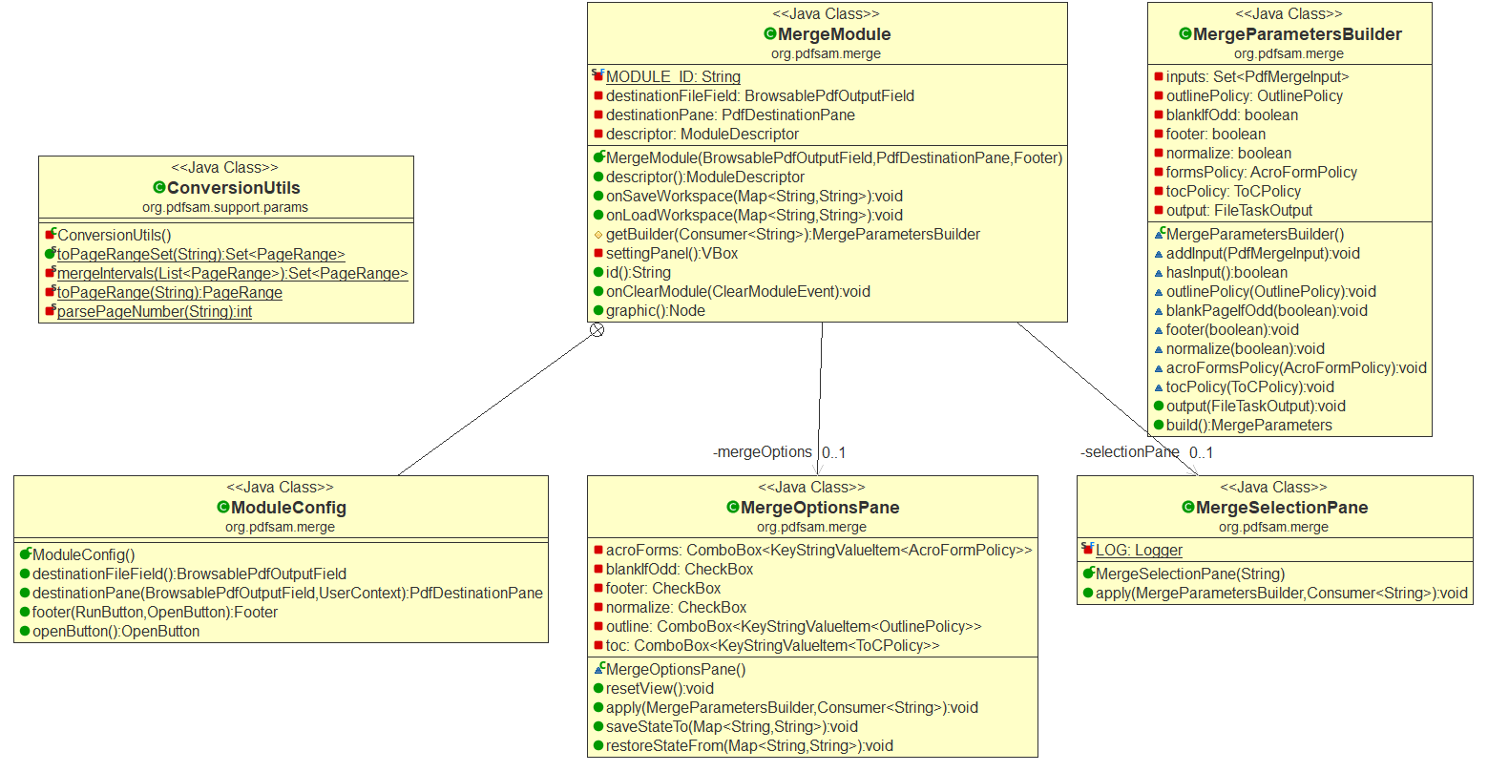

# Conclusions

*For this change, concept location was an easy part because the system is not too large. The code has been written in a much better way. Concept location was done using debugging, impact analysis was done using Jripples. Testing was performed manually.*

*Challenges:*

*This project couldn’t be built using test cases. We tried a number of times but we get errors when build is done with tests. Even in the instruction, it is mentioned to build without test. So, we have to do manual testing for this.*

*Classes and methods changed/ added:*

* *pdfsam-core/src/main/java/org/pdfsam/support/params/ConversionUtils.java*
  + *mergeIntervals()*