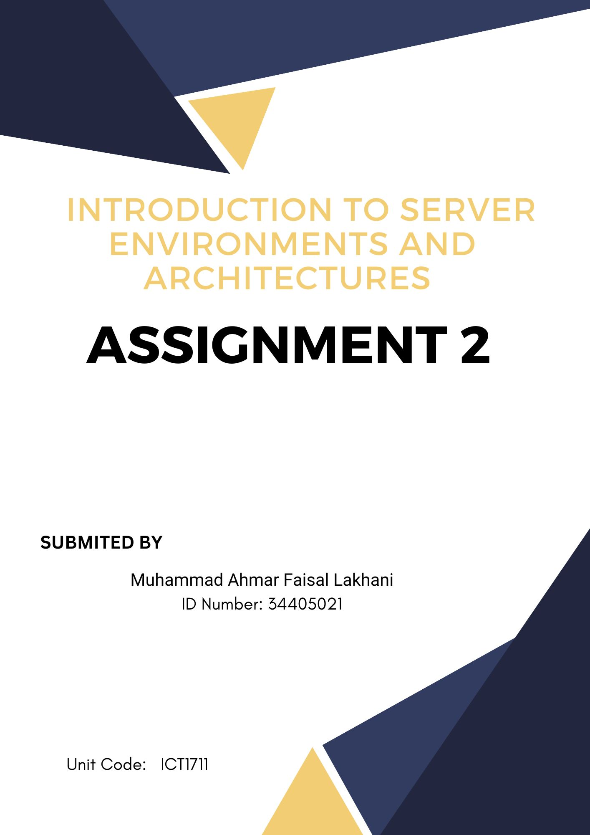

**GitHub:**

All documents are present on GitHub here is GitHub link

[https://github.com/ahmarlakhani/assignment-2](https://github.com/ahmarlakhani/assignment-2%20)

**Website:**

Link of assignment website is[http://ahmarlakhani.com/](http://ahmarlakhani.com/%20)

Website has 3 pages which are present in zip file with names

Index.html

Checkout.html

Carparts.html

**Document:**

Word documents named Project Documentation.docx explain how to use Nginx Web Server Setup

**Video:**

[**https://drive.google.com/file/d/1-0zYuUgbGqbn6de7Lp-vC5d0mA4GuObH/view?usp=drive_link**](https://drive.google.com/file/d/1-0zYuUgbGqbn6de7Lp-vC5d0mA4GuObH/view?usp=drive_link)