Assignment 2 — Comparative Environmental Impact of Model Compression
ENSF 619 · Quantization vs. Pruning vs. Knowledge Distillation, measured with CodeCarbon
October 2026
Code repository: https://github.com/ahmd-nish/ensf619-assignments/tree/main/Assignment_2 (see Assignment_2/README.md to reproduce the results).

1. Summary table
Task: generate a Google-style docstring for below_zero (identical to Assignment 1), using prompt P-2, the best prompt in Assignment 1. Each model was run for 5 epochs. A new CodeCarbon EmissionsTracker was started right before and stopped right after every inference run. CO₂ and latency are per inference, as the mean of the 5 runs.
Model version | Technique | CO₂ per inference (mg CO₂eq) | Δ CO₂ vs baseline | Energy per inference (J) | Latency, mean / median (s) | Model size (MB) | Δ size | Accuracy (P/F)
1. Baseline (FP16) | None | 33.28 ± 0.59 | — | 498 | 3.86 / 3.84 | 2,944.5 | — | P (5/5)
2. Quantized (4-bit NF4) | Quantization | 53.93 ± 0.79 | +62 % | 807 | 7.15 / 7.12 | 1,148.6 | −61 % | P (5/5)
2b. Quantized (8-bit), extra | Quantization | 238.04 ± 104.3 | +615 % | 3,562 | 36.82 / 24.39 | 1,697.6 | −42 % | P (5/5)
3. Pruned (40 % unstructured + fine-tune) | Pruning | 36.01 ± 2.42 | +8 % | 539 | 4.38 / 4.20 | 2,944.5 dense (≈2,101 sparse*) | 0 % (≈−29 %*) | P (5/5)
4. Distilled (0.5B student) | Knowledge distillation | 28.02 ± 0.33 | −16 % | 419 | 3.93 / 3.97 | 942.4 | −68 % | P (5/5)
ref: pruned 40 %, no fine-tune | ablation | 55.65 | +67 % | 833 | 6.78 / 6.80 | 2,944.5 | 0 % | F (0/5)
ref: 0.5B student before KD | ablation | 20.26 | −39 % | 303 | 2.73 / 2.74 | 942.4 | −68 % | F (0/5)
Notes on the table:
- ± is the standard deviation over the 5 runs.
- Model size is the serialized state_dict, measured with the provided get_model_size function. That function reports MiB.
- * The pruned model is stored densely: the zeros still take space. The value in brackets is the estimated size if the 1,019.6 M non-zero FP16 values were stored with a 1-bit mask over the 1,310 M pruned weights.
- All runs used an NVIDIA RTX A6000 48 GB in Bucharest, Romania. CodeCarbon used a grid carbon intensity of 240.6 g CO₂/kWh.
- Held-out check: a broader accuracy check ran each model once on 33 unseen HumanEval functions. Pass counts: baseline 5/33, INT4 5/33, INT8 4/33, pruned + fine-tune 27/33, distilled 12/33, pruned without fine-tune 2/33, student before KD 1/33. Section 3.3 discusses the jump for the two fine-tuned models.
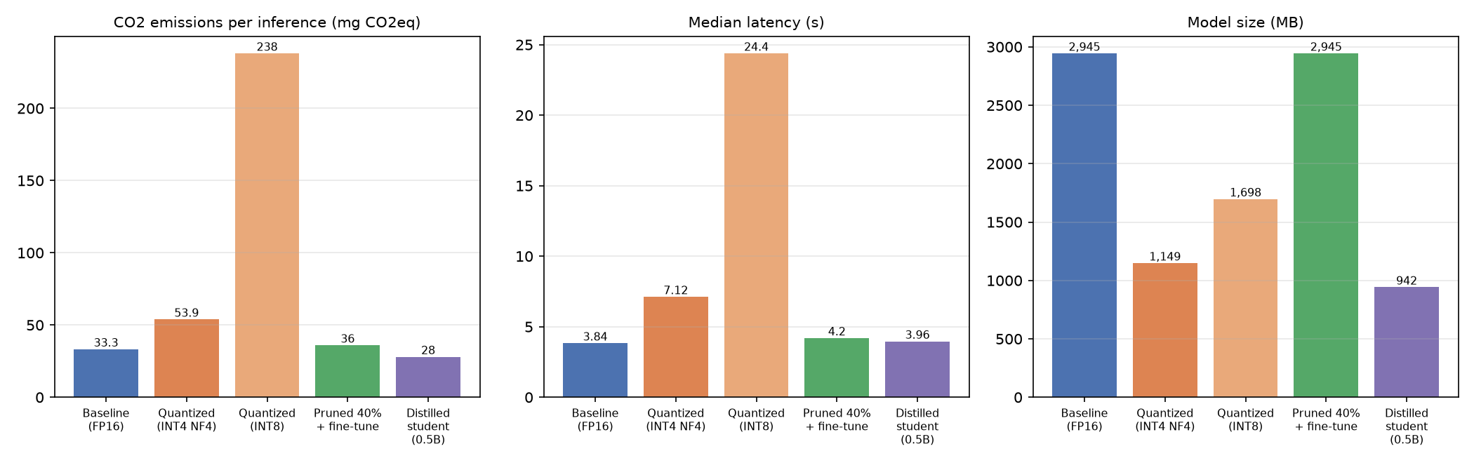
CO₂, latency and size per model version

2. Implementation details
Chosen SLM (baseline and teacher): Qwen2.5-Coder-1.5B-Instruct, 1.54 B parameters, run in FP16 on CUDA. It was the most accurate model in Assignment 1 and shares its tokenizer with a smaller sibling model, which makes logit-level distillation possible. Decoding was greedy with max_new_tokens=512, and each model had one untimed warm-up run.
Quantization: bitsandbytes post-training weight quantization, loaded with BitsAndBytesConfig:
- 4-bit NF4, the primary model 2: load_in_4bit, bnb_4bit_quant_type="nf4", FP16 compute.
- 8-bit LLM.int8(), an extra row (2b), reported because Assignment 1 also tested it.
No calibration or retraining was needed. The 4-bit state_dict packs two weights per byte, which is why it reports 889 M stored “parameters”.
Pruning (40 % unstructured):
- Method: torch.nn.utils.prune.l1_unstructured with amount=0.4, applied to every nn.Linear in the 28 transformer blocks (196 layers: q, k, v, o, gate, up and down projections). The 40 % of weights with the smallest magnitude in each layer were set to zero. The tied embedding and LM head were left dense. The result is 40.0 % sparsity in the pruned layers and 33.9 % of all parameters.
- Recovery fine-tune: full-parameter AdamW, learning rate 1e-5, batch 8, 2 epochs (224 steps), with bf16 autocast and FP32 master weights. The binary masks were re-applied after every optimizer step, and the final sparsity was verified at exactly 40 %. Loss fell from 0.148 to 0.033.
Knowledge distillation:
- Teacher and student: the FP16 baseline Qwen2.5-Coder-1.5B, frozen, teaching Qwen2.5-Coder-0.5B-Instruct (0.49 B parameters, 3.1× smaller, same 151,936-token vocabulary).
- Loss: α·T²·KL(teacher‖student) at temperature T = 2, plus (1−α)·cross-entropy on the teacher-written tokens, with α = 0.5. The loss was computed on response tokens only.
- Training: AdamW, learning rate 2e-5, batch 8, 3 epochs (336 steps). KL fell from 0.96 to 0.28 and cross-entropy from 0.165 to 0.042.
Training data: the same data was used for the pruning fine-tune and for distillation. The teacher generated docstrings for:
- the HumanEval training split, under all three Assignment 1 prompts, and
- 974 MBPP functions, using P-2. Each MBPP function’s task description was inserted as a plain prose docstring, so the input matches the assignment’s input format.
Only outputs that passed the same checker used for P/F grading were kept: 892 of 1,364. HumanEval/3 (below_zero) and the 33 held-out functions were never used for training.
CodeCarbon setup: v3.3.2, with EmissionsTracker(measure_power_secs=1, tracking_mode="process") started and stopped around each generate() call. GPU power comes from NVML and is measured; it is about 85 % of total energy. The container exposes no RAPL interface, so CodeCarbon estimates CPU power (about 8 W) and RAM power (10 W).

3. Comparative analysis

3.1 Which technique achieved the lowest CO₂ emissions?
Knowledge distillation achieved the lowest emissions: 28.0 mg CO₂eq per inference, 16 % below the 33.3 mg baseline. It did so even though the student wrote longer answers (151 against 129 output tokens). Its energy per generated token was 2.8 J, against 3.9 J for the baseline.
Pruning came second at 36.0 mg, 8 % above the baseline. 4-bit quantization came last at 53.9 mg, 62 % above the baseline. The 8-bit variant was far worse at 238 mg. The untrained 0.5B student emitted even less (20.3 mg) but failed the task, so it does not count.

3.2 Relationship between model-size reduction and CO₂ reduction
Smaller files did not mean lower emissions. Of the three techniques, the two that shrank the model on disk the most were not the greenest:
- 4-bit quantization: 61 % smaller, but 62 % more CO₂.
- 8-bit quantization: 42 % smaller, but more than 7× the emissions.
bitsandbytes stores the weights compactly but de-quantizes them inside every matrix multiply. A 1.5 B model generating one request at a time on a 48 GB GPU is limited by kernel-launch overhead, not by memory bandwidth. Quantization therefore adds compute and time (7.1 s and 24.4 s against 3.8 s) without saving anything that mattered for this workload.
Unstructured pruning removed 34 % of the parameters but saved neither storage nor energy. The zeros are still stored in dense tensors and still multiplied by dense GPU kernels. Emissions rose slightly (+8 %) because the pruned model generated 9 more tokens.
Only distillation reduced the actual compute per token. The student has 3.1× fewer parameters and 24 layers against 28, which cut size by 68 % and CO₂ by 16 %. The emissions saving is much smaller than the size saving because single-request decoding is dominated by fixed per-token overhead.
In short, CO₂ follows the work actually executed on the hardware, not the bytes on disk. Size reduction only pays off when the runtime can exploit it: real 4-bit kernels for quantization, sparse or 2:4 structured kernels for pruning, or a genuinely smaller architecture for distillation.
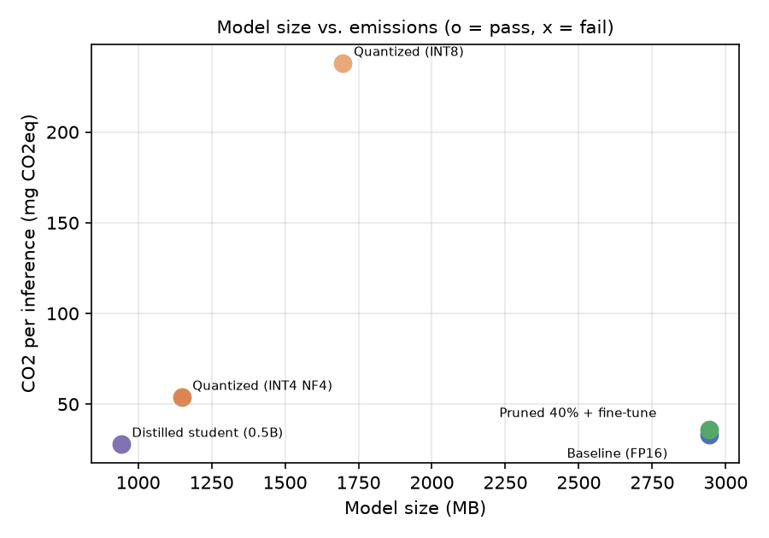
Model size vs. emissions

3.3 Best environmental-performance trade-off
Knowledge distillation gives the best trade-off:
- the lowest emissions of any passing model (−16 % CO₂, −16 % energy),
- a 68 % smaller model,
- the same latency (3.9 s),
- P/F accuracy kept on all 5 runs, with byte-identical output every run.
The ablations show that both recovery steps were essential. Without distillation, the raw 0.5B student failed (0/5): its docstring had no Args or Returns sections. Without the recovery fine-tune, the pruned model failed (0/5) and also produced 68 % more tokens and emissions.
Distillation cost 7.8 mg CO₂ per inference more than the raw student, which is the price of turning a failing model into a passing one.
One caveat applies to the held-out figures. The pruned (27/33) and distilled (12/33) models beat the baseline (5/33) because their training data consisted only of teacher outputs that passed the checker. The training therefore also aligned them to the required Google docstring format. This is a benefit of the recovery and distillation training, not of compression itself. The untrained ablations (2/33 and 1/33) show that compression on its own reduced quality.

3.4 Difficulty of implementation
- Quantization was the easiest. It needs one BitsAndBytesConfig argument, no data and no training, and was ready in minutes. However, it depends on hardware and libraries: bitsandbytes needed CUDA and could not be used on the Apple-silicon laptop from Assignment 1. Whether it saves energy depends entirely on kernel quality, and here it did not.
- Pruning was moderate. Zeroing the weights takes a few lines of torch.nn.utils.prune. Recovering accuracy, however, required:
  - a labelled fine-tuning set,
  - a training loop that keeps the masks fixed, and
  - full fine-tuning of a 1.5 B model, which needs about 25 GB of GPU memory for FP32 weights and Adam state.
- Turning the sparsity into real savings would need sparse storage formats, structured (2:4) pruning or sparse kernels. Plain PyTorch provides none of these.
- Distillation was the hardest. It needed:
  - a student with a compatible tokenizer,
  - a transfer set (the teacher generated 1,364 answers, of which 892 were kept after filtering),
  - teacher and student held in GPU memory together,
  - a custom KL plus cross-entropy loss, and
  - tuning of α and the temperature.
- It also has a one-time training footprint. On the A6000 the training took about 5 minutes of GPU time. The estimated upper bound is about 25 Wh, or about 6 g CO₂; this was not measured. That cost is repaid after roughly 1,100 inferences. It was the most work, but it was the only technique that gave a real environmental gain for this task.
Overall: for small code models served one request at a time, distillation into a smaller architecture is the greenest compression option. Quantization should only be used where efficient low-bit kernels exist, and unstructured pruning should be used only together with sparse-aware storage and kernels.

