**ABDUL MANNAN**

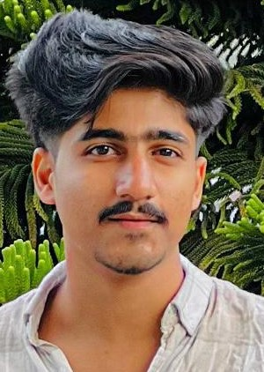

##### 9072797181



[mannanzid@gmail.com](mailto:mannanzid@gmail.com)

Pravil(H), Karuvanpoil Post, Koduvally, Kozhikode – 673572.

 08/November/2001

Linked in profile : <https://linkedin.com/in/abdul-mannan-365168296>

## LANGUAGE

**ENGLISH**

*Full Professional Proficiency*

**MALAYALAM**

*Native or Bilingual Proficiency*

**TAMIL**

*Elementary Proficiency*

**. ARABIC**

*Elementary Proficiency*

## TECHNICAL SKILLS

**C++ AUTOCAD**

**STAAD PRIMEVERA**

**Slide presentation**

HOBBIES AND INTEREST

**FOOTBALL SWIMMING ATHLETICS**

#### KEY STRENGTHS

* Effective in teamwork
* Goal and result oriented
* Efficient in time management
* Passionate professionalism

EDUCATION

**BACHELOR OF TECHNOLOGY**

CIVIL ENGINEERING

*ILAHIA COLLEGE OF ENGINEERING & TECHNOLOGY*

*APJ Abdul Kalam Technological University, Ernakulam, Kerala.*

*2020-2024*

***CGPA - 7.68***

***Studied AutoCAD, Primevera & STAAD***

**XII GRADE**

BIOLOGY SCIENCE

*GHSS KARUVANPOIL*

*2018-2020*

***81% Marks***

### X GRADE

*CKAKKALAKKAL HSS*

*2017-2018*

***95 % Marks***

ACTIVITIES AND ACCOLADES

Completed 2 years of volunteer ship in YOUTH RED

CROSS

#### PROJECT

##### REJUVENATION OF MULAVOOR CHIRA BY WATER

DIVERSION

## DECLARATION

##### I hereby declare that the above written particulars are true to my knowledge and belief.

ABDUL MANNAN

## 