


Sinai University
Faculty of Information Technology &Computer Science

Inventory Management System (IMS)
Introduction
This project is called Inventory Management System (IMS). It is a desktop application built using Python (Tkinter) and SQL Server. The system helps in managing products, employees, suppliers, and sales in an easy and organized way.
The idea of the system is to make it easier for companies or small businesses to track their inventory and control their operations.

Project Team
This project was developed by a team of four students:
- Ahmed Elsayed
- Gamal Esam
- Shanouda Romany
- Youssef Songor
We worked together to design, implement, and test the system.

Objectives
The main goals of this project are:
- To manage employees and their roles (Admin / Employee)
- To organize products and categories
- To manage suppliers and their data
- To track sales and generate bills
- To provide a secure login system with password recovery

System Features
The system includes the following features:
- Login system with username and password
- Forget password using OTP sent by email
- Dashboard showing system statistics
- Employee management (add, update, delete)
- Supplier management
- Product and category management
- Billing system for generating invoices
- Sales records saved in files

Technologies Used
We used the following technologies in this project:
- Python (Tkinter) for the user interface
- SQL Server for the database
- pyodbc for connecting Python with database
- smtplib for sending OTP emails
System Design
Use Case Diagram
The use case diagram shows how the user interacts with the system like login, managing data, and generating bills.

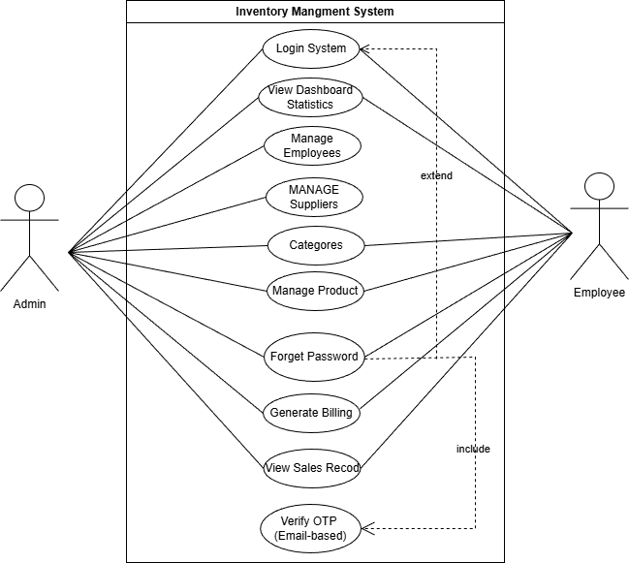

UML Diagram
The UML diagram explains the structure of the system and the main classes used like Employee, Product, and Supplier.
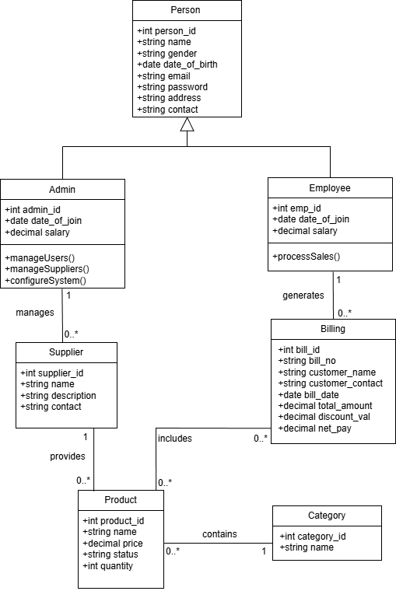

EER Diagram
The EER diagram shows the database design including entities, attributes, and relationships.

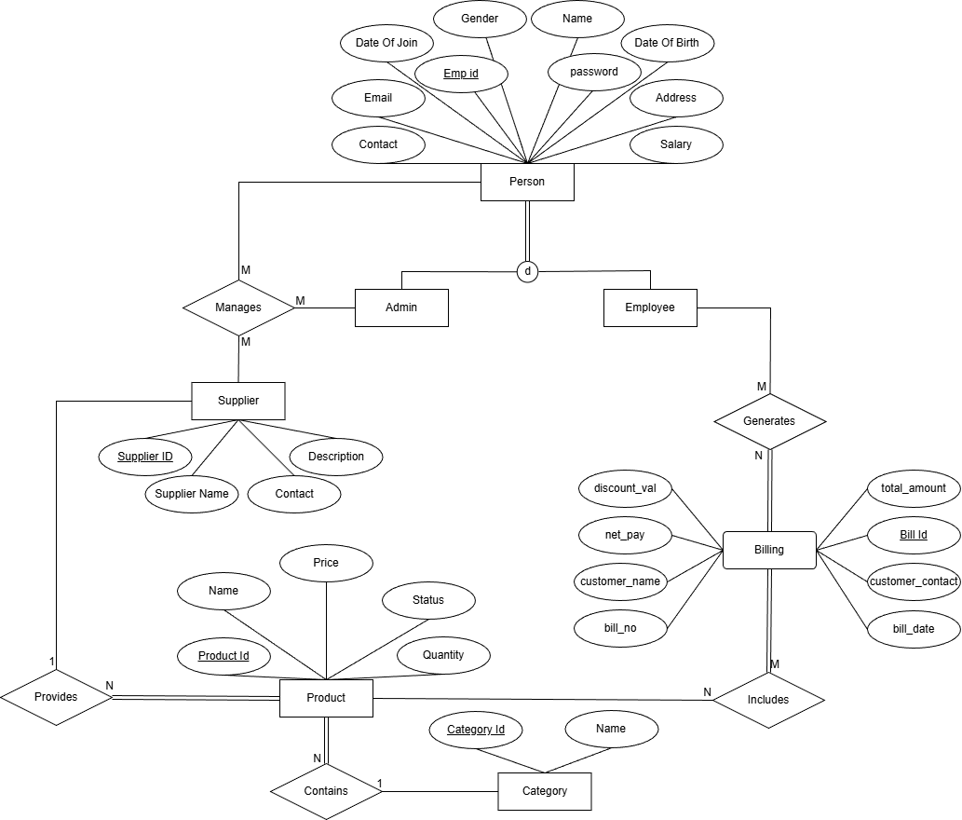

Database Schema
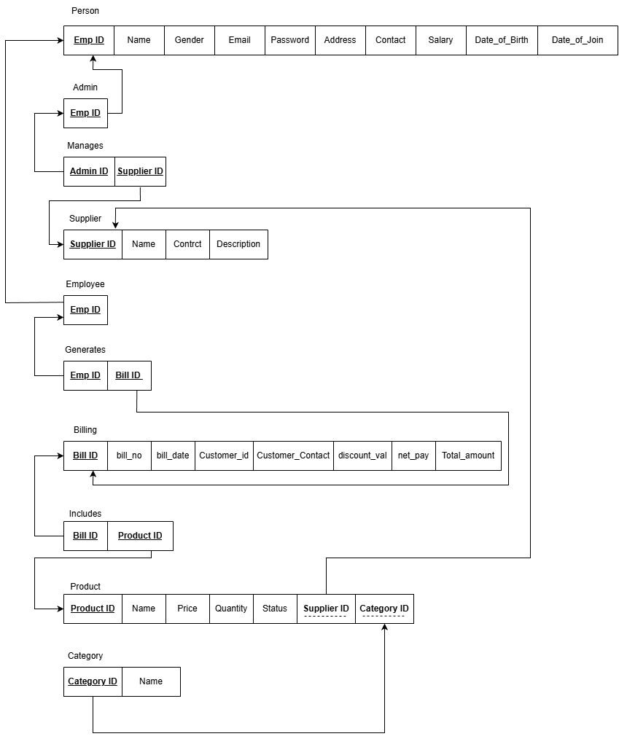
The schema shows the tables and how they are connected using primary keys and foreign keys.

Database Tables
In this system, we created several tables to store and manage the data efficiently. Each table has a primary key to uniquely identify records.

Employee
- employee_id (Primary Key)
- name
- email
- contact
- gender
- dob
- doj
- password
- user type
- address
- salary

Product
- product_id (Primary Key)
- name
- category
- supplier
- price
- quantity
- status

Supplier
- invoice (Primary Key)
- name
- contact
- description

Category
- category_id (Primary Key)
- name

Billing
- bill_id (Primary Key)
- bill_no
- bill_date
- customer_name
- customer_contact
- total_amount
- discount
- net_pay

Challenges
During this project, we faced some challenges such as:
- Connecting Python with SQL Server
- Handling email sending for OTP
- Designing a good user interface using Tkinter

Future Improvements
In the future, the system can be improved by:
- Converting it to a web application
- Adding reports in PDF format
- Improving security by encrypting passwords
- Adding more user roles and permissions

Project Repository
The full source code of the project, including Python files and SQL database scripts, is available on GitHub:
🔗 https://github.com/ahmdelsayed/Poject-Database.git
This repository contains:
- Complete Python source code (Tkinter application)
- SQL Server database scripts
- Project diagrams and screenshots
- All required files to run the system

Conclusion
In conclusion, this project helped us understand how to build a complete system using Python and databases. It improved our skills in programming, database design, and teamwork.

