Example1:

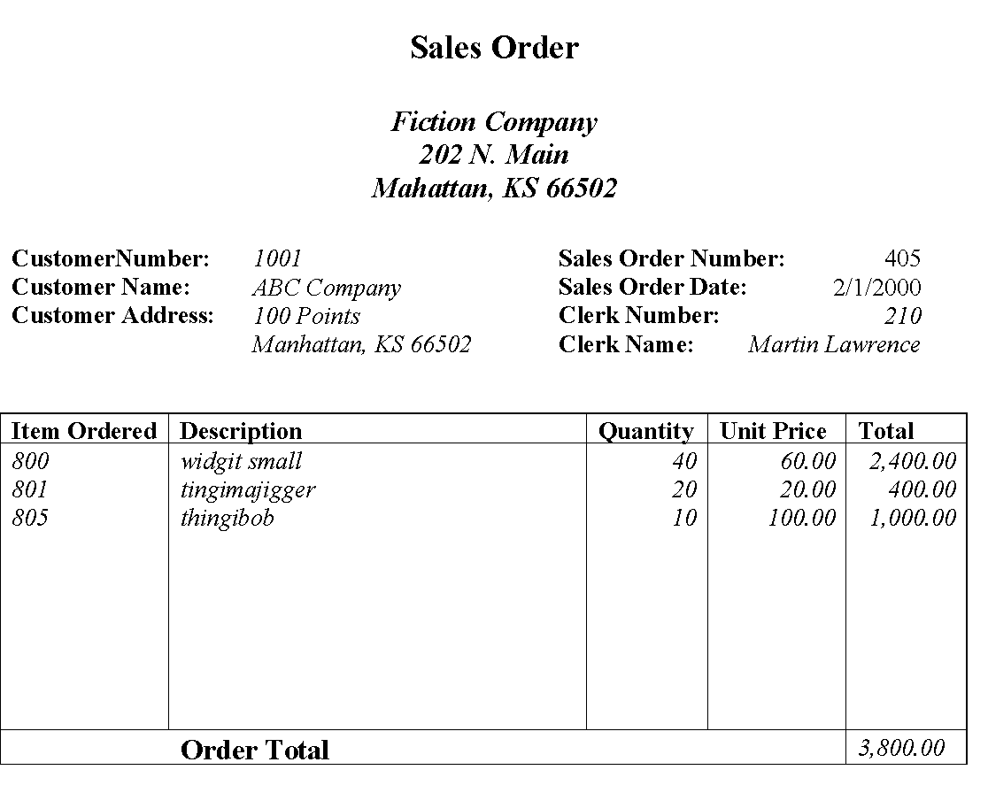

**Primary Key:** Sales Order Number,

Example2:

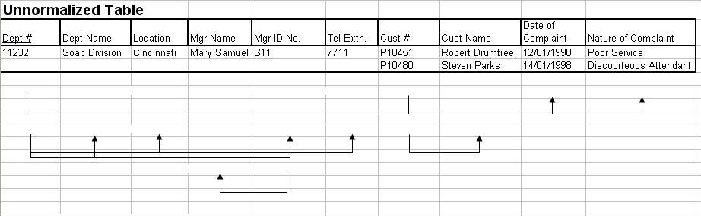

First Normal Form

Department

Dept # , Dept Name , Location , Mgr Name , Mgr ID No , Tel Extn

Customer

Cust # , Cust Name

Dept_Cust

Dept # , Cust # , Date of Complaint , Nature of Complaint

Second Normal Form

Department

Dept # , Dept Name , Location , Mgr Name , Mgr ID No , Tel Extn

Customer

Cust # , Cust Name

Dept_Cust

Dept # , Cust # , Date of Complaint , Nature of Complaint

Third Normal From

Customer

Cust # , Cust Name

Dept_Cust

Dept # , Cust # , Date of Complaint , Nature of Complaint

Department

Dept # , Dept Name , Location , Mgr ID No , Tel Extn

Manger

Mgr ID No # , Mgr name