**Easy To Control**

It’s a system can control in any places like shopping center, markets and malls…etc.

by just one click .

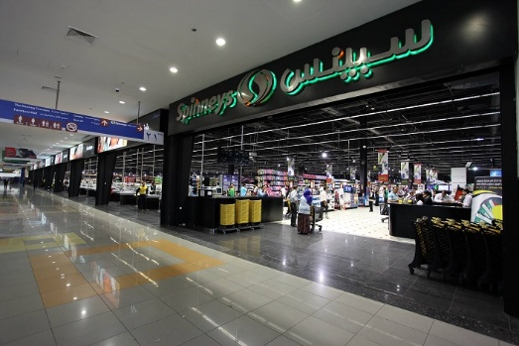

**this system contents on :**

**Accounting System**

System can do calculation and open the locker by password

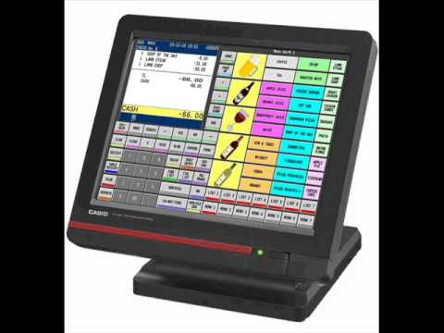

**Airconditiongs System**

System controls in decreasing or increasing temperature by sensors

**Security System**

Dedicates to secure place with cams inside and outside and alarm devices.

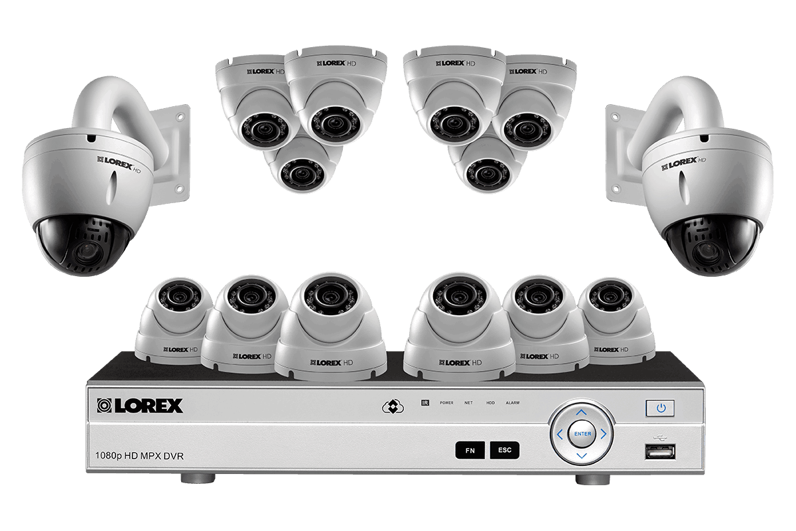

**Doors System**

System responses on open and close the doors

The main doors open by password

, Inside doors open by sensors can sense people