# System Development and Operation:

## Overview:

The system is developed using Agile Technique . Initially , R&D is applied to tools and techniques that are intended to be used . Later , during development phase , continuous R&D will take place alongside the development . First prototype will be available by the end of the second week . On finishing this prototype , the system should enter an initial operation phase that lasts for six weeks . During that time , development team will be communicating and getting feedback from operating and business teams to make sure that the system fulfills all agreed requirements and will be solving any stuck issue . Lastly , system will enter final operation and maintenance phase during which indirect technical support will be provided by a minor development team .

# Development Plan:

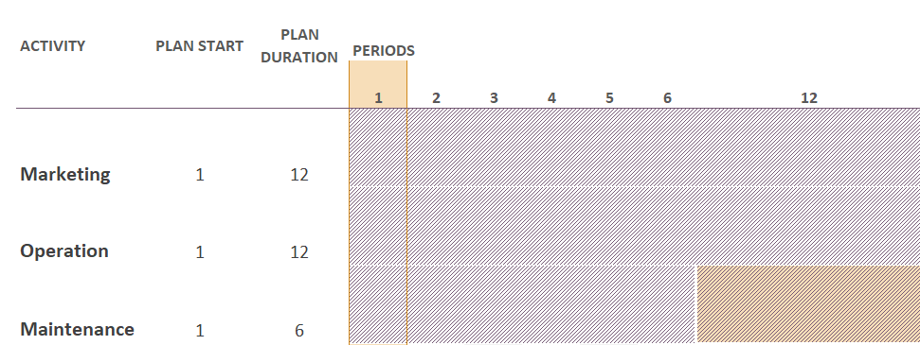

A screenshot of a cell phone

Description generated with high confidence

# Operation Plan: