Verification of an AMBA APB Slave using UVM
A UVM-Based Functional Verification Project
Ahmed Razi Ullah
BEE 13 B
366191

1. Introduction
This project develops a UVM-based verification environment for an AMBA APB slave containing a 32-word by 32-bit memory. The environment drives constrained-random write data to all addresses, reads the data back, and uses a self-checking scoreboard to confirm data integrity. The work covers APB protocol timing, UVM component design, monitor-to-scoreboard transaction flow, and waveform-level debugging.

1.1 Abstract
Modern SoCs contain many peripherals connected over standard buses. Verifying these interfaces is a major part of a chip's development effort. This project was chosen to build hands-on experience with the UVM methodology on a real, industry-standard protocol.

1.2 Objectives
- Understand APB transfer timing (setup and access phases).
- Build a reusable UVM testbench with a driver, monitor, scoreboard and agent.
- Automatically check that data written to the slave is returned correctly on reads.
- Inspect waveforms to confirm protocol-correct behavior.

1.3 Scope
The verified DUT is a single APB slave with a 32-entry memory. Error responses (PSLVERR), byte strobes (PSTRB) and functional coverage are outside the current scope and are listed as future work (Section 10).

2. Background: The APB Protocol
APB (Advanced Peripheral Bus) is a low-bandwidth, low-power bus in ARM's AMBA family, intended for peripheral registers.

2.1 Signals
Signal | Direction (master view) | Purpose
PCLK | Input | Bus clock; all transfers are sampled on the rising edge
PRESET | Input | Reset (active-high in this implementation)
PADDR[31:0] | Output | Target address
PSEL | Output | Selects the slave
PENABLE | Output | Marks the access phase
PWRITE | Output | 1 = write, 0 = read
PWDATA[31:0] | Output | Write data
PRDATA[31:0] | Input | Read data
PREADY | Input | Slave indicates the transfer can complete

The interface file also declares PSTRB and PSLVERR; these are not implemented in the DUT (see Section 9).

2.2 Transfer Phases
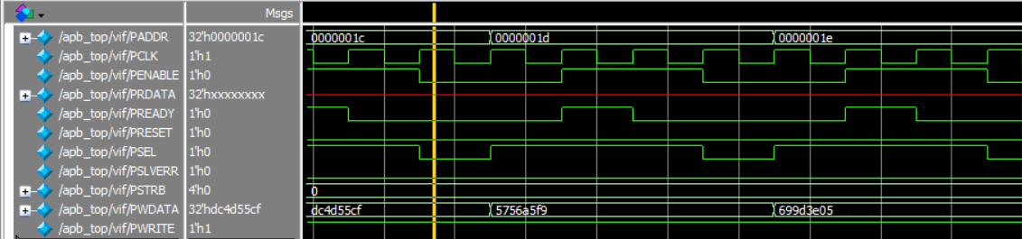
- Idle: PSEL = 0, PENABLE = 0.

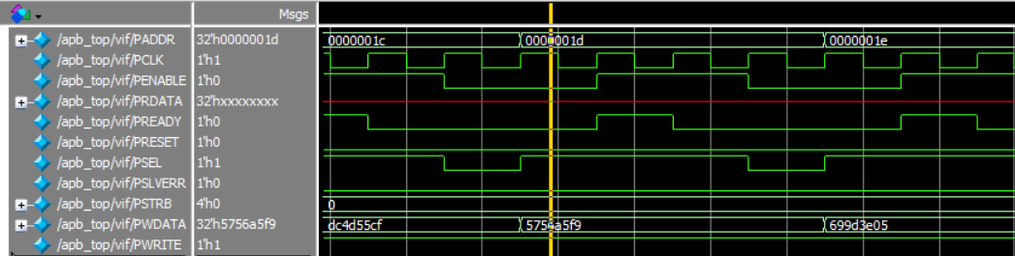
- Setup: PSEL = 1, PENABLE = 0 for one clock; address, direction and write data are presented.
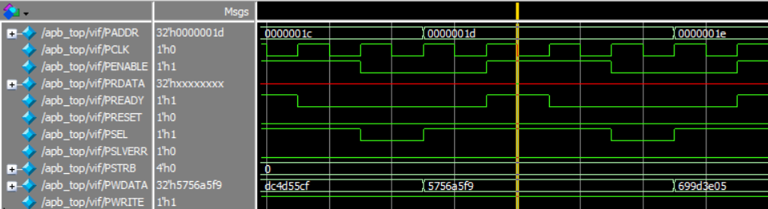
- Access: PSEL = 1, PENABLE = 1; the transfer completes when PREADY = 1.

3. Design Under Test
Module AMBA_APB (design.sv) is a slave with:
- A 32 x 32-bit memory array.
- A three-state FSM: IDLE, SETUP, ACCESS.
- On the access phase, a write stores PWDATA at PADDR; a read places mem[PADDR] on PRDATA; PREADY is asserted.

3.1 State Transitions
Current State | Condition | Next State
IDLE | PSEL=1, PENABLE=0 | SETUP
IDLE | PSEL=0, PENABLE=0 | IDLE
SETUP | PSEL=1, PENABLE=1 | ACCESS (transfer performed, PREADY=1)
SETUP | PSEL=0, PENABLE=0 | IDLE
ACCESS | PSEL=1, PENABLE=1 | ACCESS
ACCESS | PSEL=0, PENABLE=0 | IDLE

4. Verification Plan

4.1 Features to Verify
ID | Feature | Method | Pass Criterion
F1 | Write to every address 0–31 | Sequence writes random data | Monitor observes 32 writes
F2 | Read back every address 0–31 | Sequence reads all addresses | Monitor observes 32 reads
F3 | Data integrity | Scoreboard compares read vs written | All comparisons match
F4 | Protocol timing | Waveform inspection | PSEL precedes PENABLE; PREADY asserted in access phase
F5 | Slave responsiveness | Monitor watchdog | PREADY high within 10 cycles; no UVM_ERROR

4.2 Pass / Fail Criteria
The test passes when the scoreboard reports zero failed comparisons and the UVM report shows UVM_ERROR : 0 and UVM_FATAL : 0.

5. Testbench Architecture
Data flow: sequence → sequencer → driver → pins → DUT, and pins → monitor → scoreboard.

5.1 Components
Component | Responsibility
apb_top | Generates a 10 ns-period clock, applies reset for 15 ns, instantiates DUT and interface, stores the virtual interface in uvm_config_db, calls run_test("apb_base_test")
apb_base_test | Builds the environment, raises an objection, starts the sequence on the agent's sequencer
apb_env | Instantiates agent and scoreboard; connects monitor analysis ports to the scoreboard
agent | Contains sequencer, driver and monitor
first_sequence | Generates 32 write items followed by 32 read items
tx_item | Sequence item with a constraint keeping PADDR in 0–31
driver | Converts items to pin-level activity
monitor | Two concurrent processes (write and read) that reconstruct transactions
scoreboard | Receives write and read transactions through uvm_analysis_imp ports and compares them

6. Implementation Details

6.1 Stimulus
The sequence writes $urandom data to addresses 0 to 31 in order, then reads addresses 0 to 31 in order. Burst lengths are set by WRITE_BURST_LENGTH and READ_BURST_LENGTH (both 32).

6.2 Driver
After reset is released, the driver waits for a rising clock edge, gets an item and drives:
- Setup: PWRITE, PSEL, PADDR (and PWDATA for writes).
- Access: one clock later, PENABLE is asserted.
- It waits until PREADY is high, then clears PENABLE and PSEL and calls item_done().

6.3 Monitor
The monitor runs write and read collection in parallel with fork...join. It samples the bus when PSEL/PENABLE and the matching PWRITE value are seen, waits for PREADY (raising a UVM_ERROR after 10 cycles without it), and publishes a transaction when the address or data changes from the previous one.

6.4 Scoreboard
Written data and read-back data are pushed into two queues. On each clock, when both queues have data, the scoreboard pops one entry from each, compares them, increments a pass or fail counter and prints the result. The report_phase prints the totals.

7. Simulation Setup
Item | Value
Simulator | Siemens Questa 2024.1
Top module | apb_top
Test | apb_base_test
Compile order | apb_if.sv, design.sv, pkg.sv, top.sv
Script | run.do

Run with:
vsim -do run.do

8. Results

8.1 Scoreboard Output

8.2 UVM Report Summary
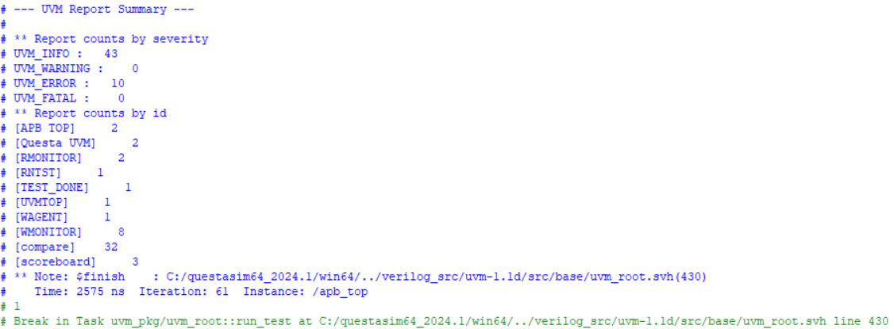

8.3 Waveforms
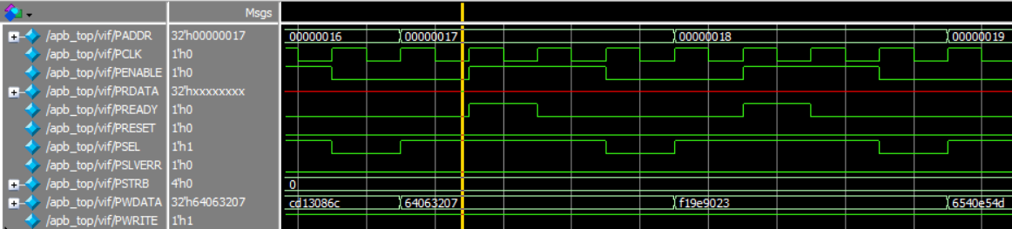
Write transfers. PSEL rises before PENABLE, and PREADY pulses during the access phase: PSEL, then PENABLE, PREADY pulse, address incrementing.

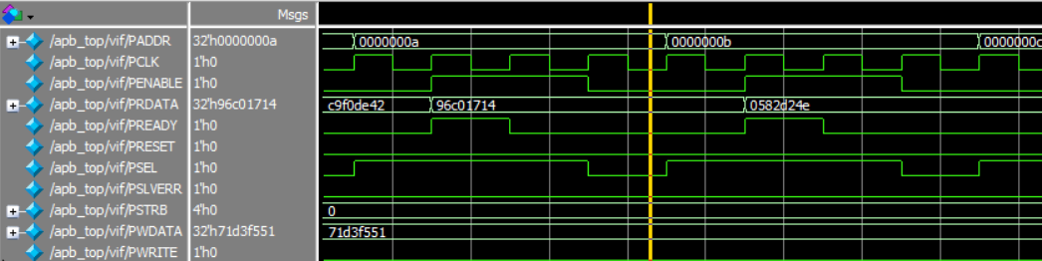
Read transfers. PRDATA matches the value written to the same address

8.4 Verification Summary
ID | Feature | Result
F1 | Write all addresses | [Pass / Fail]
F2 | Read all addresses | [Pass / Fail]
F3 | Data integrity | [x of 32 matched]
F4 | Protocol timing | [Pass / Fail, from waveforms]
F5 | PREADY watchdog | [No errors / errors]

