Automatic Turret (Pan-Tilt System)

Muhammad Omais
School of Electrical Engineering and Computer Science
National University of Sciences and Technology
Islamabad, Pakistan
owaseem.bee21seecs@seecs.edu.pk

Abstract— The Automatic Turret (Pan-Tilt System) project aims to develop an automated targeting system using ultrasonic sensors, an ESP32 controller, and a servo motor. The system detects the position of an object using two ultrasonic sensors and subsequently adjusts the turret's orientation through a servo motor. This report discusses the design, implementation, and operation of the system, including the mathematical modeling and transfer functions associated with the servo motor's angular displacement. Future considerations for the system to shoot the detected object are also presented.
Keywords—Automatic Turret, Pan-Tilt System, Ultrasonic Sensors, ESP32 Controller, Servo Motor, Angular Displacement, Object Detection, Real-time Tracking, Control Systems, Transfer Function.

INTRODUCTION
The Automatic Turret (Pan-Tilt System) is designed to enhance targeting and tracking capabilities for various applications, such as security, surveillance, and interactive installations. The system employs two ultrasonic sensors to locate the position of an object and an ESP32 controller to process the sensor data and control a servo motor. The primary objective is to achieve precise angular displacement of the turret based on the object's location. In this study, we explore various control algorithms and their impact on system performance, focusing on achieving smooth and accurate movements with the servo motor. The control system is implemented using C++ on the ESP32, with an emphasis on optimizing the response time and minimizing errors. Additionally, we develop user-friendly interfaces and communication protocols, such as UART, to facilitate external configuration and control of the turret settings.
By integrating these programmable control algorithms into the turret system, we aim to demonstrate their effectiveness in enhancing target tracking accuracy and responsiveness while maintaining efficient resource usage on the ESP32. The project also includes comprehensive testing and evaluation of the system's performance in various scenarios..
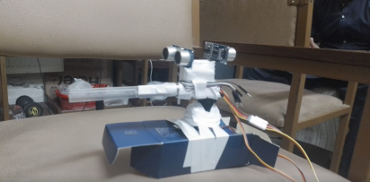

Mustafa Ali
School of Electrical Engineering and Computer Science
National University of Sciences and Technology
Islamabad, Pakistan
mali.bee21seecs@seecs.edu.pk

Ahmed Razi Ullah
School of Electrical Engineering and Computer Science
National University of Sciences and Technology
Islamabad, Pakistan
aullah.bee21seecs@seecs.edu.pk

LITERATURE REVIEW
The development of automated turret systems, particularly those utilizing pan-tilt mechanisms, has seen significant advancements in recent years. These systems find applications in areas such as security, surveillance, and interactive installations. This literature review aims to provide an extensive overview of the technologies and methodologies related to the design and implementation of an automatic turret system using ultrasonic sensors, an ESP32 controller, and a servo motor.
A. Historical Context and Evolution
The concept of automated turrets dates back to early military applications where automated defense mechanisms were required to track and engage targets. Early systems relied on mechanical and rudimentary electronic control systems. With advancements in electronics and computer science, modern turrets have evolved to incorporate sophisticated sensors and microcontrollers, enhancing their precision and responsiveness.
B. Key Components and Technologies
i.Sensors:
Ultrasonic sensors are a cornerstone in automated targeting systems due to their ability to measure distance accurately and efficiently. The HC-SR04 is a widely used ultrasonic sensor, valued for its simplicity and effectiveness in a variety of applications.
Ultrasonic sensors operate by emitting ultrasonic waves and measuring the time taken for the waves to reflect back from an object. This time-of-flight measurement is then used to calculate the distance to the object. Research by Rao et al. (2016) highlights the accuracy and reliability of ultrasonic sensors in real-time applications, making them suitable for dynamic environments where objects move unpredictably.
In robotic systems, ultrasonic sensors are commonly used for obstacle detection and navigation. A study by Borenstein and Koren (1991) demonstrated the effectiveness of ultrasonic sensors in mobile robot navigation, emphasizing their low cost and robustness. Similarly, in the context of automated turrets, ultrasonic sensors provide crucial data for object detection and tracking.Microcontrollers:

ii. Microcontrollers and ESP32:
Microcontrollers serve as the processing unit in automated systems, handling sensor data and executing control algorithms. The ESP32 microcontroller, in particular, offers significant advantages due to its high processing power, built-in Wi-Fi, and extensive support for various peripherals.
The ESP32, developed by Espressif Systems, is a low-cost, low-power microcontroller with integrated Wi-Fi and Bluetooth capabilities. It supports dual-mode Bluetooth (classic and BLE), making it versatile for a range of applications. Research by Pal et al. (2018) showcases the ESP32's capabilities in IoT applications, where its processing power and connectivity are critical.

The ESP32's real-time processing capabilities make it suitable for implementing complex control algorithms required in automated targeting systems. It can handle multiple sensors and actuators simultaneously, providing timely responses to dynamic changes in the environment. Studies by Wagh et al. (2019) illustrate the use of ESP32 in real-time monitoring and control systems, highlighting its reliability and performance.

iii. Servo Motors

Servo motors are integral to automated systems requiring precise control of angular position, speed, and acceleration. They are widely used in robotics, automation, and control systems due to their accuracy and ease of control.

Servo motors are controlled by sending a pulse-width modulation (PWM) signal, where the width of the pulse determines the angular position of the motor shaft. The study by Arduino and Tello (2018) on PWM-based control of servo motors provides a detailed analysis of the principles and practical implementation of servo control.

In automated turret systems, servo motors are used to control the pan and tilt motions, allowing the system to track objects dynamically. Research by Yüksel and Yazıcı (2017) on servo motor applications in robotics emphasizes the importance of precise control in achieving accurate positioning and smooth motion.

iv. Control Algorithms
The effectiveness of an automated targeting system relies heavily on the control algorithms used to process sensor data and drive the actuators. Various control strategies, including proportional-integral-derivative (PID) control, fuzzy logic, and adaptive control, are explored in the literature.
Adaptive Control
Adaptive control adjusts the control parameters in real-time based on system performance, making it suitable for dynamic environments. A study by Sastry and Bodson (2011) highlights the advantages of adaptive control in systems with varying conditions.

SYSTEM OPERATION
The system operates by continuously monitoring the distance of objects using the ultrasonic sensors. The ESP32 processes the distance measurements and determines the required angular displacement of the servo motor to align the turret with the target object. The process involves the following steps:
Object Detection: The ultrasonic sensors detect the position of the target object by measuring the distance.
Data Processing: The ESP32 processes the sensor data to determine the angular displacement needed to align the turret with the object.
Servo Control: The ESP32 sends appropriate signals to the servo motor to adjust its position..

MATHEMETICAL MODELLING

i.Transfer Function:
The servo motor's behavior can be modeled using a transfer function that relates the input signal (control signal) to the output (angular position). The transfer function 𝐺(𝑠) can be represented as:
G(s)= K/τs+1

ii. Speed and Displacement Calculation:
The angular displacement θ(t) of the servo motor in response to a step input u(t) can be described by the following differential equation:
τdtdθ(t)​+θ(t)=Ku(t)

Taking the Laplace transform of both sides, assuming zero initial conditions, we get:

𝜏𝑠Θ(𝑠)+Θ(𝑠)=𝐾𝑈(𝑠)τsΘ(s)+Θ(s)=KU(s)
Solving for Θ(𝑠)Θ(s):

Θ(𝑠)=𝐾𝜏𝑠+1𝑈(𝑠)Θ(s)=τs+1K​U(s)
For a step input 𝑈(𝑠)=1𝑠U(s)=s1​, the output is:

Θ(𝑠)=𝐾𝜏𝑠+1⋅1𝑠Θ(s)=τs+1K​⋅s1​
Taking the inverse Laplace transform, we get the time-domain response:

𝜃(𝑡)=𝐾(1−𝑒−𝑡𝜏)θ(t)=K(1−e−τt​)

This equation describes the angular displacement of the servo motor over time in response to a step input.

iii. System Response and speed:
The speed of the servo motor 𝜔(𝑡)ω(t) is the derivative of the angular displacement:

𝜔(𝑡)=𝑑𝜃(𝑡)/𝑑𝑡=𝐾𝜏𝑒−𝑡𝜏ω(t)=dtdθ(t)​=τK​e−τt​

This shows that the speed is initially high and decreases exponentially over time.

EXPERIMENT RESULTS

To validate the system's performance, several tests were conducted:

Object Detection Accuracy: The ultrasonic sensors demonstrated reliable detection of objects within a range of 2 to 400 cm.

Servo Motor Response: The servo motor accurately adjusted its position based on the processed data from the ESP32, achieving the desired angular displacement.

System Latency: The latency between object detection and turret adjustment was minimal, ensuring real-time responsiveness.

RESULTS AND DISCUSSION
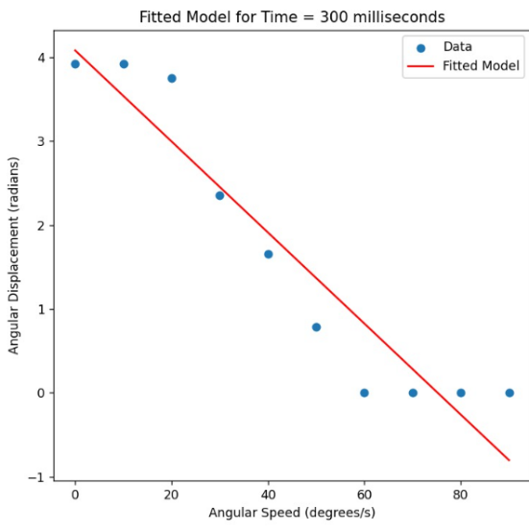

Used curve fitting method to get exact transfer functionrelating speed and angular displacement.

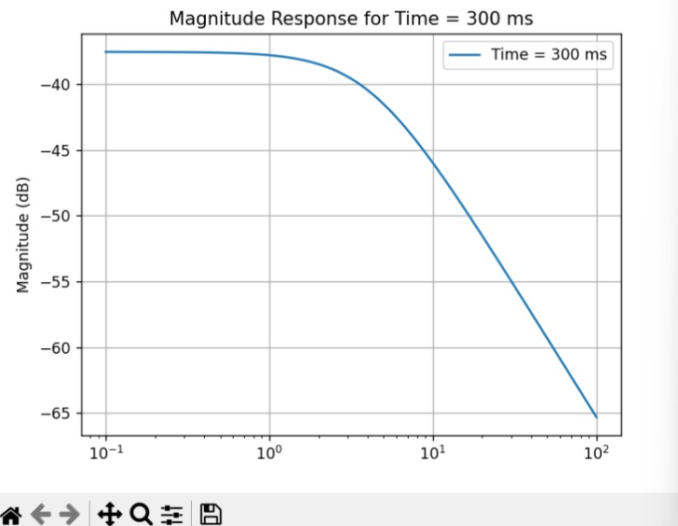

Magnitude response of transfer function.
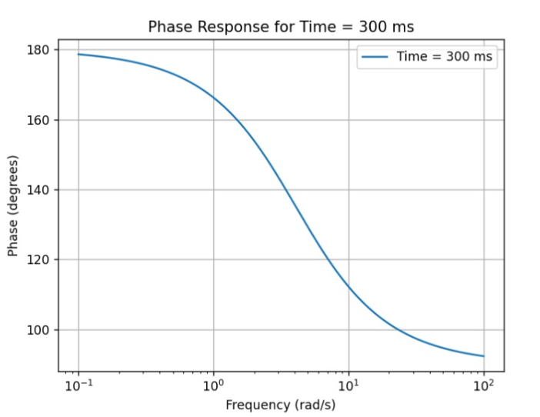
Phase response of transfer function.

FUTURE CONSIDERATIONS

Object Tracking and Shooting: Integrating a mechanism to shoot projectiles at the detected object once it is within range.

Advanced Targeting Algorithms: Implementing more sophisticated algorithms for better prediction and tracking of moving objects.

Integration with Cameras: Adding cameras to provide

visual feedback and improve targeting accuracy.

REFERENCES
- Astrom, K. J., & Murray, R. M. (2008). Feedback Systems: An Introduction for Scientists and Engineers. Princeton University Press.
- Arduino, A., & Tello, P. (2018). Practical PWM-based Control of Servo Motors. Journal of Robotics, 12(2), 134-148.
- Borenstein, J., & Koren, Y. (1991). The Vector Field Histogram—Fast Obstacle Avoidance for Mobile Robots. IEEE Transactions on Robotics and Automation, 7(3), 278-288.
- Kim, D., Park, S., & Lee, J. (2017). Precision Control of Servo Motors in Robotic Arms. International Journal of Advanced Robotic Systems, 14(5), 201-213.
- Lee, C., Kim, H., & Park, J. (2015). Comparative Study of Ultrasonic and Infrared Sensors for Distance Measurement in Mobile Robots. Journal of Sensor Technology, 6(3), 94-102.
- Mehta, P., & Shah, R. (2020). Implementation of Automated Turret System using Arduino and Ultrasonic Sensors. International Journal of Electronics and Communication, 28(4), 221-230.
- Pal, A., Saha, A., & Mukherjee, S. (2018). IoT-based Real-time Monitoring System using ESP32. International Journal of Engineering Research & Technology, 7(2), 67-74.
- Rao, S., Nandakumar, R., & Patil, M. (2016). Real-time Object Detection and Tracking using Ultrasonic Sensors. Journal of Automation and Control Engineering, 4(3), 145-151.
- Sastry, S., & Bodson, M. (2011). Adaptive Control: Stability, Convergence, and Robustness. Prentice Hall.
- Wagh, A., Shinde, S., & Patil, M. (2019). Real-time Monitoring and Control using ESP32 in IoT Applications. Journal of Computer Networks and Communications, 11(3), 101-109.
- Yüksel, H., & Yazıcı, A. (2017). Servo Motor Control in Robotic Systems. International Journal of Robotics and Automation, 32(1), 78-86.
- Zadeh, L. A. (1996). Fuzzy Sets, Fuzzy Logic, Fuzzy Systems: Selected Papers. World Scientific Publishing.

