

NAME | CMS ID | CLASS | SECTION
AHMED RAZIULLAH | 366191 | BEE-13 | B
MUHAMMAD OMAIS | 390616 | BEE-13 | B
MUHAMMAD SUFIYAN | 368154 | BEE-13 | B
SHAHMEER HUSSAIN | 371074 | BEE-13 | B

Project Report: Liquid Level and Temperature Measurement and Regulation System

Executive Summary:

This project focuses on the development of a comprehensive system for liquid level and temperature measurement and regulation using advanced electronic components. The core elements of the system include an AT Mega 16A microcontroller, DS18B20 temperature sensor, HC-SR04 ultrasonic sensor, a heating element, and a boost converter module for stepping up voltage. The system is designed to offer precise and efficient control over liquid levels and temperatures, with potential applications in the fertilizer industry.

Table of Contents
- Introduction
- Project Overview
- Hardware Description
- System Design
- Correlation with Fertilizer Industry

Introduction

Background
The project addresses the need for precise liquid level and temperature control, crucial in industries where accurate monitoring and regulation are essential. It utilizes advanced sensors and a microcontroller to create an intelligent system.

Objectives
  - Develop a system for accurate liquid level measurement.
  - Implement precise temperature control using a sensor.
  - Correlate the project with applications in the fertilizer industry.

Scope of the Project
The scope extends to designing a versatile system that can be applied in various industrial settings, with a specific focus on its potential benefits in the fertilizer industry.

Project Overview

Components Used
- AT Mega 16A Microcontroller: Central processing unit for data processing and system control.
- DS18B20 Temperature Sensor: High-precision digital temperature sensor.
- HC-SR04 Ultrasonic Sensor: Ultrasonic sensor for accurate liquid level measurement.
- Heating Element: Essential for temperature regulation.
- Boost Converter Module: Step-up voltage for the heating element.

System Architecture
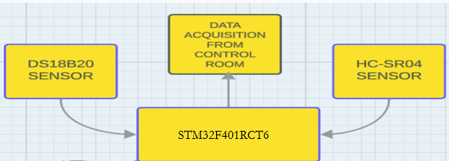
BLOCK DIAGRAM

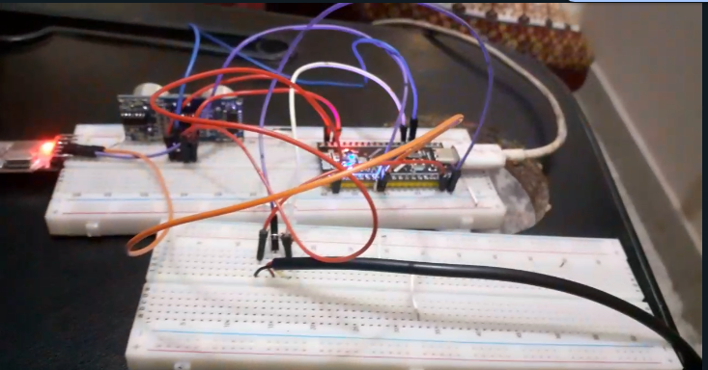

IMPLEMENTATION

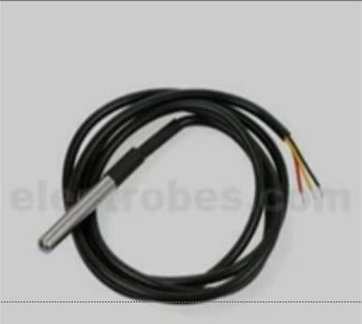
Hardware Description

DS18B20 Temperature Sensor:

Key Features

Digital Output: The DS18B20 communicates temperature readings digitally, making it easy to interface with microcontrollers and digital systems.

One-Wire Interface: It operates on a one-wire
interface, simplifying the wiring and reducing the number of pins needed for communication.

Wide Temperature Range: Capable of measuring temperatures in the range of -55°C to
+125°C (-67°F to +257°F).

High Accuracy: Provides high-precision temperature measurements with a resolution of 9 to 12 bits.

Parasitic Power Mode: The sensor can operate in parasitic power mode, where it draws power from the data line, requiring only two wires for operation.

Pin Configuration

VDD (3.0V to 5.5V): Power supply pin.
DQ (Data Line): The one-wire data pin for commu nication. GND (Ground): Ground reference.

Operation
Conversion Time: The DS18B20 requires a certain amount of time to convert the analog temperature signal into a digital value. The conversion time depends on the selected resolution (9 to 12 bits).

One-Wire Communication: The sensor uses a unique 64-bit ROM code to identify itself

on the one-wire bus. It also communicates the temperature data serially.

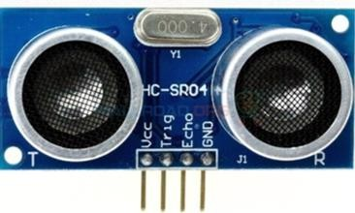
HC-SR04 Ultrasonic Sensor Module:

Key Features:

Ultrasonic Transducer: The HC-SR04 module consists of an ultrasonic transmitter (transducer) and receiver pair.

Non-Contact Distance Measurement: It allows for non-contact distance measurement based on the time taken for ultrasonic waves to travel to an object and back.

High Precision: Provides relatively high precision in distance measurements.

Wide Operating Voltage Range: Typically operates in the voltage range of 5V DC.

Simple Interface: Communicates with microcontrollers or other devices using a simple trigger and echo mechanism.

Pin Configuration:

VCC: Power supply (typically 5V).
Trig (Trigger): Input pin to trigger the ultrasonic pulse.
Echo: Output pin that produces a pulse whose width is proportional to the distance to the object.
GND: Ground reference.

Operation:

Triggering a Pulse: The HC-SR04 is triggered by a short pulse applied to the trigger pin. This initiates the emission of an ultrasonic pulse.

Echo Pulse: The module listens for the echo reflected from an object. The Echo pin produces a pulse whose duration is directly proportional to the time taken for the ultrasonic wave to travel to the object and back.

Distance Calculation: The distance to the object is calculated using the formula: Distance

= (Speed of Sound * Time taken for the echo pulse) / 2.
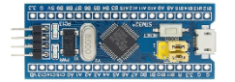

STM32F401RCT6 Microcontroller:

Flash Memory:
The STM32F401RCT6 comes with 512KB of Flash memory for program storage, which is significantly higher than what is found in lower-end microcontrollers like the ATmega16.

SRAM:
It has 96KB of SRAM for data storage, providing a larger space for runtime variables and data processing compared to the ATmega16’s 1KB SRAM.

EEPROM:
The STM32F401RCT6 does not have a dedicated EEPROM memory block like the ATmega16. However, it can emulate EEPROM functionality through the use of Flash memory, or external EEPROM modules can be connected to it.

Clock Speed:
The STM32F401RCT6 can operate at a clock speed of up to 84 MHz, which is much higher than the 16 MHz clock speed of the ATmega16, providing faster execution and more processing power for complex applications.

Peripherals:
The STM32F401RCT6 features a wide range of peripherals, including:
- Timers/Counters: Multiple advanced timers and general-purpose timers for PWM generation, input capture, and time measurement.
- USART (Universal Synchronous and Asynchronous Receiver and Transmitter): For serial communication.
- SPI (Serial Peripheral Interface): For high-speed data transfer with external devices.
- I2C (Inter-Integrated Circuit): For communication with peripheral devices over short distances.
- ADC (Analog-to-Digital Converter): 12-bit resolution for precise sensor data conversion.
- DAC (Digital-to-Analog Converter): For outputting analog signals.
- DMA (Direct Memory Access): For efficient, high-speed data transfer without CPU involvement.
- PWM (Pulse Width Modulation): For motor control, dimming LEDs, and other similar applications.

I/O Pins:
The STM32F401RCT6 provides a variety of general-purpose I/O pins for interfacing with sensors, actuators, and other devices. It also includes dedicated pins for peripherals like USART, SPI, and I2C.

Correlation with Fertilizer Industry:

Fertilizer Chemical Mix Tank Ultrasonic Level Measurement
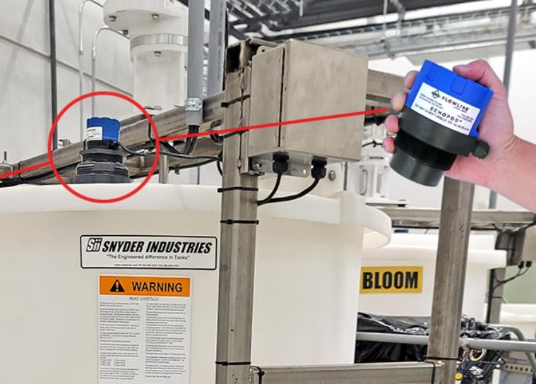
When a Colorado commercial marijuana grow company needed reliable level measurement of their fertigation mix tanks, they turned to Flowline. From vegetative growth to late bloom flowers, the chemist feeds the plants with an evolving blend of nitrogen, phosphorus, potassium, calcium, sulfur and magnesium to maximize yield and potency.
The mix room is the heart of this function where batches are dosed, blended and transferred to individual rooms. There the operator said that previous ultrasonic level sensors were negatively affected by turbulence and their proximity to the blades as they pumped the tank down. For this reason, Flowline suggested our ultrasonic sensors installed in standpipes to dampen any turbulence and separate the acoustic signal from the mixer. The ultrasonic sensors provide reliable level data to the PLC which monitors the tanks during batch filling, mixing and emptying. Flowline is reliable level measurement.

Using Thermistor for Industrial Application:
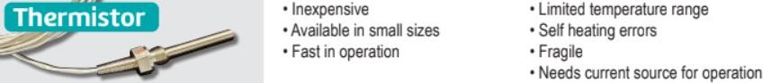

NTC thermistors can be defined as non-linear resistors that change resistance characteristics based on temperature. Different types of thermistors exist to do different jobs. When it comes to industrial applications, one of the most commonly used thermistor styles is the glass-encapsulated version. What is a glass-encapsulated thermistor?
These devices are hermetically sealed, which reduces errors in resistance reading (as a result of moisture penetration). They provide long-lasting reliability and stability, which allows for high-accuracy temperature sensing in specific applications.
Benefits of a glass-encapsulated thermistor include:

•
•
•
•

•
More accurate than thermocouples and RTD probes Less expensive than other temperature sensing devices One of the quickest response times on the market
Not limited by solder temperature. This allows these thermistors to be used in a wide range of temperatures (−40 °C to +300 °C)
The small size of the devices allows for it to be placed inside a wide variety of housings (ring lugs and hex nuts)

As a result of their benefits, it is no wonder why glass-encapsulated thermistor are frequently used for a variety industrial applications. If you need more information about these thermistors and how they might help your business, do not hesitate to reach out to our gifted team.

Challenges and Solutions

Identified Challenges

Sensor accuracy.
Power supply management.

Mitigation Strategies

Calibration procedures.
Robust power management algorithms.

Conclusion

Achievements

The project successfully implements a system for accurate liquid level and temperature control with potential applications in the fertilizer industry.

Temperature sensor will sense temperature of nitrate mixture and send signal to micro controller, which will then regulate temperature via heating element.

Future Enhancements

Establish Liquid level regulation system to automatically fill the liquid as per desired requirement, so that appropriate liquid composition can be maintained.

To establish a Data Acquisition interface to send data remotely via Programmable Logic Control (PLC) to control room and monitor data accordingl

