**Company Sales Report**

**1. Executive Summary**

* **📌This report presents the final analysis of Company sales for your products.**
* **✅Key findings: The analysis for Profit by Product Category and Region**

**Shows that Computers > North America Profit: $7,085,510.49.**

* **📊 Trends and recommendations: The analysis results are good in this year and suggest that marketing improvements or discounts can help attract more customers, increase product sales, and boost overall profit.**

**2. Introduction**

* **Objective: The main goal of this analysis is to evaluate Company sales performance. If sales if high, or low: we explore solutions such as discounts or introducing new products to attract more customers.**
* **Dataset Description: The data comes from a real Company and covers the year 2023.**
  + **Key metrics: Total Revenue, Total of sales, Profit by Product Category and Region.**
* **Business Questions:**
  + **What is the most profitable city?**
  + **Which Products type generates the highest revenue?**
  + **How can sales performance be improved? Etc.….**

**3. Data Preparation & Methodology**

* **Data Source: Real Company Sales data.**
* **Data Cleaning & Transformation: No cleaning was needed as the dataset was already clean.**
* **Analysis Method: Various charts and visualizations were created to display results clearly.**

**4. Data Visualization & Insights**

* **Dashboard Overview: *(screenshots of report):***

**1.**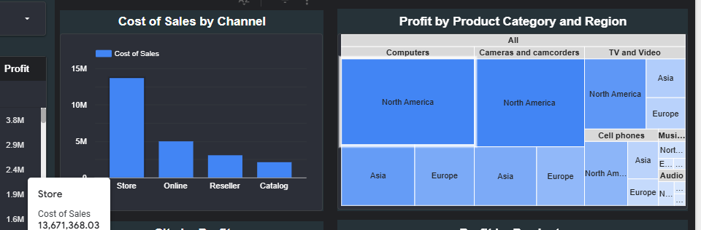

**2.**

* **Trends & Key Findings:**
  + **Sales Performance: Sales and profit are at a moderate level, with a total profit of $31.6M**
  + **Total of Sales: Total of Sales is generally high for company sales this year.**
  + **Top Region for Sales: Computers > North America has the highest total profit of: $7,085,510.49M**

**5. Business Impact & Recommendations**

* **Decision-Making Impact: Insights help stakeholders make data-driven decisions to improve sales performance and customer satisfaction.**
* **And The company This year She achieved her goal.**
* **Suggested Actions:**
  + **Introduce discounts to attract more customers.**
  + **Improve marketing strategies to boost sales.**

**6. Conclusion**

* **Next Steps:**
  + **Conduct weekly sales analysis to measure the impact of new strategies.**
  + **Continue improving customer satisfaction to increase profitability.**