NATIONAL UNIVERSITY OF COMPUTER AND EMERGING SCIENCES
PROGRAM: SOFTWARE ENGINEERING



SOFTWARE CONSTRUCTION AND DEVELOPMENT
LAB

LAB TASK 07

SUBMITTED BY:
Name: Ahmed Ali
Roll No: 22P-9318
Section: BS(SE)-5B

INSTRUCTOR NAME: Sir Saood Sarwar
A DEPARTMENT OF COMPUTER SCIENCE
Service Account JSON: Do not submit the actual JSON file. Ensure you understand how to use it securely.
ANSWER:
To ensure I use the Firebase Service Account JSON securely Some practices are:
- Do Not Hardcode Sensitive Information:
- Never hardcode the Service Account JSON credentials directly in your code
Instead, store it in a secure location, such as on the server or in environment variables.

2) Secure File Permissions:
- Ensure that the file containing the JSON credentials is not accessible by unauthorized users. Set restrictive file permissions on the file, so only your application can read it

3) Use Secret Management Services:
- If possible, use secret management services such as AWS Secrets Manager, Google Secret Manager, or PythonAnywhere environment variables to store and retrieve your sensitive credentials dynamically at runtime.

4) Rotate Credentials Regularly:
- Periodically rotate your service account credentials to reduce the risk of misuse if they are ever exposed.

5) Restrict Service Account Permissions:
- Assign only the necessary permissions to your Firebase service account. Use the principle of least privilege to minimize the potential impact if the credentials are compromised.
____________________________________________________________________

Deployment Steps: Provide a brief document outlining the steps you took to
deploy the Flask app on PythonAnywhere.

Step 1: Create an account on PythonAnywhere and log in.

Step 2: Go to the "Web" section and create a new web app.

Step 3: Select Flask as your web framework and choose Python version (matching the version you're developing with).

Step 4: In the web app configuration, under the "Code" section, set the path to your Flask app's app.py file (e.g., /home/ahmed121176/mysite/app.py).

Step 5: Install required dependencies using the "Bash console" in PythonAnywhere: pip install firebase-admin xmltodict

Step 6: Place your Firebase Service Account JSON file (p-9318-ahmed-bse-5b-project-firebase-adminsdk-f7jn6-13df3b6df6.json) in the correct directory (e.g., /home/ahmed121176/mysite/).

Step 7: Reload the web app from the "Web" section in PythonAnywhere to apply the changes.

Step 8: Test it using the provided code in instructions in Jupyter Notebook.

____________________________________________________________________

Successful response from the Jupyter notebook.
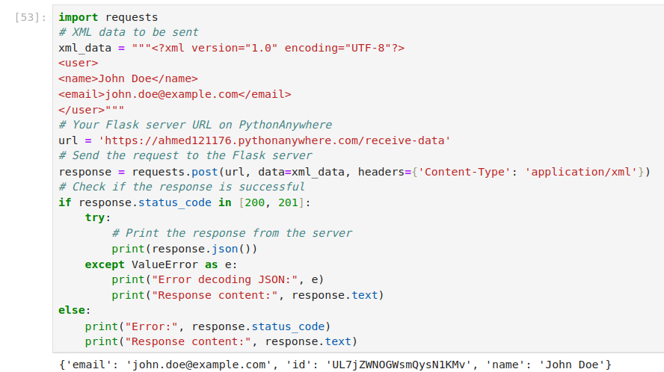
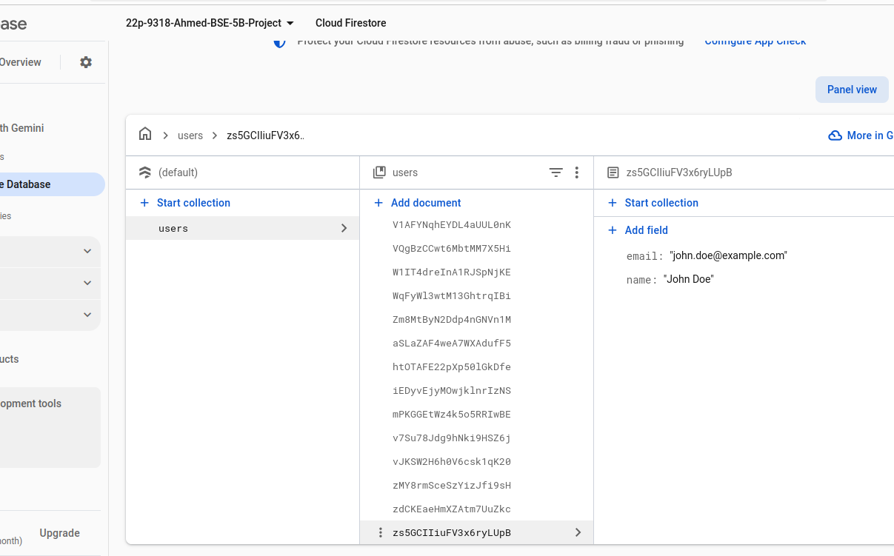
Entry in Firestore Database under the users collection.

