NATIONAL UNIVERSITY OF COMPUTER AND EMERGING SCIENCES
PROGRAM: SOFTWARE ENGINEERING



SOFTWARE CONSTRUCTION AND DEVELOPMENT
LAB

LAB TASK 08

SUBMITTED BY:
Name: Ahmed Ali
Roll No: 22P-9318
Section: BS(SE)-5B

INSTRUCTOR NAME: Sir Saood Sarwar
A DEPARTMENT OF COMPUTER SCIENCE

Issues find Using flake8:
- Number of errors and warnings, especially focusing on naming conventions (For Example: class and function names in snake_case)
- Naming issues for classes, methods, or variables
- Line length exceeding the recommended limit
- Unused imports
You can see the issues in python code when I first used flake8 command on python file below:
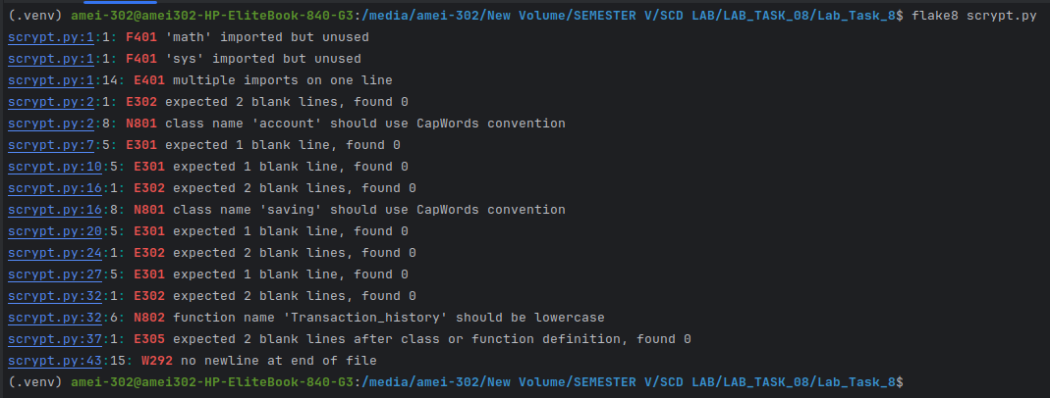
Issues find Using pylint:
- Naming conventions
- Missing or improper docstrings
- logical errors (Example: incorrect method names or misuse of inheritance).
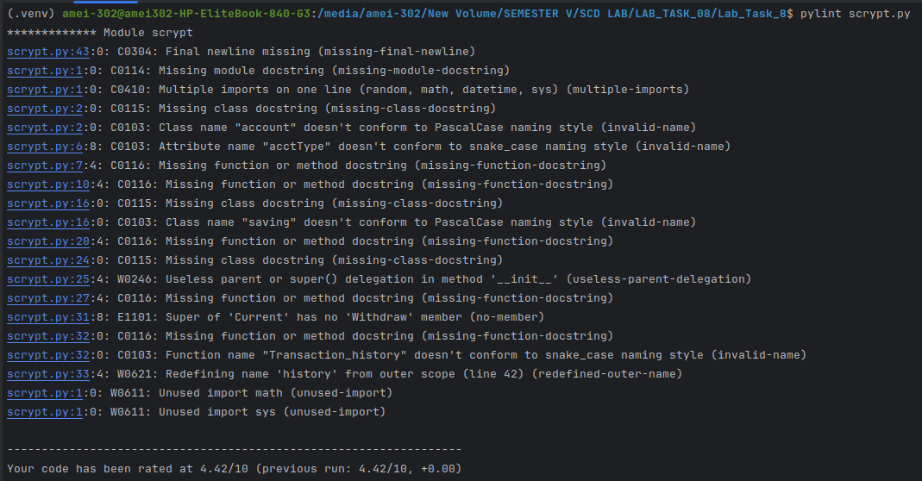
- inefficient patterns

Applying Black:

I'll apply Black to standardize the code style. The key changes from Black should be:
- Consistent indentation and line breaks.
- Standardized quotation marks.
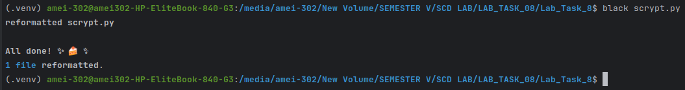

Re-running Flake8 and Pylint After Black:

FLAKE8:
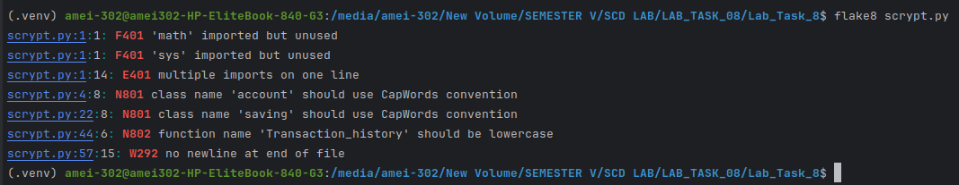
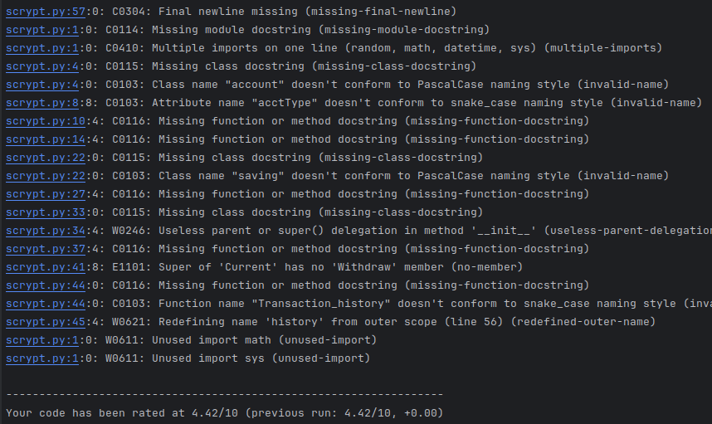
PYLINT:
STILL THERE WERE ISSUES LEFT BUT IN (FLAKE8) AFTER Running BLACK A NUMBER OF ISSUES WERE SOLVED WHILE THERE IS NO EFFECTS OBSERVED IN (PYLINT) NUMBER OF ISSUES.

____________________________________________________________________

Manual Refactoring and Final Code Review:

Improvements To Be Made:

- Proper naming conventions.
- Removed unused imports (math, sys).
- Corrected logical issues in CurrentAccount.withdraw by properly calling super().withdraw(amount).

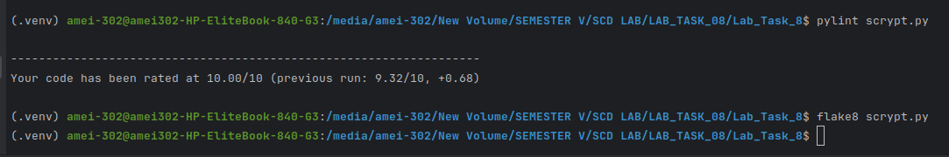
RESULTS OF PYLINT AND FLAKE8 AFTER REFACTORING THE CODE:

Detailed Explanation of Changes: (the refactored .py file is attached in gcr sir)

- Adding Docstring:
  - Initial Issue: Pylint flagged the code as missing a module docstring, a module docstring is essential for documenting the modules functionality

  - Solution: A concise docstring was added at the top of the module to describe the codes purpose, which improves readability and provides context for other developers

- Naming Conventions:
  - Initial Issue: The initial code had non-standard naming conventions (e.g., account, fun1, fun2, Transaction_history) Pylint and Flake8 enforce PEP 8 naming conventions to ensure consistency

  - Solution: Renamed classes, methods, and functions following PEP 8 standards:

    - account to Account
    - saving to SavingAccount
    - fun1 to deposit
    - fun2 to withdraw
    - Transaction_history to generate_transaction_history

  - Result: Improved code readability and consistency with PEP 8 guidelines

- Removing Unused Imports:
  - Initial Issue: The initial code imported math and sys, though neither was used, this redundancy can increase the memory

  - Solution: Removed math and sys, keeping only relevant imports (random and datetime) Flake8 often flags unused imports as it’s good practice to keep code concise

- Useless Parent Delegation in CurrentAccount.__init__:
  - Initial Issue: The CurrentAccount class had an __init__ method that simply called super().__init__, creating redundant delegation

  - Solution: Removed CurrentAccount.__init__, as the superclass Account already initializes the necessary attributes

  - Result: Reduced redundancy and improved readability

- Correcting Typo in Method Call:
  - Initial Issue: In CurrentAccount, the method super().Withdraw(amount) was incorrect due to capitalization, as the correct method is withdraw

  - Solution: Corrected the call to super().withdraw(amount)

  - Result: This fixes a runtime error, ensuring the withdraw functionality works as expected in CurrentAccount

- Renaming Transaction_history and history:
  - Initial Issue: The Transaction_history function and history variable shared a name, creating ambiguity in the code

  - Solution: Renamed Transaction_history to generate_transaction_history and history to transaction_history

  - Result: Avoided namespace conflicts, which is especially important for readability and when debugging larger programs
- Adding Class and Method Docstrings:
  - Initial Issue: The initial code was missing docstrings for its classes and methods, which Pylint checks for

  - Solution: Added meaningful docstrings to the Account, SavingAccount, and CurrentAccount classes, as well as to each method

  - Result: Enhanced documentation, making the code easier to understand and maintain

Final Result After Refactoring
The final refactored code is now according to Pylint and Flake8 standards, eliminating:
- Naming convention errors.
- Unnecessary imports.
- Redundant initializer methods.
- Namespace conflicts.
- Missing docstrings.

