NATIONAL UNIVERSITY OF COMPUTER AND EMERGING SCIENCES

PROGRAM: SOFTWARE ENGINEERING

SOFTWARE CONSTRUCTION AND DEVELOPMENT
LAB

LAB TASK 09

SUBMITTED BY:
Name: Ahmed Ali
Roll No: 22P-9318
Section: BS(SE)-5B

INSTRUCTOR NAME: Sir Saood Sarwar
A DEPARTMENT OF COMPUTER SCIENCE

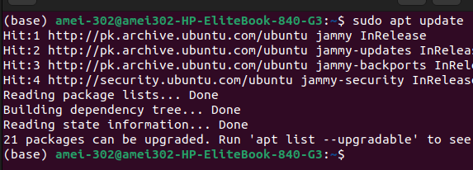
This command will update the packages in the system.

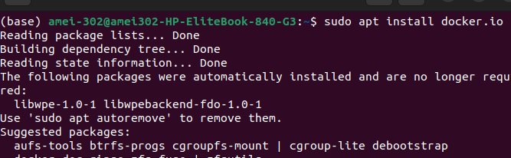
Command to install Dockers:
The Below command will start the docker services:

To check the docker version type docker --version:
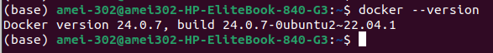
Building first Docker image:
First I create an new directory and make a .html file inside it, you can see in the image below all the code of html file
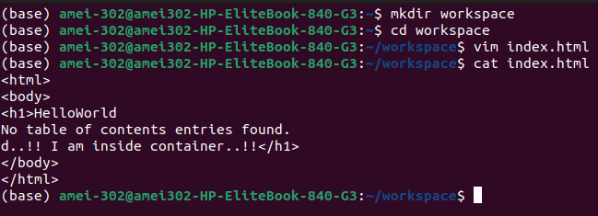
add the following code inside the Dockerfile, to be able to build a working image with the web application
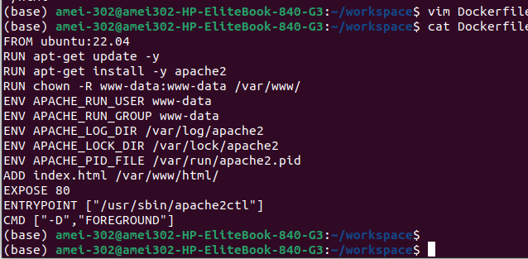
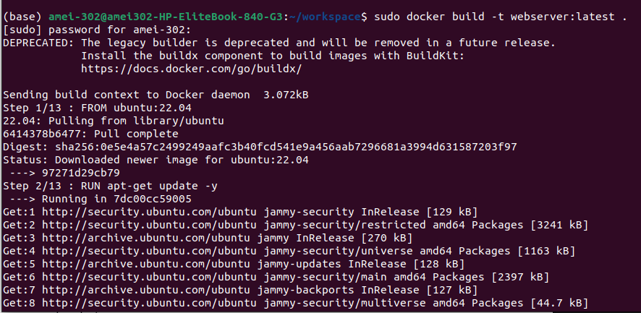
Build the docker image
By entering below command, it will show list of images that has been installed on dockers till current time
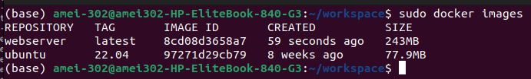
Installing Alpine ISO File on dockers:
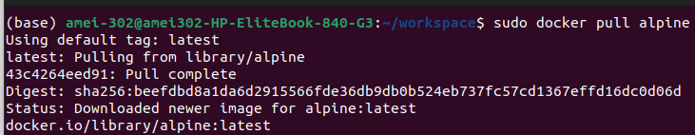
To check if it has been installed or not, do:
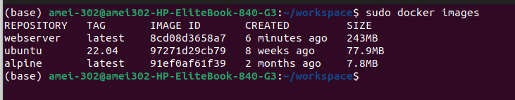
Installing Ubuntu ISO File on dockers and checking is it installed or not:
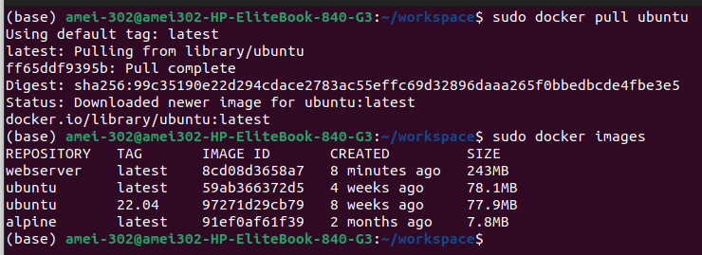
Now, let's start a container from the Alpine image.
Type the following command and press Enter to start a new container from Alpine image.
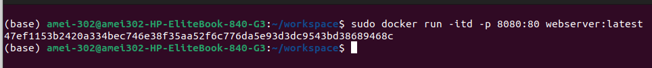
Let us open up Firefox and type localhost:8080:
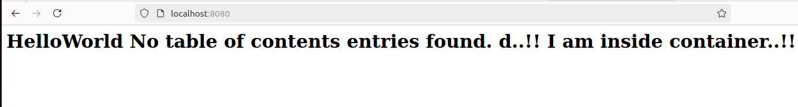
let's try to start Alpine image:
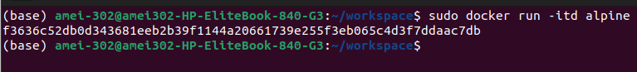
let's try to start Ubuntu image:
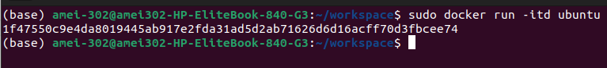
Now we can check the container ids using the following command.
We can also get an interactive shell using the container id using the docker exec command:
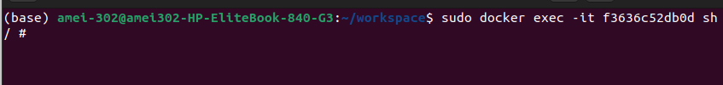
We can specify the container id and the command we want to use, in this case we are specifying sh which will give us a shell on the alpine container.

Running Practical Tasks in Containers:
(a) Container 1 - Alpine: Start a container with the alpine image, then:
• Install curl inside the container.
• Use curl to fetch and display the HTML content of https://example.com.
• Take a screenshot showing the successful installation of curl and the
output of the curl command.
____________________________________________________________________
By Entering: sudo docker run -it alpine COMMAND we get access to apline container.
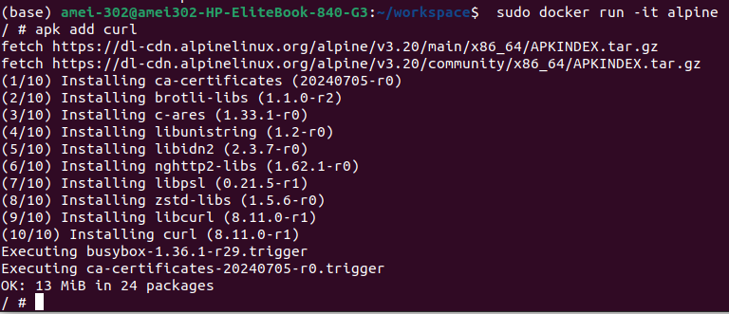
Then I add the command of apk add curl COMMAND through which curl is now installed in apline container

NOW to fetch and display the HTML content of https://example.com
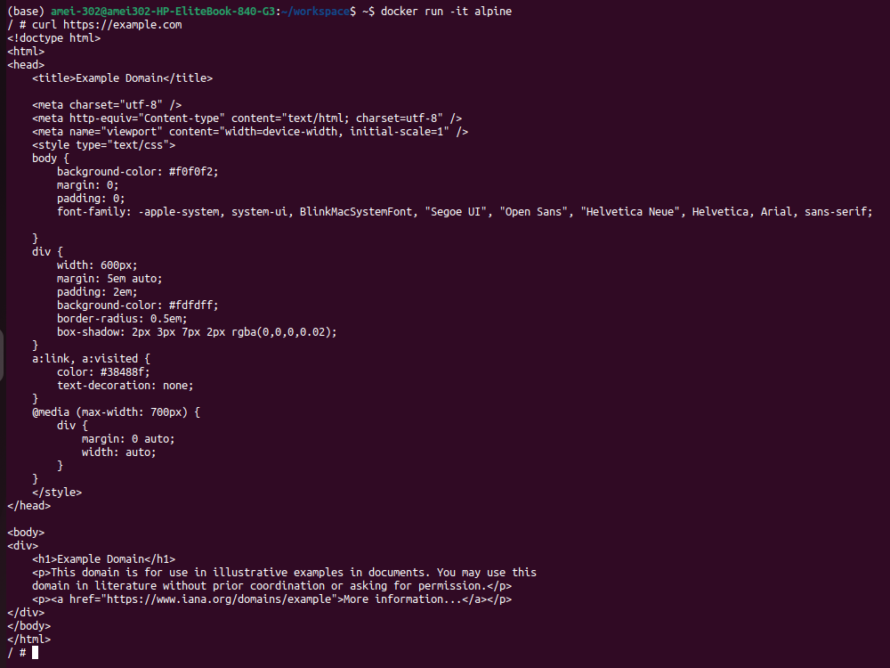
(b) Container 2 - Ubuntu: Start a container with the ubuntu image, then:
• Install Python inside the container.
• Write and execute a simple Python script that calculates the factorial of
a number provided as input.
• Show the installation of Python, the code for the Python script, and the
output after running it with an example input.
____________________________________________________________________

Command to Start a container with the ubuntu image
To install python in ubuntu container we need first to update the container and the install python in it when you enter the command apt update && apt install python3 after a while you will be asked do you want to continue, you need to press y and hit enter key here. You can see in the image where the text is selected.
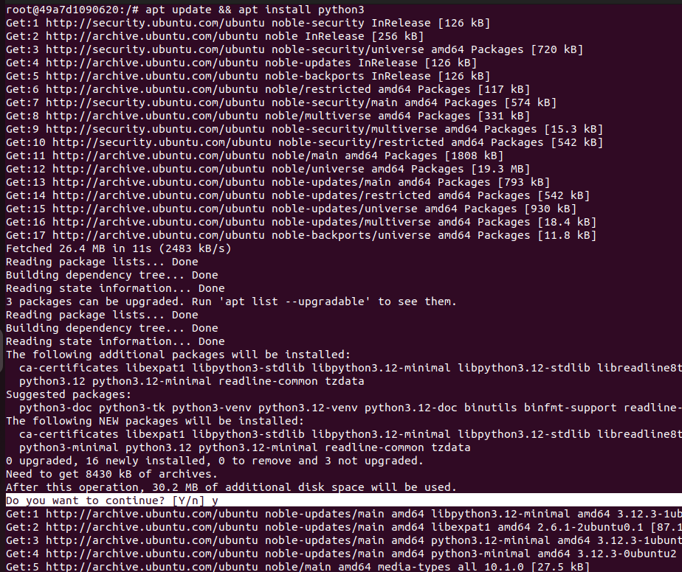
After this Please Select your time zone first and hit enter key, then select your area accordingly and hit enter key.
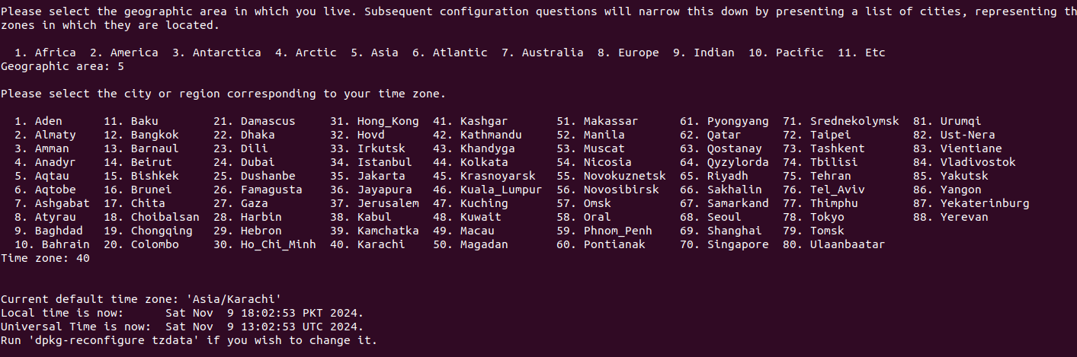
Now we need to install vim or nano, both are text editor used to edit or add text to a file, while remaining inside the terminal.
Here I am installing Vim
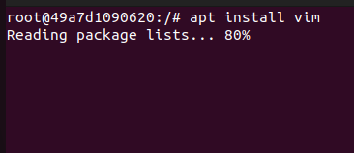

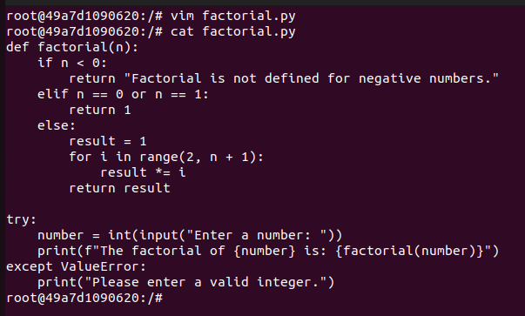
Making a python file and entering code in it.

Running the Program and Entering Input
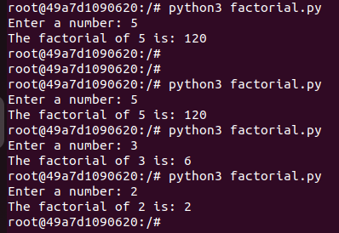

(c) Make sure both containers are running simultaneously
