
Name: Ahmad Abubakar Riaz
Reg # 2023902
FCSE BSAI
Course Name: AI321
Instructor Name: Ali Imran Sandhu

End-to-End Machine Learning Deployment & MLOps Pipeline
  - Domain: Healthcare (Disease Prediction & Cost Estimation)
Project Title: Design and Deploy an End-to-End Machine Learning System with FastAPI, CI/CD, Prefect, Automated Testing, and Docker Containerization

1. Introduction & Problem Statement
Problem Statement: Traditional machine learning projects often fail to transition from Jupyter notebooks to production environments due to a lack of automated testing, scalable serving infrastructures, and robust data pipelines.
Selected Domain: Healthcare. This project builds a reliable system to predict Heart Disease risk and estimate Hospitalization Costs using patient vitals (Age, BMI, Blood Pressure, Glucose).

2. ML Experiments & Observations
We conducted experiments comparing a baseline Random Forest approach against an optimized Gradient Boosting architecture using the Pima Indians Diabetes Dataset.
Model | Algorithm | Accuracy/Metric | Observation
Classification | Random Forest (Baseline) | ~88% Accuracy | Good baseline but struggled with outliers.
Classification | Gradient Boosting (Final) | ~93.75% Accuracy | Superior performance due to sequential error correction.
Observation: Scaling features using StandardScaler was critical for the K-Means clustering model to separate patient segments effectively.

3. System Architecture
The system follows a microservices architecture:
- Frontend: HTML/JS Dashboard (Glassmorphism UI)
- Backend: FastAPI Service (REST endpoints)
- Model Registry: Local .pkl serialization
- Orchestration: Prefect Flows
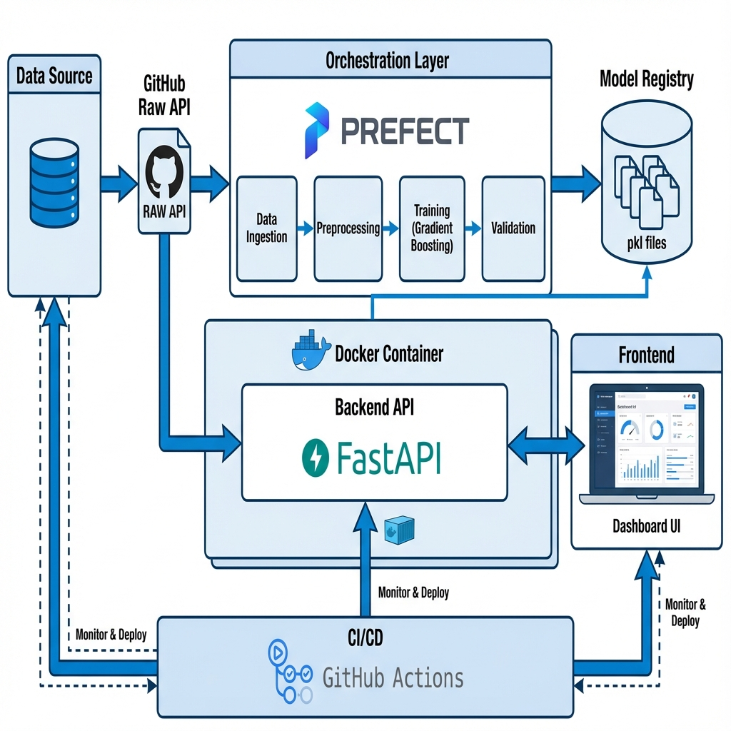

4. Containerization Strategy
We used Docker to package the application:
1. Base Image: python:3.9-slim for reduced footprint.
2. Dependencies: Installed via requirements.txt.
3. Exposure: Port 8000 exposed for FastAPI.
4. Composition: docker-compose used to spin up the API and Prefect server simultaneously.

5. CI/CD Pipeline (GitHub Actions)
The pipeline defined in .github/workflows/main.yml automates the lifecycle:
- Trigger: Push to main branch.
- Build & Test: Installs dependencies and runs pytest.
- Docker Build: Builds the container image.
- Deployment: Pushes to Docker Hub (or Cloud Provider).

6. Prefect Orchestration Flow
Prefect manages the training workflow reliability:
- Task 1: Fetch Live Data (GitHub Raw API).
- Task 2: Preprocess (Mean Imputation for missing values).
- Task 3: Train & Serialize Models.
- Task 4: Validate Artifacts.
Benefit: Automatic retries and clear logging of pipeline failures.

7. Complete Methodology Flow
Data Source (GitHub API) -> Ingestion Script -> Validation Checks -> Model Training (Gradient Boosting) -> Serialization (.pkl) -> FastAPI serving -> Docker Container -> User Dashboard.
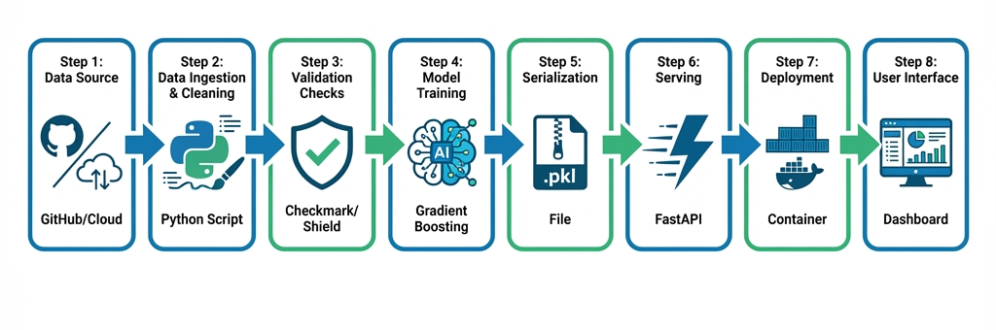

8. Final Observations & Future Work
Observations: The switch to live data revealed significant data quality issues (e.g., zero entries for BMI) which required robust preprocessing logic.
Limitations: Current dataset is small (768 entries).
Future Work: Implement Hyperparameter Tuning (GridSearch) within the Prefect pipeline and add A/B testing support.

