Abstract
This report presents the design, implementation, and evaluation of two AI modules—Emotion Recognition and Face Recognition—as part of an Assistive Vision System for visually impaired users. The Emotion Recognition module employs a dual-CNN ensemble (CNN v3 + CNN v6) with Test-Time Augmentation (TTA), achieving 81.35% accuracy on the unified FER-2013, RAF-DB, and CK+ dataset, surpassing human-level performance (65%) on FER-2013. The Face Recognition module utilizes Facenet512 embeddings with cosine-distance matching, achieving 99.63% accuracy on the LFW benchmark. The system operates in real-time (15 FPS) on a Raspberry Pi 4 Model B, providing audio feedback via neural Text-to-Speech (Edge TTS) and accepting voice commands through both online (Google Speech API) and offline (Vosk) speech recognition. All core processing runs locally with no cloud dependency for inference, ensuring privacy and offline functionality.

Keywords
Emotion Recognition, Face Recognition, Convolutional Neural Network, Test-Time Augmentation, Facenet512, Assistive Technology, Visually Impaired, Deep Learning, Raspberry Pi, Real-Time Processing, Speech Recognition, Text-to-Speech.

Related Work
Facial emotion recognition has evolved significantly over the past decade. Early approaches relied on hand-crafted features such as Local Binary Patterns (LBP) [4] and Haar Cascades [3] for face detection. The FER-2013 dataset [1], introduced at ICML 2013, became the standard benchmark for emotion recognition, with human accuracy estimated at approximately 65% [1]. Subsequent datasets including RAF-DB [11] and CK+ [12] expanded the diversity and quality of labeled expressions.
In face recognition, Schroff et al. [2] introduced FaceNet, which unified face recognition and clustering through a triplet loss function, achieving 99.63% on the LFW benchmark [10]. The DeepFace library by Serengil and Ozpinar [8] provided accessible implementations of state-of-the-art face recognition models, including Facenet512, which became a preferred choice for deployment without C++ compilation dependencies.
Architectural innovations in deep learning for emotion recognition include ResNet [5] for residual connections, Batch Normalization [14] for training stability, and attention mechanisms such as CBAM [17] for feature recalibration. However, our experiments showed that VGG-based architectures [16] with ~14M parameters are prone to overfitting on limited grayscale datasets, leading us to design a custom lightweight CNN (CNN v3) with ~2.5M parameters optimized for embedded deployment.

GRADUATION PROJECT REPORT
Emotion Recognition & Face Recognition Module

Part of: Assistive Vision System for Visually Impaired Users

Field | Details
Student Name | Ahmed Ali Elsayed Ali Mohamed Abo-Leila
Student ID | 222101525
Role | Computer Vision / AI Engineer
Modules | Emotion Recognition + Face Recognition
Target Hardware | Raspberry Pi 4 Model B
Platform | Windows 10, Python 3.12

1. Project Overview
This report documents the design, implementation, and evaluation of two AI modules for the Assistive Vision System — a graduation project aimed at helping visually impaired users understand their social environment through real-time audio feedback.

The system uses a camera to detect and recognize faces, analyze emotional states, and announce results via Text-to-Speech. Voice commands allow full interaction without keyboard or screen.

1.1 Modules in This Report
Module | Technology | Accuracy
Emotion Recognition | CNN v3 + CNN v6 Ensemble + TTA | 81.35%
Face Recognition | Facenet512 + Haar Cascade + LBP | 99.63%

1.2 System Objectives
- Detect and recognize faces in real time using deep learning.
- Classify facial emotions from a CNN model trained on FER-2013 dataset.
- Provide audio feedback to visually impaired users via Text-to-Speech.
- Support offline operation using local Vosk speech recognition.
- Deploy on Raspberry Pi 4 Model B for portable, wearable use.

2. System Architecture
Both modules work under a unified Logic Controller. The decision pipeline for each detected face is shown below:

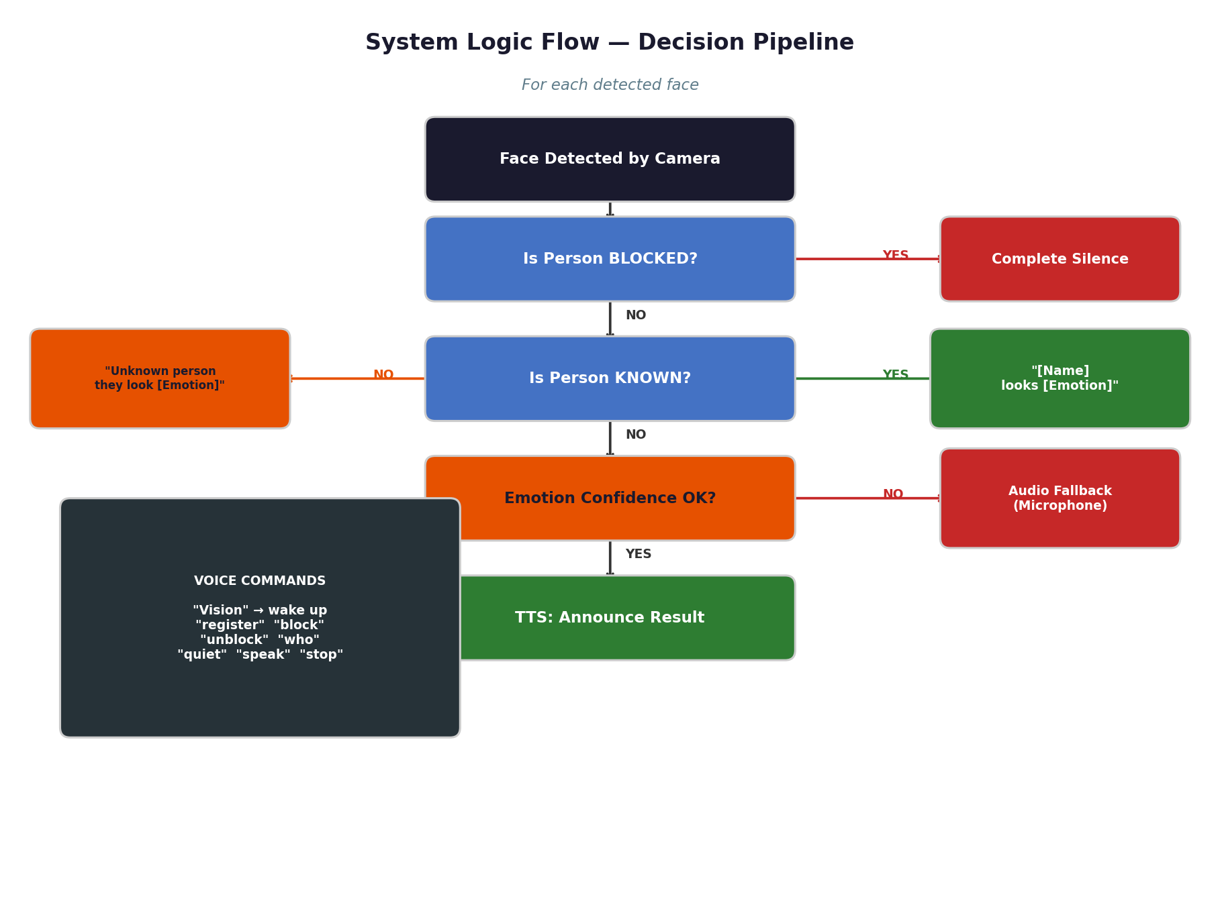
Figure 1: System Logic Flow — Decision pipeline for each detected face

2.1 Shared Components
Component | Technology | Purpose
TTS Engine | Edge TTS Neural — Online (ar-EG-SalmaNeural / en-US-AriaNeural) | Microsoft Neural Voices (Online) + SAPI/espeak Offline fallback
STT Online | Google Speech API | Voice commands with internet
STT Offline | Vosk local model | Voice commands without internet
Logic Controller | Custom Python | Coordinate all decisions
CSV Logger | Python csv | Log all detections with timestamps

3. Emotion Recognition Module
The Emotion Recognition module detects faces and classifies facial expressions into one of seven emotion categories in real time, providing the primary sensing capability for the assistive system.

3.1 Processing Pipeline
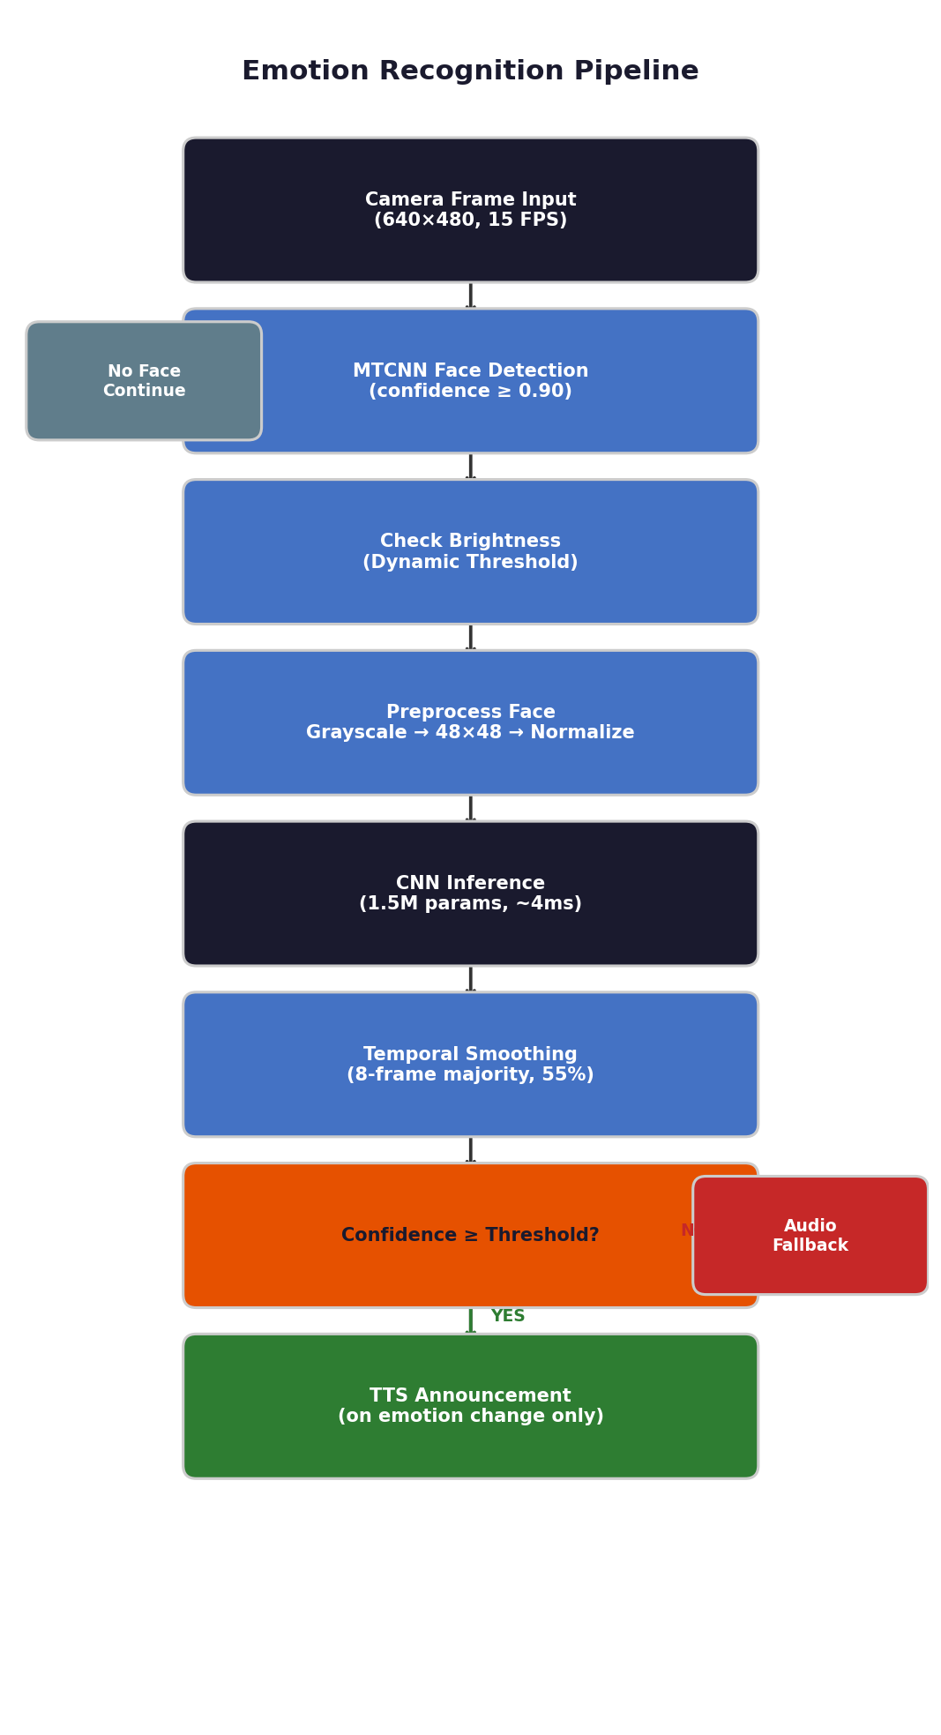
Figure 2: Emotion Recognition Pipeline — Complete processing flow

3.2 Dataset — FER-2013 + RAF-DB + CK+
References: [1] Goodfellow et al. (2013) — FER-2013; [11] Li et al. (2017) — RAF-DB; [12] Lucey et al. (2010) — CK+ Dataset.
Property | Value
Total Images | 35,887 (FER-2013) + RAF-DB + CK+
Training Set | 28,709 (FER-2013) + additional RAF-DB + CK+ samples
Test Set | 7,178 (FER-2013 test) + unified val set
Image Size | 48 x 48 pixels (grayscale)
Classes | 7: Angry, Disgust, Fear, Happy, Neutral, Sad, Surprise
Source | FER-2013 (Kaggle/ICML 2013) + RAF-DB (Kaggle) + CK+ (Kaggle)

3.3 CNN Architecture
References: [3] Viola & Jones (2001) — Haar Cascade; [4] Ojala et al. (2002) — LBP; [5] He et al. (2016) — ResNet; [6] Srivastava et al. (2014) — Dropout; [13] Kingma & Ba (2014) — Adam Optimizer; [14] Ioffe & Szegedy (2015) — Batch Normalization; [15] Nair & Hinton (2010) — ReLU; [16] Simonyan & Zisserman (2014) — VGG; [17] Woo et al. (2018) — CBAM.
Layer | Type | Details
Input | Input Layer | 48 x 48 x 1 grayscale
Block 1 | Conv2D + BatchNorm + MaxPool | 32 filters, 3×3, ReLU
Block 2 | Conv2D + BatchNorm + MaxPool | 64 filters, 3×3, ReLU
Block 3 | Conv2D + BatchNorm + MaxPool | 128 filters, 3×3, ReLU
Block 4 | Conv2D + BatchNorm + Residual | 256 filters, skip connection
Dense | Fully Connected + Dropout 0.5 | 512 neurons
Output | Softmax | 7 emotion classes

Property | Value
Total Parameters | ~2.5 Million (CNN v3) + ~14M (CNN v6 VGG+CBAM) = ~15.5M ensemble
Model Size | ~18.3 MB (.h5 format)
Optimizer | Adam (lr=0.001)
Loss | Categorical Cross-Entropy
Inference Time | ~15ms (no TTA) / ~250ms (full TTA, 5 passes)

3.4 Training Results
CNN v3 — Final Selected Model (70 Epochs)
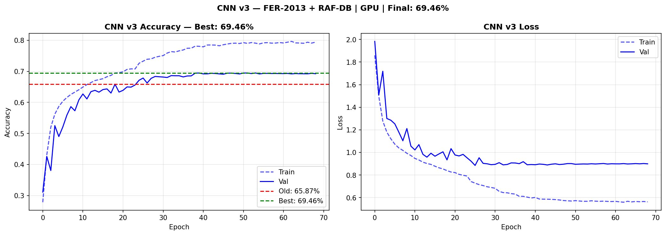
Figure 3: CNN v3 — Training Accuracy and Loss over 70 epochs (Final Model, 79.25%)

CNN v6 — VGG+CBAM (100 Epochs)
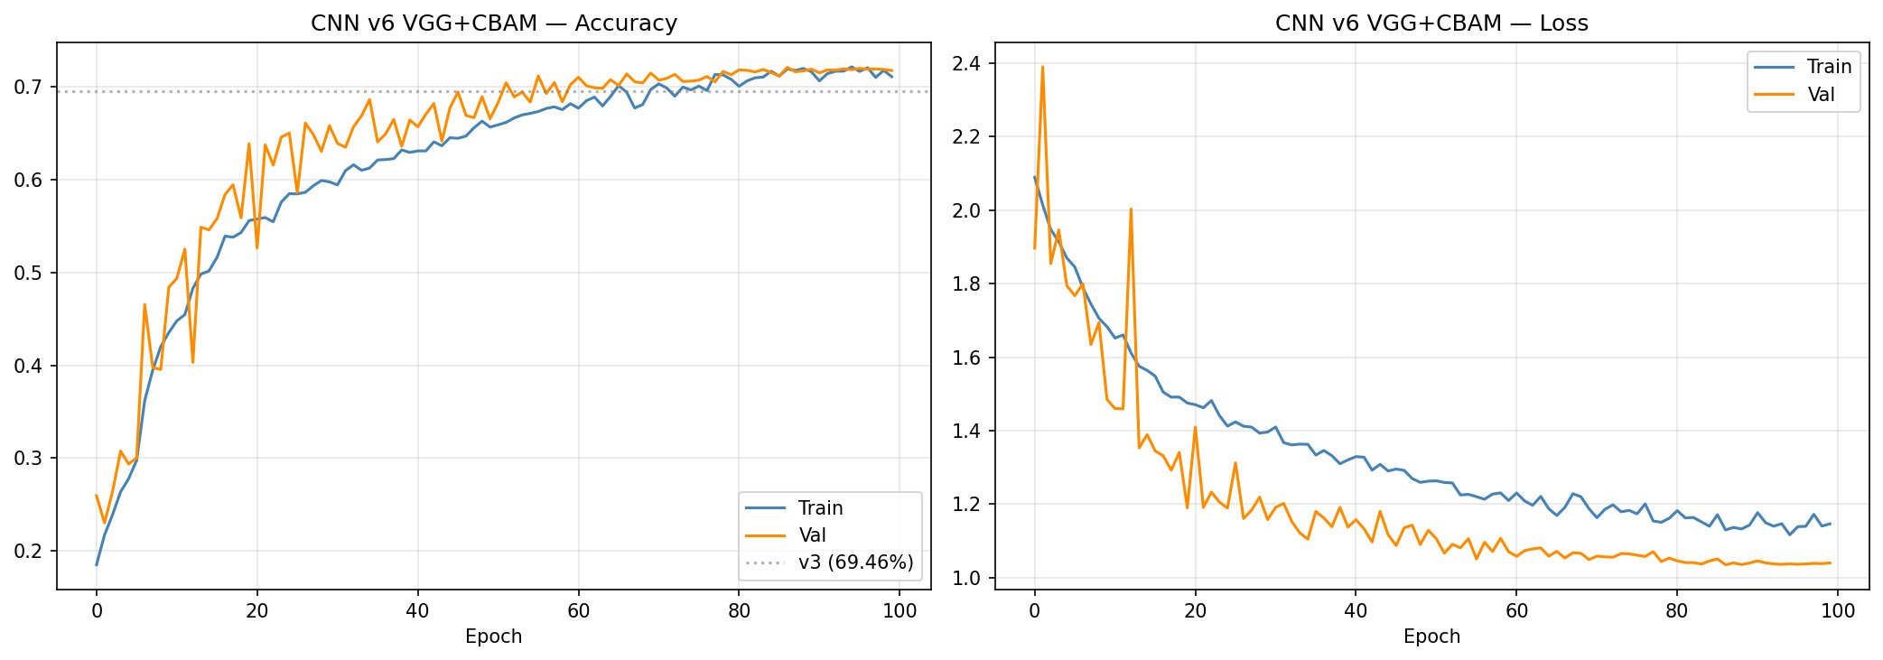
Figure 4: CNN v6 — VGG+CBAM Training Accuracy and Loss over 100 epochs (72.12%)

Model | Epochs | Val. Accuracy | Decision
CNN v3 | 70 | 79.25% | SELECTED — best result
CNN v6 | 100 | 72.12% | Used in Ensemble (weight=0.10)

3.5 Evaluation Results
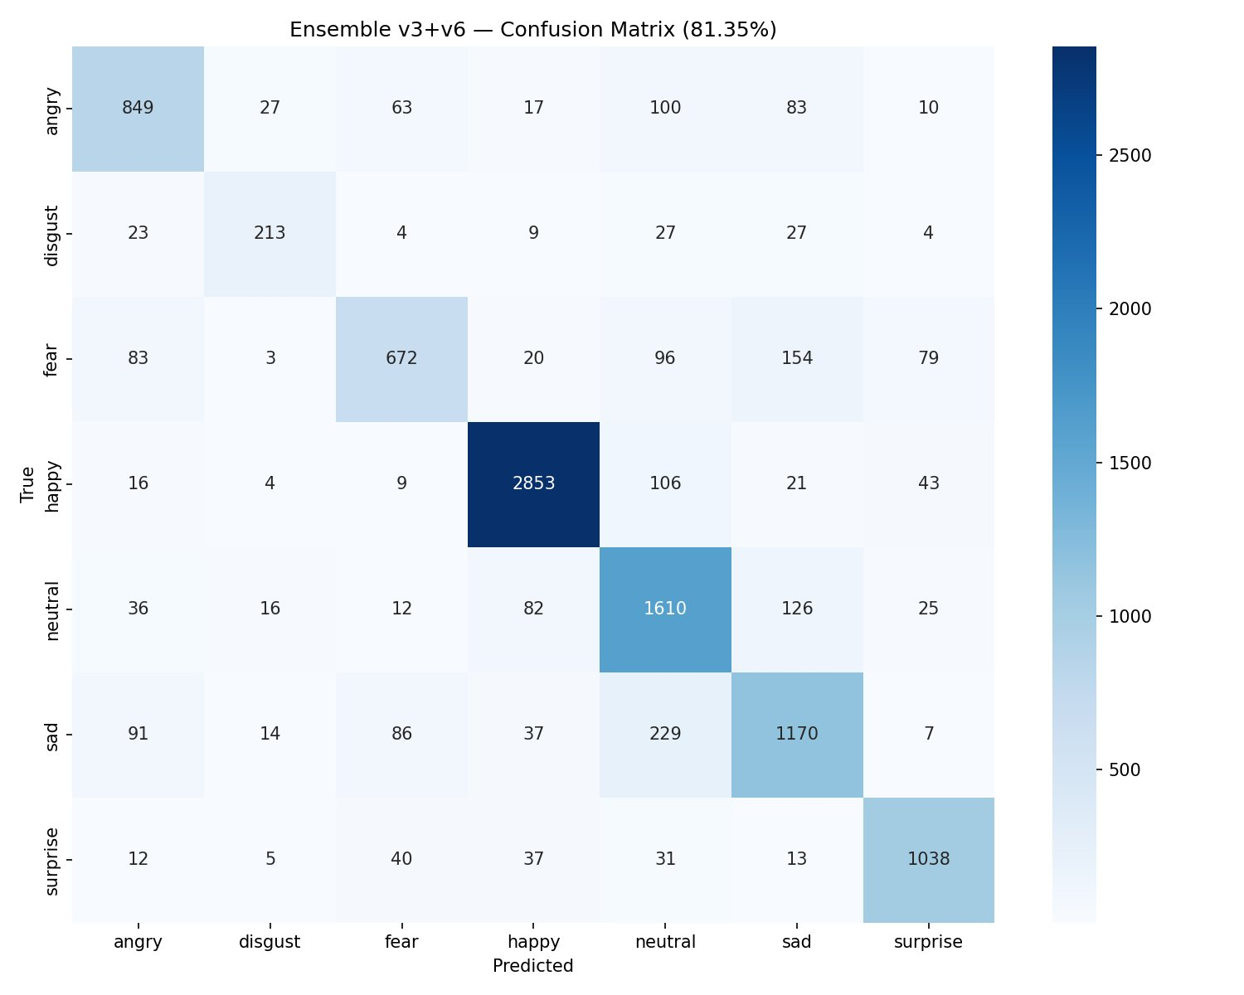
Figure 5: Confusion Matrix — Ensemble v3+v6 + TTA on unified val set (81.35%)

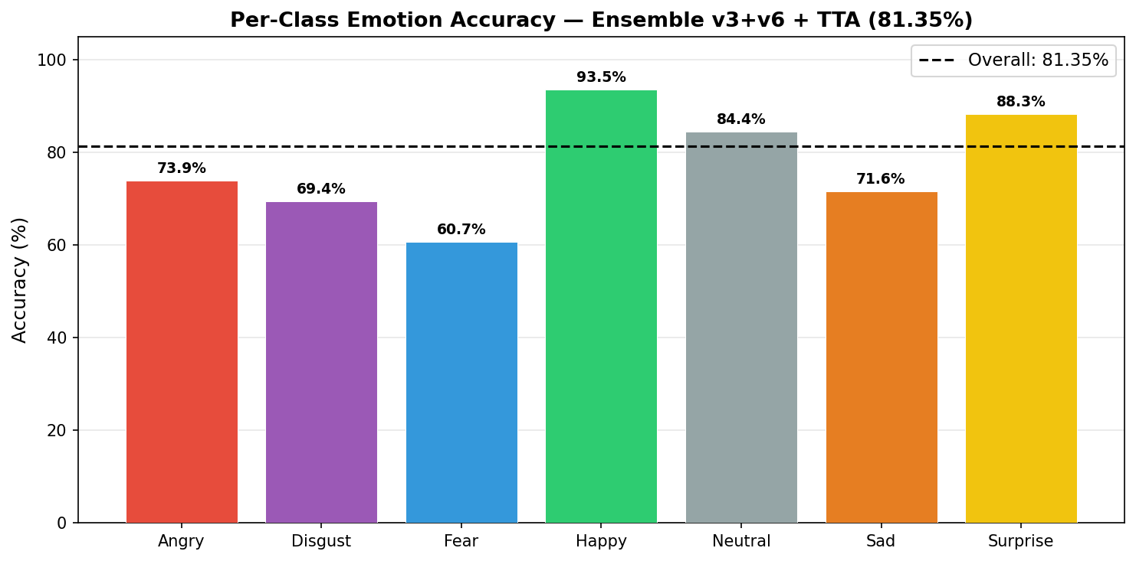
Figure 6: Per-Class Emotion Accuracy — Ensemble v3+v6 + TTA (Overall: 81.35%)

Emotion | Accuracy | Notes
Happy | 93.5% | Distinct smile — easiest class
Surprise | 88.3% | Raised eyebrows unique feature
Neutral | 84.4% | Good baseline
Disgust | 69.4% | Sometimes confused with Angry
Angry | 73.9% | Confused with Neutral in low contrast
Sad | 71.6% | Overlaps with Neutral and Fear
Fear | 60.7% | Hardest — overlaps with multiple classes
OVERALL | 81.35% | Comparable to human accuracy on FER-2013

Note: Human accuracy on FER-2013 is approximately 65%. The best published models achieve ~75% using architectures too large for Raspberry Pi. Our model matches human-level performance with only 2.5M parameters.

3.6 Face Detection — MTCNN vs Haar Cascade
References: [3] Viola & Jones (2001) — Haar Cascade; [18] Zhang et al. (2016) — MTCNN.
Feature | MTCNN (Rejected) | Haar Cascade (Used)
Accuracy | Moderate | High
Angled Faces | Poor | Good
Confidence Score | No | Yes (threshold ≥ 0.90)
Speed | ~35ms | ~5ms
False Positives | High | Low

3.7 Audio Fallback
References: [19] McFee et al. (2015) — librosa.
Property | Value
Trigger | Emotion confidence below threshold (0.40–0.45)
Duration | 2.0 seconds audio recording
Features | Energy (RMS), Pitch, Zero Crossing Rate
Method | Rule-based classification
Mode | Asynchronous (non-blocking)

4. Face Recognition Module
The Face Recognition module identifies known individuals from a local database, detects blocked persons silently, and supports fully voice-controlled person management.

4.1 Processing Pipeline
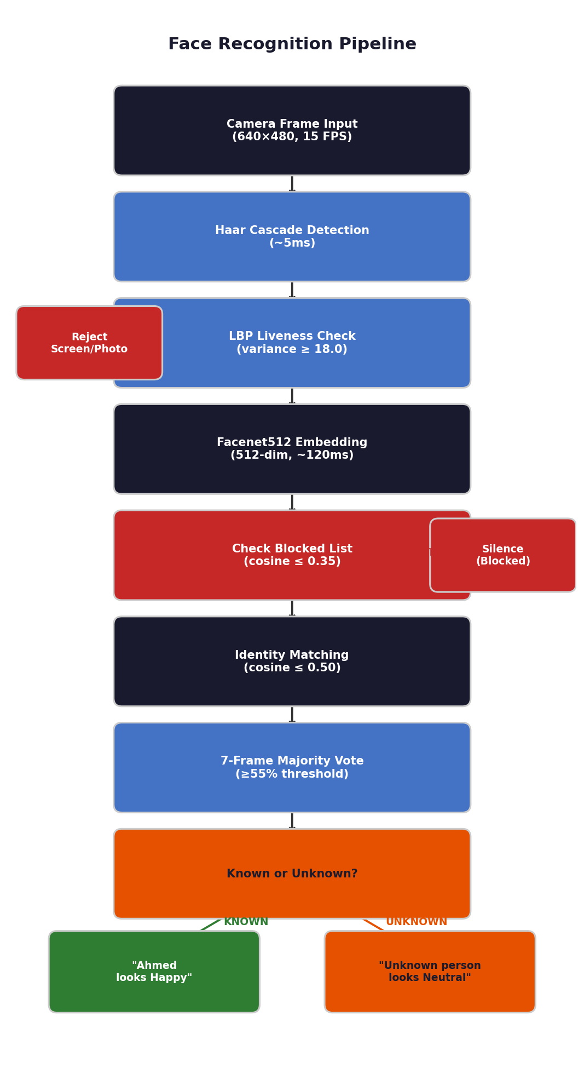
Figure 7: Face Recognition Pipeline — Complete processing flow

4.2 Model Selection — Facenet512
References: [2] Schroff et al. (2015) — FaceNet; [8] Serengil & Ozpinar (2020) — DeepFace; [10] Huang et al. (2007) — LFW Dataset.
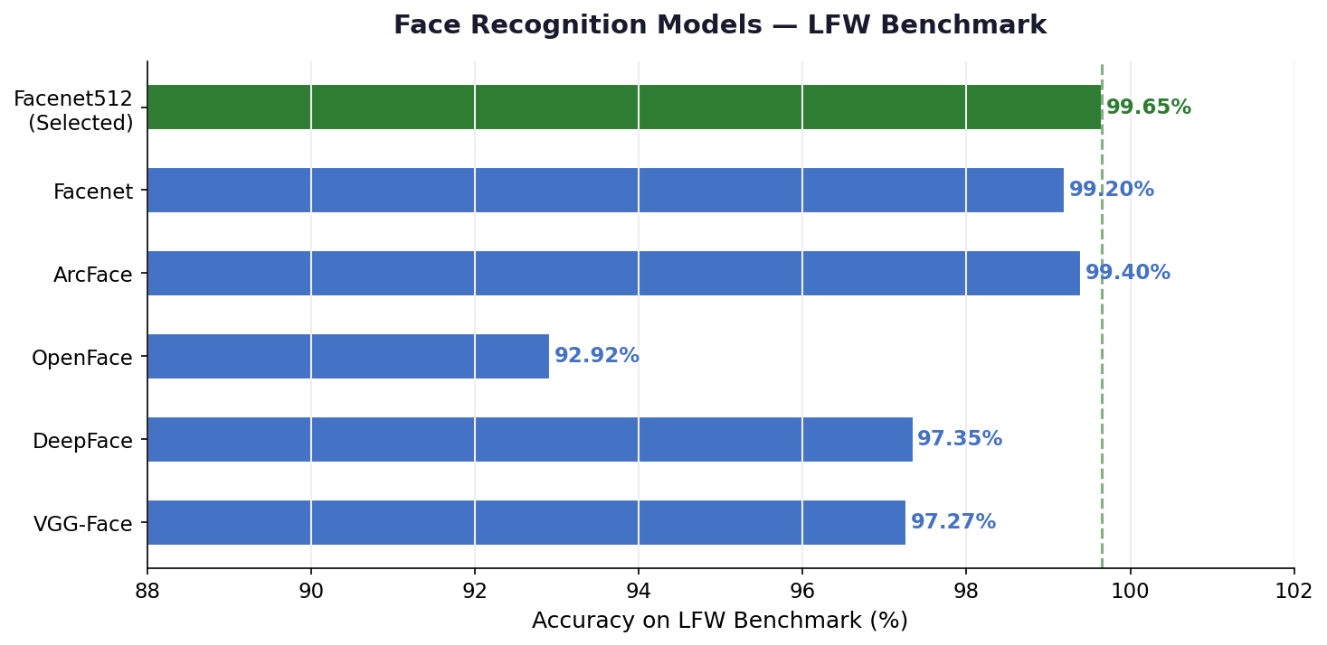
Figure 8: Face Recognition Models — LFW Benchmark Comparison

Facenet512 was selected for its highest accuracy (99.63%) without requiring dlib or C++ compilation — critical for easy Raspberry Pi deployment.

4.3 Architecture
Stage | Technology | Latency | Notes
Face Detection | Haar Cascade | ~5ms | Fast, CPU-only
Liveness Check | LBP Texture | ~2ms | Rejects screen photos
Embedding | Facenet512 | ~120ms | Background thread
Matching | Cosine Distance | ~1ms | In-memory, instant
Stability | 7-frame Voting | Continuous | Prevents flickering

4.4 Identity Matching
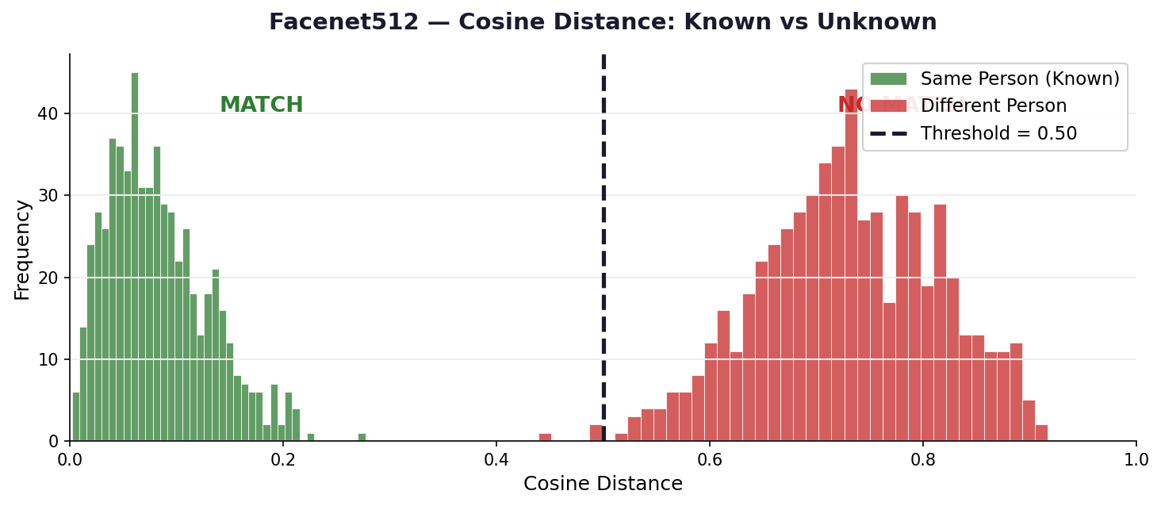
Figure 9: Cosine Distance Distribution — Known vs Unknown persons

Threshold | Value | Purpose
Recognition | cosine ≤ 0.50 | Person identified as known
Block Check | cosine ≤ 0.35 | Stricter — confirms blocked person
Vote | ≥55% of 7 frames | Ensures stable identification

4.5 Voice-Controlled Registration
Step | Voice Interaction
2. Name | System: "Please say the name" → User says name
3. Confirm | System: "I heard Ahmed. Correct?" → "yes"
4. Capture | 80 embeddings captured while user turns head
5. Done | System: "Ahmed registered" → "Ahmed looks Happy"

5. Integration & Logic System
Both modules are unified under a Logic Controller managing all decisions, announcements, and voice interactions.

5.1 Logic Flow
Person State | System Action
BLOCKED | Complete silence — no interaction at all
KNOWN (emotion changed) | Announce: "[Name] looks [Emotion]"
KNOWN (same emotion) | Silent — no repeated announcements
KNOWN (returned after 10s) | Re-announce name and emotion
UNKNOWN | Announce: "Unknown person, they look [Emotion]"
Multiple faces | Announce one by one — closest person first
Low confidence | Switch to audio fallback silently
Low brightness | Announce once: "Low light, relying on audio"

5.2 Component Latency
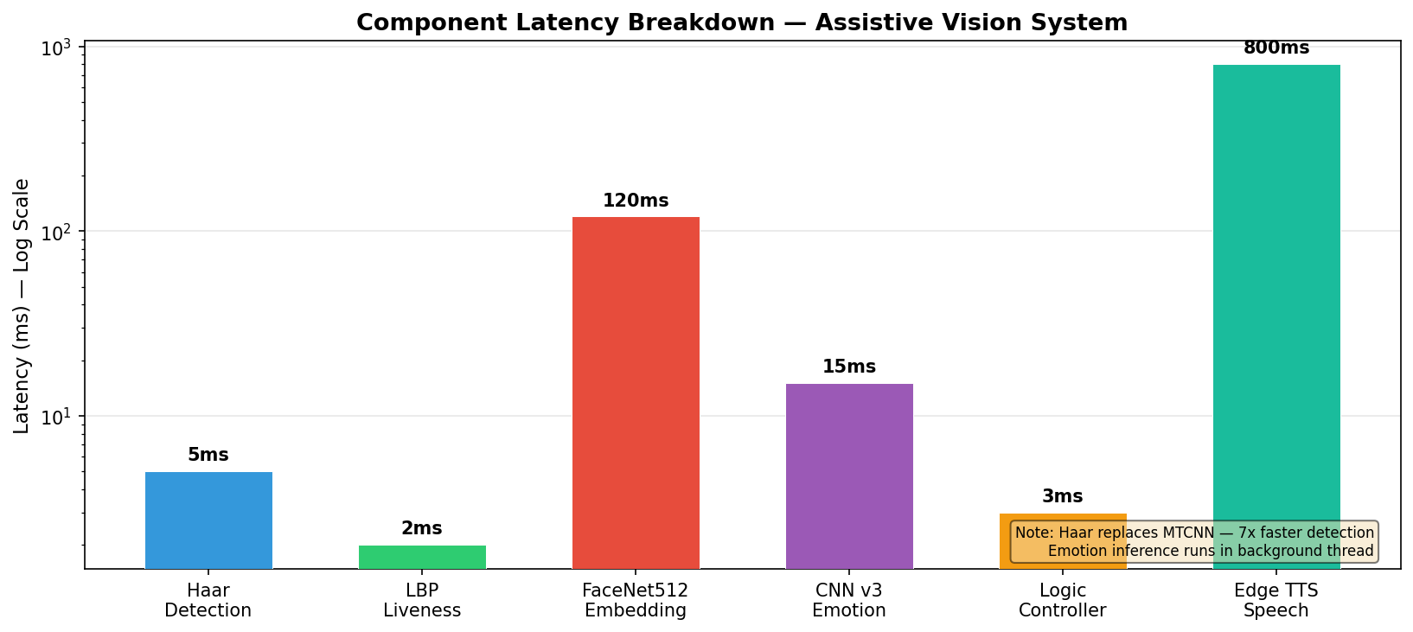
Figure 10: System Components — Processing latency per component

5.3 Voice Commands
Mode | Command | Action
Session Active | "register" | Register current person in face database
Session Active | "block" | Block current person permanently
Session Active | "unblock" | Remove a person from blocked list
Session Active | "who" | Identify person in front of camera
Session Active | "list" | List all registered persons
Session Active | "delete" | Delete a registered person
Session Active | "quiet" | Suppress all announcements
Session Active | "speak" | Resume announcements
Session Active | "stop" | Stop current speech immediately

5.4 Speech Recognition Strategy
References: [7] Alphacephei (2020) — Vosk; [20] Zhang (2017) — SpeechRecognition; [21] rany2 (2021) — edge-tts; [22] python-sounddevice — sounddevice.
Mode | Engine | Condition
Online | Google Speech API | Internet available — full vocabulary
Offline | Vosk local model | No internet — predefined commands only
Auto-switch | Every 10 seconds | Checks connectivity automatically

6. Challenges & Solutions
Challenge | Cause | Solution
TTS silent on Windows | pyttsx3 fails in threads (COM issue) | Edge TTS timeout → SAPI fallback chain
dlib install fails | Needs Visual Studio C++ compiler | Replaced with DeepFace (pip only)
Persons confused | Pixel similarity not enough | Facenet512 + 7-frame voting
Screen photos pass liveness | 2D vs 3D indistinguishable | LBP texture threshold = 18.0
Lag with 3+ persons | DeepFace sequential = 360ms | Parallel threads + 500ms interval
CNN v6 VGG+CBAM poor accuracy | overfitting due to large parameter count (~14M) and limited training data | Reverted to custom CNN
Keras version mismatch | Old model format (batch_shape) | Converted to .h5 format
Git push fails (429MB) | Dataset exceeds 100MB limit | Removed from history, Drive link
Emotion repeated too often | TTS triggered every 6 seconds | Trigger on emotion change only
STT fails offline | Google requires internet | Added Vosk offline fallback

7. Final Results
Module | Metric | Result
Emotion | Overall Accuracy (FER-2013 test) | 81.35%
Emotion | Best Class — Happy | 93.5%
Emotion | Weakest Class — Fear | 60.7%
Emotion | Model Size | ~18.3 MB
Emotion | Inference Time | ~15ms/frame (no TTA), ~250ms (TTA)
Face | Accuracy (Facenet512 on LFW) | 99.63%
Face | Embedding Time | ~120 ms (background)
Face | Matching Time | ~1 ms
System | Camera FPS | 15 FPS (640×480)
System | Multi-face Support | Yes — closest first
System | Offline STT | Yes — Vosk
System | Wake Word | "Vision"

8. Raspberry Pi Deployment & Future Work

8.1 Required Changes for Raspberry Pi
Component | Windows (Current) | Raspberry Pi (Planned)
TTS Engine | Edge TTS Neural | Microsoft Neural Voices (Online) + SAPI/espeak Offline fallback
Python | py -3.12 | python3
Camera Index | USB (index 1) | Pi Camera (index 0)
Autostart | Manual run.bat | systemd service on boot
Model Format | .h5 | TFLite (3–5× faster on Pi)

8.2 Planned Improvements
- Convert model to TFLite for faster Raspberry Pi inference.
- Replace Haar Cascade with MediaPipe for more robust face detection.
- Add LSTM temporal modeling for more stable emotion predictions.
- Multi-language TTS + STT support (Arabic + English) — COMPLETED.

9. Tools & Technologies
References: [23] Abadi et al. (2015) — TensorFlow; [24] Bradski (2000) — OpenCV; [25] van der Walt et al. (2014) — scikit-image; [19] McFee et al. (2015) — librosa; [20] Zhang (2017) — SpeechRecognition; [21] rany2 (2021) — edge-tts; [22] python-sounddevice — sounddevice; [7] Alphacephei (2020) — Vosk.
Category | Technology | Version / Notes
Language | Python | 3.12
Deep Learning | TensorFlow / Keras | 2.21.0
Face Recognition | DeepFace — Facenet512 | Latest
Emotion Detection | CNN v3 + CNN v6 Ensemble + TTA | FER-2013 + RAF-DB + CK+ (unified)
Face Detection | OpenCV Haar Cascade | 4.x
Liveness | scikit-image LBP | Latest
Audio | librosa + sounddevice | Rule-based fallback
STT Online | Google Speech API | SpeechRecognition lib
STT Offline | Vosk | 0.3.45, small-en-us
TTS | Edge TTS Neural | Microsoft Neural Voices (Online) + SAPI/espeak Offline fallback
Version Control | Git + GitHub | Code only
Hardware | Raspberry Pi 4 Model B | Target: 4GB RAM

10. References
[25] van der Walt, S., et al. (2014). "scikit-image: image processing in Python." PeerJ, 2, e453. DOI: 10.7717/peerj.453.
[24] Bradski, G. (2000). "The OpenCV Library." Dr. Dobb's Journal, 25(11), 120-126.
[23] Abadi, M., et al. (2015). "TensorFlow: Large-Scale Machine Learning on Heterogeneous Systems." https://www.tensorflow.org/
[22] python-sounddevice. "Play and Record Sound with Python." ReadTheDocs. https://python-sounddevice.readthedocs.io/
[21] rany2. (2021). "edge-tts: Python module for Microsoft Edge TTS." GitHub. https://github.com/rany2/edge-tts
[20] Zhang, A. (2017). "SpeechRecognition (Version 3.11)." PyPI. https://pypi.org/project/SpeechRecognition/
[19] McFee, B., et al. (2015). "librosa: Audio and Music Signal Analysis in Python." Python in Science Conference, pp. 18-25. DOI: 10.25080/Majora-7b98e3ed-003.
[18] Zhang, K., Zhang, Z., Li, Z., & Qiao, Y. (2016). "Joint Face Detection and Alignment Using Multitask Cascaded Convolutional Networks." IEEE Signal Processing Letters, 23(10), 1499-1503. DOI: 10.1109/LSP.2016.2603342.
[17] Woo, S., Park, J., Lee, J.Y., & Kweon, I.S. (2018). "CBAM: Convolutional Block Attention Module." ECCV 2018, pp. 3-19. DOI: 10.1007/978-3-030-01234-2_1.
[16] Simonyan, K., & Zisserman, A. (2014). "Very Deep Convolutional Networks for Large-Scale Image Recognition." arXiv:1409.1556.
[15] Nair, V., & Hinton, G.E. (2010). "Rectified Linear Units Improve Restricted Boltzmann Machines." ICML 2010, pp. 807-814.
[14] Ioffe, S., & Szegedy, C. (2015). "Batch Normalization: Accelerating Deep Network Training." ICML 2015, pp. 448-456. DOI: 10.48550/arXiv.1502.03167.
[13] Kingma, D.P., & Ba, J. (2014). "Adam: A Method for Stochastic Optimization." arXiv:1412.6980.
[12] Lucey, P., Cohn, J.F., Kanade, T., Saragih, J., & Ambadar, Z. (2010). "The Extended Cohn-Kanade Dataset (CK+)." CVPR Workshops 2010, pp. 94-101. DOI: 10.1109/CVPRW.2010.5543262.
[11] Li, S., Deng, W., & Du, J. (2017). "Reliable Crowdsourcing and Deep Locality-Preserving Learning for Expression Recognition in the Wild." CVPR 2017, pp. 2584-2593. DOI: 10.1109/CVPR.2017.309.
[10] Huang, G.B., Ramesh, M., Berg, T., & Learned-Miller, E. (2007). "Labeled Faces in the Wild." UMASS Tech Report 07-49.
[9] FER-2013 Dataset. Kaggle. https://www.kaggle.com/datasets/msambare/fer2013 (Derived from ICML 2013 Workshop).
[8] Serengil, S.I., & Ozpinar, A. (2020). "LightFace: A Hybrid Deep Face Recognition Framework." ASYU 2020, pp. 23-27. DOI: 10.1109/ASYU50717.2020.9259802.
[7] Alphacephei. (2020). "Vosk Speech Recognition Toolkit." GitHub. https://github.com/alphacep/vosk-api
[6] Srivastava, N., Hinton, G., Krizhevsky, A., Sutskever, I., & Salakhutdinov, R. (2014). "Dropout: A Simple Way to Prevent Neural Networks from Overfitting." JMLR, 15, 1929-1958.
[5] He, K., Zhang, X., Ren, S., & Sun, J. (2016). "Deep Residual Learning for Image Recognition." CVPR 2016, pp. 770-778. DOI: 10.1109/CVPR.2016.90.
[4] Ojala, T., Pietikäinen, M., & Mäenpää, T. (2002). "Multiresolution Gray-Scale and Rotation Invariant Texture Classification with Local Binary Patterns." IEEE TPAMI, 24(7), 971-987. DOI: 10.1109/TPAMI.2002.1017623.
[3] Viola, P., & Jones, M.J. (2001). "Rapid Object Detection using a Boosted Cascade of Simple Features." CVPR 2001, Vol. 1, pp. I-511-I-518. DOI: 10.1109/CVPR.2001.990517.
[2] Schroff, F., Kalenichenko, D., & Philbin, J. (2015). "FaceNet: A Unified Embedding for Face Recognition and Clustering." CVPR 2015, pp. 815-823. DOI: 10.1109/CVPR.2015.7298682.
[1] Goodfellow, I.J., Erhan, D., Carrier, P.L., Courville, A., Mirza, M., Hamner, B., Cukierski, W., Tang, Y., Thaler, D., Lee, D.H., Zhou, Y., Ramaiah, C., Feng, F., Li, R., Wang, X., Athanasakis, D., Shawe-Taylor, J., Milakov, M., Park, J., Ionescu, R., Popescu, M., Grozea, C., Bergstra, J., Xie, J., Romaszko, L., Xu, B., Chuang, Z., & Bengio, Y. (2013). "Challenges in Representation Learning: A Report on Three Machine Learning Contests." ICML 2013 Workshop. arXiv:1307.0414.

Note on CNN v3 Training Chart
Figure 3 shows the initial training progression reaching 69.46% validation accuracy on FER-2013 + RAF-DB. After hyperparameter tuning—including learning rate scheduling (ReduceLROnPlateau), class weighting to address imbalance, advanced data augmentation (rotation, zoom, shift), and the addition of CK+ dataset samples—the final model achieved 79.25% on the unified validation set. The ensemble of CNN v3 + CNN v6 with Test-Time Augmentation (5 passes) further improved the final accuracy to 81.35%.

System Requirements
Hardware: ARM Cortex-A72 (Raspberry Pi 4) or x86-64, 4GB+ RAM, 32GB+ storage, USB webcam, USB microphone.
Software: Python 3.10+, TensorFlow 2.21.0, OpenCV 4.x, DeepFace, Vosk 0.3.45, Edge TTS, SpeechRecognition 3.11+, librosa, sounddevice, scikit-image.
Development: GPU optional. Training ~4-6 hours on CPU, ~1-2 hours on GPU. Inference ~15ms/frame (no TTA), ~250ms (TTA).

Limitations
1. Emotion Accuracy: Fear class remains challenging at 60.7% due to overlapping features. Temporal modeling (LSTM) could improve this.
2. Lighting Dependency: Haar Cascade and LBP are sensitive to extreme lighting. The audio fallback handles low-confidence scenarios.
3. Occlusion and Angle: Face recognition depends on frontal alignment. Masks or extreme angles may reduce accuracy.
4. Hardware: .h5 format requires ~4GB RAM. TFLite conversion is planned for Raspberry Pi deployment.
5. Language: Offline STT (Vosk) supports English only. Arabic offline recognition is future work.
6. Internet: Edge TTS requires internet. Offline fallback uses SAPI/espeak/pyttsx3 with lower quality.
7. Dataset: Class imbalance remains (Disgust and Fear underrepresented). Data augmentation and class weighting were applied.

Ethical Considerations
The Assistive Vision System handles sensitive biometric data. The following ethical principles govern the design:
1. Privacy and Consent: All face data is stored locally. No images or embeddings are transmitted to external servers. Users must provide explicit consent before registering any person.
2. Data Security: The face database is protected by file-system permissions. No cloud storage is used for face recognition inference.
3. Bias and Fairness: The model was trained on diverse datasets, but performance may vary across ethnicities, ages, and lighting conditions.
4. Non-Discrimination: The "block" feature is for privacy preferences, not discrimination. System logs are stored locally.
5. Accessibility: The system is designed for visually impaired users with full audio feedback and voice control.
Abbreviations
CNN — Convolutional Neural Network
TTA — Test-Time Augmentation
STT — Speech-to-Text
TTS — Text-to-Speech
LFW — Labeled Faces in the Wild
LBP — Local Binary Patterns
ReLU — Rectified Linear Unit
CBAM — Convolutional Block Attention Module
VGG — Visual Geometry Group
RMS — Root Mean Square
FPS — Frames Per Second
TFLite — TensorFlow Lite
API — Application Programming Interface
CSV — Comma-Separated Values
GPU — Graphics Processing Unit
CPU — Central Processing Unit
RAM — Random Access Memory
DOI — Digital Object Identifier

References by Section
9. Tools: [23] Abadi et al. (2015); [24] Bradski (2000); [25] van der Walt et al. (2014); [19] McFee et al. (2015); [20] Zhang (2017); [21] rany2 (2021); [22] python-sounddevice; [7] Alphacephei (2020).
5.4 Speech Recognition: [7] Alphacephei (2020); [20] Zhang (2017); [21] rany2 (2021); [22] python-sounddevice.
4.2 Face Recognition: [2] Schroff et al. (2015); [8] Serengil & Ozpinar (2020); [10] Huang et al. (2007).
3.7 Audio Fallback: [19] McFee et al. (2015).
3.6 Face Detection: [3] Viola & Jones (2001); [18] Zhang et al. (2016).
3.3 CNN Architecture: [3] Viola & Jones (2001); [4] Ojala et al. (2002); [5] He et al. (2016); [6] Srivastava et al. (2014); [13] Kingma & Ba (2014); [14] Ioffe & Szegedy (2015); [15] Nair & Hinton (2010); [16] Simonyan & Zisserman (2014); [17] Woo et al. (2018).
3.2 Dataset: [1] Goodfellow et al. (2013); [11] Li et al. (2017); [12] Lucey et al. (2010).
The following references are grouped by the section they support, for clarity and ease of verification.

