





Student Name | Student ID
Jood Usamah Ahmed Moafa | 202413360
Juri Sahli | 202414312
Raghad Saree Mhnashy | 202413388
Arjwan Mohammed Mahnashy | 202413473

1. Introduction
"World of Flavors" is more than just a recipe-sharing website; it's a comprehensive, intelligent system that revolutionizes how we discover and experience recipes. The project offers an innovative solution to one of the biggest challenges facing cooking enthusiasts: "What should I cook today with the ingredients I have?"
This is where the idea for the smart recipe finder comes in. It's the key feature that distinguishes our project and makes it unique – an advanced, intelligent system that changes how users interact with food content. Instead of traditional keyword searches, our system provides a smart solution that reflects the practical realities of the kitchen.
This feature allows users to input the ingredients they have, and then the system searches for recipes that match those ingredients and displays them to the user.
"World of Flavors" is more than just a website – it's a smart assistant in your kitchen, a friend that understands what you have and suggests what you can prepare, and a platform that brings food lovers together in a creative, interactive digital space.

2. Project Objectives
The "World of Flavors" project aims to design and develop an intelligent online platform that helps users discover food recipes in a practical and efficient way by relying on the ingredients they already have. The project focuses on solving a common problem many people face in their daily lives: the difficulty of choosing a suitable recipe based on what is available in the kitchen.
The primary goal of the project is to provide a smart recipe search system that allows users to enter the ingredients they own. The system then analyzes these ingredients, matches them with a recipe database, and displays recipes that fit these inputs accurately and easily. In this way, the project moves beyond the traditional search method based on recipe names or keywords and shifts toward a more realistic approach that considers users’ actual needs.
The project also aims to:
- Save users time and effort when choosing appropriate recipes.
- Reduce food waste by making optimal use of available ingredients.
- Encourage users to try new recipes in creative ways.
- Create an interactive user experience that combines technology and cooking in an easy-to-use digital environment.
Overall, the "World of Flavors" project seeks to be a smart kitchen assistant that connects available ingredients with creative cooking ideas, offering a practical solution that enhances the user experience and adds real value to everyday life.
3. Technologies Used for Implementation
Layer | Technology
Frontend | HTML5, CSS3, JavaScript
Backend | PHP
Database | MySQL
Web Server | XAMPP (Apache & MySQL)
Library | Bootstrap 5
These technologies work together to provide a responsive interface and reliable backend functionality.

4. Project Structure
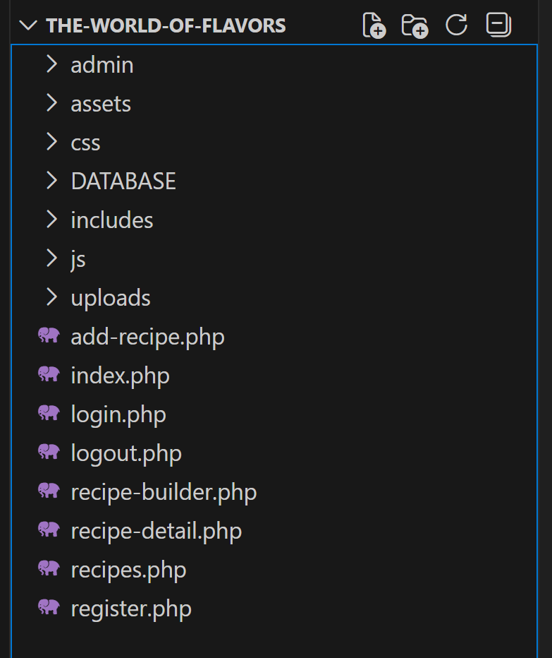
-Folders and files:
- admin: it contains administration pages.
- assets: It contains images,fonts and jquery.
- css: It contains CSS files.
- DATABASE: It contains database file.
- Includes: It contains config.php, footer.php
and header.php
- js: It contains javascript files
- uploads: It contains images that are uploaded
via the website.
- and websites pages: add-recipe.php,index.php,
login.php,logout.php,recipe-builder.php,
recipe-details.php,recipes.php,register.php.

5. Project Setup
This section explains how to install, configure, and run the project on a local or hosted server.
5.1 Requirements
- PHP 7.0 or higher
- MySQL
- Apache server (XAMPP)
- A web browser
5.2 Installation Steps
1- Download or extract the project files
Extract all files of The World of Flavors into your server directory:
- htdocs/ for XAMPP
2- Create the database
- Open phpMyAdmin (open your browser and go to http://localhost/phpmyadmin)
- Create a database named: cooking_project
3- Import the SQL file
- Import the file: cooking_project.sql
4- Run the project
- Open your browser and visit: (http://localhost/ The-world-of-flavors/index.php)

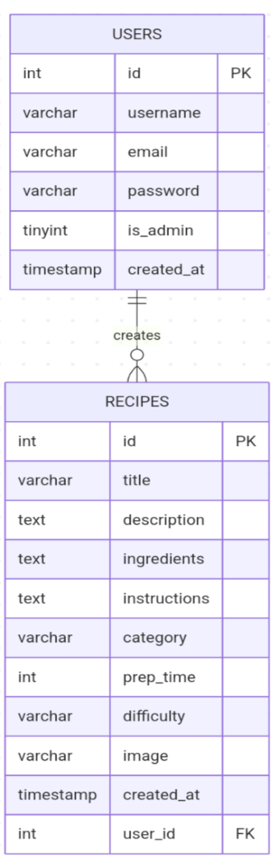
6. Database Schema
The project uses a MySQL database named cooking_project, containing two main tables: "users" and "recipes".
6.1 ERD Overview

6.2 Tables Description
- users
Column | Type | Description
id | INT(PK) | Unique user ID
username | VARCHAR | User’s name
email | VARCHAR | User’s email (Unique)
password | VARCHAR | Hashed password
is_admin | TINYINT | 1=admin, 0=user
Created_at | TIMESTAMP | Registration date

- recipes
Column | Type | Description
id | INT(PK) | Unique recipe ID
title | VARCHAR | Recipe title
description | TEXT | Short summary
ingredients | TEXT | List of ingredients
instructions | TEXT | Steps to prepare the dish
category | VARCHAR | Type/category of the recipe
prep_time | INT | Preparation time in minutes
difficulty | VARCHAR | Easy / Medium / Hard
Image | VARCHAR | Image filename stored in uploads/
created_at | TIMESTAMP | Date of recipe creation
user_id | INT(FK) | ID of the user who created the recipe

7. Usage Instructions
This section explains how to use the project as a regular user and as an administrator.
7.1 Using the Website
1- Three .php files are added to all pages using "require_once", as follows:
  - config.php: It contains the database connection code and validation functions.
CODE:
<?php
session_start();

$host = 'localhost';
$dbname = 'cooking_project';
$username = 'root';
$password = '';

try {
$pdo = new PDO("mysql:host=$host;dbname=$dbname;charset=utf8mb4", $username, $password);
$pdo->setAttribute(PDO::ATTR_ERRMODE, PDO::ERRMODE_EXCEPTION);
} catch(PDOException $e) {
die("فشل الاتصال بقاعدة البيانات: " . $e->getMessage());
}

function clean_input($data) {
$data = trim($data);
$data = stripslashes($data);
$data = htmlspecialchars($data);
return $data;
}

function is_logged_in() {
return isset($_SESSION['user_id']) && !empty($_SESSION['user_id']);
}

function is_admin() {
return isset($_SESSION['user_role']) && $_SESSION['user_role'] === 'admin';
}

function show_message($type, $message) {
$bg_color = $type == 'success' ? '#d4edda' : '#f8d7da';
$text_color = $type == 'success' ? '#155724' : '#721c24';
$border_color = $type == 'success' ? '#c3e6cb' : '#f5c6cb';

return '<div style="padding: 15px; background: ' . $bg_color . '; color: ' . $text_color . ';
border: 1px solid ' . $border_color . '; border-radius: 5px; margin-bottom: 20px;font-family: \'Tajawal\',sans-serif;">
' . $message . '
</div>';
}
?>
  - header.php: It includes the website name and logo, and page links to enable user navigation.

CODE:
<!DOCTYPE html>
<html>
<head>
<meta charset="utf-8">
<meta http-equiv="X-UA-Compatible" content="IE=edge">
<title><?php echo isset($page_title) ? $page_title . ' - موقع الوصفات' : 'موقع عالم النكهات'; ?></title>
<meta name="description" content="">
<meta name="viewport" content="width=device-width, initial-scale=1">
<link rel="preconnect" href="https://fonts.gstatic.com">
<link href="https://fonts.googleapis.com/css2?family=Roboto+Mono:wght@700&display=swap" rel="stylesheet">
<link rel = "stylesheet" href = "assets/font-awesome/all.css">
<link rel="stylesheet" href="css/style.css">
</head>
<body>

<header>

<!-- navbar -->
<nav class = "navbar">
<div class = "container">
<div class = "brand-and-toggler">
<a href = "index.php" class = "navbar-brand">
<img src = "assets/images/logo-png.png" alt = "logo">
<h2 style="font-family: 'Tajawal',sans-serif;">عالم النكهات</h2>
</a>
<button type = "button" id = "navbar-toggler">
<i class = "fas fa-bars"></i>
</button>
</div>
<div class = "navbar-collapse">
<ul class = "navbar-nav">
<li>
<a href = "index.php" style="font-family: 'Tajawal',sans-serif;">الرئيسية</a>
</li>
<li>
<a href = "recipes.php" style="font-family: 'Tajawal',sans-serif;">جميع الوصفات</a>
</li>
<li>
<a href = "recipe-builder.php" style="font-family: 'Tajawal',sans-serif;">البحث الذكي</a>
</li>
<li>
<a href = "add-recipe.php" style="font-family: 'Tajawal',sans-serif;">اضافة وصفة</a>
</li>
<?php if(is_logged_in() && is_admin()): ?>
<li>
<a href = "admin/dashboard.php" style="font-family: 'Tajawal',sans-serif;">لوحة التحكم</a>
</li>
<?php endif; ?>
<?php if(is_logged_in()): ?>
<li>
<a href="#" style="font-family: 'Tajawal',sans-serif; color: #ff6b6b;">
<i class="fas fa-user"></i> <?php echo $_SESSION['username']; ?>
</a>
</li>
<li>
<a href="logout.php" style="font-family: 'Tajawal',sans-serif;">
<i class="fas fa-sign-out-alt"></i> خروج
</a>
</li>
<?php else: ?>
<li>
<a href="login.php" style="font-family: 'Tajawal',sans-serif;">تسجيل دخول</a>
</li>
<li>
<a href="register.php" style="font-family: 'Tajawal',sans-serif;">تسجيل</a>
</li>
<?php endif; ?>

</ul>
</div>
</div>
</nav>
</header>

  - footer.php: It contains contact information and short links to food categories.
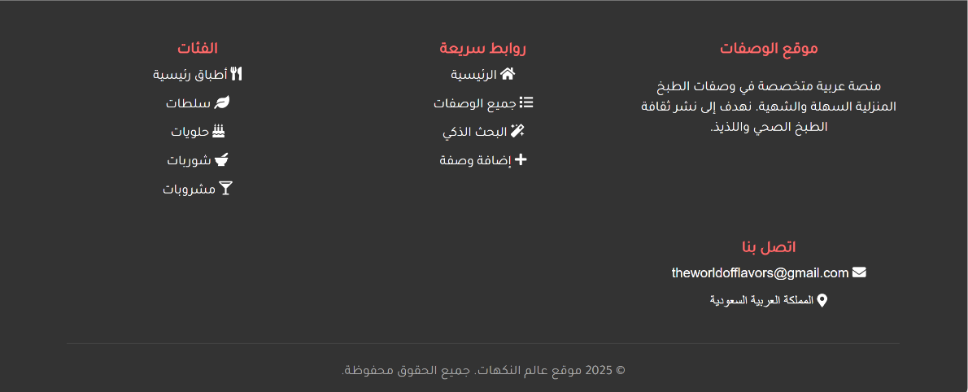

CODE:
<footer style="background: #333;color: white;padding: 40px 0 20px;margin-top: 60px;">
<div class="container">
<div class="footer-content" style="display: grid;grid-template-columns: repeat(auto-fit, minmax(250px, 1fr));gap: 30px;margin-bottom: 30px;">
<div class="footer-section">
<h3 style="margin-bottom: 15px;color: #ff6b6b;font-family: 'Tajawal',sans-serif;">موقع الوصفات</h3>
<p style="font-family: 'Tajawal',sans-serif;">منصة عربية متخصصة في وصفات الطبخ المنزلية السهلة والشهية. نهدف إلى نشر ثقافة الطبخ الصحي واللذيذ.</p>
</div>

<div class="footer-section">
<h3 style="color: #ff6b6b;font-family: 'Tajawal',sans-serif;">روابط سريعة</h3>
<ul style="list-style: none;">
<li style="margin-bottom: 10px;"><a href="index.php" style="color: white;text-decoration: none;transition: color 0.3s;font-family: 'Tajawal',sans-serif;"><i class="fas fa-home"></i> الرئيسية</a></li>
<li style="margin-bottom: 10px;"><a href="recipes.php" style="color: white;text-decoration: none;transition: color 0.3s;font-family: 'Tajawal',sans-serif;"><i class="fas fa-list"></i> جميع الوصفات</a></li>
<li style="margin-bottom: 10px;"><a href="recipe-builder.php" style="color: white;text-decoration: none;transition: color 0.3s;font-family: 'Tajawal',sans-serif;"><i class="fas fa-magic"></i> البحث الذكي</a></li>
<li style="margin-bottom: 10px;"><a href="add-recipe.php" style="color: white;text-decoration: none;transition: color 0.3s;font-family: 'Tajawal',sans-serif;"><i class="fas fa-plus"></i> إضافة وصفة</a></li>
</ul>
</div>

<div class="footer-section">
<h3 style="color: #ff6b6b;font-family: 'Tajawal',sans-serif;">الفئات</h3>
<ul>
<li style="margin-bottom: 10px;"><a href="recipes.php?category=أطباق رئيسية" style="color: white;text-decoration: none;transition: color 0.3s;font-family: 'Tajawal',sans-serif;"><i class="fas fa-utensils"></i> أطباق رئيسية</a></li>
<li style="margin-bottom: 10px;"><a href="recipes.php?category=سلطات" style="color: white;text-decoration: none;transition: color 0.3s;font-family: 'Tajawal',sans-serif;"><i class="fas fa-leaf"></i> سلطات</a></li>
<li style="margin-bottom: 10px;"><a href="recipes.php?category=حلويات" style="color: white;text-decoration: none;transition: color 0.3s;font-family: 'Tajawal',sans-serif;"><i class="fas fa-birthday-cake"></i> حلويات</a></li>
<li style="margin-bottom: 10px;"><a href="recipes.php?category=شوربات" style="color: white;text-decoration: none;transition: color 0.3s;font-family: 'Tajawal',sans-serif;"><i class="fas fa-mortar-pestle"></i> شوربات</a></li>
<li style="margin-bottom: 10px;"><a href="recipes.php?category=مشروبات" style="color: white;text-decoration: none;transition: color 0.3s;font-family: 'Tajawal',sans-serif;"><i class="fas fa-glass-martini-alt"></i> مشروبات</a></li>
</ul>
</div>

<div class="footer-section">
<h3 style="color: #ff6b6b;font-family: 'Tajawal',sans-serif;">اتصل بنا</h3>
<ul>
<li style="margin-bottom: 10px;"><i class="fas fa-envelope"></i> theworldofflavors@gmail.com</li>
<li style="margin-bottom: 10px;"><i class="fas fa-map-marker-alt"></i> المملكة العربية السعودية</li>
</ul>
</div>
</div>

<div class="copyright" style="text-align: center;padding-top: 20px;border-top: 1px solid #444;color: #aaa;">
<p style="font-family: 'Tajawal',sans-serif;">© <?php echo date('Y'); ?> موقع عالم النكهات. جميع الحقوق محفوظة.</p>
</div>
</div>
</footer>

</body>
</html>

- Home Page (index)
At the beginning of the page, three famous quotes about food are displayed one after the other

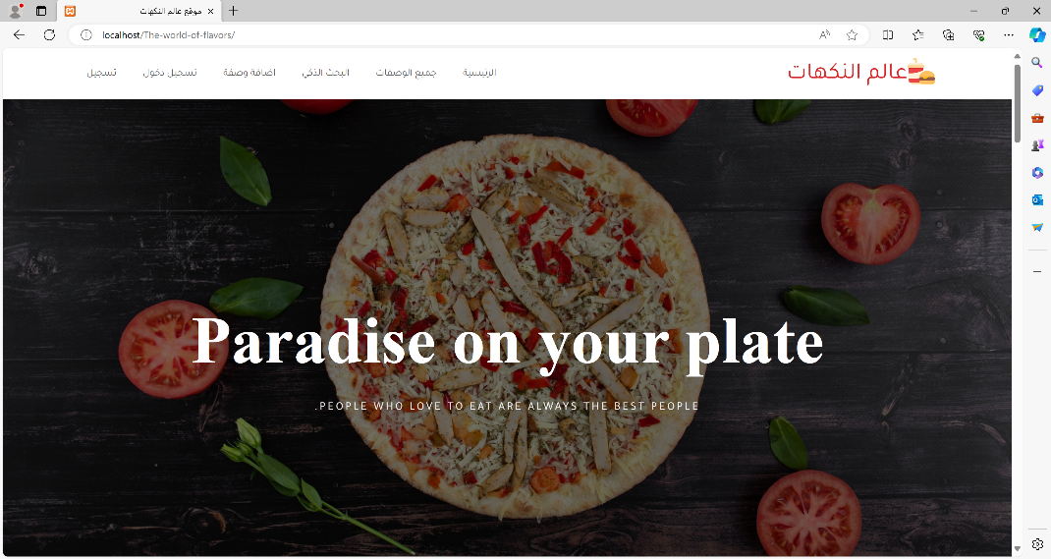

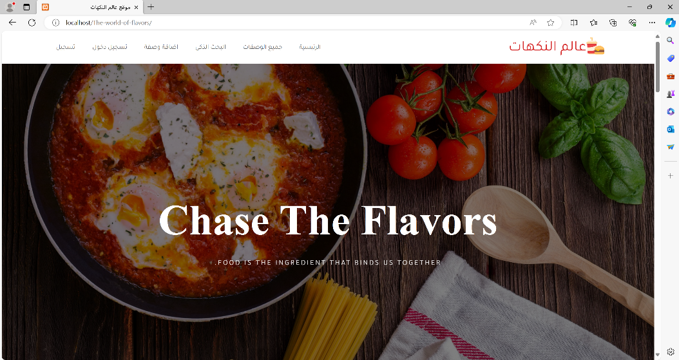
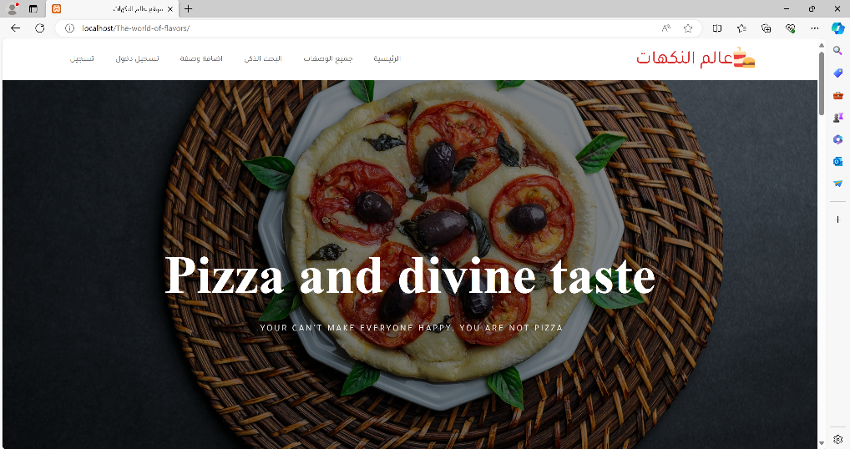

Following that is a short description of the site and the types of recipes available on the site.
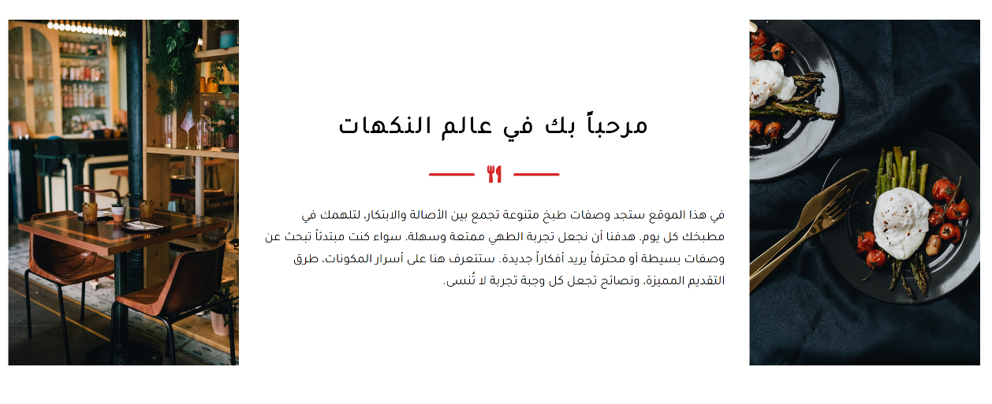

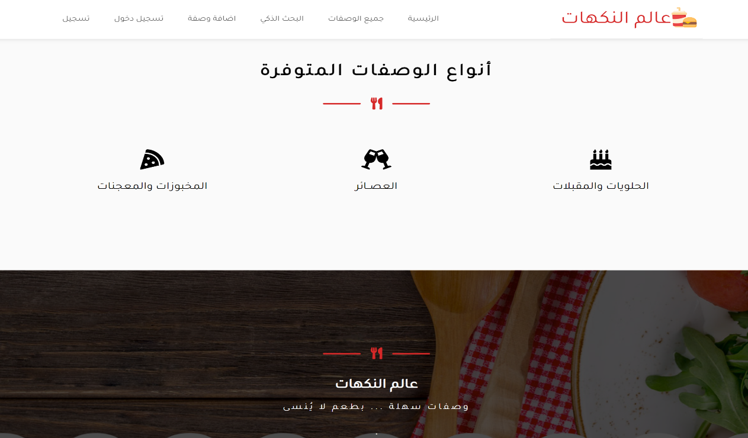

Next, there is a box to search for recipes by recipe name or specific ingredient (where when the user searches for a specific recipe, he is taken to the recipe-builder page).
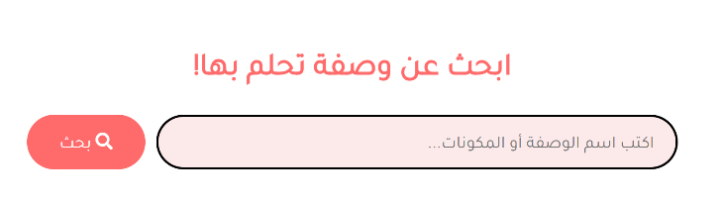

Next, the 6 most recently added recipes to the site are displayed.
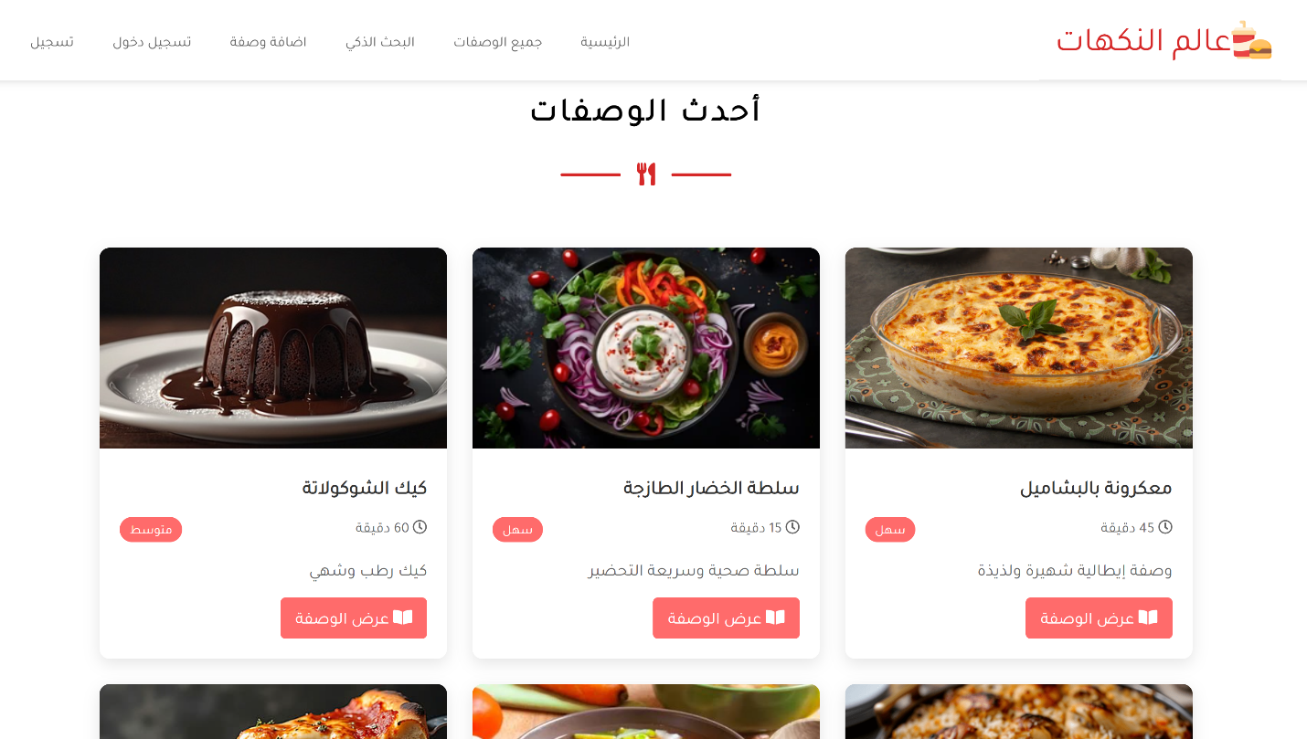

At the bottom of the page, there is a button to go to the recipes page to see all the available recipes. Finally, the footer is displayed.
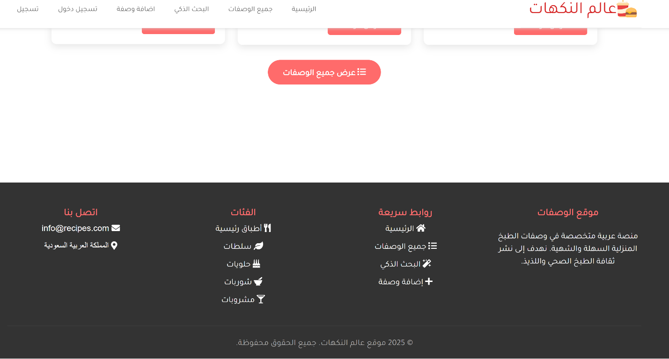

CODE:
<?php
require_once 'includes/config.php';
require_once 'includes/header.php';
?>

<section class="banner">
<ul class="banner-slider">
<li class="banner-item active-banner">
<div class="container">
<h1>Chase The Flavors</h1>
<p class="text">food is the ingredient that binds us together.</p>
</div>
</li>
<li class="banner-item">
<div class="container">
<h1>Pizza and divine taste</h1>
<p class="text">your can't make everyone happy. you are not pizza.</p>
</div>
</li>
<li class="banner-item">
<div class="container">
<h1>Paradise on your plate</h1>
<p class="text">people who love to eat are always the best people.</p>
</div>
</li>
</ul>
</section>

<section class="padding-y about" id="about">
<div class="container">
<div class="about-row">
<div class="about-col-1">
<img src="assets/images/about-img-1.jpg" alt="">
</div>
<div class="about-col-2">
<div class="title">
<h2 style="font-family: 'Tajawal',sans-serif;">مرحباً بك في عالم النكهات</h2>
<div class="line center">
<div></div>
<span><i class="fas fa-utensils"></i></span>
<div></div>
</div>
</div>
<p class="text">في هذا الموقع ستجد وصفات طبخ متنوعة تجمع بين الأصالة والابتكار، لتلهمك في مطبخك كل يوم. هدفنا أن نجعل تجربة الطهي ممتعة وسهلة، سواء كنت مبتدئاً تبحث عن وصفات بسيطة أو محترفاً يريد أفكاراً جديدة. ستتعرف هنا على أسرار المكونات، طرق التقديم المميزة، ونصائح تجعل كل وجبة تجربة لا تُنسى.</p>
</div>
<div class="about-col-3">
<img src="assets/images/about-img-2.jpg" alt="">
</div>
</div>
</div>
</section>

<section class="padding-y service" id="service">
<div class="container">
<div class="title">
<h2 style="font-family: 'Tajawal',sans-serif;">أنواع الوصفات المتوفرة</h2>
<div class="line center">
<div></div>
<span><i class="fas fa-utensils"></i></span>
<div></div>
</div>
</div>
<div class="service-row">
<div class="service-item">
<span>
<i class="fas fa-birthday-cake"></i>
</span>
<h3 style="font-family: 'Tajawal',sans-serif;">الحلويات والمقبلات</h3>
</div>

<div class="service-item">
<span>
<i class="fas fa-glass-cheers"></i>
</span>
<h3 style="font-family: 'Tajawal',sans-serif;">العصــائر</h3>
</div>

<div class="service-item">
<span>
<i class="fas fa-pizza-slice"></i>
</span>
<h3 style="font-family: 'Tajawal',sans-serif;">المخبوزات والمعجنات</h3>
</div>
</div>
</div>
</section>

<section class="openings padding-y" id="openings">
<div class="container">
<div class="title">
<h2> </h2>
<div class="line center">
<div></div>
<span><i class="fas fa-utensils"></i></span>
<div></div>
</div>
</div>
<div class="openings-row">
<h1 style="font-family: 'Tajawal',sans-serif;">عالم النكهات</h1>
<p class="text" style="font-family: 'Tajawal',sans-serif;">وصفات سهلة ... بطعم لا يُنسى</p>

<ul>
<li> . </li>
<li> . </li>
<li> . </li>
<li> . </li>
</ul>
</div>
</div>
</section>

<div class="padding-y menu" id="menu">
<div class="container">
<section class="search-section">
<div class="containerrr">
<h2>ابحث عن وصفة تحلم بها!</h2>
<form action="recipe-builder.php" method="GET" class="search-box">
<input type="text" name="q" placeholder="اكتب اسم الوصفة أو المكونات..." required="">
<button type="submit"><i class="fas fa-search"></i> بحث</button>
</form>
</div>
</section>

<div class="title">
<h2 style="font-family: 'Tajawal',sans-serif;">أحدث الوصفات</h2>
<div class="line center">
<div></div>
<span><i class="fas fa-utensils"></i></span>
<div></div>
</div>
</div>

<section class="recipes-section">
<div class="container">
<div class="recipes-grid">
<?php
try {
$stmt = $pdo->query("SELECT * FROM recipes ORDER BY created_at DESC LIMIT 6");
$recipes = $stmt->fetchAll();

if (count($recipes) > 0) {
foreach ($recipes as $recipe) {
$recipe_id = $recipe['id'];
$recipe_title = htmlspecialchars($recipe['title']);
$recipe_description = htmlspecialchars($recipe['description']);
$prep_time = $recipe['prep_time'];
$difficulty = $recipe['difficulty'];
$image = $recipe['image'];

if (!empty($image) && file_exists("uploads/$image")) {
$image_path = "uploads/$image";
} else {
$image_path = "images/pic05.jpg";
}
?>
<div class="recipe-card">
<img src="<?php echo $image_path; ?>" alt="<?php echo $recipe_title; ?>" class="recipe-image">

<div class="recipe-info">
<h3 class="recipe-title" style="font-family: 'Tajawal',sans-serif;"><?php echo $recipe_title; ?></h3>

<div class="recipe-meta">
<span style="font-family: 'Tajawal',sans-serif;"><i class="far fa-clock"></i> <?php echo $prep_time; ?> دقيقة</span>
<span class="recipe-difficulty" style="font-family: 'Tajawal',sans-serif;"><?php echo $difficulty; ?></span>
</div>

<p class="recipe-description" style="font-family: 'Tajawal',sans-serif;">
<?php
if (strlen($recipe_description) > 80) {
echo substr($recipe_description, 0, 80) . '...';
} else {
echo $recipe_description;
}
?>
</p>

<a href="recipe-detail.php?id=<?php echo $recipe_id; ?>" class="recipe-link" style="font-family: 'Tajawal',sans-serif;">
<i class="fas fa-book-open"></i> عرض الوصفة
</a>
</div>
</div>
<?php
}
} else {
?>
<div class="no-recipes">
<p style="font-family: 'Tajawal',sans-serif;" >لا توجد وصفات بعد. كن أول من يضيف وصفة!</p>
</div>
<?php
}
} catch(PDOException $e) {
echo '<div class="error">خطأ في تحميل الوصفات: ' . $e->getMessage() . '</div>';
}
?>
</div>

<div style="text-align: center; margin-top: 30px;">
<a href="recipes.php" class="btn-primary" style="display: inline-block; text-decoration: none;font-family: 'Tajawal',sans-serif;">
<i class="fas fa-list"></i> عرض جميع الوصفات
</a>
</div>
</div>
</section>
</div>
</div>

<?php
require_once 'includes/footer.php';
?>

<script src="assets/jquery/jquery-3.5.1.js"></script>
<!-- Fontawesome js -->
<script src="assets/font-awesome/all.js"></script>
<!-- custom js file -->
<script src="js/script.js"></script>

- Recipes page
This page displays all recipes, with the user able to filter them.
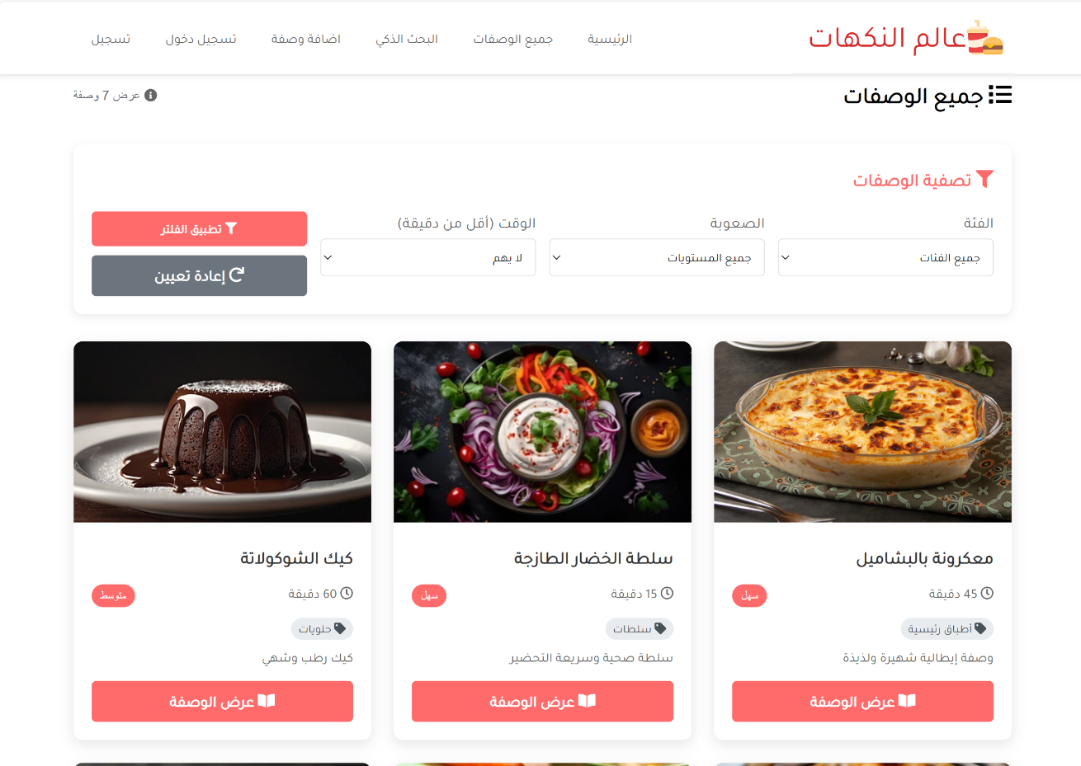

CODE:
<?php
require_once 'includes/config.php';
$page_title = 'جميع الوصفات';
require_once 'includes/header.php';
$category = isset($_GET['category']) ? clean_input($_GET['category']) : '';
$difficulty = isset($_GET['difficulty']) ? clean_input($_GET['difficulty']) : '';
$time = isset($_GET['time']) ? intval($_GET['time']) : 0;
$sql = "SELECT * FROM recipes WHERE 1=1";
$params = [];
if (!empty($category)) {
$sql .= " AND category = ?";
$params[] = $category;
}
if (!empty($difficulty)) {
$sql .= " AND difficulty = ?";
$params[] = $difficulty;
}
if ($time > 0) {
$sql .= " AND prep_time <= ?";
$params[] = $time;
}
$sql .= " ORDER BY created_at DESC";
try {
$stmt = $pdo->prepare($sql);
$stmt->execute($params);
$recipes = $stmt->fetchAll();
$categories_stmt = $pdo->query("SELECT DISTINCT category FROM recipes WHERE category IS NOT NULL ORDER BY category");
$categories = $categories_stmt->fetchAll();
} catch(PDOException $e) {
die("خطأ في قاعدة البيانات: " . $e->getMessage());
}
?>
<section class="container" id="contact">
<div class="recipes-page">
<div style="display: flex; justify-content: space-between; align-items: center; margin-bottom: 30px;">
<h1 style="font-family: 'Tajawal',sans-serif;"><i class="fas fa-list" ></i> جميع الوصفات</h1>
<div style="font-size: 0.9rem; color: #666;">
<i class="fas fa-info-circle"></i> عرض <?php echo count($recipes); ?> وصفة
</div>
</div>
<div class="filters-section" style="background: white; padding: 20px; border-radius: 10px; margin-bottom: 30px; box-shadow: 0 3px 10px rgba(0,0,0,0.08);">
<h3 style="margin-bottom: 15px; color: #ff6b6b;font-family: 'Tajawal',sans-serif;"><i class="fas fa-filter"></i> تصفية الوصفات</h3>
<form method="GET" action="recipes.php" style="display: grid; grid-template-columns: repeat(auto-fit, minmax(200px, 1fr)); gap: 15px;">
<div>
<label style="display: block; margin-bottom: 5px; color: #666;font-family: 'Tajawal',sans-serif;">الفئة</label>
<select name="category" style="width: 100%; padding: 10px; border: 1px solid #ddd; border-radius: 5px;font-family: 'Tajawal',sans-serif;">
<option value="" >جميع الفئات</option>
<?php foreach($categories as $cat): ?>
<option value="<?php echo $cat['category']; ?>" <?php echo ($category == $cat['category']) ? 'selected' : ''; ?>>
<?php echo $cat['category']; ?>
</option>
<?php endforeach; ?>
</select>
</div>
<div>
<label style="display: block; margin-bottom: 5px; color: #666;font-family: 'Tajawal',sans-serif;">الصعوبة</label>
<select name="difficulty" style="width: 100%; padding: 10px; border: 1px solid #ddd; border-radius: 5px;font-family: 'Tajawal',sans-serif;">
<option value="">جميع المستويات</option>
<option value="سهل" <?php echo ($difficulty == 'سهل') ? 'selected' : ''; ?>>سهل</option>
<option value="متوسط" <?php echo ($difficulty == 'متوسط') ? 'selected' : ''; ?>>متوسط</option>
<option value="صعب" <?php echo ($difficulty == 'صعب') ? 'selected' : ''; ?>>صعب</option>
</select>
</div>
<div>
<label style="display: block; margin-bottom: 5px; color: #666;font-family: 'Tajawal',sans-serif;">الوقت (أقل من دقيقة)</label>
<select name="time" style="width: 100%; padding: 10px; border: 1px solid #ddd; border-radius: 5px;font-family: 'Tajawal',sans-serif;">
<option value="0">لا يهم</option>
<option value="15" <?php echo ($time == 15) ? 'selected' : ''; ?>>15 دقيقة</option>
<option value="30" <?php echo ($time == 30) ? 'selected' : ''; ?>>30 دقيقة</option>
<option value="60" <?php echo ($time == 60) ? 'selected' : ''; ?>>ساعة</option>
<option value="120" <?php echo ($time == 120) ? 'selected' : ''; ?>>ساعتين</option>
</select>
</div>
<div style="align-self: end;">
<button type="submit" class="btn btn-primary" style="width: 100%;font-family: 'Tajawal',sans-serif;">
<i class="fas fa-filter"></i> تطبيق الفلتر
</button>
<a href="recipes.php" class="btn btn-secondary" style="width: 100%; margin-top: 10px; text-align: center; display: block;font-family: 'Tajawal',sans-serif;">
<i class="fas fa-redo"></i> إعادة تعيين
</a>
</div>
</form>
</div>
<?php if(count($recipes) > 0): ?>
<div class="recipes-grid" style="display: grid; grid-template-columns: repeat(auto-fill, minmax(300px, 1fr)); gap: 25px;">
<?php foreach($recipes as $recipe): ?>
<div class="recipe-card" style="background: white; border-radius: 10px; overflow: hidden; box-shadow: 0 5px 15px rgba(0,0,0,0.1); transition: transform 0.3s;">
<?php if(!empty($recipe['image'])): ?>
<img src="uploads/<?php echo $recipe['image']; ?>"
alt="<?php echo $recipe['title']; ?>"
style="width: 100%; height: 200px; object-fit: cover;">
<?php else: ?>
<div style="width: 100%; height: 200px; background: linear-gradient(45deg, #ff6b6b, #ff8e53); display: flex; align-items: center; justify-content: center; color: white; font-size: 3rem;">
<i class="fas fa-utensils"></i>
</div>
<?php endif; ?>

<div style="padding: 20px;">
<h3 style="margin-bottom: 10px; color: #333; font-size: 1.2rem;font-family: 'Tajawal',sans-serif;">
<?php echo $recipe['title']; ?>
</h3>
<div style="display: flex; justify-content: space-between; color: #666; font-size: 0.9rem; margin-bottom: 10px;">
<span style="font-family: 'Tajawal',sans-serif;"><i class="far fa-clock"></i> <?php echo $recipe['prep_time']; ?> دقيقة</span>
<span style="background: #ff6b6b; color: white; padding: 3px 10px; border-radius: 15px; font-size: 0.8rem;">
<?php echo $recipe['difficulty']; ?>
</span>
</div>
<?php if(!empty($recipe['category'])): ?>
<div style="margin-bottom: 10px;">
<span style="background: #e9ecef; color: #495057; padding: 3px 8px; border-radius: 15px; font-size: 0.8rem;font-family: 'Tajawal',sans-serif;">
<i class="fas fa-tag"></i> <?php echo $recipe['category']; ?>
</span>
</div>
<?php endif; ?>
<p style="color: #666; margin-bottom: 15px; font-size: 0.9rem; line-height: 1.5;font-family: 'Tajawal',sans-serif;">
<?php
$desc = $recipe['description'];
echo strlen($desc) > 80 ? substr($desc, 0, 80) . '...' : $desc;
?>
</p>
<div style="display: flex; gap: 10px;">
<a href="recipe-detail.php?id=<?php echo $recipe['id']; ?>" class="btn btn-primary" style="flex: 1; text-align: center;font-family: 'Tajawal',sans-serif;">
<i class="fas fa-book-open"></i> عرض الوصفة
</a>
</div>
</div>
</div>
<?php endforeach; ?>
</div>
<?php else: ?>
<div style="text-align: center; padding: 60px 20px; background: white; border-radius: 10px; box-shadow: 0 3px 10px rgba(0,0,0,0.08);">
<i class="fas fa-utensils" style="font-size: 4rem; color: #ddd; margin-bottom: 20px;"></i>
<h3 style="color: #666; margin-bottom: 15px;font-family: 'Tajawal',sans-serif;">لا توجد وصفات</h3>
<p style="color: #999; margin-bottom: 25px;font-family: 'Tajawal',sans-serif;">لم يتم العثور على وصفات تطابق بحثك.</p>
<a href="add-recipe.php" class="btn btn-primary" style="font-family: 'Tajawal',sans-serif;">
<i class="fas fa-plus"></i> أضف أول وصفة
</a>
</div>
<?php endif; ?>
<?php if(count($recipes) > 12): ?>
<div style="text-align: center; margin-top: 40px;">
<button onclick="loadMore()" class="btn btn-secondary" style="padding: 12px 40px;">
<i class="fas fa-arrow-down"></i> تحميل المزيد
</button>
</div>
<?php endif; ?>
</div>
<script>
function loadMore() {
alert('ميزة التحميل الإضافي ستكون في النسخة القادمة!');
}
</script>
</section>
<?php
require_once 'includes/footer.php';
?>
<script src="assets/jquery/jquery-3.5.1.js"></script>
<!-- Fontawesome js -->
<script src="assets/font-awesome/all.js"></script>
<!-- custom js file -->
<script src="js/script.js"></script>

- Recipe Detail
Displays the full recipe: title, ingredients, steps, and image
When the user clicks the "عرض الوصفة" button, they will be taken to the "Recipe Details" page, where all the data related to the recipe is displayed.
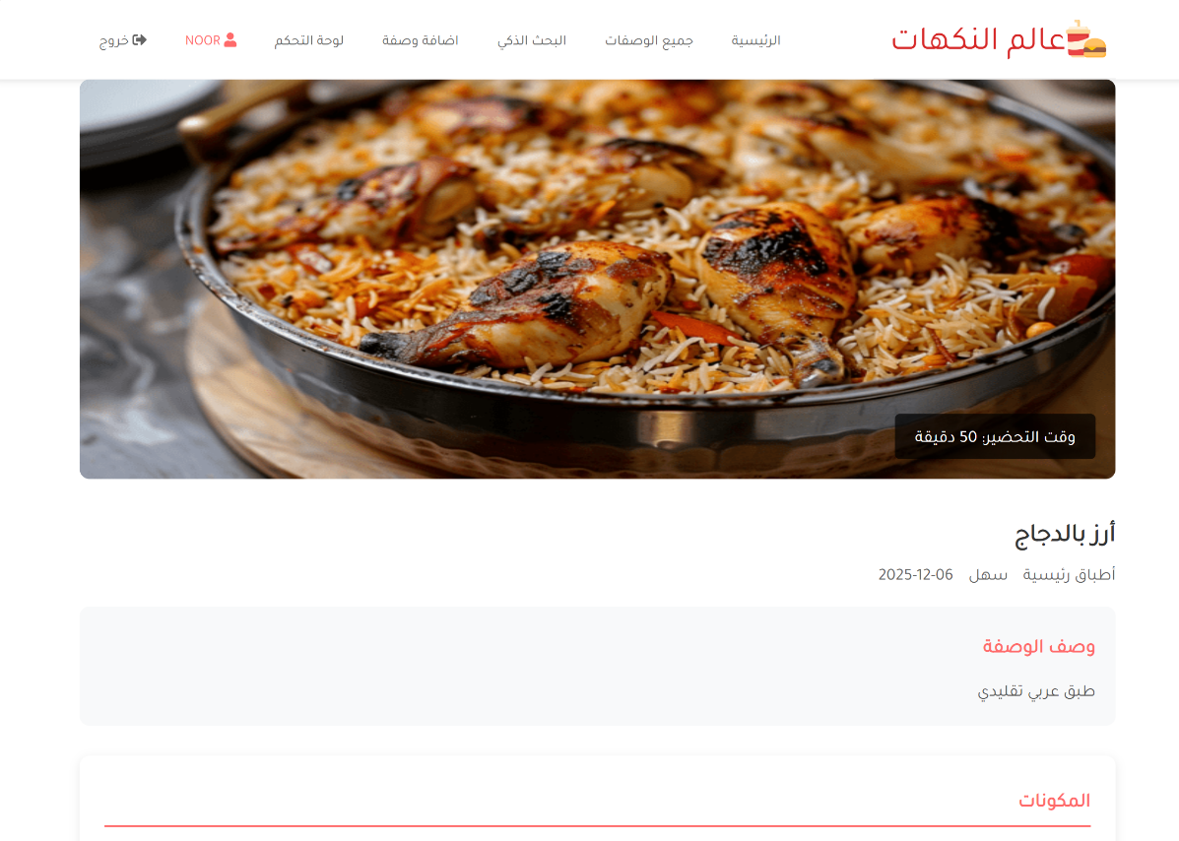

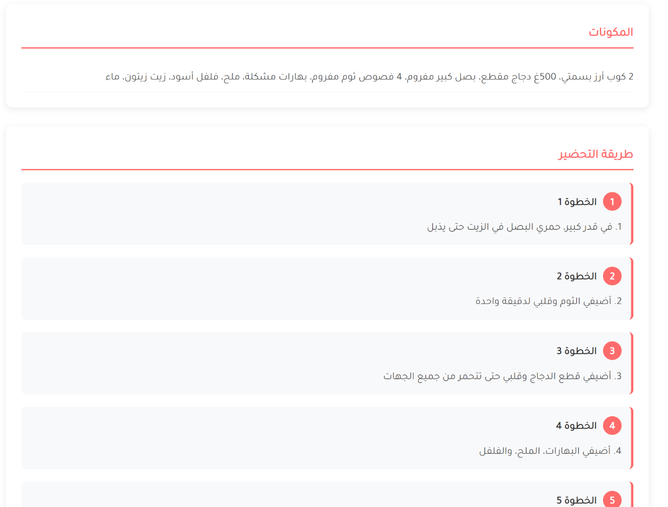

7.2 User Action
- Register page
Users can create an account using a username, email, and password
The user must perform this procedure in order to add a recipe or to use the smart search engine.
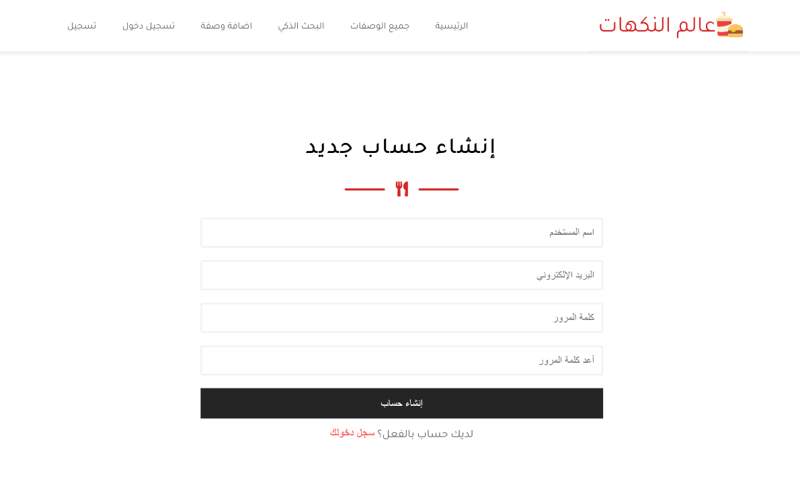

CODE:

<?php
require_once 'includes/config.php';
$page_title = 'إنشاء حساب جديد';
require_once 'includes/header.php';
$errors = [];
$success = false;
if($_SERVER['REQUEST_METHOD'] == 'POST') {
$username = clean_input($_POST['username']);
$email = clean_input($_POST['email']);
$password = $_POST['password'];
$confirm_password = $_POST['confirm_password'];
if(empty($username)) {
$errors[] = 'اسم المستخدم مطلوب';
} elseif(strlen($username) < 3) {
$errors[] = 'اسم المستخدم يجب أن يكون 3 أحرف على الأقل';
}
if(empty($email)) {
$errors[] = 'البريد الإلكتروني مطلوب';
} elseif(!filter_var($email, FILTER_VALIDATE_EMAIL)) {
$errors[] = 'البريد الإلكتروني غير صحيح';
}

if(empty($password)) {
$errors[] = 'كلمة المرور مطلوبة';
} elseif(strlen($password) < 6) {
$errors[] = 'كلمة المرور يجب أن تكون 6 أحرف على الأقل';
}
if($password !== $confirm_password) {
$errors[] = 'كلمتا المرور غير متطابقتين';
}
if(empty($errors)) {
try {
$stmt = $pdo->prepare("SELECT id FROM users WHERE username = ? OR email = ?");
$stmt->execute([$username, $email]);
$existing_user = $stmt->fetch();
if($existing_user) {
$errors[] = 'اسم المستخدم أو البريد الإلكتروني موجود مسبقاً';
}
} catch(PDOException $e) {
$errors[] = 'خطأ في التحقق من البيانات: ' . $e->getMessage();
}
}
if(empty($errors)) {
try {
$hashed_password = password_hash($password, PASSWORD_DEFAULT);
$sql = "INSERT INTO users (username, email, password, is_admin) VALUES (?, ?, ?, ?)";
$stmt = $pdo->prepare($sql);
$stmt->execute([$username, $email, $hashed_password, false]);
$user_id = $pdo->lastInsertId();
$_SESSION['user_id'] = $user_id;
$_SESSION['username'] = $username;
$_SESSION['email'] = $email;
$_SESSION['user_role'] = 'user';
$success = true;
echo show_message('success', 'تم إنشاء حسابك بنجاح! جاري تحويلك إلى الصفحة الرئيسية...');
header("refresh:3;url=index.php");
} catch(PDOException $e) {
$errors[] = 'خطأ في إنشاء الحساب: ' . $e->getMessage();
}
}
if(!empty($errors) && !$success) {
foreach($errors as $error) {
echo show_message('error', $error);
}
}
}
?>
<section class="padding-y contact" id="contact">
<div class="container">
<div class="title">
<h2 style="font-family: 'Tajawal',sans-serif;">إنشاء حساب جديد</h2>
<div class="line center">
<div></div>
<span><i class="fas fa-utensils"></i></span>
<div></div>
</div>
</div>
<?php if(!$success): ?>
<div class="contact-row-1">
<form class="contact-form" method="POST" action="">
<input type="text" class="form-control" name="username" required
placeholder="اسم المستخدم" value="<?php echo $_POST['username'] ?? ''; ?>">
<input type="email" class="form-control" name="email" required
placeholder="البريد الإلكتروني" value="<?php echo $_POST['email'] ?? ''; ?>">
<input type="password" class="form-control" name="password" required
placeholder="كلمة المرور">
<input type="password" class="form-control" name="confirm_password" required
placeholder="أعد كلمة المرور">
<input type="submit" class="form-submit-btn" value="إنشاء حساب">
</form>
<center>
<p style="color: #666; margin-bottom: 15px;font-family: 'Tajawal',sans-serif;">
لديك حساب بالفعل؟
<a href="login.php" style="color: #ff6b6b; text-decoration: none; font-weight: 600;">
سجل دخولك
</a>
</p>
</center>
</div>
<?php endif; ?>
</div>
</section>
<?php
require_once 'includes/footer.php';
?>
<script src="assets/jquery/jquery-3.5.1.js"></script>
<!-- Fontawesome js -->
<script src="assets/font-awesome/all.js"></script>
<!-- custom js file -->
<script src="js/script.js"></script>

- Login page
Users log in using their credentials
Passwords are validated securely
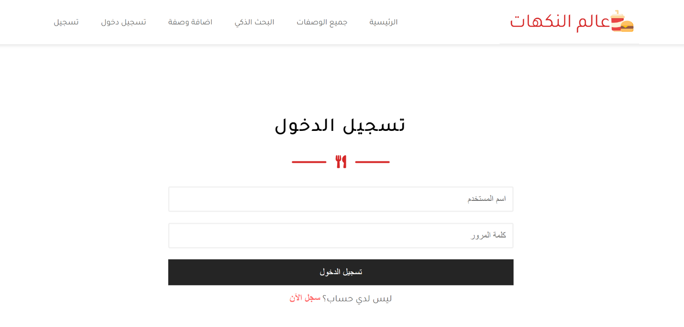

After the user logs in to the site, the user will be allowed to add a recipe and use the smart search engine.
CODE:
<?php
require_once 'includes/config.php';
$page_title = 'تسجيل الدخول';
require_once 'includes/header.php';
$errors = [];
$success = false;
if($_SERVER['REQUEST_METHOD'] == 'POST') {
$username = clean_input($_POST['username']);
$password = $_POST['password'];
if(empty($username)) {
$errors[] = 'اسم المستخدم مطلوب';
}
if(empty($password)) {
$errors[] = 'كلمة المرور مطلوبة';
}
if(empty($errors)) {
try {
$stmt = $pdo->prepare("SELECT * FROM users WHERE username = ?");
$stmt->execute([$username]);
$user = $stmt->fetch();
if($user) {
if(password_verify($password, $user['password'])) {
$_SESSION['user_id'] = $user['id'];
$_SESSION['username'] = $user['username'];
$_SESSION['email'] = $user['email'];
$_SESSION['user_role'] = $user['is_admin'] ? 'admin' : 'user';
$success = true;
echo '<div style="padding: 15px; background: #d4edda; color: #155724;
border: 1px solid #c3e6cb; border-radius: 5px; margin-bottom: 20px;font-family: \'Tajawal\',sans-serif;">
تم تسجيل الدخول بنجاح! جاري تحويلك إلى الصفحة الرئيسية...
</div>';
$redirect = isset($_GET['redirect']) ? $_GET['redirect'] . '.php' : 'index.php';
header("refresh:2;url=" . $redirect);
} else {
$errors[] = 'كلمة المرور غير صحيحة';
}
} else {
$errors[] = 'اسم المستخدم غير موجود';
}
} catch(PDOException $e) {
$errors[] = 'خطأ في النظام: ' . $e->getMessage();
}
}
if(!empty($errors) && !$success) {
foreach($errors as $error) {
echo '<div style="padding: 15px; background: #f8d7da; color: #721c24;
border: 1px solid #f5c6cb; border-radius: 5px; margin-bottom: 20px;font-family: \'Tajawal\',sans-serif;">
' . $error . '
</div>';
}
}
}
?>
<section class="padding-y contact" id="contact">
<div class="container">
<div class="title">
<h2 style="font-family: 'Tajawal',sans-serif;">تسجيل الدخول</h2>
<div class="line center">
<div></div>
<span><i class="fas fa-utensils"></i></span>
<div></div>
</div>
</div>
<?php if(!$success): ?>
<div class="contact-row-1">
<form class="contact-form" method="POST" action="">
<input type="text" class="form-control" name="username" required
placeholder="اسم المستخدم" value="<?php echo $_POST['username'] ?? ''; ?>">
<input type="password" class="form-control" name="password" required
placeholder="كلمة المرور">
<input type="submit" class="form-submit-btn" value="تسجيل الدخول">
</form>
<center>
<p style="color: #666; margin-bottom: 15px;font-family: 'Tajawal',sans-serif;">
ليس لدي حساب؟
<a href="register.php" style="color: #ff6b6b; text-decoration: none; font-weight: 600;">
سجل الآن
</a>
</p>
</center>
</div>
<?php endif; ?>
</div>
</section>
<?php
require_once 'includes/footer.php';
?>
<!-- jQuery -->
<script src="assets/jquery/jquery-3.5.1.js"></script>
<!-- Fontawesome js -->
<script src="assets/font-awesome/all.js"></script>
<!-- custom js file -->
<script src="js/script.js"></script>

- Add Recipe
Fill in the title, description, ingredients, steps, category, difficulty, and upload an image
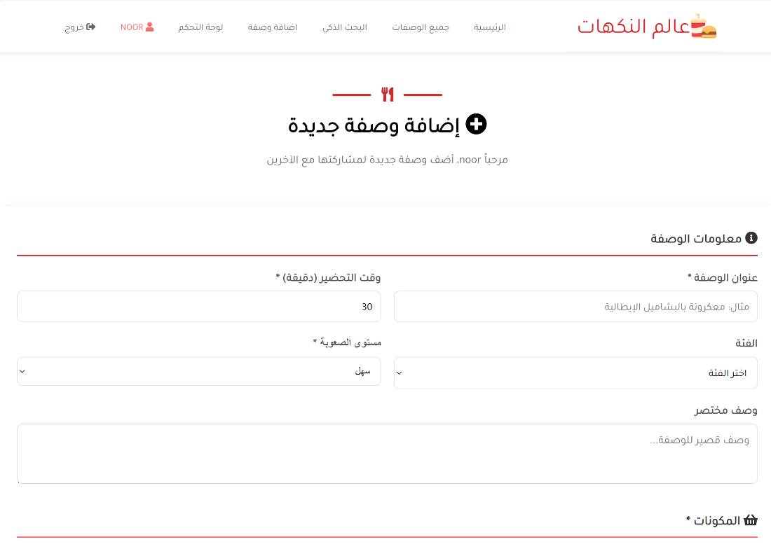

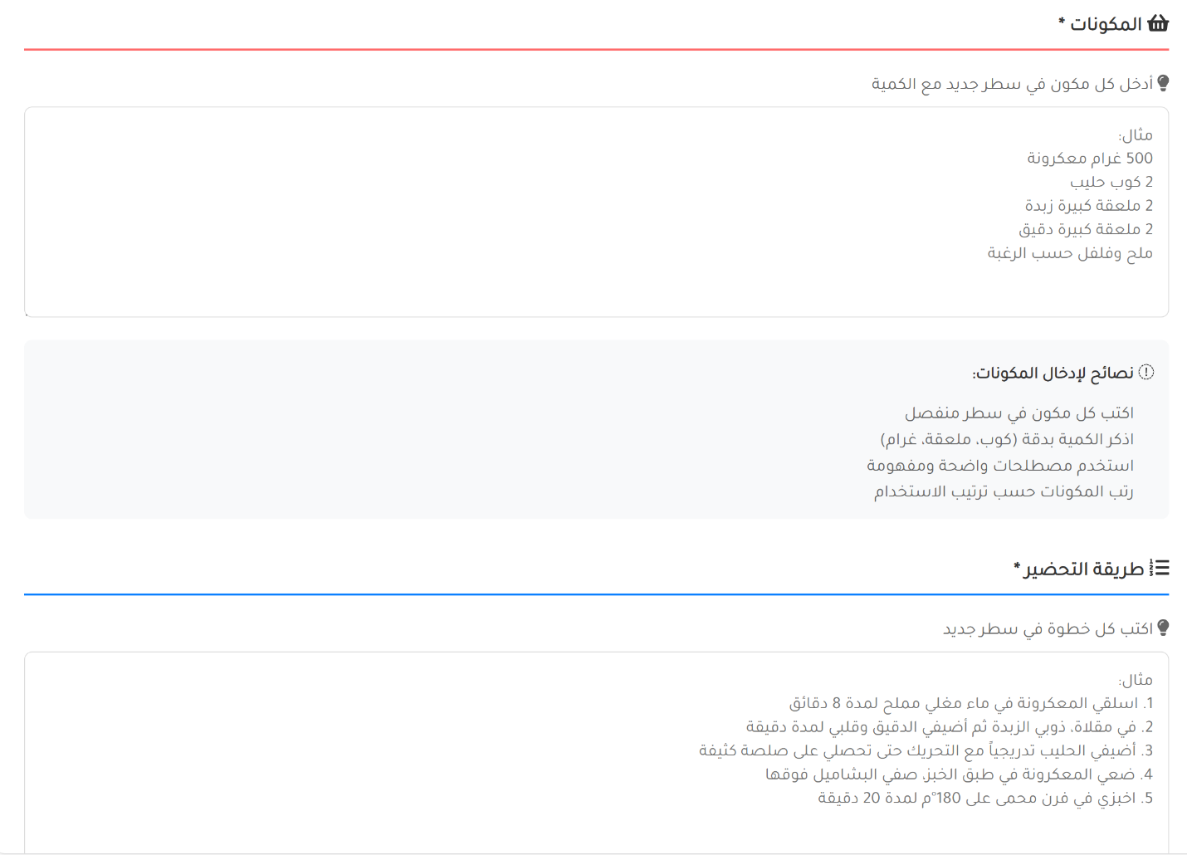

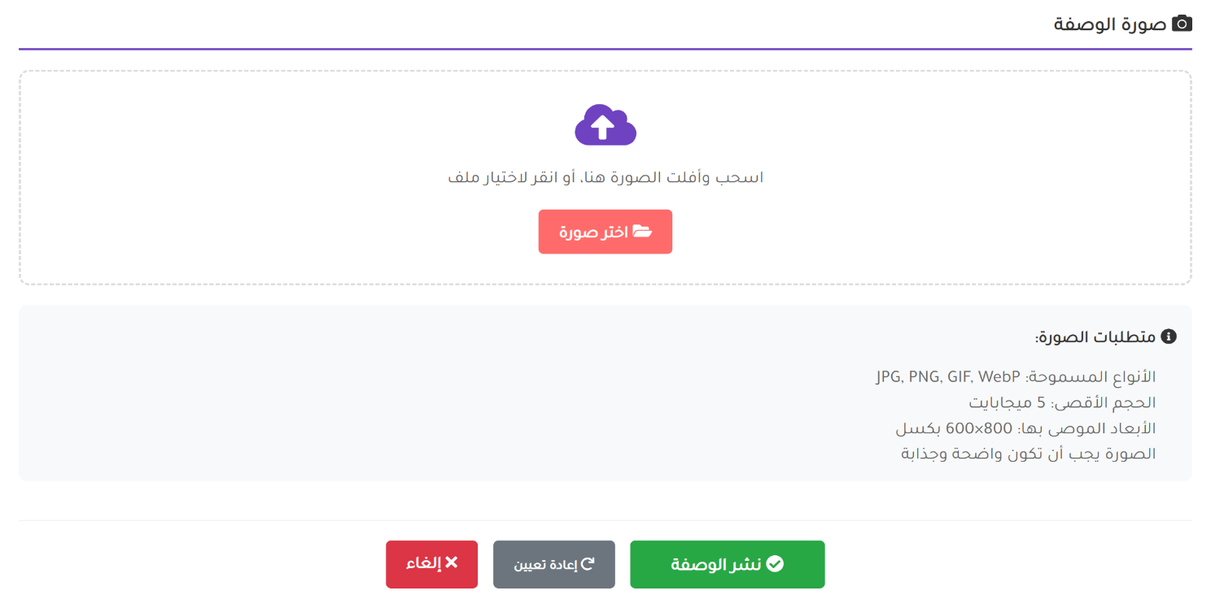

CODE:

<?php
require_once 'includes/config.php';
if(!is_logged_in()) {
header('Location: login.php?redirect=add-recipe');
exit();
}
$page_title = 'إضافة وصفة جديدة';
require_once 'includes/header.php';
$errors = [];
$success = false;
if($_SERVER['REQUEST_METHOD'] == 'POST') {
$title = clean_input($_POST['title']);
$description = clean_input($_POST['description']);
$ingredients = clean_input($_POST['ingredients']);
$instructions = clean_input($_POST['instructions']);
$prep_time = intval($_POST['prep_time']);
$category = clean_input($_POST['category']);
$difficulty = clean_input($_POST['difficulty']);
if(empty($title)) {
$errors[] = 'العنوان مطلوب';
}
if(empty($ingredients)) {
$errors[] = 'المكونات مطلوبة';
}
if(empty($instructions)) {
$errors[] = 'طريقة التحضير مطلوبة';
}
if($prep_time <= 0) {
$errors[] = 'وقت التحضير غير صحيح';
}
$image_name = '';
if(isset($_FILES['image']) && $_FILES['image']['error'] == 0) {
$allowed_types = ['image/jpeg', 'image/png', 'image/gif', 'image/webp'];
$max_size = 5 * 1024 * 1024;
if(in_array($_FILES['image']['type'], $allowed_types)) {
if($_FILES['image']['size'] <= $max_size) {
$ext = pathinfo($_FILES['image']['name'], PATHINFO_EXTENSION);
$image_name = uniqid() . '_' . time() . '.' . $ext;
$upload_path = 'uploads/' . $image_name;
if(!move_uploaded_file($_FILES['image']['tmp_name'], $upload_path)) {
$errors[] = 'فشل في رفع الصورة';
}
} else {
$errors[] = 'حجم الصورة يجب أن يكون أقل من 5MB';
}
} else {
$errors[] = 'نوع الصورة غير مدعوم. المسموح: JPG, PNG, GIF, WebP';
}
}
if(empty($errors)) {
try {
$sql = "INSERT INTO recipes (title, description, ingredients, instructions, image, prep_time, category, difficulty, user_id)
VALUES (?, ?, ?, ?, ?, ?, ?, ?, ?)";
$stmt = $pdo->prepare($sql);
$stmt->execute([
$title,
$description,
$ingredients,
$instructions,
$image_name,
$prep_time,
$category,
$difficulty,
$_SESSION['user_id']
]);
$recipe_id = $pdo->lastInsertId();
$success = true;
echo '<div style="padding: 15px; background: #d4edda; color: #155724;
border: 1px solid #c3e6cb; border-radius: 5px; margin-bottom: 20px;font-family: \'Tajawal\',sans-serif;">
تم إضافة الوصفة بنجاح! <a href="recipe-detail.php?id=' . $recipe_id . '" style="color: #0b2e13; font-weight: bold;">عرض الوصفة</a>
</div>';
$_POST = [];
} catch(PDOException $e) {
$errors[] = 'خطأ في قاعدة البيانات: ' . $e->getMessage();
}
}
if(!empty($errors) && !$success) {
foreach($errors as $error) {
echo '<div style="padding: 15px; background: #f8d7da; color: #721c24;
border: 1px solid #f5c6cb; border-radius: 5px; margin-bottom: 20px;font-family: \'Tajawal\',sans-serif;">
' . $error . '
</div>';
}
}
}
?>
<div class="add-recipe-page" style="direction:rtl;">
<div style="color: black; padding: 30px; border-radius: 10px; margin-bottom: 30px;">
<div class="line center">
<div></div>
<span><i class="fas fa-utensils"></i></span>
<div></div>
</div>
<h1 style="text-align: center; margin-bottom: 10px;font-family: 'Tajawal',sans-serif;"><i class="fas fa-plus-circle"></i> إضافة وصفة جديدة</h1>
<p style="text-align: center; color: #666;font-family: 'Tajawal',sans-serif;">
مرحباً <?php echo $_SESSION['username']; ?>، أضف وصفة جديدة لمشاركتها مع الآخرين
</p>
</div>
<?php if(!$success): ?>
<form method="POST" action="" enctype="multipart/form-data" style="background: white; padding: 30px; border-radius: 10px; box-shadow: 0 5px 15px rgba(0,0,0,0.1);">
<div style="margin-bottom: 30px;">
<h3 style="color: #333; margin-bottom: 20px; padding-bottom: 10px; border-bottom: 2px solid #a72828ff;font-family: 'Tajawal',sans-serif;">
<i class="fas fa-info-circle"></i> معلومات الوصفة
</h3>
<div style="display: grid; grid-template-columns: 1fr 1fr; gap: 20px; margin-bottom: 20px;">
<div>
<label style="display: block; margin-bottom: 8px; color: #555; font-weight: 600;font-family: 'Tajawal',sans-serif;">
عنوان الوصفة *
</label>
<input type="text" name="title" required
value="<?php echo $_POST['title'] ?? ''; ?>"
style="width: 100%; padding: 12px; border: 1px solid #ddd; border-radius: 8px; font-size: 1rem;font-family: 'Tajawal',sans-serif;"
placeholder="مثال: معكرونة بالبشاميل الإيطالية">
</div>
<div>
<label style="display: block; margin-bottom: 8px; color: #555; font-weight: 600;font-family: 'Tajawal',sans-serif;">
وقت التحضير (دقيقة) *
</label>
<input type="number" name="prep_time" required min="1" max="480"
value="<?php echo $_POST['prep_time'] ?? '30'; ?>"
style="width: 100%; padding: 12px; border: 1px solid #ddd; border-radius: 8px; font-size: 1rem;font-family: 'Tajawal',sans-serif;">
</div>
</div>
<div style="display: grid; grid-template-columns: 1fr 1fr; gap: 20px; margin-bottom: 20px;">
<div>
<label style="display: block; margin-bottom: 8px; color: #555; font-weight: 600;font-family: 'Tajawal',sans-serif;">
الفئة
</label>
<select name="category" style="width: 100%; padding: 12px; border: 1px solid #ddd; border-radius: 8px; font-size: 1rem;font-family: 'Tajawal',sans-serif;">
<option value="">اختر الفئة</option>
<option value="أطباق رئيسية" <?php echo ($_POST['category'] ?? '') == 'أطباق رئيسية' ? 'selected' : ''; ?>>أطباق رئيسية</option>
<option value="سلطات" <?php echo ($_POST['category'] ?? '') == 'سلطات' ? 'selected' : ''; ?>>سلطات</option>
<option value="حلويات" <?php echo ($_POST['category'] ?? '') == 'حلويات' ? 'selected' : ''; ?>>حلويات</option>
<option value="شوربات" <?php echo ($_POST['category'] ?? '') == 'شوربات' ? 'selected' : ''; ?>>شوربات</option>
<option value="مقبلات" <?php echo ($_POST['category'] ?? '') == 'مقبلات' ? 'selected' : ''; ?>>مقبلات</option>
<option value="مشروبات" <?php echo ($_POST['category'] ?? '') == 'مشروبات' ? 'selected' : ''; ?>>مشروبات</option>
<option value="وجبات سريعة" <?php echo ($_POST['category'] ?? '') == 'وجبات سريعة' ? 'selected' : ''; ?>>وجبات سريعة</option>
</select>
</div>
<div>
<label style="display: block; margin-bottom: 8px; color: #555; font-weight: 600;">
مستوى الصعوبة *
</label>
<select name="difficulty" required style="width: 100%; padding: 12px; border: 1px solid #ddd; border-radius: 8px; font-size: 1rem;">
<option value="سهل" <?php echo ($_POST['difficulty'] ?? '') == 'سهل' ? 'selected' : ''; ?>>سهل</option>
<option value="متوسط" <?php echo ($_POST['difficulty'] ?? '') == 'متوسط' ? 'selected' : ''; ?>>متوسط</option>
<option value="صعب" <?php echo ($_POST['difficulty'] ?? '') == 'صعب' ? 'selected' : ''; ?>>صعب</option>
</select>
</div>
</div>
<div>
<label style="display: block; margin-bottom: 8px; color: #555; font-weight: 600;font-family: 'Tajawal',sans-serif;">
وصف مختصر
</label>
<textarea name="description" rows="3"
style="width: 100%; padding: 12px; border: 1px solid #ddd; border-radius: 8px; font-size: 1rem; resize: vertical;font-family: 'Tajawal',sans-serif;"
placeholder="وصف قصير للوصفة..."><?php echo $_POST['description'] ?? ''; ?></textarea>
</div>
</div>
<div style="margin-bottom: 30px;">
<h3 style="color: #333; margin-bottom: 20px; padding-bottom: 10px; border-bottom: 2px solid #ff6b6b;font-family: 'Tajawal',sans-serif;">
<i class="fas fa-shopping-basket" ></i> المكونات *
</h3>
<div style="margin-bottom: 15px;">
<p style="color: #666; margin-bottom: 10px;font-family: 'Tajawal',sans-serif;">
<i class="fas fa-lightbulb"></i> أدخل كل مكون في سطر جديد مع الكمية
</p>
<textarea name="ingredients" required rows="8"
style="width: 100%; padding: 15px; border: 1px solid #ddd; border-radius: 8px; font-size: 1rem; resize: vertical;font-family: 'Tajawal',sans-serif;"
placeholder="مثال:
500 غرام معكرونة
2 كوب حليب
2 ملعقة كبيرة زبدة
2 ملعقة كبيرة دقيق
ملح وفلفل حسب الرغبة"><?php echo $_POST['ingredients'] ?? ''; ?></textarea>
</div>
<div style="background: #f8f9fa; padding: 15px; border-radius: 8px;">
<h4 style="color: #333; margin-bottom: 10px; font-size: 1rem;font-family: 'Tajawal',sans-serif;">
<i class="fas fa-tips"></i> نصائح لإدخال المكونات:
</h4>
<ul style="color: #666; padding-right: 20px; margin: 0;font-family: 'Tajawal',sans-serif;">
<li style="font-family: 'Tajawal',sans-serif;">اكتب كل مكون في سطر منفصل</li>
<li style="font-family: 'Tajawal',sans-serif;">اذكر الكمية بدقة (كوب، ملعقة، غرام)</li>
<li style="font-family: 'Tajawal',sans-serif;">استخدم مصطلحات واضحة ومفهومة</li>
<li style="font-family: 'Tajawal',sans-serif;">رتب المكونات حسب ترتيب الاستخدام</li>
</ul>
</div>
</div>
<div style="margin-bottom: 30px;">
<h3 style="color: #333; margin-bottom: 20px; padding-bottom: 10px; border-bottom: 2px solid #007bff;font-family: 'Tajawal',sans-serif;">
<i class="fas fa-list-ol"></i> طريقة التحضير *
</h3>
<div style="margin-bottom: 15px;font-family: 'Tajawal',sans-serif;">
<p style="color: #666; margin-bottom: 10px;font-family: 'Tajawal',sans-serif;">
<i class="fas fa-lightbulb"></i> اكتب كل خطوة في سطر جديد
</p>
<textarea name="instructions" required rows="10"
style="width: 100%; padding: 15px; border: 1px solid #ddd; border-radius: 8px; font-size: 1rem; resize: vertical; font-family: monospace;font-family: 'Tajawal',sans-serif;"
placeholder="مثال:
1. اسلقي المعكرونة في ماء مغلي مملح لمدة 8 دقائق
2. في مقلاة، ذوبي الزبدة ثم أضيفي الدقيق وقلبي لمدة دقيقة
3. أضيفي الحليب تدريجياً مع التحريك حتى تحصلي على صلصة كثيفة
4. ضعي المعكرونة في طبق الخبز، صفي البشاميل فوقها
5. اخبزي في فرن محمى على 180°م لمدة 20 دقيقة"><?php echo $_POST['instructions'] ?? ''; ?></textarea>
</div>
</div>
<div style="margin-bottom: 30px;">
<h3 style="color: #333; margin-bottom: 20px; padding-bottom: 10px; border-bottom: 2px solid #6f42c1;font-family: 'Tajawal',sans-serif;">
<i class="fas fa-camera"></i> صورة الوصفة
</h3>
<div style="border: 2px dashed #ddd; padding: 30px; text-align: center; border-radius: 10px; margin-bottom: 20px;">
<i class="fas fa-cloud-upload-alt" style="font-size: 3rem; color: #6f42c1; margin-bottom: 15px;"></i>
<p style="color: #666; margin-bottom: 20px;font-family: 'Tajawal',sans-serif;">
اسحب وأفلت الصورة هنا، أو انقر لاختيار ملف
</p>
<input type="file" name="image" id="imageUpload" accept="image/*"
style="display: none;" onchange="previewImage(this)">
<label for="imageUpload" class="btn btn-primary" style="cursor: pointer;font-family: 'Tajawal',sans-serif;">
<i class="fas fa-folder-open"></i> اختر صورة
</label>
</div>
<div id="imagePreview" style="display: none; text-align: center; margin-top: 20px;">
<img id="preview" src="#" alt="معاينة الصورة"
style="max-width: 300px; max-height: 200px; border-radius: 8px; box-shadow: 0 3px 10px rgba(0,0,0,0.1);">
<button type="button" onclick="removeImage()" class="btn btn-danger" style="margin-top: 10px;font-family: 'Tajawal',sans-serif;">
<i class="fas fa-trash"></i> إزالة الصورة
</button>
</div>
<div style="background: #f8f9fa; padding: 15px; border-radius: 8px; margin-top: 20px;">
<h4 style="color: #333; margin-bottom: 10px; font-size: 1rem;font-family: 'Tajawal',sans-serif;">
<i class="fas fa-info-circle"></i> متطلبات الصورة:
</h4>
<ul style="color: #666; padding-right: 20px; margin: 0;">
<li style="font-family: 'Tajawal',sans-serif;">الأنواع المسموحة: JPG, PNG, GIF, WebP</li>
<li style="font-family: 'Tajawal',sans-serif;">الحجم الأقصى: 5 ميجابايت</li>
<li style="font-family: 'Tajawal',sans-serif;">الأبعاد الموصى بها: 800×600 بكسل</li>
<li style="font-family: 'Tajawal',sans-serif;">الصورة يجب أن تكون واضحة وجذابة</li>
</ul>
</div>
</div>
<div style="display: flex; justify-content: center; gap: 15px; margin-top: 40px; padding-top: 20px; border-top: 1px solid #eee;">
<button type="submit" class="btn btn-success" style="padding: 12px 40px; font-size: 1.1rem;font-family: 'Tajawal',sans-serif;">
<i class="fas fa-check-circle"></i> نشر الوصفة
</button>
<button type="reset" class="btn btn-secondary" style="font-family: 'Tajawal',sans-serif;">
<i class="fas fa-redo"></i> إعادة تعيين
</button>
<a href="recipes.php" class="btn btn-danger" style="font-family: 'Tajawal',sans-serif;">
<i class="fas fa-times"></i> إلغاء
</a>
</div>
</form>
<?php endif; ?>
<?php if(!$success): ?>
<div style="background: #fff3cd; padding: 20px; border-radius: 10px; margin-top: 30px; border: 1px solid #ffeaa7;">
<h4 style="color: #856404; margin-bottom: 10px;font-family: 'Tajawal',sans-serif;">
<i class="fas fa-lightbulb"></i> نصائح لوصفة ناجحة:
</h4>
<div style="display: grid; grid-template-columns: repeat(auto-fit, minmax(200px, 1fr)); gap: 15px;">
<div style="padding: 10px;">
<div style="color: #856404; font-weight: bold; margin-bottom: 5px;font-family: 'Tajawal',sans-serif;">
<i class="fas fa-check"></i> كن دقيقاً
</div>
<div style="color: #856404; font-size: 0.9rem;font-family: 'Tajawal',sans-serif;">
اذكر الكميات بدقة لضمان نجاح الوصفة
</div>
</div>
<div style="padding: 10px;">
<div style="color: #856404; font-weight: bold; margin-bottom: 5px;font-family: 'Tajawal',sans-serif;">
<i class="fas fa-camera"></i> صور جذابة
</div>
<div style="color: #856404; font-size: 0.9rem;font-family: 'Tajawal',sans-serif;">
استخدم صوراً واضحة وذات إضاءة جيدة
</div>
</div>
<div style="padding: 10px;">
<div style="color: #856404; font-weight: bold; margin-bottom: 5px;font-family: 'Tajawal',sans-serif;">
<i class="fas fa-list-ol"></i> خطوات واضحة
</div>
<div style="color: #856404; font-size: 0.9rem;font-family: 'Tajawal',sans-serif;">
قسم العملية إلى خطوات سهلة المتابعة
</div>
</div>
<div style="padding: 10px;">
<div style="color: #856404; font-weight: bold; margin-bottom: 5px;font-family: 'Tajawal',sans-serif;">
<i class="fas fa-clock"></i> وقت دقيق
</div>
<div style="color: #856404; font-size: 0.9rem;font-family: 'Tajawal',sans-serif;">
حدد الوقت الحقيقي للتحضير والطهي
</div>
</div>
</div>
</div>
<?php endif; ?>
</div>
<script>
function previewImage(input) {
const preview = document.getElementById('preview');
const previewDiv = document.getElementById('imagePreview');
if (input.files && input.files[0]) {
const reader = new FileReader();
reader.onload = function(e) {
preview.src = e.target.result;
previewDiv.style.display = 'block';
}
reader.readAsDataURL(input.files[0]);
}
}
function removeImage() {
document.getElementById('imageUpload').value = '';
document.getElementById('imagePreview').style.display = 'none';
}
</script>
<?php require_once 'includes/footer.php'; ?>
<script src="assets/jquery/jquery-3.5.1.js"></script>
<!-- Fontawesome js -->
<script src="assets/font-awesome/all.js"></script>
<!-- custom js file -->
<script src="js/script.js"></script>

- Recipe-builder
The user enters the ingredients they have, and then recipes that match the user's ingredients are retrieved
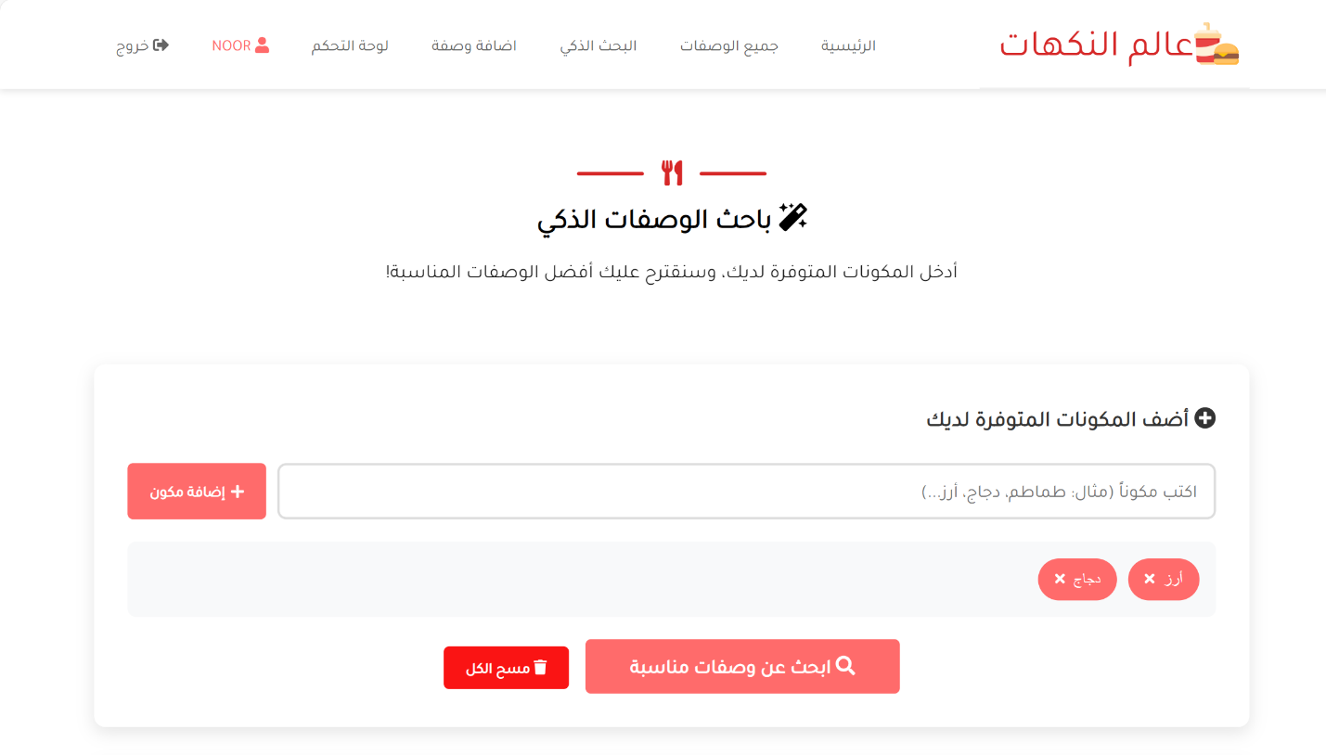

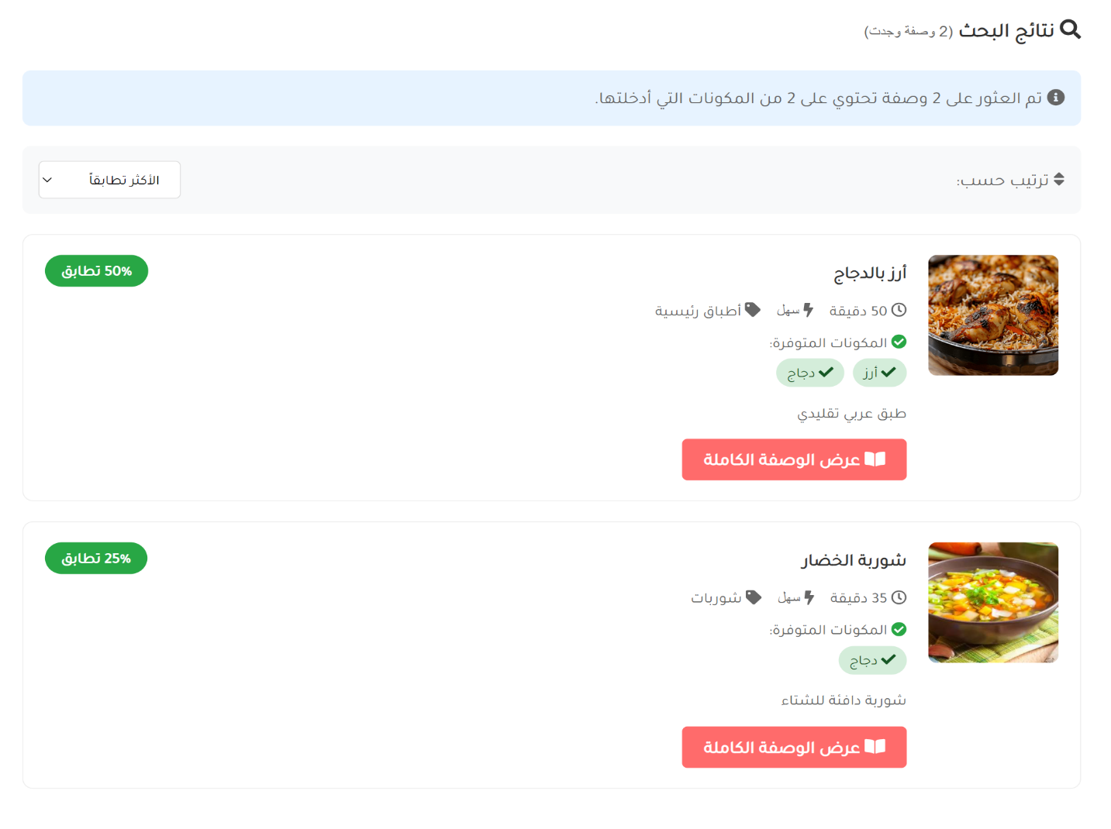

CODE:
<?php
require_once 'includes/config.php';
$page_title = 'البحث الذكي للوصفات';
require_once 'includes/header.php';
$results = [];
$search_performed = false;
$user_ingredients = [];
if(isset($_GET['q']) && !empty(trim($_GET['q']))) {
$search_query = clean_input($_GET['q']);
$user_ingredients = explode(' ', $search_query);
$user_ingredients = array_map('trim', $user_ingredients);
$user_ingredients = array_filter($user_ingredients);
}
if($_SERVER['REQUEST_METHOD'] == 'POST' && isset($_POST['ingredients'])) {
$search_performed = true;
$user_ingredients = explode(',', $_POST['ingredients']);
$user_ingredients = array_map('trim', $user_ingredients);
$user_ingredients = array_filter($user_ingredients);
}
elseif(isset($_GET['q']) && !empty(trim($_GET['q']))) {
$search_performed = true;
}
if($search_performed && count($user_ingredients) > 0) {
try {
$sql = "SELECT *,
(";
foreach($user_ingredients as $index => $ingredient) {
if($index > 0) $sql .= " + ";
$sql .= "CASE WHEN ingredients LIKE ? OR title LIKE ? THEN 1 ELSE 0 END";
}
$sql .= ") AS match_count,
(";
foreach($user_ingredients as $index => $ingredient) {
if($index > 0) $sql .= " + ";
$sql .= "CASE WHEN ingredients LIKE ? OR title LIKE ? THEN 1 ELSE 0 END";
}
$sql .= ") / " . (count($user_ingredients) * 2) . " * 100 AS match_percentage
FROM recipes
HAVING match_count > 0
ORDER BY match_count DESC, prep_time ASC
LIMIT 20";
$params = [];
foreach($user_ingredients as $ingredient) {
$params[] = "%$ingredient%";
$params[] = "%$ingredient%";
}
foreach($user_ingredients as $ingredient) {
$params[] = "%$ingredient%";
$params[] = "%$ingredient%";
}
$stmt = $pdo->prepare($sql);
$stmt->execute($params);
$results = $stmt->fetchAll();
} catch(PDOException $e) {
echo show_message('error', 'خطأ في البحث: ' . $e->getMessage());
}
}
?>
<section class = "container" id = "contact">
<div class="recipe-builder">
<div style="color: black; padding: 40px; border-radius: 15px; margin-bottom: 30px;">
<div class = "line center">
<div></div>
<span><i class = "fas fa-utensils"></i></span>
<div></div>
</div>
<h1 style="text-align: center; margin-bottom: 10px;font-family: 'Tajawal',sans-serif;"><i class="fas fa-magic"></i> باحث الوصفات الذكي</h1>
<p style="text-align: center; opacity: 0.9; font-size: 1.1rem;font-family: 'Tajawal',sans-serif;">
أدخل المكونات المتوفرة لديك، وسنقترح عليك أفضل الوصفات المناسبة!
</p>
</div>
<!-- نموذج إدخال المكونات -->
<div style="background: white; padding: 30px; border-radius: 10px; box-shadow: 0 5px 15px rgba(0,0,0,0.1); margin-bottom: 30px;">
<h3 style="color: #333; margin-bottom: 20px;font-family: 'Tajawal',sans-serif;"><i class="fas fa-plus-circle"></i> أضف المكونات المتوفرة لديك</h3>
<form method="POST" id="smartForm">
<div style="display: flex; gap: 10px; margin-bottom: 20px; flex-wrap: wrap;">
<input type="text" id="ingredientInput"
placeholder="اكتب مكوناً (مثال: طماطم، دجاج، أرز...)"
style="flex: 1; min-width: 200px; padding: 12px 15px; border: 2px solid #ddd; border-radius: 8px; font-size: 1rem;font-family: 'Tajawal',sans-serif;"
autocomplete="off"
value="<?php echo isset($_GET['q']) ? htmlspecialchars($_GET['q']) : ''; ?>">
<button type="button" onclick="addIngredient()"
class="btn btn-primary"
style="display: flex; align-items: center; gap: 5px;font-family: 'Tajawal',sans-serif;">
<i class="fas fa-plus"></i> إضافة مكون
</button>
</div>
<!-- عرض المكونات المضافة -->
<div id="ingredientsContainer" style="margin-bottom: 20px; min-height: 50px; padding: 15px; background: #f8f9fa; border-radius: 8px;">
<div id="ingredientsList" style="display: flex; flex-wrap: wrap; gap: 10px;"></div>
<div id="noIngredientsMessage" style="text-align: center; color: #999; padding: 10px;font-family: 'Tajawal',sans-serif;">
لم تقم بإضافة أي مكونات بعد. ابدأ بإضافة المكونات المتوفرة لديك.
</div>
</div>
<input type="hidden" name="ingredients" id="hiddenIngredients">
<div style="text-align: center;">
<button type="submit" class="btn btn-primary" style="padding: 12px 40px; font-size: 1.1rem;font-family: 'Tajawal',sans-serif;">
<i class="fas fa-search"></i> ابحث عن وصفات مناسبة
</button>
<button type="button" onclick="clearAllIngredients()" class="btn btn-primary" style="margin-right: 10px;font-family: 'Tajawal',sans-serif;background: #fa1414ff;">
<i class="fas fa-trash"></i> مسح الكل
</button>
</div>
</form>
</div>
<!-- عرض النتائج -->
<?php if($search_performed): ?>
<div style="background: white; padding: 30px; border-radius: 10px; box-shadow: 0 5px 15px rgba(0,0,0,0.1);">
<h3 style="color: #333; margin-bottom: 20px;font-family: 'Tajawal',sans-serif;">
<i class="fas fa-search"></i> نتائج البحث
<span style="font-size: 0.9rem; color: #666; font-weight: normal;">
(<?php echo count($results); ?> وصفة وجدت)
</span>
</h3>
<?php if(count($results) > 0): ?>
<div style="color: #666; margin-bottom: 20px; padding: 15px; background: #e7f3ff; border-radius: 8px;font-family: 'Tajawal',sans-serif;">
<i class="fas fa-info-circle"></i>
تم العثور على <?php echo count($results); ?> وصفة تحتوي على
<?php echo count($user_ingredients ?? []); ?> من المكونات التي أدخلتها.
</div>
<!-- شريط ترتيب النتائج -->
<div style="display: flex; justify-content: space-between; align-items: center; margin-bottom: 20px; padding: 15px; background: #f8f9fa; border-radius: 8px;">
<div style="color: #666;font-family: 'Tajawal',sans-serif;">
<i class="fas fa-sort"></i> ترتيب حسب:
</div>
<div>
<select id="sortResults" onchange="sortRecipes()" style="padding: 8px 15px; border: 1px solid #ddd; border-radius: 5px;font-family: 'Tajawal',sans-serif;">
<option value="match">الأكثر تطابقاً</option>
<option value="time">الأسرع تحضيراً</option>
<option value="easy">الأسهل</option>
</select>
</div>
</div>
<!-- قائمة النتائج -->
<div id="resultsContainer">
<?php foreach($results as $recipe): ?>
<div class="result-card"
data-match="<?php echo $recipe['match_percentage']; ?>"
data-time="<?php echo $recipe['prep_time']; ?>"
data-difficulty="<?php echo $recipe['difficulty'] == 'سهل' ? 1 : ($recipe['difficulty'] == 'متوسط' ? 2 : 3); ?>"
style="margin-bottom: 20px; padding: 20px; border: 1px solid #eee; border-radius: 10px; transition: all 0.3s;">
<div style="display: flex; gap: 20px; align-items: start;">
<?php if(!empty($recipe['image'])): ?>
<img src="uploads/<?php echo $recipe['image']; ?>"
alt="<?php echo $recipe['title']; ?>"
style="width: 120px; height: 120px; object-fit: cover; border-radius: 8px;">
<?php else: ?>
<div style="width: 120px; height: 120px; background: linear-gradient(45deg, #ff6b6b, #ff8e53); border-radius: 8px; display: flex; align-items: center; justify-content: center; color: white; font-size: 2rem;">
<i class="fas fa-utensils"></i>
</div>
<?php endif; ?>
<div style="flex: 1;">
<div style="display: flex; justify-content: space-between; align-items: start; margin-bottom: 10px;">
<h4 style="margin: 0; color: #333;font-family: 'Tajawal',sans-serif;">
<a href="recipe-detail.php?id=<?php echo $recipe['id']; ?>" style="color: #333; text-decoration: none;font-family: 'Tajawal',sans-serif;">
<?php echo $recipe['title']; ?>
</a>
</h4>
<!-- نسبة التطابق -->
<div style="background: #28a745; color: white; padding: 5px 15px; border-radius: 20px; font-weight: bold; font-size: 0.9rem;font-family: 'Tajawal',sans-serif;">
<?php echo round($recipe['match_percentage']); ?>% تطابق
</div>
</div>
<!-- معلومات الوصفة -->
<div style="display: flex; gap: 15px; margin-bottom: 10px; color: #666; font-size: 0.9rem;">
<span style="font-family: 'Tajawal',sans-serif;"><i class="far fa-clock"></i> <?php echo $recipe['prep_time']; ?> دقيقة</span>
<span><i class="fas fa-bolt"></i> <?php echo $recipe['difficulty']; ?></span>
<?php if(!empty($recipe['category'])): ?>
<span style="font-family: 'Tajawal',sans-serif;"><i class="fas fa-tag"></i> <?php echo $recipe['category']; ?></span>
<?php endif; ?>
</div>
<!-- المكونات المتطابقة -->
<div style="margin-bottom: 15px;">
<div style="font-size: 0.9rem; color: #666; margin-bottom: 5px;font-family: 'Tajawal',sans-serif;">
<i class="fas fa-check-circle" style="color: #28a745;"></i>
المكونات المتوفرة:
</div>
<div style="display: flex; flex-wrap: wrap; gap: 8px;font-family: 'Tajawal',sans-serif;">
<?php
foreach($user_ingredients as $ingredient):
if(stripos($recipe['ingredients'], $ingredient) !== false):
?>
<span style="background: #d4edda; color: #155724; padding: 4px 10px; border-radius: 15px; font-size: 0.85rem;font-family: 'Tajawal',sans-serif;">
<i class="fas fa-check"></i> <?php echo $ingredient; ?>
</span>
<?php
endif;
endforeach;
?>
</div>
</div>
<!-- وصف مختصر -->
<p style="color: #666; font-size: 0.9rem; line-height: 1.5; margin-bottom: 15px;font-family: 'Tajawal',sans-serif;">
<?php
$desc = $recipe['description'];
echo strlen($desc) > 150 ? substr($desc, 0, 150) . '...' : $desc;
?>
</p>
<a href="recipe-detail.php?id=<?php echo $recipe['id']; ?>" class="btn btn-primary" style="padding: 8px 20px;font-family: 'Tajawal',sans-serif;">
<i class="fas fa-book-open"></i> عرض الوصفة الكاملة
</a>
</div>
</div>
</div>
<?php endforeach; ?>
</div>
<?php else: ?>
<div style="text-align: center; padding: 40px 20px;">
<i class="fas fa-search" style="font-size: 4rem; color: #ddd; margin-bottom: 20px;"></i>
<h4 style="color: #666; margin-bottom: 15px;font-family: 'Tajawal',sans-serif;">لم نعثر على وصفات مناسبة</h4>
<p style="color: #999; margin-bottom: 20px;font-family: 'Tajawal',sans-serif;">
لم نتمكن من العثور على وصفات تحتوي على المكونات التي أدخلتها.<br>
حاول إضافة مكونات مختلفة أو تصفح <a href="recipes.php" style="font-family: 'Tajawal',sans-serif;">جميع الوصفات</a>.
</p>
<button onclick="clearAllIngredients()" class="btn btn-primary" style="font-family: 'Tajawal',sans-serif;">
<i class="fas fa-redo"></i> جرب مكونات مختلفة
</button>
</div>
<?php endif; ?>
</div>
<?php endif; ?>
<!-- اقتراحات للمستخدم -->
<?php if(!$search_performed): ?>
<div style="background: #e7f3ff; padding: 25px; border-radius: 10px; margin-top: 30px;">
<h4 style="color: #0056b3; margin-bottom: 15px;font-family: 'Tajawal',sans-serif;"><i class="fas fa-lightbulb"></i> نصائح للاستخدام</h4>
<div style="display: grid; grid-template-columns: repeat(auto-fit, minmax(250px, 1fr)); gap: 15px;">
<div style="padding: 15px; background: white; border-radius: 8px;">
<div style="font-size: 1.5rem; color: #ff6b6b; margin-bottom: 10px;">
<i class="fas fa-list"></i>
</div>
<div style="font-weight: bold; color: #333; margin-bottom: 5px;font-family: 'Tajawal',sans-serif;">أدخل المكونات الأساسية</div>
<div style="color: #666; font-size: 0.9rem;font-family: 'Tajawal',sans-serif;">أدخل 3-5 مكونات رئيسية متوفرة لديك للحصول على أفضل النتائج</div>
</div>
<div style="padding: 15px; background: white; border-radius: 8px;">
<div style="font-size: 1.5rem; color: #28a745; margin-bottom: 10px;">
<i class="fas fa-clock"></i>
</div>
<div style="font-weight: bold; color: #333; margin-bottom: 5px;font-family: 'Tajawal',sans-serif;">وفر الوقت</div>
<div style="color: #666; font-size: 0.9rem;font-family: 'Tajawal',sans-serif;">ابحث عن وصفات تستخدم ما لديك بالفعل في المطبخ</div>
</div>
<div style="padding: 15px; background: white; border-radius: 8px;">
<div style="font-size: 1.5rem; color: #007bff; margin-bottom: 10px;">
<i class="fas fa-utensils"></i>
</div>
<div style="font-weight: bold; color: #333; margin-bottom: 5px;font-family: 'Tajawal',sans-serif;">اكتشف وصفات جديدة</div>
<div style="color: #666; font-size: 0.9rem;font-family: 'Tajawal',sans-serif;">تعرف على وصفات لم تكن تعلم أنها ممكنة بمكوناتك</div>
</div>
</div>
</div>
<?php endif; ?>
</div>
</section>
<?php
require_once 'includes/footer.php';
?>
<script>
let ingredients = [];
function addIngredient() {
const input = document.getElementById('ingredientInput');
const ingredient = input.value.trim();
if (ingredient && !ingredients.includes(ingredient)) {
ingredients.push(ingredient);
updateIngredientsList();
input.value = '';
input.focus();
}
}
function removeIngredient(index) {
ingredients.splice(index, 1);
updateIngredientsList();
}
function updateIngredientsList() {
const listDiv = document.getElementById('ingredientsList');
const container = document.getElementById('ingredientsContainer');
const noIngredientsMsg = document.getElementById('noIngredientsMessage');
const hiddenInput = document.getElementById('hiddenIngredients');
listDiv.innerHTML = '';
if (ingredients.length > 0) {
noIngredientsMsg.style.display = 'none';
ingredients.forEach((ingredient, index) => {
const badge = document.createElement('div');
badge.style.cssText = `
background: #ff6b6b;
color: white;
padding: 8px 15px;
border-radius: 20px;
display: flex;
align-items: center;
gap: 8px;
font-size: 0.9rem;
`;
badge.innerHTML = `
${ingredient}
<button type="button" onclick="removeIngredient(${index})"
style="background: none; border: none; color: white; cursor: pointer; padding: 0; font-size: 0.8rem;">
<i class="fas fa-times"></i>
</button>;
listDiv.appendChild(badge);
});
hiddenInput.value = ingredients.join(', ');
} else {
noIngredientsMsg.style.display = 'block';
hiddenInput.value = '';
}
}
function clearAllIngredients() {
ingredients = [];
updateIngredientsList();
document.getElementById('ingredientInput').focus();
}
function sortRecipes() {
const sortBy = document.getElementById('sortResults').value;
const container = document.getElementById('resultsContainer');
const cards = Array.from(container.getElementsByClassName('result-card'));
cards.sort((a, b) => {
if (sortBy === 'match') {
return parseFloat(b.dataset.match) - parseFloat(a.dataset.match);
} else if (sortBy === 'time') {
return parseFloat(a.dataset.time) - parseFloat(b.dataset.time);
} else if (sortBy === 'easy') {
return parseFloat(a.dataset.difficulty) - parseFloat(b.dataset.difficulty);
}
return 0;
});
cards.forEach(card => container.appendChild(card));
}
document.getElementById('ingredientInput').addEventListener('keypress', function(e) {
if (e.key === 'Enter') {
e.preventDefault();
addIngredient();
}
});
window.addEventListener('load', function() {
const exampleIngredients = ['طماطم', 'بصل', 'دجاج', 'أرز', 'زيت', 'ملح'];
const exampleBtn = document.createElement('button');
exampleBtn.type = 'button';
exampleBtn.className = 'btn btn-secondary';
exampleBtn.innerHTML = '<i class="fas fa-lightbulb"></i> جرب أمثلة';
exampleBtn.style.marginTop = '10px';
exampleBtn.onclick = function() {
ingredients = [...exampleIngredients];
updateIngredientsList();
};
document.querySelector('.ingredients-input').appendChild(exampleBtn);
});
</script>
<!-- jQuery -->
<script src = "assets/jquery/jquery-3.5.1.js"></script>
<!-- Fontawesome js -->
<script src = "assets/font-awesome/all.js"></script>
<!-- custom js file -->
<script src="js/script.js"></script>
7.3 Admin Panel (Admin Only)
- Dashboard page
Admin features include:
Viewing statistics (new users, new recipes), Managing all users, Managing all recipes
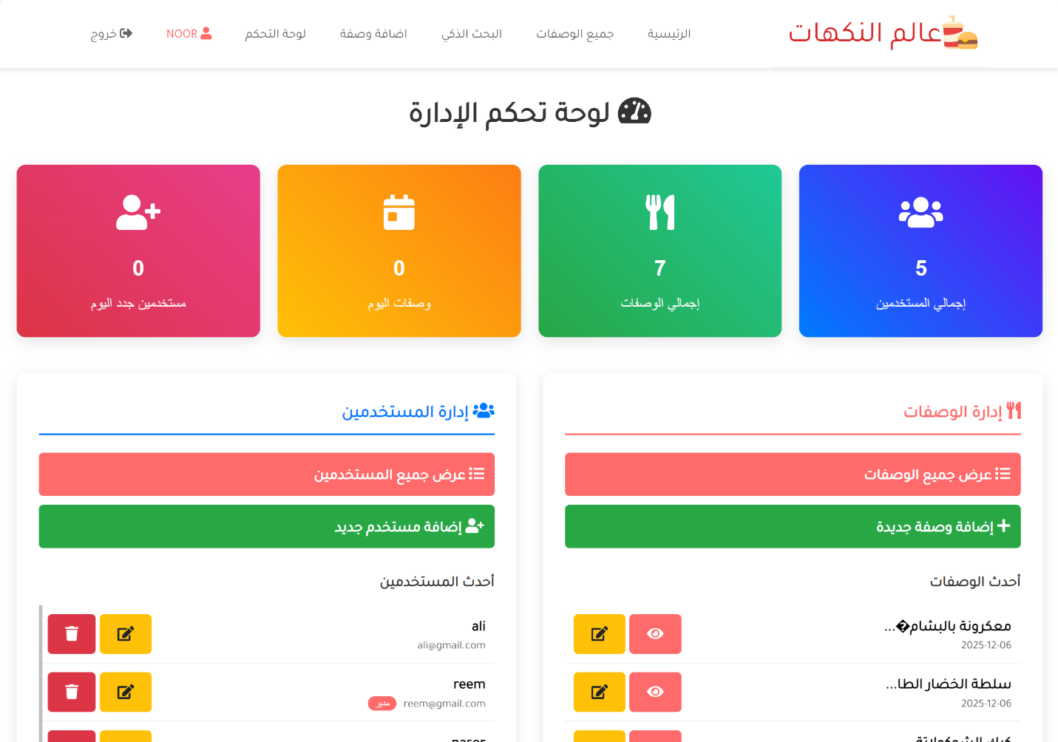

CODE:
<?php
require_once '../includes/config.php';
if(!is_logged_in() || !is_admin()) {
header('Location: ../login.php');
exit();
}
$page_title = 'لوحة تحكم الإدارة';
require_once 'header.php';
try {
$users_stmt = $pdo->query("SELECT COUNT(*) as count FROM users");
$users_count = $users_stmt->fetch()['count'];
$recipes_stmt = $pdo->query("SELECT COUNT(*) as count FROM recipes");
$recipes_count = $recipes_stmt->fetch()['count'];
$today = date('Y-m-d');
$today_stmt = $pdo->prepare("SELECT COUNT(*) as count FROM recipes WHERE DATE(created_at) = ?");
$today_stmt->execute([$today]);
$today_count = $today_stmt->fetch()['count'];
$new_users_stmt = $pdo->prepare("SELECT COUNT(*) as count FROM users WHERE DATE(created_at) = ?");
$new_users_stmt->execute([$today]);
$new_users_count = $new_users_stmt->fetch()['count'];
} catch(PDOException $e) {
die("خطأ في قاعدة البيانات: " . $e->getMessage());
}
?>
<div class="admin-dashboard" style="direction: rtl; padding: 20px;">
<h1 style="text-align: center; margin-bottom: 30px; color: #333;font-family: 'Tajawal',sans-serif;">
<i class="fas fa-tachometer-alt"></i> لوحة تحكم الإدارة
</h1>
<div class="stats-cards" style="display: grid; grid-template-columns: repeat(auto-fit, minmax(200px, 1fr)); gap: 20px; margin-bottom: 40px;">
<div style="background: linear-gradient(45deg, #007bff, #6610f2); color: white; padding: 25px; border-radius: 10px; text-align: center; box-shadow: 0 5px 15px rgba(0,0,0,0.1);">
<div style="font-size: 2.5rem; margin-bottom: 10px;">
<i class="fas fa-users"></i>
</div>
<h3 style="margin: 0; font-size: 1.5rem;"><?php echo $users_count; ?></h3>
<p style="margin: 5px 0 0; opacity: 0.9;">إجمالي المستخدمين</p>
</div>
<div style="background: linear-gradient(45deg, #28a745, #20c997); color: white; padding: 25px; border-radius: 10px; text-align: center; box-shadow: 0 5px 15px rgba(0,0,0,0.1);">
<div style="font-size: 2.5rem; margin-bottom: 10px;">
<i class="fas fa-utensils"></i>
</div>
<h3 style="margin: 0; font-size: 1.5rem;"><?php echo $recipes_count; ?></h3>
<p style="margin: 5px 0 0; opacity: 0.9;">إجمالي الوصفات</p>
</div>
<div style="background: linear-gradient(45deg, #ffc107, #fd7e14); color: white; padding: 25px; border-radius: 10px; text-align: center; box-shadow: 0 5px 15px rgba(0,0,0,0.1);">
<div style="font-size: 2.5rem; margin-bottom: 10px;">
<i class="fas fa-calendar-day"></i>
</div>
<h3 style="margin: 0; font-size: 1.5rem;"><?php echo $today_count; ?></h3>
<p style="margin: 5px 0 0; opacity: 0.9;">وصفات اليوم</p>
</div>
<div style="background: linear-gradient(45deg, #dc3545, #e83e8c); color: white; padding: 25px; border-radius: 10px; text-align: center; box-shadow: 0 5px 15px rgba(0,0,0,0.1);">
<div style="font-size: 2.5rem; margin-bottom: 10px;">
<i class="fas fa-user-plus"></i>
</div>
<h3 style="margin: 0; font-size: 1.5rem;"><?php echo $new_users_count; ?></h3>
<p style="margin: 5px 0 0; opacity: 0.9;">مستخدمين جدد اليوم</p>
</div>
</div>
<div style="display: grid; grid-template-columns: repeat(auto-fit, minmax(300px, 1fr)); gap: 30px;">
<!-- إدارة الوصفات -->
<div style="background: white; padding: 25px; border-radius: 10px; box-shadow: 0 5px 15px rgba(0,0,0,0.1);">
<h3 style="color: #ff6b6b; margin-bottom: 20px; padding-bottom: 10px; border-bottom: 2px solid #ff6b6b;font-family: 'Tajawal',sans-serif;">
<i class="fas fa-utensils"></i> إدارة الوصفات
</h3>
<div style="margin-bottom: 15px;">
<a href="manage-recipes.php" class="btn btn-primary" style="width: 100%; margin-bottom: 10px; text-align: right; display: block; padding: 12px;font-family: 'Tajawal',sans-serif;">
<i class="fas fa-list"></i> عرض جميع الوصفات
</a>
<a href="../add-recipe.php" class="btn btn-success" style="width: 100%; margin-bottom: 10px; text-align: right; display: block; padding: 12px;font-family: 'Tajawal',sans-serif;">
<i class="fas fa-plus"></i> إضافة وصفة جديدة
</a>
</div>
<!-- أحدث الوصفات -->
<?php
try {
$latest_recipes = $pdo->query("SELECT * FROM recipes ORDER BY created_at DESC LIMIT 5")->fetchAll();
} catch(PDOException $e) {
$latest_recipes = [];
}
?>
<h4 style="color: #333; margin: 20px 0 10px;font-family: 'Tajawal',sans-serif;">أحدث الوصفات</h4>
<div style="max-height: 250px; overflow-y: auto;">
<?php if(count($latest_recipes) > 0): ?>
<?php foreach($latest_recipes as $recipe): ?>
<div style="padding: 10px; border-bottom: 1px solid #eee; display: flex; justify-content: space-between; align-items: center;">
<div>
<div style="font-weight: bold;font-family: 'Tajawal',sans-serif;"><?php echo substr($recipe['title'], 0, 30); ?>...</div>
<div style="font-size: 0.8rem; color: #666;font-family: 'Tajawal',sans-serif;">
<?php echo date('Y-m-d', strtotime($recipe['created_at'])); ?>
</div>
</div>
<div>
<a href="../recipe-detail.php?id=<?php echo $recipe['id']; ?>" class="btn btn-sm btn-primary" title="عرض">
<i class="fas fa-eye"></i>
</a>
<a href="edit-recipe.php?id=<?php echo $recipe['id']; ?>" class="btn btn-sm btn-warning" title="تعديل">
<i class="fas fa-edit"></i>
</a>
</div>
</div>
<?php endforeach; ?>
<?php else: ?>
<p style="color: #999; text-align: center; padding: 20px;font-family: 'Tajawal',sans-serif;">لا توجد وصفات</p>
<?php endif; ?>
</div>
</div>
<!-- إدارة المستخدمين -->
<div style="background: white; padding: 25px; border-radius: 10px; box-shadow: 0 5px 15px rgba(0,0,0,0.1);">
<h3 style="color: #007bff; margin-bottom: 20px; padding-bottom: 10px; border-bottom: 2px solid #007bff;font-family: 'Tajawal',sans-serif;">
<i class="fas fa-users"></i> إدارة المستخدمين
</h3>
<div style="margin-bottom: 15px;">
<a href="manage-users.php" class="btn btn-primary" style="width: 100%; margin-bottom: 10px; text-align: right; display: block; padding: 12px;font-family: 'Tajawal',sans-serif;">
<i class="fas fa-list"></i> عرض جميع المستخدمين
</a>
<a href="add-user.php" class="btn btn-success" style="width: 100%; margin-bottom: 10px; text-align: right; display: block; padding: 12px;font-family: 'Tajawal',sans-serif;">
<i class="fas fa-user-plus"></i> إضافة مستخدم جديد
</a>
</div>
<!-- أحدث المستخدمين -->
<?php
try {
$latest_users = $pdo->query("SELECT * FROM users ORDER BY created_at DESC LIMIT 5")->fetchAll();
} catch(PDOException $e) {
$latest_users = [];
}
?>
<h4 style="color: #333; margin: 20px 0 10px;font-family: 'Tajawal',sans-serif;">أحدث المستخدمين</h4>
<div style="max-height: 250px; overflow-y: auto;">
<?php if(count($latest_users) > 0): ?>
<?php foreach($latest_users as $user): ?>
<div style="padding: 10px; border-bottom: 1px solid #eee; display: flex; justify-content: space-between; align-items: center;">
<div>
<div style="font-weight: bold;font-family: 'Tajawal',sans-serif;"><?php echo $user['username']; ?></div>
<div style="font-size: 0.8rem; color: #666;font-family: 'Tajawal',sans-serif;">
<?php echo $user['email']; ?>
<?php if($user['is_admin']): ?>
<span style="background: #ff6b6b; color: white; padding: 2px 8px; border-radius: 10px; font-size: 0.7rem; margin-right: 5px;">
مدير
</span>
<?php endif; ?>
</div>
</div>
<div>
<a href="edit-user.php?id=<?php echo $user['id']; ?>" class="btn btn-sm btn-warning" title="تعديل">
<i class="fas fa-edit"></i>
</a>
<?php if($user['id'] != $_SESSION['user_id']): ?>
<a href="delete-user.php?id=<?php echo $user['id']; ?>"
class="btn btn-sm btn-danger"
title="حذف"
onclick="return confirm('هل أنت متأكد من حذف هذا المستخدم؟')">
<i class="fas fa-trash"></i>
</a>
<?php endif; ?>
</div>
</div>
<?php endforeach; ?>
<?php else: ?>
<p style="color: #999; text-align: center; padding: 20px;font-family: 'Tajawal',sans-serif;">لا توجد مستخدمين</p>
<?php endif; ?>
</div>
</div>
</div>
<!-- لوحة التحكم السريعة -->
<div style="background: white; padding: 25px; border-radius: 10px; box-shadow: 0 5px 15px rgba(0,0,0,0.1); margin-top: 30px;">
<h3 style="color: #28a745; margin-bottom: 20px; padding-bottom: 10px; border-bottom: 2px solid #28a745;font-family: 'Tajawal',sans-serif;">
<i class="fas fa-cogs"></i> أدوات سريعة
</h3>
<div style="display: grid; grid-template-columns: repeat(auto-fit, minmax(200px, 1fr)); gap: 15px;">
<a href="../index.php" class="btn btn-primary" style="padding: 12px; text-align: center;font-family: 'Tajawal',sans-serif;">
<i class="fas fa-home"></i> العودة للرئيسية
</a>
</div>
</div>
<!-- ملاحظات سريعة -->
<div style="background: #fff3cd; padding: 20px; border-radius: 10px; margin-top: 30px; border: 1px solid #ffeaa7;">
<h4 style="color: #856404; margin-bottom: 10px;font-family: 'Tajawal',sans-serif;">
<i class="fas fa-info-circle"></i> ملاحظات هامة:
</h4>
<ul style="color: #856404; padding-right: 20px;">
<li style="margin-bottom: 8px;font-family: 'Tajawal',sans-serif;">لديك صلاحيات كاملة لإدارة الموقع</li>
<li style="margin-bottom: 8px;font-family: 'Tajawal',sans-serif;">يمكنك تعديل أو حذف أي وصفة أو مستخدم</li>
<li style="margin-bottom: 8px;font-family: 'Tajawal',sans-serif;">يوصى بعمل نسخة احتياطية دورية للبيانات</li>
<li style="font-family: 'Tajawal',sans-serif;">احرص على تحديث كلمات المرور بانتظام</li>
</ul>
</div>
</div>
<!-- jQuery -->
<script src = "../assets/jquery/jquery-3.5.1.js"></script>
<!-- Fontawesome js -->
<script src = "../assets/font-awesome/all.js"></script>
<!-- custom js file -->
<script src="../js/script.js"></script>
</body>
</html>
- Manage-users page
View all data of registered users on the site and be able to modify or delete data.
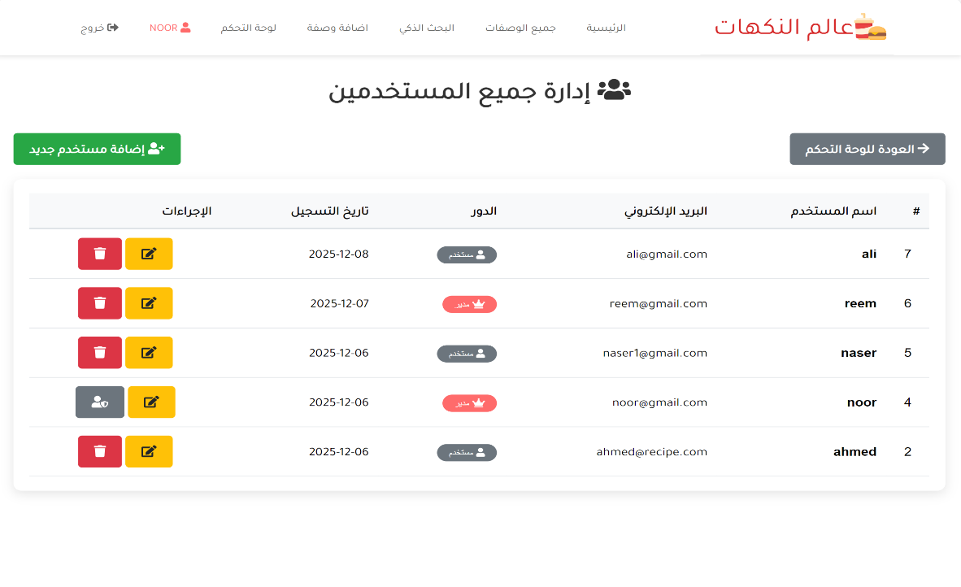

CODE:
<?php
require_once '../includes/config.php';
if(!is_logged_in() || !is_admin()) {
header('Location: ../login.php');
exit();
}
$page_title = 'إدارة المستخدمين';
require_once 'header.php';
try {
$stmt = $pdo->query("SELECT * FROM users ORDER BY created_at DESC");
$users = $stmt->fetchAll();
} catch(PDOException $e) {
die("خطأ في قاعدة البيانات: " . $e->getMessage());
}
if(isset($_GET['delete'])) {
$user_id = intval($_GET['delete']);
if($user_id == $_SESSION['user_id']) {
echo show_message('error', 'لا يمكنك حذف حسابك الخاص!');
} else {
try {
$stmt = $pdo->prepare("DELETE FROM users WHERE id = ?");
$stmt->execute([$user_id]);
echo show_message('success', 'تم حذف المستخدم بنجاح!');
echo '<script>setTimeout(function(){ window.location.href = "manage-users.php"; }, 1500);</script>';
} catch(PDOException $e) {
echo show_message('error', 'خطأ في حذف المستخدم: ' . $e->getMessage());
}
}
}
?>
<div class="manage-users" style="direction: rtl; padding: 20px;">
<h1 style="text-align: center; margin-bottom: 30px; color: #333;font-family: 'Tajawal',sans-serif;">
<i class="fas fa-users"></i> إدارة جميع المستخدمين
</h1>
<div style="display: flex; justify-content: space-between; align-items: center; margin-bottom: 20px;">
<a href="dashboard.php" class="btn btn-secondary" style="font-family: 'Tajawal',sans-serif;">
<i class="fas fa-arrow-right"></i> العودة للوحة التحكم
</a>
<a href="add-user.php" class="btn btn-success" style="font-family: 'Tajawal',sans-serif;">
<i class="fas fa-user-plus"></i> إضافة مستخدم جديد
</a>
</div>
<!-- جدول المستخدمين -->
<div style="background: white; padding: 20px; border-radius: 10px; box-shadow: 0 5px 15px rgba(0,0,0,0.1); overflow-x: auto;">
<?php if(count($users) > 0): ?>
<table style="width: 100%; border-collapse: collapse;">
<thead>
<tr style="background: #f8f9fa;">
<th style="padding: 12px; border-bottom: 2px solid #dee2e6; text-align: right;font-family: 'Tajawal',sans-serif;">#</th>
<th style="padding: 12px; border-bottom: 2px solid #dee2e6; text-align: right;font-family: 'Tajawal',sans-serif;">اسم المستخدم</th>
<th style="padding: 12px; border-bottom: 2px solid #dee2e6; text-align: right;font-family: 'Tajawal',sans-serif;">البريد الإلكتروني</th>
<th style="padding: 12px; border-bottom: 2px solid #dee2e6; text-align: right;font-family: 'Tajawal',sans-serif;">الدور</th>
<th style="padding: 12px; border-bottom: 2px solid #dee2e6; text-align: right;font-family: 'Tajawal',sans-serif;">تاريخ التسجيل</th>
<th style="padding: 12px; border-bottom: 2px solid #dee2e6; text-align: right;font-family: 'Tajawal',sans-serif;">الإجراءات</th>
</tr>
</thead>
<tbody>
<?php foreach($users as $user): ?>
<tr style="border-bottom: 1px solid #dee2e6;">
<td style="padding: 12px; text-align: center;"><?php echo $user['id']; ?></td>
<td style="padding: 12px;font-family: 'Tajawal',sans-serif;">
<strong><?php echo $user['username']; ?></strong>
</td>
<td style="padding: 12px;font-family: 'Tajawal',sans-serif;">
<?php echo $user['email']; ?>
</td>
<td style="padding: 12px;">
<?php if($user['is_admin']): ?>
<span style="background: #ff6b6b; color: white; padding: 5px 15px; border-radius: 15px; font-size: 0.8rem;">
<i class="fas fa-crown"></i> مدير
</span>
<?php else: ?>
<span style="background: #6c757d; color: white; padding: 5px 15px; border-radius: 15px; font-size: 0.8rem;">
<i class="fas fa-user"></i> مستخدم
</span>
<?php endif; ?>
</td>
<td style="padding: 12px;font-family: 'Tajawal',sans-serif;">
<?php echo date('Y-m-d', strtotime($user['created_at'])); ?>
</td>
<td style="padding: 12px; text-align: center;">
<a href="edit-user.php?id=<?php echo $user['id']; ?>" class="btn btn-sm btn-warning" title="تعديل">
<i class="fas fa-edit"></i>
</a>
<?php if($user['id'] != $_SESSION['user_id']): ?>
<a href="manage-users.php?delete=<?php echo $user['id']; ?>"
class="btn btn-sm btn-danger"
title="حذف"
onclick="return confirm('هل أنت متأكد من حذف المستخدم <?php echo addslashes($user['username']); ?>؟')">
<i class="fas fa-trash"></i>
</a>
<?php else: ?>
<span class="btn btn-sm btn-secondary" title="لا يمكن حذف حسابك">
<i class="fas fa-user-shield"></i>
</span>
<?php endif; ?>
</td>
</tr>
<?php endforeach; ?>
</tbody>
</table>
<?php else: ?>
<div style="text-align: center; padding: 40px 20px;">
<i class="fas fa-users" style="font-size: 4rem; color: #ddd; margin-bottom: 20px;"></i>
<h3 style="color: #666; margin-bottom: 15px;font-family: 'Tajawal',sans-serif;">لا يوجد مستخدمين</h3>
<p style="color: #999; margin-bottom: 25px;font-family: 'Tajawal',sans-serif;">لم يتم تسجيل أي مستخدمين بعد.</p>
<a href="add-user.php" class="btn btn-primary" style="font-family: 'Tajawal',sans-serif;">
<i class="fas fa-user-plus"></i> أضف أول مستخدم
</a>
</div>
<?php endif; ?>
</div>
</div>
<!-- jQuery -->
<script src = "../assets/jquery/jquery-3.5.1.js"></script>
<!-- Fontawesome js -->
<script src = "../assets/font-awesome/all.js"></script>
<!-- custom js file -->
<script src="../js/script.js"></script>
</body>
</html>

- Add-user page
View Create a new user or administrator account
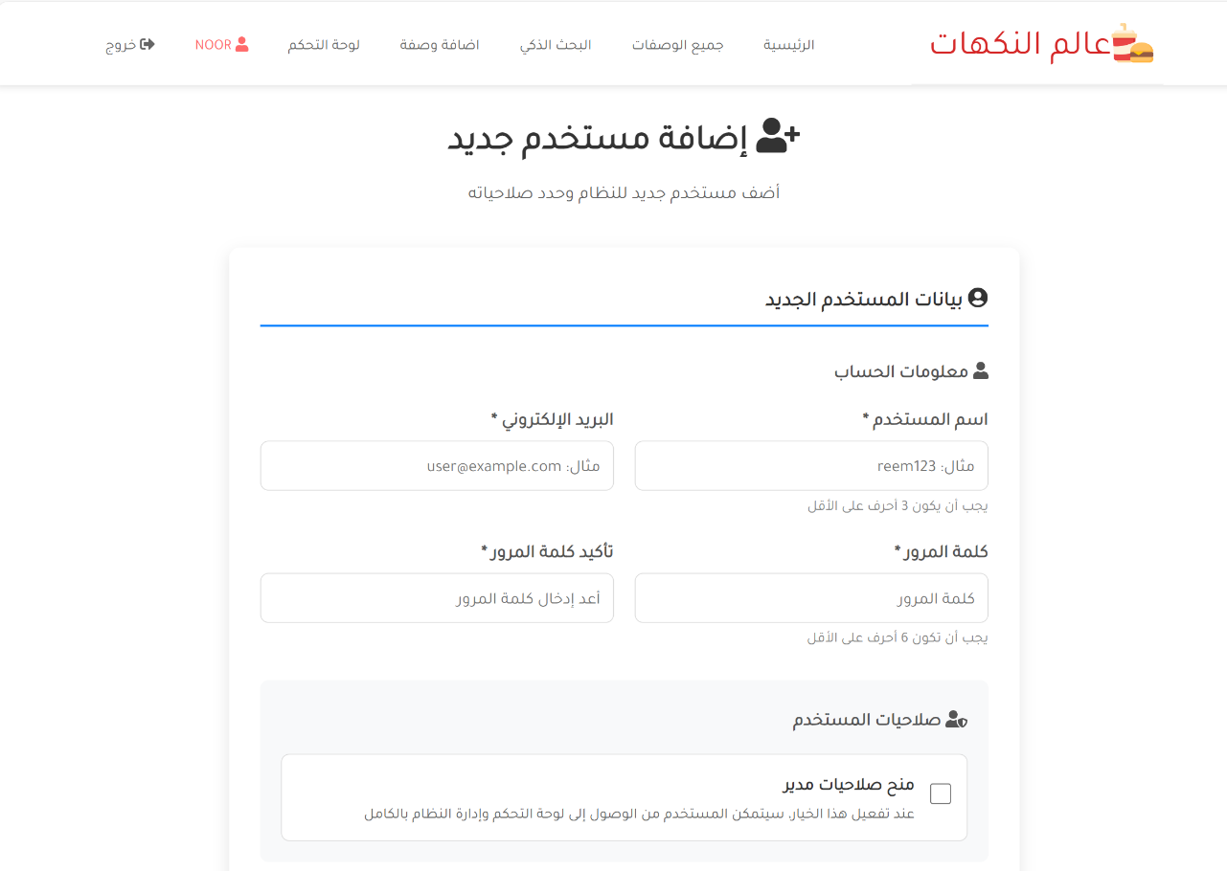

CODE:
<?php
require_once '../includes/config.php';
if(!is_logged_in() || !is_admin()) {
header('Location: ../login.php');
exit();
}
$page_title = 'إضافة مستخدم جديد';
require_once 'header.php';
$errors = [];
$success = false;
if($_SERVER['REQUEST_METHOD'] == 'POST') {
$username = clean_input($_POST['username']);
$email = clean_input($_POST['email']);
$password = $_POST['password'];
$confirm_password = $_POST['confirm_password'];
$is_admin = isset($_POST['is_admin']) ? 1 : 0;
if(empty($username)) {
$errors[] = 'اسم المستخدم مطلوب';
} elseif(strlen($username) < 3) {
$errors[] = 'اسم المستخدم يجب أن يكون 3 أحرف على الأقل';
}
if(empty($email)) {
$errors[] = 'البريد الإلكتروني مطلوب';
} elseif(!filter_var($email, FILTER_VALIDATE_EMAIL)) {
$errors[] = 'البريد الإلكتروني غير صحيح';
}
if(empty($password)) {
$errors[] = 'كلمة المرور مطلوبة';
} elseif(strlen($password) < 6) {
$errors[] = 'كلمة المرور يجب أن تكون 6 أحرف على الأقل';
}
if($password !== $confirm_password) {
$errors[] = 'كلمتا المرور غير متطابقتين';
}
if(empty($errors)) {
try {
$stmt = $pdo->prepare("SELECT id FROM users WHERE username = ? OR email = ?");
$stmt->execute([$username, $email]);
$existing_user = $stmt->fetch();
if($existing_user) {
$errors[] = 'اسم المستخدم أو البريد الإلكتروني موجود مسبقاً';
}
} catch(PDOException $e) {
$errors[] = 'خطأ في التحقق من البيانات: ' . $e->getMessage();
}
}
if(empty($errors)) {
try {
$hashed_password = password_hash($password, PASSWORD_DEFAULT);
$sql = "INSERT INTO users (username, email, password, is_admin) VALUES (?, ?, ?, ?)";
$stmt = $pdo->prepare($sql);
$stmt->execute([$username, $email, $hashed_password, $is_admin]);
$user_id = $pdo->lastInsertId();
$success = true;
echo '<div style="padding: 15px; background: #d4edda; color: #155724;
border: 1px solid #c3e6cb; border-radius: 5px; margin-bottom: 20px;font-family: \'Tajawal\',sans-serif;">
✅ تم إضافة المستخدم بنجاح!
<br><small>يمكنك <a href="manage-users.php" style="color: #0b2e13; font-weight: bold;">عرض جميع المستخدمين</a> أو <a href="add-user.php" style="color: #0b2e13; font-weight: bold;">إضافة مستخدم جديد</a></small>
</div>';
$_POST = [];
} catch(PDOException $e) {
$errors[] = 'خطأ في إضافة المستخدم: ' . $e->getMessage();
}
}
if(!empty($errors) && !$success) {
foreach($errors as $error) {
echo '<div style="padding: 15px; background: #f8d7da; color: #721c24;
border: 1px solid #f5c6cb; border-radius: 5px; margin-bottom: 20px;font-family: \'Tajawal\',sans-serif;">
' . $error . '
</div>';
}
}
}
?>

<div class="add-user-page" style="direction: rtl; padding: 20px; max-width: 800px; margin: 0 auto;">
<div style="text-align: center; margin-bottom: 40px;">
<h1 style="color: #333; margin-bottom: 10px;font-family: 'Tajawal',sans-serif;">
<i class="fas fa-user-plus"></i> إضافة مستخدم جديد
</h1>
<p style="color: #666;font-family: 'Tajawal',sans-serif;">
أضف مستخدم جديد للنظام وحدد صلاحياته
</p>
</div>
<?php if(!$success): ?>
<div style="background: white; padding: 30px; border-radius: 10px; box-shadow: 0 5px 15px rgba(0,0,0,0.1);">
<h3 style="color: #333; margin-bottom: 25px; padding-bottom: 10px; border-bottom: 2px solid #007bff;font-family: 'Tajawal',sans-serif;">
<i class="fas fa-user-circle"></i> بيانات المستخدم الجديد
</h3>
<form method="POST" action="">
<div style="margin-bottom: 30px;">
<h4 style="color: #555; margin-bottom: 15px;font-family: 'Tajawal',sans-serif;">
<i class="fas fa-user"></i> معلومات الحساب
</h4>
<div style="display: grid; grid-template-columns: 1fr 1fr; gap: 20px; margin-bottom: 20px;">
<div>
<label style="display: block; margin-bottom: 8px; color: #555; font-weight: 600;font-family: 'Tajawal',sans-serif;">
اسم المستخدم *
</label>
<input type="text" name="username" required
value="<?php echo $_POST['username'] ?? ''; ?>"
style="width: 100%; padding: 12px; border: 1px solid #ddd; border-radius: 8px; font-size: 1rem;font-family: 'Tajawal',sans-serif;"
placeholder="مثال: reem123">
<small style="color: #888;font-family: 'Tajawal',sans-serif;">يجب أن يكون 3 أحرف على الأقل</small>
</div>
<div>
<label style="display: block; margin-bottom: 8px; color: #555; font-weight: 600;font-family: 'Tajawal',sans-serif;">
البريد الإلكتروني *
</label>
<input type="email" name="email" required
value="<?php echo $_POST['email'] ?? ''; ?>"
style="width: 100%; padding: 12px; border: 1px solid #ddd; border-radius: 8px; font-size: 1rem;font-family: 'Tajawal',sans-serif;"
placeholder="مثال: user@example.com">
</div>
</div>
<div style="display: grid; grid-template-columns: 1fr 1fr; gap: 20px;">
<div>
<label style="display: block; margin-bottom: 8px; color: #555; font-weight: 600;font-family: 'Tajawal',sans-serif;">
كلمة المرور *
</label>
<input type="password" name="password" required
style="width: 100%; padding: 12px; border: 1px solid #ddd; border-radius: 8px; font-size: 1rem;font-family: 'Tajawal',sans-serif;"
placeholder="كلمة المرور">
<small style="color: #888;font-family: 'Tajawal',sans-serif;">يجب أن تكون 6 أحرف على الأقل</small>
</div>
<div>
<label style="display: block; margin-bottom: 8px; color: #555; font-weight: 600;font-family: 'Tajawal',sans-serif;">
تأكيد كلمة المرور *
</label>
<input type="password" name="confirm_password" required
style="width: 100%; padding: 12px; border: 1px solid #ddd; border-radius: 8px; font-size: 1rem;font-family: 'Tajawal',sans-serif;"
placeholder="أعد إدخال كلمة المرور">
</div>
</div>
</div>
<div style="margin-bottom: 30px; padding: 20px; background: #f8f9fa; border-radius: 8px;">
<h4 style="color: #555; margin-bottom: 15px;font-family: 'Tajawal',sans-serif;">
<i class="fas fa-user-shield"></i> صلاحيات المستخدم
</h4>
<div style="display: flex; align-items: center; gap: 15px; padding: 15px; background: white; border-radius: 8px; border: 1px solid #ddd;">
<div>
<input type="checkbox" name="is_admin" id="isAdmin"
<?php echo (isset($_POST['is_admin']) && $_POST['is_admin']) ? 'checked' : ''; ?>
style="width: 20px; height: 20px;">
</div>
<div>
<label for="isAdmin" style="font-weight: 600; color: #333; cursor: pointer;font-family: 'Tajawal',sans-serif;">
منح صلاحيات مدير
</label>
<p style="color: #666; margin: 5px 0 0; font-size: 0.9rem;font-family: 'Tajawal',sans-serif;">
عند تفعيل هذا الخيار، سيتمكن المستخدم من الوصول إلى لوحة التحكم وإدارة النظام بالكامل
</p>
</div>
</div>
</div>
<div style="background: #e7f3ff; padding: 15px; border-radius: 8px; margin-bottom: 30px;">
<h4 style="color: #0056b3; margin-bottom: 10px;font-family: 'Tajawal',sans-serif;">
<i class="fas fa-info-circle"></i> ملاحظات هامة
</h4>
<ul style="color: #0056b3; padding-right: 20px; margin: 0;">
<li style="font-family: 'Tajawal',sans-serif; margin-bottom: 5px;">سيتم تشفير كلمة المرور تلقائياً قبل تخزينها</li>
<li style="font-family: 'Tajawal',sans-serif; margin-bottom: 5px;">يمكن للمستخدم تعديل بياناته بعد تسجيل الدخول</li>
<li style="font-family: 'Tajawal',sans-serif;">يمكنك إدارة جميع المستخدمين من صفحة "إدارة المستخدمين"</li>
</ul>
</div>
<div style="display: flex; justify-content: center; gap: 15px; margin-top: 30px; padding-top: 20px; border-top: 1px solid #eee;">
<button type="submit" class="btn btn-success" style="padding: 12px 40px; font-size: 1.1rem;font-family: 'Tajawal',sans-serif;">
<i class="fas fa-check-circle"></i> إضافة المستخدم
</button>
<button type="reset" class="btn btn-secondary" style="font-family: 'Tajawal',sans-serif;">
<i class="fas fa-redo"></i> إعادة تعيين
</button>
<a href="dashboard.php" class="btn btn-outline-secondary" style="font-family: 'Tajawal',sans-serif;">
<i class="fas fa-arrow-right"></i> العودة للوحة التحكم
</a>
</div>
</form>
</div>
<?php endif; ?>
<?php if(!$success): ?>
<div style="display: grid; grid-template-columns: repeat(auto-fit, minmax(200px, 1fr)); gap: 15px; margin-top: 30px;">
<a href="manage-users.php" class="btn btn-outline-primary" style="text-align: center; padding: 15px;font-family: 'Tajawal',sans-serif;">
<i class="fas fa-list"></i> عرض جميع المستخدمين
</a>
<a href="dashboard.php" class="btn btn-outline-info" style="text-align: center; padding: 15px;font-family: 'Tajawal',sans-serif;">
<i class="fas fa-tachometer-alt"></i> لوحة التحكم
</a>
<a href="../index.php" class="btn btn-outline-secondary" style="text-align: center; padding: 15px;font-family: 'Tajawal',sans-serif;">
<i class="fas fa-home"></i> الصفحة الرئيسية
</a>
</div>
<?php else: ?>
<div style="text-align: center; margin-top: 40px;">
<a href="add-user.php" class="btn btn-primary" style="margin: 5px;font-family: 'Tajawal',sans-serif;">
<i class="fas fa-user-plus"></i> إضافة مستخدم آخر
</a>
<a href="manage-users.php" class="btn btn-success" style="margin: 5px;font-family: 'Tajawal',sans-serif;">
<i class="fas fa-list"></i> عرض جميع المستخدمين
</a>
<a href="dashboard.php" class="btn btn-info" style="margin: 5px;font-family: 'Tajawal',sans-serif;">
<i class="fas fa-tachometer-alt"></i> العودة للوحة التحكم
</a>
</div>
<?php endif; ?>
</div>
<script>
document.querySelector('input[name="password"]').addEventListener('input', function(e) {
const password = e.target.value;
const strength = calculatePasswordStrength(password);
updatePasswordStrengthIndicator(strength);
});
function calculatePasswordStrength(password) {
let strength = 0;
if(password.length >= 8) strength += 1;
if(password.length >= 12) strength += 1;
if(/[A-Z]/.test(password)) strength += 1;
if(/[a-z]/.test(password)) strength += 1;
if(/[0-9]/.test(password)) strength += 1;
if(/[^A-Za-z0-9]/.test(password)) strength += 1;
return Math.min(strength, 5);
}
function updatePasswordStrengthIndicator(strength) {
let indicator = document.getElementById('passwordStrength');
if(!indicator) {
indicator = document.createElement('div');
indicator.id = 'passwordStrength';
indicator.style.marginTop = '5px';
document.querySelector('input[name="password"]').parentNode.appendChild(indicator);
}
const strengthText = ['ضعيفة جداً', 'ضعيفة', 'متوسطة', 'جيدة', 'قوية', 'قوية جداً'];
const strengthColors = ['#dc3545', '#ff6b6b', '#ffc107', '#28a745', '#20c997', '#007bff'];

indicator.innerHTML = `
<div style="font-size: 0.85rem; color: ${strengthColors[strength]}; font-weight: bold;font-family: 'Tajawal',sans-serif;">
<i class="fas fa-shield-alt"></i> قوة كلمة المرور: ${strengthText[strength]}
</div>
<div style="height: 5px; background: #eee; border-radius: 3px; margin-top: 5px; overflow: hidden;">
<div style="width: ${(strength / 5) * 100}%; height: 100%; background: ${strengthColors[strength]};"></div>
</div>
`;
}
document.querySelector('input[name="confirm_password"]').addEventListener('input', function(e) {
const password = document.querySelector('input[name="password"]').value;
const confirmPassword = e.target.value;
const matchIndicator = document.getElementById('passwordMatch');
if(!matchIndicator) {
const indicator = document.createElement('div');
indicator.id = 'passwordMatch';
indicator.style.marginTop = '5px';
e.target.parentNode.appendChild(indicator);
}
if(confirmPassword === '') {
matchIndicator.innerHTML = '';
} else if(password === confirmPassword) {
matchIndicator.innerHTML = '<div style="color: #28a745; font-size: 0.85rem;font-family: \'Tajawal\',sans-serif;"><i class="fas fa-check-circle"></i> كلمتا المرور متطابقتان</div>';
} else {
matchIndicator.innerHTML = '<div style="color: #dc3545; font-size: 0.85rem;font-family: \'Tajawal\',sans-serif;"><i class="fas fa-times-circle"></i> كلمتا المرور غير متطابقتان</div>';
}
});
</script>
<!-- jQuery -->
<script src = "../assets/jquery/jquery-3.5.1.js"></script>
<!-- Fontawesome js -->
<script src = "../assets/font-awesome/all.js"></script>
<!-- custom js file -->
<script src="../js/script.js"></script>
</body>
</html>

- Edit-user page
This page allows you to edit user data
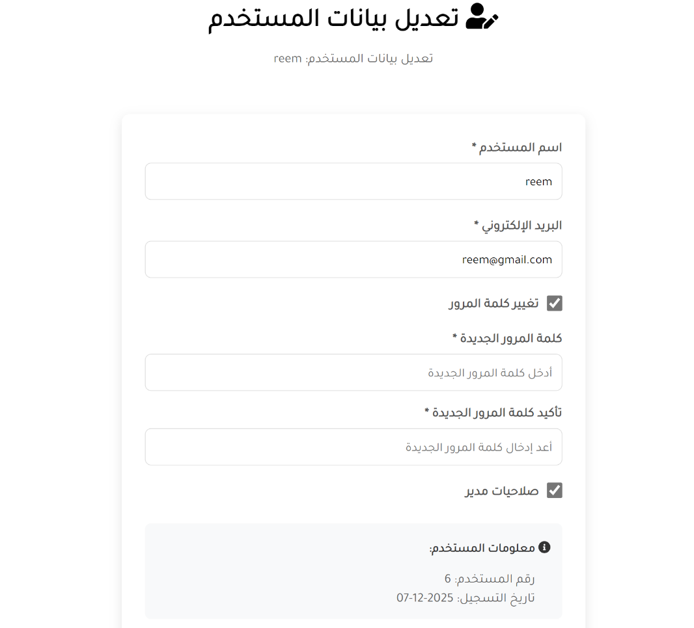

CODE:
<?php
require_once '../includes/config.php';
if(!is_logged_in() || !is_admin()) {
header('Location: ../login.php');
exit();
}
if(!isset($_GET['id']) || !is_numeric($_GET['id'])) {
header('Location: manage-users.php');
exit();
}
$user_id = intval($_GET['id']);
try {
$stmt = $pdo->prepare("SELECT * FROM users WHERE id = ?");
$stmt->execute([$user_id]);
$user = $stmt->fetch();

if(!$user) {
header('Location: manage-users.php');
exit();
}
} catch(PDOException $e) {
die("خطأ في قاعدة البيانات: " . $e->getMessage());
}
$page_title = 'تعديل بيانات المستخدم';
require_once 'header.php';
$errors = [];
$success = false;
if($_SERVER['REQUEST_METHOD'] == 'POST') {
$username = clean_input($_POST['username']);
$email = clean_input($_POST['email']);
$is_admin = isset($_POST['is_admin']) ? 1 : 0;
$change_password = isset($_POST['change_password']);
if(empty($username)) {
$errors[] = 'اسم المستخدم مطلوب';
} elseif(strlen($username) < 3) {
$errors[] = 'اسم المستخدم يجب أن يكون 3 أحرف على الأقل';
}
if(empty($email)) {
$errors[] = 'البريد الإلكتروني مطلوب';
} elseif(!filter_var($email, FILTER_VALIDATE_EMAIL)) {
$errors[] = 'البريد الإلكتروني غير صحيح';
}
if($change_password) {
$password = $_POST['password'];
$confirm_password = $_POST['confirm_password'];
if(empty($password)) {
$errors[] = 'كلمة المرور مطلوبة';
} elseif(strlen($password) < 6) {
$errors[] = 'كلمة المرور يجب أن تكون 6 أحرف على الأقل';
}
if($password !== $confirm_password) {
$errors[] = 'كلمتا المرور غير متطابقتين';
}
}
if(empty($errors)) {
try {
$stmt = $pdo->prepare("SELECT id FROM users WHERE (username = ? OR email = ?) AND id != ?");
$stmt->execute([$username, $email, $user_id]);
$existing_user = $stmt->fetch();
if($existing_user) {
$errors[] = 'اسم المستخدم أو البريد الإلكتروني موجود مسبقاً لمستخدم آخر';
}
} catch(PDOException $e) {
$errors[] = 'خطأ في التحقق من البيانات: ' . $e->getMessage();
}
}
if(empty($errors)) {
try {
if($change_password) {
$hashed_password = password_hash($password, PASSWORD_DEFAULT);
$sql = "UPDATE users SET username = ?, email = ?, password = ?, is_admin = ? WHERE id = ?";
$stmt = $pdo->prepare($sql);
$stmt->execute([$username, $email, $hashed_password, $is_admin, $user_id]);
} else {
$sql = "UPDATE users SET username = ?, email = ?, is_admin = ? WHERE id = ?";
$stmt = $pdo->prepare($sql);
$stmt->execute([$username, $email, $is_admin, $user_id]);
}
$success = true;
echo show_message('success', 'تم تحديث بيانات المستخدم بنجاح! <a href="manage-users.php">عرض جميع المستخدمين</a>');
if($user_id == $_SESSION['user_id']) {
$_SESSION['username'] = $username;
$_SESSION['email'] = $email;
$_SESSION['user_role'] = $is_admin ? 'admin' : 'user';
}
} catch(PDOException $e) {
$errors[] = 'خطأ في تحديث المستخدم: ' . $e->getMessage();
}
}
if(!empty($errors)) {
foreach($errors as $error) {
echo show_message('error', $error);
}
}
}
if($success) {
try {
$stmt = $pdo->prepare("SELECT * FROM users WHERE id = ?");
$stmt->execute([$user_id]);
$user = $stmt->fetch();
} catch(PDOException $e) {
die("خطأ في قاعدة البيانات: " . $e->getMessage());
}
}
?>
<div class="edit-user-page" style="direction: rtl; padding: 20px;">
<div style="color: black; padding: 30px; border-radius: 10px; margin-bottom: 30px;">
<h1 style="text-align: center; margin-bottom: 10px;font-family: 'Tajawal',sans-serif;">
<i class="fas fa-user-edit"></i> تعديل بيانات المستخدم
</h1>
<p style="text-align: center; color: #666;font-family: 'Tajawal',sans-serif;">
تعديل بيانات المستخدم: <?php echo $user['username']; ?>
</p>
</div>
<?php if(!$success): ?>
<form method="POST" action="" style="background: white; padding: 30px; border-radius: 10px; box-shadow: 0 5px 15px rgba(0,0,0,0.1); max-width: 600px; margin: 0 auto;">
<div style="margin-bottom: 20px;">
<label style="display: block; margin-bottom: 8px; color: #555; font-weight: 600;font-family: 'Tajawal',sans-serif;">
اسم المستخدم *
</label>
<input type="text" name="username" required
value="<?php echo $_POST['username'] ?? $user['username']; ?>"
style="width: 100%; padding: 12px; border: 1px solid #ddd; border-radius: 8px; font-size: 1rem;font-family: 'Tajawal',sans-serif;"
placeholder="أدخل اسم المستخدم">
</div>
<div style="margin-bottom: 20px;">
<label style="display: block; margin-bottom: 8px; color: #555; font-weight: 600;font-family: 'Tajawal',sans-serif;">
البريد الإلكتروني *
</label>
<input type="email" name="email" required
value="<?php echo $_POST['email'] ?? $user['email']; ?>"
style="width: 100%; padding: 12px; border: 1px solid #ddd; border-radius: 8px; font-size: 1rem;font-family: 'Tajawal',sans-serif;"
placeholder="أدخل البريد الإلكتروني">
</div>
<div style="margin-bottom: 20px;">
<label style="display: flex; align-items: center; gap: 10px; color: #555; font-weight: 600;font-family: 'Tajawal',sans-serif;">
<input type="checkbox" name="change_password" id="changePassword"
style="width: 20px; height: 20px;">
تغيير كلمة المرور
</label>
</div>

<div id="passwordFields" style="display: none; margin-bottom: 20px;">
<div style="margin-bottom: 15px;">
<label style="display: block; margin-bottom: 8px; color: #555; font-weight: 600;font-family: 'Tajawal',sans-serif;">
كلمة المرور الجديدة *
</label>
<input type="password" name="password"
style="width: 100%; padding: 12px; border: 1px solid #ddd; border-radius: 8px; font-size: 1rem;font-family: 'Tajawal',sans-serif;"
placeholder="أدخل كلمة المرور الجديدة">
</div>
<div style="margin-bottom: 15px;">
<label style="display: block; margin-bottom: 8px; color: #555; font-weight: 600;font-family: 'Tajawal',sans-serif;">
تأكيد كلمة المرور الجديدة *
</label>
<input type="password" name="confirm_password"
style="width: 100%; padding: 12px; border: 1px solid #ddd; border-radius: 8px; font-size: 1rem;font-family: 'Tajawal',sans-serif;"
placeholder="أعد إدخال كلمة المرور الجديدة">
</div>
</div>
<div style="margin-bottom: 30px;">
<label style="display: flex; align-items: center; gap: 10px; color: #555; font-weight: 600;font-family: 'Tajawal',sans-serif;">
<input type="checkbox" name="is_admin"
<?php echo (isset($_POST['is_admin']) ? $_POST['is_admin'] : $user['is_admin']) ? 'checked' : ''; ?>
style="width: 20px; height: 20px;">
صلاحيات مدير
</label>
</div>
<!-- معلومات إضافية -->
<div style="background: #f8f9fa; padding: 15px; border-radius: 8px; margin-bottom: 20px;">
<h4 style="color: #333; margin-bottom: 10px; font-size: 1rem;font-family: 'Tajawal',sans-serif;">
<i class="fas fa-info-circle"></i> معلومات المستخدم:
</h4>
<ul style="color: #666; padding-right: 20px; margin: 0;">
<li style="font-family: 'Tajawal',sans-serif;">رقم المستخدم: <?php echo $user['id']; ?></li>
<li style="font-family: 'Tajawal',sans-serif;">تاريخ التسجيل: <?php echo date('Y-m-d', strtotime($user['created_at'])); ?></li>
<?php if($user_id == $_SESSION['user_id']): ?>
<li style="font-family: 'Tajawal',sans-serif; color: #ff6b6b;"><strong>أنت تقوم بتعديل حسابك الخاص</strong></li>
<?php endif; ?>
</ul>
</div>
<!-- أزرار الإرسال -->
<div style="display: flex; justify-content: center; gap: 15px; margin-top: 30px; padding-top: 20px; border-top: 1px solid #eee;">
<button type="submit" class="btn btn-success" style="padding: 12px 40px; font-size: 1.1rem;font-family: 'Tajawal',sans-serif;">
<i class="fas fa-check-circle"></i> حفظ التعديلات
</button>
<a href="manage-users.php" class="btn btn-secondary" style="font-family: 'Tajawal',sans-serif;">
<i class="fas fa-times"></i> إلغاء
</a>
</div>
</form>
<?php endif; ?>
</div>
<script>
document.getElementById('changePassword').addEventListener('change', function() {
const passwordFields = document.getElementById('passwordFields');
const passwordInputs = passwordFields.querySelectorAll('input[name="password"], input[name="confirm_password"]');
if(this.checked) {
passwordFields.style.display = 'block';
passwordInputs.forEach(input => input.required = true);
} else {
passwordFields.style.display = 'none';
passwordInputs.forEach(input => input.required = false);
}
});
</script>
<!-- jQuery -->
<script src = "../assets/jquery/jquery-3.5.1.js"></script>
<!-- Fontawesome js -->
<script src = "../assets/font-awesome/all.js"></script>
<!-- custom js file -->
<script src="../js/script.js"></script>
</body>
</html>

- manage-recipes page
View all data of recipes on the site and be able to modify or delete data.
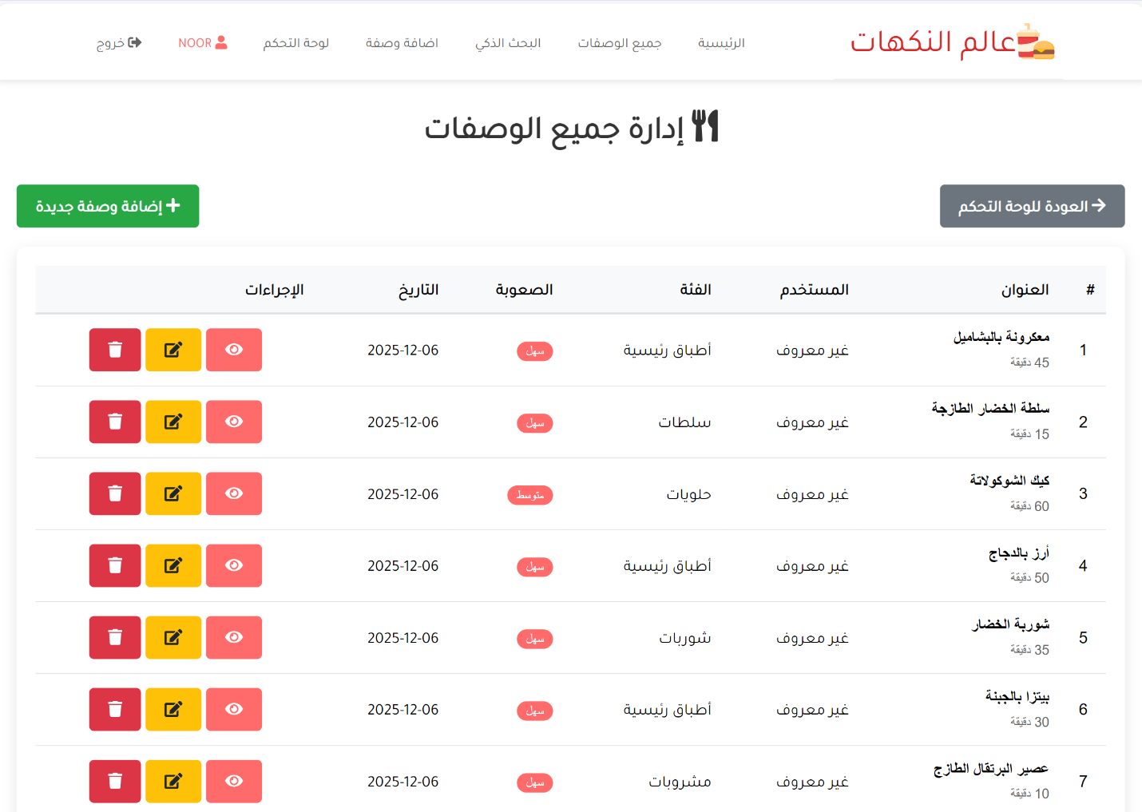

CODE:
<?php
require_once '../includes/config.php';
if(!is_logged_in() || !is_admin()) {
header('Location: ../login.php');
exit();
}
$page_title = 'إدارة الوصفات';
require_once 'header.php';
try {
$stmt = $pdo->query("SELECT r.*, u.username FROM recipes r LEFT JOIN users u ON r.user_id = u.id ORDER BY r.created_at DESC");
$recipes = $stmt->fetchAll();
} catch(PDOException $e) {
die("خطأ في قاعدة البيانات: " . $e->getMessage());
}
if(isset($_GET['delete'])) {
$recipe_id = intval($_GET['delete']);
try {
$stmt = $pdo->prepare("DELETE FROM recipes WHERE id = ?");
$stmt->execute([$recipe_id]);
echo show_message('success', 'تم حذف الوصفة بنجاح!');
echo '<script>setTimeout(function(){ window.location.href = "manage-recipes.php"; }, 1500);</script>';
} catch(PDOException $e) {
echo show_message('error', 'خطأ في حذف الوصفة: ' . $e->getMessage());
}
}
?>
<div class="manage-recipes" style="direction: rtl; padding: 20px;">
<h1 style="text-align: center; margin-bottom: 30px; color: #333;font-family: 'Tajawal',sans-serif;">
<i class="fas fa-utensils"></i> إدارة جميع الوصفات
</h1>
<div style="display: flex; justify-content: space-between; align-items: center; margin-bottom: 20px;">
<a href="dashboard.php" class="btn btn-secondary" style="font-family: 'Tajawal',sans-serif;">
<i class="fas fa-arrow-right"></i> العودة للوحة التحكم
</a>
<a href="../add-recipe.php" class="btn btn-success" style="font-family: 'Tajawal',sans-serif;">
<i class="fas fa-plus"></i> إضافة وصفة جديدة
</a>
</div>
<div style="background: white; padding: 20px; border-radius: 10px; box-shadow: 0 5px 15px rgba(0,0,0,0.1); overflow-x: auto;">
<?php if(count($recipes) > 0): ?>
<table style="width: 100%; border-collapse: collapse;">
<thead>
<tr style="background: #f8f9fa;">
<th style="padding: 12px; border-bottom: 2px solid #dee2e6; text-align: right;font-family: 'Tajawal',sans-serif;">#</th>
<th style="padding: 12px; border-bottom: 2px solid #dee2e6; text-align: right;font-family: 'Tajawal',sans-serif;">العنوان</th>
<th style="padding: 12px; border-bottom: 2px solid #dee2e6; text-align: right;font-family: 'Tajawal',sans-serif;">المستخدم</th>
<th style="padding: 12px; border-bottom: 2px solid #dee2e6; text-align: right;font-family: 'Tajawal',sans-serif;">الفئة</th>
<th style="padding: 12px; border-bottom: 2px solid #dee2e6; text-align: right;font-family: 'Tajawal',sans-serif;">الصعوبة</th>
<th style="padding: 12px; border-bottom: 2px solid #dee2e6; text-align: right;font-family: 'Tajawal',sans-serif;">التاريخ</th>
<th style="padding: 12px; border-bottom: 2px solid #dee2e6; text-align: right;font-family: 'Tajawal',sans-serif;">الإجراءات</th>
</tr>
</thead>
<tbody>
<?php foreach($recipes as $recipe): ?>
<tr style="border-bottom: 1px solid #dee2e6;">
<td style="padding: 12px; text-align: center;"><?php echo $recipe['id']; ?></td>
<td style="padding: 12px;font-family: 'Tajawal',sans-serif;">
<strong><?php echo $recipe['title']; ?></strong><br>
<small style="color: #666;"><?php echo $recipe['prep_time']; ?> دقيقة</small>
</td>
<td style="padding: 12px;font-family: 'Tajawal',sans-serif;">
<?php echo $recipe['username'] ?? 'غير معروف'; ?>
</td>
<td style="padding: 12px;font-family: 'Tajawal',sans-serif;">
<?php echo $recipe['category']; ?>
</td>
<td style="padding: 12px;">
<span style="background: #ff6b6b; color: white; padding: 3px 10px; border-radius: 15px; font-size: 0.8rem;">
<?php echo $recipe['difficulty']; ?>
</span>
</td>
<td style="padding: 12px;font-family: 'Tajawal',sans-serif;">
<?php echo date('Y-m-d', strtotime($recipe['created_at'])); ?>
</td>
<td style="padding: 12px; text-align: center;">
<a href="../recipe-detail.php?id=<?php echo $recipe['id']; ?>" class="btn btn-sm btn-primary" title="عرض">
<i class="fas fa-eye"></i>
</a>
<a href="edit-recipe.php?id=<?php echo $recipe['id']; ?>" class="btn btn-sm btn-warning" title="تعديل">
<i class="fas fa-edit"></i>
</a>
<a href="manage-recipes.php?delete=<?php echo $recipe['id']; ?>"
class="btn btn-sm btn-danger"
title="حذف"
onclick="return confirm('هل أنت متأكد من حذف وصفة <?php echo addslashes($recipe['title']); ?>؟')">
<i class="fas fa-trash"></i>
</a>
</td>
</tr>
<?php endforeach; ?>
</tbody>
</table>
<?php else: ?>
<div style="text-align: center; padding: 40px 20px;">
<i class="fas fa-utensils" style="font-size: 4rem; color: #ddd; margin-bottom: 20px;"></i>
<h3 style="color: #666; margin-bottom: 15px;font-family: 'Tajawal',sans-serif;">لا توجد وصفات</h3>
<p style="color: #999; margin-bottom: 25px;font-family: 'Tajawal',sans-serif;">لم يتم إضافة أي وصفات بعد.</p>
<a href="../add-recipe.php" class="btn btn-primary" style="font-family: 'Tajawal',sans-serif;">
<i class="fas fa-plus"></i> أضف أول وصفة
</a>
</div>
<?php endif; ?>
</div>
</div>
<!-- jQuery -->
<script src = "../assets/jquery/jquery-3.5.1.js"></script>
<!-- Fontawesome js -->
<script src = "../assets/font-awesome/all.js"></script>
<!-- custom js file -->
<script src="../js/script.js"></script>
</body>
</html>

