**Analyzing and Visualizing Waterdogs**

# Introduction

This project was about making analysis for dog rating from twitter account Waterdogs which is an account for dogs rating based on uploaded images.

# Visual analysis result:

## Most common dogs type.

Based on about 1600 tweets. The most of dog images was (golden retriever , Labrador) with more than 250 tweet.

`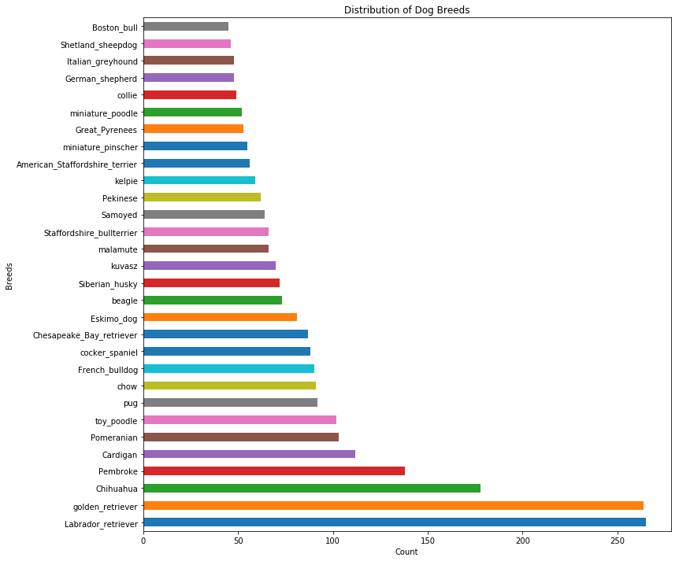

## What is the average and maximum rating values?

The average rating was found = 10.809

And the MAX. reasonable rating was found = 14

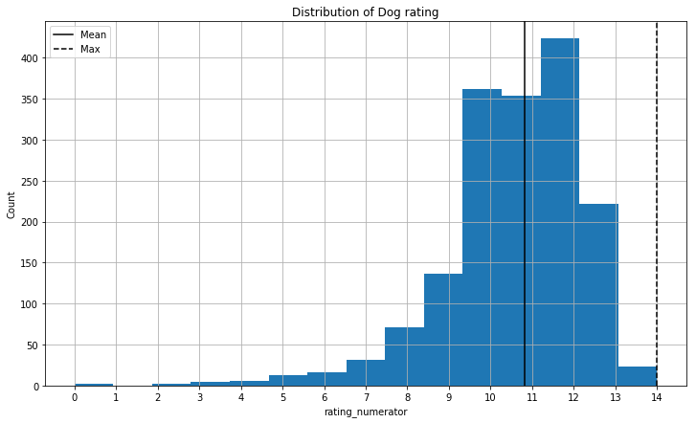

## What is the platform that users use to tweet (Web or Mobile)?

Will it seem that almost all users are tweeting using I-Phone with about 1600 tweet.

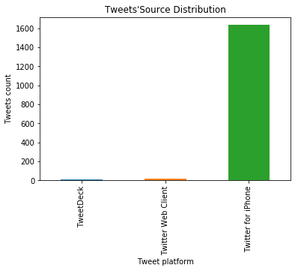

## What is the most common rating value?

After cleaning the three data sets to avoid any non-relevant ratings or rating that related to not dog images I found that the most commonly rating was 12.

