

Shoubra Faculty of engineering

**Name:** Ahmed Abdullah Mohamed Ayad

**B/n:** 5

**Section:** 5

**Topic:** Operating Systems

**Application brief :** An **operating system** is the **most important software** that runs on a computer. It manages the computer's **memory** and **processes**, as well as all of its **software** and **hardware**. It also allows you to **communicate** with the computer without knowing how to speak the computer's language. **Without an operating system, a computer is useless**.

**Github Link** **:** <https://ahmed-ayad.github.io/html-project/>

**Screen Shots:**

**Main Page**

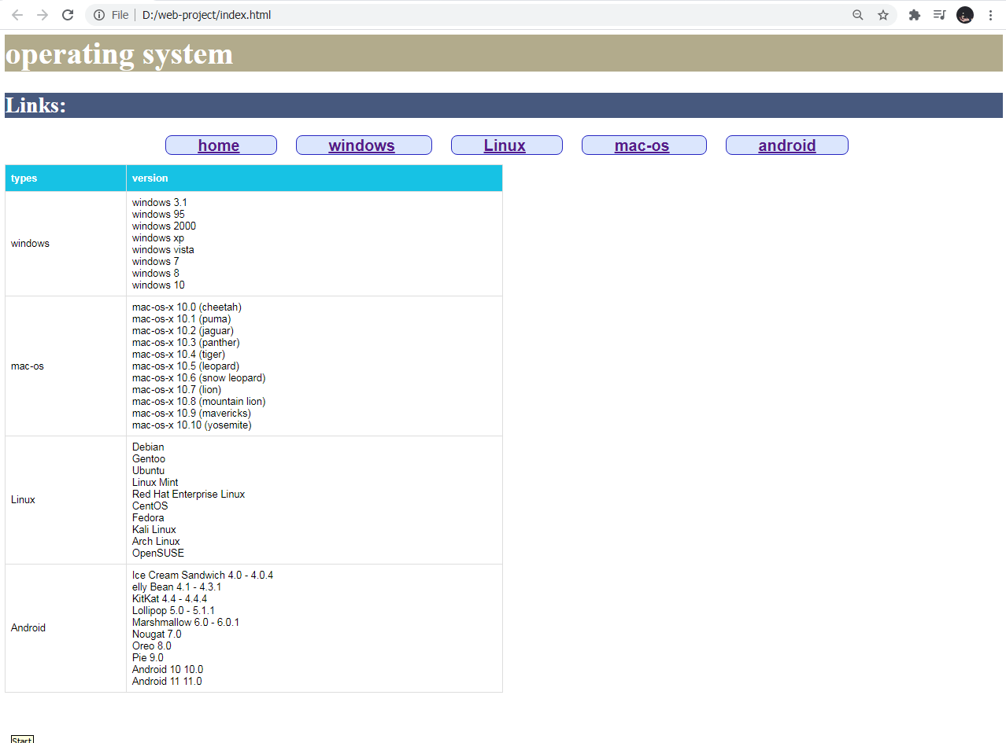

**Windows OS Page**

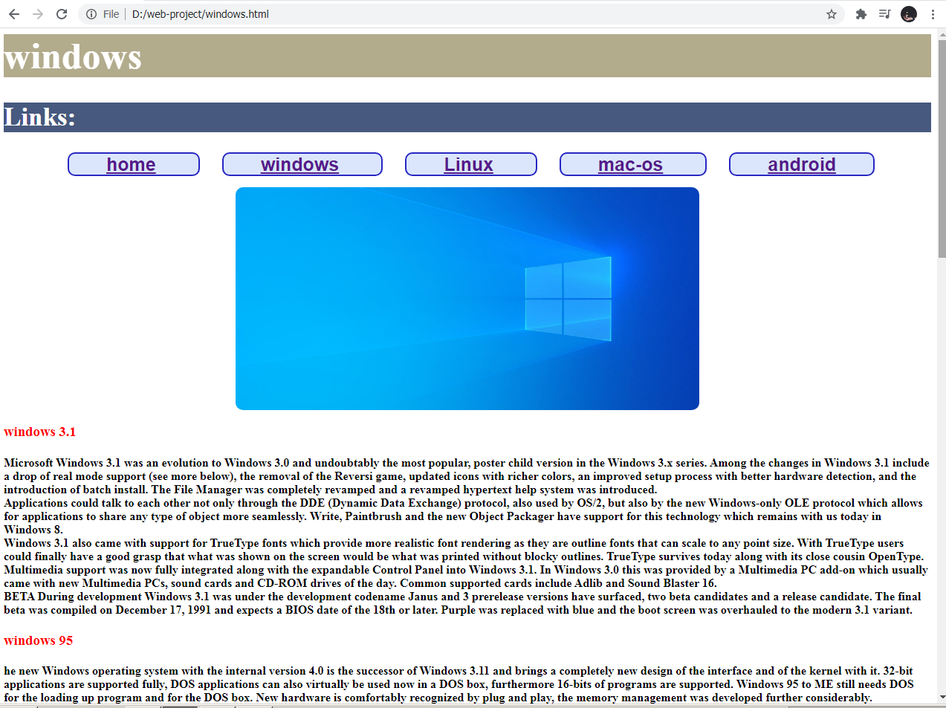

**Linux**

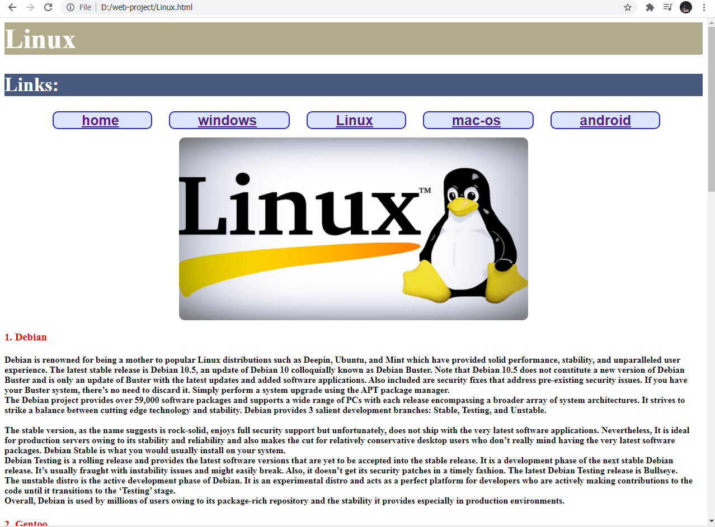

**MAC-OS**

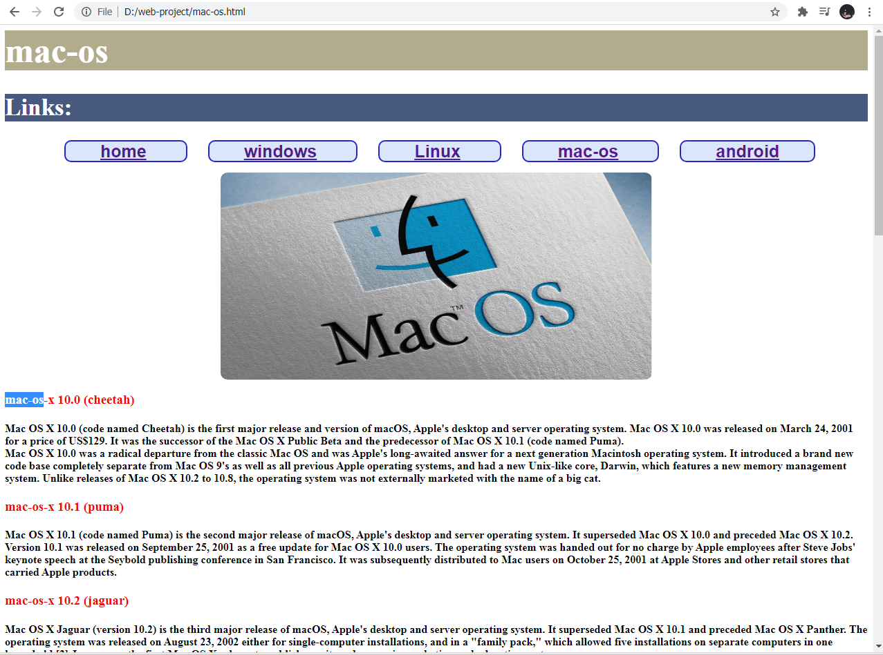

**Android**

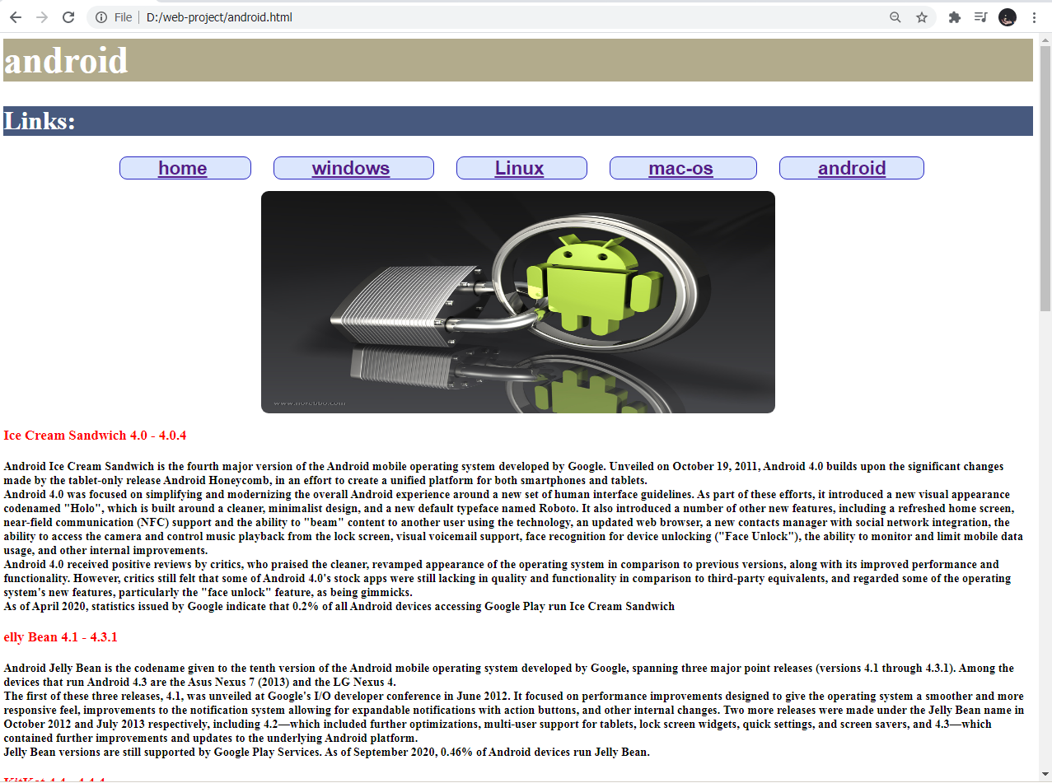

**Source Code:**

**Style Code ( CSS )**

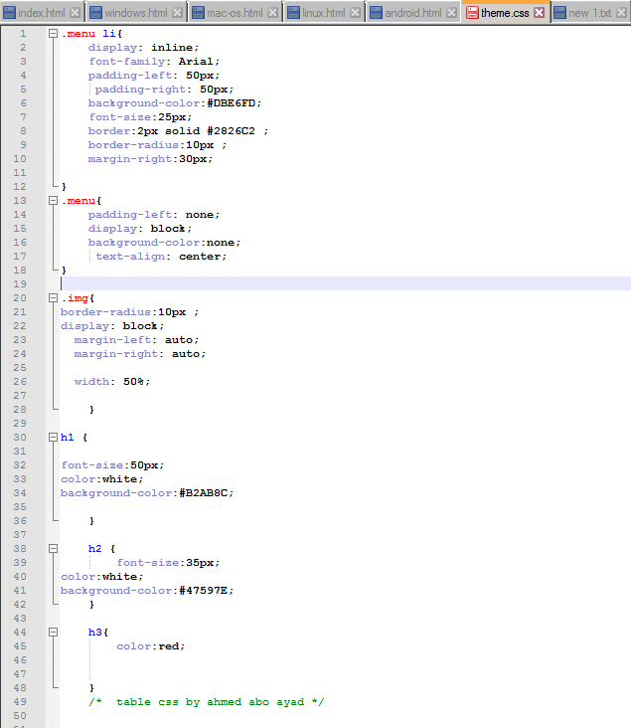

**Main page Code**

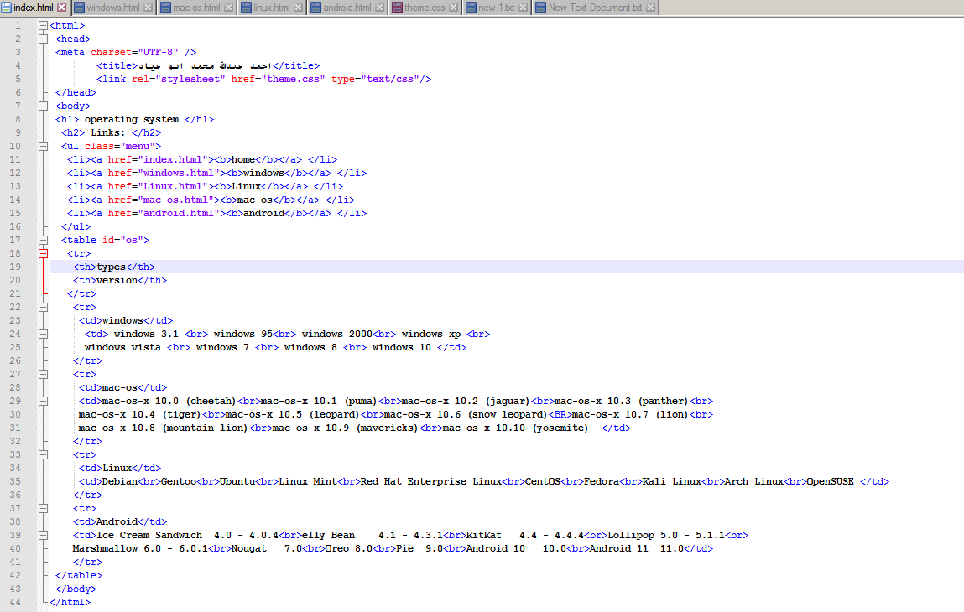

**Windows page Source code**

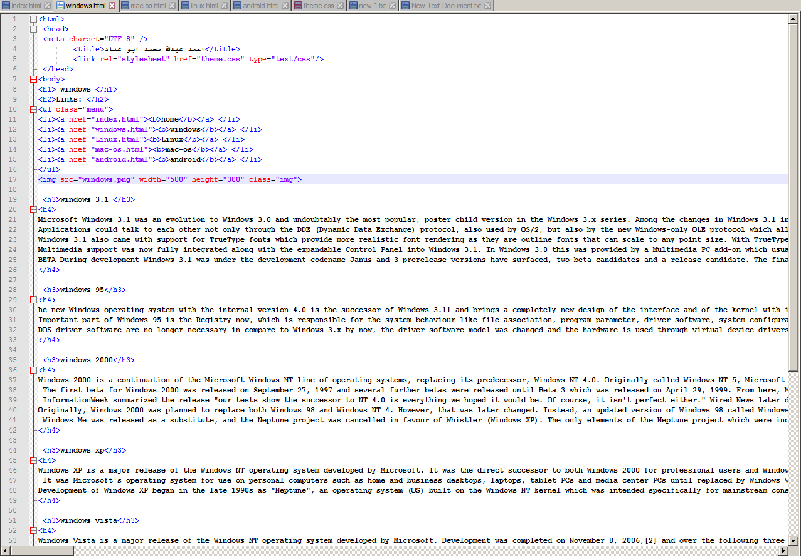

**Linux page Source code**

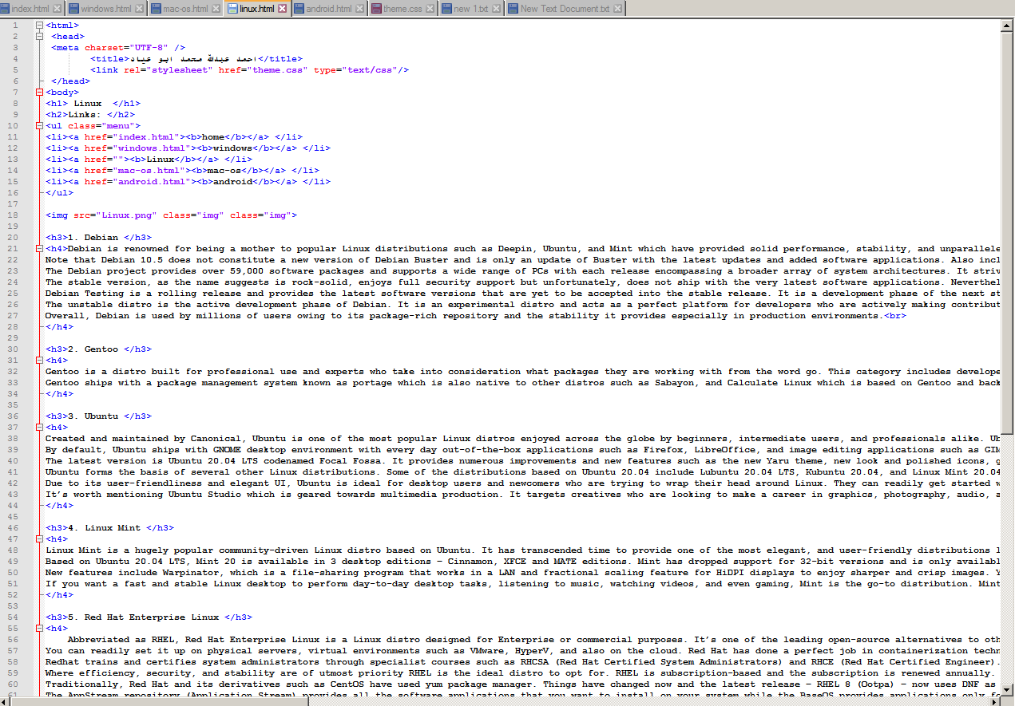

**Mac OS page Source code**

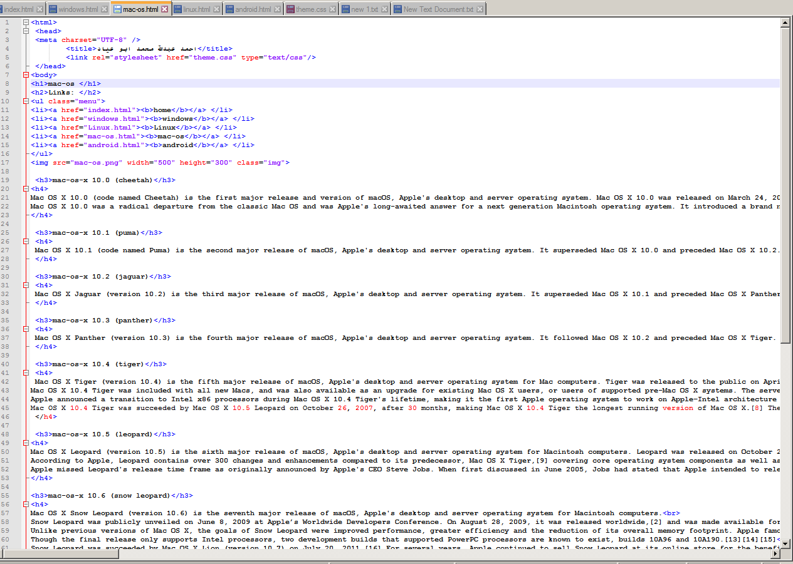

**Android page Source code**

