
Lab 1: IPv4 Addressing, Subnetting and Connectivity Testing

Teacher: Rahma Haouas Zahwanie | Academic year: 2026 - 2027
Related chapter: Chapter 1: IPv4 Addressing and Subnetting | Duration: 1h30
Tools: Cisco Packet Tracer (8.x) + a lab PC (Windows or Linux) | Work: in pairs

Objectives
At the end of this lab, you will be able to:
- Display and interpret the IPv4 configuration of a real computer (address, mask, gateway, DNS, MAC).
- Convert IPv4 addresses between decimal and binary, classify them, and compute network and broadcast addresses.
- Design a subnetting plan from a network address and a list of requirements.
- Build and configure a small routed network in Cisco Packet Tracer (routers, switches, PCs).
- Configure static routes, including a summarized route (CIDR).
- Test and troubleshoot connectivity with ping, tracert and the Packet Tracer simulation mode.
Part 1: Explore Your PC's IP Configuration
1.1 Display the IP configuration
Open a terminal on the lab PC (Windows: cmd; Linux: Terminal) and use the following commands:
Task | Windows | Linux
Display the full IP configuration | ipconfig /all | ip a, ip route, resolvectl status
Test connectivity | ping 8.8.8.8 | ping -c 4 8.8.8.8
Display the path to a destination | tracert 8.8.8.8 | traceroute 8.8.8.8 (or tracepath)

Complete the table with the values of your active network adapter (Ethernet or Wi-Fi):
Parameter | Value on your PC
Adapter name
IPv4 address
Subnet mask
Prefix length (/n)
Default gateway
DNS server(s)
Physical (MAC) address
DHCP enabled? (Yes/No)

1.2 Analyze your address
Q1. Write your IPv4 address and your subnet mask in binary.
……………………………………………………………………………………………………………………………………………………………………………………………………………………………………
Q2. Perform a logical AND between your address and the mask. Give the network address, the broadcast address and the number of usable hosts of your network.
……………………………………………………………………………………………………………………………………………………………………………………………………………………………………
Q3. What is the class of your address? Is it private or public? Justify with the RFC 1918 ranges.
……………………………………………………………………………………………………………………………………………………………………………………………………………………………………
Q4. If DHCP is enabled, list the four parameters your PC received automatically from the DHCP server.
……………………………………………………………………………………………………………………………………………………………………………………………………………………………………
1.3 Test connectivity step by step
Run the following tests in this order, and complete the table (Result: OK / Fail).
# | Command | What does this test check? | Result | Avg. time
1 | ping 127.0.0.1
2 | ping <your IP>
3 | ping <default gateway>
4 | ping 8.8.8.8
5 | ping www.google.com
6 | tracert 8.8.8.8

Note: Some networks block ICMP. A failed ping does not always mean that the destination is down: a firewall may drop Echo Requests.

Q5. Test 4 succeeds but test 5 fails. What is the most likely problem?
……………………………………………………………………………………………………………………………………………………………………………………………………………………………………
Q6. In the tracert output, how many hops are there to 8.8.8.8? What is the IP address of the first hop, and which device is it?
……………………………………………………………………………………………………………………………………………………………………………………………………………………………………
Q7. Look at the TTL value in the ping replies from 8.8.8.8. Why is it lower than the initial value (64, 128 or 255)?
……………………………………………………………………………………………………………………………………………………………………………………………………………………………………
Part 2: Addressing Exercises
Exercise 2.1: Binary and decimal conversions
Decimal | Binary
192
172
10
 | 11100000
 | 01000001
255.255.255.192
 | 11000000.10101000.00001010.01000001
Exercise 2.2: Classify the following addresses
For each address, give its class and its type: public, private, multicast or loopback.
IPv4 address | Class | Type
10.45.3.1
172.20.5.9
172.35.1.1
192.168.100.1
200.1.2.3
224.0.0.5
127.0.0.1
Exercise 2.3: Subnet calculations
Complete the table. Hint: block size = 256, the value of the mask octet that is not 0 or 255.
Address / prefix | Subnet mask | Network address | First host | Last host | Broadcast | Usable hosts
192.168.50.77/27
10.1.1.130/25
192.168.24.59/30
172.16.45.200/20 (challenge)
Q8. In the course, the address 192.168.24.59/30 was not a valid unicast host address. Using your table, explain why.
……………………………………………………………………………………………………………………………………………………………………………………………………………………………………
Exercise 2.4: Route summarization (CIDR)
A router must advertise the four networks 192.168.0.0/24, 192.168.1.0/24, 192.168.2.0/24 and 192.168.3.0/24 with one single route.
Q9. Write the third octet of each network in binary, count the matching left-most bits, and give the summary route (address, prefix and mask).
……………………………………………………………………………………………………………………………………………………………………………………………………………………………………
Part 3: Design and Configure a Subnetted Network
Scenario
A company has received the network 192.168.10.0/24. The network administrator wants to separate three departments into different subnets to improve performance (smaller broadcast domains), security and manageability. Two routers are used: R1 serves the Admin and Dev departments, R2 serves the Lab department, and R1 and R2 are connected by a point-to-point link.
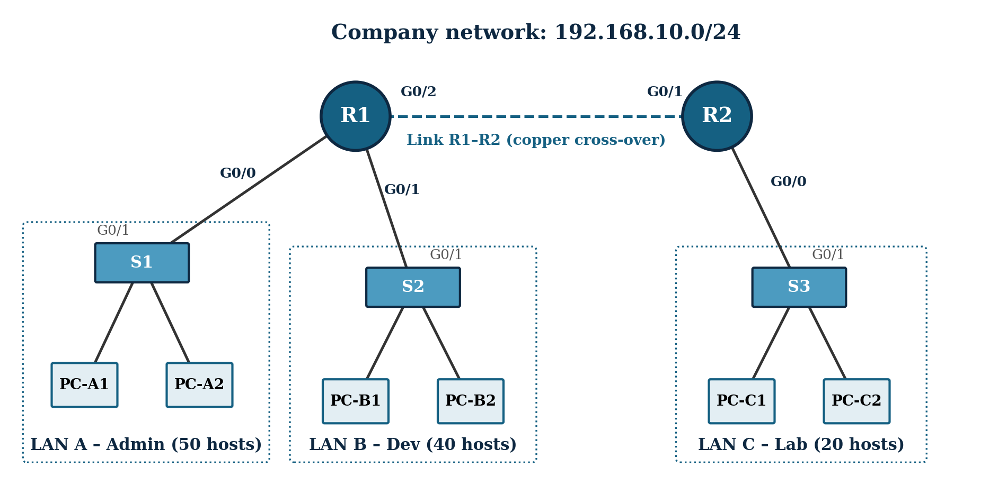
Figure 1: Lab topology (routers: Cisco 2911; switches: Cisco 2960; 6 PCs).
Addressing rules:
- Divide 192.168.10.0/24 into subnets of equal size (fixed-length subnetting).
- Assign the subnets in this order: LAN A, LAN B, LAN C, then the R1-R2 link.
- Each router interface on a LAN receives the first usable address of the subnet (it is the default gateway).
- PCs receive the next addresses (e.g., PC-A1 = gateway + 1, PC-A2 = gateway + 2).
- On the R1-R2 link: R1 receives the first usable address, R2 the second.
3.1 Design the addressing plan
Q10. How many subnets do you need? How many bits must you borrow from the host portion? Give the new mask (decimal and prefix) and the number of usable hosts per subnet. Is it enough for the Admin department?
……………………………………………………………………………………………………………………………………………………………………………………………………………………………………
Complete the addressing plan:
Subnet | Hosts needed | Network address | Mask / prefix | First usable | Last usable | Broadcast
LAN A - Admin | 50
LAN B - Dev | 40
LAN C - Lab | 20
Link R1-R2 | 2

Complete the device addressing table using the rules above:
Device | Interface | IPv4 address | Subnet mask | Default gateway
R1 | G0/0 |  |  | N/A
R1 | G0/1 |  |  | N/A
R1 | G0/2 |  |  | N/A
R2 | G0/0 |  |  | N/A
R2 | G0/1 |  |  | N/A
PC-A1 | NIC
PC-A2 | NIC
PC-B1 | NIC
PC-B2 | NIC
PC-C1 | NIC
PC-C2 | NIC

Checkpoint: Ask your teacher to check your addressing plan before configuring the devices. A wrong plan makes all the next steps fail.
3.2 Build the topology in Packet Tracer
- Open Cisco Packet Tracer. From Network Devices, add two 2911 routers and three 2960 switches. From End Devices, add six PCs. Rename each device (Config tab → Display Name) as in Figure 1.
- Connect each PC (FastEthernet0) to its switch (Fa0/1, Fa0/2) with a Copper Straight-Through cable.
- Connect each switch (G0/1) to its router interface (see Figure 1) with a Copper Straight-Through cable.
- Connect R1 G0/2 to R2 G0/1 with a Copper Cross-Over cable (two devices of the same type).
- Observe the link lights: the router links stay red until the interfaces are configured and activated.
3.3 Configure the routers
Click on R1 → CLI tab. Press Enter, answer no to the initial configuration dialog, then type:
Router> enable
Router# configure terminal
Router(config)# hostname R1
R1(config)# interface GigabitEthernet0/0
R1(config-if)# description LAN A - Admin
R1(config-if)# ip address 192.168.10.1 255.255.255.192
R1(config-if)# no shutdown
R1(config-if)# exit
R1(config)# interface GigabitEthernet0/1
R1(config-if)# description LAN B - Dev
R1(config-if)# ip address ______________ ______________
R1(config-if)# no shutdown
R1(config-if)# exit
R1(config)# interface GigabitEthernet0/2
R1(config-if)# description Link to R2
R1(config-if)# ip address ______________ ______________
R1(config-if)# no shutdown
R1(config-if)# end
R1# copy running-config startup-config

Now configure R2 (hostname, G0/0 and G0/1) on your own. Write your commands below:
……………………………………………………………………………………………………………………………………………………………………………………………………………………………………
3.4 Configure the PCs
- Click on each PC → Desktop → IP Configuration → select Static.
- Enter the IPv4 address, subnet mask and default gateway from your device addressing table.
- Verify: Desktop → Command Prompt → ipconfig.
3.5 Verify the configuration
On R1 and R2, run show ip interface brief.
Q11. What should the Status and Protocol columns show for the configured interfaces? What does "administratively down" mean?
……………………………………………………………………………………………………………………………………………………………………………………………………………………………………
From PC-A1, run the following tests and complete the table:
From | To | Command | Result (OK / Fail)
PC-A1 | PC-A2 (same LAN) | ping 192.168.10.3
PC-A1 | Its gateway (R1 G0/0) | ping 192.168.10.1
PC-A1 | PC-B1 (LAN B) | ping 192.168.10.66
PC-A1 | PC-C1 (LAN C) | ping 192.168.10.130

Note: The first ping to a new destination may lose its first packet: the device must first resolve the MAC address with ARP. This is normal.

Q12. On R1, run show ip route. Which networks does R1 know, and with which letter are they marked? Explain why the ping from PC-A1 to PC-C1 fails.
……………………………………………………………………………………………………………………………………………………………………………………………………………………………………
3.6 Configure static routes
On R1, add a static route to LAN C through R2:
R1(config)# ip route 192.168.10.128 255.255.255.192 192.168.10.194

On R2, instead of writing two routes (one for LAN A and one for LAN B), you will write one summarized route (CIDR).
Q13. Write 192.168.10.0 and 192.168.10.64 in binary (last octet only). How many left-most bits match? Give the summary route (address, prefix, mask).
……………………………………………………………………………………………………………………………………………………………………………………………………………………………………
Q14. Write the command to configure this summarized route on R2 (next hop = R1).
……………………………………………………………………………………………………………………………………………………………………………………………………………………………………
Q15. Run show ip route on R2. With which letter is the new route marked? What is the advantage of a summarized route?
……………………………………………………………………………………………………………………………………………………………………………………………………………………………………
3.7 Final tests and analysis
Q16. From PC-A1, ping PC-C1 (192.168.10.130). What is the result? What TTL value do you see in the replies? Explain the value.
……………………………………………………………………………………………………………………………………………………………………………………………………………………………………
Q17. From PC-A1, run tracert 192.168.10.130. List the IP addresses of the hops.
……………………………………………………………………………………………………………………………………………………………………………………………………………………………………
Simulation mode: click on Simulation (bottom right), keep only ICMP in the event filter, then ping PC-C1 from PC-A1. Click Capture/Forward step by step and open the packet (click on the envelope) on each link. Complete the table:
Link | Source MAC | Destination MAC | Source IP | Destination IP | TTL
PC-A1 → R1
R1 → R2
R2 → PC-C1

Q18. Which fields change at each hop, and which stay the same? Link your answer to the recap of the course (Layer 2 vs Layer 3 addressing)
……………………………………………………………………………………………………………………………………………………………………………………………………………………………………
Part 4: Troubleshooting Challenge
Four new PCs were added to the network, but none of them can communicate correctly with the other LANs. For each one, find the error and propose a correction.
PC (LAN) | IPv4 address | Subnet mask | Gateway | Error found | Correction
PC-X (LAN B) | 192.168.10.64 | 255.255.255.192 | 192.168.10.65
PC-Y (LAN B) | 192.168.10.70 | 255.255.255.0 | 192.168.10.65
PC-Z (LAN C) | 192.168.10.135 | 255.255.255.192 | 192.168.10.1
PC-W (LAN A) | 192.168.10.63 | 255.255.255.192 | 192.168.10.1

