# Clipping Line on Circle

If both the starting point and ending point of the line are outside the circle the no clipping is necessary.

Otherwise we will run intersection to find the points.

* No points or one point -> no clipping
* Two points. Only care about the points that are on the actual segment.

## Point inside circle test:

To test if a point is inside the circle, we use the equation of the circle.

Where is the origin of the circle, is the radius.

For simplicity, we will consider the origin of the circle as and the line coordinates as relative to the original origin.

Simply plug in the coordinates and return the inequality result.

## Intersection between line and circle

Circle equation:

Line equation: .

To find the values of the constants, we will use the original line equation using the two points defining the line:

So , and

To find the intersection point, we will solve the two equations together.

As a reminder, the solutions for a general equation of the form

If we plug in the expressions into the above formula we get:

We will assign .

Substituting in the line equation we get:

Notice that the line doesn’t intersect the circle if

## Point on segment

If we know that a point is on the line, to verify that it is on the segment, we calculate and The dot product indicates the type of angle. If the angle is acute, it is positive. If both angles are non-negative, then the point must be on the line.

# Clipping Circle on Circle

## Intersection between circle and circle

Subtracting gets us:

Substituting in the circle equation we get:

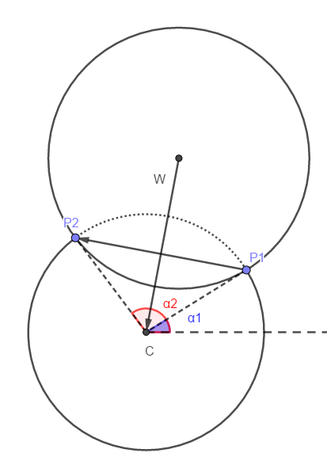These two intersection points split the circle into two arcs. One of the two arcs is inside the clipping window, and the other is outside. To figure out which is which we will start by defining , as the angles that the intersection points and make with the circle center(with respect to positive ). is the window, while is the circle we are clipping (see figure.)

The combined direction between and dictates whether the counterclockwise curve between and is inside the clipping window or not. If we organize rename the intersection points such that . We guarantee that the curve is inside the circle.

Because is guaranteed to be positive (it is a square root), we guarantee that calculating the points in the given order will ensure that the clipped curve is the clockwise curve between and

# Clipping Bezier on Circle

Since a cubic curve can intersect with a circle at 6 points, the degree of the equation could be of the 6th degree. So, I will opt in for the easy method for Bezier curve.

Simply, for each pixel, if the pixel is inside the circle (check the test above), then it is draw, otherwise it is “clipped”.