# DrawCircle1

The equation of a circle residing at point with radius is

Using . We get:

As such:

Where . Simply put, we will loop over all possible values of in the range, and calculate the corresponding and values and draw at this point. However, , and as such, we need some sort of . What is the optimal value for ?

For now, we set , we will prove this later.

From this point on, we will consider the center point of the circle at We can simply translate the point before drawing.

# Optimizing loop

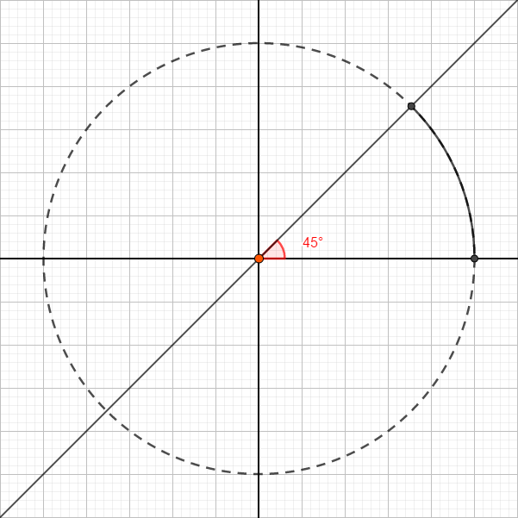A circle is highly symmetric, so instead of finding all points from , we will only be concerned with and use the and value of this to interpolate all other points:

|  |  |  |
| --- | --- | --- |
| Reflect around |  |  |
|  |  |  |
|  |  |  |
|  |  |  |
|  |  |  |
|  |  |  |
|  |  |  |
|  |  |  |
|  |  |  |

Simply put, for each and we calculate (using and or any other method), we will SetPixel the following:

|  |
| --- |
| SetPixel(hdc, xc + x, xc + y, color);  SetPixel(hdc, xc - x, xc + y, color);  SetPixel(hdc, xc + x, xc - y, color);  SetPixel(hdc, xc - x, xc - y, color);  SetPixel(hdc, xc + y, xc + x, color);  SetPixel(hdc, xc - y, xc + x, color);  SetPixel(hdc, xc + y, xc - x, color);  SetPixel(hdc, xc - y, xc - x, color); |

# DrawCircle2

As a revision:

|  |  |
| --- | --- |
|  |  |
|  |  |

# Optimal step:

For a smooth circle, we want the distance between two consecutive points to be at most one pixel.

Using Taylor series:

We will use the approximation

We will use the upper limit of this equation as a value of .

# DrawCircle3

As a revision, to figure out if a point is inside a circle residing at , we calculate its distance from the center point. If this distance is greater than , the point is outside the circle, otherwise it is inside the circle. To skip the root, we can compare the square of the distance with the square of the radius, or in another word:

If , point is outside the circle, otherwise it is inside the circle.

Out of all 8 arcs, we are only concerned with calculating and values for the first arc (highlighted in the earlier figure). Observe that starting from towards , always increases, while sometimes decreases. The arc stops at the point where . We can use the mid-point method to estimate the value of .

For a point that we have drawn, the next point is either going to be or . The midpoint is , if this point is inside the circle, then the outer point is closer, otherwise is closer.

Similar to previous procedures, we will find :

If is 0

If is

In another word, always add , and add if the condition is true