**Evaluation Only. Created with Aspose.Words. Copyright 2003-2023 Aspose Pty Ltd.**

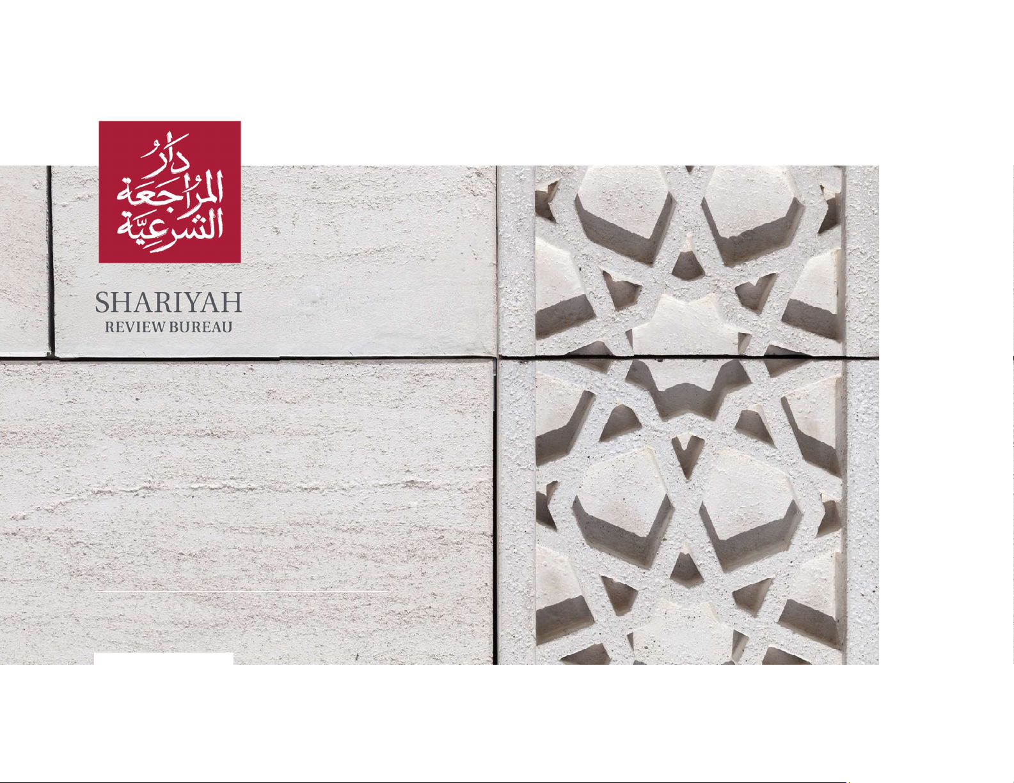

Ijara Company

Kyrgyzstan

SHARI'A AUDIT REPORT

1st January 2022 – 31st Decembe r 2022

SHARIA ADVISOR LICENSED BY

THE CENTRAL BANK OF BAHRAIN

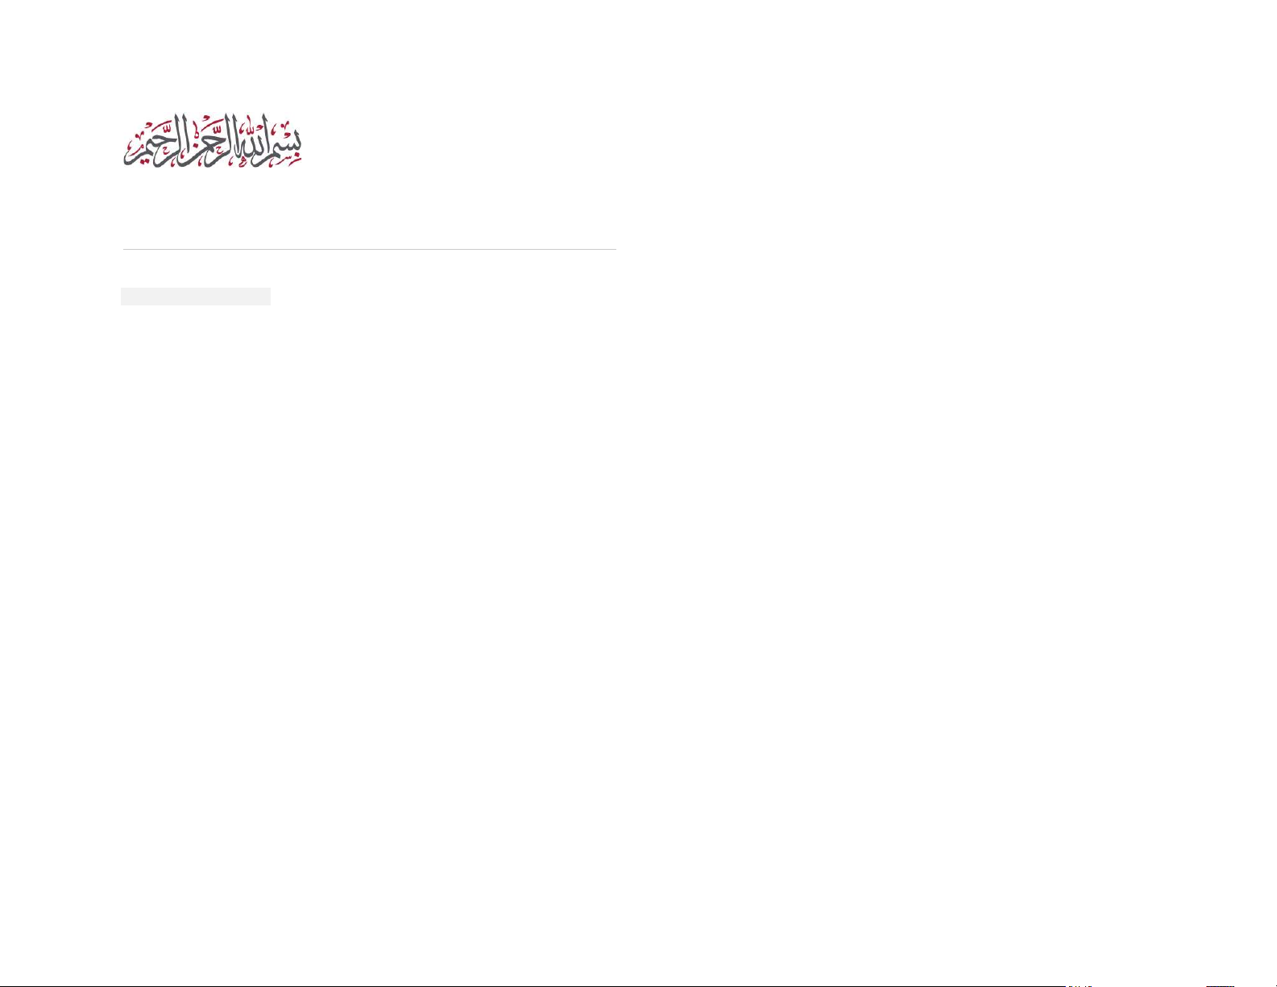

Table of Contents

PART 1: PREFA CE 3

1. INTRODUCTION 3

2. STANDARDS AND GUI DELINES 3

3. RESPONSIBILITY 4

4. PROCEDURES PERFORMED 5

5. SCOPE OF WORK 6

6. SAMPLING ME THODOLOGY 6

7. OBJECTIVES AND NO TES 7

8. RATINGS 8

9. CONFIDEN TIALITY 8

PART 2: OBSERVATI ONS 9

FINANCE DEPARTMENT 9

OPERATIONS DEPARTM ENT 10

COMPLIANC E DEPARTMENT 13

HUMAN RESOUR CES DEPARTMEN T 14

APPENDIX I 15

A PP E ND I X I I 16

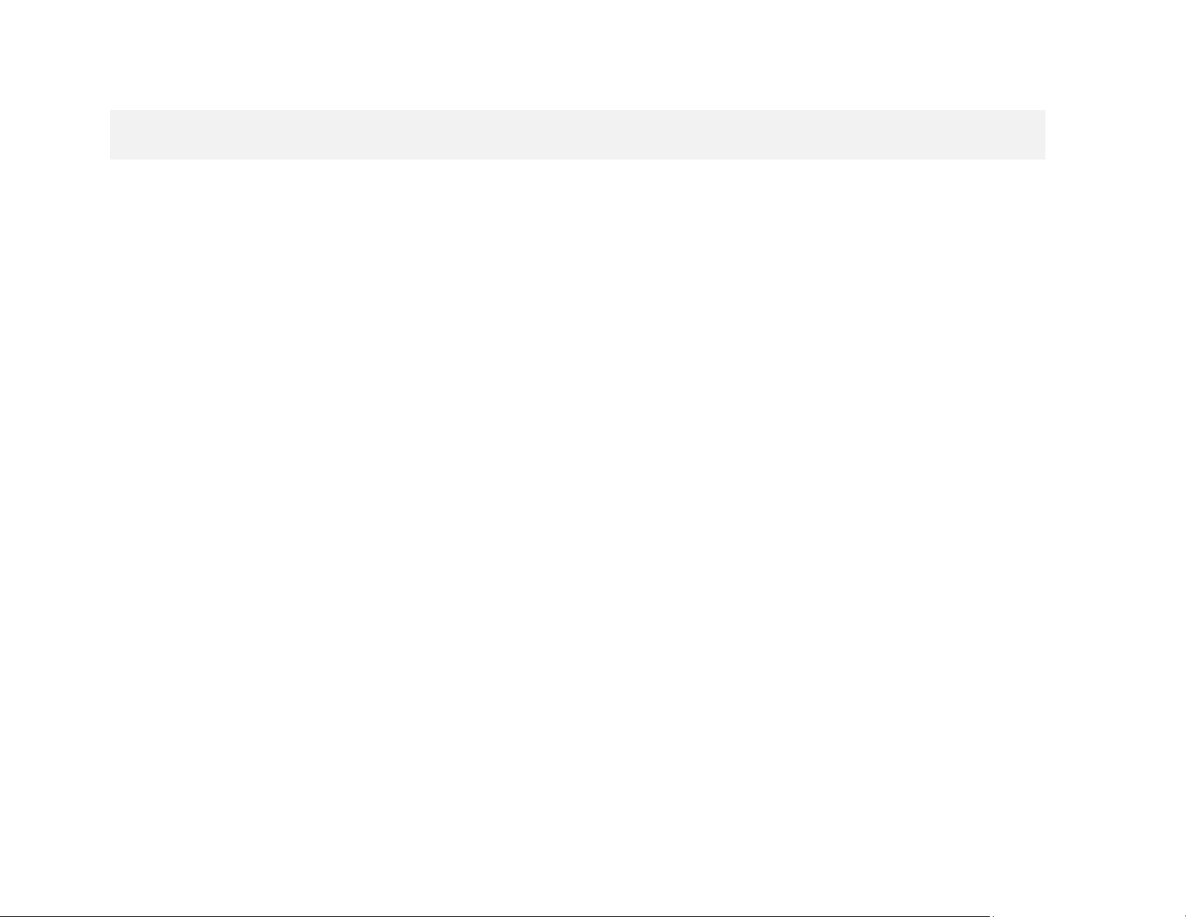

| 3 | Shariyah Review Bureau | Internal Audit Report | Ijara Company Kyrgyzstan (ICK) ICK-1203-06-01-03-23

P ar t 1 : Pr e f ac e

1. In t r od u ct i o n

This report has be en prepared after conducting Shari'a Audit

("Audit") for Ijara Company Kyrgyzstan ( "Company"), covering the

period from January 1, 2022, to Dece mber 31, 2022. In accordance

with the agreed-upon s cope of work, our responsibility as Shari'a

Auditors for the Company includes carrying out Audit on the

products, pertinent ac tivities, systematic controls, and operations in

place at Ijara Company Kyrgyzstan based on t he Sh ari'a dir ective s

and guidelines issued by the Compa ny’s Shari'a Supervisory

Committee ("SSB").

2. S ta nd a r ds an d Gu i de l i ne s

The audit was conducted in light of the Shari'a guidelines issued by

the SS B while taking i nto consideration the Shari'a stand ards issued

by t he Acc ounting and Auditing Organization for Islamic Financial

Institutions ("AAO IFI"). In the case where th e SSB de cision opposes

the AAOIFI, the SSB opinion will prevai l.



| 4 | Shariyah Review Bureau | Internal Audit Report | Ijara Company Kyrgyzstan (ICK) ICK-1203-06-01-03-23

3. R e s po n si b i li t y

The Management of The Company is responsible for ensuring that the financial arrangements, contracts, and transactions having Shari'a

implications, entered into with its customers, other financial i nstitutions, and stakeholders and related policies, procedures , and systems are,

in substance and their legal form, in compliance with the requirements of Shari'a rules and principles laid down by the SSB. The management

of the Company is also responsible for:

> Design, implementation, and maintenance of appropr iate internal Shari'a control procedures with respect to such compliance and

maintenance of relevant product documents approved by the SSB, internal control manuals, and Islamic accounting records;

> Prevention and detection of fraud and breac hes in Shari’a Compliance for identifying a nd ensuring that The Company c omplies with SSB

requirements, laws, and regulations applicable to its activities;

> Arranging training a nd/or ori entation programs on I slamic banking and finance for the staff and a ppropriate training programs for senior

executives to improve their unders tanding and g eneral acumen in Islamic finance;

> Arranging pro grams on a r egular basis for o rienting and s ensitizing the key ex ecutives about the bus iness utility a nd importance of enabling

Shari’a c ompliance environment and the key d istinguishing features of Islamic finance products vis- à - vis conventional banking products;

and

> Providing u s with access to all i nformation of which you are aware that is relevant to The Company’s compliance with the Shari’a rules and

principles such as records, source documenta tion, and other matters, additional information that we m ay request for the purpose of the

engagement; and unrestricted ac cess to persons within The Compa ny from whom we d etermine i t necessary to obtain evidence.



| 5 | Shariyah Review Bureau | Internal Audit Report | Ijara Company Kyrgyzstan (ICK) ICK-1203-06-01-03-23

4. P r oc e d ur e s P er f or me d

The procedures selected by us for the Shari'a Audit a nd the factual findings resulting therefro m with respect to each of the aspects covered in

this report were depended on our ju dgment, based o n risk assessments of the products and services with the Shari'a stand ards and g uidelines,

audit planning sampl ing and d ocumentation. In making those Shari'a risk assessments, we considered and tested the interna l Shari'a control s

on a sample of transactions relevant to The Company’s compliance with the laid down SSB rules and principles and designed procedures that

are appropriate in the c ircumstances , but not for the purpose of expressing an opi nion on the effectiveness of The Company's inter nal control

on Shari'a rules and principles.

Because of the inherent limitations in any control environment, misstatements due to error or fraud may occur a nd not be detected. Our

engagement ca nnot ensure that errors, f raud, or other il legal a cts, i f pre sent, wil l be de tected; in the case w here we d etect any fraud or red

flags, we will escalate the iss ue t o the a udit committee. Our procedures have not been planned or conducted in co ntemplation of r eliance by

any third pa rty or with respect to any specific transaction. T herefore, items of possible interest to a third pa rty have not been specifically

addressed, and matters may exist that would be assessed differently by a th ird party. Accordingly, our report should not be provided to a third

party without our prior written consent. Such consent will be granted on the basis that such reports are no t prepared for the use or benefit of

anyone other than The Company.

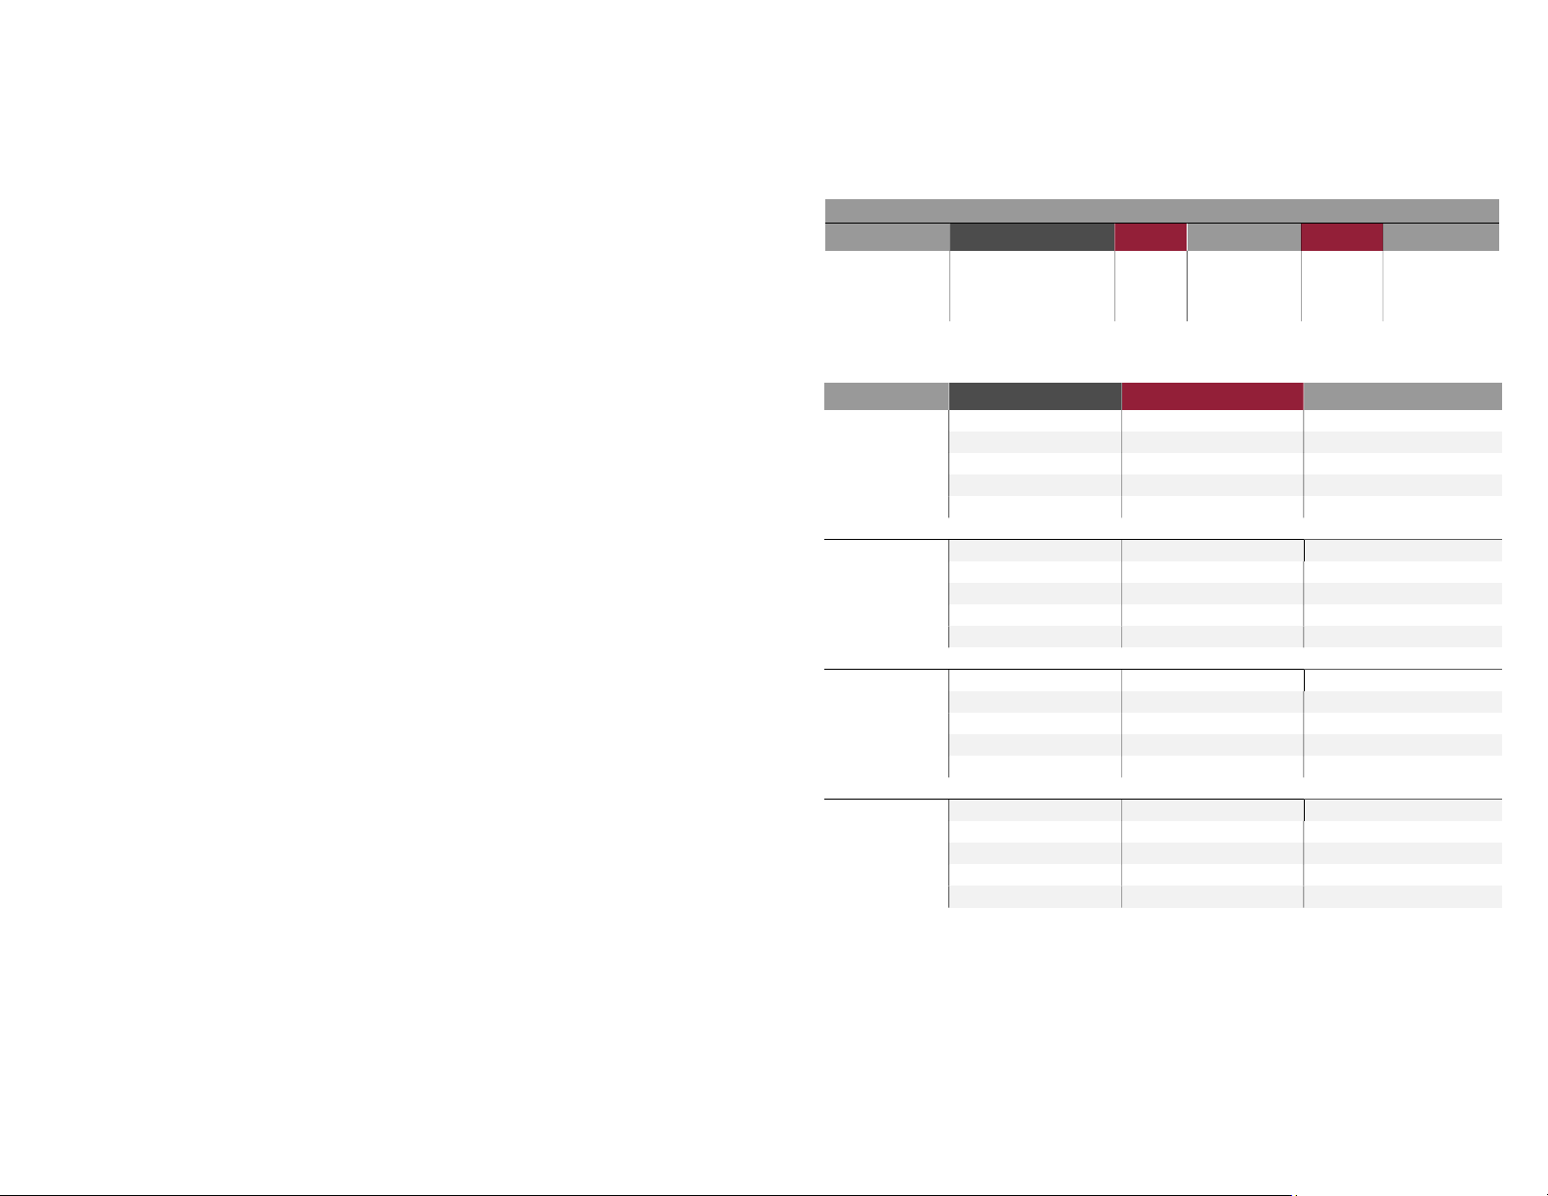

| 6 | Shariyah Review Bureau | Internal Audit Report | Ijara Company Kyrgyzstan (ICK) ICK-1203-06-01-03-23

5. S c o pe of Wo r k

The Audit included reviewing the operations and activities of the Company, in

addition to examining the products and related transactions to ensure that

they a re conducted i n accordance with the guidelines and pe rtinent controls

approved by the SSB. Exhibit 1 shows the products included in the Audit

process and sampling c overage.

6. S a mp l i ng Me t h od o log y

Our sampling methodology is based on the likelihood and Shari’a risk

involved in a particular product; where likelihood and Shari’a r isk are high,

the sampling will be increased accordi ngly.

will be

Exhibit 1: Products and Samples

Department

Product Year population

sample

Percentage

Operations Ijarah muntahia

Bittamleek 2022 19 19 100%

Population Likelihood Shari’a Risk Samples Percentage

1 to 100

High High 100%

High Medium 75%

Medium High 50%

Medium Medium 25%

Low Low 10%

101

to 300

High High 50%

High Medium 50%

Medium High 25%

Medium Medium 20%

Low Low 10%

**This document was truncated here because it was created in the Evaluation Mode.**