Ahmed Ehab Ahmed
MongoDB Lab1

1- Install mongodb server and mongosh client
2- Add mongo DB folder to your system variables path
3- Open server (on windows shell using command “mongod”);
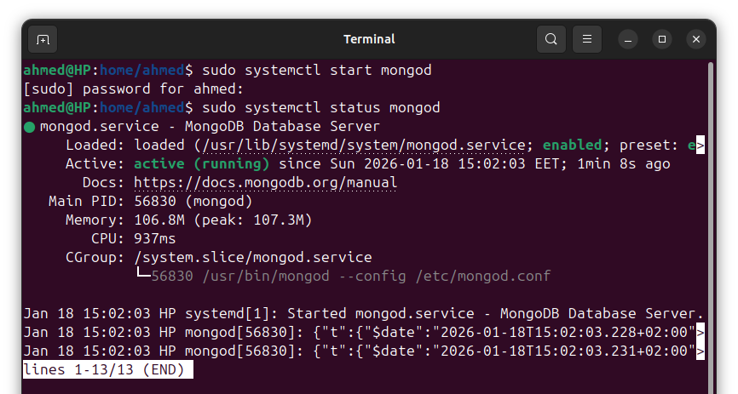

4- Open another shell for client using command “mongosh”
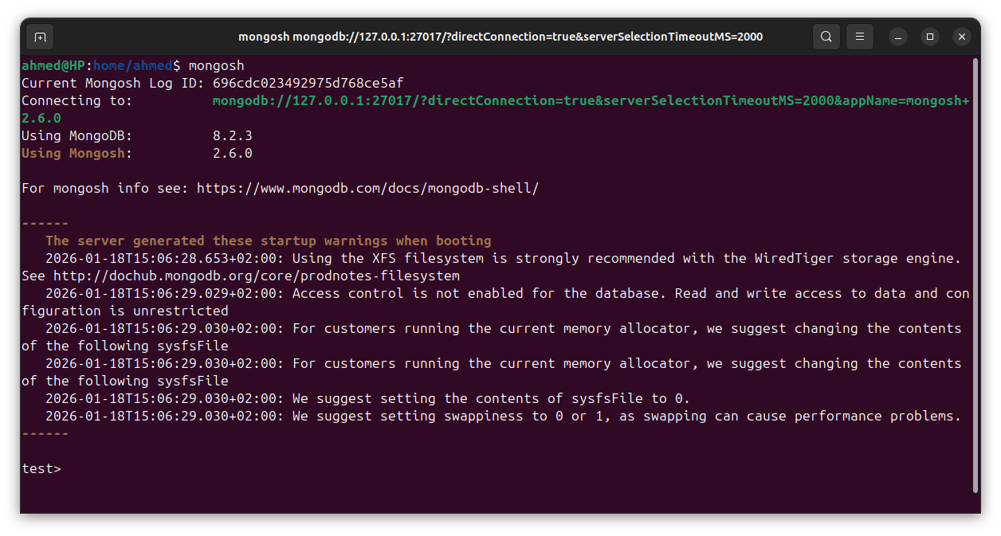
5- Create database with name ITI → by typing use ITI
6- start create new collection named instructors
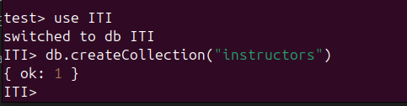

a- Insert many using array contained with lab folder instructors.txt file.
b- Insert your own data
c- Insert instructor without firstName and LastName (mongo will raise an
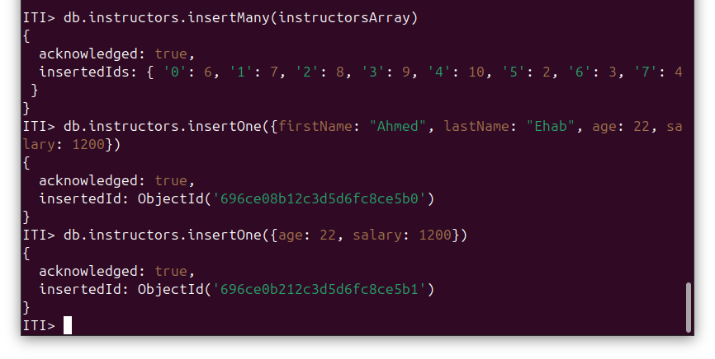
error or not ?)

7- Try the following queries: (all queries should be run using find or findOne)
a- db.instructors.find({});
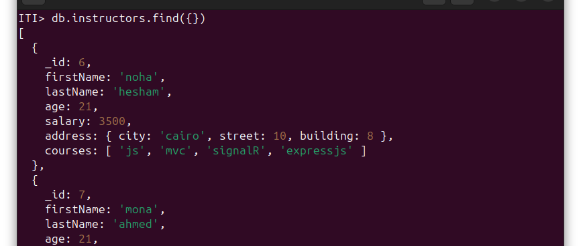
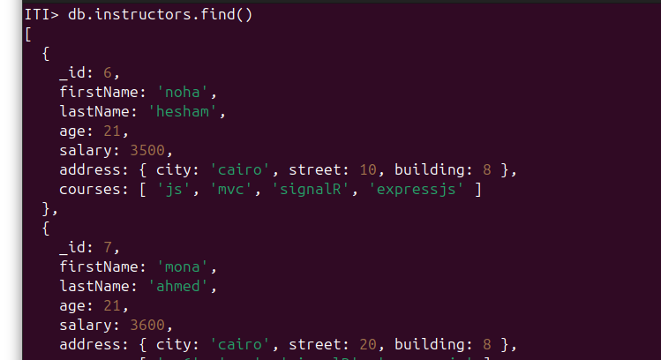
b- db.instructors.find();

c- db.instructors.findOne();
d- db.instructors.find().constructor.name
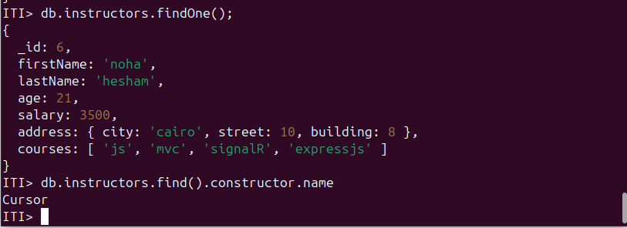

e- db.instructors.find({}).forEach((document)=>{
print(document); })
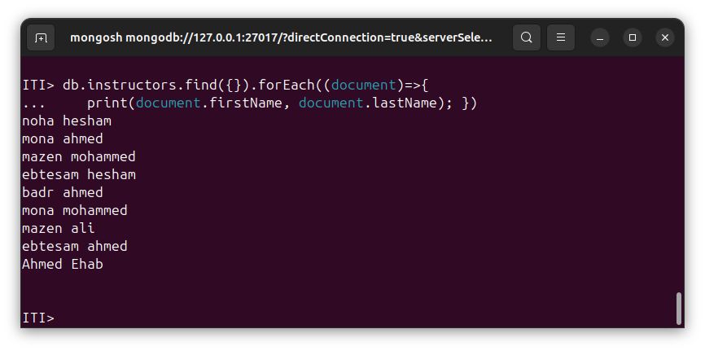
f-display only firstName and lastName for each instructor?!

